|  |
| --- |
| Faculty of Applied Sciences and Technology |
| **NODE/EXPRESS WEB API** |
| ITE5315 - Project |
|  |
| **Ashka Shah, Rushil Patel**  **Submission Date** |
| **4/11/2022** |

|  |
| --- |
| This document explains how to build Node/Express Web API …………………………. |

Table of Contents

Question 1: 2

Question 2: 3

Question 3: 4

Question 4: 5

Question 5: 6

Question 6: 7

Summary 8

# Question 1:

(Describe the major steps for implementing the MongoDB database in Atlas)

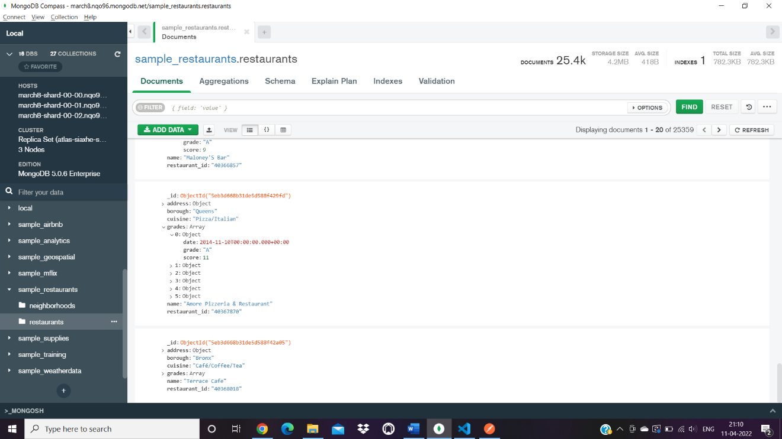

# Question 2:

(Describe the major steps for implementing Routes in the API, how you test this program, add some screenshots of the output)

* Localhost:8080
* This route will give in response the welcome message.

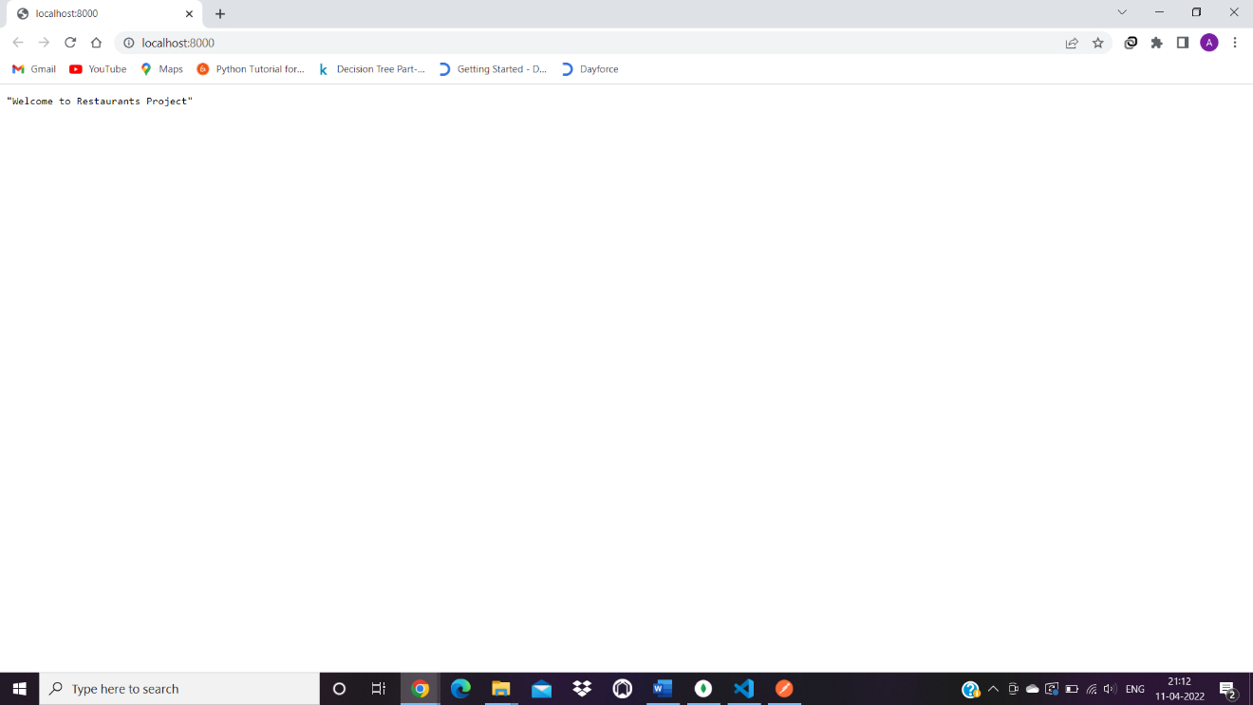

* Localhost:8080/api/restaurants
* This route will return all the data in the restaurant collection when called.

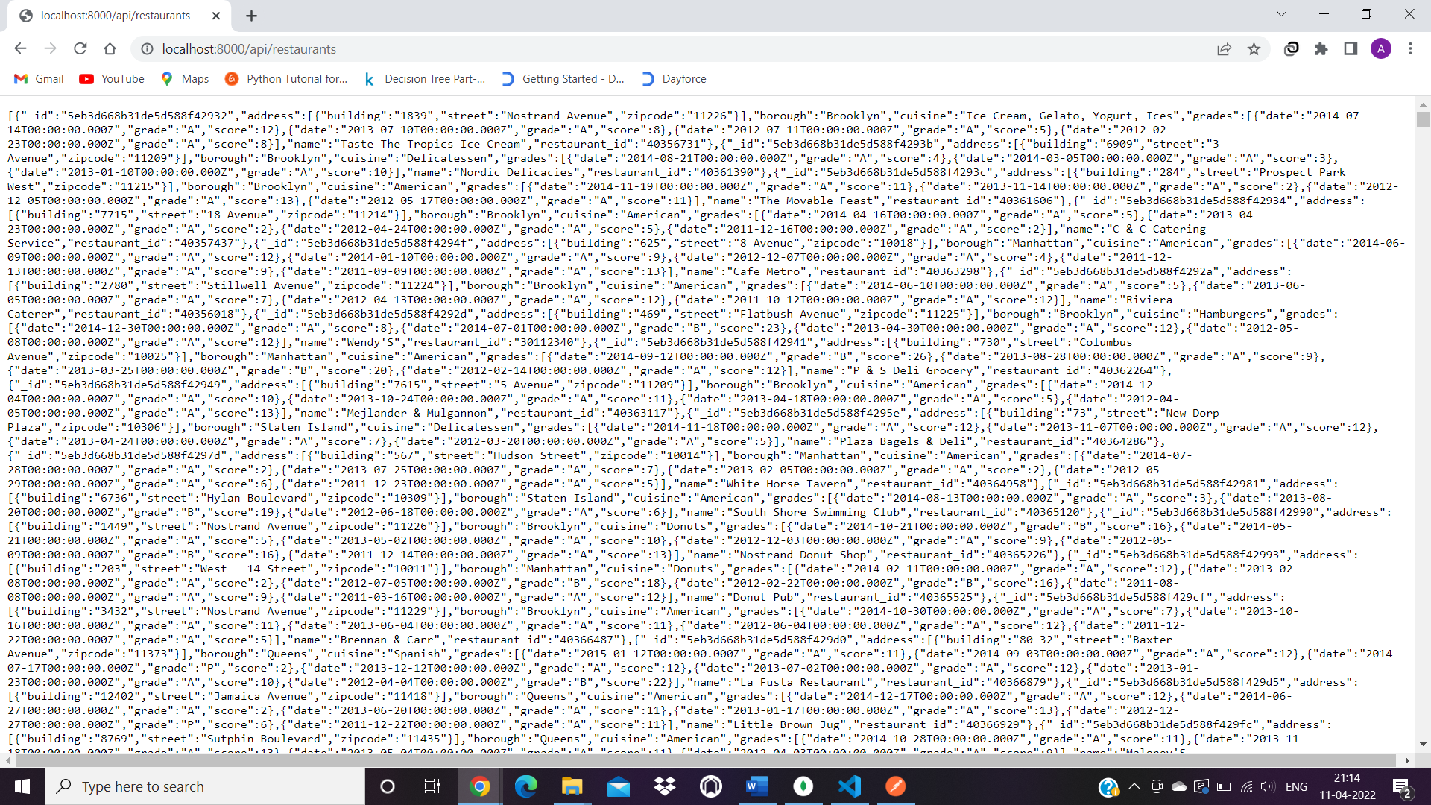

* Localhost:8080/api/restaurants/restaurant_id
* This route, when called, returns the details of a specific restaurant by searching it using the restaurant id.

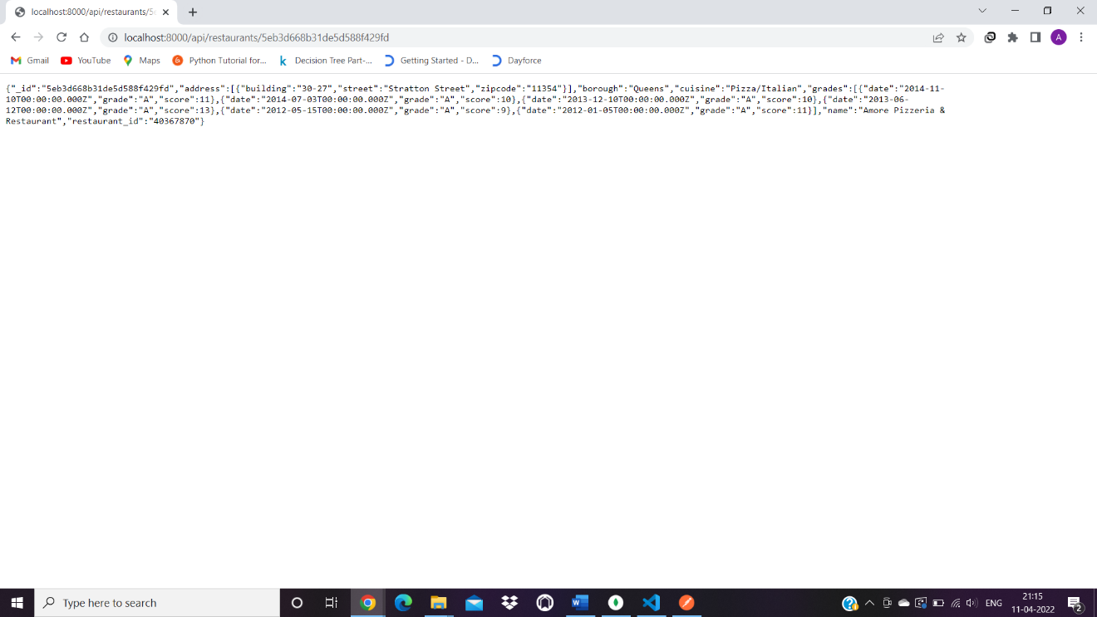

* Localhost:8000/api/restaurants Using post method adding to database

This route, when called, allows user to insert a new data entry for the restaurant along with its details and passing the values as parameters.

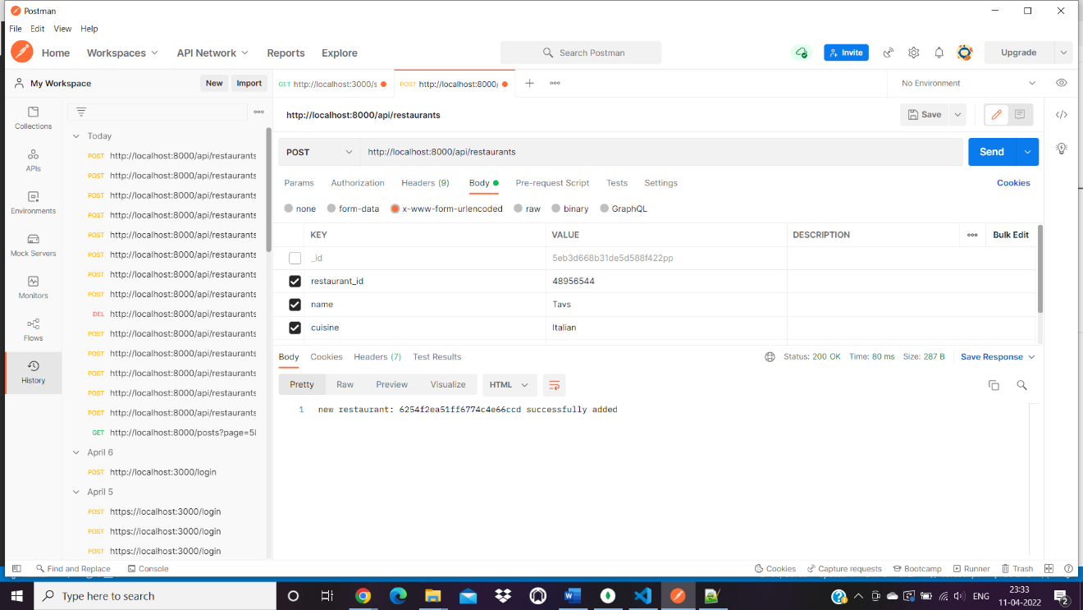

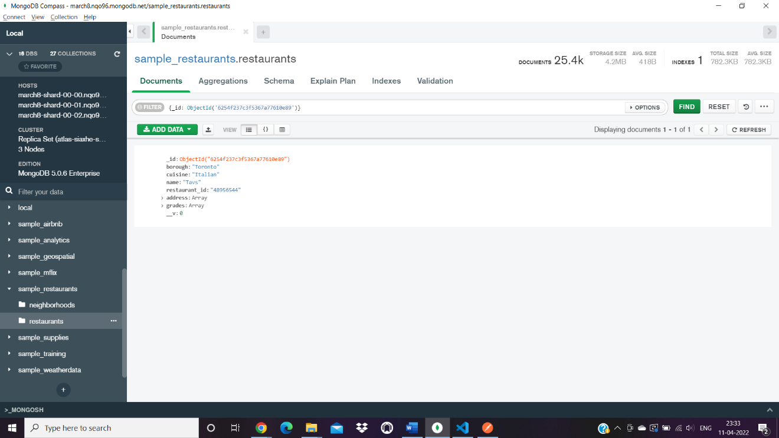

* Localhost:8000/api/restaurants/:restaurant_id

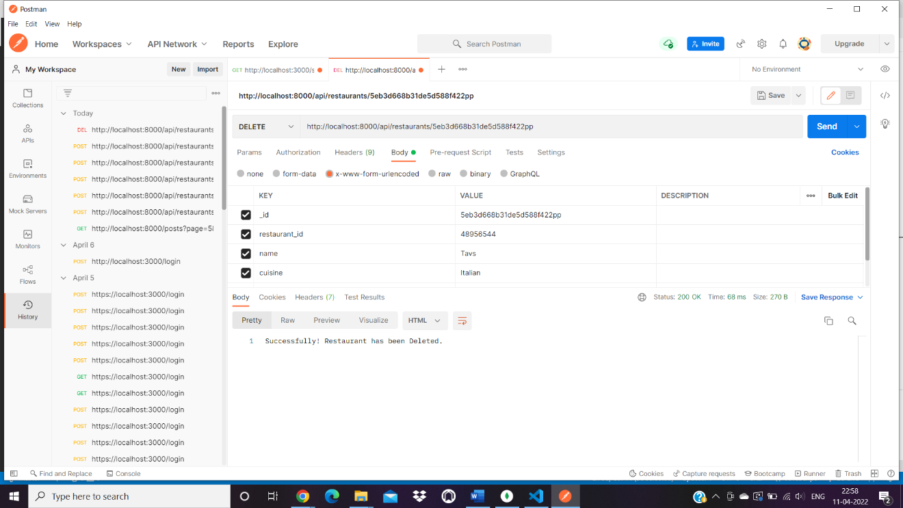

# Question 3:

(Describe the major steps for designing the FORM/UI, how you test this program, add some screenshots of the output)

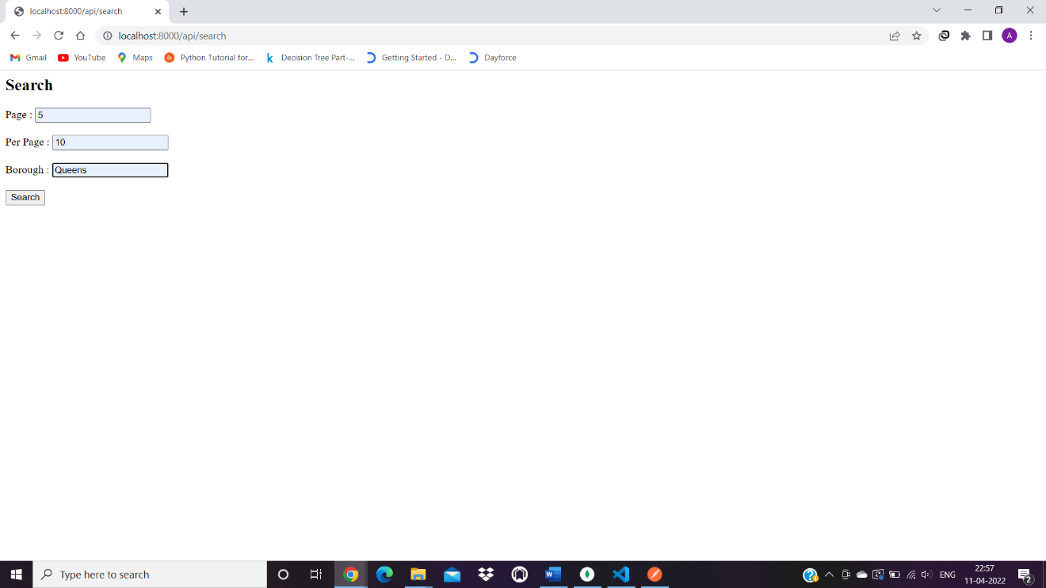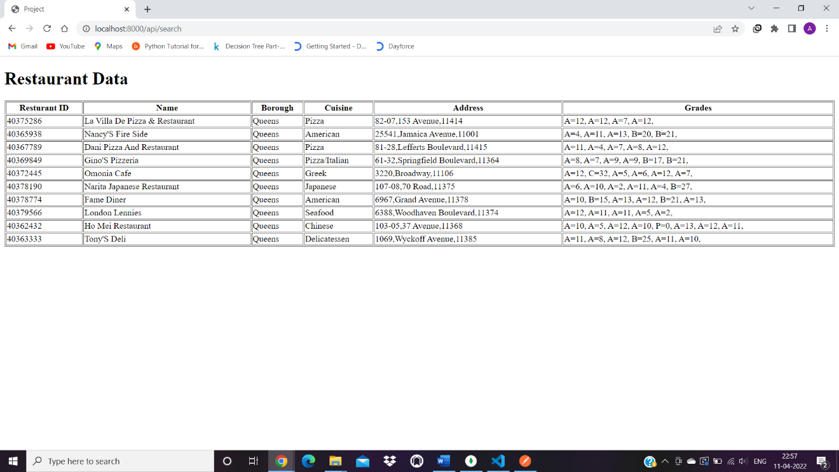

# Question 4:

(Describe the major steps for implementing security features, how you test this program, add some screenshots of the output)

At first, we are generating access token whenever the user uses the login route, whenever the user wants to access the API he has to include the access token in the header, so if the access token matches it will give the access to the user otherwise it will deny the access.

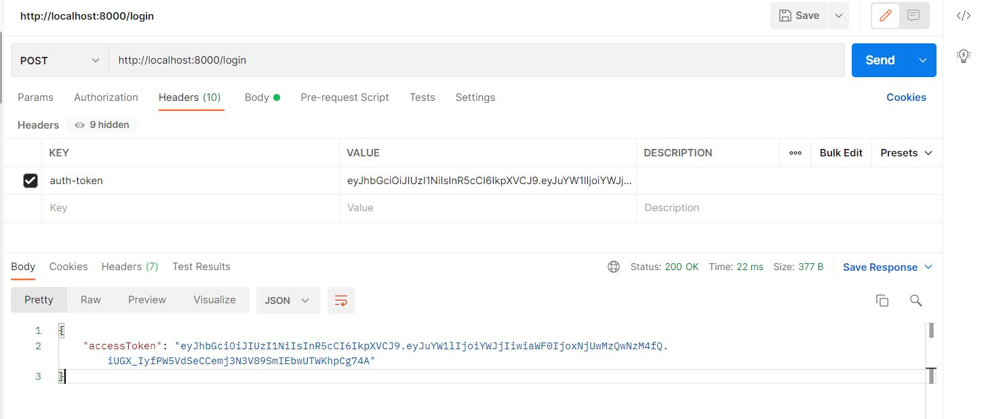

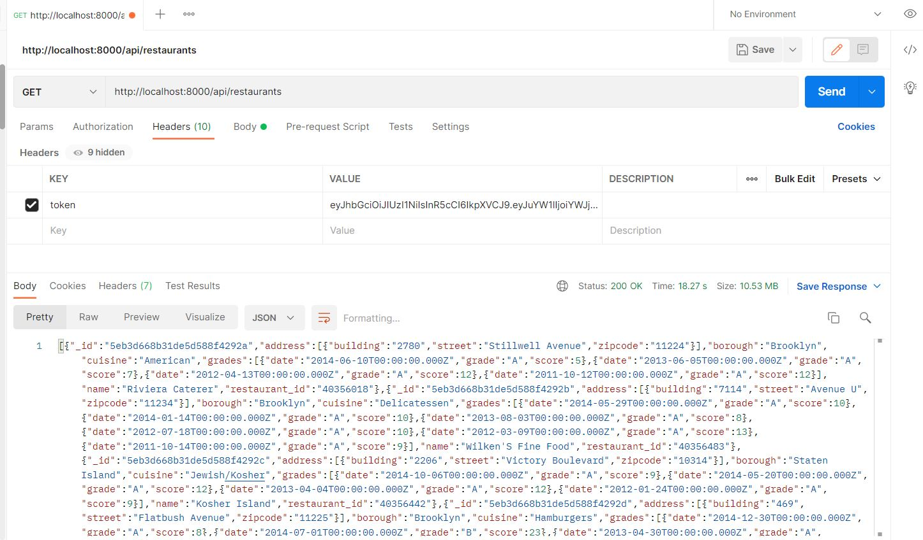

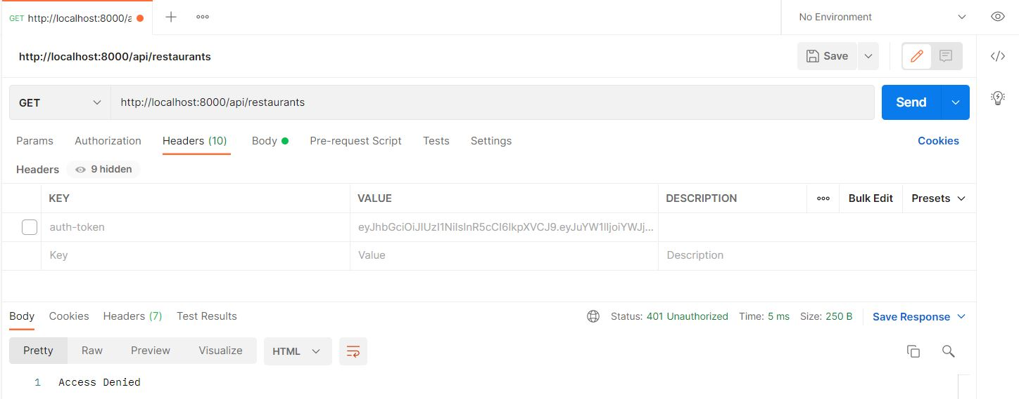

# Question 5:

(Describe the major steps for deployment)

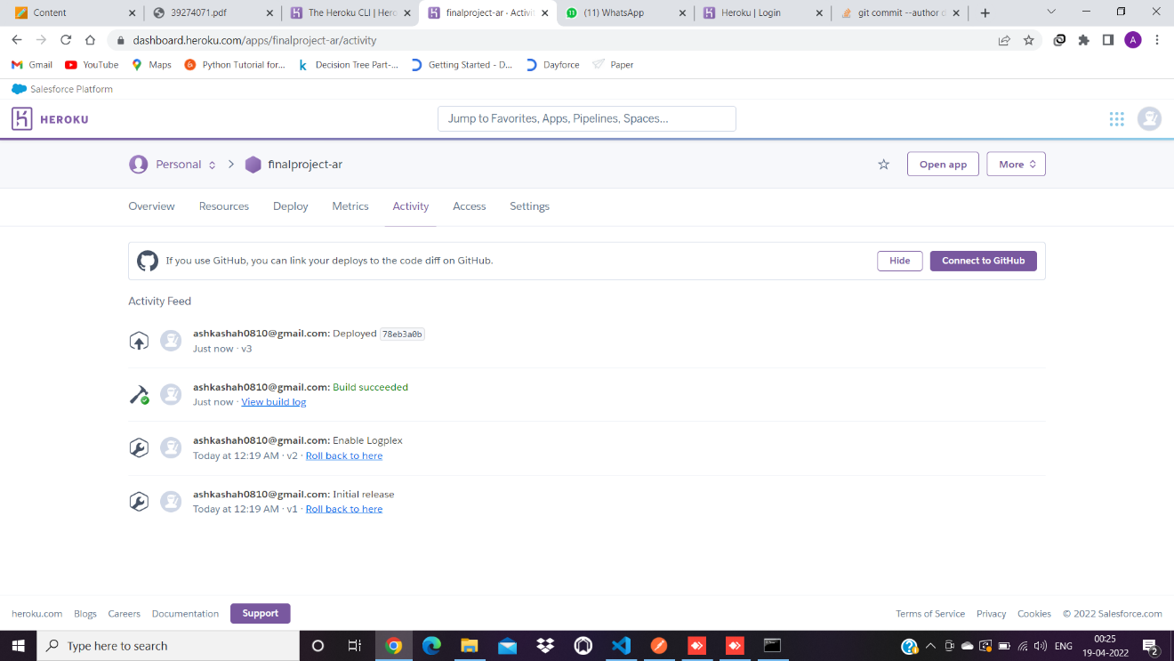

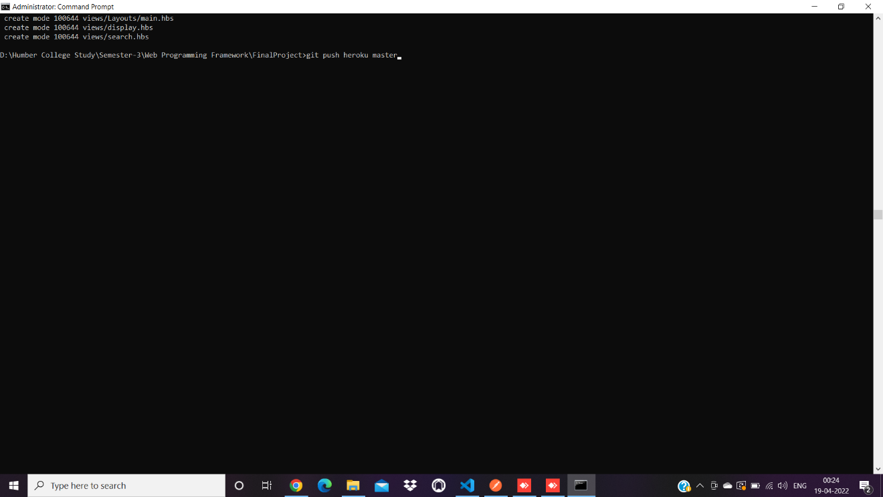

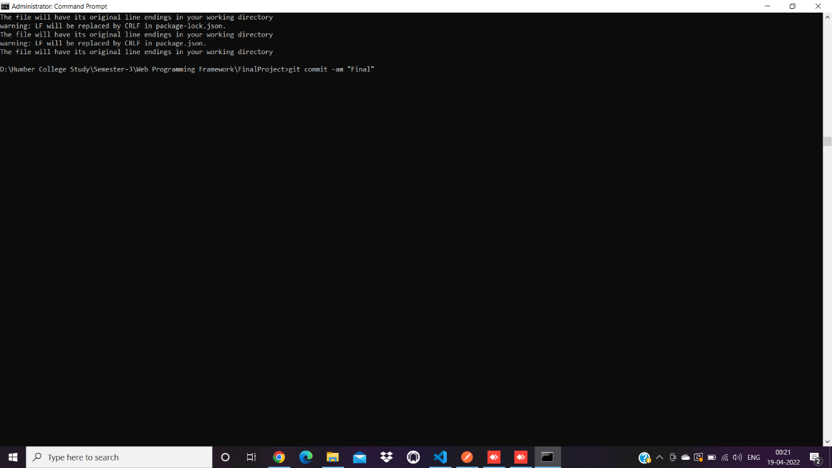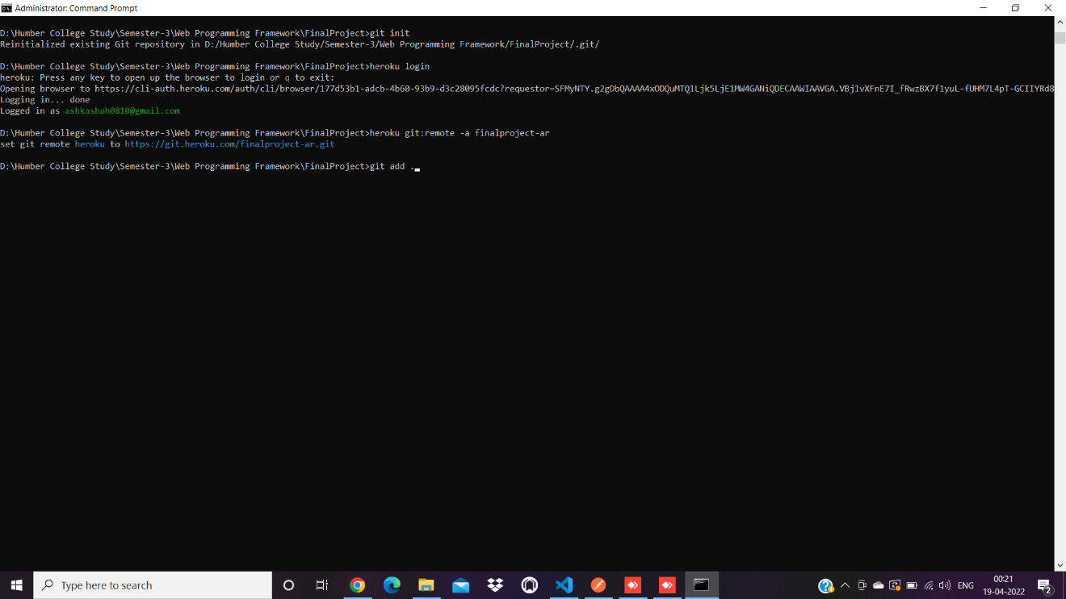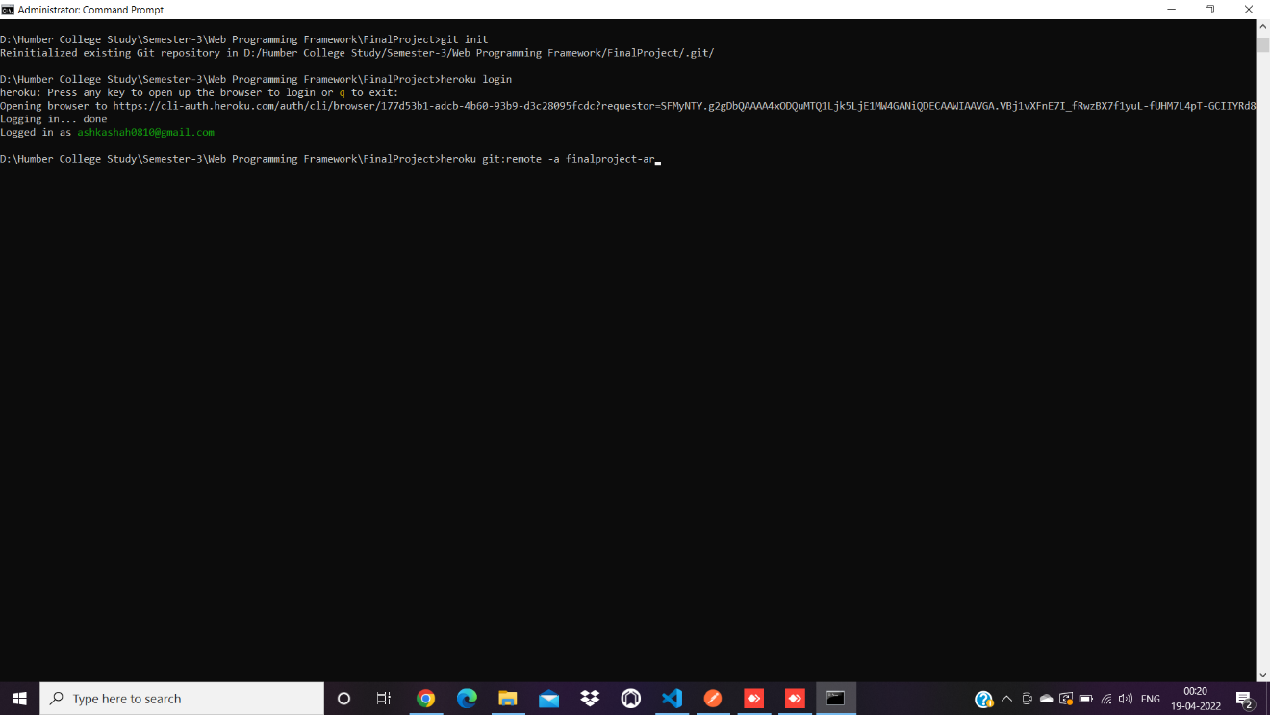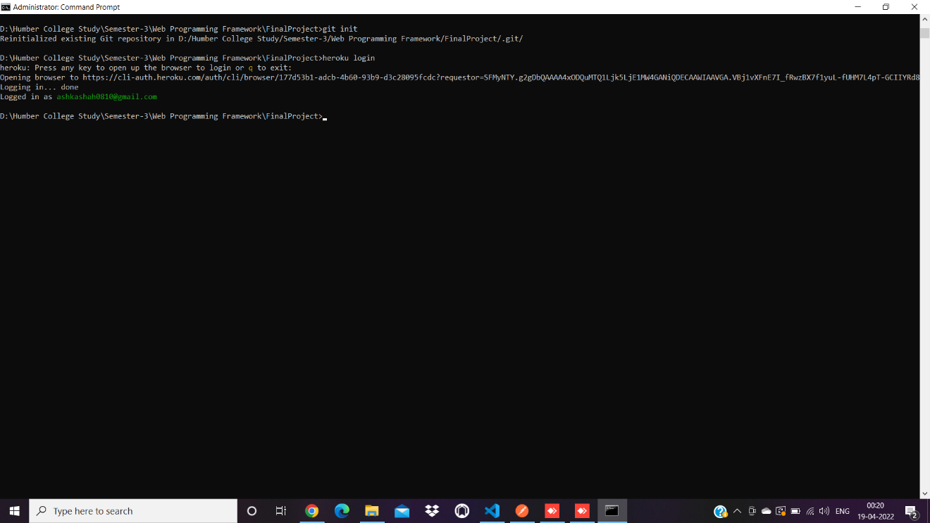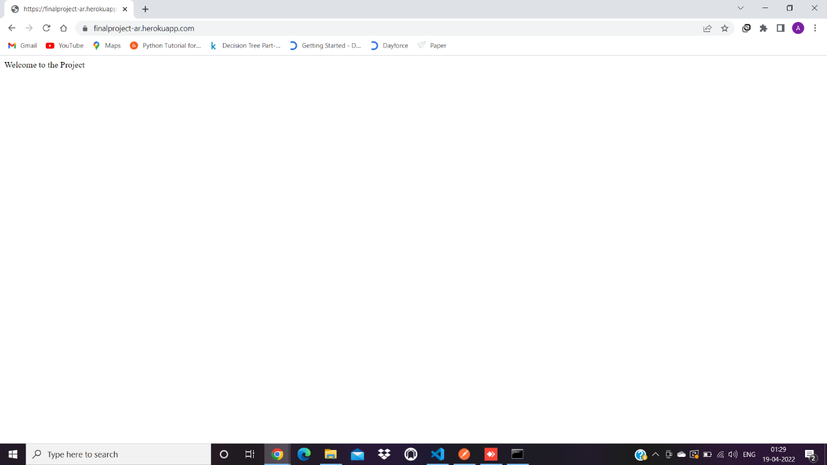

# Question 6:

(Describe the major steps for designing the bonus question)

# Summary

(Describe how did you divide the work, share your feedback about this project like new points that you learn, challenges, …)