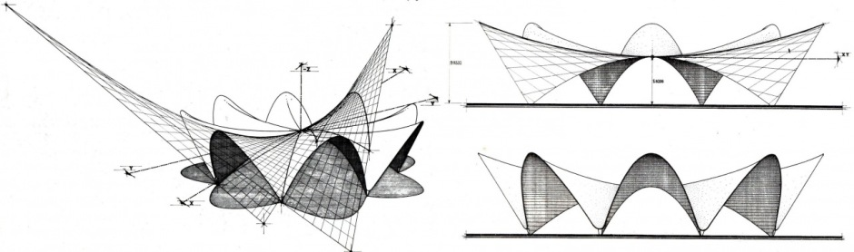**CREATE HYPERBOLIC PALABOLAS:**

***point*** *=*  create a new point (*x-coordinate, y coordinate, z-coordinate*)

***circle a****=*  create circle around that point (*point, radius)*

Divide circle into desired amount of polygon sides

***points*** *=* get points of vertices

***polyline*** *=* create a closed polyline (*points)*

***P****: list to store guide points*

***for each*** *segment* ***S***in *polyline*

***midpoints*** *=* Get the midpoint of each of the polyline segments

Save ***midpoints*** to ***P***

­Move middle ponts upward in Z Axis (*points, translation[x-coordinate, y coordinate, z-coordinate])*

Get start and end points from **S**

Save start and end points to ***P***

***moved_point*** *=* move ***point*** upward in the Z Axis (*point, translation[x-coordinate, y coordinate, z-coordinate])*

***curve*** *=* Create a continous curve (*list of points, degree)*

***circle b* =** Create a circle with a diameter no bigger than 0.01 from ***moved_point*** (*point, radius)*

Loft the continous curve and circle b

Delete all the previous points to clear up the model