Q1: The Q1 will focus on calculating the probability of the functionality of the circuit shown in the Figure 1.

Figure 1: The circuit breaker S

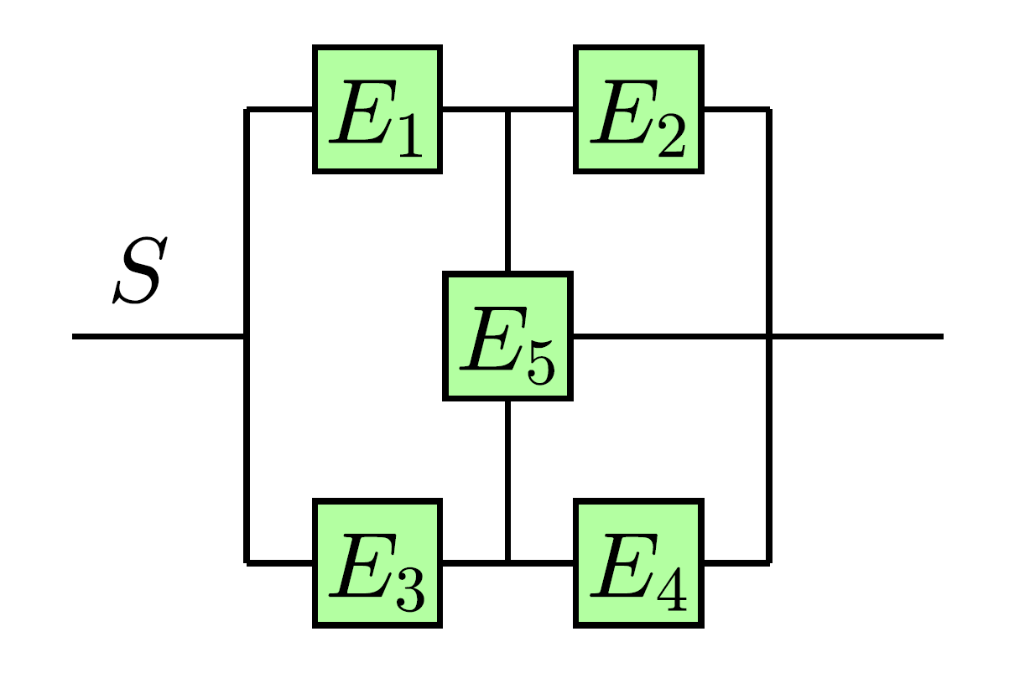

The solution can be implemented by dividing the above circuit into two parts through two hypotheses for the operation of the E5 in the Figure 1. The circuits for the hypothesis H1 and also hypothesis H2 are presented in the following Figures.

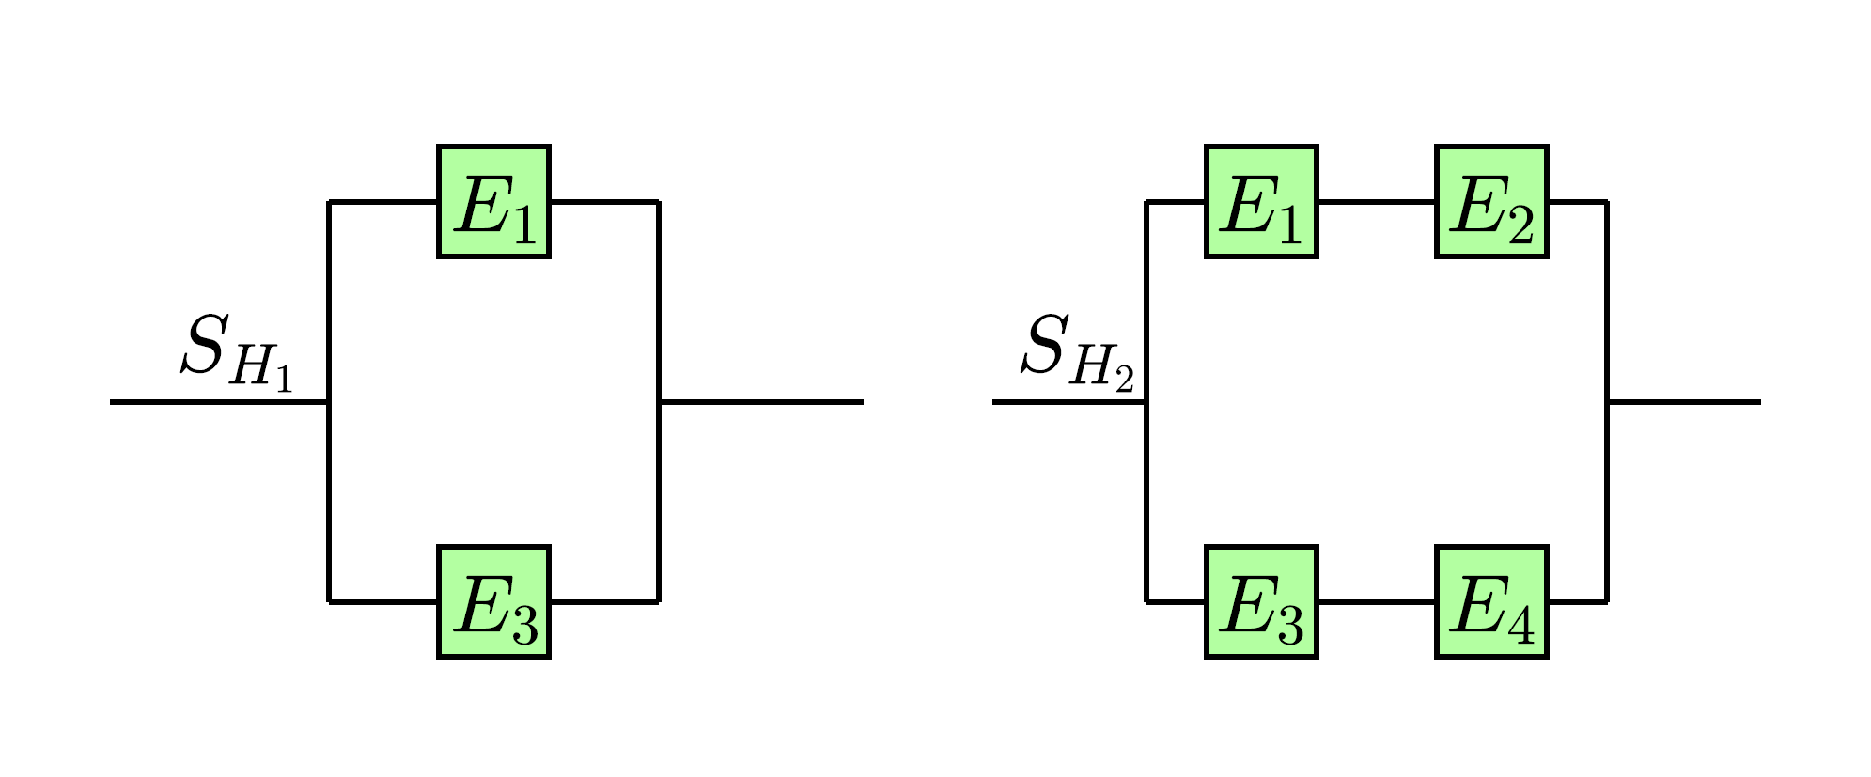

The hypothesis for the SH1 and SH2 are presented in the following:

Note: P(En) is related to the probability of the circuit functioning.

P(S|H1)= [1-[(1-P(E1)) $×(1-P(E3))]]×$ P(E5)

P(S|H2)=[1-(1-P(E1) $×$ P(E2))(1-P(E3) $×$ P(E4))] $×$ [1-P(E5)]

The total probability of the circuit operation will be calculated as follows:

P(S) = P(S|H1)P(H1) + P(S|H2)P(H2)

P(S|H1)= $(e^{-3t/2}$ + $e^{-2t}$- $e^{-5t/2}$)

P(S|H2)= ( $e^{-t}×$ $e^{-2t}$ $+$ $e^{-t/2}×$ $e^{-t/3}-e^{-23t/6}$) $×{(1-e}^{-t})$ = $(e^{-\frac{5t}{6}}+e^{-3t}-e^{-\frac{23t}{6}}-e^{-\frac{11t}{6}}-e^{-4t}+e^{-2t/6})$

P(S)=P(S|H1) $×$ P(H1) + P(S|H2) $×$ P(H2)

The part a of the question asks for the operational probability of the circuit at time t. The following graph demonstrates the probability of the circuit at time t.

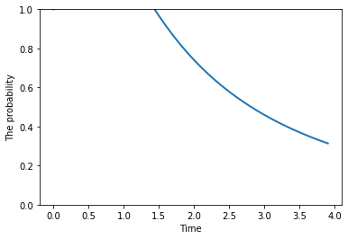

**1b:** It is necessary to use the Bayes formulation to calculate the P(E5|S)

P(E5|S) P(S)=P(S|E5) P(E5)

Q2:

The solution as mentioned by the hint is going to be combination of Bayes and total probability.

P(NC)=P(NC|H1)P(H1) + P(NC|H2)P(H2)

P(NC|H1)=0

P(H1)=0.5

P(NC|H2)=0.2

P(H2)=0.5

The Bayes formula will help to update the hypothesis according to the one experiment which we had.

P(H2|C)=P(C|H2)P(H2)/P(C) = 0.8 * 0.5 / 0.9 = 0.44 As a result

**P(H2|NC) = 0.56**

As a result the updated probability can be calculated as follows:

P(H2)=0.5

P(C|H2)=0.8

P(C)=P(C|H1)P(H1)+P(C|H2)P(H2)=1*.5+0.8*0.5=0.9

After the Bayes update, the

**P(NC|H2) = 0.112**

Q3: