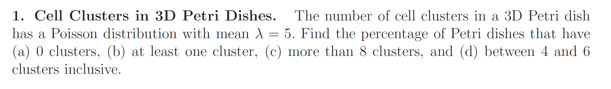

The formulation for the poisson distribution is presented in the following:

$$P\left(x,λ\right)=\frac{\left(e^{-λ}\right)\left(λ^{x}\right)}{x!}$$

**1(a)-** The value for the $λ$ is considered as 5 as per question 1.

$P\left(0,5\right)=\frac{\left(e^{-5}\right)\left(5^{0}\right)}{0!}$ = $\left(e^{-5}\right)=$ 0.0067 as a result the P(0,5)= **0.6 %**

**1(b)-** at least one cluster means that one or more which is equivalent to 1-Q(1|5) on a cumulative distribution function. The cumulative distribution function (CDF) for the poisson distribution can be calculated as follows:

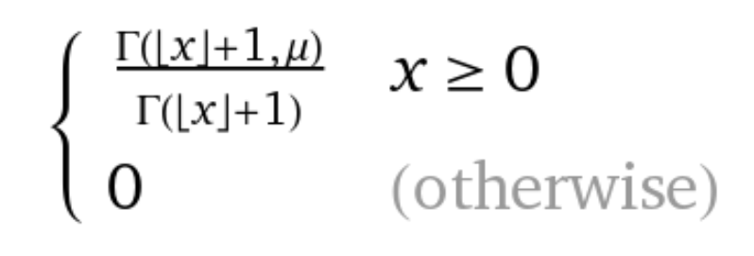

The cumulative density function can be calculated by deducing the 1 from the CDF. The final results will be **95.9%**

**1(c)-** It is possible to calculate the same approach as part (b) by calculating the CDF for 1-Q(8|5):

The result will be: (1-0.931) * 100 = **6.9%**

**1(d)-** Again it is possible to use the cumulative density function, it is mentioned that the results are inclusive so the 76.2%-44.04% which leads to **32.16%**.

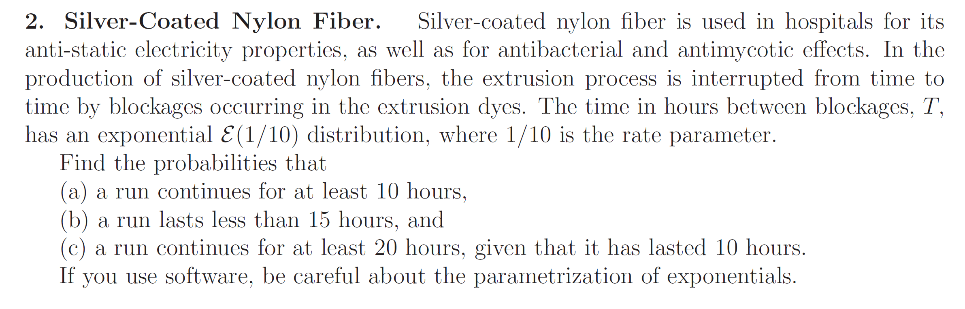

**(a):**

It is possible to use the probability density function for the exponential function:

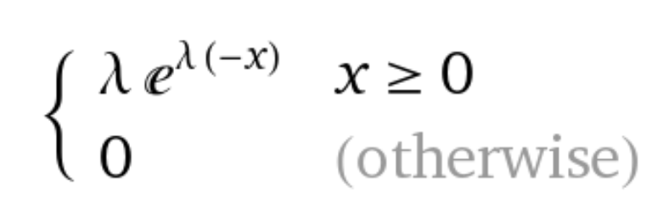

To be able to answer (a): 1-PDF(x=10) = 96.33%

(b):

The CDF for the exponential distribution need to be calculated for the X<15:

**77.68%**

(c):

The conditional probability can be used as follows:

[1- CDF(20)]/[PDF(x=10)] = **0.8975 or 89.75%**

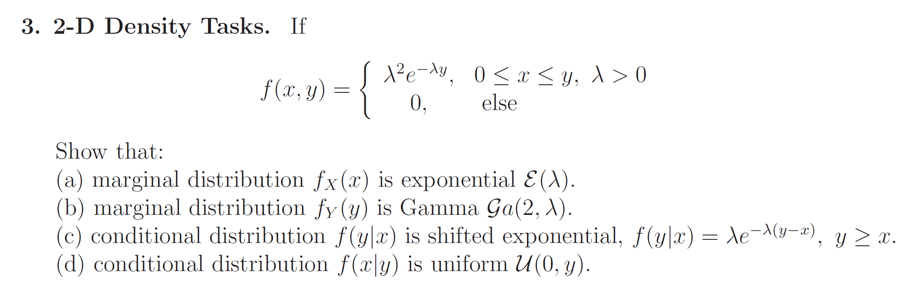

**(a)-** The marginal distribution of $f_{X}(x)$ is equivalent to ${-λ^{3}×e^{-λy}}_{}$ which is similar to the exponential distribution:

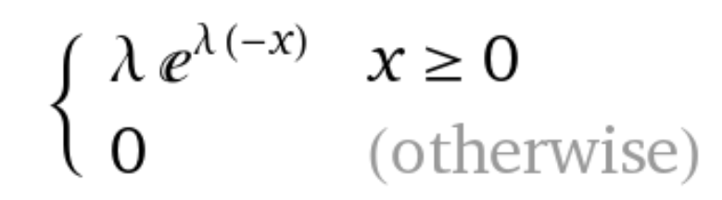

**(b)-** Marginal distribution of $f_{Y}(y)$ is equivalent to ${λ^{2}×e^{-λy}}_{}×x$ which is similar to the gamma distribution:

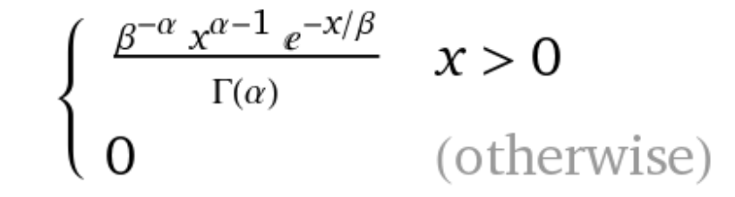

**(c)-** The conditional distribution can be calculated by division of the $f(y,x)/f(x)$. The $f(x)$ is calculated in section (a). As a result, the $f\left(y | x\right)= λe^{-λ(y-x)}, y≥x$

**(d)-**Conditional distribution is uniform. $f(x,y)/f(y)$. After calculation and substitution of f(y) from part (b), the result will be presented as follows:

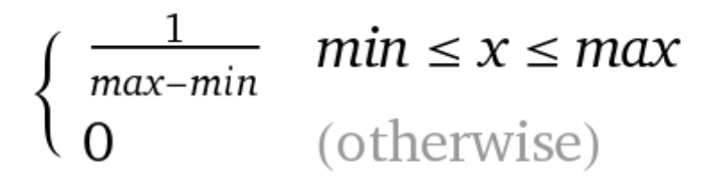



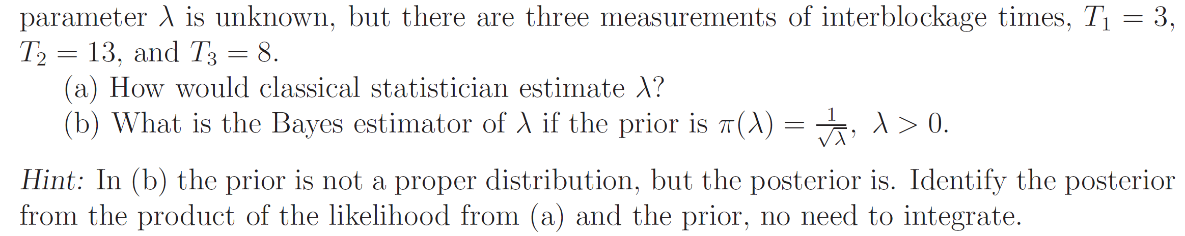

(a)-The formulation for calculating the $λ$ can be given as:

It is assumed that the probabilities for the three given events are independent.



We consider the differentiate to calculate the maximum.

$$λ=1/8$$

(b)-

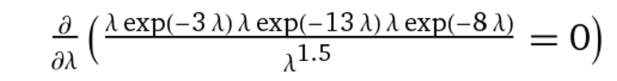

The result will be updated as follows:

$$λ=1/16$$