MINISTRY FOR EDUCATION AND SCIENCE OF RUSSIA

________________________________

SAINT PETERSBURG ELECTROTECHNICAL UNIVERSITY

«LETI»

________________________________

**APPROVED**

__________________________

Date, signature

INTERACTIVE WEB-PAGE OF A LUMBER COMPANY

Project title

PROJECT MANAGEMENT PLAN

Document name

PMP_LULAD_00.10

        Electronic & Paper

Kind of data

         12 pages ___

volume

St. Petersburg

2019

**HISTORY**

|  |  |  |  |
| --- | --- | --- | --- |
| **Version #** | **Author** | **Data** | **Short description** |
| 00.10 | Gennady Evtodiev | 01.04.19 | First version of PMP document |

**Project team**

|  |  |  |  |  |
| --- | --- | --- | --- | --- |
| **№** | **Name** | **Group** | **Project role** | **Contact Information** |
| 1 | Gennady Evtodiev | 4300 | PM, dev ,Test lead, CM | [gvevtodiev@gmail.com](mailto:gvevtodiev@gmail.com)  mob. +79041029180 |

**Technical expert – coacher**

**____________________________________ ______________**

**Full name email**

**Teacher**

**Filippov Evgeny Vasilyevich** [e.philippov.leti@mail.ru](mailto:e.philippov.leti@mail.ru)

**AGENDA**

***1.*** ***BASIS FOR DEVELOPMENT 4***

***2.*** ***DEVELOPMENT GOALS 4***

***3.*** ***DETAIL REQUIREMENTS 4***

***4.*** ***HIGH LEVEL REQUIREMENTS 4***

***5.*** ***WORK BREAKDOWN STRUCTURE AND EFFORTS ESTIMATION 4***

***6.*** ***KEY MILSTONES 4***

***7.*** ***CHOSEN TECHNOLOGY AND DEVELOPMENT FRAMEWORK 5***

***8.*** ***CONFIGURATION AND CHANGE MANAGEMENT 5***

***9.*** ***PROJECT SPECIFIC PROCESS, QUALITY PLAN, METRICS 5***

***10.*** ***PROJECT RISKS 5***

***11.*** ***PROJECT SCHEDULE (GANT DIAGRAM) 5***

***12.*** ***TEST PLAN 5***

***APPENDIX 1. TEST CASES 6***

***APPENDIX 2. TEST RESULTS 7***

***APPENDIX 3. DEFECTS 8***

1. **BASIS FOR DEVELOPMENT**

Development is carried out on the basis of the requirements for the course work in the discipline "Software Engineering"

Full name of the project

**Interactive website of a lumber company**

Short name of the program (nick-name, 4-5 characters)

LULAD

1. **DEVELOPMENT GOALS**

The software product is intended to

An interactive web page about the Lumber company. The website should have information about the cities of delivery in the area of the company, algorithm to cut logs into lumber in the most efficient way, store them into database and update it, storage of the available lumber, recipes.

1. **DETAIL REQUIREMENTS**

* The main page of our website shall be an interactive map with general information about the company and its cities.
* The website shall take in files with dimensions and prices to process the algorithm
* The website shall be interactive and to help the user navigate the website.
* The website shall be responsive design and work properly on Pc, tablets and mobile device.
* Every other page shall have its own style with different functionalities.
* There should be a navigation tool bar moving with scrolling pages to not get lost among with helpful footer.

1. **HIGH LEVEL DESIGN**

Product architecture or high level design should be provided here with some visualization diagrams (Modul diagram / UML diagram / sentence diagram/ etc.)

I am going to design our Lumber Yard Project, around a client server design utilizing a html page for user interface and php scripting for the back end processing. I also plan to utilize a SQL database to store information about inventory levels and order histories.

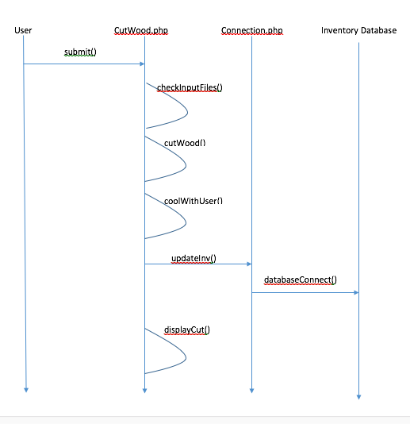

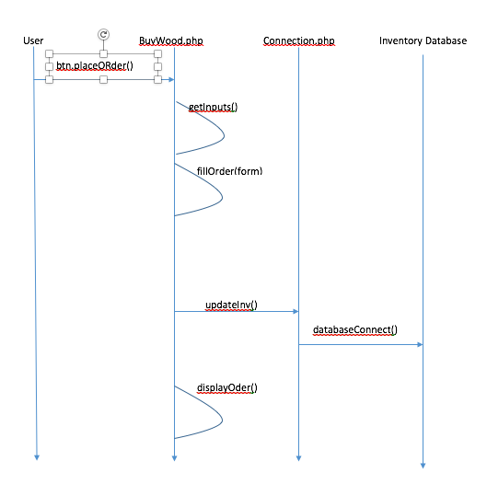

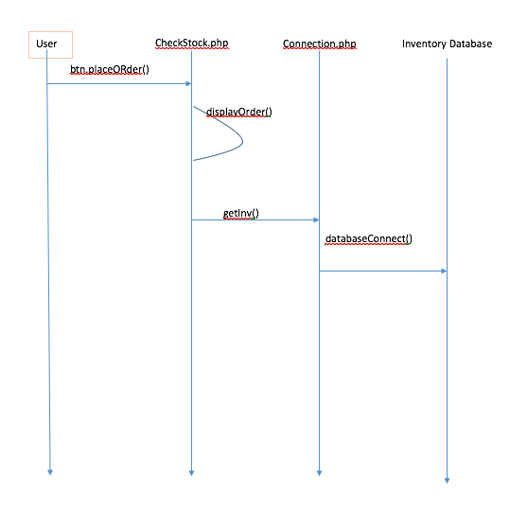

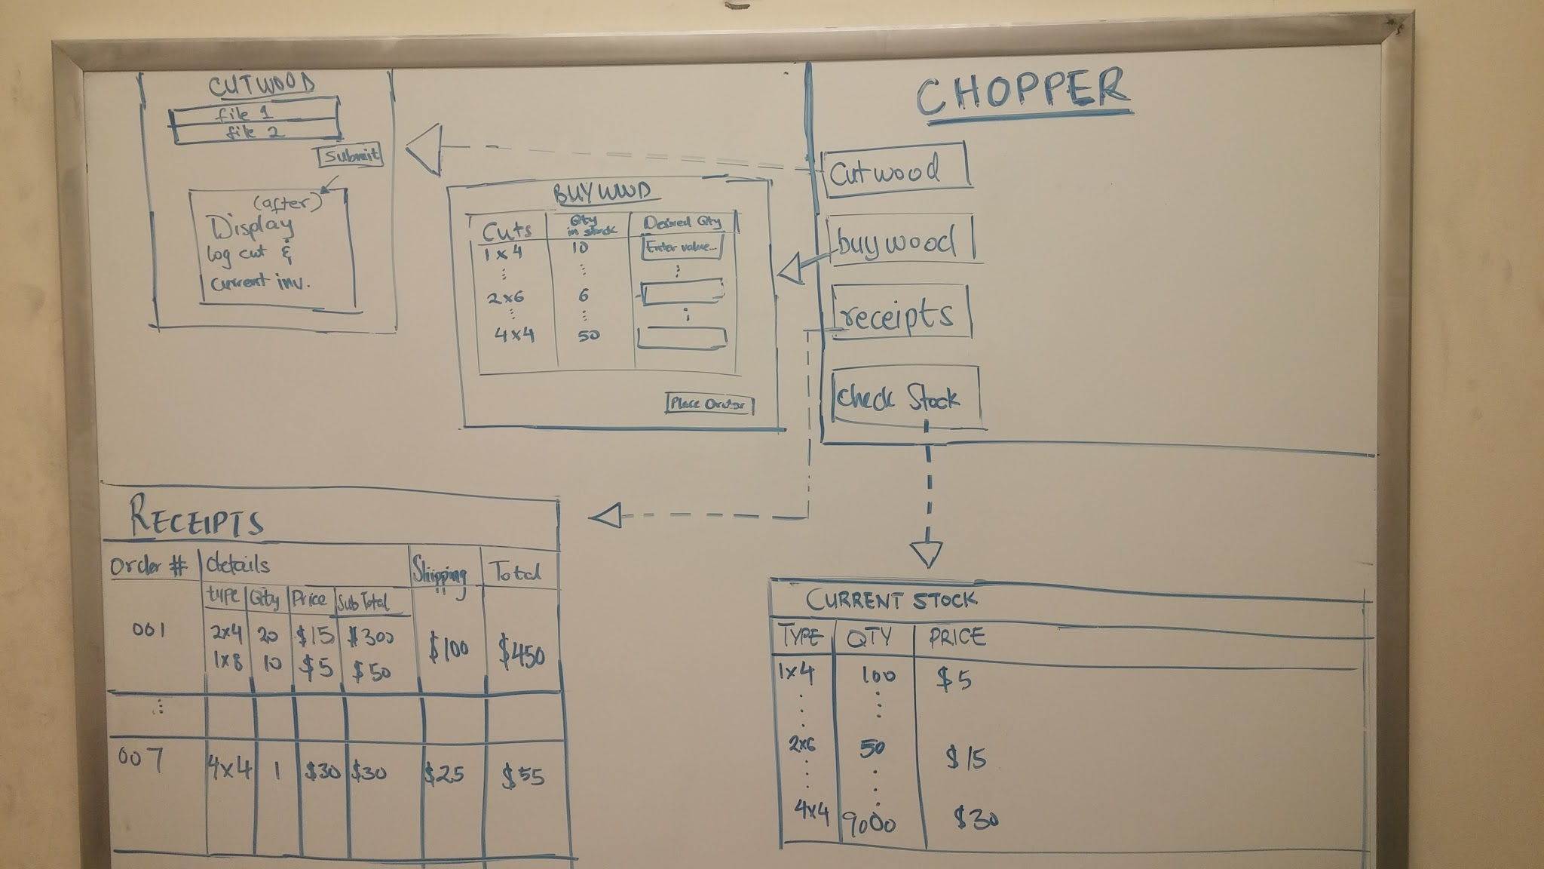

***Class: Cut***

|  |  |
| --- | --- |
| ***Field(types of cuts)*** | ***Description*** |
| *quan* | *Keeps track of quantity* |
| val | Value of the cut |
| areas | Subareas it creates |
| Parentid  Id  Mytype  Length  Width  Height  price | id of its parent cut  its id for the cut  string name of the lumber cut  length of lumber in cut  width of lumber in cut  height of lumber in cut  price of piece of lumber in the cut |

***Class: Area***

|  |  |
| --- | --- |
| ***Field(types of cuts)*** | ***Description*** |
| *height* | *Height of an area* |
| *wid* | *Width of an area* |
|  | *“ “* |
|  |  |

***Class: BUYWOOD***

|  |  |
| --- | --- |
| ***Field(types of cuts)*** | ***Description*** |
| *1 X 1* | *Types of lumber with corresponding price, desired amount, and current stock.* |
| *…* | *“ “* |
| *8x8* | *“ “* |
|  |  |

|  |  |
| --- | --- |
| ***Method*** | ***Description*** |
| *getInputs()* | *Gets the values from user form entries* |
| *fillOrder(formVals)* | *Fills order out as much as possible given current inventory, makes for incomplete order* |
| *displayOrder()* | *Shows the order that had just been placed(receipt)* |

***Class: ViewInventory***

|  |  |
| --- | --- |
| ***Method*** | ***Description*** |
| *DisplayStock()* | *Displays the current inventory levels* |
| *…* |  |

***Class: CutWood***

|  |  |
| --- | --- |
| ***Field*** | ***Description*** |
| *File1*  *File2* |  |
|  |  |

|  |  |
| --- | --- |
| ***Method*** | ***Description*** |
| *checkInputFIles(file1,file2)* | *Parses input files(if exist) for format, and get data* |
| *cutWood(int data values)* | *Analyzes given dimensions, calculates best combination of lumber cuts* |
| *coolWithUser(bool choice)* | *Confirms with user before executing cuts* |
| *displayCuts()* | *Show the produced lumber, and updated inventory* |

***Class: Receipts***

|  |  |
| --- | --- |
| ***Field*** | ***Description*** |
| *None* | *Merely displays previous order histories* |
| *…* |  |

|  |  |
| --- | --- |
| ***Method*** | ***Description*** |
| *PopulateReciepts()* | *Displays table of previous orders, sorted by date or order amount/size* |

1. **WORK BREAKDOWN STRUCTURE AND EFFORTS ESTIMATION**

List of project tasks and efforts needed to complete each task and total project should be provided here

|  |  |  |
| --- | --- | --- |
| Desription | Expert | Agreed Effort Estimation (man*hour) |
| PMP development | 5 | 5 |
| Communications with analytics, developers, testers | 8 | 8 |
| Weekly reports | 10 | 10 |
| Configuration Management | 4 | 4 |
| Metrics collection | 2 | 2 |
| Subject area evaluation and study of new technologies | 8 | 8 |
| Requirements Gathering (System Analists) | 10 | 10 |
| High Level Design (Architects) | 10 | 10 |
| Development of the system (1.5 - 2 months) | 6 | 6 |
| Data Base Development | 6 | 6 |
| Component "Data Collector" development | 8 | 8 |
| Component "Data Encoding" development | 30 | 30 |
| Component "Analitics & Reporting" development | 16 | 16 |
| Component "Web interface to data" development | 15 | 15 |
| Implementation of the system of management and control of access rights Authentification procedure development | 4 | 4 |
| Sessions state monitoring system | 3 | 3 |
| Integration System | 3 | 3 |
| Bug Fixing | 3 | 8 |
| Testing | 9 | 10 |
| Technikal documentation | 5 | 5 |
| Efforts Estimation (man*hour) | 170 | 171 |

1. **KEY MILESTONES**

Table b 1. Key milstones

|  |  |  |  |
| --- | --- | --- | --- |
| **№** | **Start date** | **End date** | **Description** |
| 1 | 13.02.19 | 28.02.19 | SOW developed, reviewed and signed and studying technologies for creation of a website(JavaScript, Html, CSS) |
| 2 | 01.03.19 | 10.03.19 | Studying technologies for creation of a website(JavaScript, HTML, CSS), also the agile methodology SCRUM |
| 3 | 10.03.19 | 18.03.19 | Application of SCRUM methodology to the project and definition of the roles in the project. General design of the main page and the web site in general. |
| 4 | 18.03.19 | 15.04.19 | First checkpoint and an advance of PMP document, reviewed, signed and the mockup of the project. |
| 5 | 15.04.19 | 28.04.19 | Second checkpoint and the first prototype and application development. |
| 6 | 28.04.19 | 13.05.19 | application development |
| 7 | 13.05.19 | 25.05.19 | Third checkpoint and and application development |
| 8 | 25.05.19 | 31.05.19 | testing of the application |
| 9 | 28.05.19 | 01.06.19 | fixing bugs |
| 10 | 01.06.19 | 01.06.19 | Forth checkpoint |

1. **CHOSEN TECHNOLOGY AND DEVELOPMENT FRAMEWORK**

PHP, SQL, HTML, CSS, GitHub(as control version system) and ATOM as IDE.

1. **CONFIGURATION AND CHANGE MANAGEMENT**

GitHub as a control version system, the project with all the necessary documents will be stored in the following repository:

<https://github.com/ashkaren/LumLad>

1. **PROJECT SPECIFIC PROCESS, QUALITY PLAN, METRICS**

You can find following excel file by the link down below

<https://github.com/ashkaren/LumLad>

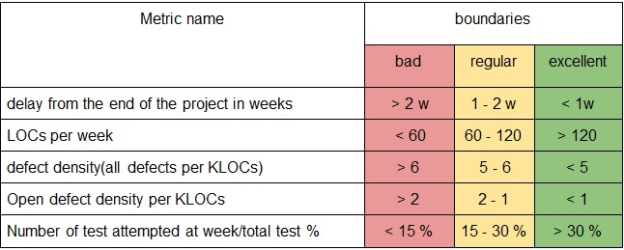

1. **PROJECT RISKS**

|  |  |  |
| --- | --- | --- |
| Risk | Possibility(1-5) | Effect on the project, possible solution |
| Health issues | 4 | It will delay the speed and later quality of the project. Postpone the dates of report and so on. I will try to catch up with timing and work faster or more when healed up. |
| Other classes and work | 3 | It will delay all the due dates and increase the possibility of mistakes and bugs due to trying to catch up. Work more, sleep less, try to work faster. |
| Technical issues with hardware | 2 | It will delay all the due dates.  I shall try to take care of my hardware and upgrade in timely manner. |
| Third-party code won’t be working properly | 2 | More time on learning and fixing. A slight delay in overall work. Might downgrade the functionality. |
| Third-party servers don’t work properly | 1 | Just delay in deployment and integration. |
| Not enough resources to complete desired features | 1 | Slight changes in the design and planning. Communication with client upon those questions. |
| Family business related issues | 5 | Do the overkill on the weeks where I have time and get done as much as possible |

1. **PROJECT SCHEDULE (GIANT DIAGRAM)**

|  |  |  |  |
| --- | --- | --- | --- |
|  | Tasks per sprint | Expected date | |
| First spint | Development of designed mock up | 01.04.19 | 08.04.19 |
| Development of the main page | 08.04.19 | 13.04.19 |
| Implementation of links for other pages | 08.04.19 | 13.04.19 |
| Testing | 13.04.19 | 14.04.19 |
| Debugging | 14.04.19 | 15.04.19 |
| Second sprint | Development of upload page | 15.04.19 | 18.04.19 |
| Development of functionality on the upload | 18.04.19 | 24.04.19 |
| Development of sharable picture for the web site | 24.04.19 | 25.04.19 |
| Testing | 25.04.19 | 26.04.19 |
| Fixing bugs | 26.04.19 | 28.04.19 |
| Third sprint | Developing storage page | 23.04.19 | 25.04.19 |
| Developing databases | 21.04.19 | 28.04.19 |
| Connecting databases to functionality | 28.04.19 | 01.05.19 |
| Develop order page | 1.05.19 | 03.05.19 |
| Fixing bugs | 03.05.19 | 04.05.19 |
| Fourth sprint | Development of recipe page | 05.05.19 | 07.05.19 |
| Develop the best cut algorithm | 01.04.19 | 12.05.19 |
| Testing and fixing | 12.05.19 | 30.05.19 |
| Deployment | 30.05.19 | 31.05.19 |

1. **TEST PLAN**

What kind of test types to be used (functional, performance, stress, cross platform, safety, usability, etc.), planned number of test cases for each type

**APPENDIX 1. TEST CASES**

|  |  |  |
| --- | --- | --- |
| **Test type** | **Test case amount** | **Test case description** |
| 1.Functional testing | 25 | Testing of website interaction and all the button functionality |
| 2. Cross platform testing | 5 | Testing different devices on friendliness |
| 3. Usability testing | 10 | Testing UI |
| 4. Performance testing | 25 | Testing code, databases, performance of algorithm, speed |