MINISTRY FOR EDUCATION AND SCIENCE OF RUSSIA

________________________________

SAINT PETERSBURG ELECTROTECHNICAL UNIVERSITY

«LETI»

________________________________

**APPROVED**

__________________________

Date, signature

INTERACTIVE WEB-PAGE OF A LUMBER COMPANY

Project title

PROJECT REPORT

Document name

**Technical expert – coacher**

**____________________________________ ______________**

**Full name email**

**Teacher**

**Filippov Evgeny Vasilyevich** [e.philippov.leti@mail.ru](mailto:e.philippov.leti@mail.ru)

St. Petersburg

2019

**INTERACTIVE WEB-PAGE OF A LUMBER COMPANY**

**___________________________________**

**Project subject and description:**

An interactive web site of the Lumber company. The website has information about the cities of delivery in the area of the company, algorithm to cut logs into lumber in the most efficient way after uploading dimensions and desired sizes with prices, store them into database and update it, storage of the available lumber, ability to make orders online and see the recipes with prices.

**The main results of the project:**

* The proposed algorithm is highly efficient in making the best cut in sense of profit based on log dimensions, types of lumber and their prices.
* Integration of Google maps for user convenience with checkpoints using coordinates
* Simple and elegant design with user friendly environment
* Ability to order lumber and look up recipes after
* Ability to upload log dimensions with desired lumber types and prices
* Efficient database implementation for easier update and access

**Key milestones and actual dates of project implementation:**

|  |  |  |  |
| --- | --- | --- | --- |
| **№** | **Start date** | **End date** | **Description** |
| 1 | 13.02.19 | 28.02.19 | SOW developed, reviewed and signed and studying technologies for creation of a website(JavaScript, Html, CSS) |
| 2 | 01.03.19 | 10.03.19 | Studying technologies for creation of a website(JavaScript, HTML, CSS), also the agile methodology SCRUM |
| 3 | 10.03.19 | 18.03.19 | Application of SCRUM methodology to the project and definition of the roles in the project. General design of the main page and the web site in general. |
| 4 | 18.03.19 | 15.04.19 | First checkpoint and an advance of PMP document, reviewed, signed and the mockup of the project. |
| 5 | 15.04.19 | 28.04.19 | Second checkpoint and the first prototype and application development. |
| 6 | 28.04.19 | 13.05.19 | application development |
| 7 | 13.05.19 | 25.05.19 | Third checkpoint and and application development |
| 8 | 25.05.19 | 31.05.19 | testing of the application |
| 9 | 28.05.19 | 01.06.19 | fixing bugs |
| 10 | 01.06.19 | 01.06.19 | Forth checkpoint |

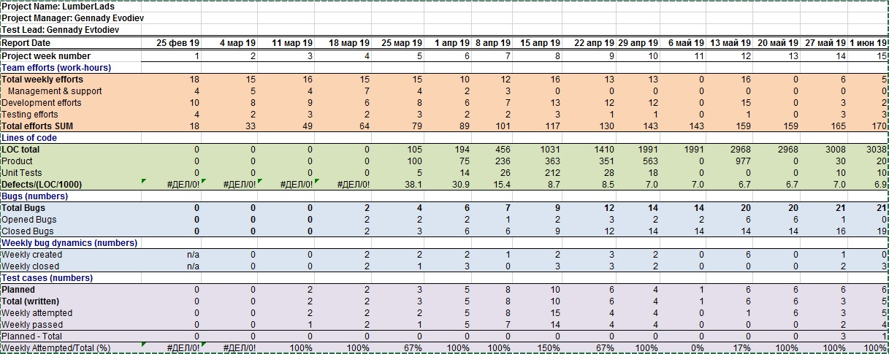**Final project metrics:**

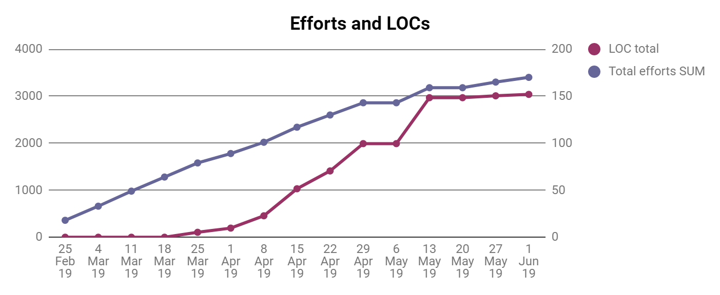

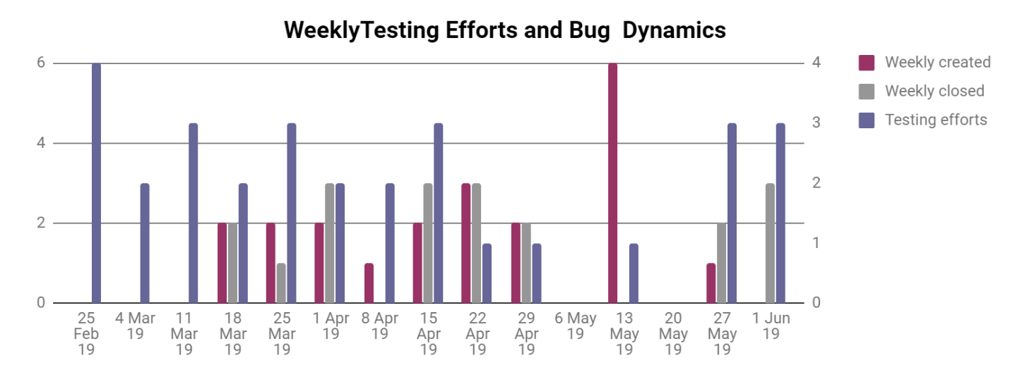

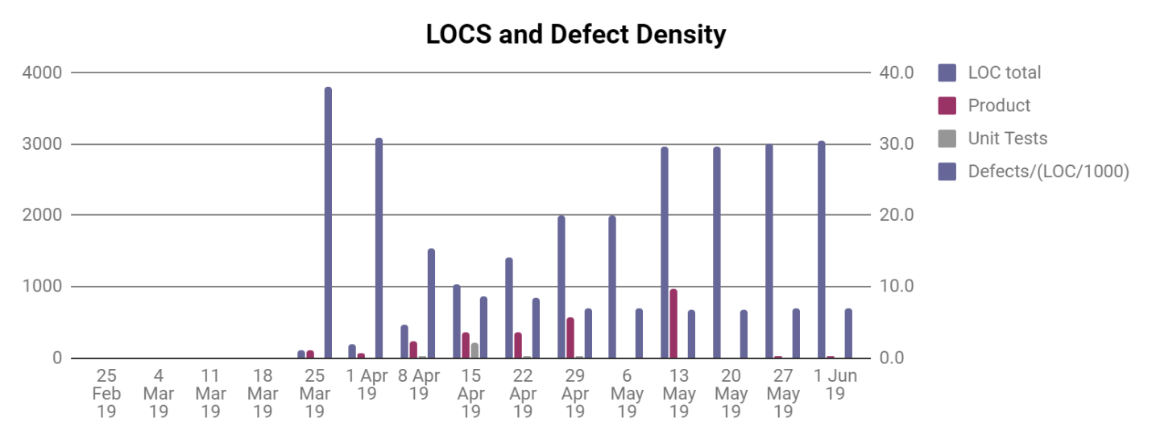

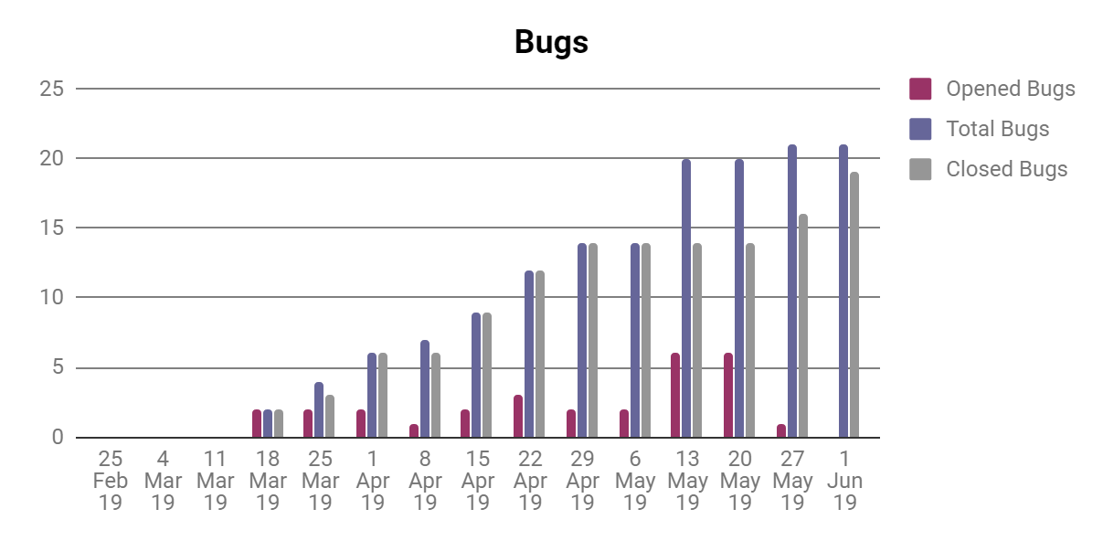

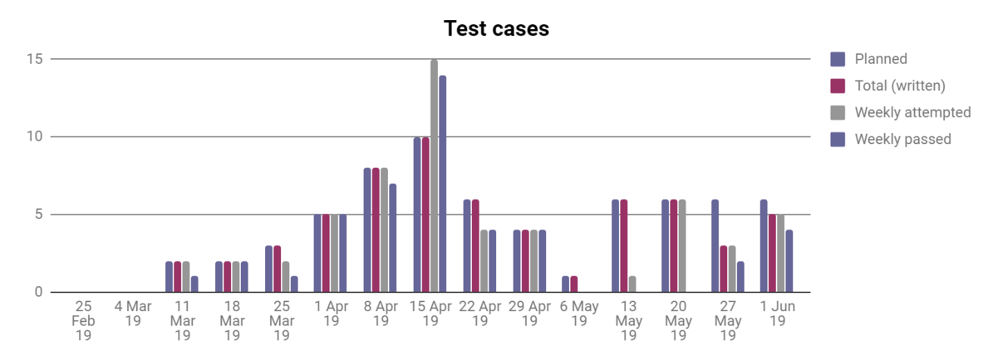

**Project risks and their impact to project:**

|  |  |  |  |  |  |  |
| --- | --- | --- | --- | --- | --- | --- |
| Risk | Possibility(1-5) | Effect on the project, possible solution | Impact |  |  |  |
| Health issues | 4 | It will delay the speed and later quality of the project. Postpone the dates of report and so on. I will try to catch up with timing and work faster or more when healed up. | M |  |  |  |
| Other classes and work | 3 | It will delay all the due dates and increase the possibility of mistakes and bugs due to trying to catch up. Work more, sleep less, try to work faster. | M |  |  |  |
| Technical issues with hardware | 2 | It will delay all the due dates.  I shall try to take care of my hardware and upgrade in timely manner. | L |  |  |  |
| Third-party code won’t be working properly | 2 | More time on learning and fixing. A slight delay in overall work. Might downgrade the functionality. | L |  |  |  |
| Third-party servers don’t work properly | 1 | Just delay in deployment and integration. | L |  |  |  |
| Not enough resources to complete desired features | 1 | Slight changes in the design and planning. Communication with client upon those questions. | L |  |  |  |
| Family business related issues | 5 | Do the overkill on the weeks where I have time and get done as much as possible | H |  |  |  |

**Lesson learned:**

1. **What was done well?**

* The efficient cut algorithm for any situation.
* Coding of database and connection to the whole project.
* Main functions and front page.
* Integration of Google maps

1. **What was not done well?**

* Consideration of all possible scenarios such as if we upload wrong files for log dimensions and lumber, it will not give us good result or proper error.
* Error messages and warnings to the user about wrong actions

1. **What can be done better?**

* The overall design since some pages look very nice and some of them just informative because of the luck of time and workforce
* Integration of tracking of loaded trucks.
* Integration of online payments.
* Integration of personal user data for security

**Summary:**

Overall the project function and performs well. It does what it supposed to do. Web site is user friendly and only has couple opened bugs that I plan on resolving since I know about them but couldn’t fix them in time since I work on my own and the time was limited. The algorithm of cutting wood is highly efficient and database is connected very well to the project without mistakes.

However, I am planning on working more on this project and hope to get some more people on it for better work. I would like to improve design and integrate new features such as I mentioned in above section. It was very good learning experience and strong base for creating a good product for the real client in Valdosta, GA, USA.

This project showed my strong sides and weak spots that I have to work on personally. However, overall I am satisfied with the result I accomplished during this semester taking in consideration all the risks and limited time. The web site will be much improved and will be working as a home for the lumber company of my brother.