MINISTRY FOR EDUCATION AND SCIENCE OF RUSSIA

________________________________

SAINT PETERSBURG ELECTROTECHNICAL UNIVERSITY

«LETI»

________________________________

**APPROVED**

__________________________

Date, signature

INTERACTIVE WEB-PAGE OF A LUMBER COMPANY

Project title / Название проекта

PROJECT MANAGEMENT PLAN / РАСШИРЕННОЕ ТЕХНИЧЕСКОЕ ЗАДАНИЕ

наименование документа

PMP_LULAD_00.10

        Electronic & Paper / Электронный и бумажный

вид носителя данных

         12 pages / страниц

объём документа

St. Petersburg / Санкт-Петербург

2019

**HISTORY / ИСТОРИЯ ВЕРСИЙ**

|  |  |  |  |
| --- | --- | --- | --- |
| **Version #/ Версия №** | **Author / Кто разработал** | **Data / Дата** | **Short description / Причина** |
| 00.10 | Gennady Evtodiev | 01.04.19 | First version of PMP document |

**Project team / Список исполнителей**

|  |  |  |  |  |
| --- | --- | --- | --- | --- |
| **№** | **Name / ФИО** | **Group / Группа** | **Project role / Обязанности** | **Contact Information / Контактные данные (email/телефон)** |
| 1 | Gennady Evtodiev | 4300 | PM, dev ,Test lead, CM | [gvevtodiev@gmail.com](mailto:gvevtodiev@gmail.com)  mob. +79041029180 |

**Technical expert – coacher / Технический эксперт – куратор**

**____________________________________ ______________**

**Full name / ФИО email/емайл**

**Teacher / Преподаватель**

**Filippov Evgeny Vasilyevich / Филиппов Евгений Васильевич** [e.philippov.leti@mail.ru](mailto:e.philippov.leti@mail.ru)

**AGENDA / СОДЕРЖАНИЕ**

***1.*** ***BASIS FOR DEVELOPMENT / ОСНОВАНИЕ ДЛЯ РАЗРАБОТКИ 4***

***2.*** ***НАЗНАЧЕНИЕ РАЗРАБОТКИ 4***

***3.*** ***DETAIL REQUIREMENTS / ДЕТАЛЬНЫЕ ТРЕБОВАНИЯ 4***

***4.*** ***ВЫСОКОУРОВНЕВЫЙ ДИЗАЙН 4***

***5.*** ***WORK BREAKDOWN STRUCTURE AND EFFORTS ESTIMATION/ ИЕРАРХИЧЕСКАЯ СТРУКТУРА РАБОТ И ОЦЕНКА ТРУДОЕМКОСТИ 4***

***6.*** ***KEY MILSTONES / СТАДИИ И ЭТАПЫ РАЗРАБОТКИ 4***

***7.*** ***CHOSEN TECHNOLOGY AND DEVELOPMENT FRAMEWORK / ОПИСАНИЕ СРЕДСТВ РАЗРАБОТКИ 5***

***8.*** ***CONFIGURATION AND CHANGE MANAGEMENT / ПЛАН УПРАВЛЕНИЯ КОНФИГУРАЦИЕЙ И ИЗМЕНЕНИЯМИ 5***

***9.*** ***PROJECT SPECIFIC PROCESS, QUALITY PLAN, METRICS / ПРОЦЕСС ПРОЕКТА, ПЛАН ПО КАЧЕСТВУ, МЕТРИКИ 5***

***10.*** ***PROJECT RISKS / ПРОЕКТНЫЕ РИСКИ 5***

***11.*** ***PROJECT SCHEDULE (GANT DIAGRAM) / ПРЕДПОЛАГАЕМЫЙ ГРАФИК РАБОТ (ДИАГРАММА ГАНТА) 5***

***12.*** ***TEST PLAN / ПЛАН ПО ТЕСТИРОВАНИЮ 5***

***APPENDIX 1. TEST CASES / ПРИЛОЖЕНИЕ 1. ТЕСТОВЫЕ НАБОРЫ 6***

***APPENDIX 2. TEST RESULTS / ПРИЛОЖЕНИЕ 2. РЕЗУЛЬТАТЫ ТЕСТИРОВАНИЯ ХХ.ХХ.2018 7***

***APPENDIX 3. DEFECTS / ПРИЛОЖЕНИЕ 3. ВЫЯВЛЕННЫЕ ДЕФЕКТЫ 8***

1. **BASIS FOR DEVELOPMENT / ОСНОВАНИЕ ДЛЯ РАЗРАБОТКИ**

Development is carried out on the basis of the requirements for the course work in the discipline "Software Engineering" / Разработка ведется на основании требований к выполнению курсовой работы по дисциплине «Технологии разработки программного обеспечения».

Full name of the project / Полное наименование проекта

**Interactive website of a lumber company**

Short name of the program (nick-name, 4-5 characters) / Краткое наименование проекта (4-5 символов)

LULAD

1. **DEVELOPMENT GOALS / НАЗНАЧЕНИЕ РАЗРАБОТКИ**

The software product is intended to / Программный продукт предназначен

An interactive web page about the Lumber company. The website should have information about the cities of delivery in the area of the company, algorithm to cut logs into lumber in the most efficient way, store them into database and update it, storage of the available lumber, recipes.

1. **DETAIL REQUIREMENTS / ДЕТАЛЬНЫЕ ТРЕБОВАНИЯ**

* The main page of our website shall be an interactive map with general information about the company and its cities.
* The website shall take in files with dimensions and prices to process the algorithm
* The website shall be interactive and to help the user navigate the website.
* The website shall be responsive design and work properly on Pc, tablets and mobile device.
* Every other page shall have its own style with different functionalities.
* There should be a navigation tool bar moving with scrolling pages to not get lost among with helpful footer.

1. **HIGH LEVEL DESIGN / ВЫСОКОУРОВНЕВЫЙ ДИЗАЙН**

Product architecture or high level design should be provided here with some visualization diagrams (Modul diagram / UML diagram / sentence diagram/ etc.)

I am going to design our Lumber Yard Project, around a client server design utilizing a html page for user interface and php scripting for the back end processing. I also plan to utilize a SQL database to store information about inventory levels and order histories.

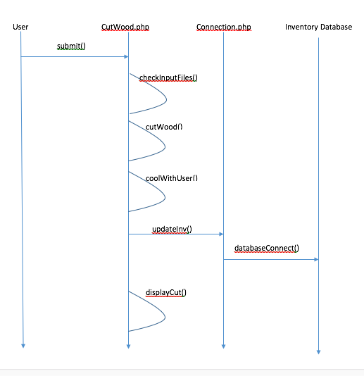

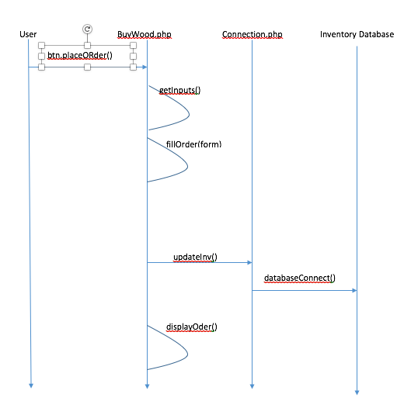

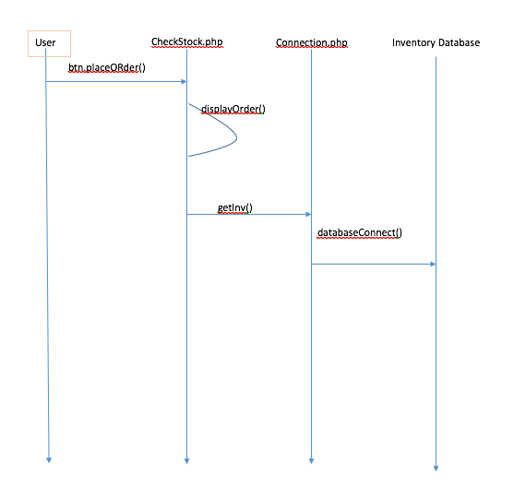

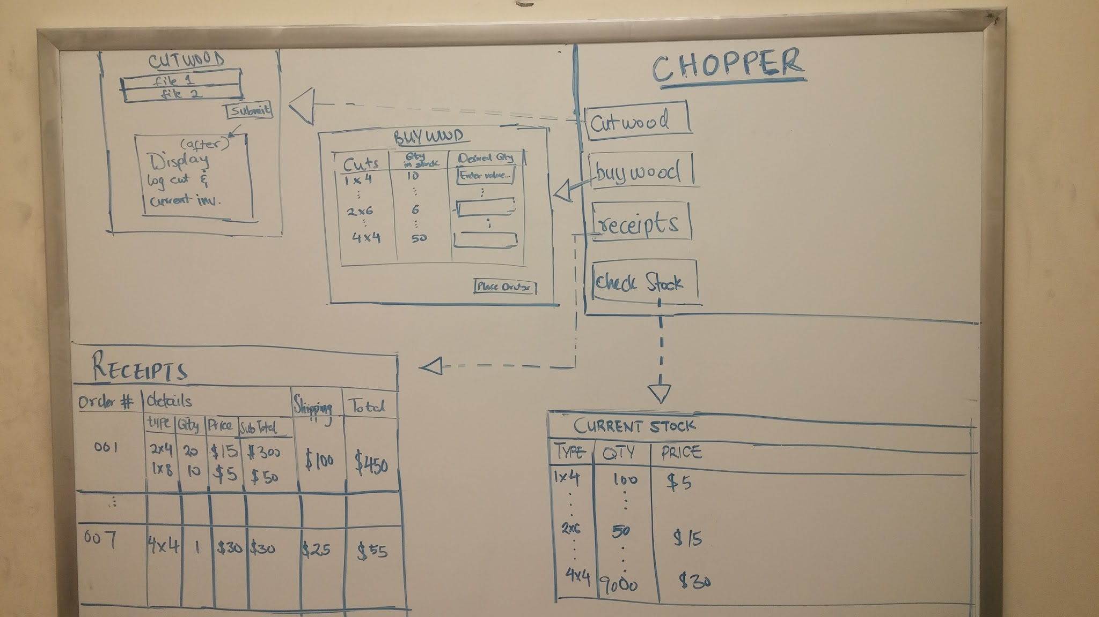

***Class: Cut***

|  |  |
| --- | --- |
| ***Field(types of cuts)*** | ***Description*** |
| *quan* | *Keeps track of quantity* |
| val | Value of the cut |
| areas | Subareas it creates |
| Parentid  Id  Mytype  Length  Width  Height  price | id of its parent cut  its id for the cut  string name of the lumber cut  length of lumber in cut  width of lumber in cut  height of lumber in cut  price of piece of lumber in the cut |

***Class: Area***

|  |  |
| --- | --- |
| ***Field(types of cuts)*** | ***Description*** |
| *height* | *Height of an area* |
| *wid* | *Width of an area* |
|  | *“ “* |
|  |  |

***Class: BUYWOOD***

|  |  |
| --- | --- |
| ***Field(types of cuts)*** | ***Description*** |
| *1 X 1* | *Types of lumber with corresponding price, desired amount, and current stock.* |
| *…* | *“ “* |
| *8x8* | *“ “* |
|  |  |

|  |  |
| --- | --- |
| ***Method*** | ***Description*** |
| *getInputs()* | *Gets the values from user form entries* |
| *fillOrder(formVals)* | *Fills order out as much as possible given current inventory, makes for incomplete order* |
| *displayOrder()* | *Shows the order that had just been placed(receipt)* |

***Class: ViewInventory***

|  |  |
| --- | --- |
| ***Method*** | ***Description*** |
| *DisplayStock()* | *Displays the current inventory levels* |
| *…* |  |

***Class: CutWood***

|  |  |
| --- | --- |
| ***Field*** | ***Description*** |
| *File1*  *File2* |  |
|  |  |

|  |  |
| --- | --- |
| ***Method*** | ***Description*** |
| *checkInputFIles(file1,file2)* | *Parses input files(if exist) for format, and get data* |
| *cutWood(int data values)* | *Analyzes given dimensions, calculates best combination of lumber cuts* |
| *coolWithUser(bool choice)* | *Confirms with user before executing cuts* |
| *displayCuts()* | *Show the produced lumber, and updated inventory* |

***Class: Receipts***

|  |  |
| --- | --- |
| ***Field*** | ***Description*** |
| *None* | *Merely displays previous order histories* |
| *…* |  |

|  |  |
| --- | --- |
| ***Method*** | ***Description*** |
| *PopulateReciepts()* | *Displays table of previous orders, sorted by date or order amount/size* |

1. **WORK BREAKDOWN STRUCTURE AND EFFORTS ESTIMATION/ ИЕРАРХИЧЕСКАЯ СТРУКТУРА РАБОТ И ОЦЕНКА ТРУДОЕМКОСТИ**

List of project tasks and efforts needed to complete each task and total project should be provided here

|  |  |  |
| --- | --- | --- |
| Описание задачи / Desription | Участник / Expert | Agreed Effort Estimation (чел*часы / man*hour) |
| Разработка Плана Управления Проектом / PMP development | 6 | 5 |
| Коммуникации с аналитиками, разработчиками, тестировщиками / Communications with analytics, developers, testers | 8 | 8 |
| Разработка Еженедельного отчета / Weekly reports | 2 | 10 |
| Управление конфигурациекй / Configuration Management | 2 | 4 |
| Сбор метрик / Metrics collection | 2 | 2 |
| Знакомство с предметной областью и изучение новых технологий / Subject area evaluation and study of new technologies | 8 | 8 |
| Разработка требований (группа системных аналитиков) / Requirements Gathering (System Analists) | 10 | 10 |
| Разработка дизайна системы (архитектурная группа) / High Level Design (Architects) | 12 | 10 |
| Разработка прототипа системы (1,5-2 месяца) / Development of the system (1.5 - 2 months) | 6 | 6 |
| Разработка базы данных / Data Base Development | 6 | 6 |
| Реализация компоненты "Сбор данных" / Component "Data Collector" development |  | 8 |
| Реализация компоненты "Кодировка данных" / Component "Data Encoding" development | 8 | 30 |
| Реализация компоненты "Аналитика-Отчетность" / Component "Analitics & Reporting" development | 8 | 16 |
| Реализация компоненты "Предоставление данных Web" / Component "Web interface to data" development | 5 | 15 |
| Реализация системы управления и контроля прав доступа / Authentification procedure development | 1 | 4 |
| Реализация системы мониторинга и сохранения состояний сессий / Sessions state monitoring system | 1 | 3 |
| Системная интеграция / Integration System |  | 3 |
| Исправление дефектов / Bag Fixing | 3 | 8 |
| Тестирование (QA специалисты) / Testing |  | 10 |
| Техническая документация / Technikal documentation | 2 | 5 |
| Ожидаемая трудоемкость (чел*час) / Efforts Estimation (man*hour) | TBA | 171 |

1. **KEY MILESTONES / СТАДИИ И ЭТАПЫ РАЗРАБОТКИ**

Table b 1. Key milstones / Таблица 1. Ключевые даты

|  |  |  |  |
| --- | --- | --- | --- |
| **## / №** | **Start date / Начало** | **End date / Конец** | **Description / Описание** |
| 1 | 13.02.19 | 28.02.19 | SOW developed, reviewed and signed and studying technologies for creation of a website(JavaScript, Html, CSS) |
| 2 | 01.03.19 | 10.03.19 | Studying technologies for creation of a website(JavaScript, HTML, CSS), also the agile methodology SCRUM |
| 3 | 10.03.19 | 18.03.19 | Application of SCRUM methodology to the project and definition of the roles in the project. General design of the main page and the web site in general. |
| 4 | 18.03.19 | 15.04.19 | First checkpoint and an advance of PMP document, reviewed, signed and the mockup of the project. |
| 5 | 15.04.19 | 28.04.19 | Second checkpoint and the first prototype and application development. |
| 6 | 28.04.19 | 13.05.19 | application development |
| 7 | 13.05.19 | 25.05.19 | Third checkpoint and and application development |
| 8 | 25.05.19 | 31.05.19 | testing of the application |
| 9 | 31.05.19 | 03.06.19 | fixing bugs |
| 10 | 03.06.19 | 06.06.19 | Forth checkpoint |

1. **CHOSEN TECHNOLOGY AND DEVELOPMENT FRAMEWORK / ОПИСАНИЕ СРЕДСТВ РАЗРАБОТКИ**

PHP, SQL, HTML, CSS, GitHub(as control version system) and ATOM as IDE.

1. **CONFIGURATION AND CHANGE MANAGEMENT / ПЛАН УПРАВЛЕНИЯ КОНФИГУРАЦИЕЙ И ИЗМЕНЕНИЯМИ**

GitHub as a control version system, the project with all the necessary documents will be stored in the following repository:

<https://github.com/ashkaren/LumLad>

1. **PROJECT SPECIFIC PROCESS, QUALITY PLAN, METRICS / ПРОЦЕСС ПРОЕКТА, ПЛАН ПО КАЧЕСТВУ, МЕТРИКИ**

You can find following excel file by the link down below

<https://docs.google.com/spreadsheets/d/1oARYe2qwJyf9ge6yAdew2bA-uzywTWSajqDSXYGJK8I/edit?usp=sharing>

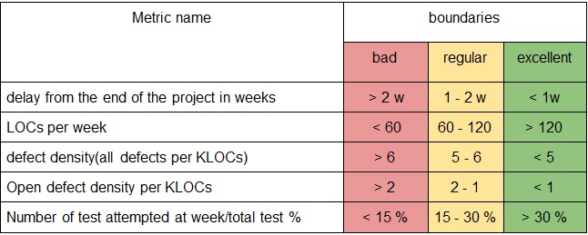

1. **PROJECT RISKS / ПРОЕКТНЫЕ РИСКИ**

|  |  |  |
| --- | --- | --- |
| Risk/Риск | Possibility(1-5)/Вероятность | Effect on the project, possible solution/Влияние на проект, возможные решения |
| Health issues | 4 | It will delay the speed and later quality of the project. Postpone the dates of report and so on. I will try to catch up with timing and work faster or more when healed up. |
| Other classes and work | 3 | It will delay all the due dates and increase the possibility of mistakes and bugs due to trying to catch up. Work more, sleep less, try to work faster. |
| Technical issues with hardware | 2 | It will delay all the due dates.  I shall try to take care of my hardware and upgrade in timely manner. |
| Third-party code won’t be working properly | 2 | More time on learning and fixing. A slight delay in overall work. Might downgrade the functionality. |
| Third-party servers don’t work properly | 1 | Just delay in deployment and integration. |
| Not enough resources to complete desired features | 1 | Slight changes in the design and planning. Communication with client upon those questions. |
| Family business related issues | 5 | Do the overkill on the weeks where I have time and get done as much as possible |

1. **PROJECT SCHEDULE (GIANT DIAGRAM) / ПРЕДПОЛАГАЕМЫЙ ГРАФИК РАБОТ (ДИАГРАММА ГАНТА)**

|  |  |  |  |
| --- | --- | --- | --- |
|  | Tasks per sprint | Expected date | |
| First spint | Development of designed mock up | 01.04.19 | 08.04.19 |
| Development of the main page | 08.04.19 | 13.04.19 |
| Implementation of links for other pages | 08.04.19 | 13.04.19 |
| Testing | 13.04.19 | 14.04.19 |
| Debugging | 14.04.19 | 15.04.19 |
| Second sprint | Development of upload page | 15.04.19 | 18.04.19 |
| Development of functionality on the upload | 18.04.19 | 24.04.19 |
| Development of sharable picture for the web site | 24.04.19 | 25.04.19 |
| Testing | 25.04.19 | 26.04.19 |
| Fixing bugs | 26.04.19 | 28.04.19 |
| Third sprint | Developing storage page | 23.04.19 | 25.04.19 |
| Developing databases | 21.04.19 | 28.04.19 |
| Connecting databases to functionality | 28.04.19 | 01.05.19 |
| Develop order page | 1.05.19 | 03.05.19 |
| Fixing bugs | 03.05.19 | 04.05.19 |
| Fourth sprint | Development of recipe page | 05.05.19 | 07.05.19 |
| Develop the best cut algorithm | 01.04.19 | 12.05.19 |
| Testing and fixing | 12.05.19 | 30.05.19 |
| Deployment | 30.05.19 | 31.05.19 |

1. **TEST PLAN / ПЛАН ПО ТЕСТИРОВАНИЮ**

What kind of test types to be used (functional, performance, stress, cross platform, safety, usability, etc.), planned number of test cases for each type

**APPENDIX 1. TEST CASES / ПРИЛОЖЕНИЕ 1. ТЕСТОВЫЕ НАБОРЫ**

|  |  |  |
| --- | --- | --- |
| **Test type** | **Test case amount** | **Test case description** |
| 1.Functional testing | 25 | Testing of website interaction and all the button functionality |
| 2. Cross platform testing / Тестирование кроссплатформенности | 5 | Testing different devices on friendliness |
| 3. Usability testing / Тестирование удобства использования | 10 | Testing UI |
| 4. Performance testing / Тестирование производительности | 25 | Testing code, databases, performance of algorithm, speed |