Ali Ashkeyev 18BD11079

**Lab – Create User Accounts**

Part 1: Creating a New Local User Account

Step 1: Open the User Account Tool.

b. All control Panel Items

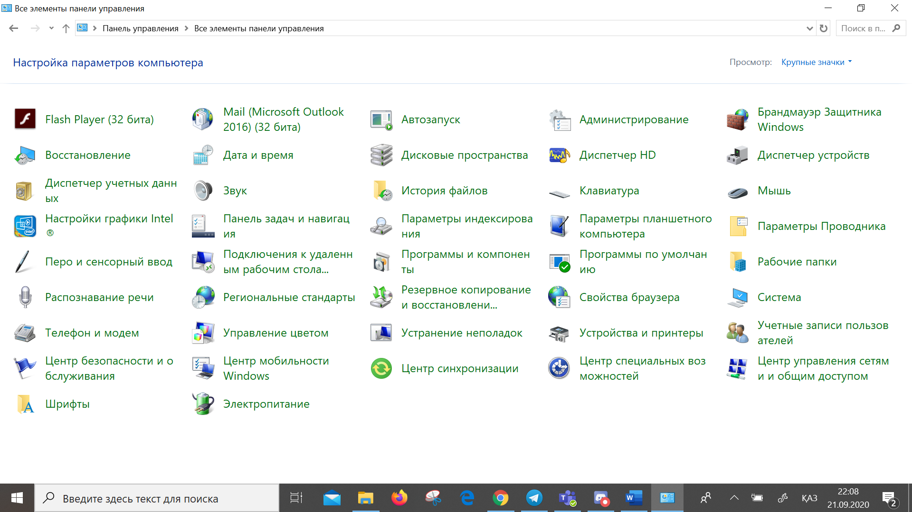

Step 2: Create a user account.

1. Manage Accounts

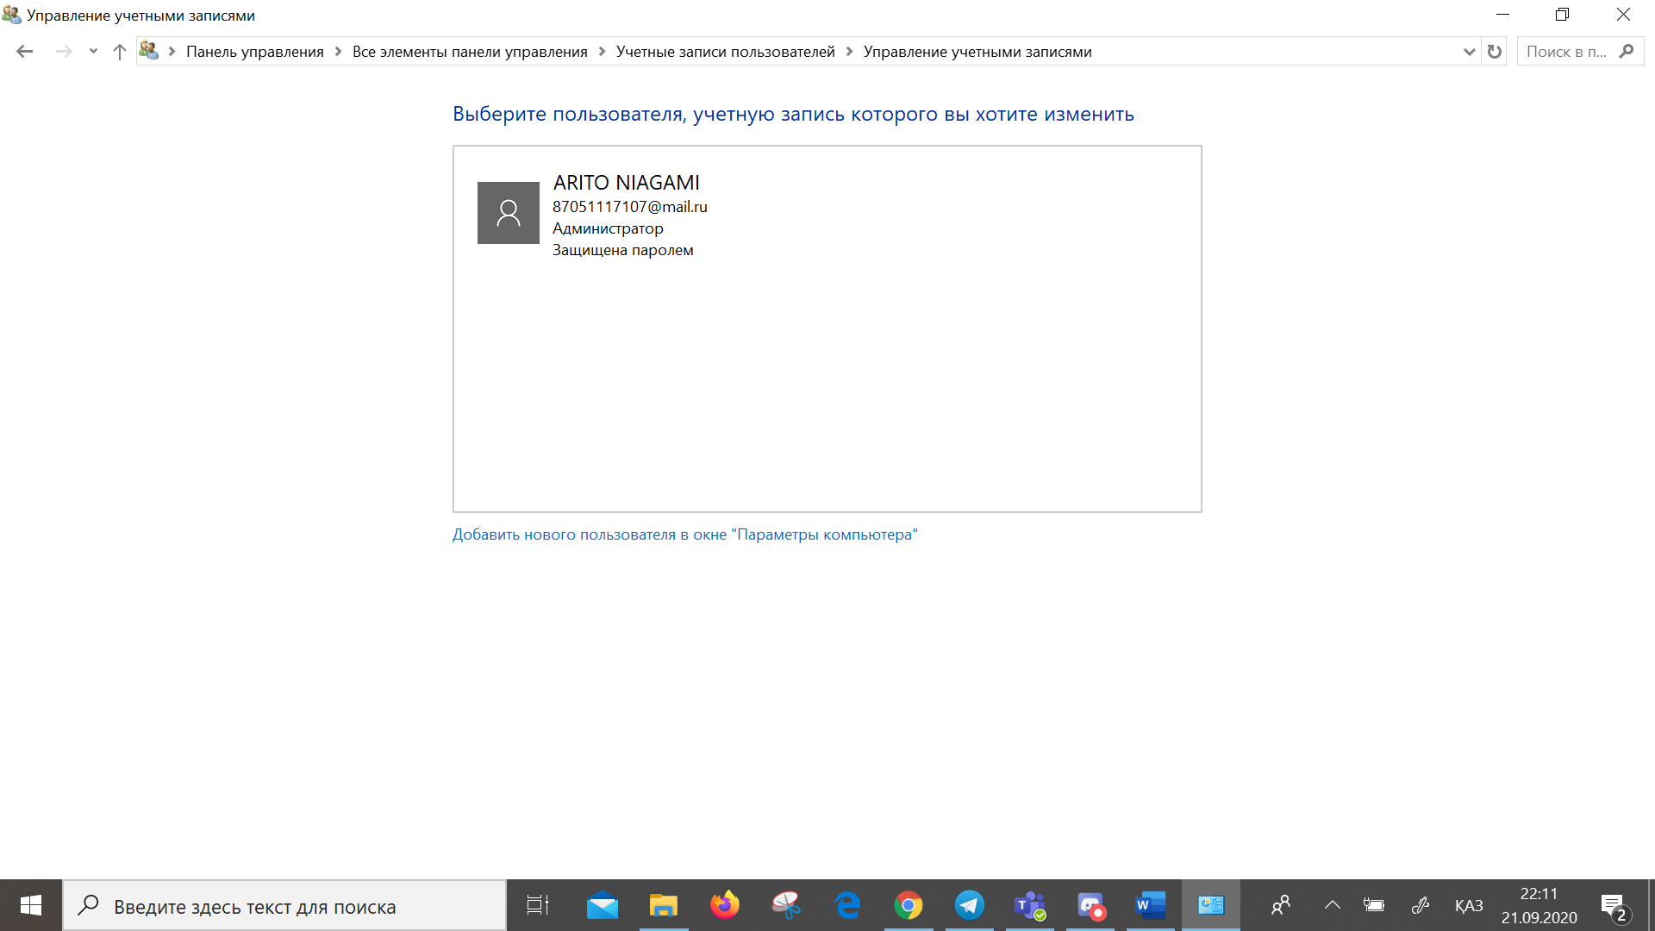

C. Settings of account window

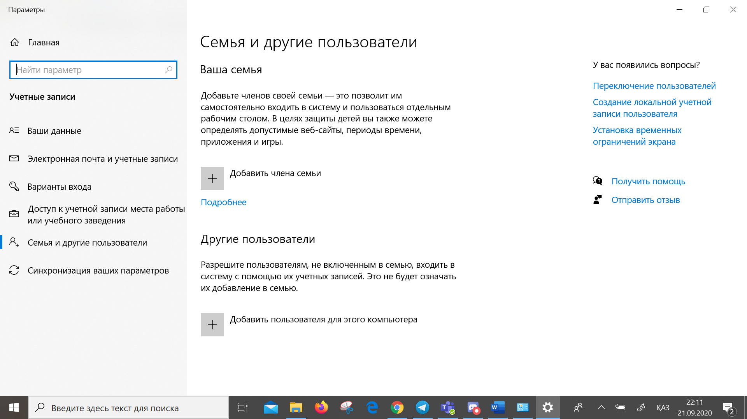

Created account screen

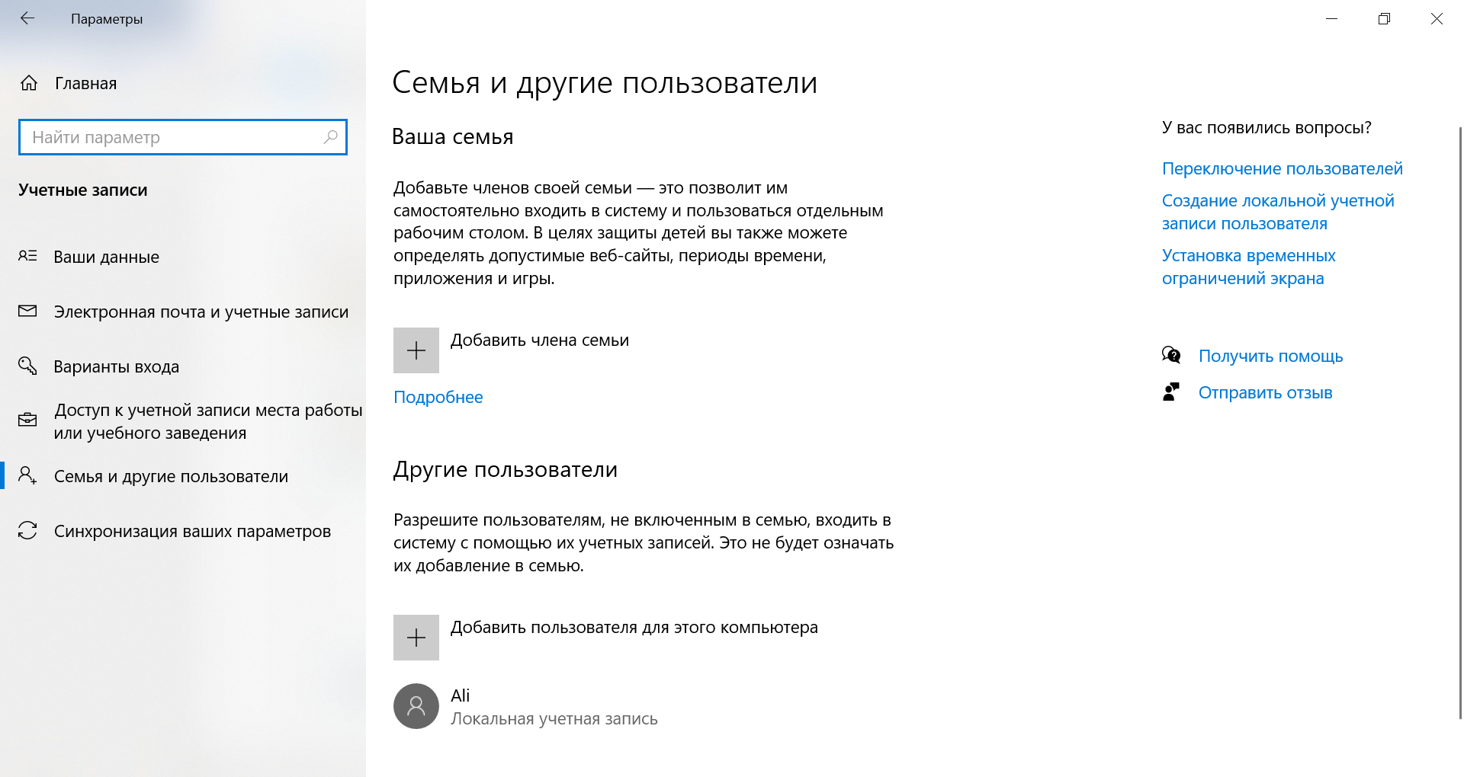

g. What type of user account did you just create?

Local user in users group with no administrator right.

I.Navigate to C:\Users folder. Right-click the User1 folder and select Properties, and then the Security tab. Which groups or users have full control of this folder?

SYSTEM, administrator and Users:Ali

j. Open the folder that belongs to CyberOpsUser. Right-click the folder and click the Properties tab. Were you able to access the folder? Explain.

You do not have permission because it is a Administrator in my case ARITO NIAGAMI account. While we logged in as a just a user.

l. Navigate to C:\Users folder. Right-click the folder and select Properties. Click the Security tab. Which groups or users have full control of this folder?

System, administrators users: ARITO NIAGAMI

Part2: Reviewing User Account Properties

In this step I had a problems for me it is not available Local Users and Group tab.

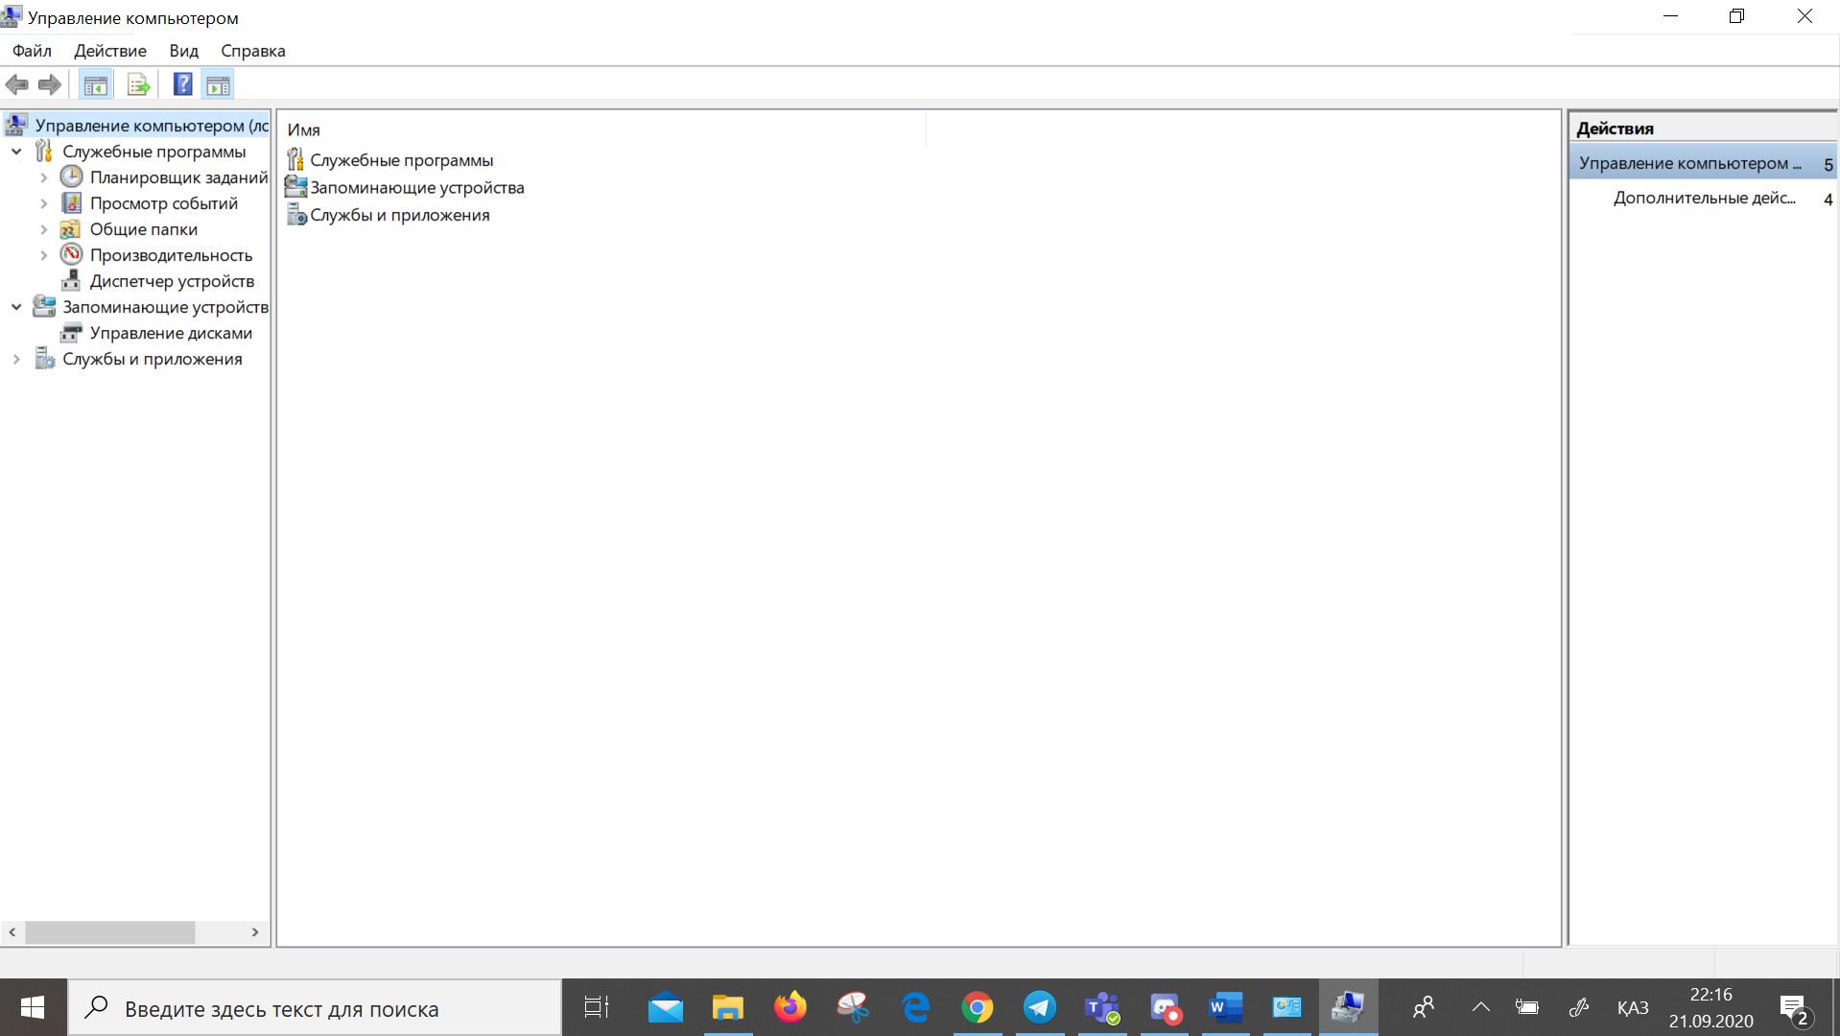

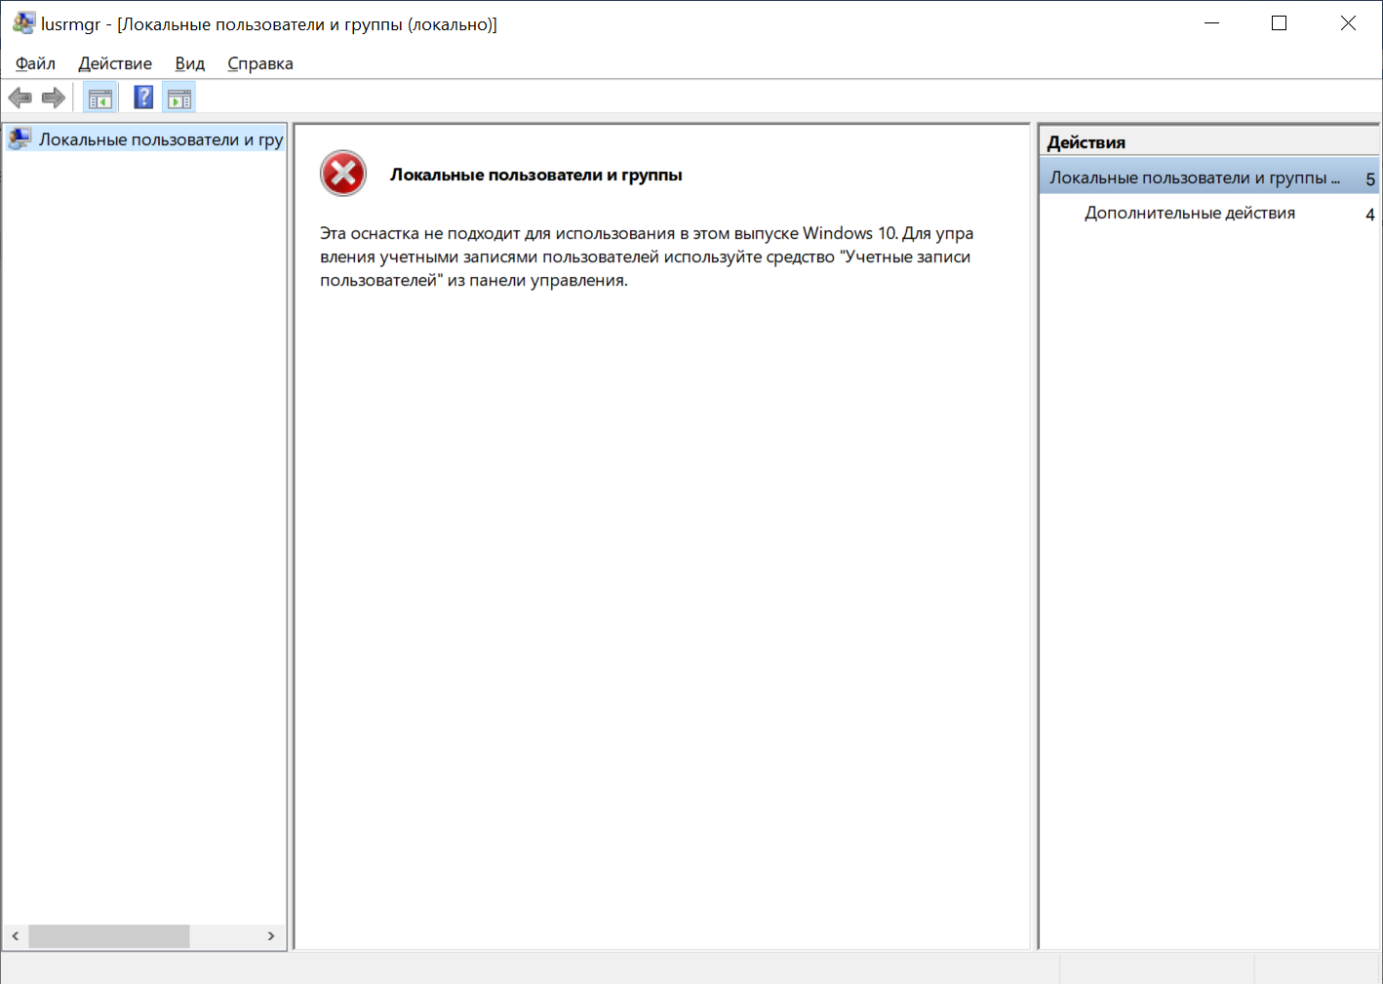

That’s is why I reached it with another method. I used win+R and typed **control userpasswords2 which opened me next window**

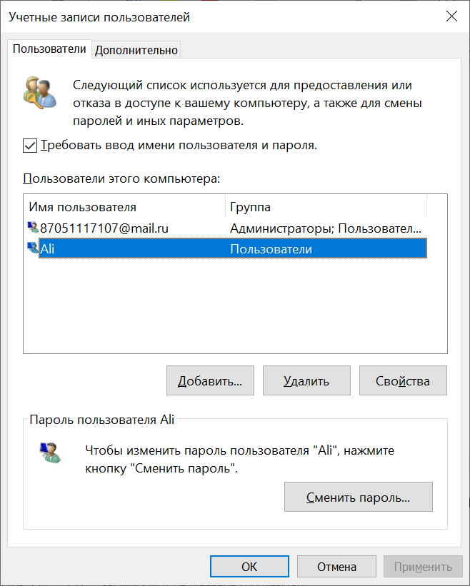

In this window I have similar functionality.

f. Which group is Ali is a member of? Users

e. ARITO NIAGAMI is member of Users and Administrators

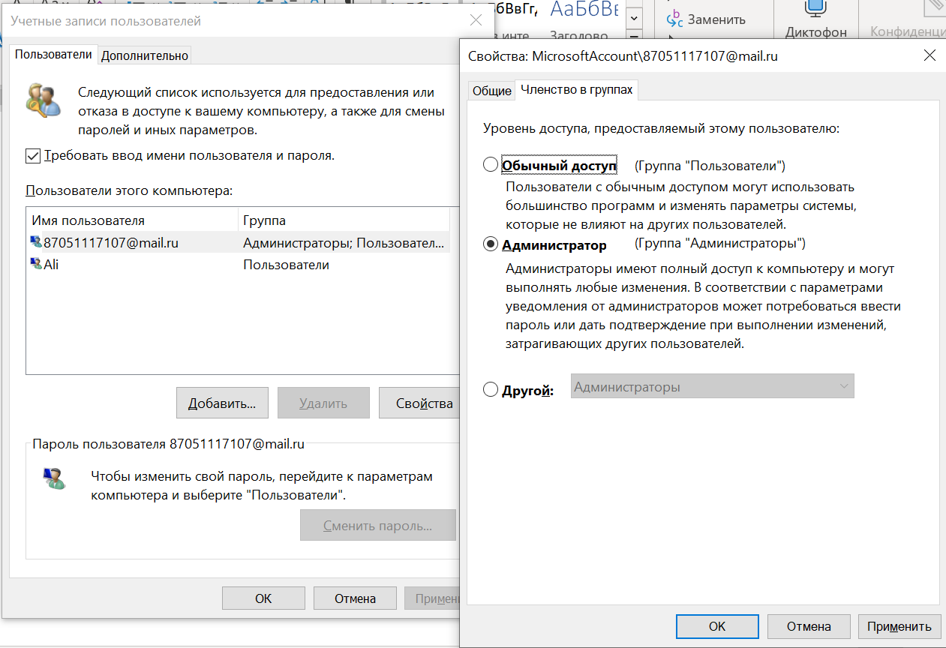

Part3: Modifying Local User Accounts

Step 1: Change the account type

Chane an account tab

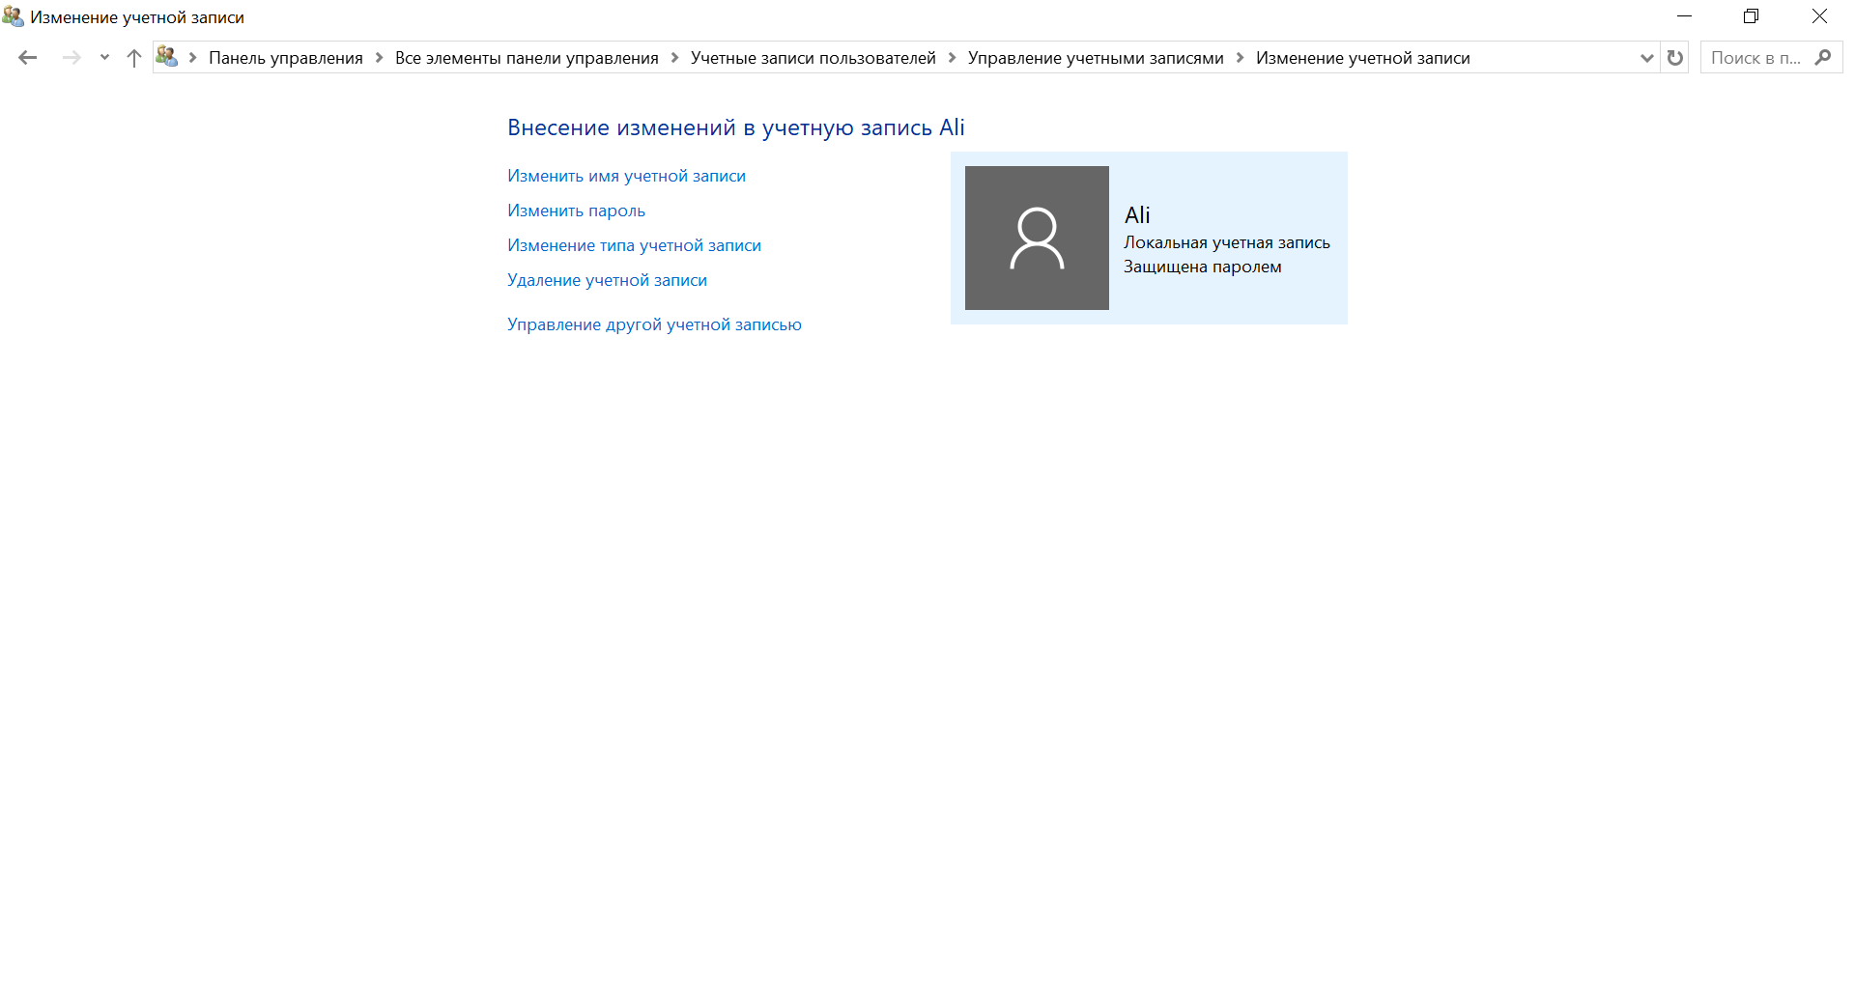

Change the account type form user to Administrator

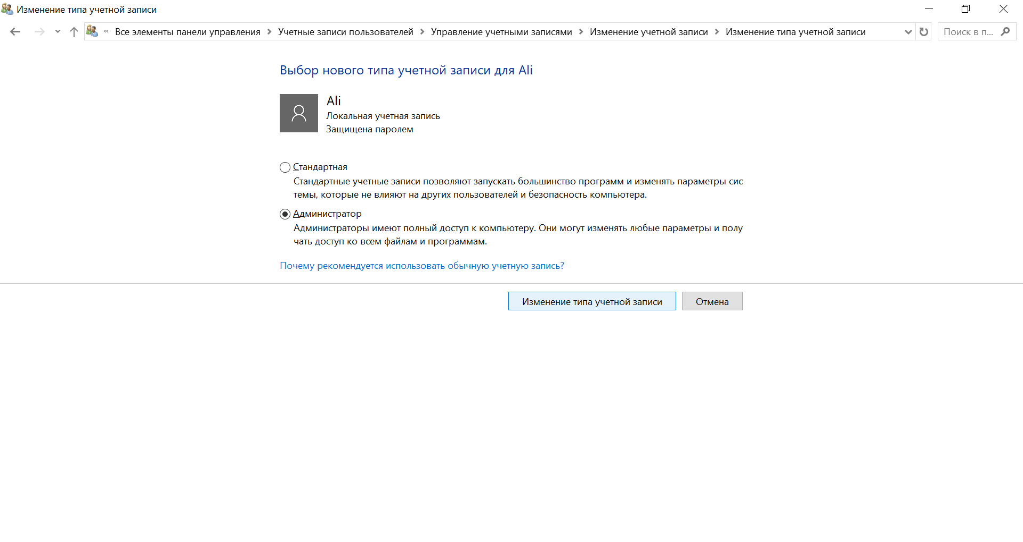

f. Now Ali is a member of administrator group and users

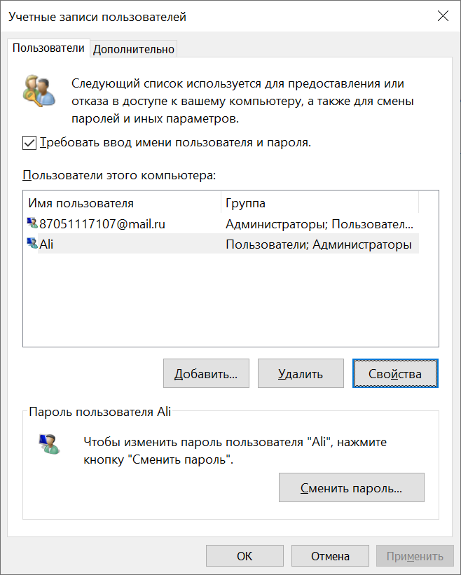

g. Remove Administrator rights for Ali

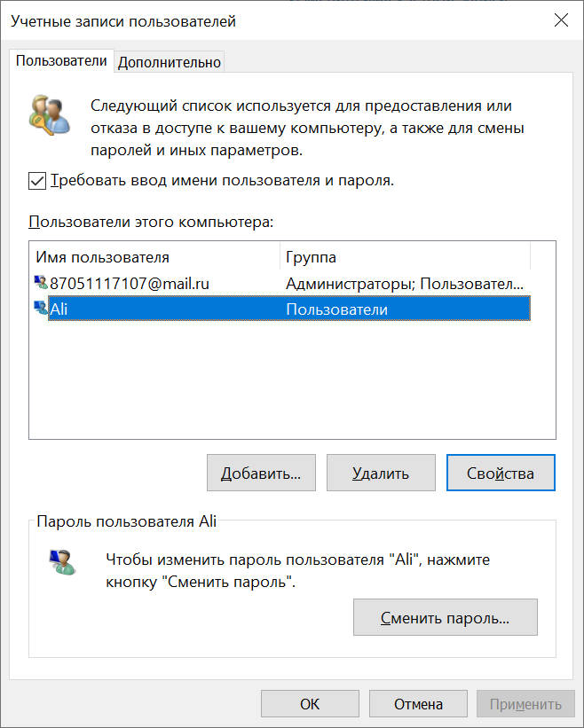

Step 2: Delete the account.

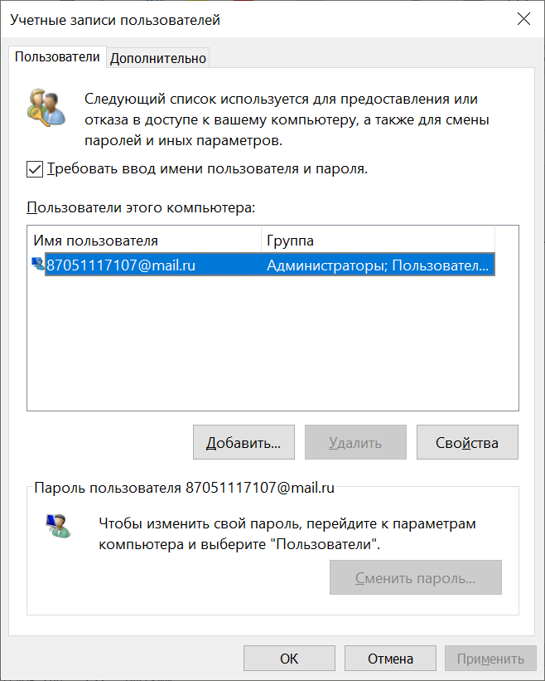

1. Way I show in this lab is one of the another methods to delete account. One of example is doing it as in example in Computer Management in Local Users and Groups tab. Also it can be done in Control panel 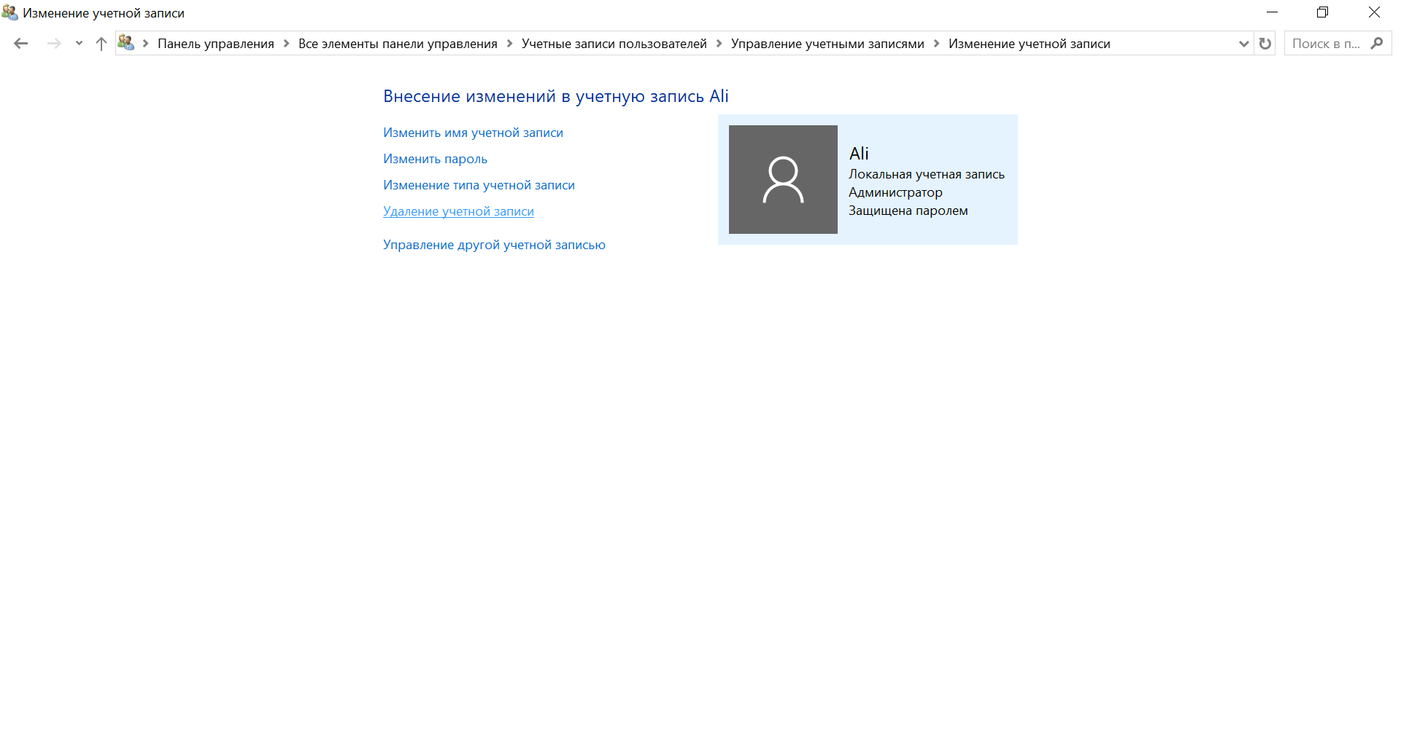

Reflection

1. Why is it important to protect all accounts with strong passwords?

Protecting account prevents form unauthorized access or protects from data stealing

1. Standard privileges does not have Administrator rights that’s why it does not show other users folder and it is securable way for your computer while it can be used by other people.