Ali Ashkeyev 18BD11079

Lab –Windows Task Manager

Part 1:Working inthe Processes tab

Task Manager

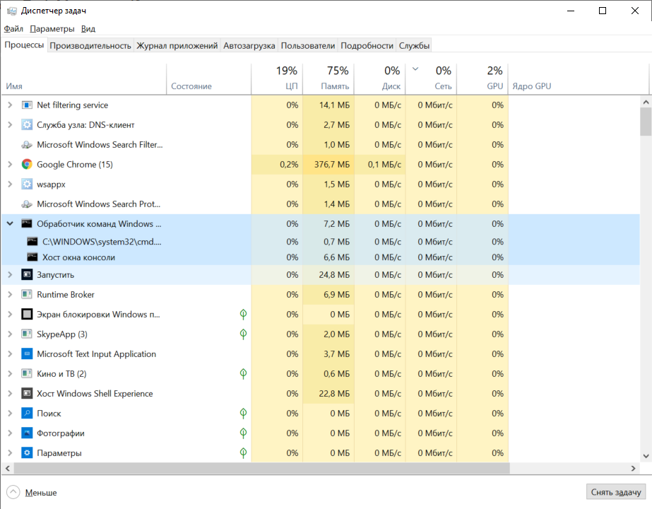

d. Expand the Windows Command Processor heading. What is listed under this heading?

Command prompt, console window host

f.conhost properties

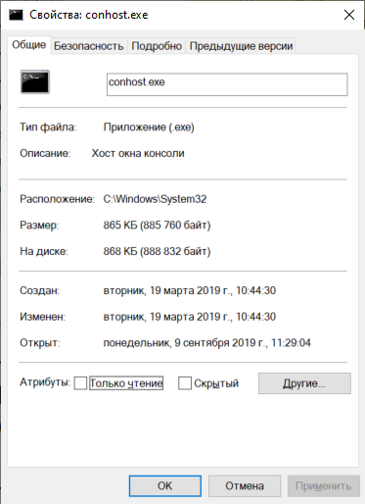

Conhost.exe located in C:\Windows\System32

g. Close the command prompt window. What happens to Windows Command Processor and Console Window Host when the command prompt window is closed?

It disappeared from task Manager

h. Memory tab

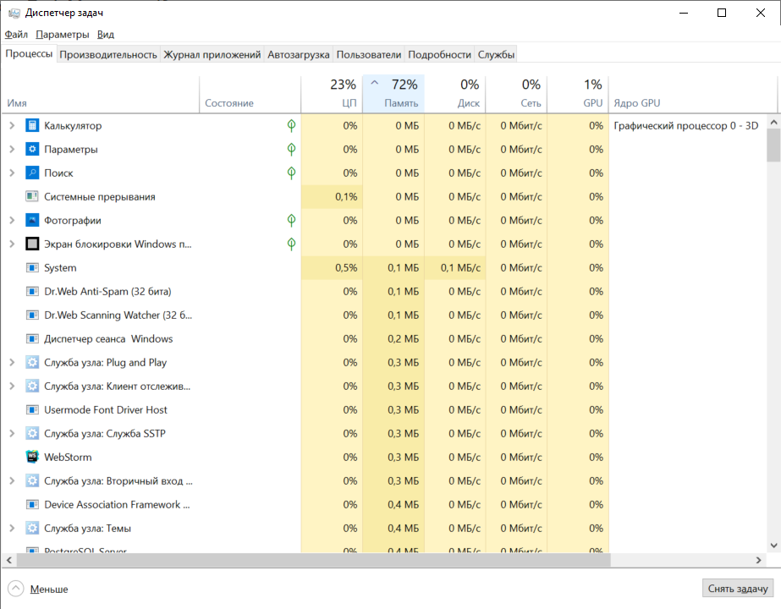

What effect does this have on the columns?

It sorted processes by the amount of memory usage in increasing order.

i.Memory resource value percents

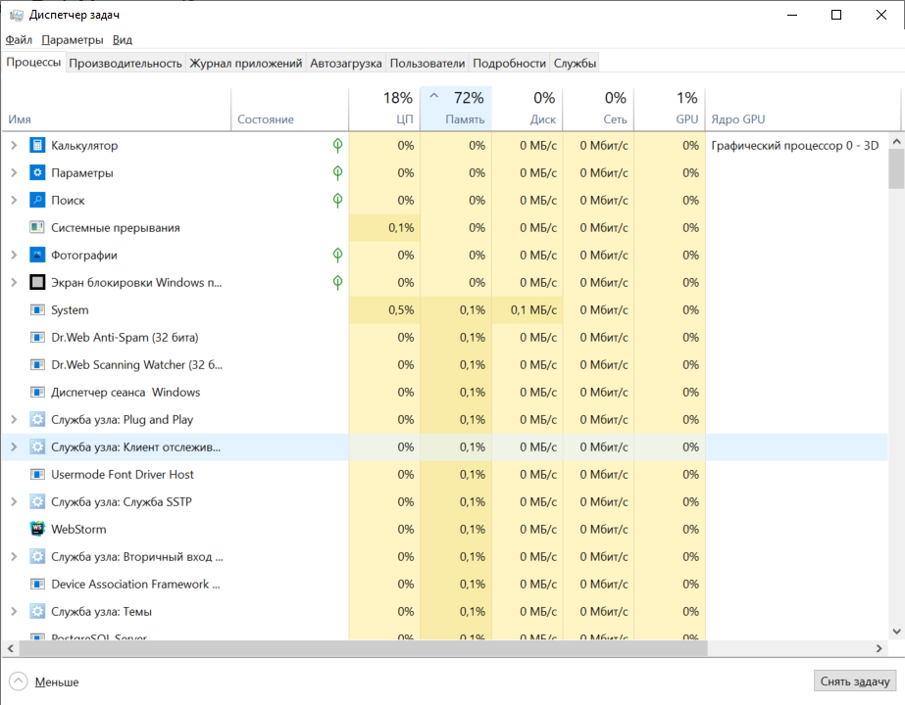

What affect does this have on the Memory column?

Memory illustrated in percent

How could this be useful?

We can see what percent of all memory concrete process takes.

j. Double-click to process

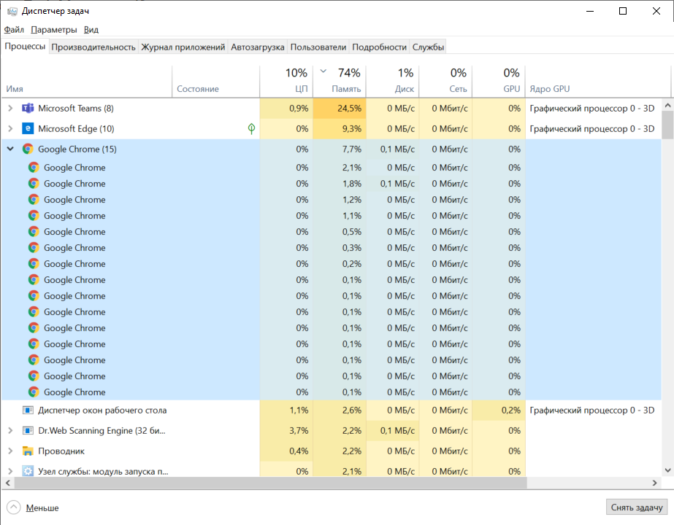

k. Double-click the Microsoft Edge. What happens?

It shows all child process.

l. It kills task and web-browser with child processes was closed.

Part 2:Workingin the Services tab

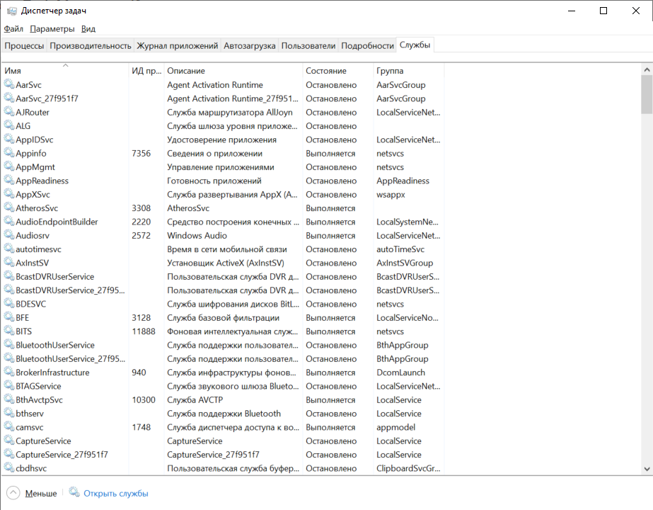a.Services tab in Task manager

What statuses are listed?

Running and Stopped services

Part 3:Workingin the Performance tab

a.Performance tab

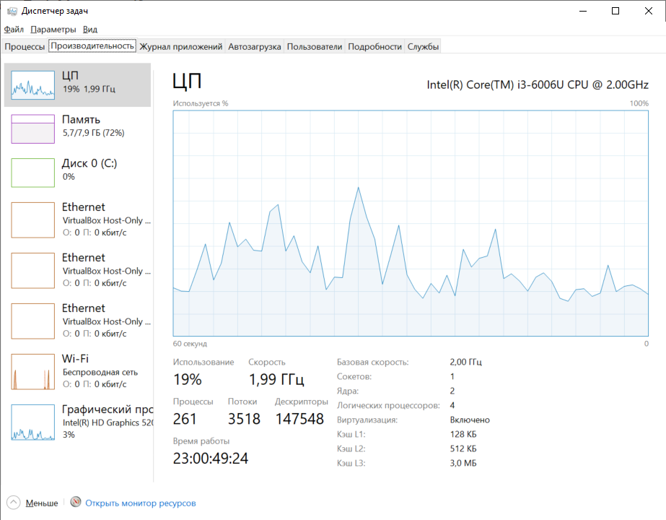

How many threads are running?

3518 threads are running

How many processes are running?

261 processes are running

b.Memory

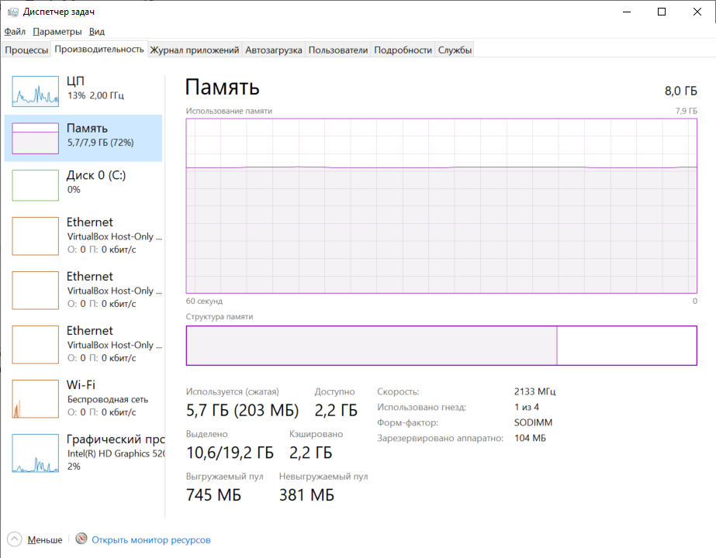

What is the total physical memory (MB)?

8.0 GB

What is the available physical memory (MB)?

2.2 GB

How much physical memory (MB) is being used by the computer?

5.7 GB

c.Ethernet Chart

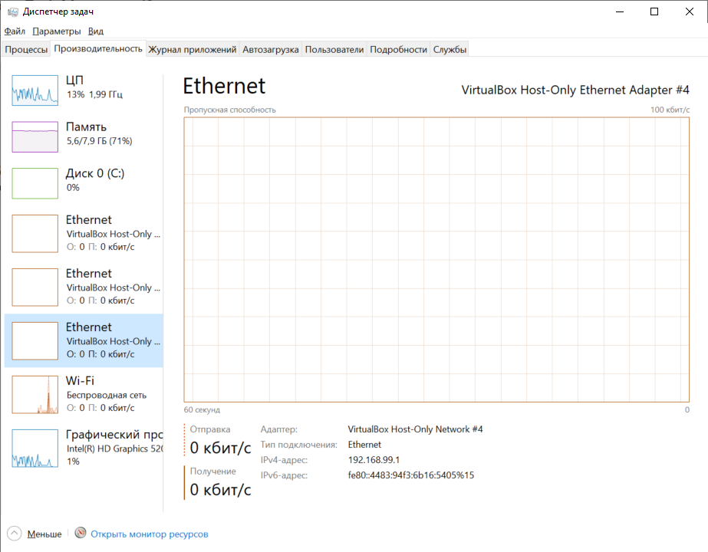

What is the link speed?

0 Kbps, because I use wireless connection Wi-Fi

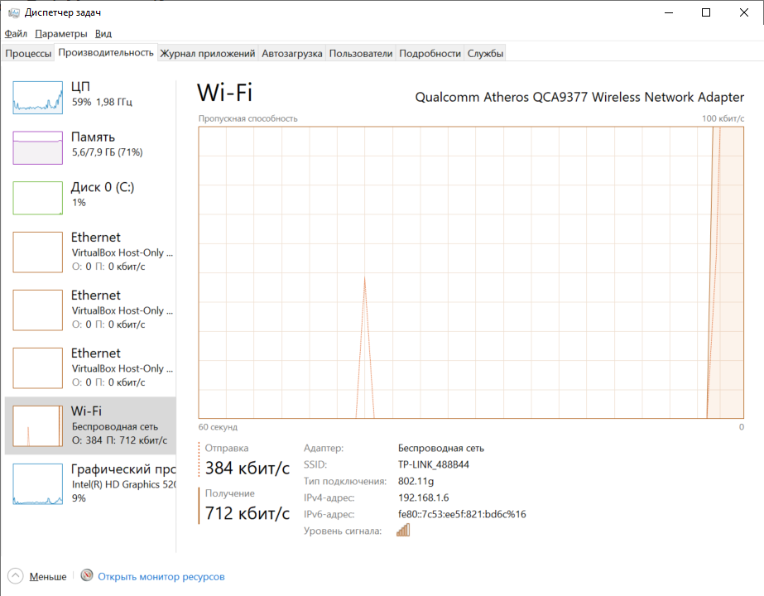

Wi-fi

Sending 384Kbpsd, receive 712Kbps

What is the IPv4 address of the PC?

192.168.99.1 ethernet

192.168.1.6 wifi

d. Resource Monitor utility

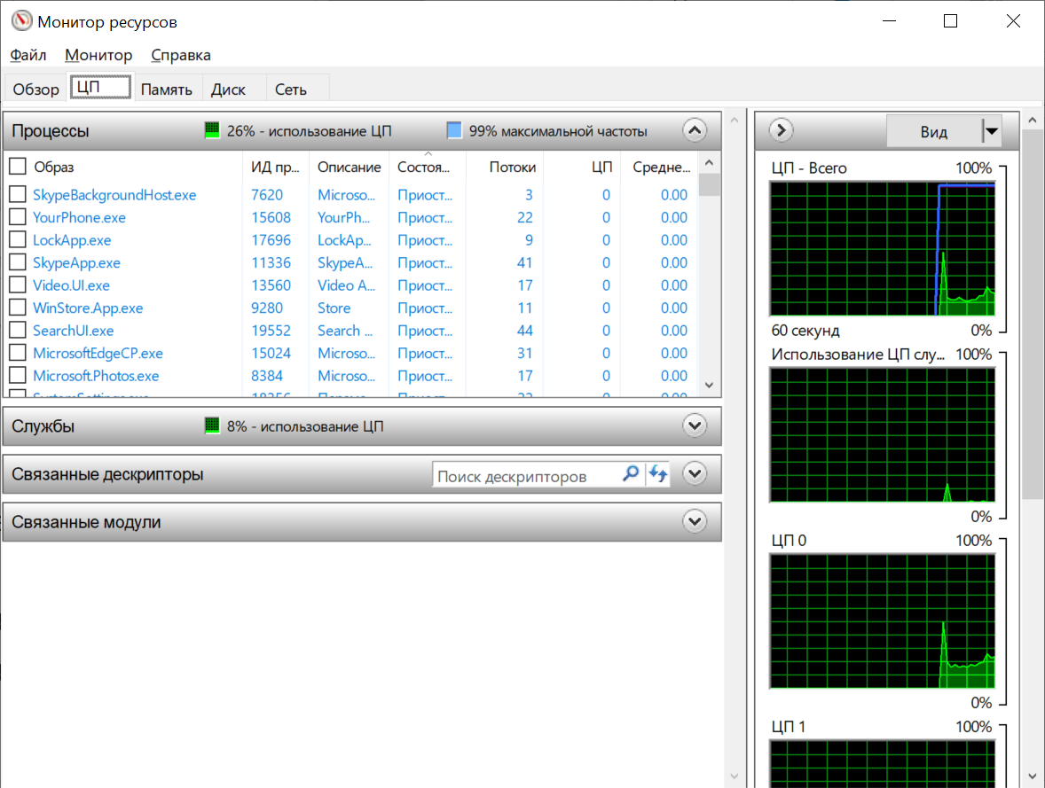

Reflection

Why is it important for an administrator to understand how to work withinthe TaskManager?

To diagnose performance issues and kill malicious process if it is needed