Ali Ashkeyev 18BD11079

Lab - Monitor and Manage System Resources in Windows

Part 1: Starting and Stopping the Routing and Remote Access service

a. Screen of network and sharing center panel

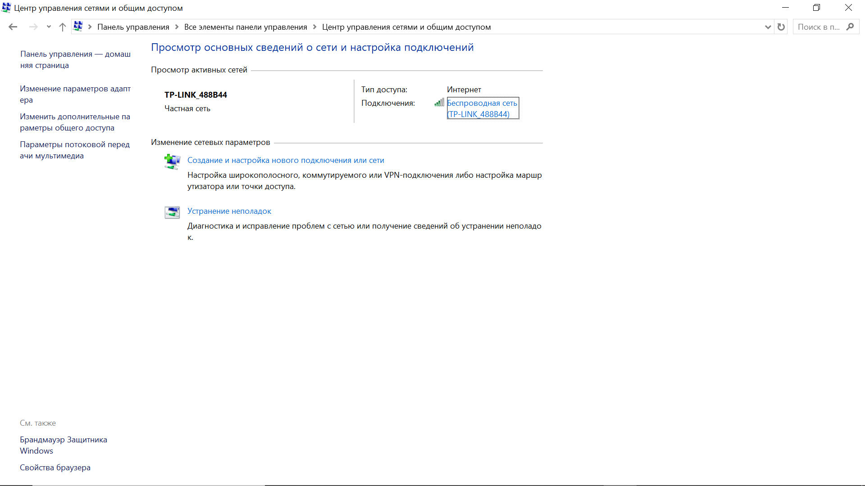

b.Network connections

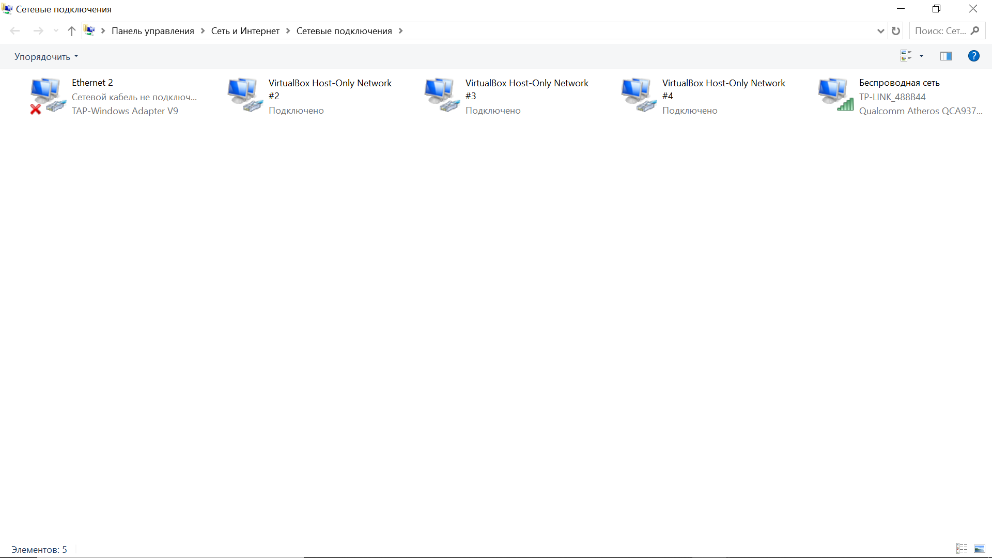

e.Performance Monitor

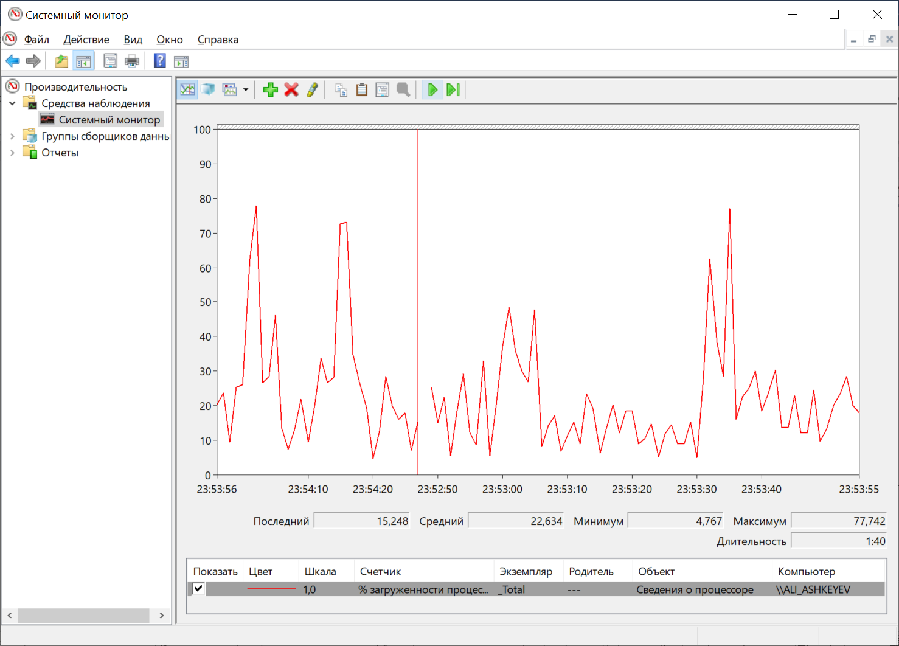

f. Clear

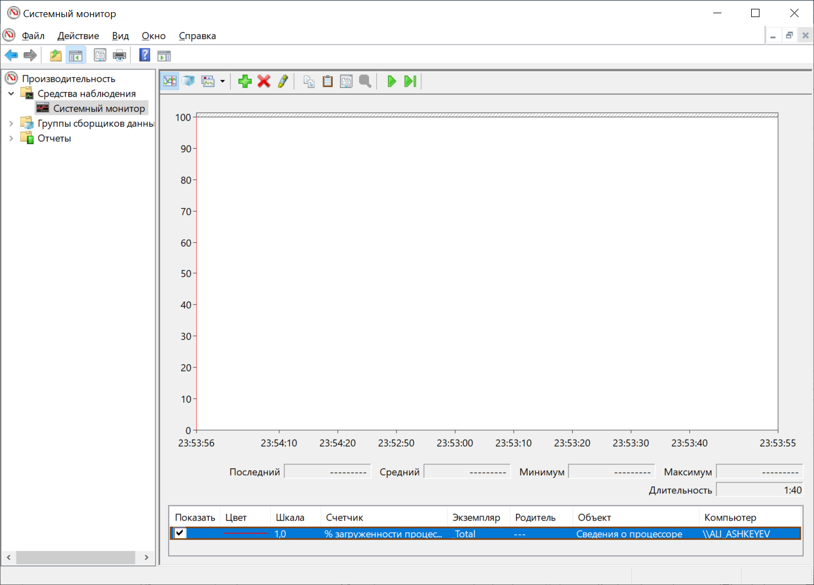

j. Routing and Remote Access Properties

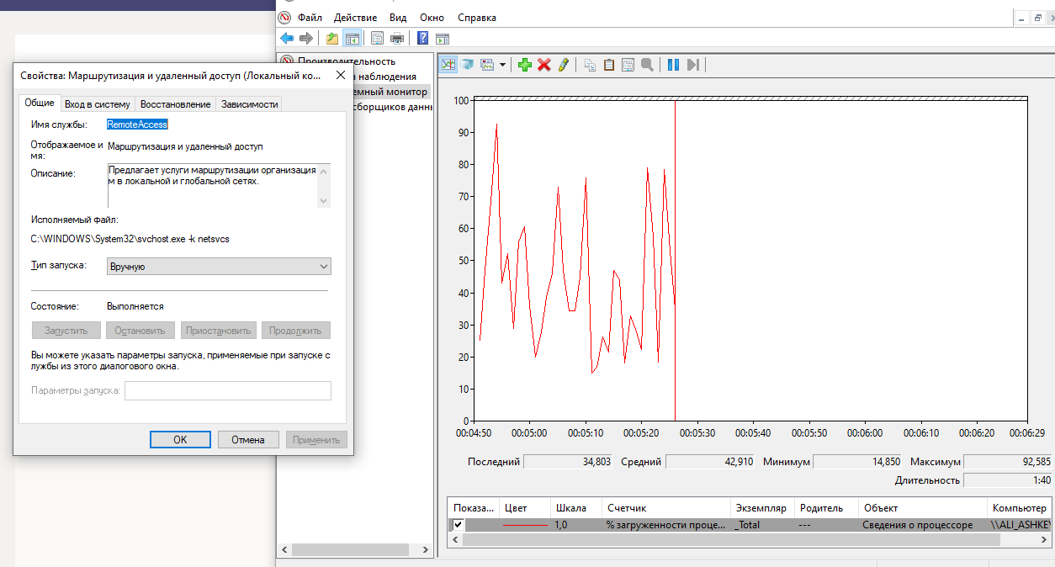

m. Navigate to Network Connections window. Press the function key F5 to refresh the content. What changes appear in the window after starting the Routing and Remote Access service?

Now we can see incoming connections.

o. Navigate to Network Connections window. What changes appear in the right pane after stopping the Routing and Remote Access service?

Incoming connections icon not displayed.

p.

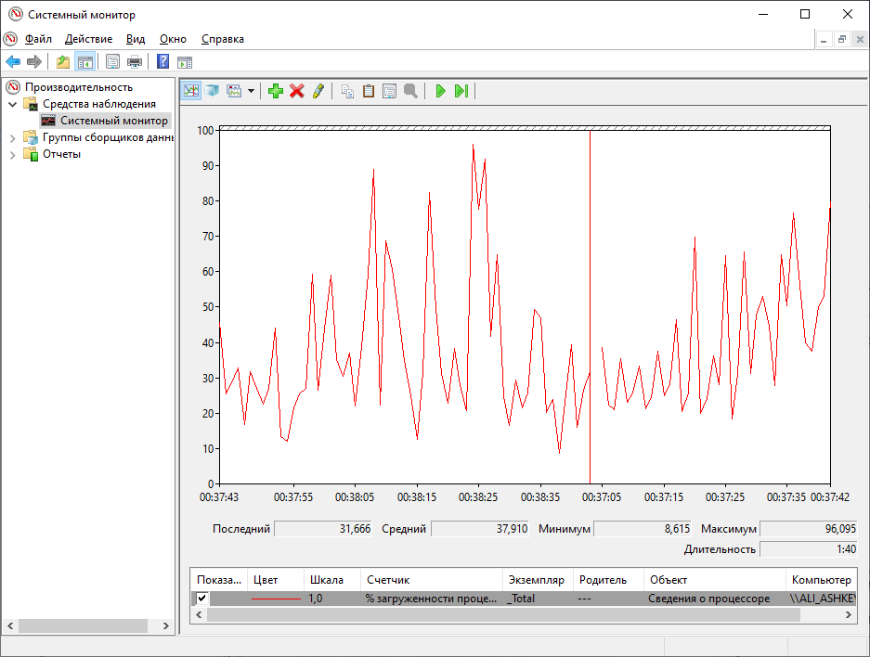

Which Counter is being recorded the most in the graph (hint: look at the graph color and Counter color)?

Processor Time

q. Report

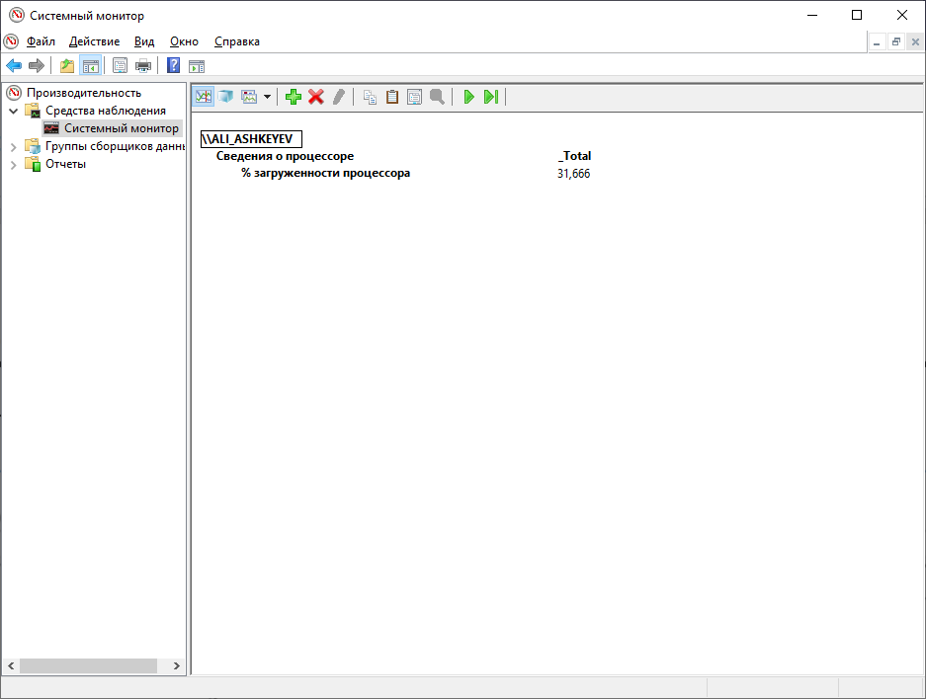

What values are displayed by the counter?

31,666

Part 2: Working in the Computer Management Utility

b.Computer Management

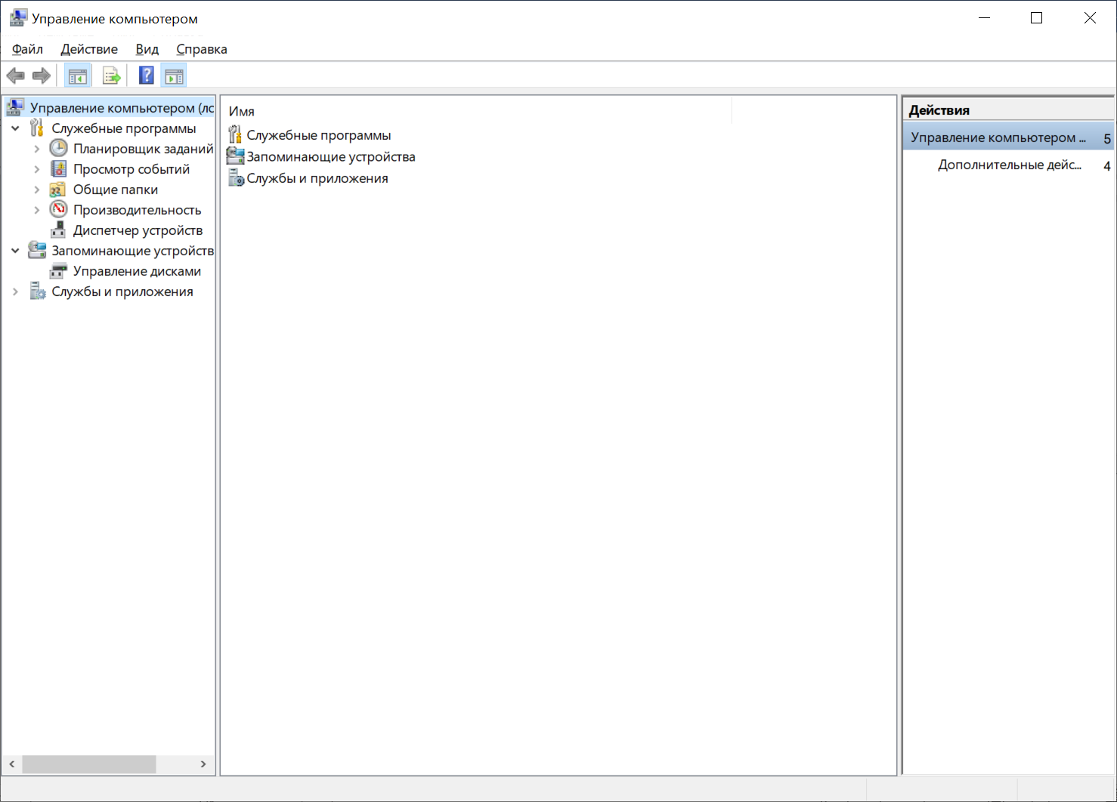

c.System events

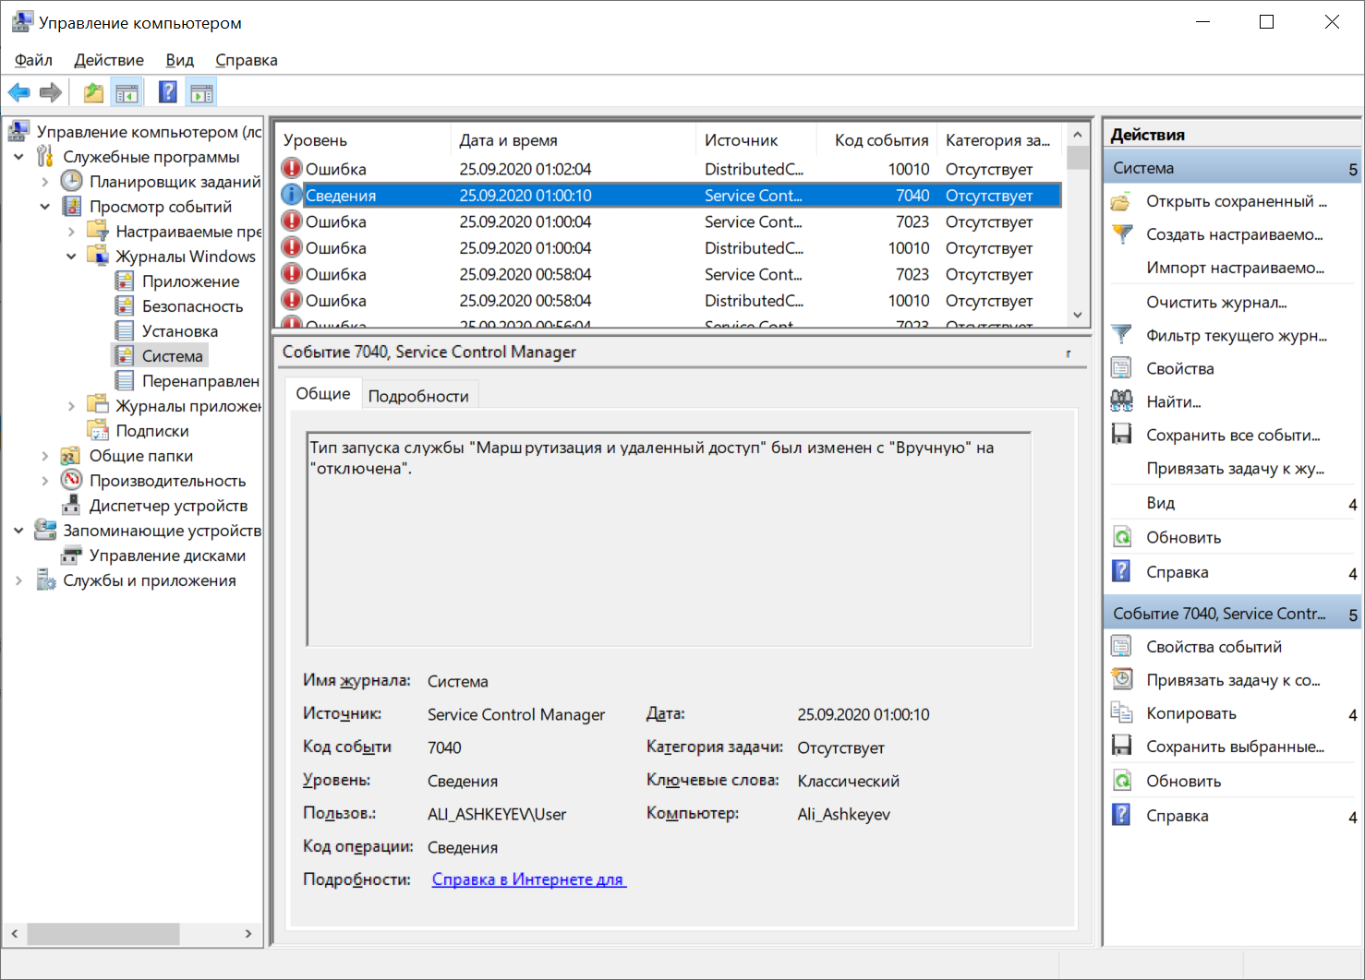

d.The start type of the Routing and Remote Access services was changed from disabled to demand start. Start. Stop. Changed to Disabled.

Part 3: Configuring Administrative Tools

b.Create new Data Collector Set

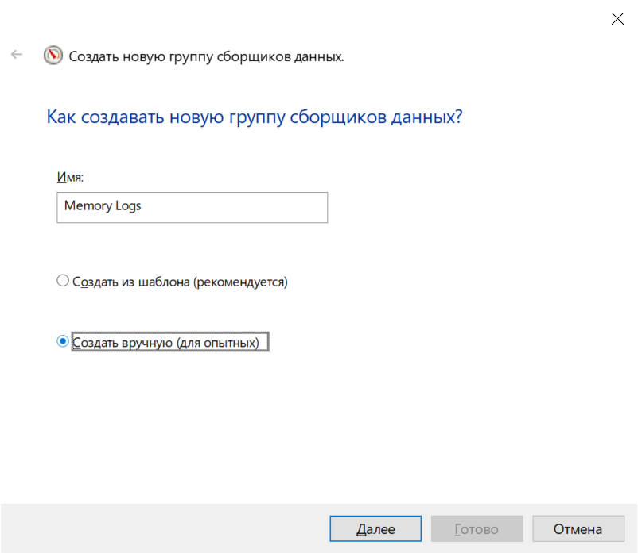

g. Sample interval

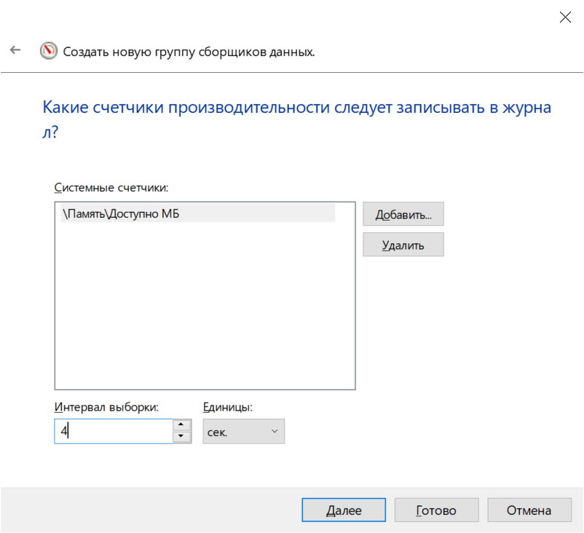

l. Memory Logs

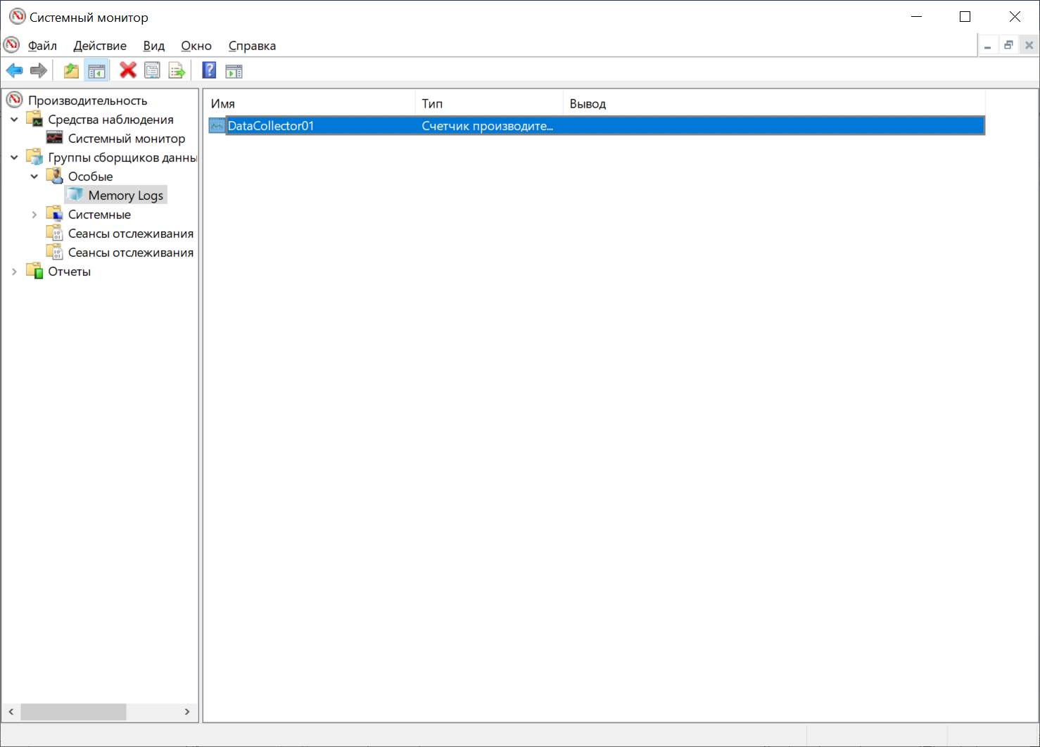

n. DataCollector01 Properties

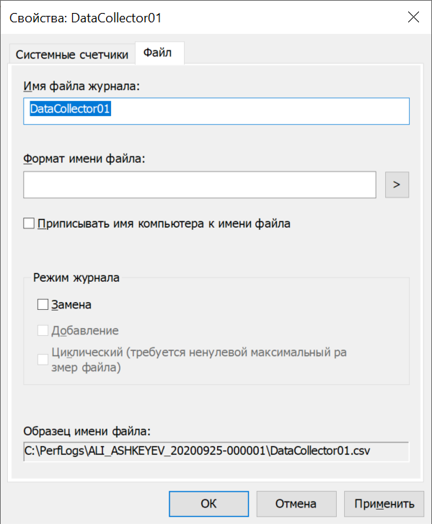

What is the full path name to the example file?

C:\PerfLogs\ALI_ASHKEYEV_20200925-000001\DataCollector01.csv

r. Stop the Data Collector Set

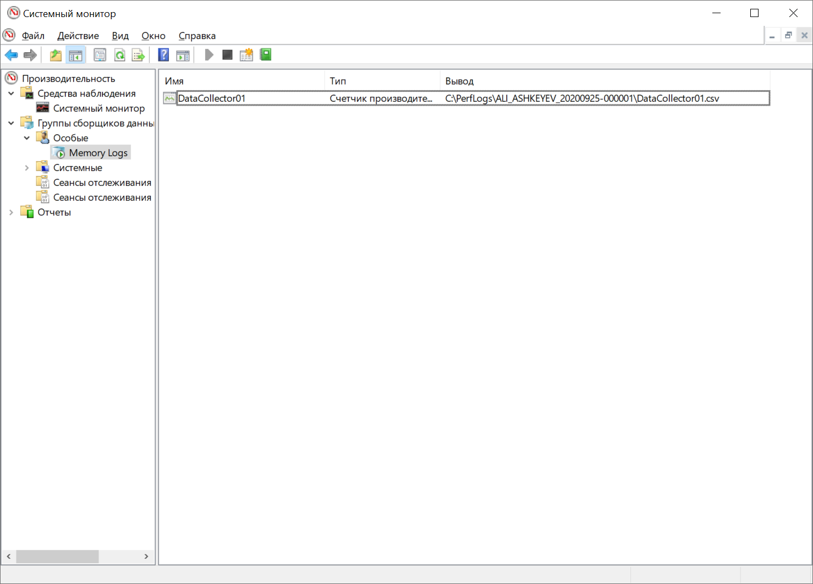

What change do you notice for the Memory Logs icon?

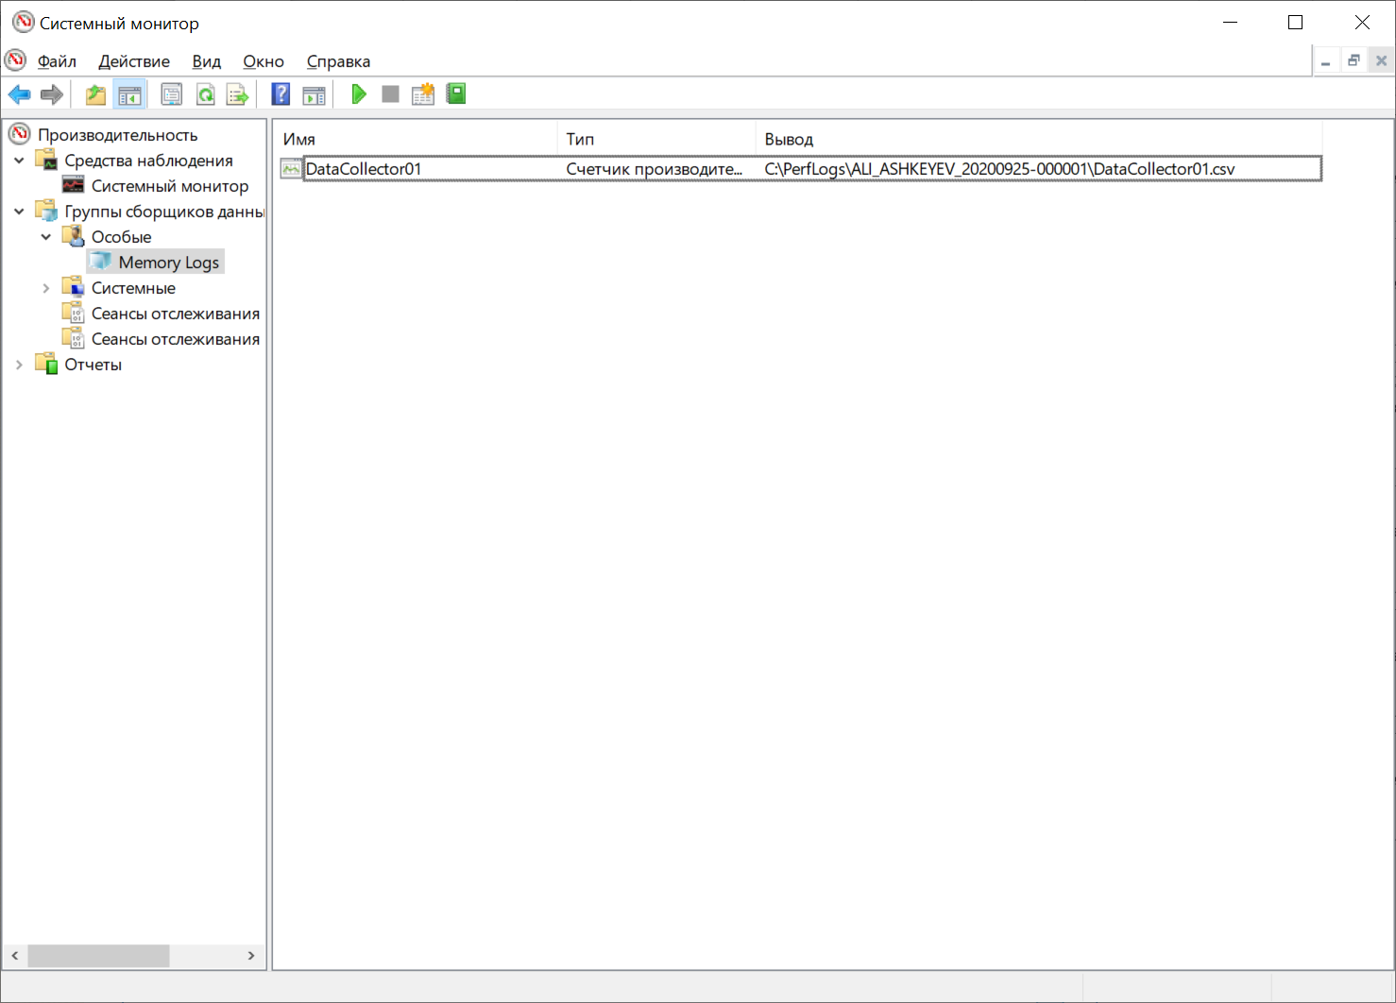**Green play(run) icon disappeared.**

**s. DataCollector01.csv**

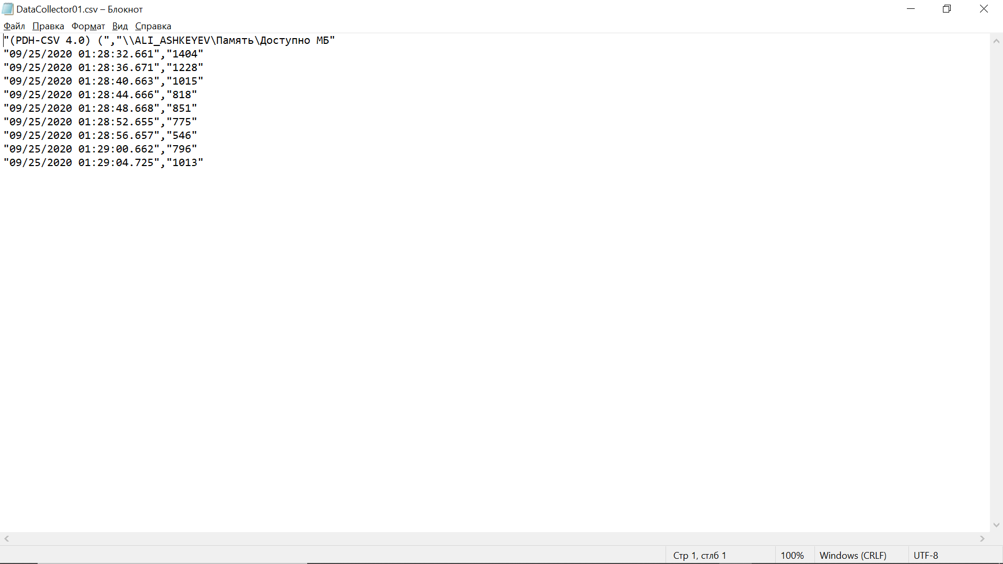

What does the column farthest to the right show?

Available MegaBytes(free space in memory).