**INTEGRATED PROJECT REPORT**

**On**

**DEPARTMENT MANAGEMENT SYSTEM**

Submitted in partial fulfillment of the requirement for the

Course Integrated Project III

**COMPUTER SCIENCE AND ENGINEERING**

**B.E. Batch-2016**

**in**

**May-2018**



|  |  |
| --- | --- |
|  | **Submitted By** |
|  | **Arpit Arora** |
|  | **1610991167** |
|  | **Arshpreet Singh Sidhu** |
|  | **1610991183** |
|  | **Ashu Singla** |
|  | **1610991199** |
|  | **Ashwani Mittal** |
|  | **1610991200** |

**DEPARTMENT OF COMPUTER SCIENCES**

**CHITKARA UNIVERSITY**

**PUNJAB**

**CERTIFICATE**

This is to be certified that the project entitled “Department Management System” has been submitted for the Bachelor of Computer Science Engineering at Chitkara University, Punjab during the academic semester January 2018- May-2018 is a bonafide piece of project work carried out by Arpit Arora(1610991167), Arshpreet Singh Sidhu(1610991183), Ashu Singla(1610991199), Ashwani Mittal(1610991200)towards the partial fulfillment for the award of the course Integrated Project (CSP2208) under the guidance of Ms. Shamaand supervision.

**Sign. of Guide**:

Ms. Shama

(Designation & Department)

**CANDIDATE’S DECLARATION**

We, **Arpit Arora(1610991167), Arshpreet Singh Sidhu(1610991183), Ashu Singla(1610991199), Ashwani Mittal(1610991200),** B.E.-2016 of the Chitkara University, Punjab hereby declare that the Integrated Project Report entitled **“DEPARTMENT MANAGEMENT SYSTEM”** is an original work and data provided in the study is authentic to the best of our knowledge. This report has not been submitted to any other Institute for the award of any other course.

|  |  |  |  |  |
| --- | --- | --- | --- | --- |
| **Sign. of Student** | **Sign. of Student** | **Sign. of Student** | **Sign. of Student** |  |
| Arpit Arora | Arshpreet Singh Sidhu | Ashu Singla | Ashwani Mittal |  |
| ID No 1610991167 | ID No 1610991183 | ID No 1610991199 | ID No 1610991200 |  |

**Place:Chitkara University**

**Date: 11-05-2018**

**ACKNOWLEDGEMENT**

It is our pleasure to be indebted to various people, who directly or indirectly contributed in the development of this work and who influenced my thinking, behavior and acts during the course of study.

We express our sincere gratitude to all for providing me an opportunity to undergo Integrated Project as the part of the curriculum.

We are thankful to Ms. Shama for his support, cooperation, and motivation provided to us during the training for constant inspiration, presence and blessings.

Lastly, We would like to thank the almighty and our parents for their moral support and friends with whom we shared our day-to day experience and received lots of suggestions that improve our quality of work.

|  |  |  |  |  |
| --- | --- | --- | --- | --- |
|  |  |  |  |  |
| Arpit Arora | Arshpreet Singh Sidhu | Ashu Singla | Ashwani Mittal |  |
| ID No 1610991167 | ID No 1610991183 | ID No 1610991199 | ID No 1610991200 |  |

**Student Template**

1. **Project Statement:Department Management System**
2. **Approximate duration (in hours) to complete the project** :**80**
3. **Project In charge: Ms. Shama**
4. **Team Members along with Name and Roll no’s:**
   1. **Arpit Arora 1610991167**
   2. **Arshpreet Singh Sidhu 1610991183**
   3. **Ashu Singla 1610991199**
   4. **Ashwani Mittal 1610991200**
5. **Check Points:**
6. Does the project statement result in a product? If yes, what type of product? **Android Application**
7. If it is a product, can a prototype be made, if not, what is it, which we can produce that our teachers can evaluate. **You can run it in Android Smartphones**
8. Does the project statement use multiple concepts to achieve the outcome? **yes**
9. Does it have enough for our team members to do sufficient amount of work? **yes**
10. **Technical Nodes** (*add more rows in the table below, if required)*

|  |  |
| --- | --- |
| Subject / Area / Topic | Technical Nodes |
| Computer Science | App Development |
| Programming | Java, XML |

1. **Prerequisites (in terms of knowledge, concepts and material) for doing the Project:**

**App Development, Internet, Powerful Computer**

1. **Material that may be required to make the project and where it might be available:**

**Android Studio**

1. **What could the total cost of the project?5000 INR**

**(Student Signature) (Project Guide Signature)**

1. **Introduction to the project** 
   1. **Background**
   2. **Problem Statement**
2. **Software and Hardware Requirement Specification** 
   1. **Methods**
   2. **Programming/Working Environment**
   3. **Requirements to run the application**
3. **Database Analyzing, design and implementation (If any)**
4. **Program’s Structure Analyzing and GUI Constructing (Project Snapshots)**
5. **Code-Implementation and Database Connections (If any)**
6. **System Testing (if any)**
7. **Limitations (if any)**
8. **Conclusion**
9. **Future Scope**
10. **Bibliography/References**

**INTRODUCTION**

**Statement of the Problem**

There are lot of man-hours being wasted in departments for the following tasks:

* Selecting and deputing faculty for placement duties and any other duties of such sort.
* Arranging alternate venues for placement and special tests.
* Looking for a free lecture hall or a lab for any departmental purpose for e.g. Meetings.

All the above-mentioned tasks are done manually by searching in the timetable (pdf format) of faculty and classrooms.

.

**Purpose of Project and Overview of Project Report**

Develop an application/web portal which automatically does the following:

* Selects faculty required for placement duty without any bias.
* Lists alternate venues and free lecture halls.

**SOFTWARE AND HARDWARE REQUIREMENT SPECIFICATION**

1. **Methods**

Windows

* Microsoft® Windows® 7/8/10 (32- or 64-bit)
* GB RAM minimum, 8 GB RAM recommended; plus 1 GB for the Android Emulator
* GB of available disk space minimum,
* GB Recommended (500 MB for IDE + 1.5 GB for Android SDK and emulator system image)
* 1280 x 800 minimum screen resolution

Mac

* Mac® OS X® 10.10 (Yosemite) or higher, up to 10.13 (macOS High Sierra)
* GB RAM minimum, 8 GB RAM recommended; plus 1 GB for the Android Emulator
* GB of available disk space minimum,
* GB Recommended (500 MB for IDE + 1.5 GB for Android SDK and emulator system image)
* 1280 x 800 minimum screen resolution

Linux

* GNOME or KDE desktop
* Tested on Ubuntu® 14.04 LTS, Trusty Tahr (64-bit distribution capable of running 32-bit applications)
* 64-bit distribution capable of running 32-bit applications
* GNU C Library (glibc) 2.19 or later
* GB RAM minimum, 8 GB RAM recommended; plus 1 GB for the Android Emulator
* GB of available disk space minimum,
* GB Recommended (500 MB for IDE + 1.5 GB for Android SDK and emulator system image)
* 1280 x 800 minimum screen resolution

1. **Programming/Working Environment**

Meet Android Studio

Android Studio is the official Integrated Development Environment (IDE) for Android app development, based on IntelliJ IDEA . On top of IntelliJ's powerful code editor and developer tools, Android Studio offers even more features that enhance your productivity when building Android apps, such as:

* A flexible Gradle-based build system
* A fast and feature-rich emulator
* A unified environment where you can develop for all Android devices
* Instant Run to push changes to your running app without building a new APK
* Code templates and GitHub integration to help you build common app features and import sample code
* Extensive testing tools and frameworks
* Lint tools to catch performance, usability, version compatibility, and other problems
* C++ and NDK support
* Built-in support for Google Cloud Platform, making it easy to integrate Google Cloud Messaging and App Engine

This page provides an introduction to basic Android Studio features

Project Structure

Each project in Android Studio contains one or more modules with source code files and resource files. Types of modules include:

* Android app modules
* Library modules
* Google App Engine modules

By default, Android Studio displays your project files in the Android project view, as shown in figure 1. This view is organized by modules to provide quick access to your project's key source files.

All the build files are visible at the top level under Gradle Scripts and each app module contains the following folders:

* manifests: Contains the AndroidManifest.xml file.
* java: Contains the Java source code files, including JUnit test code.
* res: Contains all non-code resources, such as XML layouts, UI strings, and bitmap images.

The Android project structure on disk differs from this flattened representation. To see the actual file structure of the project, select Project from the Project dropdown (in figure 1, it's showing as Android).

You can also customize the view of the project files to focus on specific aspects of your app development. For example, selecting the Problems view of your project displays links to the source files containing any recognized coding and syntax errors, such as a missing XML element closing tag in a layout file.

The Workflow

The workflow to develop an app for Android is conceptually the same as other app platforms. However, to efficiently build a well-designed app for Android, you need some specialized tools. The following list provides an overview of the process to build an Android app and includes links to some Android Studio tools you should use during each phase of development.

* Set up your workspace

This is the phase you probably already finished: Install Android Studio and create a project.

For a walkthrough with Android Studio that teaches some Android development fundamentals, also check out the guide to Building Your First App.

* Write your app

Now you can get to work. Android Studio includes a variety of tools and intelligence to help you work faster, write quality code, design a UI, and create resources for different device types. For more information about the tools and features available, see Write Your App.

* Build and run

During this phase, you build your project into a debuggable APK package that you can install and run on the emulator or an Android-powered device. For more information about how to run your code, see Build and Run Your App.

You can also begin customizing your build. For example, you can create build variants that produce different types of APKs from the same project, and shrink your code and resources to make your APK file smaller. For an introduction to customizing your build, see Configure Your Build.

* Debug, profile, and test

This is the iterative phase in which you continue writing your app but with a focus on eliminating bugs and optimizing app performance. Of course, creating tests will help you in those endeavors.

For information about basic debugging tasks, read Debug Your App and Write and View Logs.

To view and analyze various performance metrics such as memory usage, network traffic, CPU impact, and more, see Performance Profiling Tools.

And for an introduction to building tests, see Test Your App.

* Publish

When you're ready to release your app to users, there are just a few more things to consider, such as versioning your app and signing it with a key. For more information, see the Publish Your App.

1. **Requirements to run the application**

* Android Phone with Android 5.0 or above
* Might run slow on cheaper Processors

**DESIGN AND IMPLEMENTATION**

We Created threeActivities :-

First Activity is of home screen where we create three buttons. Button “Select Faculty for Duty” is used as understandable from the name so are the other buttons

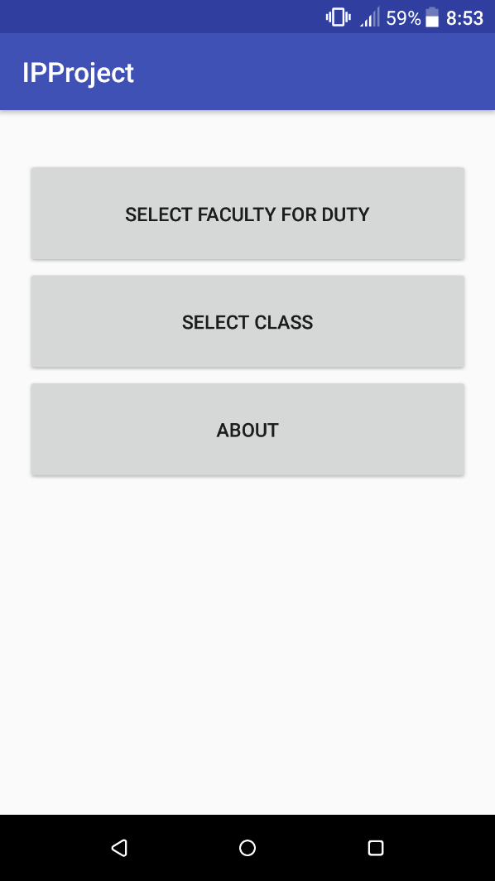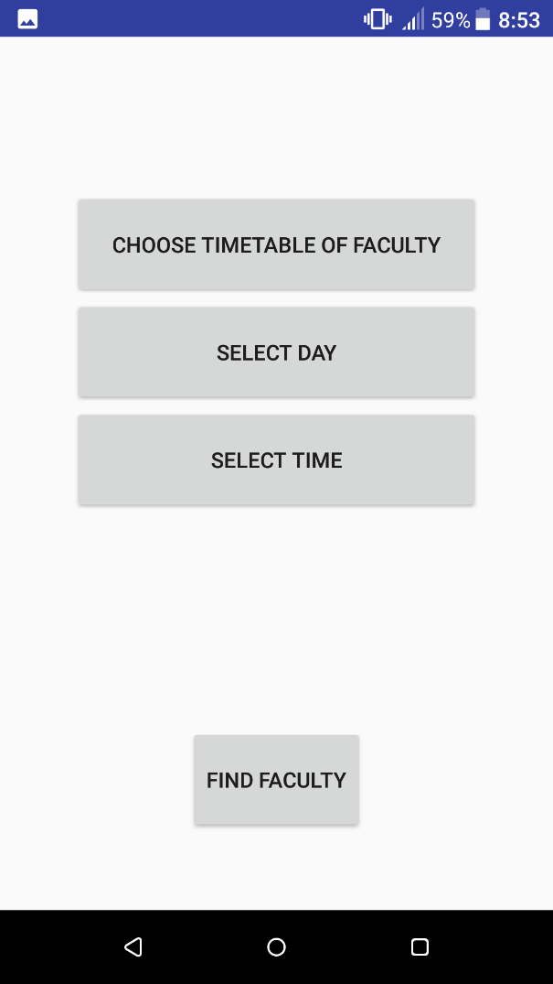

First Activity Next Activity

Next Activity Gives options to choose PDF of faculty and day, time then result is calculated using find faculty button.

**PROGRAM’S STRUCTUREAND GUI CONSTRUCTING**

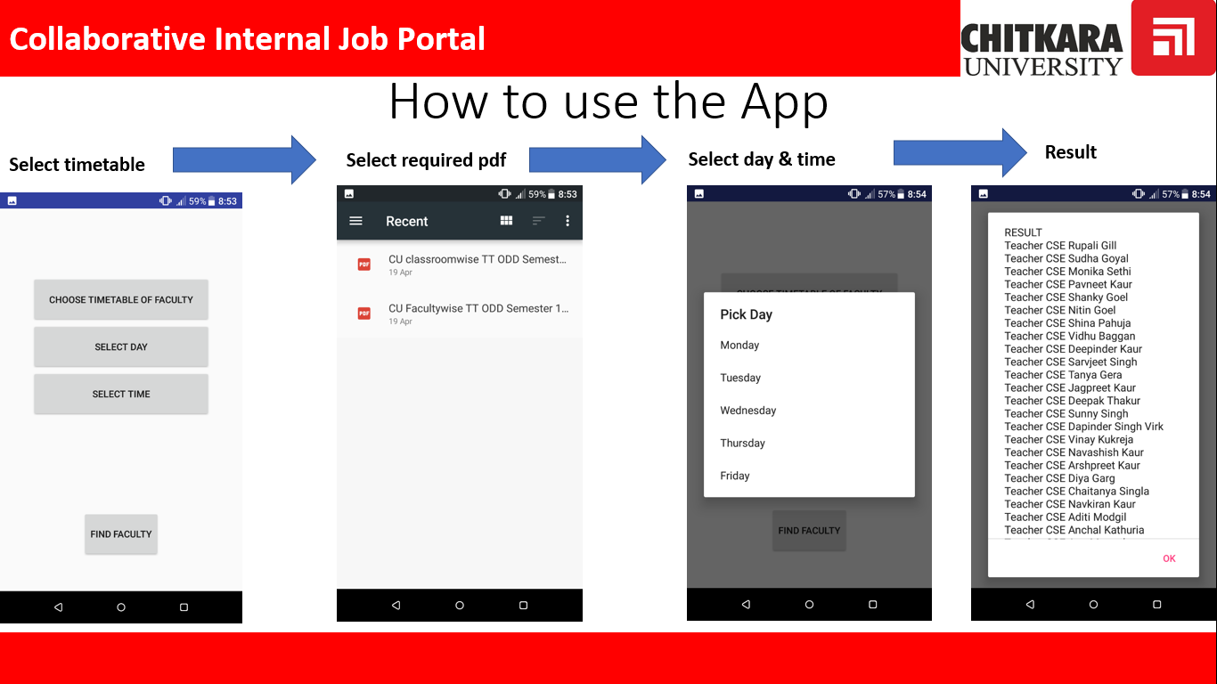

**CODE IMPLEMENTATION**

XML was used to design the interface

Java (Object Oriented Programming) is the primary language in Android Studio. The app implements multithreading without which it would not have been possible to make a stable app. Over 15 different android libraries were imported which shows how complex the code works.

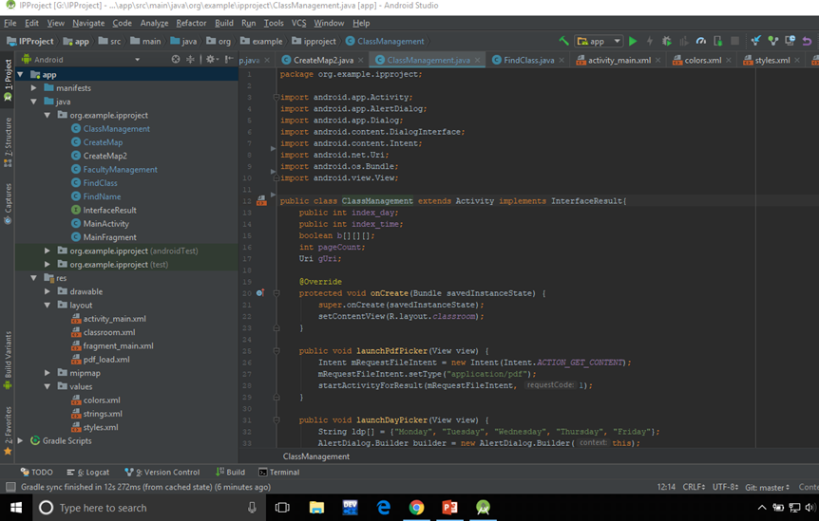

**SYSTEM TESTING**

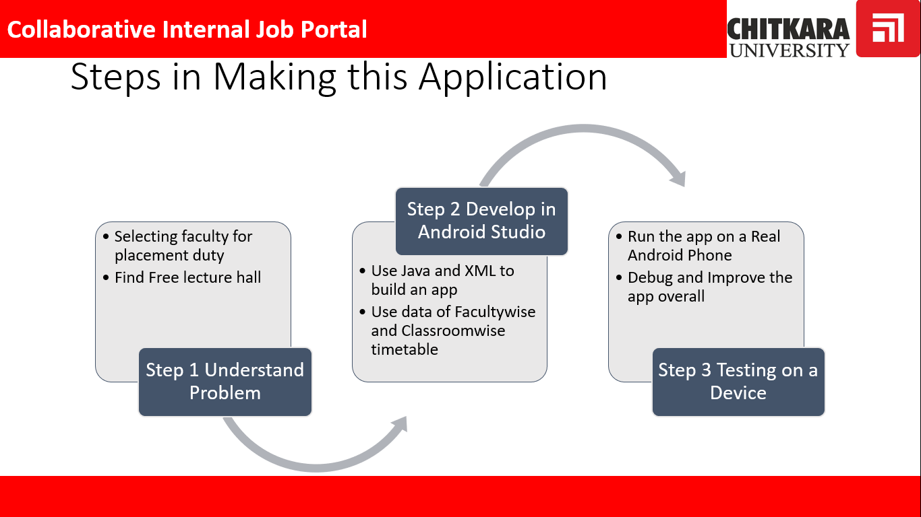

The Application was successfully tested on a Moto E4 plus, HTC A-one, Samsung j7 as well as on a Nexus Emulator.

**LIMITATIONS**

* Slow loading time
* Weak Presentation of data
* Worse Performance on slower devices
* Boring UI and UX

**CONCLUSION**

We were able to successfully create an app which achieved our core objective of Searching through the pdf to give helpful results. While core objectives were achieved much remains to be developed on the Design side of things as well as better way of presenting the extracted useful information.

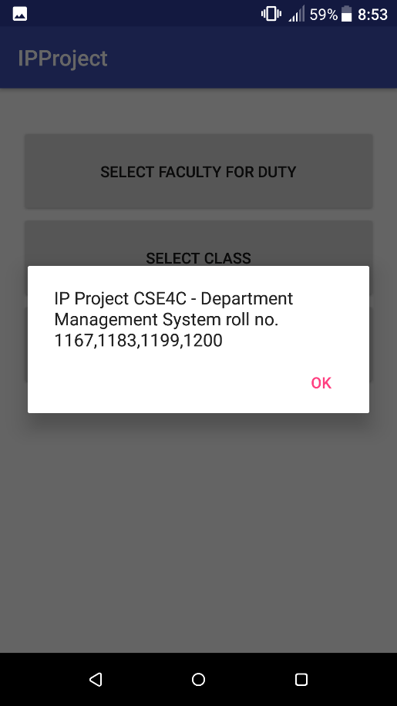

**FUTURE SCOPE**

* We can make it more efficient by highlighting teachers which have less number of working hours.
* We can use this app in our own University.
* Easy and handy to be used in every college.

**BIBLIOGRAPHY**

* developer.android.com
* www.android.com