**Software Design Specification**

**Document**

**Student Data Maintenance**

**Name: Ashish Kumar**

**Department: CSE**

**Version: 1** **Date: 03/29/2017**

**Table of Contents**

1 Introduction 1

1.1 System Overview 1

1.1.1 High level Description of system 1

1.1.2 System Issues 1

1.2 Definitions, Acronyms, and Abbreviations 1

1.3 References 1

1.4 Document Map 1

2 Design Considerations 3

2.1 Assumptions 3

2.2 Constraints 3

2.3 System Environment 3

2.4 Design Methodology 3

3 Architectural (High-level) Design 4

3.1 Overview 4

3.2 Conceptual (or Logical) View 4

4 Low Level Design 5

4.1 Component 1: Class Diagram 5

5 User Interface Design 6

5.1 Application Control 6

5.2 Screen 1: USER INTERFACE_MAIN 6

5.3 Screen 2: ADD_RECORD 6

5.4 Screen3:DELETE_RECORD 7

5.5 Screen4:QUERY_RECORD 7

5.6 Screen5:SHOW_ALL 8

# Introduction

## System Overview

### High level Description of system

The objectives of the project are:

To develop PHP script(s) for maintaining student details (roll no, first name, last name, department, email, geneder) in a small engineering college. The maintenance includes following operations: add, modify, delete and query. Student records can be added with manual entries as well as file uploads, however roll no should be automatically generated. Roll no must be with 11 characters: CSE2013-**nnn** where **nnn** is  a running serial number starting from 1 (start) to 30 (max) and to save records either in file or in MySQL database.

### System Issues

1. Linking Error.
2. Database failure
3. Power Failure

## Definitions, Acronyms, and Abbreviations

* Class:- Class is the prototype for creating object.
* Object:- It is an instance of a class.
* Php:- It is a server side scripting language used for designing back-end of websites.
* MySql:- It is a database language used for storing records in forms of table.
* Html:- A front-end language used for designing User Interface for the websites.

## References

1. Spoken- tutorial video lectures on php and mysql.
2. Tutorial points notes on php.

## Document Map

Following are the major sections of this document:

* Assumptions: It describes any assumption, background, or dependencies of the software, its use, the operational environment, or significant project issues
* Constraints: Describe any constraints on the system that have a significant impact on the design of the system.
* System Environment: It describes the hardware and software that the system must operate in and interact with.
* Design methodology: It Summarize the approach that will be used to create and evolve the design for this system.
* Logical view: It provides and describes a diagram that shows the various components and how they are connected.
* Low level design: It provides the low-level design for each of the system components identified in the logical view.
* User Interface: it illustrates all major user-interface screens and describes the behavior and state changes that the user will experience.

# Design Considerations

## Assumptions

Following are some assumptions for our project:

* Xampp Server is pre-installed in the system.
* Apache server is properly running.
* MySql services are propelry running.
* Other Environmental variables need to run the program is set properly.

## Constraints

Following are some constraints for our system:

* The System should be able to handle invalid and blank file uploads.
* The System should be able to generate Roll Numbers automatically.
* The System should be able to update roll numbers after a delete operation.
* No two students should be alloted same Roll numbers.

## System Environment

|  |  |
| --- | --- |
| **Hardware/Software** | **Specifications** |
| Operating System | Windows 8.1 |
| Hard Disk | 100 GB |
| Processor | Intel Pentium-1 |
| RAM | 1 GB |
| Softwares | Xampp,notepad++ |

## Design Methodology

We are using Object Oriented design methodology where there is a class for Add record, Query Record, Delete Record and Modify Record.

# Architectural (High-level) Design

## Overview

The whole system consists of a single php script. It contains a User Interface for the Add record, Query Record, Update Record and Delete Record. After deletion of a record, Roll Numbers are modified automatically. Also it has functionality of automatic Roll Number generation.

## Conceptual (or Logical) View

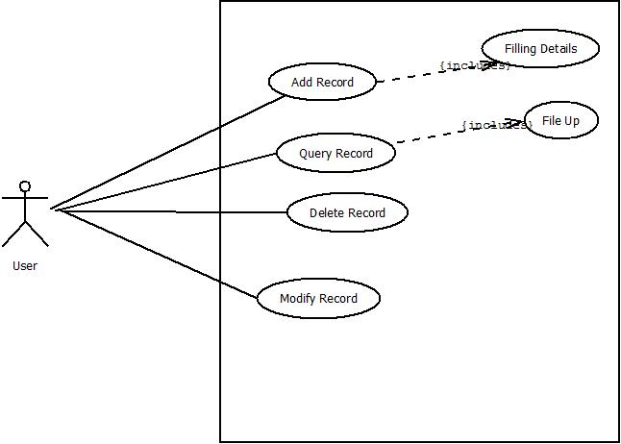

Figure 1: Use Case Diagram

This is the Use case Diagram showing all the use cases for users. i.e. It shows what are the functionalities a user can get from the software.

# Low Level Design

## Component 1: Class Diagram

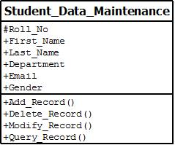

Figure 2: Class Diagram

There is a single class which contains all the functions required for our project.

# User Interface Design

## Application Control

After opening the url, It will show the UI showing all the options. Then one can eaisly perform all operations just clicking the buttons and filling up the details whenever asked.

## Screen 1: USER INTERFACE_MAIN

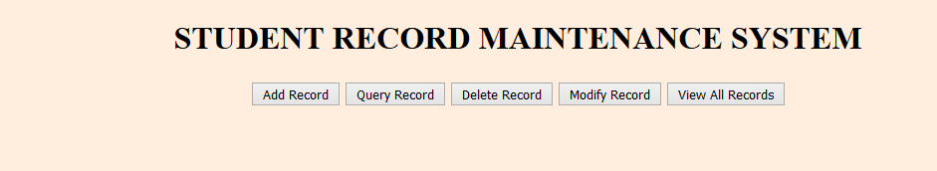

Figure 3:UI_HOME

## Screen 2: ADD_RECORD

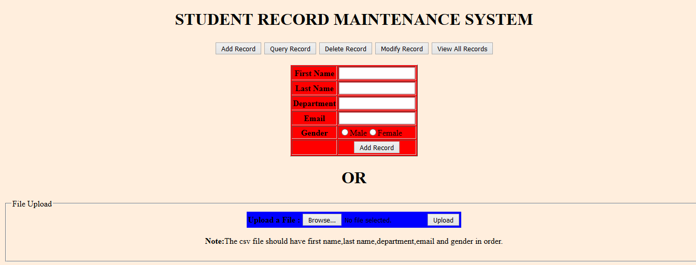

Figure 4:ADD_RECORD

## Screen3:DELETE_RECORD

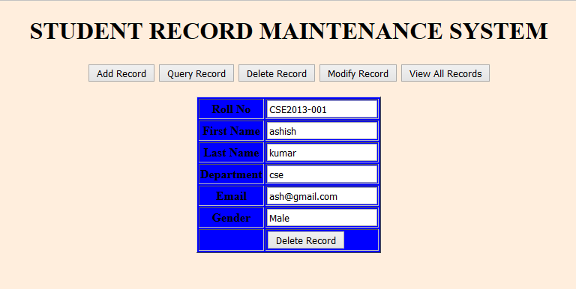

Figure 5:Delete_Record

## Screen4:QUERY_RECORD

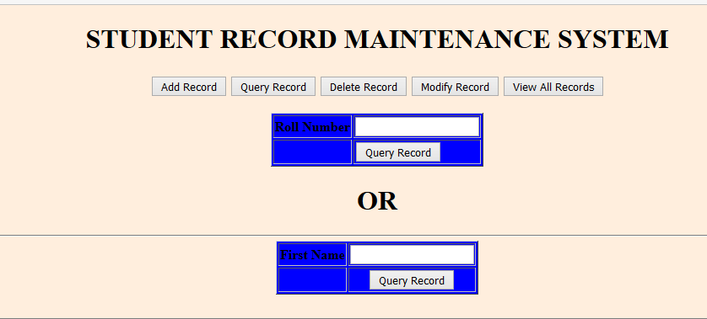

Figure 6:Query_Record

## Screen5:SHOW_ALL

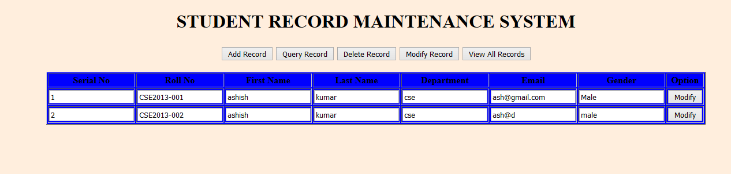

Figure 7:Show All