Introduction and Software Requirements for HTML/Javascript PHP Programs

- What are the softwares that helps to run java programs?
- JDK:
The Java Development Kit is used to develop, compile and run Java programs.
- JRE:
The Java Runtime Environment provides the environment needed to run Java programs.
- JVM:
The Java Virtual Machine executes Java bytecode and allows Java programs to run on different operating systems.
- IDE:
The Integrated Development Environment are softwares such as NetBeans, Eclipse, and IntelliJ IDEA that makes writing, compiling, and running Java programs easier.
- What is JDK and JRE?
- JDK:
Java Development Kit. It is a software package used to develop, compile, and run Java programs. It includes tools like the Java compiler and JRE.
- JRE:
Java Runtime Environment. It is a software package used to run Java programs. It provides the JVM and other required libraries.

- What is eclipse IDE?
Eclipse IDE is a software application used to write, compile, debug, and run Java programs. It provides tools that make Java programming easier and more efficient.

- How to run the java program in eclipse/netbeans IDE?
- Open Eclipse/NetBeans and create a Java Project.
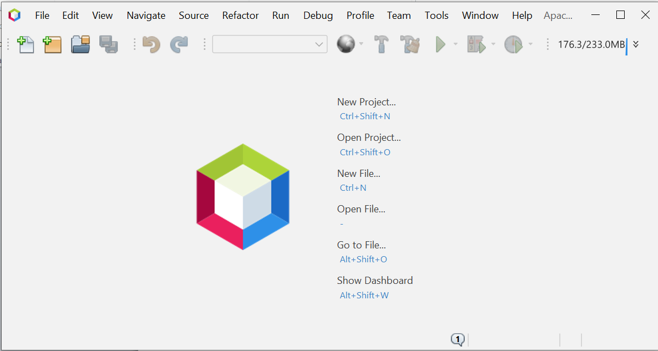
- Create a Java Class with the main() method.

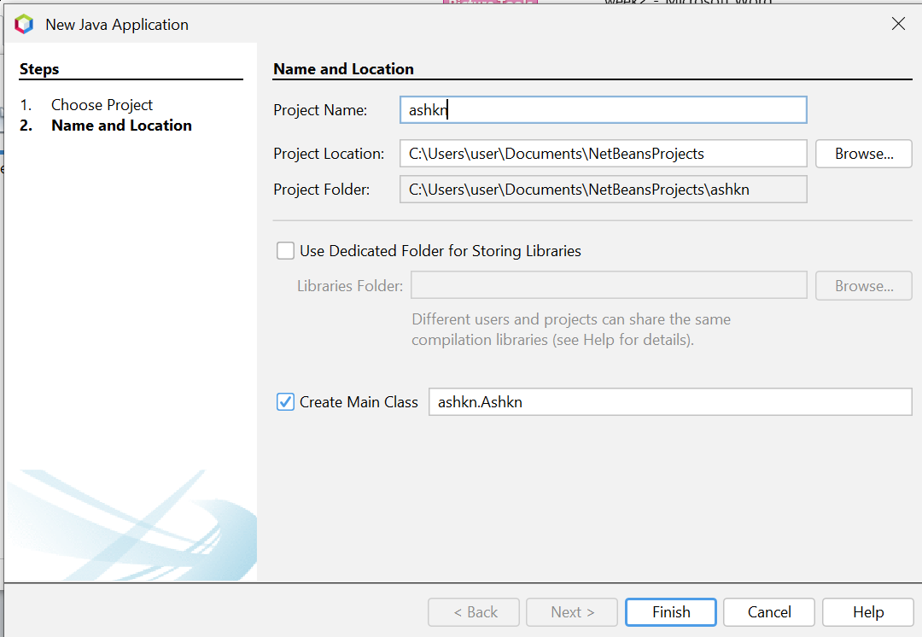

- Write the Java program and save it.
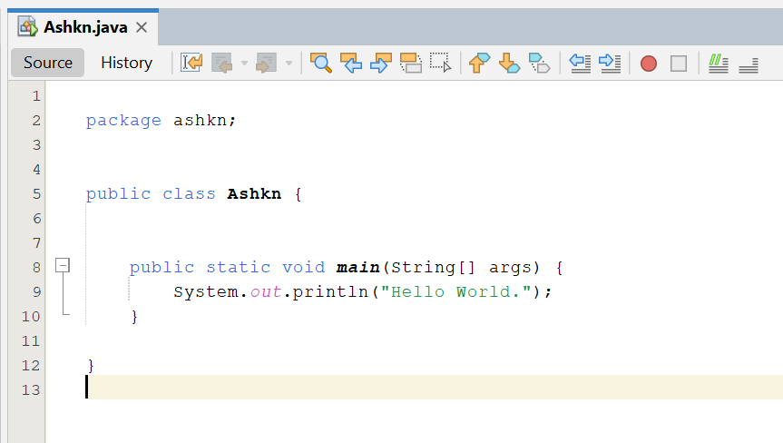

- Click Run or press Ctrl + F11.

- The program output will be displayed in the Console window.
