Readme for Radar Project

Points against each Rubric Points:

1. FMCW Waveform Design: slope is 2.0455e+13
2. Simulation Loop: Initial Range is set as 100 and velocity is set as -20 . The 1D FFT implementation clearly show peaks corresponding to 100
3. Range FFT: See the result below

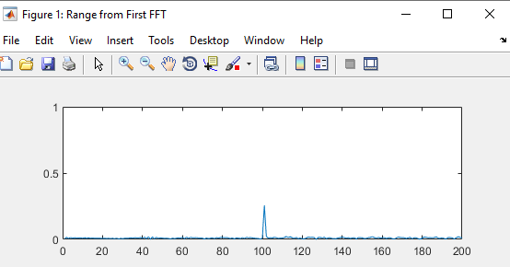

1. 2D CFAR : Output matches the one showed in walk through
2. 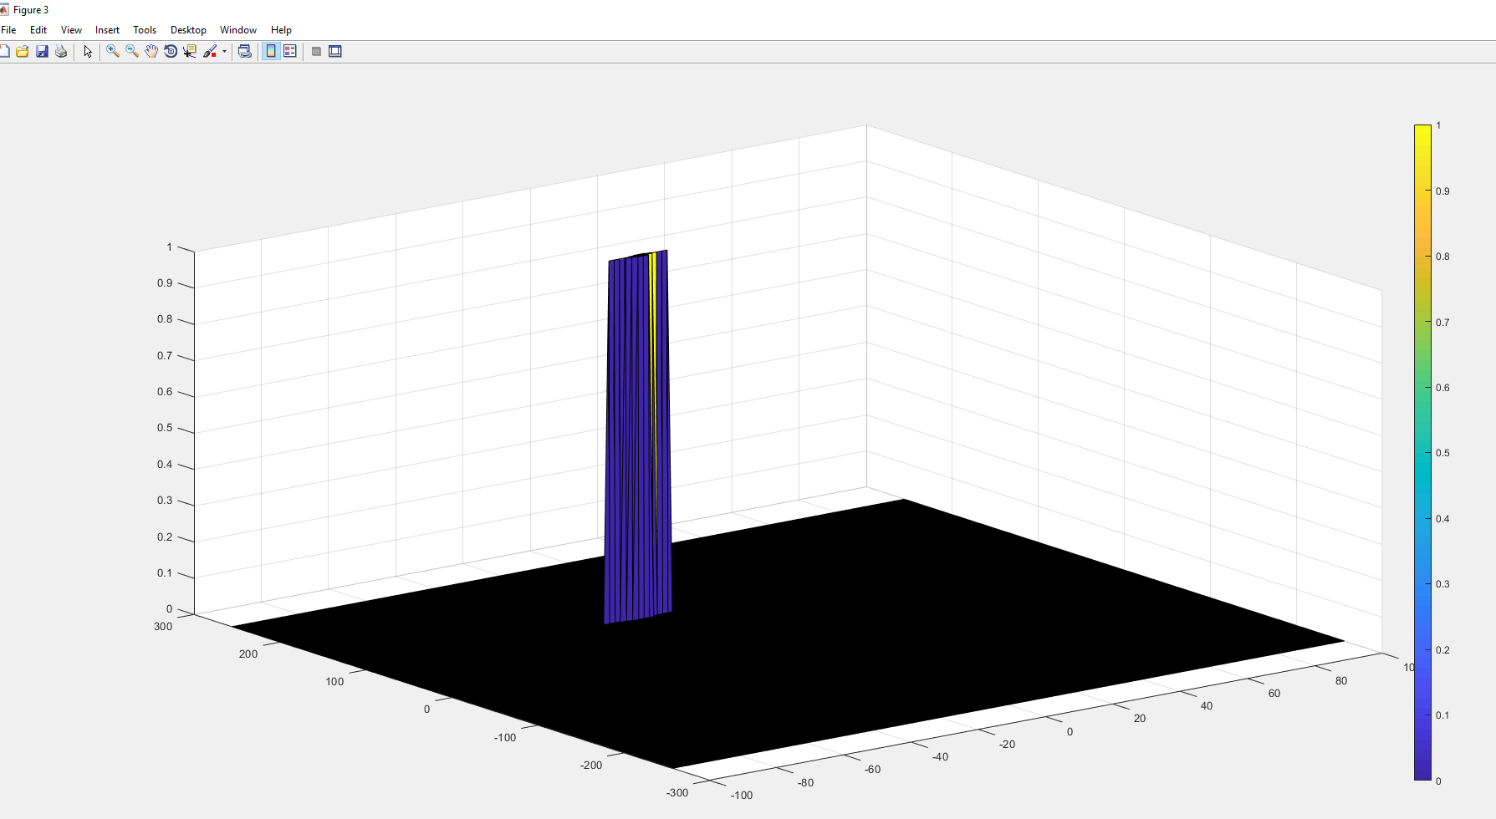

CFAR README:

1. First I created three matrices with the same size as RDM. – noise_levels, threshold and RDM_out and initiated them to zero. Then I used two for loops to iterate through the RDM cells to get the Cell under test, then through the next set of for loop we iterate through all the cells in the Grid. Through an if condition we avoid the Guard cells and cell under test. Then we add all the noise power at all training cells to get the combined noise power and store it to the variable noise_level at the same index as cell under test. Then we compute the threshold for that index. After that we compare the threshold with RDM, to compute RDM_out. Care is taken to convert Power to dBm and vice versa.
2. Offset is selected based on the general SNR of the output. The Training cells are chosen considering that we currently have only one target. Since we didn’t specify any loss on the return signal amplitude, the guard cells are chosen considering that we are getting strong reflection.
3. The non threshold cells were set to zero by default since I used a separate variable to store the output, the initialization of the output (RDM_out) was set to zero.