**Implement OOPS using JAVA with Data Structures and Beyond**

**Assignment**

**Output screenshots:**

**Welcome screen ----**

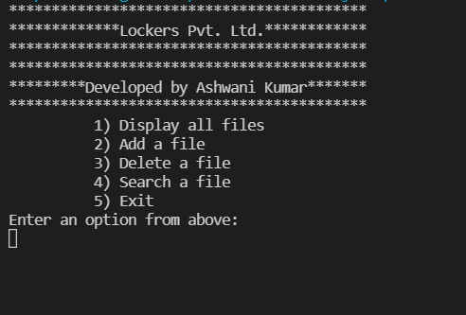

**Option 1: Displaying all files/folders ---**

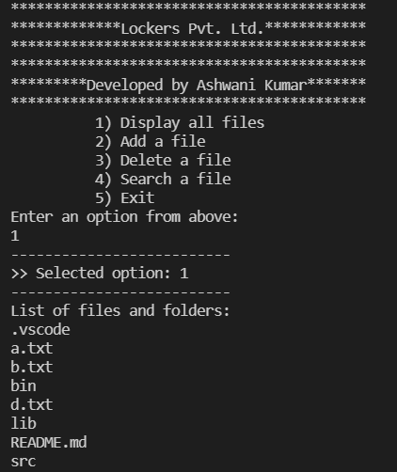

**Option 2: Add a file ---**

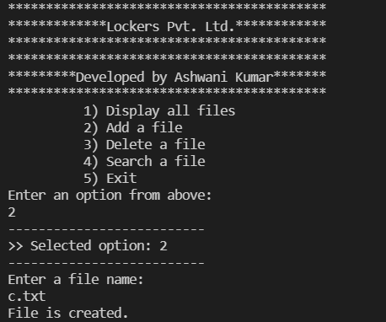

**--- Displaying the file c.txt in the folder ---**

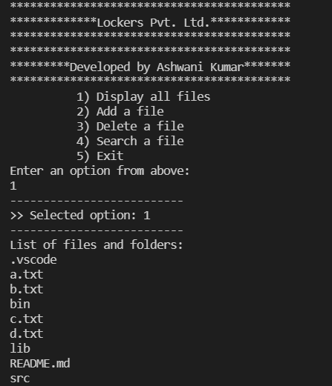

**Option 3: Delete a file ---**

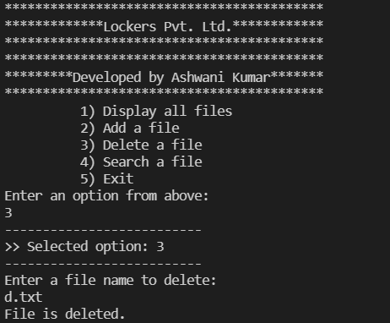

**--- Displaying the files/folders to show that d.txt is deleted ---**

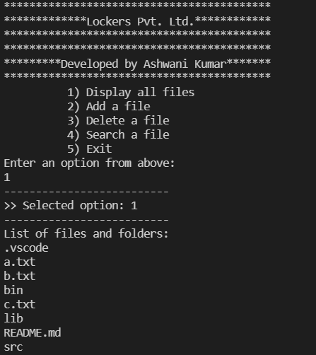

**--- Deleting a file which does not exist in the folder to show the result ---**

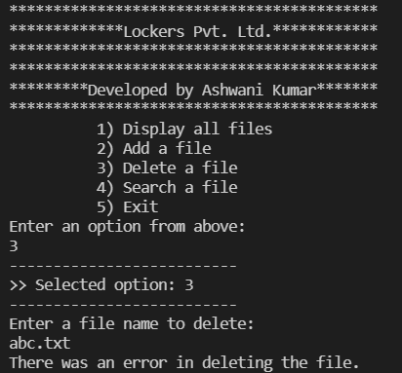

**Option 4: Search for a file ---**

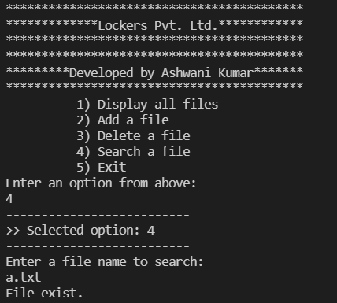

**--- Search for a file that does not exist in the folder ---**

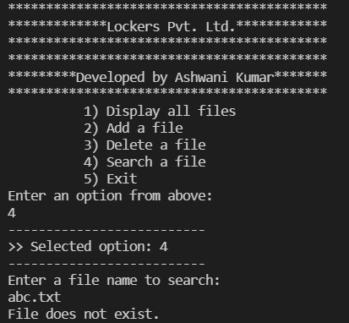

**Option 5: Exit ---**

