

Results in Engineering 28 (2025) 107529
Contents lists available at ScienceDirect

Results in Engineering

journal homepage: www.sciencedirect.com/journal/results-in-engineering


Research paper
Enhanced crop yield prediction using a hybrid artificial neural network with coati optimization algorithm
T K Nida Fariz ª, S Sharief Basha ^{b,*}
ª Department of Mathematics, School of Advanced Science, Vellore Institute of Technology, Vellore, Tamil Nadu, 632014, India
^{b} Department of Analytics, School of Computer Science and Engineering, Vellore Institute of Technology, Vellore, Tamil Nadu, 632014, India

A R T I C L E I N F O

Keywords:
Crop yield
Artificial neural network Coati optimization algorithm Levy Flight
Predictive model
A B S T R A C T

Climate change and variability exacerbate global food insecurity, necessitating advanced predictive models for crop yield forecasting. To address these challenges, an advanced predictive model for crop yield forecasting was developed, aiming to mitigate global food security concerns amidst rapid population growth. The study focuses on ten widely cultivated crops across 102 countries. These crops include: Cassava, Maize, Plantains, Potatoes, Rice (Paddy), Sorghum, Soybeans, Sweet Potatoes, Yam, and Wheat. To achieve this, a hybrid system, ANN-COA, was created, combining Artificial Neural Networks (ANN) and the Levy flight-enhanced Coati Optimization Algorithm (COA). The model incorporates weather conditions, pesticide use, and historical yield data. We trained ANN-COA using 70% of available data and evaluated it with the remaining 30 %. The model’s accuracy was assessed using statistical benchmarks and compared against ANN, ANN-PSO, ANN-GWO, and ANN-WOA models. ANN-COA outperformed other models, achieving optimal metrics with RMSE (14,338.6), MAE (8685.3), MAPE (0.06803), and R² (0.97296) for crop yield prediction. The results indicate improved accuracy and reliability in forecasting crop yields compared to existing models. The Levy flight-enhanced ANN-COA hybrid represents a sophisticated system for optimizing crop yield forecasting with enhanced predictive capabilities that can improve resource efficiency and crop management. This study demonstrates machine learning’s potential in addressing global agricultural challenges and enhancing food security strategies, with broad applicability in agricultural planning and policy-making.

Introduction

Accurate forecasting of agricultural output is vital for ensuring global food security. It supports governmental decisions regarding import and exports and assists producers in effective planning [1]. Although harvest forecasting plays a key role in agricultural decision-making, it remains a complex task due to the multitude of influencing variables [2]. It also aids in policy-making and identifies key productivity factors [3]. While traditionally based on farmers’ intuition [4], modern forecasting helps address knowledge gaps as farmers diversify crops under changing conditions. Numerous factors affect agricultural productivity, including variables unique to each crop type, environmental factors, and farming practices. As a result, developing a dependable and interpretable model for predicting harvest outcomes presents significant challenges [5]. Ef- forts to address this complexity have led to the development of knowledge-based systems tailored to diverse agricultural operations [6], alongside the growing use of advanced computational and artificial
intelligence (AI) methods in the field [7].
Predicting agricultural output is a complex challenge that could significantly reduce uncertainties in food production. However, the multitude of variables affecting crop yields, including unexpected dis- ease outbreaks and natural calamities, makes accurate forecasting difficult. To address this pressing issue, innovative and adaptable methods are required to navigate the constantly changing agricultural landscape [8]. AI offers promising solutions by leveraging large datasets and identifying complex, nonlinear relationships among influencing variables [9]. By employing advanced AI techniques in crop yield pre- diction, it becomes possible to identify and model complex, nonlinear relationships among various factors, leading to more precise forecasts [10,11]. Methods such as ensemble machine learning models [12], regression analysis [13], statistical approaches [14], adaptive neuro-fuzzy inference systems (ANFIS) [15], and neural networks including deep learning models are commonly used [16]. These AI-driven approaches support precision agriculture and help ensure food

* Corresponding author.
E-mail addresses: nidafarizkhan18@gmail.com (T.K.N. Fariz), shariefbasha.s@vit.ac.in (S.S. Basha).

https://doi.org/10.1016/j.rineng.2025.107529
Received 2 May 2025; Received in revised form 4 September 2025; Accepted 29 September 2025
Available online 30 September 2025
2590-1230/© 2025 The Authors. Published by Elsevier B.V. This is an open access article under the CC BY license (http://creativecommons.org/licenses/by/4.0/).

security by enabling timely and informed decision-making [17].
In recent years, the agricultural sector has witnessed a significant surge in the application of machine learning (ML) techniques [18], particularly since the turn of the century. Among these, artificial neural networks (ANNs) have emerged as a powerful tool in addressing various agronomic challenges [19]. Notably, ANNs have demonstrated remarkable efficacy in tackling identification and classification prob- lems that are inherent to crop protection strategies [20]. Furthermore, these sophisticated algorithms have proven invaluable in automating harvest processes [21] and enhancing product quality sorting mecha- nisms [22].
ANNs offer solutions to problems previously requiring human intervention, aligning with core ML and AI objectives [23]. Their ap- plications extend beyond classification to regression analysis, enhancing empirical quantitative models [24]. This integration of ML in agronomy reflects the field’s interdisciplinary evolution and potential for addressing food production challenges [25]. Following success in healthcare [26], genetic [27], and language processing [28], ML is now transforming agriculture [29], providing farmers with innovative tools and strategies. Despite their popularity, ML and DL models struggle with data variation, adapting across seasons, and predicting extreme yield values [30].
Furthermore, traditional machine learning (ML) techniques face significant challenges in optimal feature selection and exhibit limited learning capacity from complex agricultural data patterns [31]. While ML and deep learning (DL) models demonstrate considerable potential for crop yield prediction, they encounter substantial obstacles including convergence to local optima, inadequate parameter optimization, and difficulty in handling high-dimensional agricultural datasets [32]. Research demonstrates that swarm-based optimization techniques offer significant advantages in both architectural design and parameter optimization of artificial neural networks [33]. These bio-inspired al- gorithms excel at intelligently configuring network topologies while simultaneously achieving superior performance in optimizing connec- tion weights and bias parameters compared to traditional gradient-based methods [34]. Building upon these advantages of swarm intelligence approaches, there remains a need for more sophisticated optimization strategies that can effectively navigate the complex parameter space of neural networks while addressing the specific chal- lenges inherent in agricultural yield prediction [35].
Building upon the demonstrated advantages of swarm intelligence approaches in optimization problems, there remains a critical need for more sophisticated optimization strategies that can effectively navigate the complex, high-dimensional parameter space of neural networks while addressing the specific challenges inherent in agricultural yield prediction, including non-linear relationships, temporal dependencies, and multi-variate interactions among climatic and agronomic factors. To address these limitations and advance the state-of-the-art in agricultural forecasting, this study proposes a novel hybrid framework that strate- gically integrates Artificial Neural Networks (ANNs) with an advanced meta-heuristic optimization technique. The proposed approach signifi- cantly enhances prediction accuracy by optimizing ANN weights and biases using the Levy flight-enhanced Coati Optimization Algorithm (COA), which incorporates adaptive stochastic processes to effectively balance exploitation and exploration phases for comprehensive solution space exploration. This innovative hybrid optimization technique sub- stantially improves agricultural forecasting effectiveness by systemati- cally avoiding local optima traps while maintaining computational efficiency, convergence stability, and model interpretability, critical factors for practical deployment in real-world agricultural decision- making systems.

Related work

Tripathi and Biswas [36] proposed a novel model called Precise Ensemble Expert System for Crop Yield Prediction (PEESCYP). Their
approach integrates several advanced techniques to enhance crop yield prediction accuracy. The model employs Multiple Imputation by Chained Equation (MICE) to handle missing data, Isolation Forest (IF) for outlier detection, Ant Colony Optimization (ACO) for feature selec- tion, and Robust Scaling (RS) for data normalization. To address vari- ance and overfitting issues commonly encountered in single classifiers, the authors implemented an Extra Tree (ET) classifier. This compre- hensive approach aims to overcome various challenges in crop yield prediction, combining data preprocessing, feature engineering, and ensemble learning methods.
Patidar et al. [37] investigated crop yield prediction using various machine learning techniques. Their study focused on the importance of accurate yield forecasting in agriculture, particularly for India. The re- searchers considered multiple parameters including temperature, rain- fall, fertilizer usage, historical production data, and economic factors like minimum support price. They compared several predictive models such as Gradient Boosting Regression, Support Vector Regression, De- cision Tree, Random Forest, and Linear Regression. Their findings indicated that Linear Regression provided the best performance for crop yield prediction.
Parganiha and Verma [38] developed an innovative approach for soil analysis and crop yield prediction in smart agriculture. Their method integrates advanced data preprocessing techniques with a novel feature selection process using the Aquila-based adaptive optimization algo- rithm. The core of their model is an improved lightweight gradient-boosting machine, optimized using the Battle Royale tech- nique. This combination resulted in a highly accurate system, achieving 97 % accuracy in crop yield prediction. Their work demonstrates the potential of combining optimization algorithms with machine learning for enhancing agricultural decision-making and improving crop pro- duction efficiency.
Dhaliwal and Williams [39] conducted a comprehensive study using a historic US sweet corn dataset spanning over 25 years (19922018) from major commercial production regions. Their random forest model achieved the best performance with an RMSE of 3.29 Mt/ha and a cor- relation coefficient of 0.77. They identified year, location, and seed source as the most influential predictors, along with key weather vari- ables. This work demonstrates the potential of advanced analytics in commercial sweet corn production.
Haider et al. [40] developed an ensemble machine learning frame- work for cotton yield prediction in Pakistan. Their Random Forest Extreme Gradient (RFXG) model, using 15 years of weather and field data, achieved an RMSE of 0.05, outperforming traditional methods. This study highlights the potential of ensemble techniques in improving crop yield forecasting for weather-dependent agriculture.
Zhou et al. [41] utilized unmanned aerial vehicle (UAV) multispec- tral data combined with deep learning models such as the two-dimensional convolutional neural network (CNN-M2D), demon- strating superior performance in rice yield prediction compared to traditional methods.
Recent studies have focused on leveraging hybrid models to improve prediction accuracy. Oikonomidis et al. [42] utilized a comprehensive public soybean dataset, and their results demonstrated that the CNN-DNN hybrid model outperformed all other models, including traditional approaches. These findings highlight the potential of hybrid deep learning models to capture complex, non-linear patterns in agri- cultural data, thereby enabling more accurate yield predictions. Gaso et al. [43] utilized approximately 700,000 soybean yield data points collected from Sentinel-2 imagery, weather, and topographic inputs across 310 fields during 2020–2022. Among the deep learning models (1D-CNN, LSTM, and Transformer), all outperformed the baseline in spatial prediction, with 1D-CNN showing enhanced accuracy when combined with topographic features.
Nismi Mol et al. [44] developed a framework for extracting agri- cultural entities from unstructured textual documents by integrating dictionary-based, rule-based, and transformer-based deep learning

techniques. Their BERT-based transformer model combined with Con- ditional Random Field (CRF) achieved the highest performance, demonstrating superior precision, recall, and F1-score.
Satpathi et al. [45] utilized 22 years of data from Uttar Pradesh to predict sugarcane yield. Various methods were evaluated, including traditional regression (MLR), penalized regression models (LASSO, Ridge, Elastic Net), and machine learning techniques (XGB, RF, SVR, ANN). Among these, the Artificial Neural Network (ANN) demonstrated the highest accuracy and proved to be the most reliable for sugarcane yield forecasting.
Machine learning in crop yield prediction faces various challenges. While algorithms like kNN, Decision Trees, SVM, and Random Forest each have strengths, they also have limitations in handling agricultural data. These range from scaling issues to processing time constraints and overfitting problems. Recent studies highlight the potential of combining meta-heuristic optimization with deep learning models to improve crop yield prediction accuracy. This integrated approach aims to overcome limitations of traditional forecasting methods, enhancing overall performance in agricultural applications [46–52]. In this study, we propose a novel approach combining ANN with the Levy flight-enhanced COA for crop yield prediction. This integration lever- ages the improved global search capability of the Levy flight-enhanced COA to optimize the ANN’s performance on large, nonlinear agricul- tural datasets.

Materials and methods

  - Data collection

The Food and Agriculture Organization of the United Nations (FAOSTAT) maintains a comprehensive database on agricultural and food-related information. This particular dataset encompasses 102 na- tions and includes several key variables: the specific agricultural prod- uct, country of origin, crop yield, precipitation levels, pesticide usage, and temperature readings. The information spans from 2000 to 2013, providing annual data on countries, agricultural items, and their cor- responding yields. Fig. 1 illustrates the global distribution of crop yield data for the years 2000 and 2013, providing a visual representation of agricultural productivity across different regions of the world during this period.
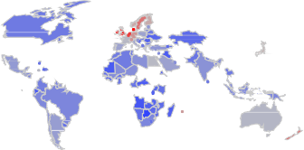
Agricultural productivity is significantly influenced by climatic conditions, with rainfall and temperature playing crucial roles. Addi- tionally, environmental factors such as pesticide application impact crop development. The pesticide data for each agricultural product was sourced from the FAO’s data repository.
  - Data preprocessing

After acquiring publicly accessible data from repositories, the initial step involves data cleansing. Following this process, categorical vari- ables such as country and specific crop types are transformed into nu- merical values through label encoding. The resulting dataset is anticipated to comprise the following key features: encoded crop and country identifiers, year of production, yield measurements, average precipitation, pesticide usage, and mean temperature. Fig. 2 presents a box plot illustrating the distribution of yield across different crop variety.
The final dataset includes the following attributes:

- Nation: The nation where the crop is cultivated
- Crop_Type: The specific agricultural product
- Production_Year: The year in which the crop was grown
- Yield_hg/ha (Hectograms per Hectare): Annual crop output for each
country
- Mean_Annual_Rainfall (mm): The average precipitation recorded for that year
- Pesticide_Application (Tonnes): The quantity of pesticides utilized for the crop in that year
- Average_Temperature: The mean temperature documented for the year.

The final dataset is compiled by integrating information from two distinct sources: the FAO database and the World Data Bank. To examine the relationships between various features, a correlation matrix is con- structed and visualized as a heatmap in Fig. 3. This visualization clearly demonstrates that there are no significant correlations between vari- ables, suggesting that all features are independent of one another.
Table 1 provides a statistical summary of the factors influencing global agricultural productivity. While weather conditions determine rainfall and temperature, the use of pesticides is primarily influenced by farming practices. The dataset reveals an average yield of 82,952.27, with a standard deviation nearly equivalent to the mean, indicating substantial variability in yield across the data. Fig. 4 illustrates the yield trends of various crop types across different countries from 2000 to 2013, providing a comparative view of agricultural productivity on a global scale.

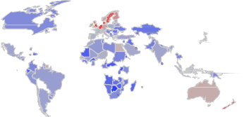
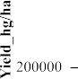
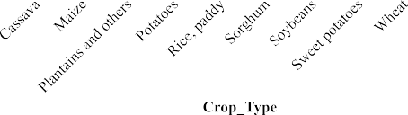
Fig. 1. Geographical distribution of global crop yields in 2000 and 2013. Fig. 2. Box plot of yield distribution by crop type.

computational framework [54]. The algorithm operates in two phases, reflecting:

- Coati attack strategies on iguanas
- Coati predator evasion methods

3.3.2. Stage 1: coati attack strategies on iguanas
The initial phase of updating coati populations in the search area is modeled after their iguana hunting behavior. This involves a coordi- nated attack where some coatis climb trees to startle the iguana, while others wait below to ambush it. This strategy represents the algorithm’s ability to explore various locations within the search space
In the COA framework, the iguana represents the optimal solution within the population. The model assumes that half of the coati group climbs the tree, while the other half remains on the ground, anticipating the iguana’s descent. To simulate the position of coatis as they leave the tree branches, Eq. (2) is utilized.
m
nωm

X^{C}1 : x^{C}1 ↑ x
Fig. 3. Heat map of the correlation matrix for the yield variable.
n
nωm
nωm
↔ rand.)Iguana
— F.x
[ω n ↑ 1ω 2ω ...ω I &m ↑ 1ω 2ω ...ω j

(2)

Within the dataset, two columns (Crop_Type and Nation) contain categorical information. It’s important to note that these categorical variables inherently lack correlation with other variables. However, many machine learning algorithms require all input and output vari- ables to be numerical, as they are not designed to process labeled data directly. Consequently, it becomes necessary to convert these categori- cal data into numerical values for further analysis.
2
To prepare the data for analysis, we employed the min-max normalization technique. This process scales all variables to a common
The iguana is modeled as falling to the ground and relocating to a random position within the search space. In response, the ground-level coatis move through the search area, a behavior simulated using Eqs.
(3) and (4). These equations govern the coatis’ exploration based on the iguana’s new random location.
Iguana^{N} : Iguana^{N} ↑ lb_{m} ↔ rand.↗ub_{m} ↓ lb_{m}↘ω m ↑ 1ω 2..ω j (3)
m
] x_{nωm} ↔ rand.)Iguana^{N} ↓ F.x_{nωm}[ω U_{Iguana}N ϑ U_{n}ω
↑
m

range between 0 and 1, ensuring that no single feature dominates the others due to differences in scale or units of measurement.
ω ↔
n nωm
xnωm
↔rand.↗x

nωm
m
XC1 : xC1
— Iguana^{N} ω elseω

X ↓ X_{min}
X ↑
(1)
for n ↑ I ↔ 1 I 2ω ...ω I & m ↑ 1ω 2ω ...ω j (4)

Scaled
Xmax ↓ Xmin 2 2

In Eq. (1), X_{Scaled} represents the normalized value, X is the original value, and X_{min} and X_{max} denote the minimum and maximum values in the dataset, respectively [53].
The dataset, after preprocessing, is split into two segments: a larger portion for training and a smaller one for testing. Specifically, 70 % of the data is allocated to the training set, while the remaining 30 % is reserved for testing purposes. The training dataset serves as the foun- dation for machine learning algorithms to learn patterns and relation- ships, enabling them to make accurate predictions. In contrast, the test dataset is utilized to evaluate the effectiveness of the trained algorithm, assessing how well it generalizes to new, unseen data based on what it learned from the training set.

  - Proposed algorithm

    - Overview of COA
The Coati Optimization Algorithm (COA), introduced by Dehghani in 2023, is a population-based optimization method inspired by coati behavior. It mimics coatis’ intelligent hunting strategies and predator evasion tactics, translating these natural problem-solving abilities into a
Conversely, if the objective function value improves at a coati’s new position, it maintains that location. This condition is deemed suitable for the updating process. The algorithm simulates this update for n↑ 1 to K
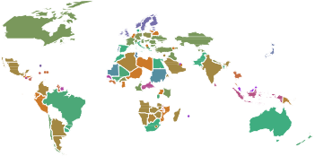
using Eq. (5).
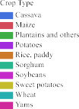
Fig. 4. Yield of different crop types across countries from 2000 to 2013.

Table 1
Statistical Analysis of Crop Yield Determinants.
 | Yield_hg/ha | Mean_Annual_Rainfall | Pesticide_Application | Average_Temperature
Mean | 82,952.27 | 82,952.27 | 42,889.53 | 20.62131
Std | 90,851.58 | 90,851.58 | 73,903.35 | 6.326479
min | 100 | 51 | 0.3 | 1.3
25 % | 22,076 | 593 | 1670 | 16.73
50 % | 41,581.5 | 1083 | 17,278.65 | 21.55
75 % | 113,272 | 1668 | 45,620 | 26.13
max | 501,412 | 3240 | 367,778 | 30.65

X_{n} ↑

C1 C1
n n
] X ω U ϑ U_{n}
X_{n}ω else

(5)

that closely mimic various natural and artificial processes [55].

3.3.5. Enhanced coati optimization algorithm

In this context, X^{C}1 denotes the n^{th} coati’s updated position, while
n
x^{C}1 represents its m^{th} dimensional component. U^{C}1 signifies the objec-
To achieve a balance between exploration and exploitation in met- aheuristic methods, we can employ the Levy Flight (LF) approach to

nωm n

tive function’s value, and Iguana_{m} corresponds to its m^{th} dimension. F is a randomly selected integer {1,2}. Iguana^{N} symbolizes the iguana’s randomly determined ground position, with Iguana^{N} indicating its m^{th} dimensional aspect. The floor function, which yields the largest integer not exceeding a given value, is represented by m.
m

    - Stage 2: coati predator evasion methods
The algorithm’s second phase emulates coatis’ predator evasion tactics, enhancing local search capabilities. This stage refines the posi- tions within the search space, mirroring how coatis seek nearby safe spots when threatened. The process is mathematically represented by mathematical Eqs. (6) and (7) that generate new positions close to each coati’s current location. This approach balances broad exploration with targeted local optimization, effectively mimicking coatis’ survival stra-
tegies. By doing so, the algorithm can fine-tune solutions in promising

update the search agent’s position [56]. This is expressed in Eq. (12) as:
X^{LF} ↑ X_{n} ↔ rand ⇓ LF↗β↘ (12)
n
Where X^{LF} represents the updated position of the nth search agent, denotes element-wise multiplication, and LF(p) is the Levy Flight func- tion with parameter p.
n
To generate a new candidate solution, we modify the position of the n^{th} coati using Eq. (13) Levy Flight process:
X^{LF} ↑ X⇔ ↔ rand ⇓ LF↗β↘ (13)
n n
Where X⇔ is the current best solution.
n
The selection of the new position is then determined by the Eq. (14):
] X^{LF} fitness)X^{LF}[ ϱ fitness)X⇔[
Xl↔1 ↑
n
n
X⇔ othewise
n
(14)
n
n

areas of the search space, potentially uncovering improved positions.
LB^{l} ↑ LBmω UB^{l} ↑ UBm ω where r ↑ 1ω 2ω ...R (6)
m r m r
The Levy Flight method has a high probability of escaping local optima and finding improved solutions due to its random nature. Fig. 5 illustrates the workflow of the enhanced COA algorithm. The step sizes
in this process follow a Levy distribution, allowing for both small and

XC2 : xC2
↑ x_{nωm} ↔ ↗1 ↓ 2.ran↘⌊LB^{l} ↔ ran.⌊UB^{l} ↓ LB^{l}⌋⌋ω
occasionally large jumps in the solution space. To maintain the pop-

n nωm j j j
n ↑ 1ω 2ω ...Iω m ↑ 1ω 2ω ...j
(7)
ulation’s quality, we retain the fittest individuals in the community. This approach ensures a balance between exploring new areas of the solution

This approach is considered valid when the recalculated position leads to an improvement in the target function’s value. The process is modeled in the given scenario using the Eq. (8).
]
X^{C}2 ω U^{C}2 ϑ U
X_{n} ↑
n
n
n
(8)
X_{n}ω else
The process of determining the updated position for the nth coati is denoted by X^{C}2 . Within this notation, x^{C}2 signifies the m^{th} dimensional component. The localized maximum and minimum boundaries for the m^{th} decision variable are represented by LB^{l} and UB^{l} , respectively.
m
m
n nωm

    - Levy flight (LF)
The application of Levy statistical information has become increas- ingly prevalent in describing a diverse range of biological and artificial phenomena. The Levy Flight (LF) is characterized by step lengths that follow a probability distribution known as the Levy stable distribution. This distribution is typically non-Gaussian, shown in Eq (9).
LF↗β↘ ≃ f ↑ l^{1↓β}ω 0 ϑ β ⇐ 2 (9)
In this formulation, p serves as a critical parameter called the Levy index, which controls the distribution’s stability.
To generate random numbers following the Levy distribution, one can employ by Eq. (10):
space and exploiting known good solutions. This adaptive approach enhances the Coati Optimization Algorithm’s ability to balance global exploration and local exploitation, potentially leading to more effective optimization outcomes.

  - Particle swarm optimization

The Particle Swarm Optimization (PSO), originally conceived by J. Kennedy [57], represents a fundamental advancement in swarm intel- ligence methodologies, operating as a prominent member of the evolu- tionary computation family. The algorithm draws its conceptual foundation from the collective behavior observed in biological systems, where individual agents (particles) emulate the flocking patterns of birds navigating toward optimal food sources. In this computational paradigm, each particle’s spatial coordinates define potential solution vectors within the search space, while their velocity parameters deter- mine the adaptive progression rates toward superior solutions through iterative refinement processes. The practical effectiveness of this bio-inspired approach has been validated in neural network optimiza- tion contexts, as demonstrated by V. G. Gudise et al. [58], who suc- cessfully employed PSO techniques to enhance the learning capabilities of artificial neural networks through systematic weight and bias parameter optimization.

LF↗β↘ ≃ ß ⇒ σ
1
⇑c⇑β

(10)
  - Grey wolf optimization

The Grey Wolf Optimization (GWO) algorithm, developed by S.

Here, σ and # represent standard normal distributions, Г denotes the standard Gamma function, and p is commonly set to 1.5. The term ß is defined as:
Mirjalili et al. [59], represents a bio-inspired metaheuristic approach that emulates the hierarchical social structure and coordinated hunting behaviors of grey wolf packs. This computational framework effectively
translates natural wolf pack dynamics into a mathematical optimization

⌈ Г↗1 ↔
⌉

β↘ ⇒

sin ^{nβ}
}
〈
2
〉1ϖβ

/
2
tool capable of solving complex problems through balanced exploration and exploitation strategies, combined with strategic attack mechanisms

ß ↑
⌉
{Г}
〈

↗1↔β↘
2

⇒ β ⇒ 2
}β↓1〈/\
(11)
that iteratively refine candidate solutions [60]. Recent applications have demonstrated the algorithm’s versatility, particularly in hybrid models such as the artificial neural network-GWO framework developed by

This formulation allows for the generation of Levy flight patterns
Nosratabadi et al. [61] for crop yield prediction, highlighting its effec- tiveness across diverse optimization domains.

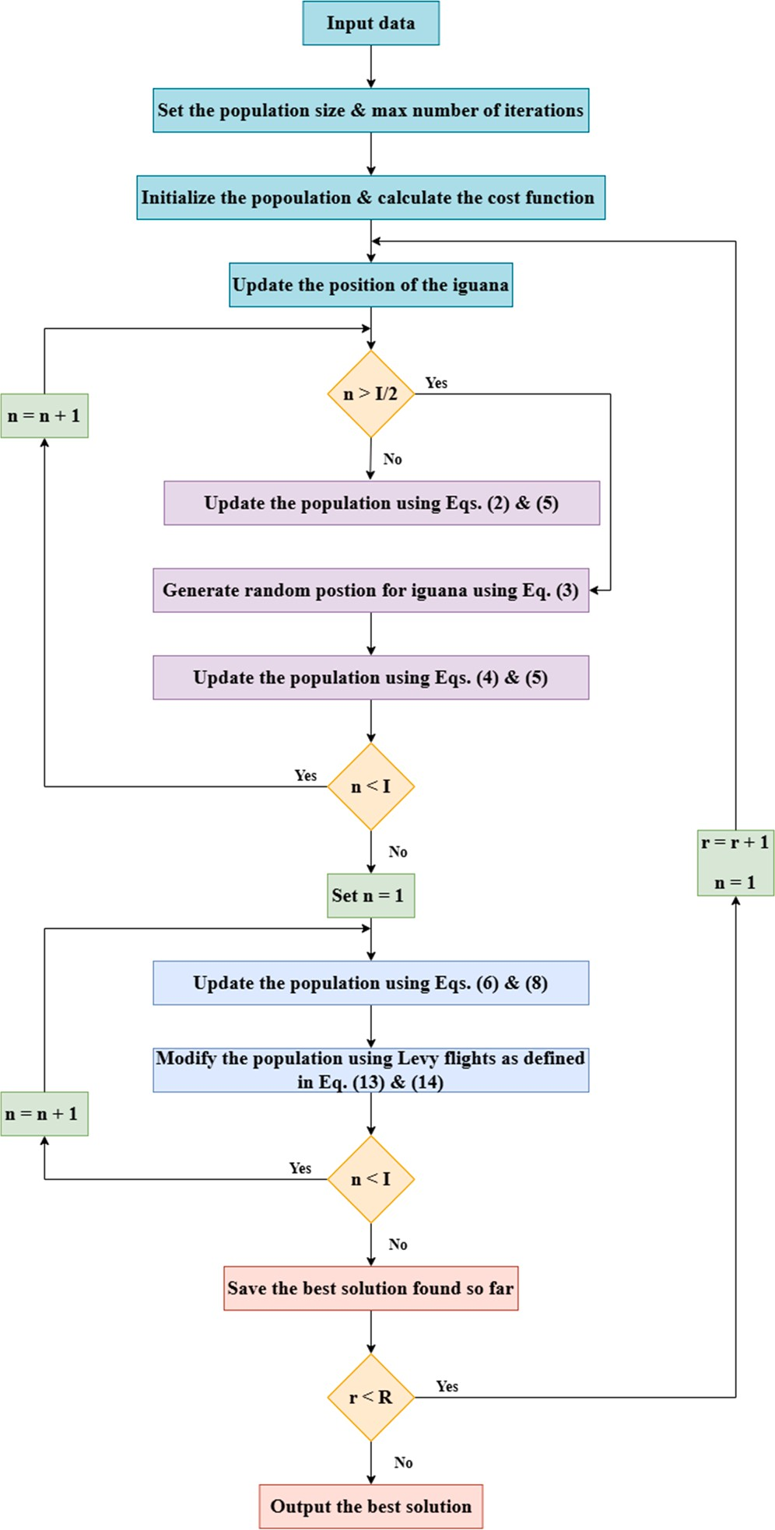
introduces an innovative hybrid model that combines ANN with the newly developed COA to achieve rapid and efficient weight determi- nation. The model estimates Yield_hg/ha using six input variables: Nation, Crop_Type, Production_Year, Mean_Annual_Rainfall, Pestici- de_Application and Average_Temperature. Fig. 6 provides an overview of the proposed crop yield prediction model. The COA optimizes the weights and biases of each ANN neuron, with the process terminating when a mathematical fit between ANN and COA weights is achieved or after a predetermined number of iterations. This technique leverages the strengths of both ANN and the Coati Optimization Algorithm for improved estimation accuracy. Fig. 7 provides a visual representation of the ANN-COA workflow.
The dataset was split, allocating 70 % for model training and 30 % for testing purposes. The model’s effectiveness was evaluated using the mean square error as the fitness function, as shown in Eq. (15).
MSE ↑ 1 / ↗Y ↓ Y\ ↘² (15)
N
N
i
i
i↑1

Result and discussion

  - Assessment of performance

This segment focuses on forecasting crop yields by incorporating various input variables, including country, crop variety, year, precipi- tation averages, pesticide usage, and mean temperature. The approach combines artificial neural networks (ANN) with meta-heuristic optimi- zation techniques. To assess the effectiveness of this proposed method- ology, four key statistical metrics were employed:
RMSE is widely regarded as a primary indicator for gauging pre- diction accuracy. It quantifies the discrepancy between observed and predicted values. The formula for RMSE can be expressed mathemati- cally using Eq. (16).
⎞⎡⎤⎛1⎛⎛⎛⎛⎛/⎛⎛N⎛⎛⎛⎛⎛⎛⎛⎛⎛⎛⎛⎛⎛⎛⎛⎛⎛⎛⎛⎛⎛⎛⎛2⎛⎛
RMSE ↑
N
↗Y_{i} ↓ Y\i ↘
(16)
i↑1
MAE represents the absolute difference between actual and fore- casted results. This metric can be calculated using Eq. (17).
MAE ↑ 1 / ⇑Y ↓ Y\ ⇑ (17)
i↑1
N
N
i
i

Fig. 5. Flow chart of enhanced COA.

3.6. Whale optimization algorithm

MAPE is frequently utilized in time series forecasting to estimate prediction precision. A mathematical Eq. (18) is used for computing MAPE.
1 / ⎣Y_{i} ↓ Y\i ⎣
N
MAPE ↑
N i↑1 ⎣
Y_{i}
⎣
(18)

The Whale Optimization Algorithm (WOA), developed by Mirjalili and Lewis [62], represents a bio-inspired metaheuristic technique that emulates the bubble-net feeding behavior of humpback whales. This computational approach translates the whales’ prey encirclement and spiral-attack strategies into an effective optimization framework for exploring solution spaces and achieving global convergence. Lei et al.
[63] demonstrated the algorithm’s practical utility by implementing WOA-optimized neural networks for potato yield prediction, showcasing its effectiveness in agricultural applications.

3.7. Hybrid ANN and COA

The ANN model does not necessitate intricate computations but rather the modification of network weights and the synchronization of neurons during local convergence and optimization. This research

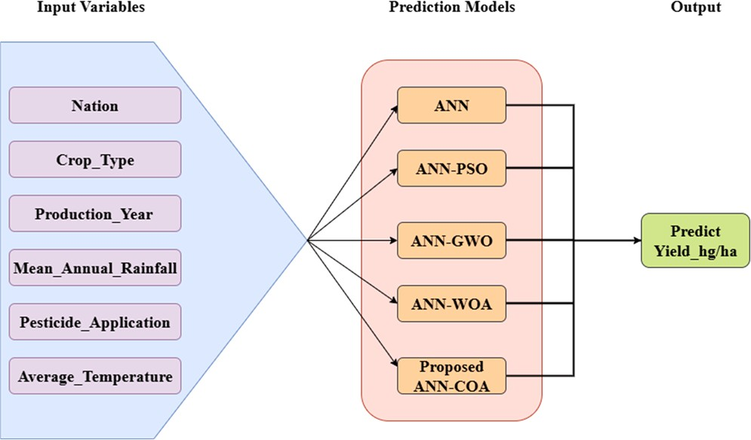

Fig. 6. Overview of the proposed crop yield prediction model.

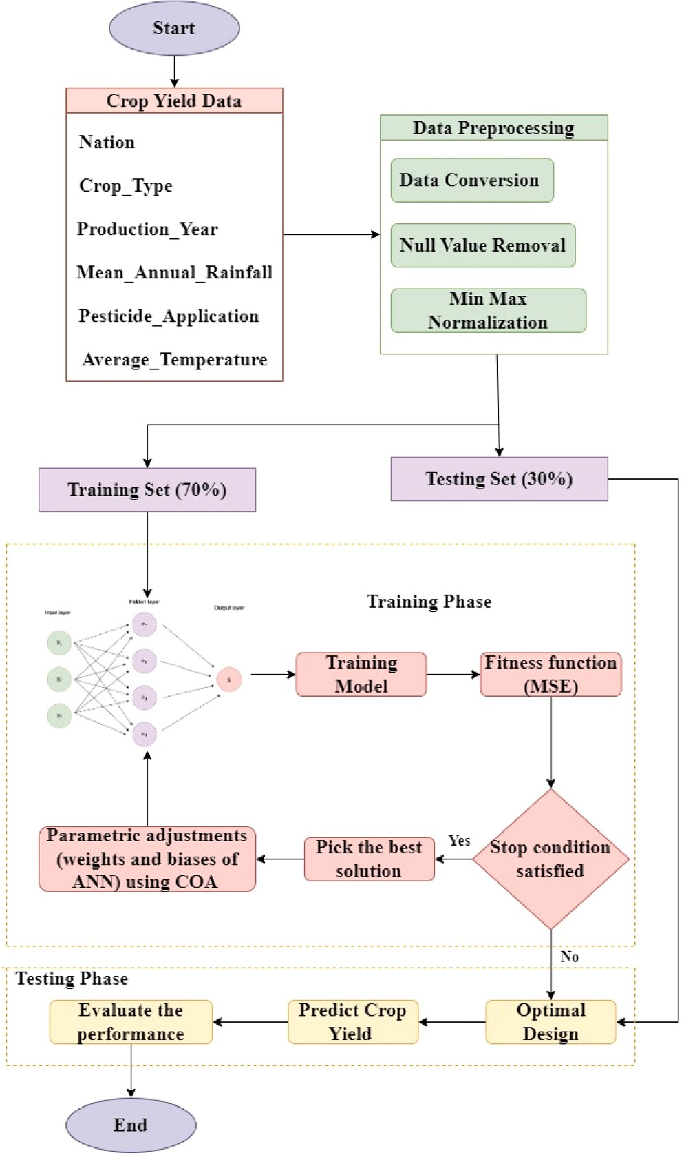
specifications, neural network structure, and parameter settings for each optimization algorithm. The results of this analysis are visually repre- sented in Fig. 8. The convergence graphs clearly demonstrate that incorporating COA into the ANN framework leads to a marked enhancement in performance. This improvement can be attributed to the effective exploration and exploitation capabilities inherent in the COA methodology. The parameters that yielded the best performance, as determined by COA training, are summarized in Table 3 and Table 4.
Through comprehensive evaluation, we found that the ANN-COA framework demonstrates exceptional performance by integrating two complementary optimization phases that effectively address the inherent challenges of high-dimensional agricultural prediction models. The algorithm draws its strength from nature-inspired coati behavioral patterns, where the intensive hunting phase enables focused refinement of promising solution areas, while the escape mechanism facilitates broad exploration across the entire parameter landscape. This biological foundation provides a robust theoretical framework that prevents the optimization process from becoming confined to locally optimal but globally suboptimal solutions.
The incorporation of Levy flight dynamics further strengthens the model’s exploratory potential by introducing strategically timed, long- distance movements within the search domain. These probabilistic leaps serve as a safeguard against convergence stagnation, allowing the algorithm to discover previously unexplored regions that may contain superior solutions. Consequently, the ANN-COA approach exhibits remarkable versatility in simultaneously conducting thorough global searches while maintaining the precision necessary for local optimiza- tion. This dual capability proves particularly valuable in agricultural yield prediction, where the complex interplay of environmental, bio- logical, and management factors demands both comprehensive param- eter exploration and accurate fine-tuning of optimal configurations. This balance enables the algorithm to effectively escape local optima and thoroughly explore the solution space, making it particularly suitable for complex, high-dimensional optimization problems, such as those encountered in crop yield prediction. The statistical benchmarks, as shown in Table 3, highlight its superior performance. This model ach- ieved the lowest error rates and highest accuracy, with an RMSE of

Fig. 7. A workflow of ANN-COA. Table 2
Configuration Details.

The coefficient of determination (R²) serves as a measure of forecast

Algorithm Parameter Values

reliability. R² values typically fall between 0 and 1, with values closer to 1 indicating higher accuracy. A formula for calculating R² is given in Eq. (19).
⎦ ↗Y_{i} ↓ Y\i ↘²
N
System Parameters Processor
Processor 11th Gen Intel(R) Core(TM) i5–1145G7 @ 2.60 GHz
System type 64-bit operating system, x64- based processor
Installed ram 16.0 GB
MATLAB version R2023a

R² ↑ 1 ↓ ^{i↑1}
N
⎦ ↗Y ↓ Y ↘²
i↑1
i
i
(19)
Neural Network Parameters
Loss function Mean Square Error (MSE)
Activation function Sigmoid

Population size 50
Hidden neurons 9
COA Parameters Iterations 250
(number of coatis)

  - Experimental result
The primary aim of this study is to determine the most effective model for predicting crop yields across various countries. To achieve this, we conducted a comparative analysis of several advanced hybrid models alongside a traditional approach. To obtain the best possible
WOA Parameters Iterations 250
Search agents (number 60
of whales)
GWO Parameters Iterations 250
Search agents (number 100
of wolves)
PSO Parameters Iterations 250

fitness function (MSE) Specifically, we evaluated the performance of ANN combined with COA, WOA, GWO, and PSO, as well as a conven-
Number of particles (swarm size)
150

tional ANN model. To assess the efficacy of the proposed ANN-COA
Weight (w) 1

model, we ran a series of 250 iterations, tracking its training error in comparison to the other models. The optimal hyperparameters for each metaheuristic algorithm were determined through a systematic trial- and-error process. Table 2 presents the configuration details and optimal parameter values used in all experiments, including system
Weight damping ratio (wdamp)
Personal learning coefficient (c1) Global learning coefficient (c2)
0.99

1.5

2

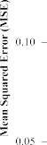
Fig. 8. Convergence rate of proposed models for crop yield data.

14,338.6, MAE of 8685.3, MAPE of 0.06803, and an R² value of 0.97296.
To validate our findings, we compared the predicted crop yields against observed data. This comparison not only demonstrated the ac- curacy of our results but also underscored the effectiveness of our chosen model. The Proposed ANN-COA exhibited optimal efficiency and mini- mal error in our simulation analysis. We further illustrated the rela- tionship between observed and predicted crop yields through a linear regression analysis, as depicted in Fig. 9. This visual representation helps to reinforce the model’s predictive power.
To provide a comprehensive evaluation of our developed models, we conducted an extensive statistical analysis. The values reported in Table 3 were calculated after denormalizing the model outputs, showing absolute error metrics in hectograms per hectare. Table 4 presents the normalized error metrics as percentages of mean yield values, offering additional evidence of the models’ effectiveness in crop yield prediction. It is noted that the performance metrics such as MAPE and R² remain invariant to the normalization process, as these measures are inherently scale-independent and express model performance in relative terms.
We conducted a comprehensive study by sequentially removing in- dividual input variables from our proposed ANN-COA model to evaluate feature importance and contribution to crop yield prediction accuracy. Two separate analyses were carried out: the first using all the inputs: Country, Crop_Type, Production_Year, Mean_Annual_Rainfall,
Average_Temperature, and Pesticide_Application as input features for yield prediction with results presented using both denormalized abso- lute error metrics (Table 3) and normalized percentage values (Table 4), and the second where we systematically removed one feature out of six to understand the individual effect of these variables on yield forecasting performance. Following an analysis of the results for each feature exclusion on the same proposed ANN-COA model individually (Table 5), the following observations were made: The combined exclusion of Mean_Annual_Rainfall and
Average_Temperature resulted in the most severe performance degradation (R² dropping to 0.061 training and 0.069 testing, RMSE exceeding 87,000), highlighting the critical synergistic importance of climatic variables in yield prediction. Crop_Type emerged as the second most critical individual predictor, with its removal causing severe per- formance degradation (R² dropping to 0.090 training and 0.088 testing, RMSE increasing to over 85,000), demonstrating its fundamental importance in yield prediction. Mean_Annual_Rainfall showed the third-
highest importance with substantial performance drops (R² ≃ 0.46, RMSE ≃ 67,000), confirming the critical role of climatic variables.
Nation information demonstrated moderate geographical significance (R² ≃ 0.58, RMSE ≃ 58,000), while Average_Temperature maintained reasonable model performance (R² ≃ 0.71). Production_Year parameters showed less influence on prediction accuracy (R² ≃ 0.75), and Pestici- de_Application exhibited the least impact, with the model retaining relatively strong predictive capability (R² ≃ 0.81 training, 0.79 testing) even in its absence.
These results affirm that biological factors (Crop_Type) and climatic conditions dominate yield prediction accuracy within our ANN-COA framework, while management and temporal variables appear to have lesser roles given the current dataset. The systematic and statistically validated ablation study enhances model interpretability and guides future data collection priorities. This comprehensive evaluation, as detailed in Table 5, confirms that the synergistic combination of climatic variables (Mean_Annual_Rainfall and Average_Temperature) along with biological factors (Crop_Type) contribute more significantly to accurate yield prediction than management practices (Pesticide_Application) and temporal factors (Production_Year) in our ANN-COA framework.
The performance of the proposed ANN-COA model was systemati- cally evaluated against three established forecasting approaches: Long Short-Term Memory (LSTM) networks [64], Convolutional Neural Network-Recurrent Neural Network (CNN-RNN) hybrid models [65], and Autoregressive Integrated Moving Average (ARIMA) time series models [66]. Table 6 presents a comprehensive performance compari- son across eight major Indian crops (Cassava, Maize, Potatoes, Rice,

Table 3
Statistical evaluation of forecasting models using denormalized values, showing absolute error metrics (hg/ha).
Improved ANN models | Training |  |  |  |  | Testing
 | RMSE | MAE | MAPE | R2 |  | RMSE | MAE | MAPE | R2
ANN | 31,976.3 | 33,174.8 | 0.85670 | 0.71151 |  | 31,127.7 | 29,623.1 | 0.83307 | 0.79027
ANN-PSO | 27,100.5 | 22,625.0 | 0.62108 | 0.86402 |  | 29,707.8 | 25,269.8 | 0.51188 | 0.82814
ANN-GWO | 18,620.1 | 11,502.0 | 0.26390 | 0.95225 |  | 22,821.9 | 14,324.3 | 0.29152 | 0.92725
ANN-WOA | 15,882.2 | 10,424.1 | 0.12553 | 0.96449 |  | 17,313.4 | 12,511.8 | 0.13795 | 0.95711
Proposed ANN-COA | 14,338.6 | 8685.3 | 0.06803 | 0.97296 |  | 15,534.5 | 10,425.7 | 0.07794 | 0.96845

Table 4
Statistical evaluation of forecasting models using normalized percentage values showing normalized error metrics ( % of mean yield).
Improved ANN models | Training |  |  |  |  | Testing
 | RMSE | MAE | MAPE | R2 |  | RMSE | MAE | MAPE | R2
ANN | 38.08 | 39.51 | 85.67 | 71.15 |  | 37.07 | 35.28 | 83.31 | 79.03
ANN-PSO | 32.28 | 26.95 | 62.11 | 86.40 |  | 35.38 | 30.10 | 51.19 | 82.81
ANN-GWO | 22.18 | 13.70 | 26.39 | 95.22 |  | 27.18 | 17.06 | 29.15 | 92.72
ANN-WOA | 18.92 | 12.42 | 12.55 | 96.45 |  | 20.62 | 14.90 | 13.79 | 95.71
Proposed ANN-COA | 17.08 | 10.34 | 7.80 | 97.30 |  | 18.50 | 12.42 | 8.79 | 96.84

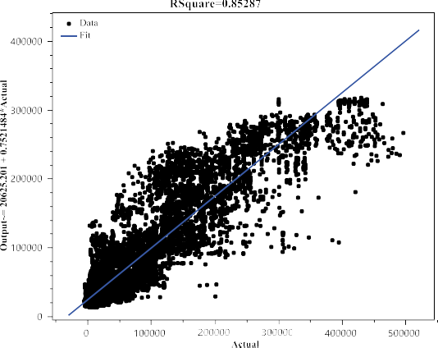
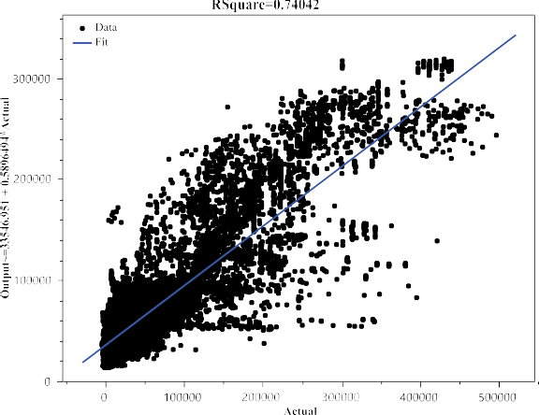

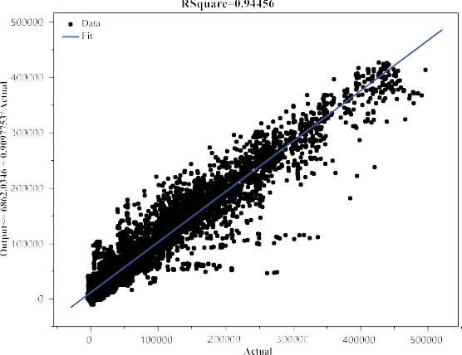
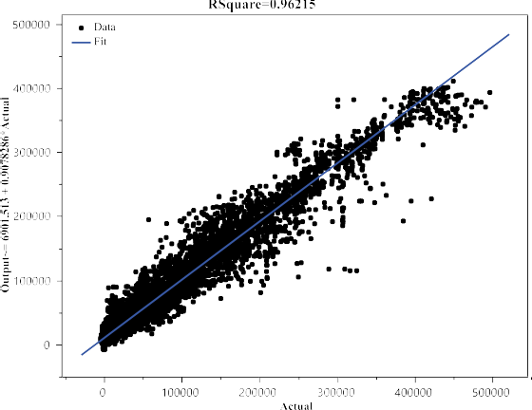
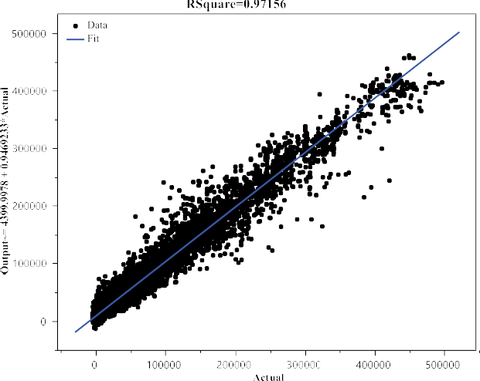

Fig. 9. A regression analysis comparing the actual and forecasted crop yield utilizing the suggested ANN models.

Table 5
Performance of the proposed ANN-COA model through variable exclusion analysis, showing absolute error metrics (hg/ha).
Excluded Variable | Dataset | R2 | RMSE | MAE
Mean_Annual_Rainfall & | Training | 0.060788 | 88,332.37 | 67,170.18
Average_Temperature
 | Testing | 0.06943 | 87,061.85 | 66,269.06
Crop_Type | Training | 0.09046 | 85,332.89 | 66,615.43
 | Testing | 0.088379 | 89,292.67 | 68,754.11
Mean_Annual_Rainfall | Training | 0.455589 | 67,132.89 | 45,639.86
Testing 0.466371 66,159.98 45,641.89
Nation Training 0.581385 58,412.73 39,043.78
Testing 0.592026 58,745.22 39,519.5
Average_Temperature Training 0.713825 48,505.25 29,092.06
Testing 0.711255 49,007.09 29,575.62
Production_Year Training 0.748349 45,358.8 30,333.59
thereby contributing to sustainable agricultural development when strategically integrated with farmers’ traditional knowledge and field expertise. The results emphasize the feasibility and effectiveness of deploying the Proposed model for crop yield prediction in the Indian agricultural context.
Fig. 10 depicts crop yield trends from 2000 to 2013. Cassava shows the highest yield with an upward trend despite fluctuations. Maize, potatoes, rice (paddy), and soybeans exhibit increasing yields. Plantains, sorghum, and yams maintain relatively stable yields with minor im- provements. Sweet potatoes show an overall positive trend despite annual variations. Wheat yields steadily increase over time. This anal- ysis reveals diverse patterns of stability and improvement in agricultural productivity across various crops.

 | Testing | 0.753437 | 45,527.43 | 30,588.02 | 5. Conclusion
Pesticide_Application | Training | 0.814409 | 39,136.81 | 25,766.44
 | Testing | 0.786137 | 42,012.63 | 27,642.33 | This study introduces decision support tools for policymakers and
 |  |  |  |  | farmers, designed to forecast the yields of ten major crops across the

Sorghum, Soybeans, Sweet Potatoes, and Wheat), using data from 2000 to 2012 to forecast 2013 yields, evaluated with three critical evaluation metrics: coefficient of determination (R²), Mean Absolute Percentage Error (MAPE), and Mean Absolute Error (MAE). The experimental re- sults demonstrate the consistent superiority of the Proposed model across all evaluated crops. The Proposed ANN-COA model achieved exceptionally high R² values ranging from 0.9380 to 0.9680, indicating that over 93 % of yield variance was captured by the model predictions. This represents a substantial improvement over LSTM models (R²: 0.7380–0.8900), CNN-RNN models (R²: 0.5240–0.7530), and ARIMA
models (R²: 0.1270–0.5840). MAPE analysis reveals remarkable con- sistency in Proposed model performance, with values consistently below 1.8160 across all crops, demonstrating exceptional forecasting precision compared to LSTM (0.8727–5.4851), CNN-RNN (1.5938–8.6334), and
ARIMA models (2.1714–10.0419). The MAE evaluation further sub- stantiates the superior accuracy, with the Proposed ANN-COA model achieving the lowest absolute errors (37.4–6319.2) across all crop types, representing a substantial reduction in prediction error compared to ARIMA models (364.0–1953.7).
The improved performance of the Proposed ANN-COA model can be attributed to the underlying optimization algorithm’s global search ca- pabilities that effectively address local minima problems in neural network training. Its efficient navigation of complex parameter spaces results in optimal weight configurations that enhance predictive accu- racy. Rice (paddy), India’s most critical staple crop, achieved strong
predictive performance (R²↑0.96, MAPE ↑ 0.5073, MAE ↑ 155.1),
which is particularly significant for national food security planning, while wheat demonstrated the highest accuracy (R²↑0.968, MAPE ↑ 0.5002, MAE ↑ 144.8). These findings demonstrate that developing
robust data-driven predictive models has significant potential to enhance agricultural productivity across diverse cropping systems,
globe from 2000 to 2013. The crops included in this analysis are cassava,
maize, potatoes, rice, sorghum, soybeans, sweet potatoes, wheat, yams, and plantains. The research leverages data from the Food and Agricul- ture Organization of the United Nations (FAOSTAT), incorporating factors such as agricultural yield, pesticide use, temperature, cultivated area, crop type, and year. A novel hybrid model combining ANN with COA was developed to enhance prediction accuracy. The COA optimi- zation process was further enhanced through the incorporation of Levy flight mechanisms to improve exploration capabilities and avoid local optima. To evaluate its effectiveness, the ANN-COA model was compared against other hybrid models, including ANN-WOA, ANN- GWO, ANN-PSO, and the traditional ANN approach. Performance as- sessments were conducted using various statistical benchmarks. The experimental outcomes reveal that the ANN-COA and ANN-WOA hybrid approaches demonstrated superior performance compared to
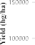
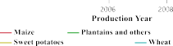
Fig. 10. The annual crop yields (hg/ha) for various crop types across different regions from 2000 to 2013.

Table 6
Comparative performance of crop yield forecasting models for major Indian crops in 2013.
 | Crop Type
Method | Error | Cassava | Maize | Potatoes | Rice (paddy) | Sorghum | Soybeans | Sweet potatoes | Wheat
Proposed ANN-COA | R2 | 0.9380 | 0.9530 | 0.9540 | 0.9600 | 0.9470 | 0.9420 | 0.9570 | 0.9680
 | MAPE | 1.8160 | 0.8298 | 0.5132 | 0.5073 | 0.4225 | 0.8196 | 0.2681 | 0.5002
 | MAE | 6319.2 | 176.6 | 1010.7 | 155.1 | 37.4 | 87.6 | 243.9 | 144.8
LSTM | R2 | 0.8150 | 0.791 | 0.7380 | 0.7880 | 0.8900 | 0.7990 | 0.8060 | 0.8560
 | MAPE | 3.1545 | 5.4851 | 3.2806 | 2.9054 | 0.8727 | 2.3416 | 1.4652 | 1.7890
 | MAE | 10,394.6 | 1129.0 | 6316.1 | 884.5 | 77.6 | 252.6 | 1334.5 | 510.0
CNN-RNN | R2 | 0.6200 | 0.576 | 0.6890 | 0.597 | 0.5670 | 0.5240 | 0.695 | 0.753
 | MAPE | 4.7569 | 6.2836 | 3.6042 | 4.0928 | 4.5491 | 8.6334 | 1.5938 | 2.8368
 | MAE | 15,624.6 | 1335.6 | 6984.6 | 1262.3 | 400.01 | 916.3 | 1442.5 | 808.9
ARIMA | R2 | 0.4780 | 0.384 | 0.4800 | 0.1270 | 0.365 | 0.2950 | 0.5840 | 0.3640
 | MAPE | 5.2637 | 8.5272 | 4.7165 | 5.9061 | 5.6709 | 10.0419 | 2.1741 | 4.1634
 | MAE | 17,348.3 | 1728.4 | 9275.8 | 1792.7 | 512.4 | 1067.3 | 1953.7 | 1170.3

conventional methods. The ANN-COA model demonstrated superior performance in crop yield prediction, evidenced by its higher accuracy, the lowest RMSE, MAE, MAPE, and the highest R² values compared to other models. These results indicate that while the benchmark ANN model exhibited the lowest performance, the proposed ANN-COA hybrid model achieved the highest level of accuracy among the tested ap- proaches. The detailed ablation study further highlighted the critical importance of biological and climatic factors, particularly Crop_Type and Mean_Annual_Rainfall, in achieving high prediction accuracy, while management practices and temporal variables exhibited comparatively lower influence. This insight underscores the need to prioritize these key variables in future model development and data collection efforts to enhance the robustness and practical utility of crop yield forecasting tools. The feasibility analysis confirms the practical applicability of the proposed model across diverse agricultural systems, with consistent performance across varied crop types and growing conditions, making it suitable for deployment in real-world agricultural decision-making contexts. In future work, we plan to incorporate the most recent data- sets and explore additional features, including climatic variables and remote sensing inputs. We also intend to implement advanced deep learning architectures such as CNN-LSTM and Transformer models adapted for heterogeneous and cross-sectional agricultural data. Addi- tionally, we aim to expand the model’s applicability to a wider range of regions and develop decision-support tools to help farmers and agri- cultural planners make informed crop management decisions.

Funding

No funding is provided for the preparation of the manuscript.

Data availability

The data utilized in this study was sourced from an open-access dataset available on: https://www.kaggle.com/code/mahmoudmagd yelnahal/crop-yield-prediction-99/input.

CRediT authorship contribution statement

T K Nida Fariz: Writing – original draft, Visualization, Software, Resources, Methodology, Formal analysis, Data curation, Conceptuali- zation. S Sharief Basha: Writing – review & editing, Validation, Su- pervision, Project administration.

Declaration of competing interest

The authors declare that they have no known competing financial interests or personal relationships that could have appeared to influence the work reported in this paper.

References

- S. Khaki, L. Wang, Crop yield prediction using deep neural networks, Front. Plant. Sci 10 (2019) 621.
- J. Pant, R.P. Pant, M.K. Singh, D.P. Singh, H. Pant, Analysis of agricultural crop yield prediction using statistical techniques of machine learning, Mater. Today.: Proc. 46 (2021) 10922–10926.
- R. Aworka, L.S. Cedric, W.Y.H. Adoni, J.T. Zoueu, F.K. Mutombo, C.L.M. Kimpolo,
T. Nahhal, M. Krichen, Agricultural decision system based on advanced machine learning models for yield prediction: case of East African countries, Smart. Agric. Technol. 2 (2022) 100048.
- S. Manimekalai, K. Nandhini, Crop yield prediction from soil parameters through Neupper rule established algorithm, Int. J. Eng. Technol 7 (2018) 908–912.
- R.A. Fischer, Definitions and determination of crop yield, yield gaps, and of rates of change, Field. Crops. Res 182 (2015) 9–18.
- J.M. McKinion, H.E. Lemmon, Expert systems for agriculture, Comput. Electron. Agric. 1 (1985) 31–40.
- A. Schultz, R. Wieland, G. Lutze, Neural networks in agroecological modelling—Stylish application or helpful tool? Comput. Electron. Agric. 29 (2000) 73–97.
- X. Wang, J. Huang, Q. Feng, D. Yin, Winter wheat yield prediction at county level and uncertainty analysis in main wheat-producing regions of China with deep learning approaches, Remote. Sens. (Basel) 12 (2020) 1744.
- C. Singha, K.C. Swain, Rice and potato yield prediction using artificial intelligence techniques, in: P.K. Pattnaik, R. Kumar, S. Pal (Eds.), Internet of Things and Analytics for Agriculture, Springer Singapore, Singapore, 2022, pp. 185–199, https://doi.org/10.1007/978-981-16-6210-2_9. Volume 3.
- A. Bhatsada, P. Payomthip, T. Itsarathorn, Y.N.N. Lwin, E. Wahyanti,
S. Towprayoon, S. Patumsawad, C. Chiemchaisri, K. Wangyao, AI-powered machine learning models for monitoring and optimization of biodrying process, Results. Eng. (2025) 105584.
- F. Rodríguez-Díaz, A.M. Chaco!n-Maldonado, A.R. Troncoso-García, G. Asencio-
Corte!s, Explainable olive grove and grapevine pest forecasting through machine learning-based classification and regression, Results. Eng. 24 (2024) 103058.
- M.S.B. Alam, V. Esichaikul, A. Lameesa, S.F. Ahmed, A.H. Gandomi, An approach for crop recommendation with uncertainty quantification based on machine learning for sustainable agricultural decision-making, Results. Eng. (2025) 105505.
- A. Keikha, M.G. Parashkoohi, A. Mohammadi, H. Afshari, Comparing mechanization systems for regression model based crop production under different tillage systems, Results. Eng. (2025) 104056.
- P. Hesadi, H. Mozaffari, S.S. Hemayati, P. Moaveni, B. Sani, Unveiling constraints and cultivating potential: optimizing spring sugar beet yield through boundary line analysis, Results. Eng. 22 (2024) 102101.
- J. Mirzaei, M.G. Parashkoohi, D.M. Zamani, H. Afshari, Examining energy use efficiency and conducting an environmental life cycle assessment through the application of artificial intelligence: a case study on the production of cumin and fennel, Results. Eng. 20 (2023) 101522.
- S. Tiwari, A. Gehlot, R. Singh, B. Twala, N. Priyadarshi, Design of an iterative method for disease prediction in finger millet leaves using graph networks, dyna networks, autoencoders, and recurrent neural networks, Results. Eng. 24 (2024) 103301.
- P.K. Guru, P. Sahu, P. Shukla, P. Diwan, G. Panwar, P. Tiwari, A. Nagori,
G. Carpenter, R. Sanodiya, B.S. Meena, A critical review on rice cultivation and mechanization level in Indian perspective, Results. Eng. (2025) 105632.
- A. Sharma, A. Jain, P. Gupta, V. Chowdary, Machine learning applications for precision agriculture: a comprehensive review, IEEE. Access 9 (2020) 4843–4873.
- M. Kaul, R.L. Hill, C. Walthall, Artificial neural networks for corn and soybean yield prediction, Agric. Syst 85 (2005) 1–18.
- G.A. Mesías-Ruiz, M. P!erez-Ortiz, J. Dorado, A.I. De Castro, J.M. Pen”a, Boosting
precision crop protection towards agriculture 5.0 via machine learning and emerging technologies: a contextual review, Front. Plant. Sci 14 (2023) 1143326.
- S. Puttemans, Y. Vanbrabant, L. Tits, T. Goedem!e, Automated visual fruit detection
for harvest estimation and robotic harvesting, in: 2016 Sixth International Conference on Image Processing Theory, Tools and Applications (IPTA), IEEE, 2016, pp. 1–6. https://ieeexplore.ieee.org/abstract/document/7820996/. accessed
August 13, 2024.
- T.L. Saitone, R.J. Sexton, Product differentiation and quality in food markets: industrial organization implications, Annu. Rev. Resour. Econ 2 (2010) 341–368, https://doi.org/10.1146/annurev.resource.050708.144154.
- P. Miralles, K. Thangavel, A.F. Scannapieco, N. Jagadam, P. Baranwal, B. Faldu,
R. Abhang, S. Bhatia, S. Bonnart, I. Bhatnagar, A critical review on the state-of-the- art and future prospects of machine learning for Earth observation operations, Adv. Space. Res. 71 (2023) 4959–4986.
- B. Basso, L. Liu, Seasonal crop yield forecast: methods, applications, and accuracies, Adv. Agron. 154 (2019) 201–255.
- S.O. Araújo, R.S. Peres, J.C. Ramalho, F. Lidon, J. Barata, Machine learning applications in agriculture: current trends, challenges, and future perspectives, Agronomy 13 (2023) 2976.
- M. Shehab, L. Abualigah, Q. Shambour, M.A. Abu-Hashem, M.K.Y. Shambour, A.
I. Alsalibi, A.H. Gandomi, Machine learning in medical applications: a review of state-of-the-art methods, Comput. Biol. Med 145 (2022) 105458.
- M.W. Libbrecht, W.S. Noble, Machine learning applications in genetics and genomics, Nat. Rev. Genet. 16 (2015) 321–332.
- T.P. Nagarhalli, V. Vaze, N.K. Rana, Impact of machine learning in natural language processing: a review, in: 2021 Third International Conference on Intelligent Communication Technologies and Virtual Mobile Networks (ICICV), IEEE, 2021, pp. 1529–1534. https://ieeexplore.ieee.org/abstract/document
/9388380/. accessed July 26, 2024.
- A. Kamilaris, F.X. Prenafeta-Boldú, Deep learning in agriculture: a survey, Comput. Electron. Agric. 147 (2018) 70–90.
- M.A. Jabed, M.A.A. Murad, Crop yield prediction in agriculture: a comprehensive review of machine learning and deep learning approaches, with insights for future research and sustainability, Heliyon (2024). https://www.cell.com/h eliyon/fulltext/S2405-8440(24)16867-3. accessed June 2, 2025.
- F. Rahman, M.A.R. Khan, M. Alam, Hybrid PSO-GA optimization for enhancing decision tree performance in soil classification and crop cultivation prediction, Evol. Intell 18 (2025) 30.
- M.O. Aderele, A.K. Srivastava, K. Butterbach-Bahl, J. Rahimi, Integrating machine learning with agroecosystem modelling: current state and future challenges, Eur. J. Agron. 168 (2025) 127610.
- B.A.S. Emambocus, M.B. Jasser, A. Amphawan, A survey on the optimization of artificial neural networks using swarm intelligence algorithms, IEEE. Access 11 (2023) 1280–1294.
- F. Akram, S. Aziz, N.A. Khan, S.A. Faizi, K. Raza, Integrating artificial bee colony algorithms for deep learning model optimization: a comprehensive review, in:

K. Raza (Ed.), Solving With Bees, Springer Nature Singapore, Singapore, 2024,
pp. 73–102, https://doi.org/10.1007/978-981-97-7344-2_5.
- P. Filippi, S.Y. Han, T.F.A. Bishop, On crop yield modelling, predicting, and forecasting and addressing the common issues in published studies, Precis. Agric 26 (2025) 8, https://doi.org/10.1007/s11119-024-10212-2.
- D. Tripathi, S.K. Biswas, Design of a precise ensemble expert system for crop yield prediction using machine learning analytics, J. Forecast (2024), https://doi.org/ 10.1002/for.3183 for.3183.
- B. Patidar, S.K. Sinha, A. Jain, Crop yield prediction using automated analytical and predictive techniques. Artificial Intelligence and Information Technologies, CRC Press, 2024, pp. 441–446. https://www.taylorfrancis.com/chapters/edit/ 10.1201/9781032700502-70/crop-yield-prediction-using-automated-analytical-p redictive-techniques-banshilal-patidar-sitesh-kumar-sinha-anurag-jain. accessed October 10, 2024.
- V. Parganiha, M. Verma, An effective soil analysis and crop yield prediction based on optimised light GBM in smart agriculture, J. Agron. Crop. Sci. 210 (2024) e12726, https://doi.org/10.1111/jac.12726.
- D.S. Dhaliwal, M.M. Williams, Sweet corn yield prediction using machine learning models and field-level data, Precis. Agric 25 (2024) 51–64, https://doi.org/ 10.1007/s11119-023-10057-1.
- S.T. Haider, W. Ge, J. Li, S.U. Rehman, A. Imran, M. Sharaf, S.M. Haider, An ensemble machine learning framework for cotton crop yield prediction using weather parameters: a case study of Pakistan, IEEE. Access (2024). https:// ieeexplore.ieee.org/abstract/document/10664030/. accessed October 18, 2024.
- H. Zhou, F. Huang, W. Lou, Q. Gu, Z. Ye, H. Hu, X. Zhang, Yield prediction through UAV-based multispectral imaging and deep learning in rice breeding trials, Agric. Syst 223 (2025) 104214.
- A. Oikonomidis, C. Catal, A. Kassahun, Hybrid deep learning-based models for crop yield prediction, Appl. Artif. Intell. 36 (2022) 2031822, https://doi.org/10.1080/
08839514.2022.2031823.
- D.V. Gaso, L.E.C. La Rosa, L.A. Puntel, J.I.R. Edreira, A. de Wit, L. Kooistra, Predicting spatial and temporal variability in soybean yield using deep learning and open source data, Eur. J. Agron. 164 (2025) 127498.
- E.N. Mol, M.S. Kumar, End-to-end framework for agricultural entity extraction–A hybrid model with transformer, Comput. Electron. Agric. 225 (2024) 109309.
- A. Satpathi, N. Chand, P. Setiya, R. Ranjan, A.S. Nain, D.K. Vishwakarma,
K. Saleem, A.J. Obaidullah, K.K. Yadav, O. Kisi, Evaluating statistical and machine learning techniques for sugarcane yield forecasting in the tarai region of North India, Comput. Electron. Agric. 229 (2025) 109667.
- L. Jovanovic, M. Zivkovic, N. Bacanin, M. Dobrojevic, V. Simic, K.K. Sadasivuni, E.
B. Tirkolaee, Evaluating the performance of metaheuristic-tuned weight agnostic neural networks for crop yield prediction, Neural. Comput. Applic 36 (2024) 14727–14756, https://doi.org/10.1007/s00521-024-09850-4.
- P. Nevavuori, N. Narra, P. Linna, T. Lipping, Crop yield prediction using multitemporal UAV data and spatio-temporal deep learning models, Remote. Sens. (Basel) 12 (2020) 4000.
- Z. Chu, J. Yu, An end-to-end model for rice yield prediction using deep learning fusion, Comput. Electron. Agric. 174 (2020) 105471.
- D. Elavarasan, P.D. Vincent, Crop yield prediction using deep reinforcement learning model for sustainable agrarian applications, IEEE. Access 8 (2020) 86886–86901.
- T. Kasinathan, D. Singaraju, S.R. Uyyala, Insect classification and detection in field crops using modern machine learning techniques, Inf. Process. Agric. 8 (2021) 446–457.
- P. Abbaszadeh, K. Gavahi, A. Alipour, P. Deb, H. Moradkhani, Bayesian multi- modeling of deep neural nets for probabilistic crop yield prediction, Agric. Meteorol 314 (2022) 108773.
- T.N. Fariz, S.S. Basha, Enhancing solar radiation predictions through COA optimized neural networks and PCA dimensionality reduction, Energy. Rep. 12 (2024) 341–359.
- L. Al Shalabi, Z. Shaaban, Normalization as a preprocessing engine for data mining and the approach of preference matrix, in: 2006 International Conference on Dependability of Computer Systems, IEEE, 2006, pp. 207–214. https://ieeexplore. ieee.org/abstract/document/4024051/. accessed June 12, 2025.
- M. Dehghani, Z. Montazeri, E. Trojovska!, P. Trojovskỳ, Coati Optimization
Algorithm: a new bio-inspired metaheuristic algorithm for solving optimization problems, Knowl. Based. Syst 259 (2023) 110011.
- H. Haklı, H. Ug#uz, A novel particle swarm optimization algorithm with Levy flight,
Appl. Soft. Comput 23 (2014) 333–345.
- S. Balavignesh, C. Kumar, R. Sripriya, T. Senjyu, An enhanced coati optimization algorithm for optimizing energy management in smart grids for home appliances, Energy. Rep. 11 (2024) 3695–3720.
- J. Kennedy, R. Eberhart, Particle swarm optimization, in: Proceedings of ICNN’95- International Conference on Neural Networks, ieee, 1995, pp. 1942–1948. http s://ieeexplore.ieee.org/abstract/document/488968/. accessed May 6, 2025.
- V.G. Gudise, G.K. Venayagamoorthy, Comparison of particle swarm optimization and backpropagation as training algorithms for neural networks, in: Proceedings of the 2003 IEEE Swarm Intelligence Symposium. SIS’03 (Cat. No. 03EX706), IEEE, 2003, pp. 110–117. https://ieeexplore.ieee.org/abstract/document/1202255/.
accessed July 24, 2025.
- S. Mirjalili, S.M. Mirjalili, A. Lewis, Grey wolf optimizer, Adv. Eng. Softw. 69 (2014) 46–61.
- K. Biswas, P.M. Vasant, J.A.G. Vintaned, J. Watada, Cellular automata-based multi- objective hybrid Grey Wolf Optimization and particle swarm optimization algorithm for wellbore trajectory optimization, J. Nat. Gas. Sci. Eng 85 (2021) 103695.
- S. Nosratabadi, K. Szell, B. Beszedes, F. Imre, S. Ardabili, A. Mosavi, Comparative analysis of ANN-ICA and ANN-GWO for crop yield prediction, in: 2020 RIVF International Conference on Computing and Communication Technologies (RIVF), IEEE, 2020, pp. 1–5. https://ieeexplore.ieee.org/abstract/document/9140786/.
accessed July 24, 2025.
- S. Mirjalili, A. Lewis, The whale optimization algorithm, Adv. Eng. Softw. 95 (2016) 51–67.
- X. Lei, X. Xu, S. Zhou, Potato yield prediction research based on improved artificial neural networks using whale optimization algorithm, Potato. Res 68 (2025) 1717–1726, https://doi.org/10.1007/s11540-024-09819-9.
- S.M. Kuriakose, T. Singh, Indian crop yield prediction using LSTM deep learning networks, in: 2022 13th International Conference on Computing Communication and Networking Technologies (ICCCNT), IEEE, 2022, pp. 1–5. https://ieeexplore. ieee.org/abstract/document/9984407/. accessed September 2, 2025.
- S. Khaki, L. Wang, S.V. Archontoulis, A CNN-RNN framework for crop yield prediction, Front. Plant. Sci 10 (2020) 1750.
- P. Mishra, C. Sarkar, K.P. Vishwajith, B.S. Dhekale, P.K. Sahu, Instability and forecasting using ARIMA model in area, production and productivity of onion in India, J. Crop. Weed 9 (2013) 96–101.

