Deep Learning–Based Framework for Real-Time ECG Arrhythmia Classification in Big Data Environments
Mohammed Ashlab N  23MIA1081  School of Computer Science and Engineering  Vellore Institute of Technology, Chennai, India | Srishreyan S  23MIA1088  School of Computer Science and Engineering  Vellore Institute of Technology, Chennai, India

Abstract-About 90% of the beats of a continuous ECG stream are normal, so running a full multi-classifier on each beat will be a waste of computation. A real-time arrhythmia analytics framework which keeps a trained anomaly detector (based on autoencoder anomaly gate and XGBoost/Wildlife) in front of an Apache Kafka and a Spark Structured Streaming stream with SHAP explanations and a live dashboard. The hybrid gate is able to boost the throughput by 67% compared to XGBoost alone (0.24 vs. 0.94), in 100,689 MIT-BIH heartbeats (44 recordings, 32 features per beat) at the cost of reducing the SVEB recall. We quantify this trade-off. The autoencoder hyperparameter selection is then studied with Particle swarm optimization (PSO), Grey Wolf Optimizer (GWO) and Coati Optimization Algorithm (COA) with 36 evaluations for each method and the objective is to maximize the validation AUPRC. GWO achieves the highest AUROC (0.9466) and AUPRC (0.7612) (78.50% sensitivity at 94.52% specificity) and COA achieved the smallest model we could (9,280 parameters) and the highest batch throughput (4.92M inferences/s).
Index Terms—ECG arrhythmia classification; autoencoder; XGBoost; Apache Spark Structured Streaming; Apache Kafka; SHAP; anomaly detection; class imbalance; metaheuristic optimization.

I. INTRODUCTION
Cardiovascular diseases are one of the major causes of death in the world, and the general method of non-invasive monitoring of cardiac abnormalities is by using an ECG. The increase in cardiac telemetry data from wearables and connected medical devices places a new emphasis on real-time, automated analysis. The most widely used standard benchmark is the MIT-BIH Arrhythmia Database [2, 3] which is highly imbalanced, with 89.47% of beats labelled Normal and the remaining 10.53% of beats grouped in four classes of arrhythmia (AAMI).
In the conventional pipeline, the same compute is used for each beat that enters the pipeline. This is inefficient in a hospital environment as the vast majority of beats are normal. We take advantage of this imbalance directly: A light autoencoder trained only on normal beats provides a gate and only beats that pass the threshold are fed into a stronger multi-classifier. This paper makes the following contributions:
A two-stage autoencoder → XGBoost streaming pipeline on Kafka and Spark Structured Streaming, with explanations using SHAP, REST and WebSocket serving and a live alerting dashboard.
• A five configuration ablation that measures the throughput increase of gating (+67%) and the cost in SVEB recall (0.94→0.24).
A comparison of PSO, GWO and COA on hyperparameter selection of autoencoders with held-out accuracy, model size, throughput, threshold-sensitivity and noise-robustness results, under an equal 36-evaluation budget.
II. RELATED WORK
Classic heartbeat classifiers are based on RR-interval features and ECG morphology [4]. Deep models, such as convolutional networks on MIT-BIH beats [5] and deep networks on ambulatory ECGs [6] can achieve high accuracy but they have the same cost per beat and are rarely tested for streaming throughput. Reconstruction-based anomaly detection [7] – Trains on the majority class only which is suitable for imbalanced telemetry. We merge 'two' and measure the recall cost of the 'two' gate, which is on the lion's share of the SVEB beats as shown in Section IV.
III. PROPOSED METHODOLOGY
A. Dataset and Feature Description
The MIT-BIH Arrhythmia Database [2], [3] contains 48 half-hour two-lead recordings sampled at 360 Hz.feature-level export of our team has 100,689 beats from 44 recordings, grouped into the five AAMI EC57 classes [8] (Table I). Validation rejects missing columns, unknown labels and zero-variance features, and drops rows with NaN or infinite values.
TABLE I
MIT-BIH CLASS DISTRIBUTION (AAMI GROUPING)
Class | Description | Count | Share (%)
N | Normal sinus rhythm | 90,083 | 89.47
SVEB | Supraventricular ectopic | 2,779 | 2.76
VEB | Ventricular ectopic | 7,009 | 6.96
F | Fusion beat | 803 | 0.80
Q | Unknown / paced | 15 | 0.015
Total |  | 100,689 | 100

Each beat has 32 features, 16 per lead (Lead II and Lead V), in four groups (Table II). One shared module fixes the feature order for training and serving, which prevents training–serving skew. Fig. 1 shows the class imbalance (log scale).
TABLE II
FEATURE GROUPS (PER LEAD; 32 IN TOTAL)
Group | Features | Count | Clinical role
Rhythm | pre-RR, post-RR | 2 | Timing regularity
Wave amplitudes | P, Q, R, S, T peaks | 5 | (De)polarization
Intervals | QRS, PQ, QT, ST | 4 | Conduction time
QRS morphology | qrs_morph_0…4 | 5 | Ventricular activation shape

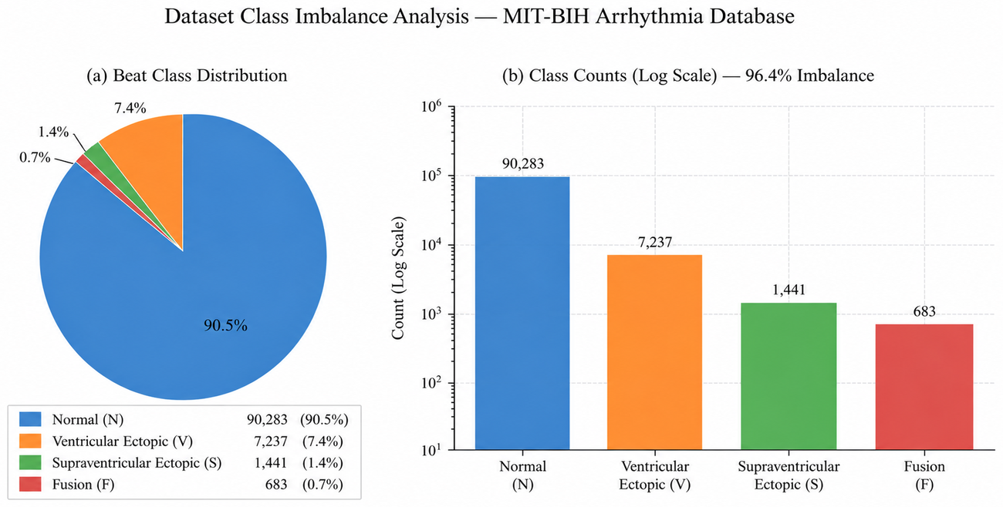
Fig. 1. Class distribution of the MIT-BIH feature set (log scale).
Exploratory analysis guided the design. Arrhythmic beats shows its characteristic deviations in pre-RR and post-RR timing (Fig. 2(a)), which a normal-only autoencoder turns into elevated reconstruction error. In Lead II the QRS-morphology features are strongly inter-correlated and pre-RR and post-RR are moderately correlated (r = 0.72; Fig. 2(b)), so the 32 features are redundant enough for a compact 16-dimensional bottleneck.

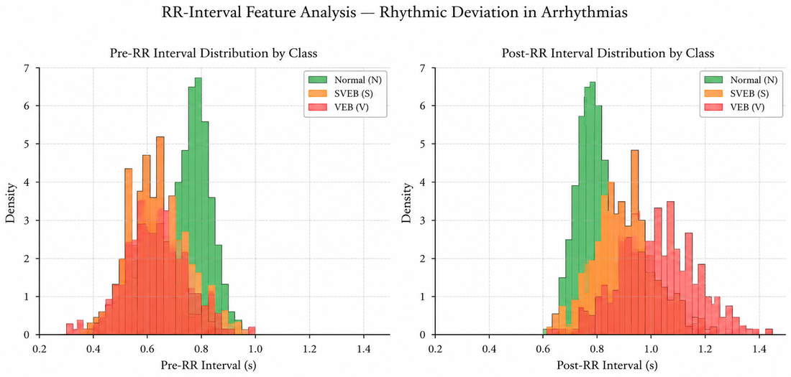 | 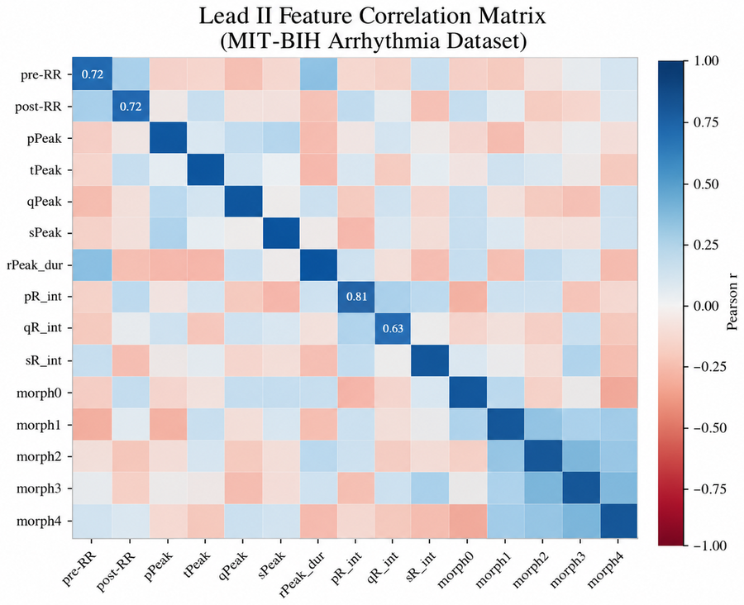
(a) Pre-RR and post-RR distributions by class. | (b) Lead II feature correlation matrix.
Fig. 2. Exploratory data analysis of the MIT-BIH feature set.

B. System Architecture
Fig. 3 shows the architecture. Beats receive events from the dataset or simulator from a configurable source on the Apache Kafka [9] platform (topics ecg-events, ecg-predictions and ecg-errors). The events are parsed and validated by the Structured streaming of Apache Spark [10] and malformed events are forwarded to the error topic, then the 32-feature vector is stored in a canonical order and the two-stage model is executed in a vectorized Pandas UDF module, with the model bundle loaded only once per Python worker. Predictions are added to Kafka using event ID, which are stored in PostgreSQL via a FastAPI service and pushed over a WebSocket to a React-based dashboard that displays the live prediction feed, abnormal-beat alerts, SHAP bars and model-performance views. A one-process demo mode (no Kafka, Spark or PostgreSQL) offers the same dashboard, a Docker Compose setup offers the complete distributed deployment, with the ability to scale horizontally and with checkpointing.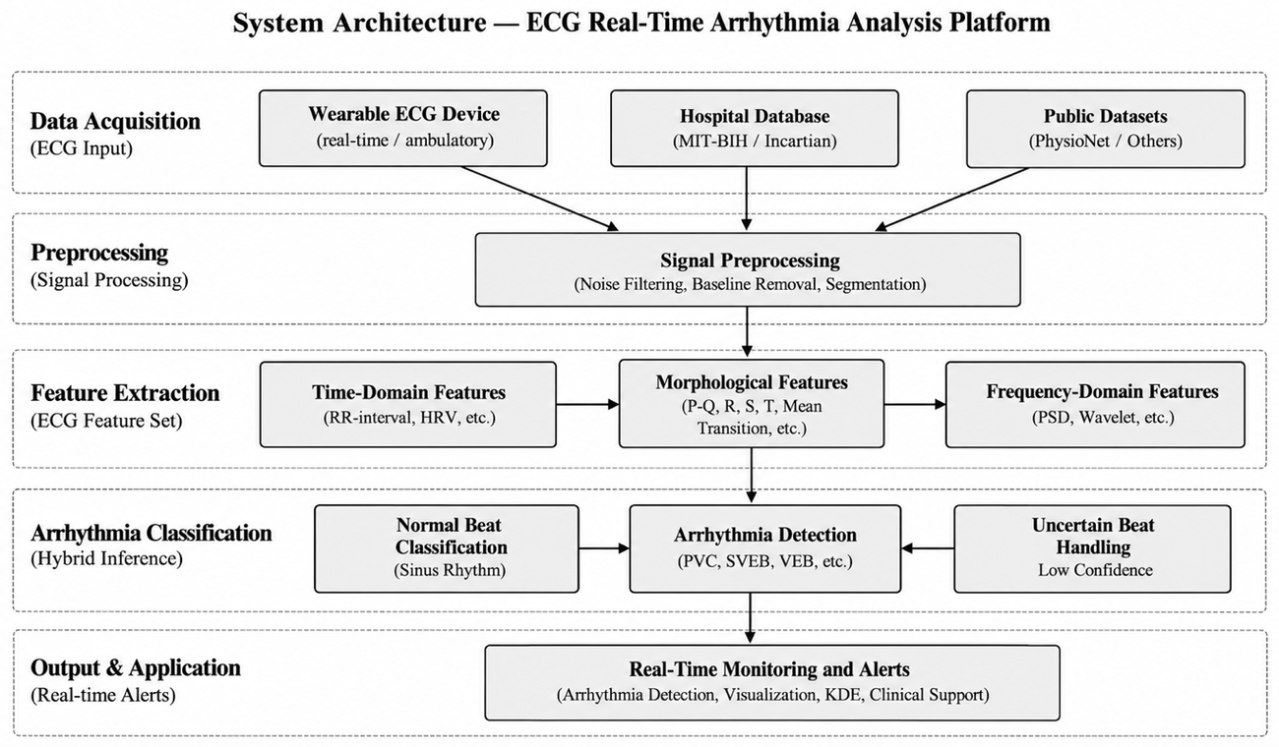
Fig. 3. System architecture: data sources → transport → streaming inference → API and persistence → dashboard.
The React/TypeScript dashboard (Fig. 4) has four sections: simulation control (mode, event rate, component health); a live monitor that receives predictions over WebSocket and shows a colour-coded feed, a waveform synthesized from the tabular features, per-beat latency, SHAP bars and visual alerts for abnormal beats; a model-performance view that renders the ablation results; and an analytics view with live class distribution and a rolling 60-second reconstruction-error timeline. Rolling-window statistics (throughput, abnormal rate, p50/p95/p99 latency) are served by the API (Table III). In demo mode, in-process inference takes 0.2–2 ms and end-to-end delivery including WebSocket is typically under 50 ms.
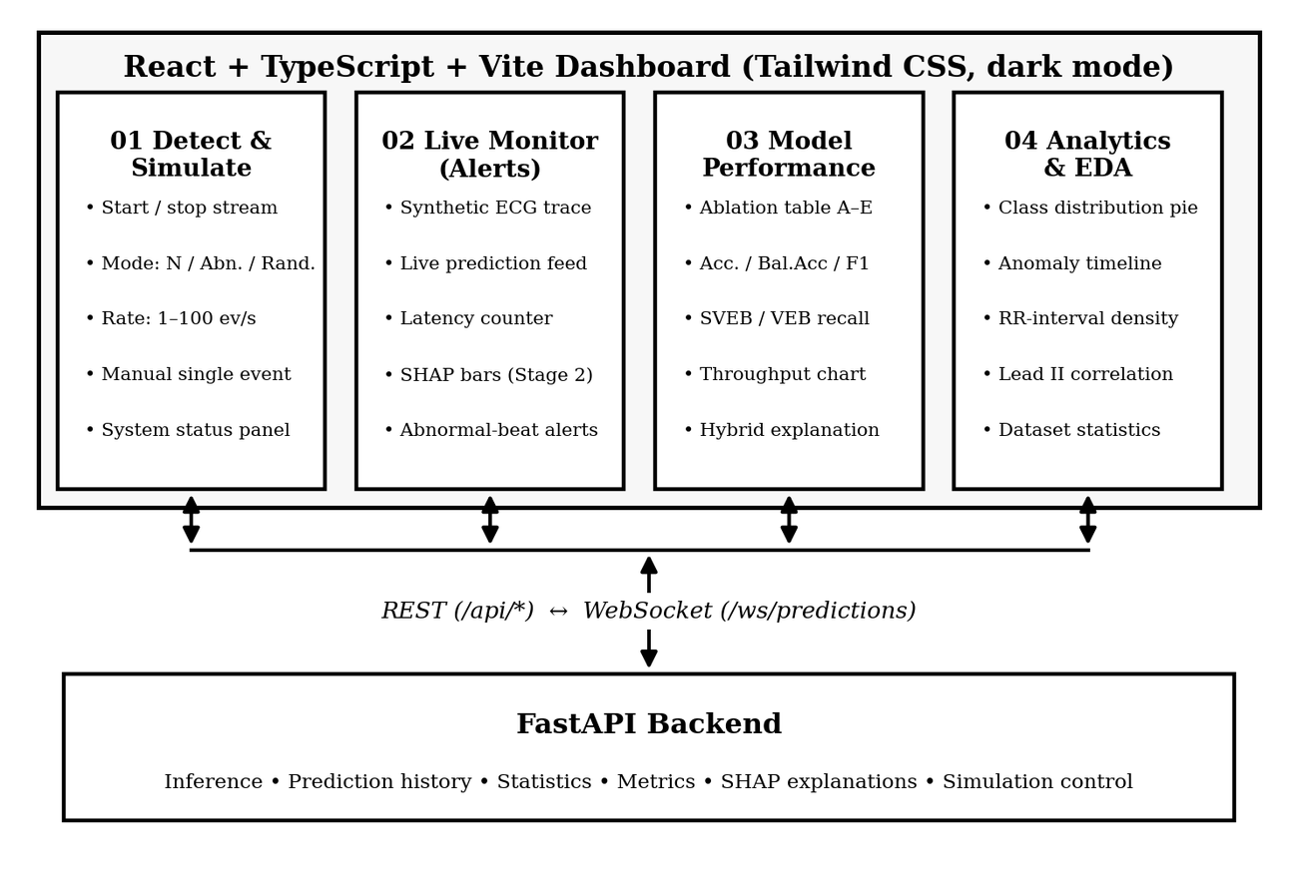
Fig. 4. Dashboard architecture: four sections served by REST and WebSocket endpoints of the FastAPI backend.
TABLE III
KEY FASTAPI ENDPOINTS
Endpoint | Method | Purpose
/api/ecg/send | POST | Validate and publish one event
/api/simulation/start | stop | POST | Control the event simulator
/api/predictions | GET | Prediction history (class filter)
/api/statistics | GET | Totals, abnormal rate, class mix
/api/metrics?window_seconds= | GET | Rolling throughput, p50/p95/p99
/api/explain/{event_id} | GET | Top-5 SHAP contributions
/ws/predictions | WS | Live prediction stream

C. Data Preprocessing and Splitting
A StandardScaler is fit on the training split only and persisted for serving. The default split is stratified 70/15/15 (train/validation/test) using scikit-learn [11]; a record-aware split that keeps each patient in one partition is also implemented. All results in this paper use the stratified split.
D. Stage 1: Autoencoder Anomaly Gate
A fully connected autoencoder [12] with layers 32→128→64→16→64→128→32 (ReLU hidden, linear output) is trained on normal beats only with MSE loss, Adam [13] (learning rate 10⁻³), batch size 256 and 50 epochs. The anomaly threshold θ = 0.059017 is the 95th percentile of reconstruction error on held-out normal beats. As Fig. 5 shows, about 87% of beats fall below θ and are labeled Normal; the remaining ≈13% go to Stage 2. Fig. 6 shows the resulting error distributions.
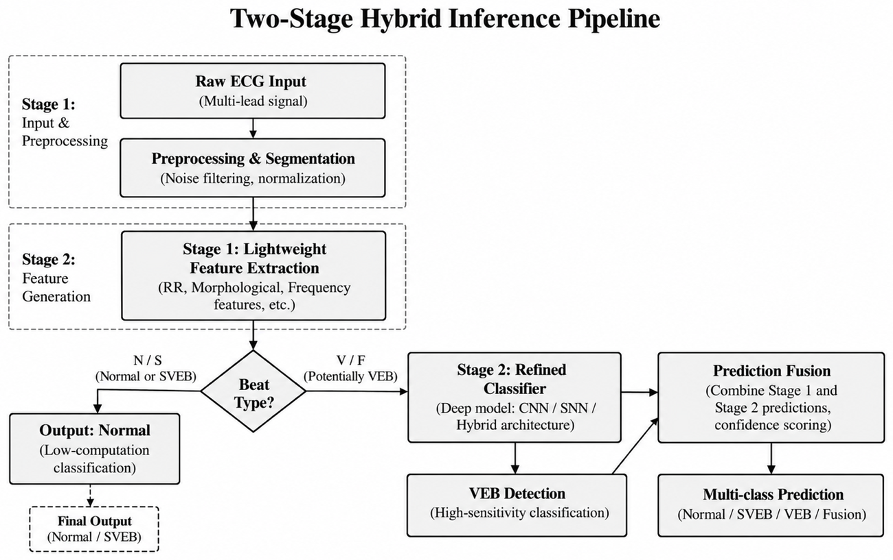
Fig. 5. Two-stage inference: autoencoder gate (Stage 1) and XGBoost classifier (Stage 2).
TABLE IV
BASELINE AUTOENCODER CONFIGURATION
Parameter | Value
Architecture | 32→128→64→16→64→128→32 (ReLU hidden, linear output)
Loss / optimizer | MSE / Adam, learning rate 1e-3
Epochs / batch size | 50 / 256
Training data | Normal beats only (≈90K)
Threshold θ | 0.059017 (95th percentile, normal validation)

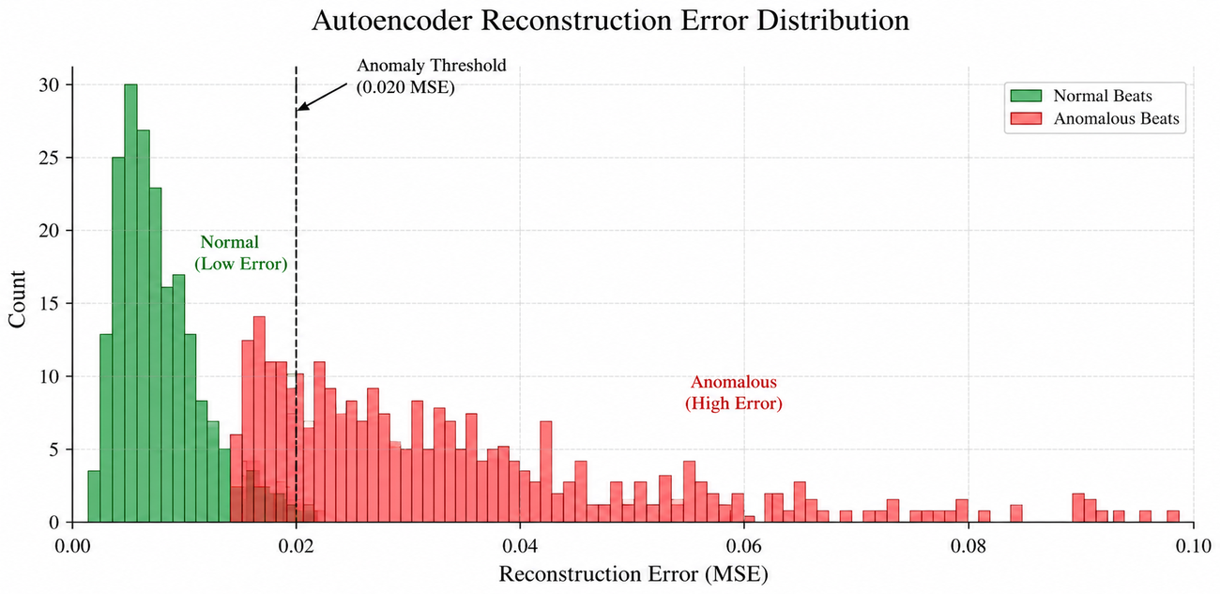
Fig. 6. Baseline autoencoder reconstruction-error distribution for normal and abnormal beats; the threshold θ separates the two populations.
E. Stage 2: XGBoost Classifier
An XGBoost model [14] trained only on abnormal beats assigns one of SVEB, VEB, F or Q, using per-class weights (Stage-2 macro-F1 0.7210 on the abnormal subset). Final confidence is the mean of the gate confidence and the XGBoost class probability. SHAP contributions are obtained from XGBoost’s native pred_contribs option.
IV. EXPERIMENTAL RESULTS AND ANALYSIS
A. System Ablation Study
Five configurations were compared on the stratified test split: (A) XGBoost alone, 5-class; (B) autoencoder only; (C) the hybrid AE→XGBoost; (D) XGBoost with autoencoder latent features and reconstruction error appended; and (E) an MLP baseline (Table V). Throughput is measured in batch mode, and accuracy metrics use the held-out test split.
TABLE V
ABLATION RESULTS (EXPERIMENTS A–E)
Exp. | Configuration | Acc. | Bal. acc. | Macro-F1 | SVEB rec. | VEB rec. | Events/s
A | XGBoost only | 0.9919 | 0.7551 | 0.7562 | 0.940 | 0.980 | 339K
B | AE only | 0.9299 | 0.8585 | 0.8290 | – | – | 2.66M
C | Hybrid AE→XGB | 0.9278 | 0.5710 | 0.5253 | 0.240 | 0.955 | 569K
D | XGB + AE features | 0.9914 | 0.7494 | 0.7532 | 0.938 | 0.979 | 309K
E | MLP baseline | 0.9383 | 0.7577 | 0.6042 | 0.964 | 0.954 | 4.09M

XGBoost alone is the most accurate (99.19%) and has the best SVEB recall among the multi-class models, but at 339K events/s it is the bottleneck for dense monitoring. The hybrid (C) is 67% faster (569K events/s) because only ≈13% of beats reach Stage 2, and it keeps VEB recall at 0.955. Its cost is SVEB recall: 0.24 versus 0.94, because SVEB beats often resemble Normal beats and are reconstructed well enough to pass the gate. This also lowers balanced accuracy to 0.571, the lowest of the five. Appending autoencoder features (D) does not help, suggesting the tabular features already carry the relevant information. The MLP (E) is fastest (4.09M events/s) but its macro-F1 (0.6042) is below XGBoost, a sign of how hard end-to-end deep learning is on imbalanced tabular data. The autoencoder alone (B) has the best balanced accuracy (0.8585) but cannot name the arrhythmia class.

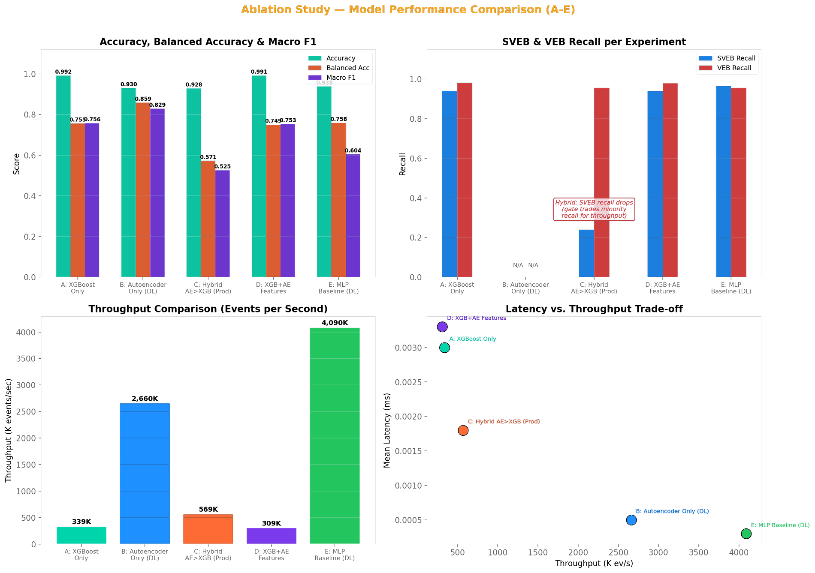
Fig. 7. Ablation results: accuracy, F1 and recall (top); throughput and the latency–throughput trade-off (bottom).
Note: Experiment B (AE-only) performs binary normal/abnormal detection; therefore, SVEB and VEB class-specific recall are not applicable.
B. Metaheuristic Autoencoder Optimization
This second experiment asks a different question from Section IV-A: how should the gate’s autoencoder be configured? PSO [15], GWO [16] and COA [17] each searched seven hyperparameters (hidden widths, latent size, learning rate, weight decay, dropout, denoising noise, batch size), each with 36 evaluations (6 initial candidates plus five iterations of 6) and validation AUPRC as fitness. The untuned Adam autoencoder (128–64–16) is the baseline. Every model is trained on normal beats only and thresholded at the 95th percentile of normal validation error. All four are evaluated on the same 15,104-beat held-out test split (13,513 normal, 1,591 abnormal).
TABLE VI
HELD-OUT TEST RESULTS FOR AUTOENCODER OPTIMIZATION
Metric | Baseline | PSO | GWO | COA
Architecture | 128–64–16 | 192–96–24 | 192–96–32 | 64–32–12
Parameters | 26,080 | 54,944 | 57,280 | 9,280
AUROC | 0.9404 | 0.9451 | 0.9466 | 0.9216
AUPRC | 0.7346 | 0.7289 | 0.7612 | 0.6966
Sensitivity | 76.68% | 76.43% | 78.50% | 73.16%
Specificity | 94.91% | 94.70% | 94.52% | 94.55%
F1 | 0.6973 | 0.6903 | 0.6976 | 0.6669
Throughput (inf./s) | 2.97M | 1.92M | 1.90M | 4.92M
Mean latency | 0.357 µs | 0.573 µs | 0.551 µs | 0.240 µs
Search time | – | 108.7 s | 139.6 s | 118.0 s

GWO gave the best AUROC, AUPRC, sensitivity and F1 (Table VI). Its confusion matrix has 12,772 true negatives, 741 false positives, 342 false negatives and 1,249 true positives, i.e. 78.50% sensitivity and a 5.48% false-positive rate. Against the baseline (1,220 TP, 371 FN, 688 FP) it detects 29 more abnormal beats at the price of 53 more false alarms, so the gain is modest and is a sensitivity–specificity trade-off rather than a free improvement; the baseline keeps the highest specificity. The tuned GWO model uses hidden layers 192→96, latent size 32, learning rate 1.26×10⁻³, weight decay 2.2×10⁻⁶, dropout 3.37%, denoising σ = 0.116 and batch size 512 (final training 14.3 s). COA’s model has 9,280 parameters, 6.2× fewer than GWO’s 57,280, and the highest throughput (4.92M inferences/s), at lower AUROC (0.9216). PSO reached 0.9451 AUROC and stopped early after 27 epochs. Timings were measured in batch mode on an Apple Silicon CPU and are not single-beat clinical latency.
TABLE VII
GWO-TUNED AUTOENCODER CONFUSION MATRIX (TEST SET)
Actual \ Predicted | Normal | Abnormal | Total
Normal | 12,772 (TN) | 741 (FP) | 13,513
Abnormal | 342 (FN) | 1,249 (TP) | 1,591

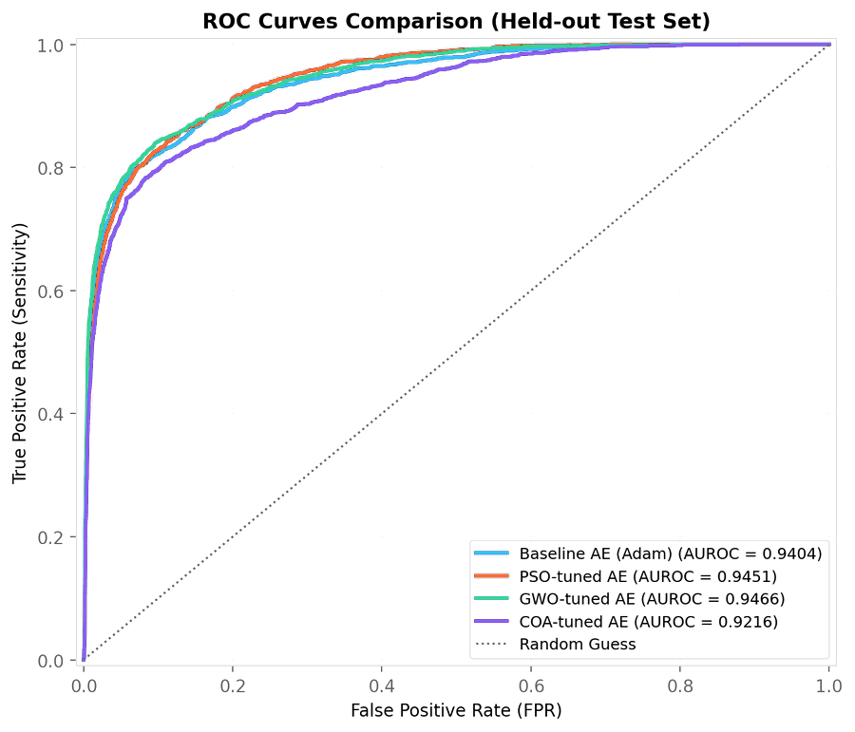 | 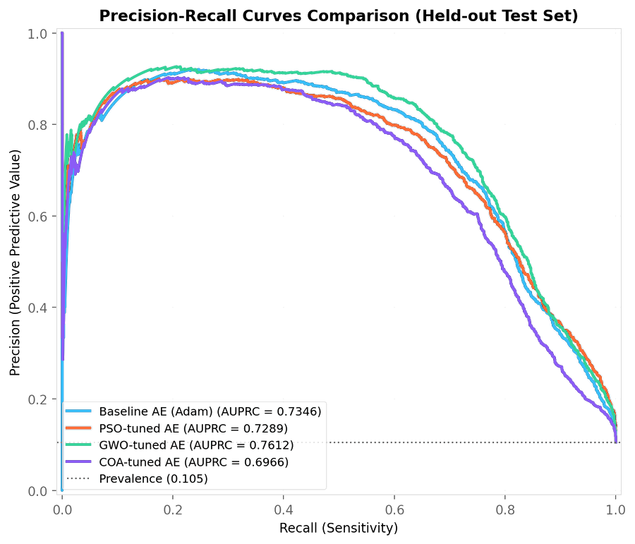 | 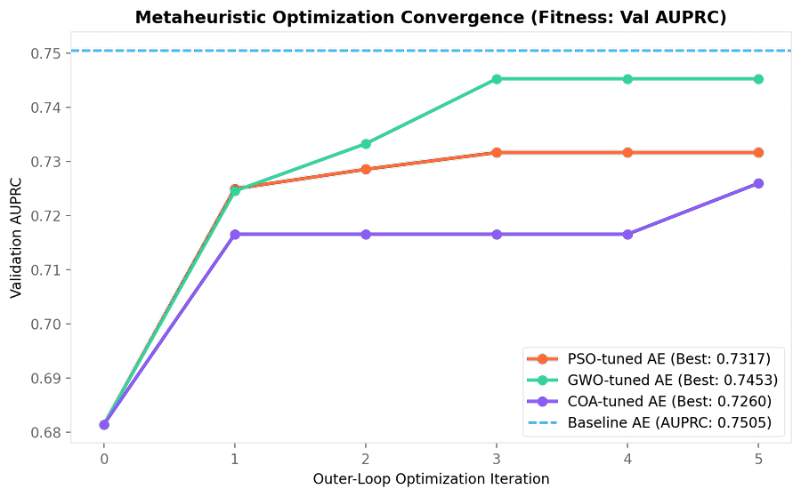
(a) ROC curves (GWO AUROC 0.9466). | (b) Precision–recall curves (GWO AUPRC 0.7612). | (c) Best validation AUPRC per search iteration.
Fig. 8. Held-out discrimination and search behavior of the four autoencoders. In (c), the dashed line is the baseline autoencoder’s validation AUPRC (0.7505); search fitness is not the same quantity as the final retrained validation metric.

Fig. 8(a,b) shows that GWO dominates on the held-out ROC and precision–recall curves. Fig. 8(c) is a caution: no optimizer’s best search fitness (GWO 0.7453, PSO 0.7317, COA 0.7260) exceeded the untuned baseline’s validation AUPRC (0.7505) within 36 evaluations, so the tuning benefit seen on the test split should be read as suggestive, not established.
C. Threshold Sensitivity and Robustness
Fig. 9(a) varies the calibration percentile for the GWO model on the test split. Recall falls and precision rises as the percentile increases; F1 peaks near the 97.5th percentile (≈0.735), above the F1 of 0.698 at the selected 95th percentile, so the 95th percentile favors sensitivity over F1. Fig. 9(b) adds Gaussian noise to the standardized features: AUROC degrades gradually from 0.947 to 0.712 at σ = 0.5, whereas thresholded F1 drops quickly (≈0.51 at σ = 0.1), because noise raises reconstruction error and pushes normal beats over the fixed threshold. A deployed gate therefore needs input-quality monitoring or periodic recalibration. Fig. 9(c) explains the residual errors: normal errors concentrate just below the threshold, but a visible share of abnormal beats also falls below it (the 342 false negatives), while the abnormal distribution has a long tail that the gate catches easily.

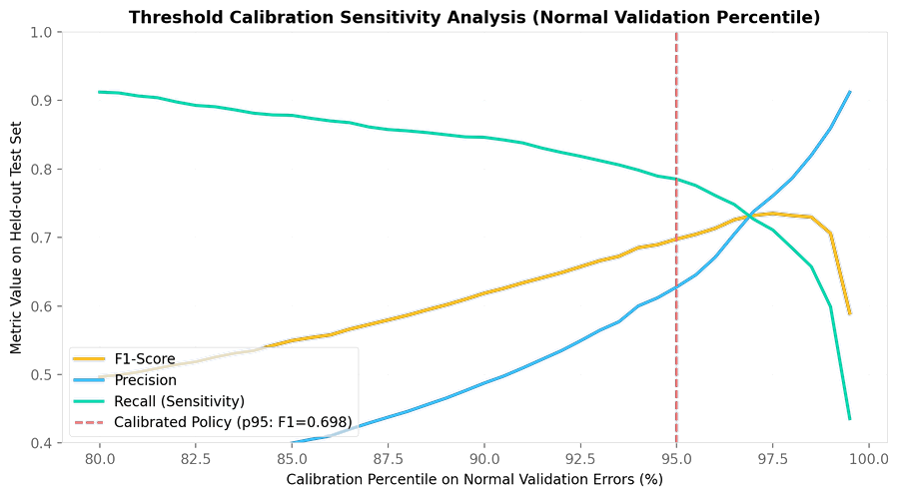 | 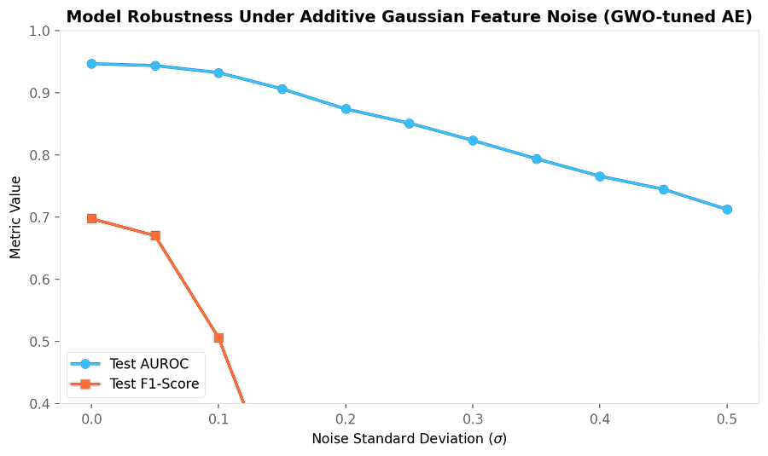 | 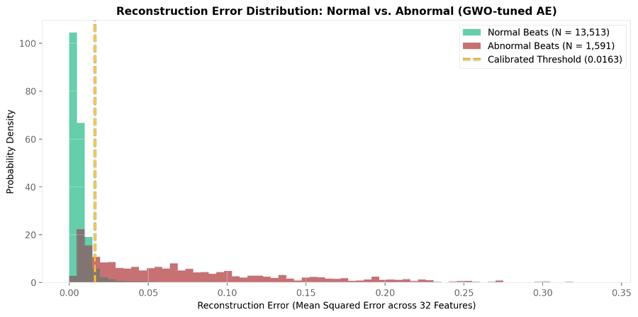
(a) Test metrics vs. calibration percentile (dashed: p95). | (b) AUROC and F1 under additive Gaussian feature noise. | (c) Normal vs. abnormal reconstruction error (θ = 0.0163).
Fig. 9. Threshold-calibration sensitivity, noise robustness and error distribution of the GWO-tuned autoencoder on the held-out test set.

D. Training Behavior and Gating Features
Fig. 10(a) shows that the GWO model reaches the lowest reconstruction loss (≈0.022 training, ≈0.008 validation at epoch 50, against ≈0.064 and ≈0.023 for the baseline); COA tracks the baseline and PSO stopped early at epoch 27. Fig. 10(b) ranks the features by the gap between abnormal and normal reconstruction error. T-peak amplitude (Lead II, then Lead V) leads, followed by the Lead II S peak, PQ interval and P peak. No RR-interval feature appears in the top ten, whereas Stage-2 SHAP (Section IV-F) is dominated by RR intervals, so the two stages emphasize different feature groups.

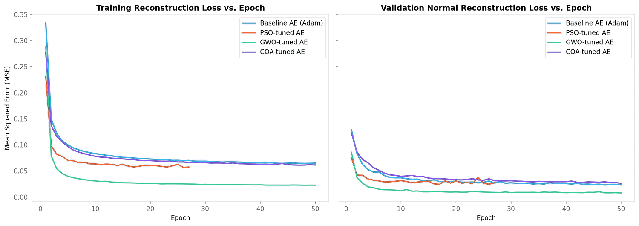 | 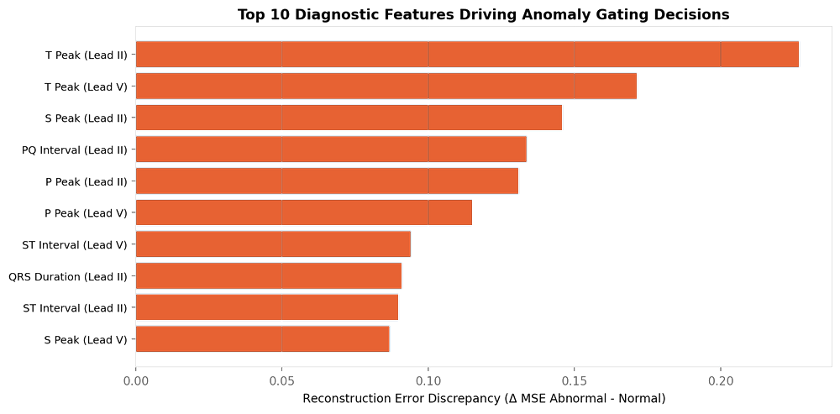
(a) Training and normal-validation reconstruction loss per epoch. | (b) Top-10 features by abnormal–normal error gap.
Fig. 10. Autoencoder training curves and the features that drive gating.

E. Distribution Drift Sensitivity
Fig. 11(a) shifts the Lead II feature means by a standardized amount Δμ. The false-positive rate of the fixed-threshold gate rises from 5.5% with no shift to ≈17% at Δμ = 0.2, ≈69% at 0.3 and ≈100% from 0.5, while AUROC changes little on the plotted scale. The ranking of beats is therefore largely preserved, but the fixed threshold fails quickly, which indicates that periodic threshold recalibration on recent normal beats is needed in deployment (we have not yet tested this). Fig. 11(b) is a single normal/VEB reconstruction pair for illustration only.

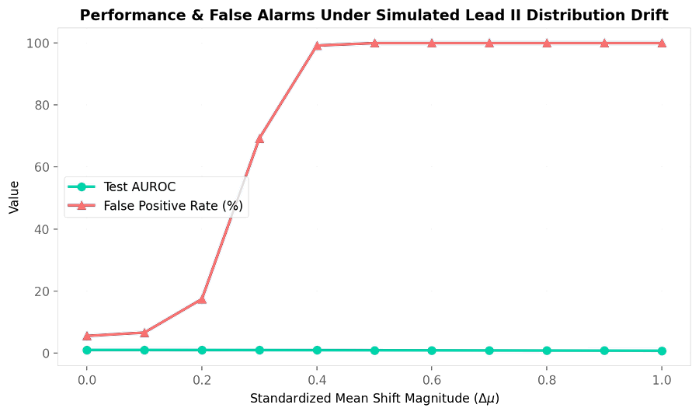 | 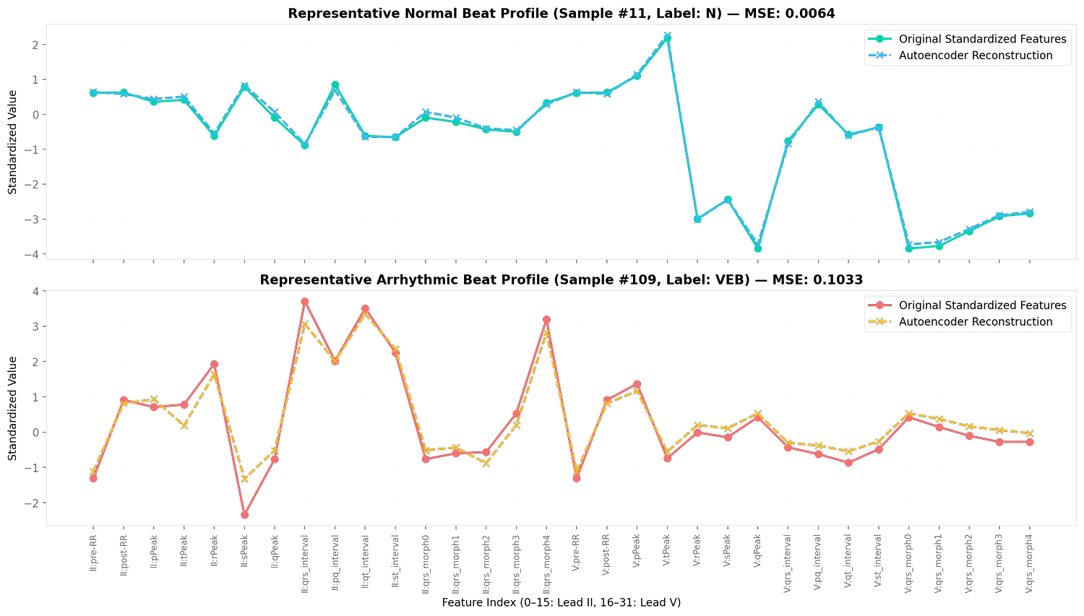
(a) False-positive rate (%) and AUROC under simulated Lead II mean shift. | (b) Example feature reconstruction for one normal and one VEB beat.
Fig. 11. Simulated drift sensitivity and an illustrative reconstruction example (not a population-level estimate).

F. SHAP-Based Explainability
For each Stage-2 prediction the system returns the top-5 features by absolute SHAP value [18], computed with XGBoost’s native contribution output (no separate SHAP library at inference time) and drawn as bars in the live monitor. Fig. 12 shows that the RR intervals dominate for both SVEB and VEB, followed by QRS duration for VEB and R-peak amplitude for SVEB. This is consistent with clinical knowledge that ectopic beats alter timing and ventricular beats widen the QRS complex, although SHAP shows what the model uses, not that its reasoning is clinically valid.
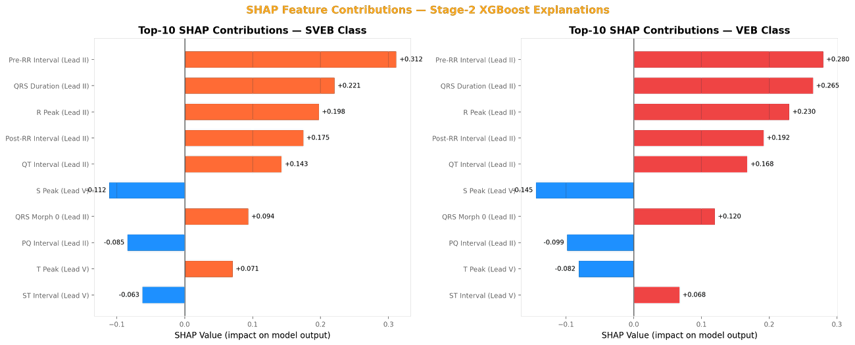
Fig. 12. SHAP feature contributions for SVEB (left) and VEB (right).
V. DISCUSSION
A. Key Findings
Gating by a normal-only autoencoder is an effective way to cut per-beat cost on imbalanced telemetry: the hybrid is 67% faster than XGBoost alone and keeps VEB recall high. It is not free, however. SVEB recall falls from 0.94 to 0.24, so the current hybrid suits settings where ventricular events matter most or where throughput is the binding constraint. In the optimization study, GWO gave the best discrimination, COA the smallest and fastest model, and the untuned baseline the best specificity, so the choice of optimizer should follow the deployment objective.
B. Limitations
Development is by beat not patient, which means that there can be beats present in both the training and test sets which belong to one patient; results can overestimate performance on new patients. (ii) Pre-extracted features are used instead of raw waveforms for the study. (iii) There was no repeated seed or confidence interval, and AUPRC differences were small for each optimizer with 36 evaluations. (iv) There are only 15 samples in the class Q, and the class is effectively unlearnable. The effect of the tuned AEs on SVEB recall is not measured but they are evaluated as stand-alone detectors prior to being used as the Stage-1 gate. (vi) The throughput is provided for machines which are used in batch mode. (vii) None of the Redis Streams path is end-to-end verified or implemented in drift detection.
C. Future Work
Patient-level splits and an external dataset are the first priority. Next are plugging the tuned autoencoders into the gate, lowering the threshold percentile or adding an SVEB-specific path to recover SVEB recall, raw-waveform inputs, and drift monitoring.
VI. CONCLUSION
We built and evaluated the streaming ECG arrhythmia pipeline in which a normal-only autoencoder gate reduces its classification cost by 67% relative to XGBoost alone as well as ablation study on nature based optimization algorithm, at a quantified cost in SVEB recall, and showed how metaheuristic tuning changes the gate’s accuracy, size and speed. The documented trade-offs and limitations we mentioned in here define the next steps toward clinical-grade evaluation.
REFERENCES
[1] World Health Organization, “Cardiovascular diseases (CVDs),” Fact sheet. [Online]. Available: https://www.who.int/news-room/fact-sheets/detail/cardiovascular-diseases-(cvds). Accessed: Oct. 25, 2026.
[2] G. B. Moody and R. G. Mark, “The impact of the MIT-BIH Arrhythmia Database,” IEEE Eng. Med. Biol. Mag., vol. 20, no. 3, pp. 45–50, 2001.
[3] A. L. Goldberger et al., “PhysioBank, PhysioToolkit, and PhysioNet: Components of a new research resource for complex physiologic signals,” Circulation, vol. 101, no. 23, pp. e215–e220, 2000.
[4] P. de Chazal, M. O’Dwyer, and R. B. Reilly, “Automatic classification of heartbeats using ECG morphology and heartbeat interval features,” IEEE Trans. Biomed. Eng., vol. 51, no. 7, pp. 1196–1206, Jul. 2004.
[5] U. R. Acharya et al., “A deep convolutional neural network model to classify heartbeats,” Comput. Biol. Med., vol. 89, pp. 389–396, 2017.
[6] A. Y. Hannun et al., “Cardiologist-level arrhythmia detection and classification in ambulatory electrocardiograms using a deep neural network,” Nat. Med., vol. 25, no. 1, pp. 65–69, 2019.
[7] R. Chalapathy and S. Chawla, “Deep learning for anomaly detection: A survey,” arXiv:1901.03407, 2019.
[8] Association for the Advancement of Medical Instrumentation, Testing and Reporting Performance Results of Cardiac Rhythm and ST Segment Measurement Algorithms, ANSI/AAMI EC57:2012, 2012.
[9] J. Kreps, N. Narkhede, and J. Rao, “Kafka: A distributed messaging system for log processing,” in Proc. NetDB Workshop, 2011.
[10] M. Armbrust et al., “Structured Streaming: A declarative API for real-time applications in Apache Spark,” in Proc. ACM SIGMOD Int. Conf. Manage. Data, 2018, pp. 601–613.
[11] F. Pedregosa et al., “Scikit-learn: Machine learning in Python,” J. Mach. Learn. Res., vol. 12, pp. 2825–2830, 2011.
[12] G. E. Hinton and R. R. Salakhutdinov, “Reducing the dimensionality of data with neural networks,” Science, vol. 313, no. 5786, pp. 504–507, 2006.
[13] D. P. Kingma and J. Ba, “Adam: A method for stochastic optimization,” in Proc. 3rd Int. Conf. Learn. Represent. (ICLR), 2015.
[14] T. Chen and C. Guestrin, “XGBoost: A scalable tree boosting system,” in Proc. 22nd ACM SIGKDD Int. Conf. Knowl. Discovery Data Mining, 2016, pp. 785–794.
[15] J. Kennedy and R. Eberhart, “Particle swarm optimization,” in Proc. IEEE Int. Conf. Neural Netw., 1995, vol. 4, pp. 1942–1948.
[16] S. Mirjalili, S. M. Mirjalili, and A. Lewis, “Grey wolf optimizer,” Adv. Eng. Softw., vol. 69, pp. 46–61, 2014.
[17] M. Dehghani, Z. Montazeri, E. Trojovská, and P. Trojovský, “Coati optimization algorithm: A new bio-inspired metaheuristic algorithm for solving optimization problems,” Knowl.-Based Syst., vol. 259, Art. no. 110011, 2023.
[18] S. M. Lundberg and S.-I. Lee, “A unified approach to interpreting model predictions,” in Adv. Neural Inf. Process. Syst. 30, 2017, pp. 4765–4774.

