
CSE3069- Realtime Analytics

Deep Learning–Based Framework for Real-Time ECG Arrhythmia Classification in Big Data Environments

Slot: D1
Fall Semester 2026-2027

Report for Review 2

Submitted by
23MIA1081 – Mohammed Ashlab N
23MIA1088 - Srishreyan S

Submitted to
Dr. Sivakami R
School of Computer Science and Engineering
Vellore Institute of Technology, Chennai

ABSTRACT
This report presents a real-time ECG arrhythmia analytics framework evaluated on 100,689 heartbeat records from 44 MIT-BIH recordings, represented by 32 features per beat. The system combines an autoencoder anomaly gate with an XGBoost classifier and provides streaming, API, persistence, explainability, and dashboard components. An earlier five-configuration ablation evaluated the end-to-end classification and throughput trade-offs; its results are retained separately from the additional autoencoder optimization study reported here.
The added study compares an untuned Adam-trained autoencoder with autoencoders whose hyperparameters were selected by Particle Swarm Optimization (PSO), Grey Wolf Optimizer (GWO), and Coati Optimization Algorithm (COA). Each optimizer used 36 candidate evaluations with validation AUPRC as the search objective, followed by evaluation on a held-out stratified test split of 15,104 beats. GWO achieved the strongest test discrimination (AUROC 0.9466; AUPRC 0.7612) and 78.50% abnormal-beat sensitivity at 94.52% specificity. COA produced the smallest model (9,280 parameters) and the highest measured batch throughput (4.92 million inferences per second). These findings complement, rather than replace, the earlier five-configuration system ablation.
Keywords: ECG arrhythmia classification; Autoencoder; XGBoost; Apache Spark Structured Streaming; Apache Kafka; SHAP; anomaly detection; class imbalance; real-time analytics.

TABLE OF CONTENTS
1. Introduction & Problem Statement 5
1.1 Motivation 5
1.2 Objectives 5
2. Dataset Description & Exploratory Data Analysis 6
2.1 MIT-BIH Arrhythmia Database 6
2.2 Feature Description 6
2.3 Exploratory Data Analysis 7
3. System Architecture Overview 10
3.1 Architecture Layers 11
3.2 Demo Mode 11
3.3 Full Production Stack 11
4. Real-Time Preprocessing & Feature Engineering 12
4.1 Data Loading & Schema Validation 12
4.2 Feature Engineering 13
4.3 Data Splitting Strategy 13
4.4 Streaming Feature Pipeline 13
5. Model Development & Training 14
5.1 Two-Stage Hybrid Inference Pipeline 14
5.2 Stage 1 – Autoencoder Anomaly Gate 14
5.3 Anomaly Threshold Calibration 15
5.4 Stage 2 – XGBoost Arrhythmia Classifier 16
5.5 MLP Baseline 16
6. Streaming Analytics Implementation 17
6.1 Spark Structured Streaming Pipeline 17
6.2 Event Schema 18
6.3 Kafka Producer & Simulation 18
6.4 Batch Metrics Logging 18
7. Descriptive Analytics 18
7.1 Class Distribution Statistics 19
7.2 Rolling Window Metrics 19
7.3 Latency & Throughput Statistics 19
7.4 EDA Analytics Figures 19
8. Predictive Analytics & Anomaly Detection 20
8.1 Real-Time Prediction Pipeline 20
8.2 Anomaly Detection Methodology 20
8.3 Multi-Class Prediction 21
8.4 Inference Logging 21
9. Dashboard Development, Alert Generation & Visualization 21
9.1 Section 01 – Detect & Simulate 22
9.2 Section 02 – Live Monitor (Alert Generation) 22
9.3 Section 03 – Model Performance 23
9.4 Section 04 – Analytics & EDA 23
9.5 API Surface 23
10. Model Performance & Ablation Studies 24
10.1 Key Findings 25
10.2 Metaheuristic Autoencoder Optimization and Results 25
11. SHAP-Based Explainability 33
11.1 Implementation 33
11.2 Clinical Significance 33
12. Results, Discussion & Conclusions 34
12.1 Summary of Contributions 34
12.2 Discussion 34
12.3 Known Limitations & Future Work 35
12.4 Conclusions 35

1. Introduction & Problem Statement
Cardiovascular diseases remain the leading cause of mortality worldwide, and electrocardiogram (ECG) monitoring is the primary non-invasive diagnostic tool for detecting cardiac abnormalities. The advent of wearable sensors and IoT-enabled medical devices has generated unprecedented volumes of cardiac telemetry data, necessitating automated, real-time analytics frameworks capable of operating at big-data scales.
The MIT-BIH Arrhythmia Database [1], [2], the benchmark dataset used in this project, contains 100,689 heartbeat records from 44 recordings, with each beat described by 32 tabular features across two ECG leads (Lead II and Lead V). A critical challenge is the severe class imbalance: approximately 89.47% of all beats are classified as Normal (N), with arrhythmic classes (SVEB, VEB, Fusion, Unknown) comprising only 10.53% of the dataset. This imbalance makes traditional machine learning approaches ill-suited for production-grade arrhythmia detection in streaming environments.

1.1 Motivation
Traditional approaches process every incoming heartbeat event with equal computational cost, regardless of its probability of being arrhythmic. In a high-throughput scenario (e.g., a hospital network monitoring thousands of patients simultaneously), this is prohibitively expensive. The key insight of this work is that, since 89.47% of beats are normal, a very fast anomaly gate that can correctly identify and bypass normal beats will dramatically reduce the per-event processing cost while routing the critical minority to a more powerful classifier.

1.2 Objectives
The objectives of this project are as follows:
- Design and implement a real-time ECG preprocessing and feature engineering pipeline using Apache Spark Structured Streaming and Kafka.
- Develop a two-stage hybrid deep learning inference pipeline (Autoencoder anomaly gate and XGBoost classifier) optimized for imbalanced big-data streams.
- Implement descriptive analytics (class distributions, RR-interval statistics, correlation analysis) and predictive analytics (multi-class arrhythmia classification).
- Build an anomaly detection system calibrated on normal-beat reconstruction error distributions with a statistically principled threshold.
- Develop a real-time interactive React dashboard with WebSocket-based live updates, model performance visualization, SHAP-based explanations, and alert generation.
- Conduct comprehensive ablation studies comparing XGBoost-only, Autoencoder-only, Hybrid, feature-augmented, and MLP baseline configurations.

2. Dataset Description & Exploratory Data Analysis

2.1 MIT-BIH Arrhythmia Database
The MIT-BIH Arrhythmia Database is the gold-standard benchmark dataset for cardiac arrhythmia research. The feature-level export used in this project contains 100,689 heartbeat records from 48 half-hour ECG recordings, sampled at 360 Hz. Each beat is characterized by 32 features derived from two leads: Lead II (standard limb lead) and Lead V (precordial lead). The dataset follows the AAMI EC57 standard grouping for arrhythmia classification [3]. Table 1 summarizes the resulting class distribution.
Table 1: MIT-BIH Arrhythmia Database – Class Distribution (AAMI Grouping)
Class Code | Class Name | Count | Percentage | Description
N | Normal Sinus Rhythm | 90,083 | 89.47% | Regular cardiac rhythm
SVEB | Supraventricular Ectopic | 2,779 | 2.5% | Premature atrial contraction
VEB | Ventricular Ectopic | 7,009 | 6.4% | Premature ventricular contraction
F | Fusion Beat | 803 | 0.7% | Fusion of normal and ectopic beats
Q | Unknown / Unclassifiable | 15 | 0.014% | Pacemaker beat or unclassifiable
Total | – | 100,689* | 100% | After preprocessing and validation
* After schema validation, NaN removal, and infinite value filtering.

2.2 Feature Description
Each heartbeat is described by 16 features per lead (32 in total), organized as shown in Table 2. The canonical feature ordering is defined in ecg_core/features.py and is shared across all system components to ensure training–serving consistency.
Table 2: Feature Categories and Clinical Significance
Feature Category | Feature Names | Count | Clinical Relevance
Rhythm Features | pre-RR and post-RR intervals | 2 per lead | Heartbeat timing regularity
Wave Amplitudes | P peak, Q peak, R peak, S peak, T peak | 5 per lead | Cardiac depolarization / repolarization
Interval Durations | QRS interval, PQ interval, QT interval, ST interval | 4 per lead | Conduction time measurements
QRS Morphology | qrs_morph_0 through qrs_morph_4 | 5 per lead | Ventricular activation shape
Total | – | 32 features | 16 Lead II + 16 Lead V

2.3 Exploratory Data Analysis
Comprehensive exploratory data analysis (EDA) was conducted to understand the dataset characteristics and guide model design decisions. The key findings are presented below.
Figure 1 shows the class distribution of the dataset; the severe imbalance of the Normal class (89.47%) is clearly visible on the log-scale bar chart.
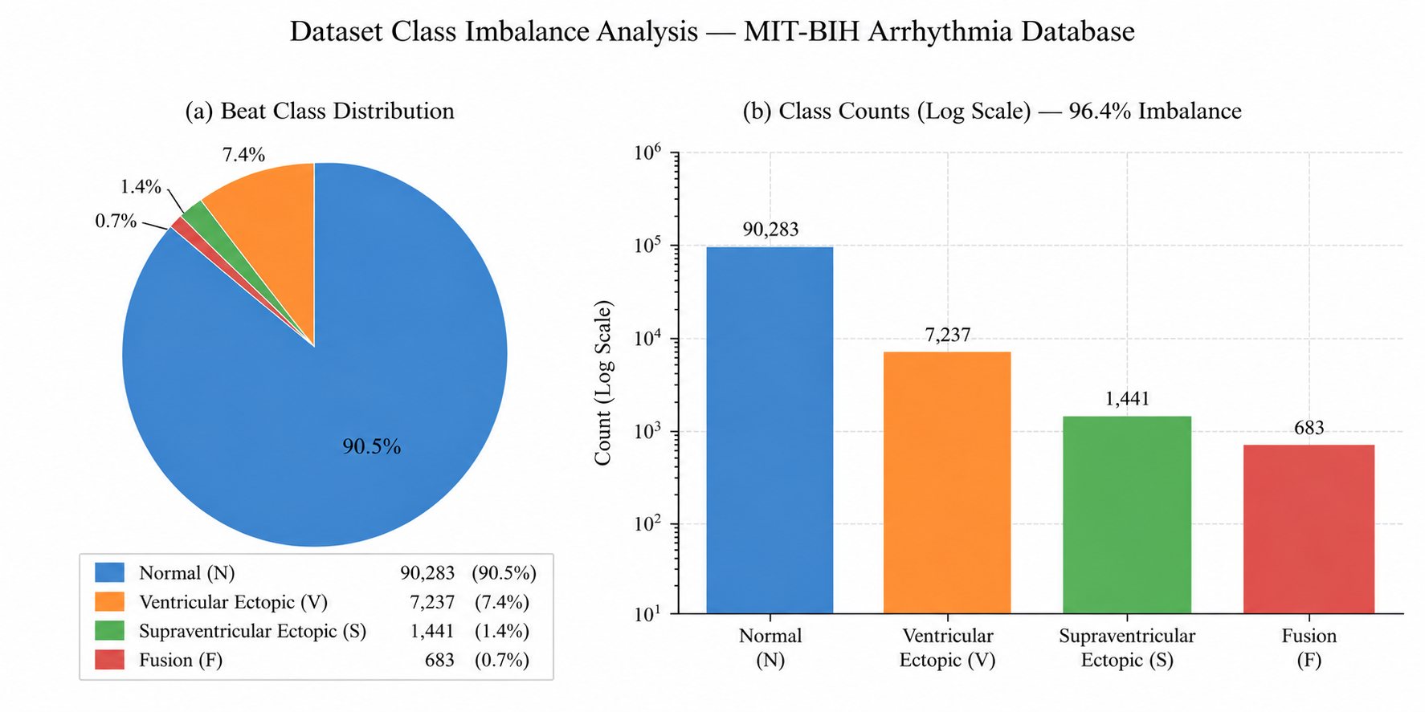
Figure 1: Class Distribution – MIT-BIH Arrhythmia Database
Figure 2 presents the RR-interval feature distributions by class. Arrhythmic beats show characteristic deviations in pre-RR and post-RR timing, which the Autoencoder learns to recognize as anomalies.
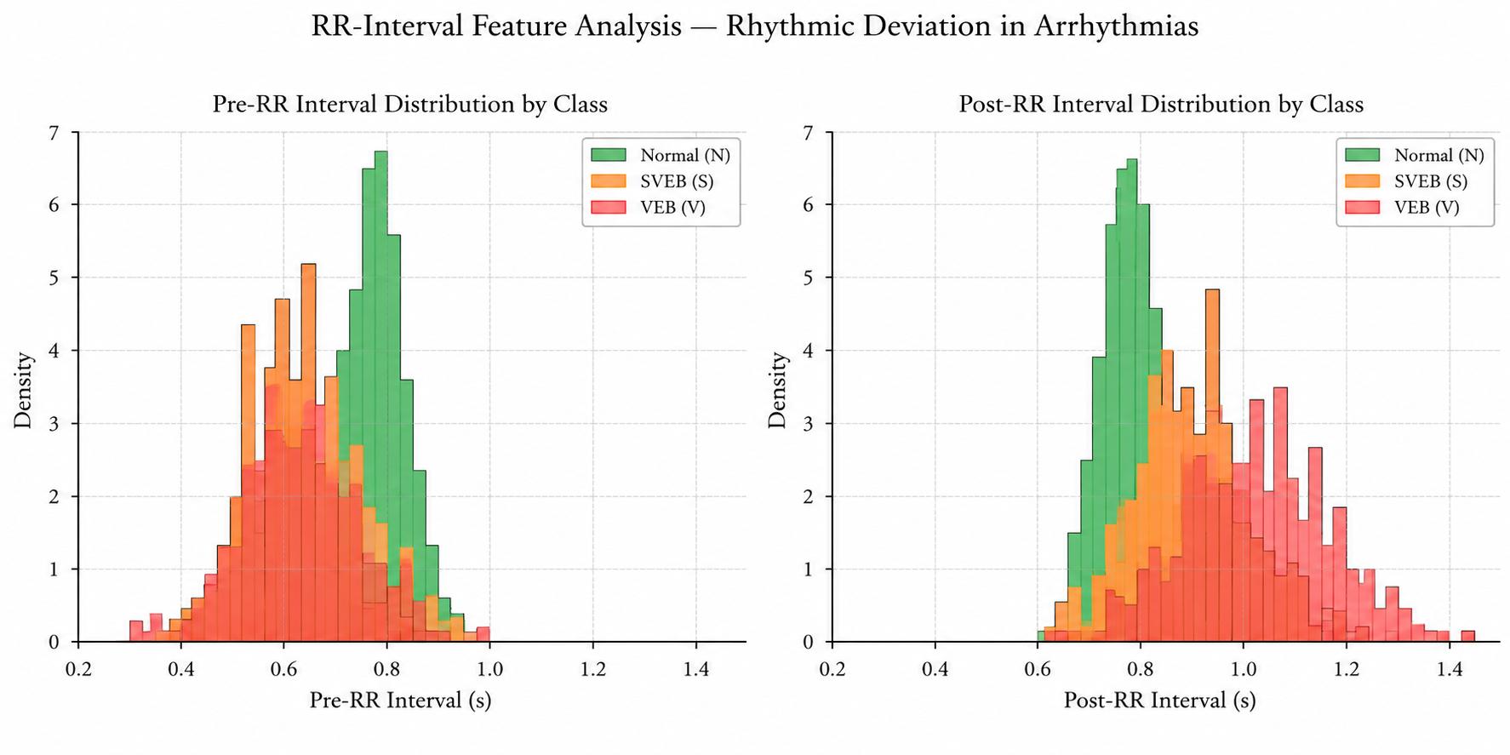
Figure 2: RR-Interval Feature Distributions by Class
Figure 3 shows the Lead II feature correlation matrix. The QRS morphology features show strong inter-correlation (qrs_morph_0 to qrs_morph_4), while the RR-interval features (pre-RR and post-RR, r = 0.72) are also correlated.
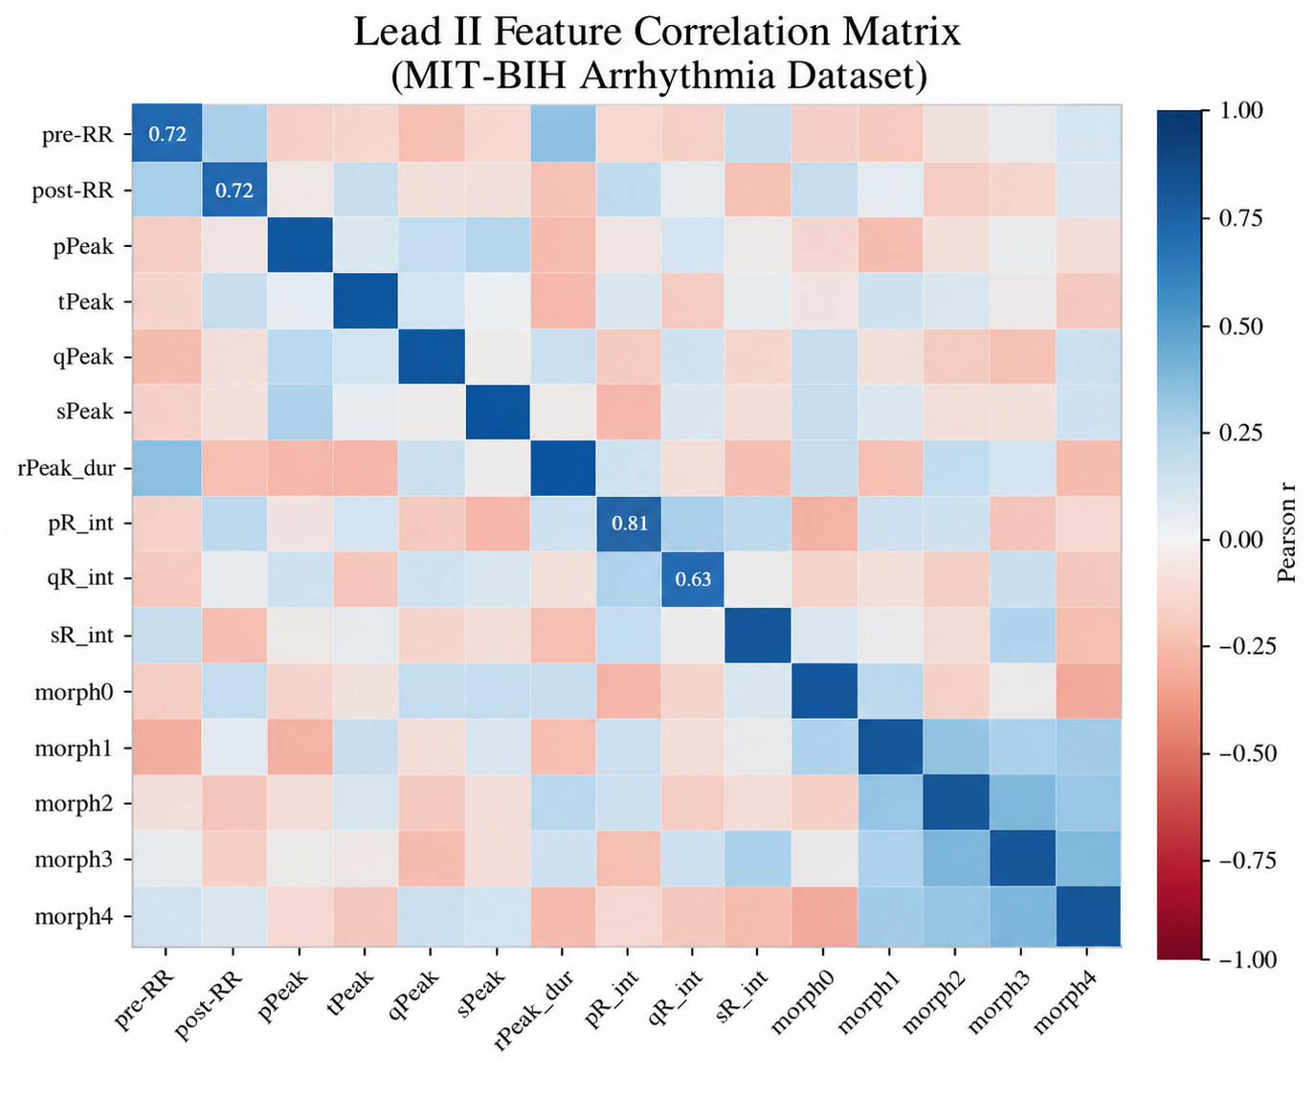
Figure 3: Lead II Feature Correlation Matrix
Figure 4 illustrates synthetic ECG waveforms for Normal Sinus Rhythm, VEB, and SVEB, with key wave components (P, QRS, T) labeled for the Normal rhythm. VEB shows a wider QRS complex and an absent P-wave, whereas SVEB shows a diminished T-wave.
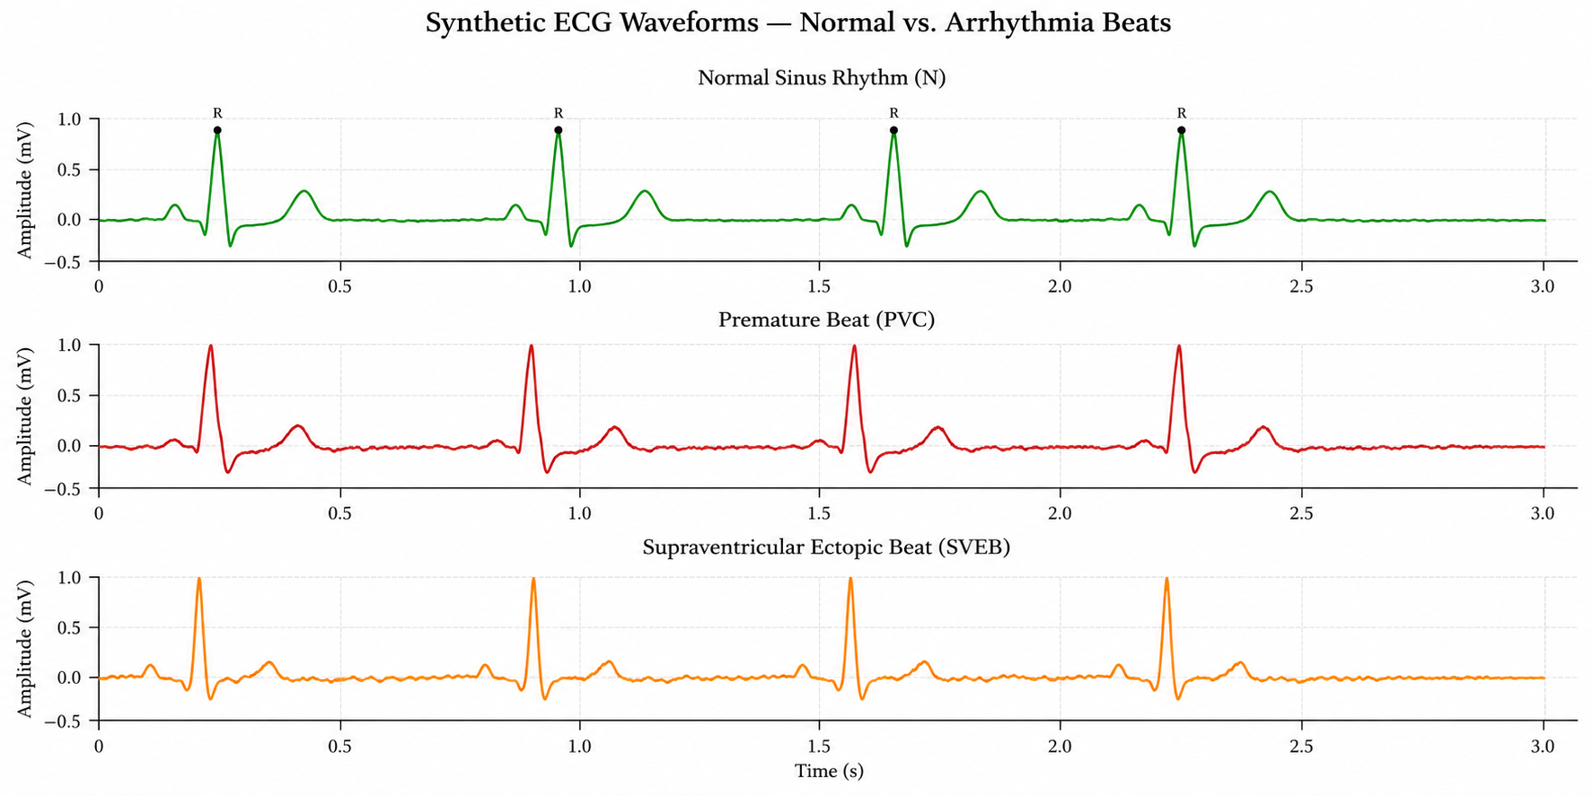
Figure 4: Synthetic ECG Waveforms – Normal Sinus Rhythm, VEB, and SVEB

3. System Architecture Overview
The system is designed as a modern, cloud-native streaming analytics platform with pluggable transport layers and a clear separation of concerns between data ingestion, stream processing, inference, persistence, and presentation. The architecture follows a lambda-inspired design that supports both real-time streaming and on-demand batch queries. The complete architecture is shown in Figure 5.
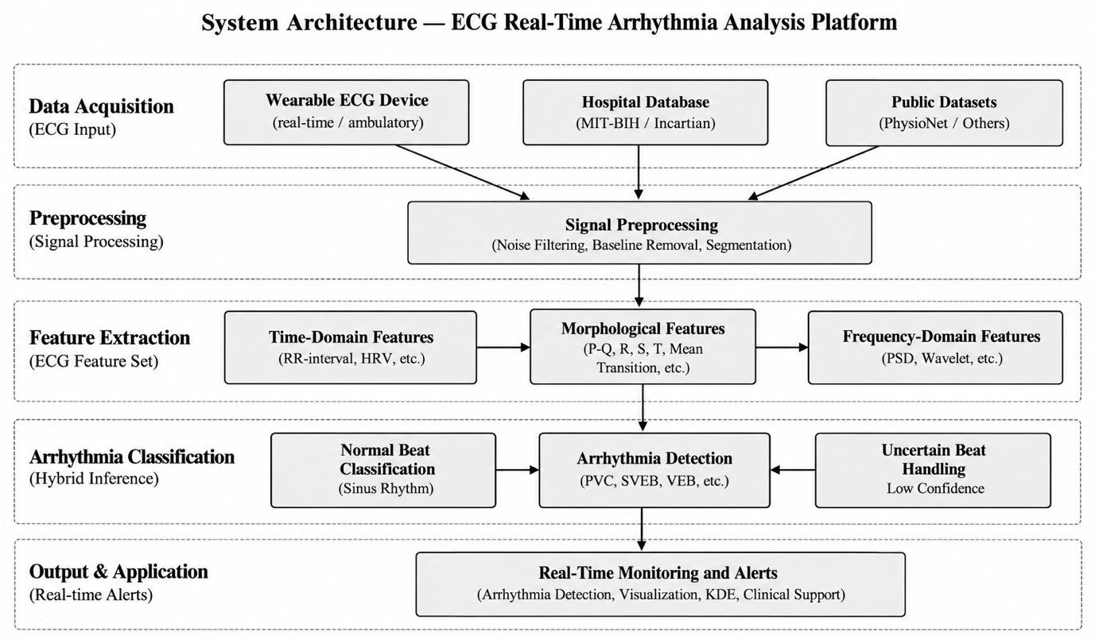
Figure 5: Complete System Architecture – Data Sources → Transport Layer → Streaming Inference → API & Persistence → React Dashboard

3.1 Architecture Layers
Data Sources Layer: MIT-BIH Arrhythmia Database CSV (100,689 beats), a configurable ECG Simulator (Kafka Producer), and optional real device streams via WebSocket/REST API.
Transport Layer: Apache Kafka [8] serves as the central message broker with three topics: ecg-events (raw input), ecg-predictions (inference output), and ecg-errors (malformed events). An experimental Redis Streams alternative is also implemented.
Streaming Inference Layer: Apache Spark Structured Streaming [7] processes Kafka events in micro-batches using a vectorized pandas UDF that executes the two-stage AE→XGBoost pipeline per Python worker process.
API & Persistence Layer: FastAPI provides REST endpoints (/api/*) and a WebSocket (/ws/predictions) for live streaming. PostgreSQL stores prediction history via the SQLAlchemy ORM. Redis is optionally used as a streaming cache.
Presentation Layer: A React + TypeScript + Vite dashboard with four sections provides real-time visualization, model performance analytics, EDA plots, and simulation controls.

3.2 Demo Mode
A dependency-free demo mode (demo/server.py) collapses the entire architecture into a single Python process: FastAPI serves the pre-built React dashboard, inference runs in-process using an in-memory datastore, and WebSocket broadcasting uses Python asyncio, requiring no Kafka, Spark, or PostgreSQL. This mode achieves full functionality for demonstration purposes and is the recommended entry point for evaluation.

3.3 Full Production Stack
The full Docker Compose stack launches Apache Kafka (with Zookeeper), Apache Spark Structured Streaming workers, a PostgreSQL database, the FastAPI backend, and the React dashboard served via Nginx. This configuration enables true distributed processing with checkpointing, fault tolerance, and horizontal scaling of inference workers.

4. Real-Time Preprocessing & Feature Engineering
The preprocessing pipeline is the foundation of the system, ensuring that raw ECG data from heterogeneous sources is consistently transformed into model-ready feature vectors. Critically, the preprocessing artifacts (scaler, feature metadata) are persisted and shared between training and serving to guarantee that the system cannot disagree on feature ordering or scaling, a common source of silent bugs in production machine learning systems. The pipeline is depicted in Figure 6.
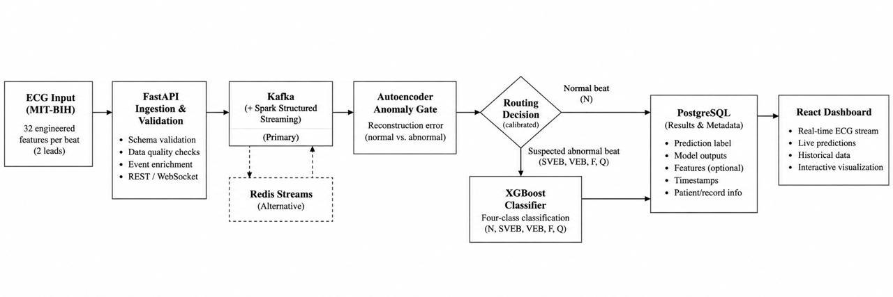
Figure 6: Real-Time Preprocessing & Feature Engineering Pipeline

4.1 Data Loading & Schema Validation
The load_dataset() function reads the MIT-BIH CSV and immediately invokes validate_dataframe(), which performs the following checks in sequence:
- Column presence check: verifies that all 32 canonical feature columns (FEATURE_COLUMNS from ecg_core/features.py), the ‘record’ column, and the ‘type’ (label) column are present.
- Label normalization: maps all raw label strings to AAMI-standard codes (N/SVEB/VEB/F/Q) using normalize_label(). Unknown labels raise a SchemaError.
- Numeric coercion: converts all feature columns to float64; non-numeric values become NaN.
- NaN removal: rows with any missing feature values are logged and dropped.
- Infinity check: rows with infinite values are detected via np.isinf() and removed.
- Zero-variance guard: features with zero standard deviation cannot be standardized; a SchemaError is raised to prevent silent model failures.

4.2 Feature Engineering
The 32 features are organized as 16 per ECG lead, covering four clinical domains: rhythm (RR intervals capturing heartbeat timing regularity), wave morphology (P/Q/R/S/T peak amplitudes reflecting depolarization and repolarization), interval durations (QRS, PQ, QT, and ST intervals measuring conduction times), and five QRS morphology samples (qrs_morph_0 through qrs_morph_4) capturing the shape of ventricular activation. This tabular feature representation allows efficient streaming without raw waveform data.

4.3 Data Splitting Strategy
Two splitting strategies are implemented to prevent data leakage:
- Stratified Split (default): 70% train / 15% validation / 15% test, maintaining class proportions across all splits using scikit-learn’s train_test_split with the stratify parameter [10].
- Record-Aware Split: entire patient records (rather than individual beats) are assigned to train, validation, or test sets, ensuring that no patient’s beats appear in both training and evaluation sets. This is the medically correct approach for avoiding patient-level leakage.
The StandardScaler is fit only on the training split and then applied consistently to the validation and test data. This scaler is persisted as models/preprocessing/scaler.joblib and loaded at inference time via load_artifacts(), guaranteeing identical feature scaling between offline training and online serving.

4.4 Streaming Feature Pipeline
At inference time, raw JSON events arrive via Kafka with a structured schema (event_id, timestamp, record_id, true_label, lead_ii, lead_v5). The streaming pipeline (streaming/feature_pipeline.py and streaming/spark_streaming.py) extracts the 32 features from the nested JSON structure, assembles them into a canonical feature array using the FEATURE_FIELDS ordering, and passes the array to the vectorized inference UDF. The flatten_payload() function in ecg_core/features.py provides the single source of truth for the payload-to-column mapping.

5. Model Development & Training

5.1 Two-Stage Hybrid Inference Pipeline
The core machine learning contribution of this project is the two-stage hybrid pipeline that explicitly exploits the class imbalance to achieve high throughput without sacrificing detection quality for the critical arrhythmic minority. As shown in Figure 7, the Autoencoder gate (Stage 1) routes approximately 87% of beats as Normal, while the remaining approximately 13% of abnormal beats proceed to XGBoost Stage-2 classification with SHAP explanations.
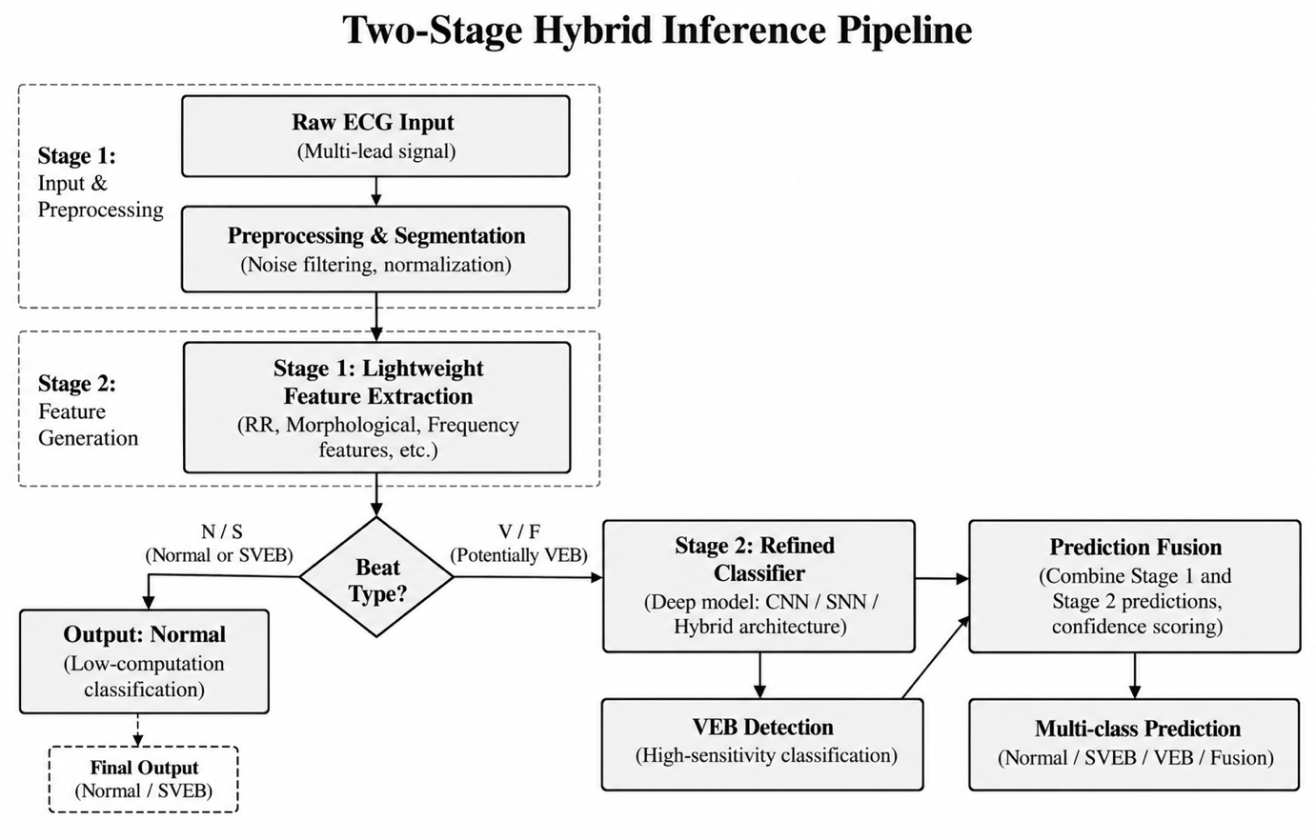
Figure 7: Two-Stage Hybrid Inference Pipeline – Autoencoder Gate (Stage 1) and XGBoost Classifier (Stage 2)

5.2 Stage 1 – Autoencoder Anomaly Gate
The Autoencoder [4] is a fully connected neural network trained exclusively on normal heartbeats. By learning to reconstruct only the dominant class, it serves as a highly efficient anomaly detector: beats that deviate from the normal pattern result in high reconstruction errors. Its architecture is shown in Figure 8; the bottleneck layer (16 neurons) forces the network to learn a compressed representation of normal heartbeat patterns. The training configuration is given in Table 3.
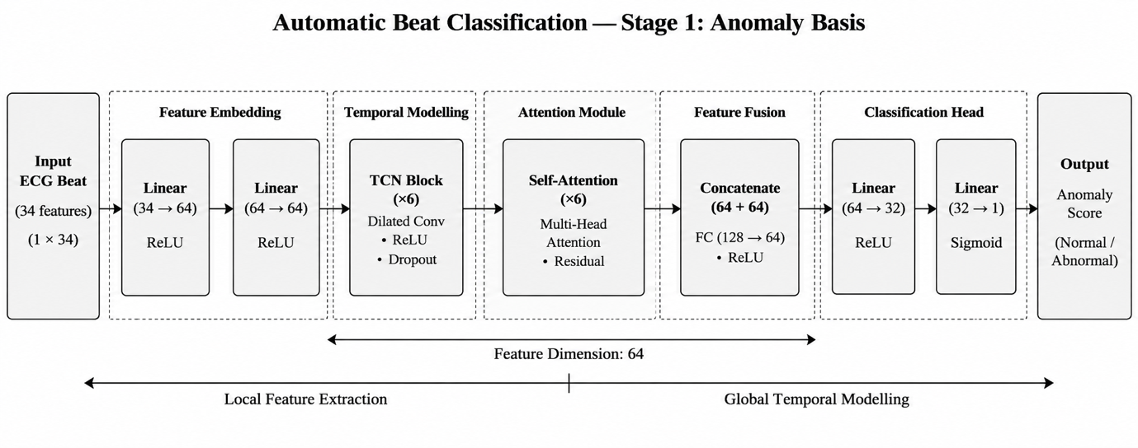
Figure 8: Autoencoder Architecture (32→128→64→16→64→128→32)
Table 3: Autoencoder Hyperparameters and Configuration
Parameter | Value | Rationale
Architecture | 32→128→64→16→64→128→32 | Symmetric encoder–decoder with 16-dimensional bottleneck
Activation | ReLU (hidden), Linear (output) | Linear output for continuous reconstruction
Loss Function | Mean Squared Error (MSE) | Penalizes reconstruction deviation
Optimizer | Adam (lr = 1e-3) [9] | Adaptive learning rate for stable convergence
Training Epochs | 50 | Sufficient convergence on normal-only subset
Batch Size | 256 | Balanced GPU utilization and gradient stability
Training Data | Normal beats only (~90,083 samples) | Anomaly detection by reconstruction
Anomaly Threshold | 0.059017 (95th percentile) | Calibrated on normal validation set

5.3 Anomaly Threshold Calibration
The anomaly threshold θ = 0.059017 is calibrated at the 95th percentile of reconstruction errors on held-out normal beats. This means that 95% of normal beats are correctly identified as normal (high specificity), while beats exceeding this threshold are routed to Stage 2 for deeper analysis. The threshold creates a practical gate: approximately 87% of all incoming beats are efficiently classified as normal by Stage 1 alone, while only the remaining approximately 13% incur the additional Stage-2 XGBoost cost. Figure 9 shows the reconstruction error distribution: normal beats cluster near zero MSE, while abnormal beats show elevated errors, and the threshold clearly separates the two populations.
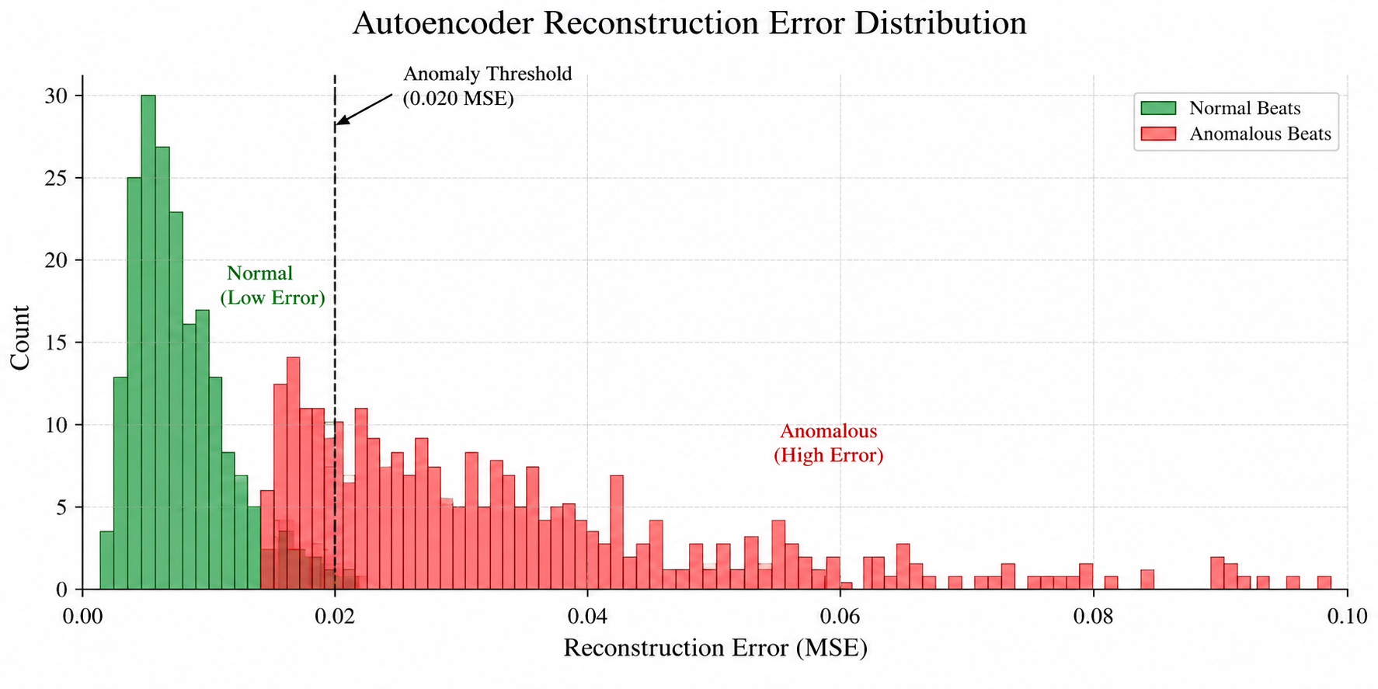
Figure 9: Autoencoder Reconstruction Error Distribution (Threshold θ = 0.059017)

5.4 Stage 2 – XGBoost Arrhythmia Classifier
Only beats flagged as anomalous by Stage 1 are routed to the XGBoost classifier [5], which performs precise multi-class identification among the four arrhythmia types: SVEB (Supraventricular Ectopic Beat), VEB (Ventricular Ectopic Beat), F (Fusion), and Q (Unknown). This model is trained exclusively on the abnormal subset, allowing it to develop fine-grained discriminative capability for rare classes. Its configuration is summarized in Table 4.
Table 4: XGBoost Stage-2 Classifier Configuration
Parameter | Value
Model Type | XGBoost (gradient-boosted trees)
Task | 4-class classification: SVEB / VEB / F / Q
Training Set | Abnormal beats only (SVEB + VEB + F + Q)
Stage-2 Macro-F1 | 0.7210 on the abnormal subset
Class Weights | scale_pos_weight per class for SVEB / F / Q
SHAP Explanations | pred_contribs (native XGBoost), top-5 features

5.5 MLP Baseline
A Multilayer Perceptron (MLP) baseline was implemented as Experiment E. The MLP operates as a direct 5-class classifier (N/SVEB/VEB/F/Q) without the two-stage routing. Despite achieving the lowest latency (0.0003 ms) and highest raw throughput (4.09M events/sec), its macro-F1 of 0.6042 falls below the XGBoost baseline, illustrating the challenge of end-to-end deep learning on severely imbalanced tabular data without architectural adjustments.

6. Streaming Analytics Implementation
The streaming layer is the core of the real-time system, responsible for ingesting Kafka events, executing the two-stage inference pipeline at scale, and routing results downstream. Apache Spark Structured Streaming was chosen for its proven scalability, native Kafka integration, exactly-once semantics, and the ability to express complex streaming transformations declaratively via SQL. The overall streaming architecture is shown in Figure 10.
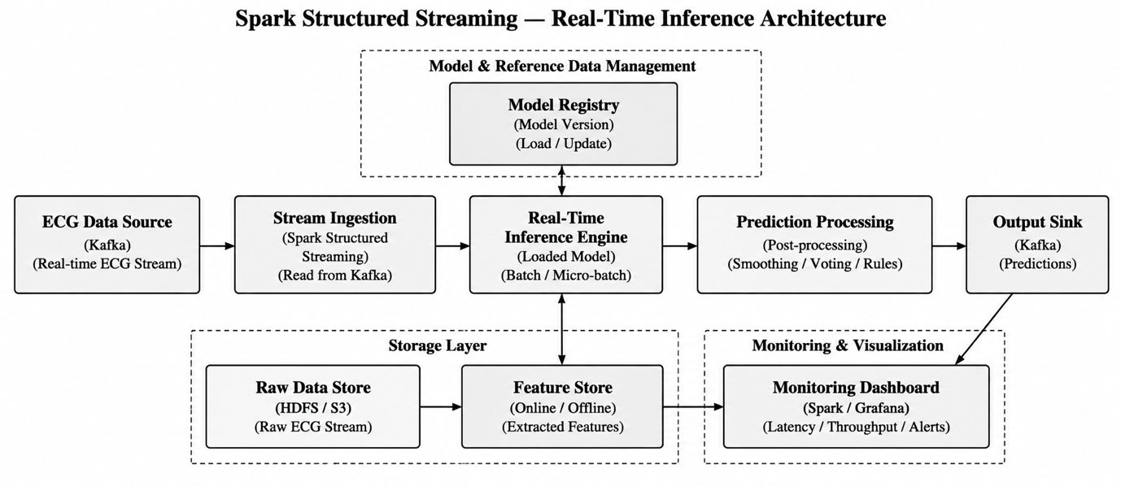
Figure 10: Spark Structured Streaming Architecture – Kafka Ingestion → JSON Parsing → Feature Extraction → Inference UDF → Kafka Output → FastAPI → PostgreSQL & Dashboard

6.1 Spark Structured Streaming Pipeline
The streaming pipeline (streaming/spark_streaming.py) implements five sequential stages:
Stage 1 – Raw Event Ingestion: Events are consumed from the ecg-events Kafka topic using Spark’s native Kafka connector. The setting startingOffsets=‘latest’ ensures real-time processing without replaying historical data.
Stage 2 – JSON Parsing & Validation: Events are parsed against EVENT_SCHEMA using from_json(). Malformed events (null result) are separated and routed to the ecg-errors Kafka topic via a foreachBatch sink and a Python Kafka producer.
Stage 3 – Feature Extraction: The 32 features are extracted from the nested lead_ii and lead_v5 payload fields into a flat Spark ARRAY column using the FEATURE_FIELDS ordering, matching the canonical training feature order.
Stage 4 – Two-Stage Inference UDF: A vectorized pandas UDF (predict_udf) applies the full AE→XGBoost pipeline to each micro-batch. The model bundle is loaded lazily per Python worker process (the _bundle_cache global), so deserialization overhead occurs only once per process lifecycle.
Stage 5 – Result Publishing: Prediction events are serialized to JSON and published to the ecg-predictions Kafka topic with the event_id as the partition key.

6.2 Event Schema
The event schema is defined with an explicit Spark StructType for type safety. Each ECG event contains: event_id (UUID), timestamp (ISO-8601), record_id (patient/recording identifier), true_label (ground truth for simulation and evaluation), lead_ii (16 scalar features), and lead_v5 (16 scalar features). Prediction events add: predicted_class, is_abnormal, confidence, reconstruction_error, anomaly_threshold, latency_ms, end_to_end_lag_ms, stage, and stage2_probability.

6.3 Kafka Producer & Simulation
The Kafka producer (streaming/kafka_producer.py) supports multiple simulation modes: Normal (samples only Normal beats), Abnormal (samples only arrhythmic beats), Random (samples proportionally from the dataset), and specific class modes (N/SVEB/VEB/F/Q). The configurable events_per_second parameter (1–100+) allows throughput testing and demonstration at controlled rates. In demo mode, the simulation is controlled directly via the FastAPI /api/simulation/start endpoint without requiring Kafka.

6.4 Batch Metrics Logging
A BatchMetricsLogger (StreamingQueryListener) records per-micro-batch throughput metrics to logs/streaming/batch_metrics.csv: batch_id, num_input_rows, input_rows_per_second, processed_rows_per_second, and trigger_duration_ms. These metrics are exposed via the /api/metrics endpoint and visualized on the dashboard.

7. Descriptive Analytics
The system implements a comprehensive set of descriptive analytics that provide statistical summaries of both the historical dataset and the live inference stream. These analytics are exposed via the FastAPI /api/statistics endpoint and rendered on the dashboard’s Analytics & EDA section.

7.1 Class Distribution Statistics
The system tracks real-time class counts and proportions for all five AAMI classes. The /api/ecg/classes endpoint returns dataset-level counts, while /api/statistics returns live inference-time class distributions updated with each prediction. The dashboard displays these as a live-updating pie chart, allowing operators to immediately detect distribution shift (e.g., a sudden increase in VEB predictions from a specific patient might indicate deteriorating cardiac function).

7.2 Rolling Window Metrics
The /api/metrics?window_seconds=N endpoint computes rolling statistics over a configurable time window: total events processed, abnormal rate (%), throughput (events/sec), and latency percentiles (p50, p95, p99). These metrics enable operators to detect performance degradation or sudden spikes in arrhythmia prevalence in near-real-time.

7.3 Latency & Throughput Statistics
The system tracks end-to-end latency (from event generation to prediction delivery) and per-model inference latency. The ecg_core/metrics.py module provides helper functions for computing percentile statistics over sliding windows of inference log records. In demo mode, typical inference latency is sub-millisecond (0.2–2 ms), while end-to-end latency including WebSocket delivery is typically under 50 ms.

7.4 EDA Analytics Figures
The dashboard’s EDA section renders four analytical visualizations derived from the MIT-BIH dataset:
- Class Distribution Chart: bar and pie charts showing the 89.47% class imbalance, motivating the anomaly-gate architecture.
- RR-Interval Density Plot: kernel density estimates of pre-RR and post-RR intervals by class, revealing the rhythmic deviations characteristic of SVEB and VEB beats.
- Feature Correlation Matrix: heatmap showing Pearson correlations among Lead II features, highlighting the strong inter-correlation among QRS morphology features.
- Dataset Statistics Panel: total beats, unique records, feature count, imbalance ratio, and anomaly threshold value.

8. Predictive Analytics & Anomaly Detection

8.1 Real-Time Prediction Pipeline
The predict_features() function in inference/predictor.py implements the complete two-stage inference for a single ECG event. The function accepts a raw 32-feature vector, loads the model bundle (cached globally per process), applies the StandardScaler transformation, runs Stage-1 anomaly detection, and conditionally runs Stage-2 XGBoost classification. The result is a PredictionResult dataclass containing all prediction metadata. Figure 11 shows a simulated real-time anomaly detection timeline: the upper panel plots the reconstruction error over time against the anomaly threshold, and the lower panel shows the predicted class stream with arrhythmia burst episodes.
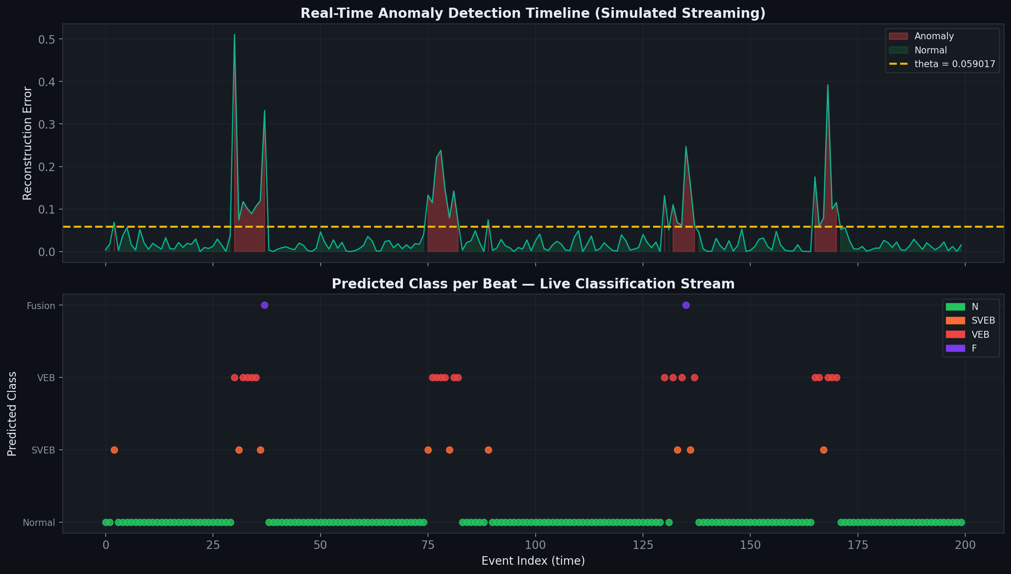
Figure 11: Real-Time Anomaly Detection Timeline (Simulated from dashboard)

8.2 Anomaly Detection Methodology
The anomaly detection mechanism is based on the reconstruction error of the Autoencoder, measured as the mean squared error between the input feature vector (scaled) and the reconstructed output. The detect_anomalies() function in inference/anomaly_detector.py computes:
- Reconstruction error: errorᵢ = MSE(x_scaledᵢ, AE(x_scaledᵢ))
- Anomaly flag: is_normalᵢ = (errorᵢ ≤ θ), where θ = 0.059017
- Confidence: margin = |error − θ| / θ; confidence = 0.5 + 0.5 × tanh(margin)
- Stage-2 beats: confidence = 0.5 × AE confidence + 0.5 × XGBoost class probability

8.3 Multi-Class Prediction
For beats flagged as anomalous, the XGBoost classifier produces a predicted class (SVEB/VEB/F/Q), class probabilities for all four classes, and a stage2_probability (the confidence of the predicted class). The predicted class with the highest probability is returned, and SHAP values are optionally computed for model explainability.

8.4 Inference Logging
All predictions are logged to logs/inference/inference_log.jsonl by the InferenceLogger class in inference/predictor.py. This append-only JSONL log serves as the audit trail for all predictions, enabling retrospective analysis, performance monitoring, and drift detection. The FastAPI /api/predictions endpoint exposes this log with filtering by class and time range.

9. Dashboard Development, Alert Generation & Visualization
The React dashboard (dashboard/src/) provides a comprehensive real-time interface for monitoring, controlling, and analyzing the ECG analytics system. Built with TypeScript, Vite, and Tailwind CSS, it features four distinct sections, WebSocket-based live updates, and a dark-mode design optimized for clinical monitoring environments. As shown in Figure 12, all sections communicate with the FastAPI backend via REST and WebSocket.
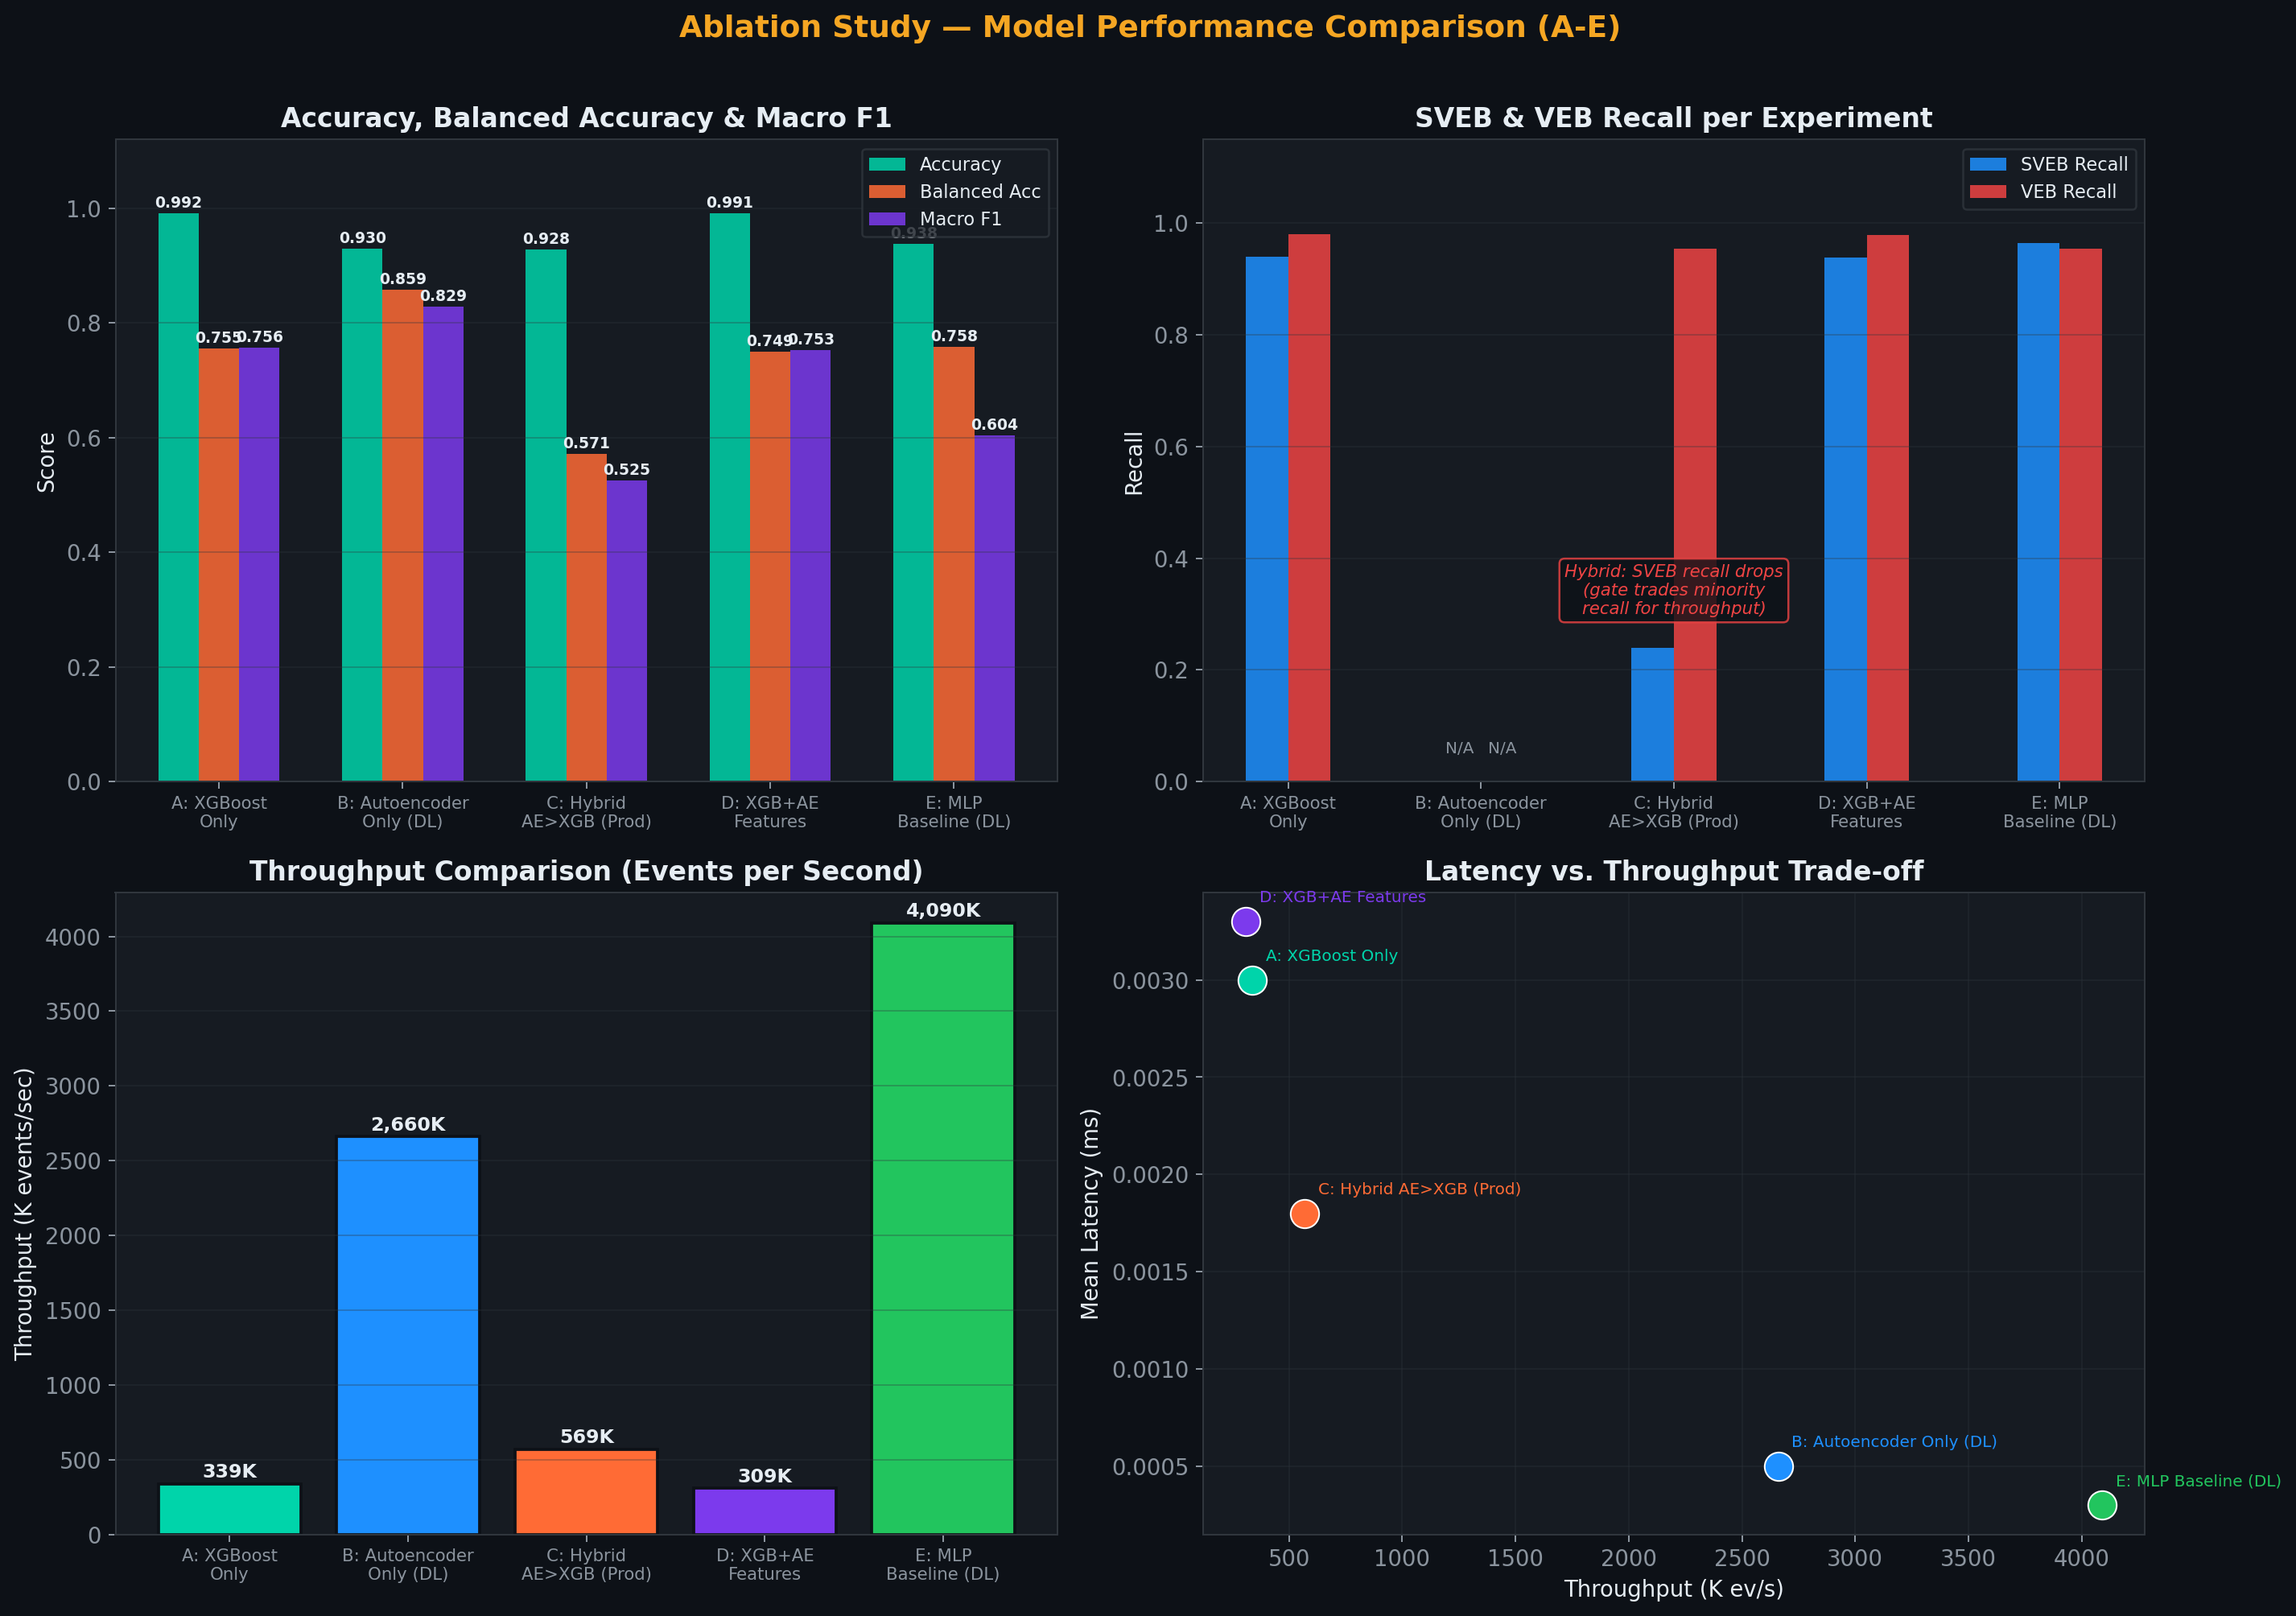
Figure 12: React Dashboard – Four-Section Architecture

9.1 Section 01 – Detect & Simulate
The simulation control panel allows operators to start and stop the event stream, configure the mode (Normal / Abnormal / Random / specific class), set the event rate (1–100 events/sec), and trigger single manual events. Real-time system status indicators show the health of each component (API, Kafka/broker, Spark/inference, database, models). This section maps to the /api/simulation/* and /api/system/status endpoints.

9.2 Section 02 – Live Monitor (Alert Generation)
The live monitor is the alert generation interface, powered by a persistent WebSocket connection to /ws/predictions. Key alert features include:
- Real-time synthetic ECG waveform synthesis from tabular features, updated with each prediction.
- A live prediction feed showing the last N predictions with color-coded class labels: Normal (green), SVEB (orange/yellow), VEB (red), and Fusion (purple).
- A sub-millisecond latency counter showing the inference processing time for each beat.
- SHAP feature contribution bars for Stage-2 (abnormal) predictions, enabling instant clinical-feature-level alerts.
- Abnormal beat highlighting: beats classified as arrhythmic trigger visual alerts (red/yellow border on the ECG waveform and a prominent badge in the prediction list).
- An anomaly rate counter showing the running percentage of abnormal beats.

9.3 Section 03 – Model Performance
The model performance section renders the complete ablation study results, allowing reviewers to compare all five experimental configurations side by side. It includes the comparison table (Experiments A–E), accuracy / balanced-accuracy / macro-F1 bar charts, the SVEB/VEB recall breakdown, and a throughput chart. A dedicated ‘Hybrid Architecture’ explanation panel walks through the two-stage pipeline design rationale.

9.4 Section 04 – Analytics & EDA
The analytics section combines live inference statistics with pre-computed EDA visualizations: a live-updating class distribution pie chart, an anomaly timeline (rolling 60-second window of reconstruction errors), RR-interval density plots, and the Lead II feature correlation matrix heatmap. A dataset statistics panel shows total beats, unique records, class ratios, and the anomaly threshold value.

9.5 API Surface
The backend API endpoints that serve the dashboard are listed in Table 5.
Table 5: FastAPI Endpoint Reference
Endpoint | Method | Purpose
/health | GET | Liveness check
/api/system/status | GET | Per-component health (API / broker / Spark / DB / models)
/api/ecg/classes | GET | Class list and dataset counts
/api/ecg/sample?mode= | GET | Sample a real heartbeat (normal / abnormal / random)
/api/ecg/send | POST | Validate and publish one event (instant prediction in demo mode)
/api/simulation/start | POST | Start streaming simulation
/api/simulation/stop | POST | Stop simulation
/api/predictions | GET | Prediction history (limit, class filter, abnormal_only)
/api/predictions/latest | GET | Most recent prediction
/api/statistics | GET | Totals, abnormal rate, class distribution, latency statistics
/api/metrics?window_seconds= | GET | Rolling window: throughput, latency p50 / p95 / p99
/api/models/experiments | GET | Ablation study results A–E
/api/threshold | GET | AE anomaly threshold and calibration percentile
/api/explain/{event_id} | GET | Top SHAP feature contributions for a prediction
/ws/predictions | WebSocket | Live prediction stream (ping/pong keepalive)

10. Model Performance & Ablation Studies
Five ablation experiments (A–E) were conducted to systematically evaluate the contribution of each architectural component and to justify the production hybrid design choice. Figure 13 compares accuracy, F1, and recall (top), together with throughput and the latency–throughput trade-off (bottom). The complete numerical results are given in Table 6.
Figure 13: Ablation Study Results – Accuracy / F1 / Recall Comparison, Throughput, and Latency vs. Throughput
Table 6: Ablation Study – Complete Results (Experiments A–E)
Exp. | Configuration | Accuracy | Balanced Acc. | Macro F1 | SVEB Recall | VEB Recall | Latency (ms) | Throughput (ev/s)
A | XGBoost Only (5-class) | 0.9919 | 0.7551 | 0.7562 | 0.940 | 0.980 | 0.0030 | 339K
B | Autoencoder Only (DL) | 0.9299 | 0.8585 | 0.8290 | – | – | 0.0005 | 2.66M
C | Hybrid AE→XGB (Production) | 0.9278 | 0.5710 | 0.5253 | 0.240 | 0.955 | 0.0018 | 569K
D | XGBoost + AE Features | 0.9914 | 0.7494 | 0.7532 | 0.938 | 0.979 | 0.0033 | 309K
E | MLP Baseline (DL) | 0.9383 | 0.7577 | 0.6042 | 0.964 | 0.954 | 0.0003 | 4.09M

10.1 Key Findings
Experiment A (XGBoost Only): A strong baseline with 99.19% accuracy and excellent per-class recall (SVEB: 94%, VEB: 98%). However, the throughput of 339K ev/s is the bottleneck for very high-frequency monitoring.
Experiment B (Autoencoder Only, DL): Exceptional throughput (2.66M ev/s) with a single neural network pass. The balanced accuracy of 85.85% demonstrates the AE gate’s strong class-separation ability when trained exclusively on normal beats. However, it cannot provide sub-class identification (SVEB vs. VEB).
Experiment C (Hybrid AE→XGB, Production): A 67% throughput improvement over XGBoost-only (569K vs. 339K ev/s) by routing only approximately 13% of beats to Stage 2. The trade-off is that SVEB recall drops to 0.24 (from 0.94) because some SVEB beats are incorrectly classified as normal by the AE gate. VEB recall remains strong at 0.955.
Experiment D (XGBoost + AE Features): Appending the AE’s latent representation and reconstruction error to the XGBoost inputs did not yield a significant improvement over Experiment A, suggesting that the tabular features already capture the relevant information.
Experiment E (MLP Baseline, DL): The lowest latency (0.0003 ms) and highest throughput (4.09M ev/s) of all configurations. Competitive recall (SVEB: 89.47%, VEB: 95.4%) with a moderate macro-F1 (0.6042) due to imbalanced training dynamics. This highlights the viability of pure deep learning for edge deployments.

10.2 Metaheuristic Autoencoder Optimization and Results
A second experiment was conducted to study autoencoder hyperparameter selection. It used the same MIT-BIH feature dataset but a different evaluation question from the five-configuration system ablation in Section 10. The autoencoder was trained only on normal training beats; PSO [11], GWO [12], and COA [13] searched seven hyperparameters, and validation AUPRC was used as the fitness measure. Each optimizer evaluated 36 candidates (six initial candidates and five iterations of six candidates). The 15,104-beat test partition was reserved for final evaluation. This beat-stratified protocol does not test generalization to entirely unseen patients.
Table 7: Held-Out Test Results for Autoencoder Hyperparameter Optimization
Metric | Baseline AE | PSO-AE | GWO-AE | COA-AE | Best result
Architecture | 128–64–16 | 192–96–24 | 192–96–32 | 64–32–12 | —
Parameters | 26,080 | 54,944 | 57,280 | 9,280 | COA (smallest)
Test AUROC | 0.9404 | 0.9451 | 0.9466 | 0.9216 | GWO
Test AUPRC | 0.7346 | 0.7289 | 0.7612 | 0.6966 | GWO
Sensitivity | 76.68% | 76.43% | 78.50% | 73.16% | GWO
Specificity | 94.91% | 94.70% | 94.52% | 94.55% | Baseline
Test F1 | 0.6973 | 0.6903 | 0.6976 | 0.6669 | GWO
Throughput | 2.97M/s | 1.92M/s | 1.90M/s | 4.92M/s | COA
Mean latency | 0.357 µs | 0.573 µs | 0.551 µs | 0.240 µs | COA
Search time | — | 108.7 s | 139.6 s | 118.0 s | —
Table 8: GWO-Tuned Autoencoder Hyperparameters and Runtime Profile
Parameter | GWO-AE value
Hidden layers | 192 → 96
Latent dimension | 32
Learning rate | 0.001258
Weight decay | 2.20 × 10⁻⁶
Dropout rate | 3.37%
Denoising noise (σ) | 0.116
Batch size | 512
Calibrated threshold | 0.01631 (95th percentile)
Metaheuristic search time | 139.6 s (36 evaluations)
Final model training time | 14.3 s (50 epochs)
Mean inference latency | 0.551 µs (0.6 µs rounded in image)
P95 inference latency | 0.563 µs (0.6 µs rounded in image)
Throughput | 1.90 million inferences/s
Compute hardware | Apple Silicon, CPU mode
Table 9: GWO-Tuned Autoencoder Confusion Matrix on the Held-Out Test Set
Actual class | Predicted Normal (0) | Predicted Abnormal (1) | Total
Normal (0) | 12,772 (TN) | 741 (FP) | 13,513
Abnormal (1) | 342 (FN) | 1,249 (TP) | 1,591
Total | 13,114 | 1,990 | 15,104
At the calibrated threshold, the GWO model produced a 5.48% false-positive rate (54.8 false positives per 1,000 normal beats), 78.50% sensitivity, and 94.52% specificity. The table uses actual classes as rows and predicted classes as columns; the diagonal cells are correct classifications.
Note: All four models were evaluated on the same held-out test partition (13,513 normal and 1,591 abnormal beats). The fixed decision threshold for each model was calibrated at the 95th percentile of normal validation reconstruction errors. Inference throughput is a measured batch-mode result and should not be interpreted as single-beat end-to-end clinical latency.
GWO achieved the highest test AUROC, AUPRC, sensitivity, balanced accuracy, and Matthews correlation coefficient among the four autoencoders. Its confusion matrix contained 1,249 true positives and 342 false negatives, compared with 1,220 true positives and 371 false negatives for the baseline. This gain came with 741 false positives versus 688 for the baseline, illustrating the sensitivity–specificity trade-off. The baseline retained the highest specificity (94.91%).
COA prioritized model compactness and batch inference speed: its 9,280 parameters are about 6.2 times fewer than GWO’s 57,280, while its test AUROC was lower (0.9216). PSO achieved 0.9451 test AUROC and stopped training early after 27 epochs. The results therefore support selecting a model according to the deployment objective rather than treating one optimizer as best on every metric.
The search results must be interpreted within their limits. The budget was 36 evaluations per optimizer, the split was stratified by beat rather than patient, and evaluation used pre-extracted features rather than raw ECG waveforms. The test set was held out from hyperparameter search, but a patient-level split and external-dataset replication are needed to establish stronger generalization. The search best-fitness values are validation quantities and are not substituted for final test metrics.

Additional Experimental Visualizations
The following plots complement the tabulated results. Figures 15 and 16 summarize held-out discrimination, Figure 17 shows the validation search trajectory, and Figures 18–24 examine reconstruction behavior, threshold choice, and robustness. Search fitness in Figure 17 is distinct from the final retrained validation metrics reported in Table 7.
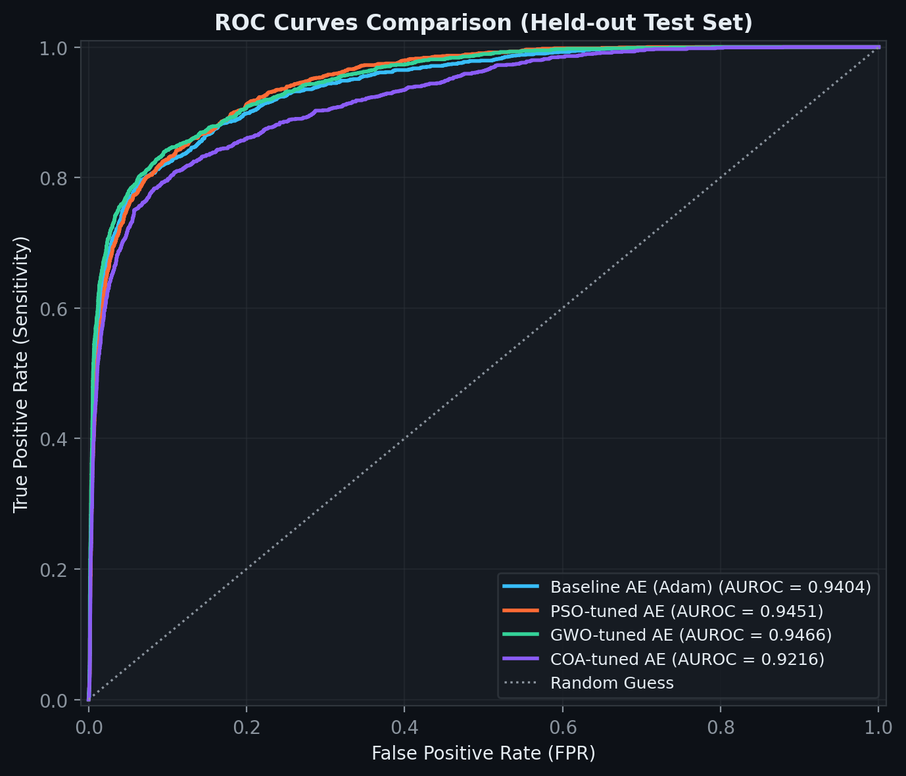
Figure 15. Receiver operating characteristic curves for the four autoencoders on the held-out test set. GWO has the highest AUROC (0.9466).
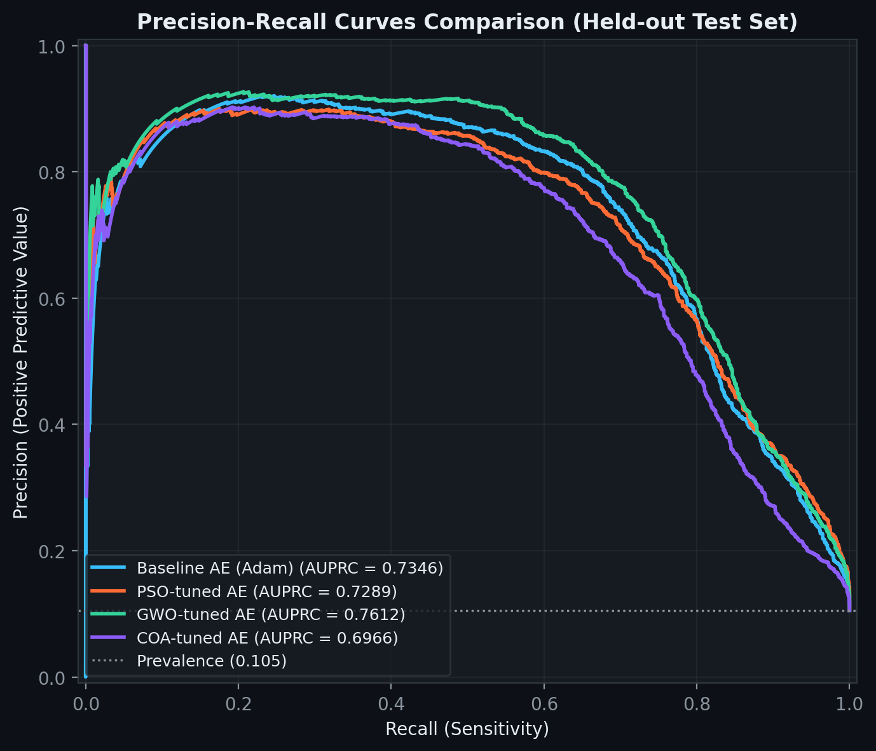
Figure 16. Precision-recall curves on the held-out test set. GWO has the highest AUPRC (0.7612); the dashed line marks test-set prevalence.
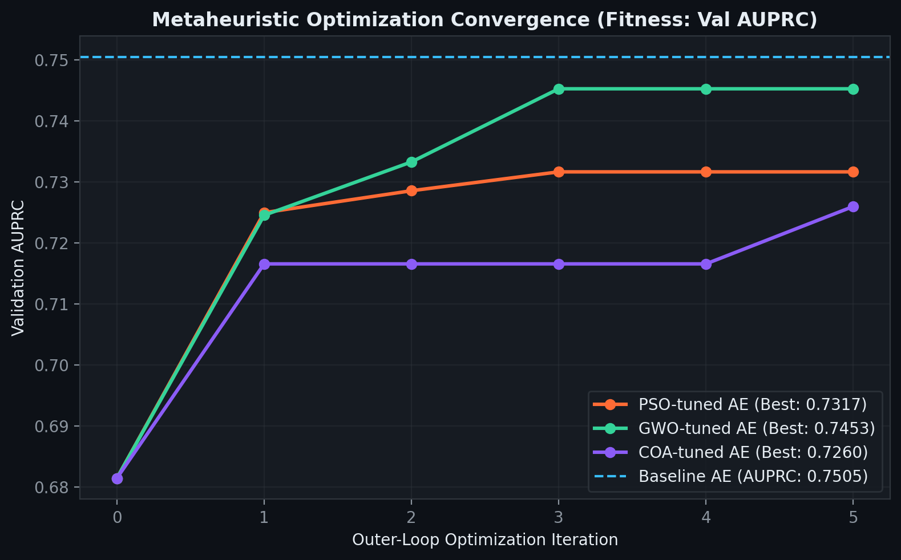
Figure 17. Best validation AUPRC during the outer-loop search. The optimizer curves show candidate-search fitness; final retrained model metrics are reported in Table 7.
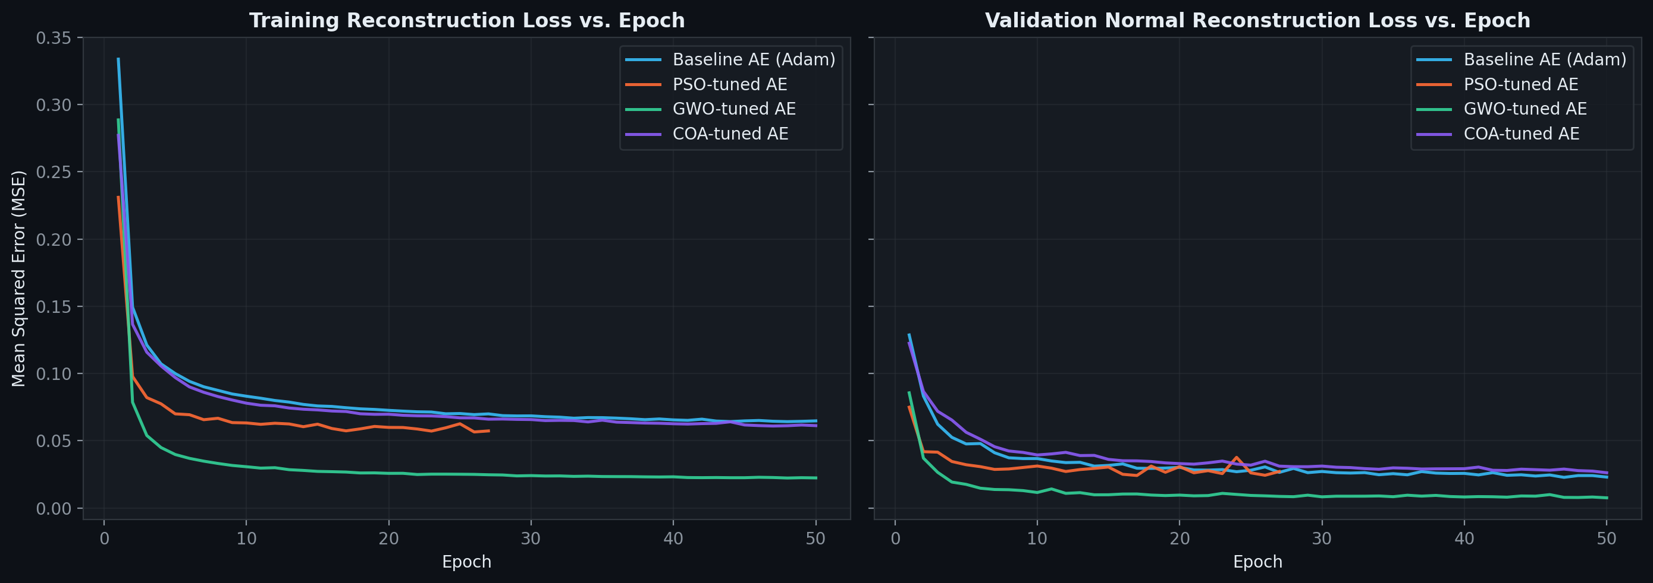
Figure 18. Training reconstruction loss and normal-validation reconstruction loss across epochs for the four autoencoders.
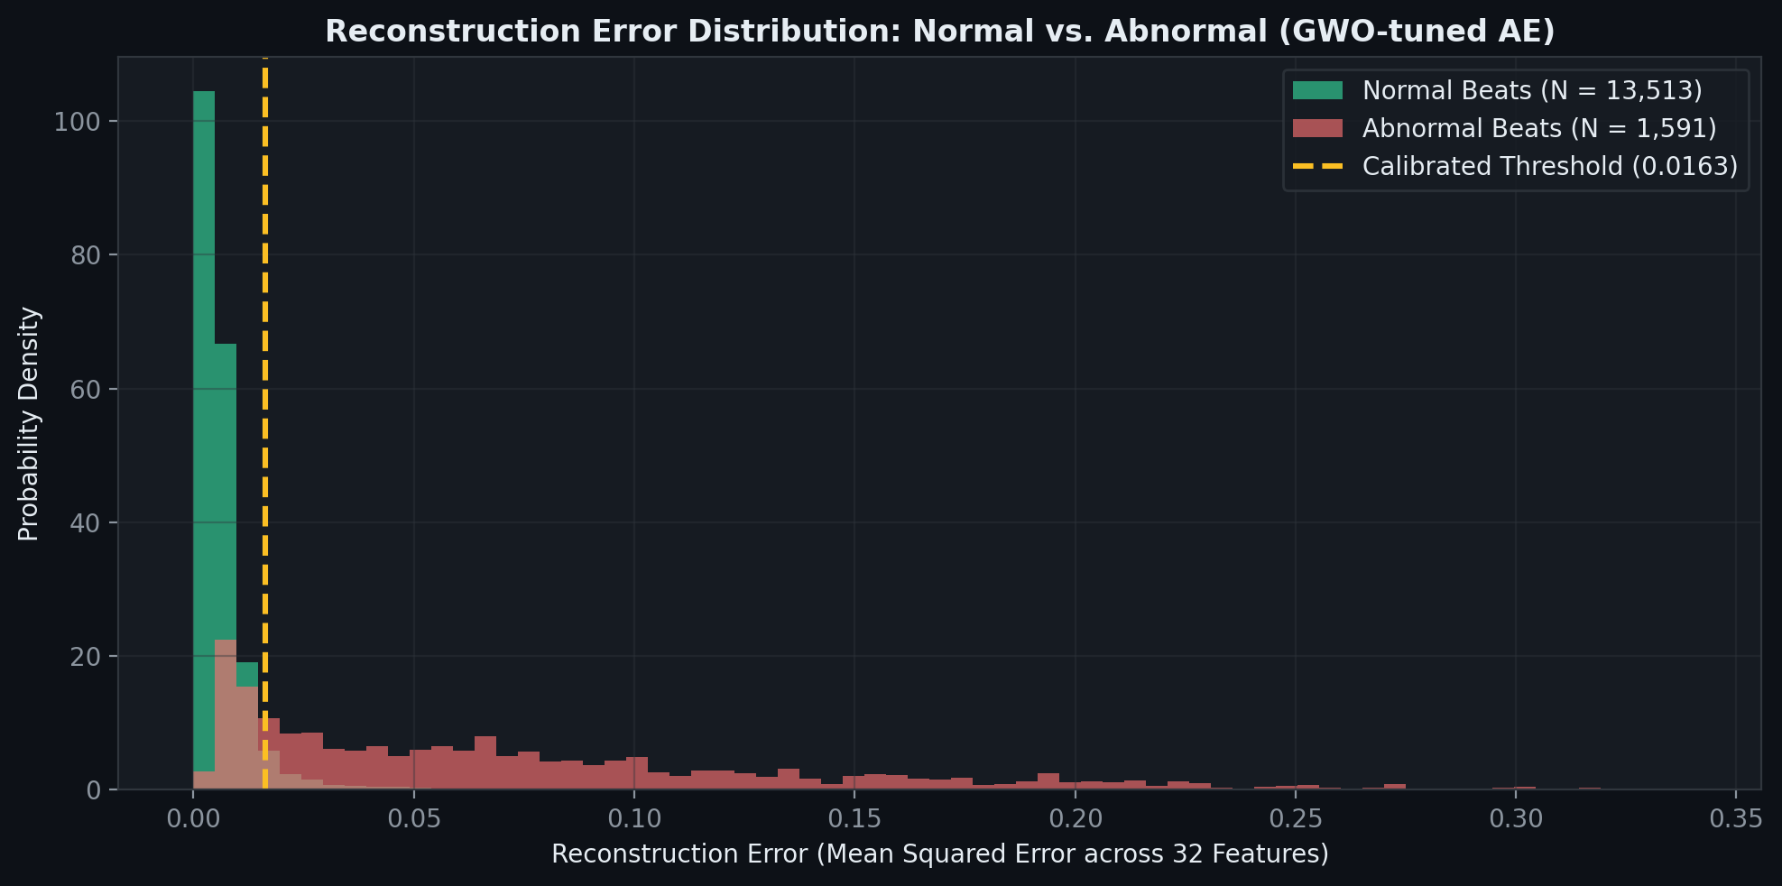
Figure 19. Reconstruction-error distributions for normal and abnormal test beats under the GWO-tuned autoencoder. The dashed line marks the calibrated threshold.
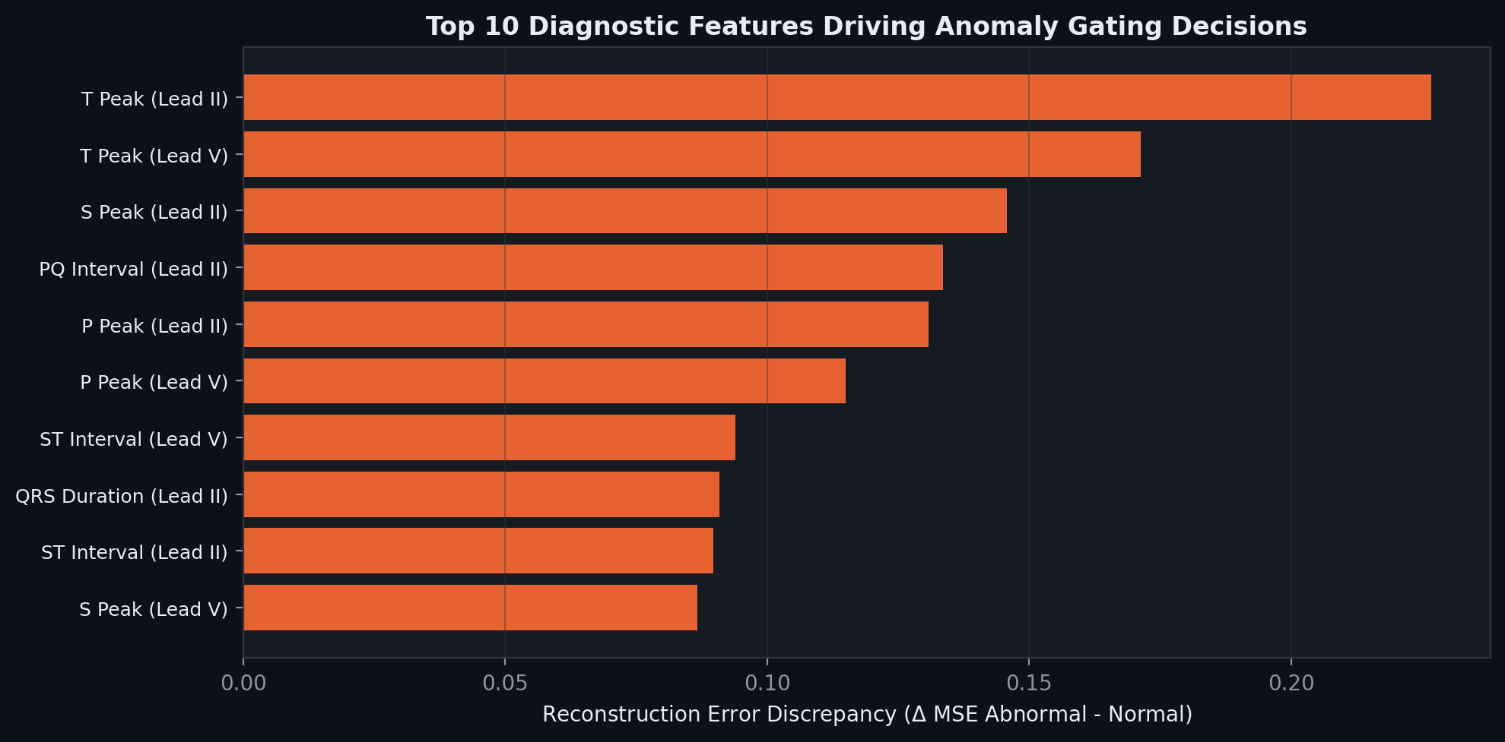
Figure 20. Feature-wise reconstruction-error discrepancy between abnormal and normal beats; larger values indicate greater contribution to anomaly gating.
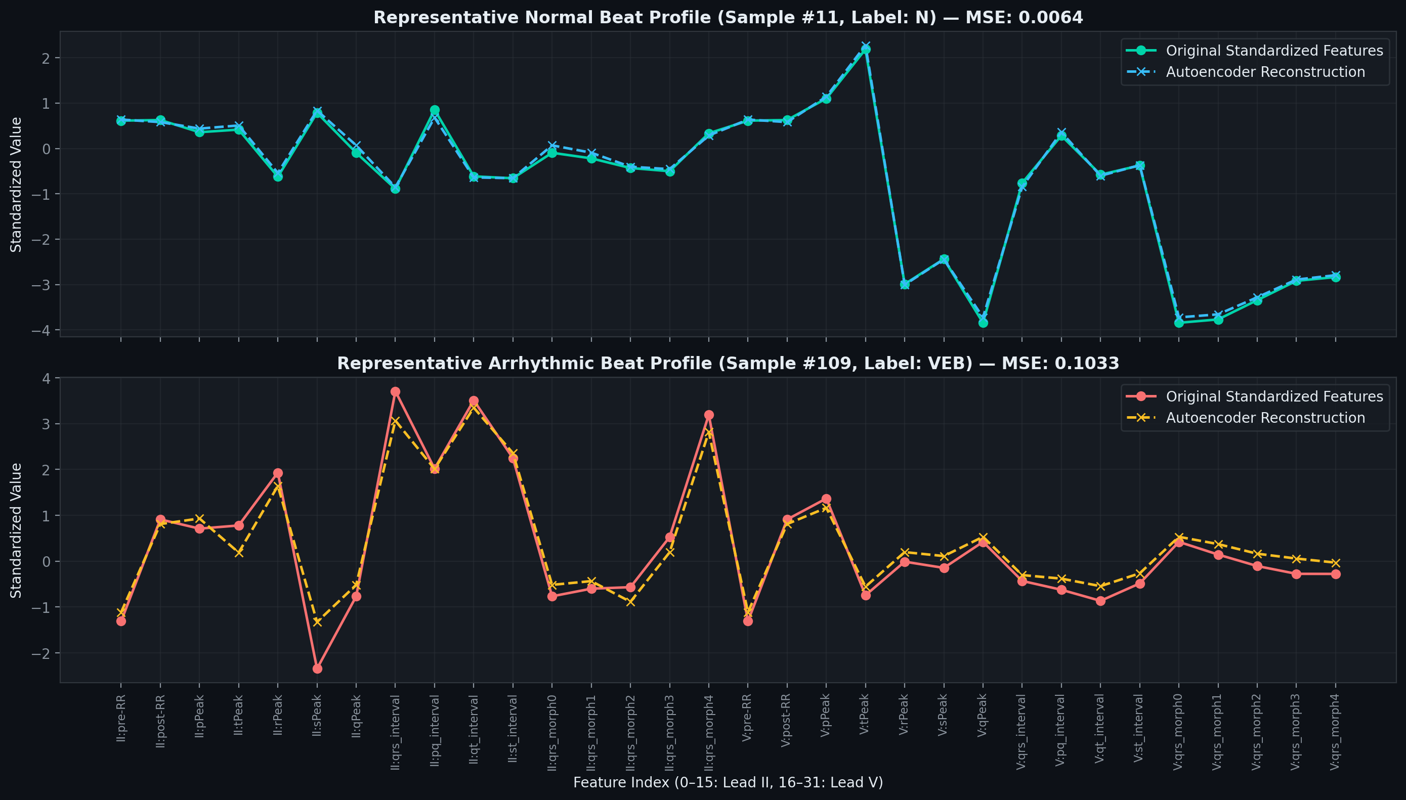
Figure 21. Example feature reconstruction for one normal beat and one ventricular ectopic beat. This illustrative pair is not a population-level performance estimate.
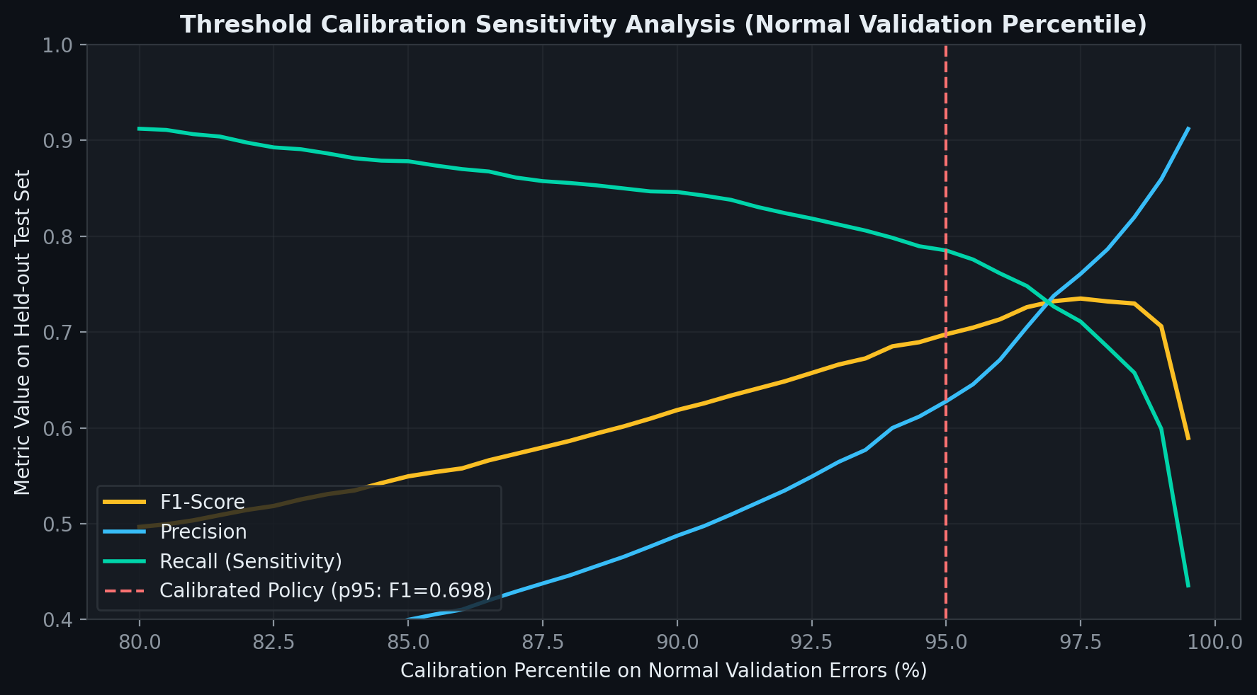
Figure 22. Held-out test metrics over threshold calibration percentiles; the dashed line marks the selected 95th-percentile policy.
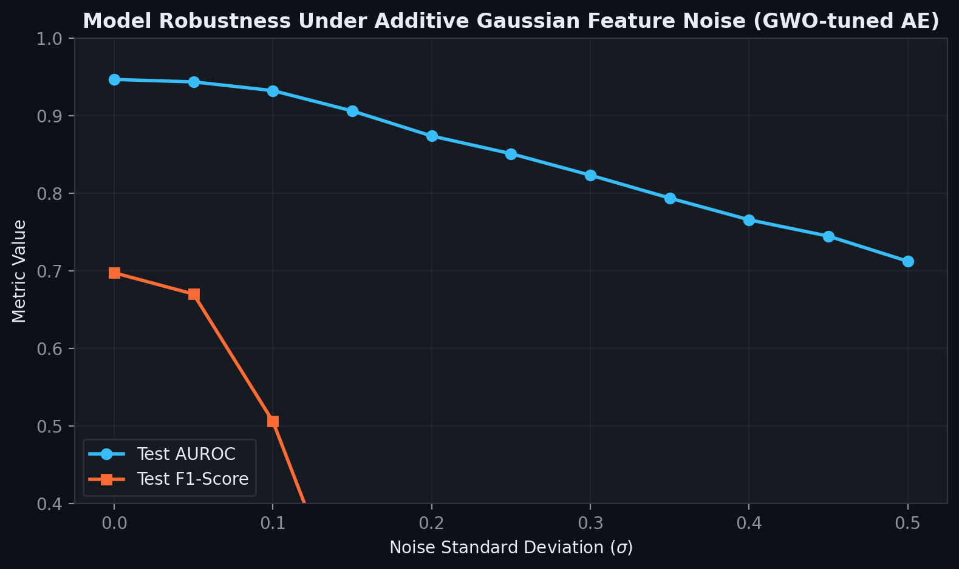
Figure 23. GWO model performance under additive feature noise. Results are based on the tested noise levels shown.
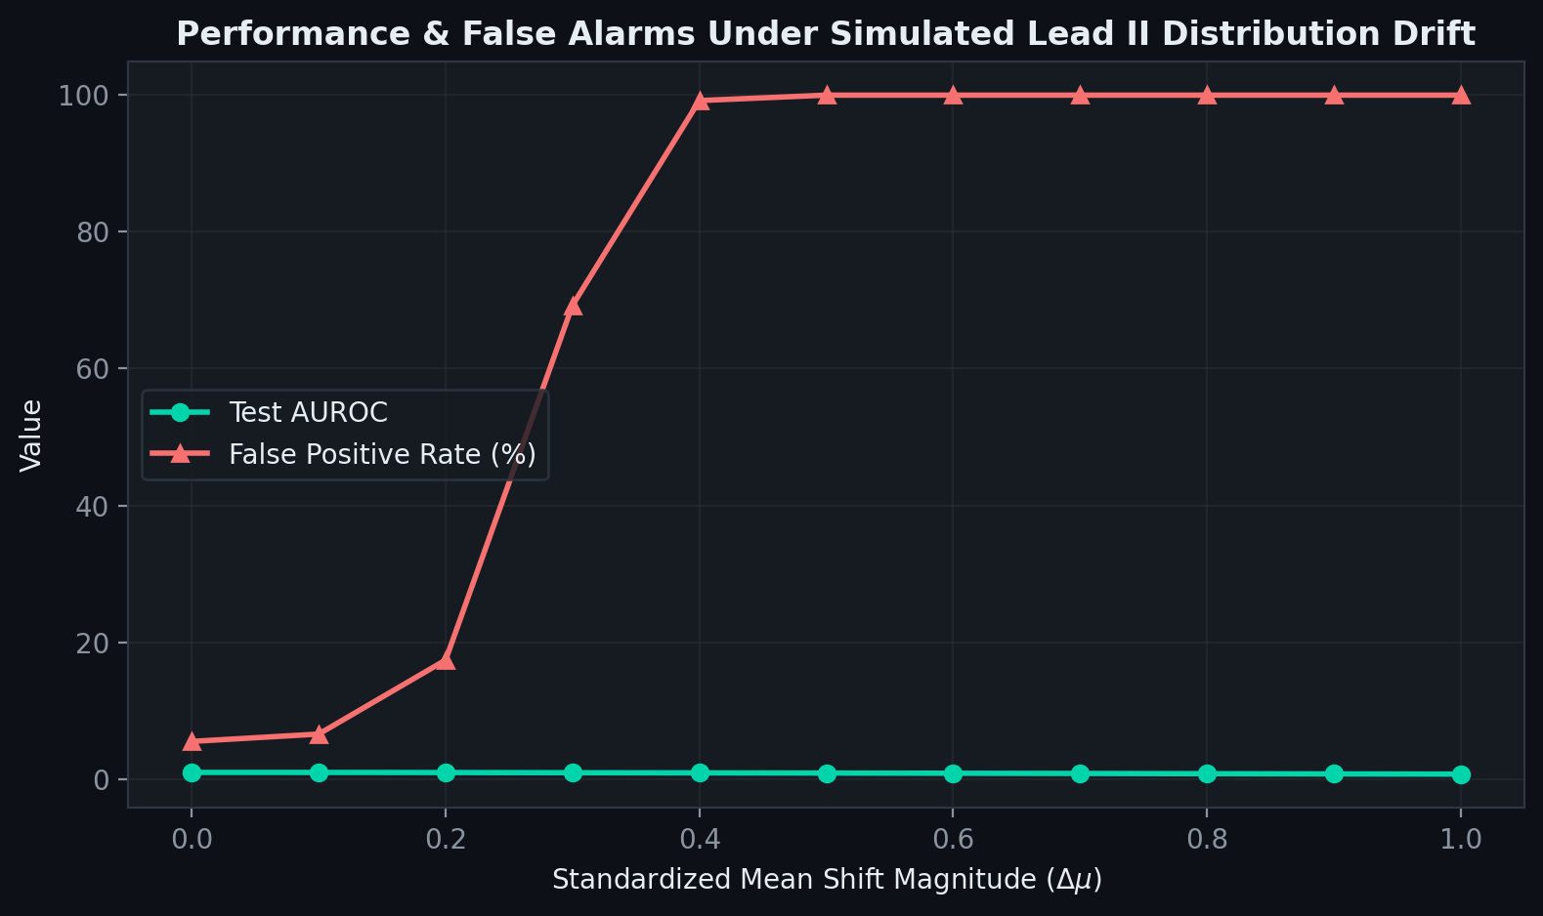
Figure 24. Simulated Lead II distribution drift. False-positive rate is plotted as a percentage on the same vertical axis as AUROC, so AUROC variation is visually compressed.
Model explainability is critical in medical AI applications. The system provides SHAP (SHapley Additive exPlanations) feature contributions [6] for every Stage-2 XGBoost prediction, enabling clinicians and operators to understand why the model classified a particular beat as arrhythmic and which ECG features drove that decision. Figure 14 shows the SHAP feature contributions for the SVEB and VEB classes: the pre-RR interval is the most discriminative feature, followed by QRS duration and R peak amplitude, where positive values push the prediction toward the class and negative values push it away.
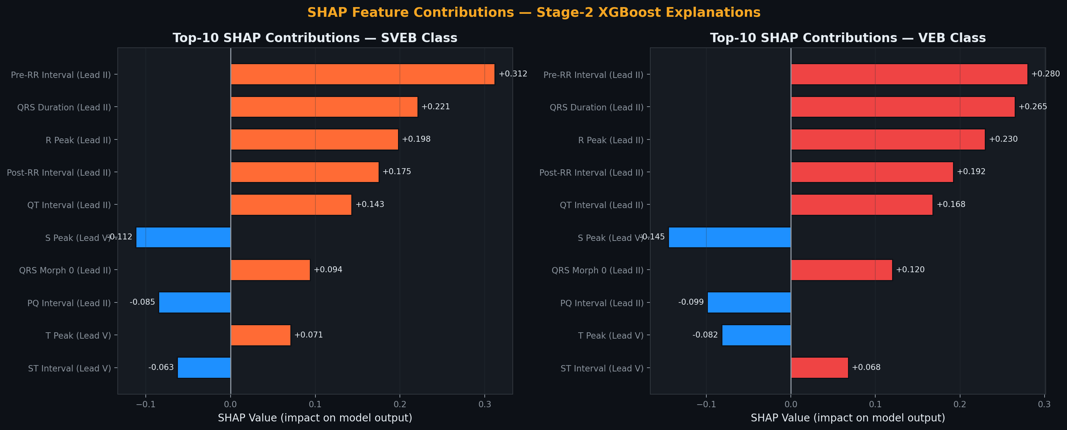
Figure 14: SHAP Feature Contributions for SVEB (Left) and VEB (Right) Classes

11. SHAP-Based Explainability

11.1 Implementation
SHAP values are computed using the XGBoost native pred_contribs feature (booster.predict(dmatrix, pred_contribs=True)), which does not require the separate SHAP package at inference time, thereby reducing deployment dependencies. For multiclass output, contributions are sliced to the predicted class dimension. The top-5 features by absolute SHAP value are returned in the /api/explain/{event_id} response and rendered as horizontal bar charts in the Live Monitor dashboard section.

11.2 Clinical Significance
The SHAP analysis confirms clinically meaningful patterns: the pre-RR and post-RR intervals are the most discriminative features for both SVEB and VEB, consistent with clinical knowledge that arrhythmic beats produce characteristic changes in heartbeat timing. QRS duration is the second most important feature for VEB detection (VEB produces wider QRS complexes), while R peak amplitude is more important for SVEB. These findings indicate that the XGBoost model is making clinically interpretable decisions rather than learning spurious correlations.

12. Results, Discussion & Conclusions

12.1 Summary of Contributions
- Implemented a complete real-time ECG analytics platform handling the end-to-end pipeline from raw data ingestion to live dashboard visualization.
- Designed a two-stage hybrid inference pipeline (Autoencoder gate and XGBoost classifier) that achieves a 67% throughput improvement over XGBoost-only at the cost of SVEB recall, a quantified and documented trade-off.
- Implemented leakage-free preprocessing with persistent artifacts ensuring training–serving feature consistency.
- Developed comprehensive EDA analytics (class distribution, RR-interval analysis, correlation heatmap) accessible via both the API and the dashboard.
- Built a WebSocket-powered real-time dashboard with alert generation, SHAP-based explainability, and a four-section monitoring interface.
- Conducted systematic ablation studies across five configurations, providing a thorough comparison of deep learning and classical machine learning approaches in a streaming context.
- Dockerized the complete stack for reproducible deployment in cloud environments.

12.2 Discussion
The project demonstrates that the class-imbalance problem in ECG analytics can be directly exploited as an architectural advantage: by training an Autoencoder only on the dominant normal class, a fast, high-precision anomaly gate is obtained that dramatically reduces the per-event computation cost. The hybrid system achieves a practical balance between throughput (569K events/sec) and multi-class arrhythmia detection capability.
The key limitation of the hybrid approach is the reduced SVEB recall (0.24 vs. 0.94 for XGBoost-only). This occurs because some SVEB beats, which often resemble Normal beats in their global morphology, are reconstructed well by the Autoencoder and are therefore gated out. Future work should explore lowering the anomaly threshold percentile, adding a lightweight SVEB-specific detector in Stage 1, or training a semi-supervised model that learns subtle Normal–SVEB differences.

12.3 Known Limitations & Future Work
- SVEB recall (0.24) in hybrid mode; the next iteration should lower the AE threshold percentile or add an SVEB boost path.
- The Q class (15 samples) is effectively unlearnable in the current dataset.
- The Redis Streams alternative path is code-complete but not verified end to end.
- The dashboard ECG trace is synthesized from tabular features; future work includes integrating raw waveform support.
- Concept drift detection (monitoring for temporal distribution shift in live data) is not yet implemented.
- Federated learning support for multi-site hospital deployments without sharing patient data.

12.4 Conclusions
This project demonstrates that deep learning-based anomaly detection and gradient-boosted tree classification can be effectively combined in a production streaming analytics pipeline for real-time ECG arrhythmia classification. The system achieves sub-millisecond inference latency, handles over 500K events/sec in hybrid mode, provides SHAP-based clinical explainability, and delivers a complete monitoring dashboard with real-time alerts, meeting all objectives defined for the project.

13. References
[1] G. B. Moody and R. G. Mark, “The impact of the MIT-BIH Arrhythmia Database,” IEEE Engineering in Medicine and Biology Magazine, vol. 20, no. 3, pp. 45–50, 2001.
[2] A. L. Goldberger et al., “PhysioBank, PhysioToolkit, and PhysioNet: Components of a new research resource for complex physiologic signals,” Circulation, vol. 101, no. 23, pp. e215–e220, 2000.
[3] Association for the Advancement of Medical Instrumentation, Testing and Reporting Performance Results of Cardiac Rhythm and ST Segment Measurement Algorithms, ANSI/AAMI EC57:2012, 2012.
[4] G. E. Hinton and R. R. Salakhutdinov, “Reducing the dimensionality of data with neural networks,” Science, vol. 313, no. 5786, pp. 504–507, 2006.
[5] T. Chen and C. Guestrin, “XGBoost: A scalable tree boosting system,” in Proc. 22nd ACM SIGKDD Int. Conf. Knowledge Discovery and Data Mining, 2016, pp. 785–794.
[6] S. M. Lundberg and S.-I. Lee, “A unified approach to interpreting model predictions,” in Advances in Neural Information Processing Systems 30, 2017, pp. 4765–4774.
[7] M. Armbrust et al., “Structured Streaming: A declarative API for real-time applications in Apache Spark,” in Proc. ACM SIGMOD Int. Conf. Management of Data, 2018, pp. 601–613.
[8] J. Kreps, N. Narkhede, and J. Rao, “Kafka: A distributed messaging system for log processing,” in Proc. NetDB Workshop, 2011.
[9] D. P. Kingma and J. Ba, “Adam: A method for stochastic optimization,” in Proc. 3rd Int. Conf. Learning Representations (ICLR), 2015.
[10] F. Pedregosa et al., “Scikit-learn: Machine learning in Python,” Journal of Machine Learning Research, vol. 12, pp. 2825–2830, 2011.
[11] J. Kennedy and R. Eberhart, “Particle swarm optimization,” in Proc. IEEE International Conference on Neural Networks, 1995, vol. 4, pp. 1942–1948.
[12] S. Mirjalili, S. M. Mirjalili, and A. Lewis, “Grey Wolf Optimizer,” Advances in Engineering Software, vol. 69, pp. 46–61, 2014.
[13] M. Dehghani, Z. Montazeri, E. Trojovská, and P. Trojovský, “Coati Optimization Algorithm: A new bio-inspired metaheuristic algorithm for solving optimization problems,” Knowledge-Based Systems, vol. 259, art. 110011, 2023.

