


Module Code & Module Title
Level 6 – Application Development

Assessment Type
Semester
2024/25 Autumn

Student Name: Aishworya Shrivastav
London Met ID: 21049631
College ID: NP01CP4A210128
Assignment Due Date: Friday, August 1, 2025
Assignment Submission Date: Tuesday, July 29, 2025
Submitted To: Bikram Poudel
Word Count (Where Required):

I confirm that I understand my coursework needs to be submitted online via MST Classroom under the relevant module page before the deadline in order for my assignment to be accepted and marked. I am fully aware that late submissions will be treated as non-submission and a mark of zero will be awarded.

Table of Contents
1. Introduction 1
1.1 Purpose 2
1.2 Scope 3
1.3 Objectives 4
2 Outcomes and deliverables 6
2.1 Initialise Git Repository 6
2.2 Technology Stack Selection 8
2.3 Persistence Mechanism(File Handling) 10
3 Features and functionalities. 11
3.1 GitHub commit history 49
3.2 System Testing 50
4 Conclusion 70
5 Bibliography 72

Figure 1 Initialising GitHub Repo 7
Figure 2 .NET framework 8
Figure 3 Credit transaction 11
Figure 4 Debit transaction 12
Figure 5 Debt transaction 13
Figure 6 Transaction types in the system 13
Figure 7 Sufficient balance check 14
Figure 8 Clearing debts from inflow 15
Figure 9 Highlighting pending debts 16
Figure 10 Adding custom or default tags to the transaction 17
Figure 11 Adding notes to the transaction 18
Figure 12 Filtering transaction through credit 19
Figure 13 Credit transaction 19
Figure 14 Filtering transaction of debit 20
Figure 15 Filtering transaction of debt 21
Figure 16 Filtering transaction through tag 22
Figure 17 Food tag 22
Figure 18 Filtering through dates 23
Figure 19 Searching transactions with title 24
Figure 20 Filtering through title 24
Figure 21 Filtering through Debit and Amount 25
Figure 22 Filtering through ascending date 26
Figure 23 Searching transactions by title 27
Figure 24 Total number of transactions 28
Figure 25 Debt transaction 28
Figure 26 Credit transaction 28
Figure 27 Debit transaction 28
Figure 28 displaying of total inflows, outflows, debt, cleared debt and remaining debts 29
Figure 29 Total number of transactions on different types 29
Figure 30 Highest and lowest transactions 30
Figure 31 All transactions in the particular date 30
Figure 32 Pending debts in dashboard 31
Figure 33 Dashboard with specified time range 32
Figure 34 Login to the system 33
Figure 35 Register in the system 33
Figure 36 Profile options 34
Figure 37 Change of transaction currency 34
Figure 38 JSON storage 35
Figure 39 Login Screen 36
Figure 40 Registration Page 37
Figure 41 User profile page 38
Figure 42 Dashboard Page 39
Figure 43 Continued Dashboard 40
Figure 44 Transaction wireframe 41
Figure 45 Example of ERD 43
Figure 46 ERD of Finance Tracker 44
Figure 47 Use case diagram 45
Figure 48 Use case diagram 46
Figure 49 Example of class diagram 47
Figure 50 Class diagram 48
Figure 51 Added GitHub commit history as of 29th July 2025 49
Figure 52 Merged and pulled the commit of all branches 49
Figure 53 Cash inflow transaction 51
Figure 54 Debit transaction 52
Figure 55 Debt transaction 54
Figure 56 checking for sufficient balance 55
Figure 57 highlighting pending debts 56
Figure 58 Adding transaction without custom or existing tags and notes. 58
Figure 59 Updating transaction with custom or existing tags, labels and notes 59
Figure 60 Transaction added successfully 59
Figure 61 Adding notes to the transaction 60
Figure 62 Filtering transactions by type 61
Figure 63 Filtering transactions by tag 61
Figure 64 Filtering transactions by date 62
Figure 65 Sorting transactions by date 63
Figure 66 Sorted by date 63
Figure 67 Searching transactions by title with existing filter and sort 64
Figure 68 Total number of transactions 65
Figure 69 Total transactions 65
Figure 70 Display of total inflows, outflows, debt related transactions 66
Figure 71 display of highest and lowest inflows, outflows and debt 67
Figure 72 Filtering transactions by date in dashboard with title 69
Figure 73 After filtering of transactions 69

Introduction

This project focuses on building an expense tracker system for Pranlancer platform. Using the .NET framework of MAUI Hybrid Blazor app: as a web app. Using this system, the user can login with their username and password and the currency type they chose in initial setup of app. It shows the total cash inflows: considering all the sources of money that has been deposited in the account, cash outflows: all the sources of money where the money has been used for different expenses of the user along with maintain debt accounts showing how much user has borrowed from each transaction. The pending debts are highlighted and the users are optionally supposed to keep tags or notes of the system for future reference.
It also gives users an ability to search, filter and sort different transactions and each of these transactions are stored inside the system using JSON as a storage mechanism.

Purpose

The Finance Tracker system is an app which aims to help user to monitor and manage their financial transactions from income, expenses and debts. This project is a key tool for people to understand about their transactions and keeping them aware about their finances. It uses .NET MAUI framework and Blazor which helps to create a cross platform application which can work on mobile and desktop platforms.

It is mainly used to track the incomes, expenses and debts. It is made for users to help them access their transactions anywhere and used in multiple platforms which can help them in decision making.

Scope

The scope of the project covers the following points:
- Categorise the different types of transactions like credit, debt and debits.
- To clear debts and tracking any pending debts.
- Creating a financial dashboard which can oversee the total income, expenses and outstanding debts.
- Track the transactions with the help of tags and notes for future reference.
- Allowing the user to filter, sort and search transactions with the different options.

The system uses modern web and mobile technologies to ensure cross platform support using .NET MAUI Hybrid Blazor framework and storing these transactions in JSON which ensures an optimal usage of user experience.

Objectives

The key objectives of the Finance Tracker system are as follows:
- Manage users income, expenses and debts.
- Search, filter and sort the transactions.
- Ensuring the data of each transactions are consistent and reliable.
- Supporting cross platforms to help users with decision making.
- Providing designs of app which helps to understand more about the app.

Outcomes and deliverables

Initialise Git Repository

For completing this coursework, a Finance Tracker System would be made using .NET framework. To commit the changes and creating a backup of our work it is required to maintain an empty GitHub repository.
Git is a popular version control system. It was created by Linus Torvalds in 2005, and has been maintained by Junio Hamano since then. It is used for tracking code changes, tracking who made changes and coding collaboration. (GeeksforGeeks, 2019)
Popular tool like Git is used to maintain the version control of files and committing the changes of codes during the development phases. The repository named as “Finance Tracker” is created to maintain these changes.
It can be accessed through the link as given:

https://github.com/ashlearns/FinanceTracker.git

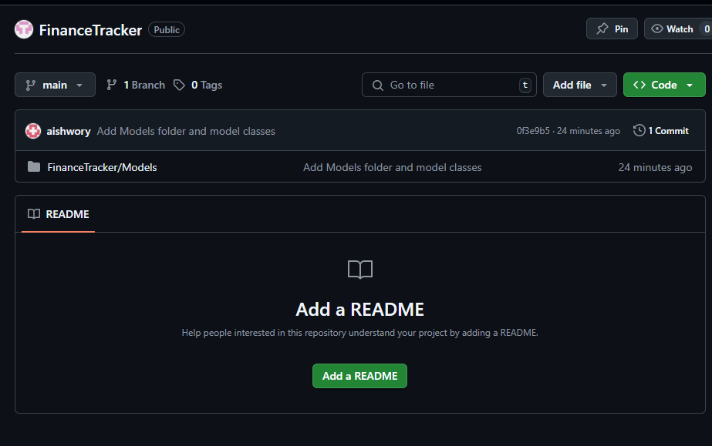
Figure 1 Initialising GitHub Repo

Technology Stack Selection

For the completion of coursework, a set of different tech stack was created to understand about the different development phases that was undertaken. For this, external libraries like Bootstrap CDN was used to customise the UI in Razor pages.
An importance of tech stack is to create the developments in smooth and efficient manner that can help to understand about knowledge in .NET as well as creating proper milestones for timely deliver the coursework.

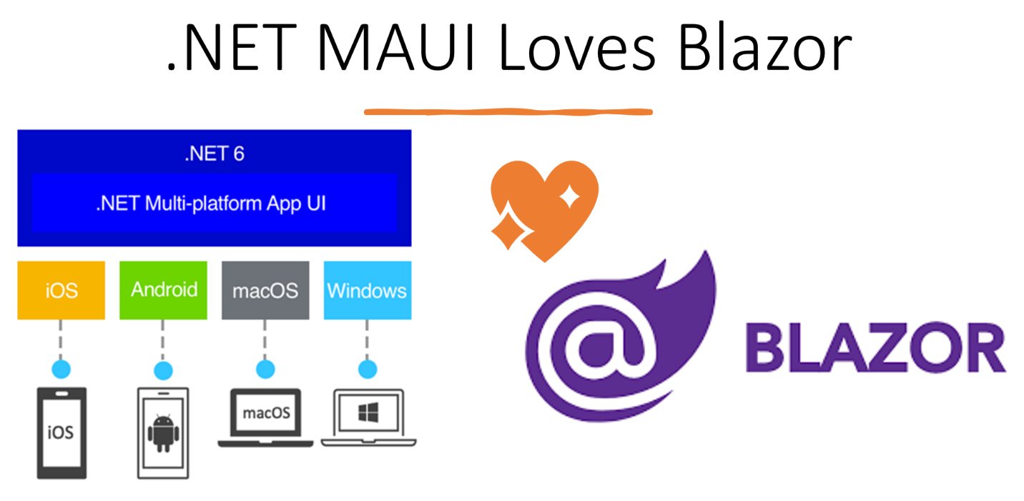
Figure 2 .NET framework

- Framework: for this .NET MAUI Hybrid Blazor App was chosen to build the platform. It was used because it helps to use cross platform services. It is used to build native mobile and desktop applications with HTML, CSS and C# blended with Blazor. It even provides UI elements and platform specific APIs which can be rendered using Razor components.

.NET MAUI, Multi-platform UI is a cross-platform framework that allows us to create native mobile and desktop apps using C#. Using Blazor with MAUI, we can develop native Android, iOS, Desktop applications using the same code and .NET platform with C#.
(Ansari, 2023)
- External Libraries: for this project, Bootstrap CDN is used as it can help to improve the UI as well as make it a cleaner UX. It is like a collection of different template designs that can help in improving the feel of web development.
Bootstrap is a free front-end framework for faster and easier web development
It includes HTML and CSS based design templates for typography, forms, buttons, tables, navigation, modals, image carousels and many other, as well as optional JavaScript plugins. It also gives you the ability to easily create responsive designs.
(GeeksforGeeks, 2019)

- Blazor (Razor components) were used to write the various logics of pages and UI and improve the bootstrap functionality. Blazor is a modern front-end web framework based on HTML, CSS, and C# that helps you build web apps faster.
(Microsoft Corp., 2017)

Persistence Mechanism(File Handling)

For storing each of the files of our project JSON was used as a primary data storage which can be located in the various app data folders, similarly a helper class of JSON is stored inside to use the functionality of JSON files asynchronously which means it can save multiple files without waiting for the previous file to be saved or completed before moving to the next file.

JSON (JavaScript Object Notation) is a lightweight data-interchange format. It is easy for humans to read and write. It is easy for machines to parse and generate. It is based on a subset of the JavaScript Programming Language.
JSON is built on two structures:
A collection of name/value pairs. In various languages, this is realized as an object, record, struct, dictionary, hash table, keyed list, or associative array.
An ordered list of values. In most languages, this is realized as an array, vector, list, or sequence. (JSON Org., 2019)

Features and functionalities.

The key features of these apps include:
- Tracking of cash inflows, outflows and debts which specifies about the source of money through income, expense or a liability to pay off. Each of these transactions are displayed with the transaction type and with listed details.

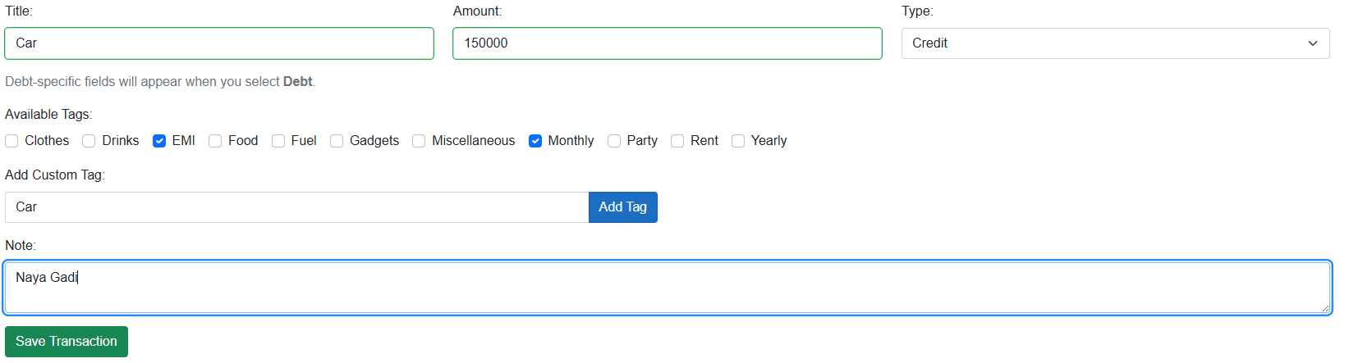
Figure 3 Credit transaction

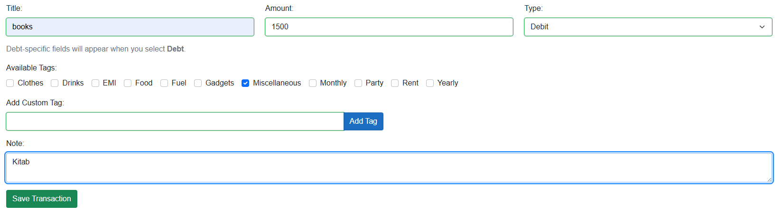
Figure 4 Debit transaction

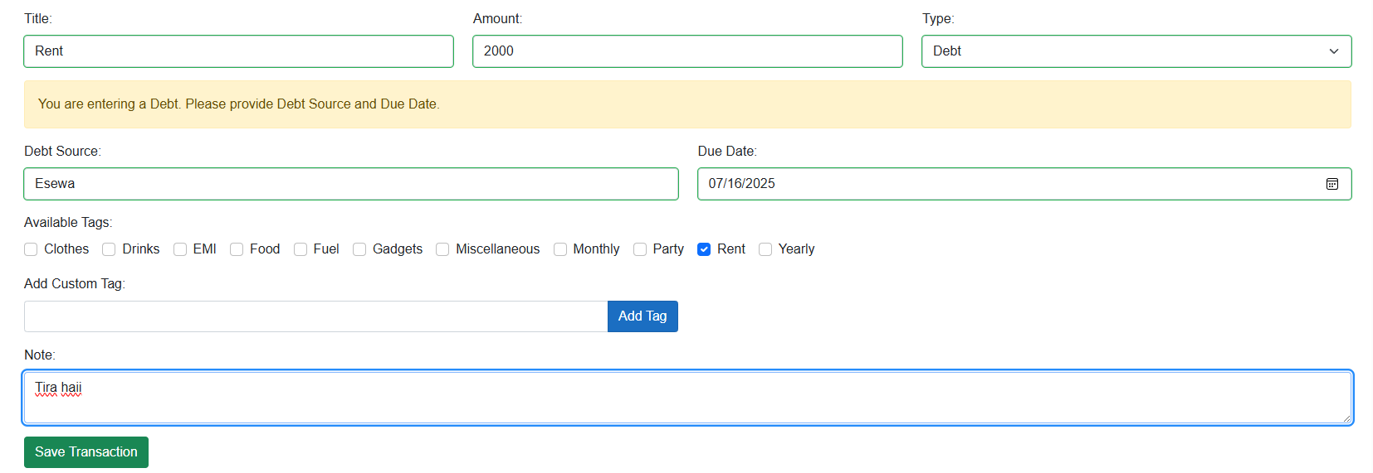
Figure 5 Debt transaction

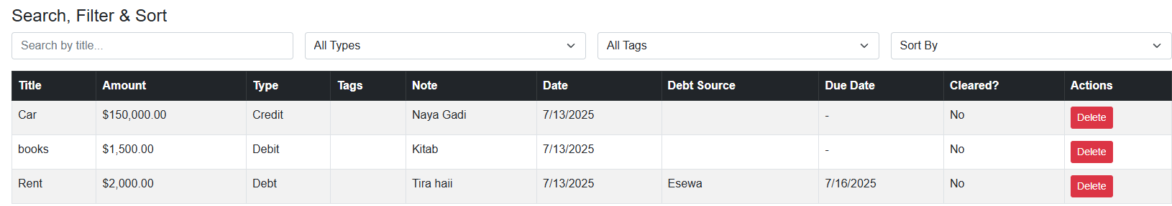
Figure 6 Transaction types in the system

- Sufficient Balance Check for outflows:
Where users can spend money by checking the available balance before performing a transaction. An error message is displayed when the user tries to clear the debt from the outstanding debts.

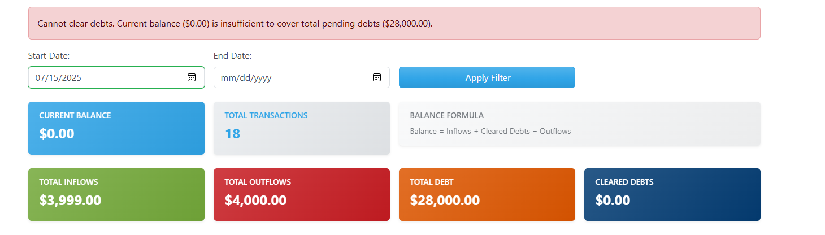
Figure 7 Sufficient balance check

- Clearing debt from inflows and highlighting pending debts
Users can clear debts from their cash inflows. These pending debts can be seen on dashboard, these have due dates and amount that needs to be cleared in the specific amount of time.

Figure 8 Clearing debts from inflow

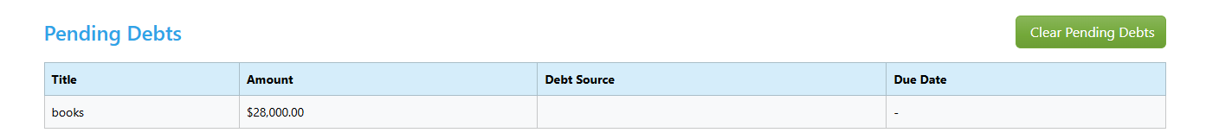
Figure 9 Highlighting pending debts

- Ability to add custom or existing tags/labels to a transaction
Users can categorise the transactions with the default tags or with custom tags. A checklist of default tags can be visible as well as an whitespace to fill these details.

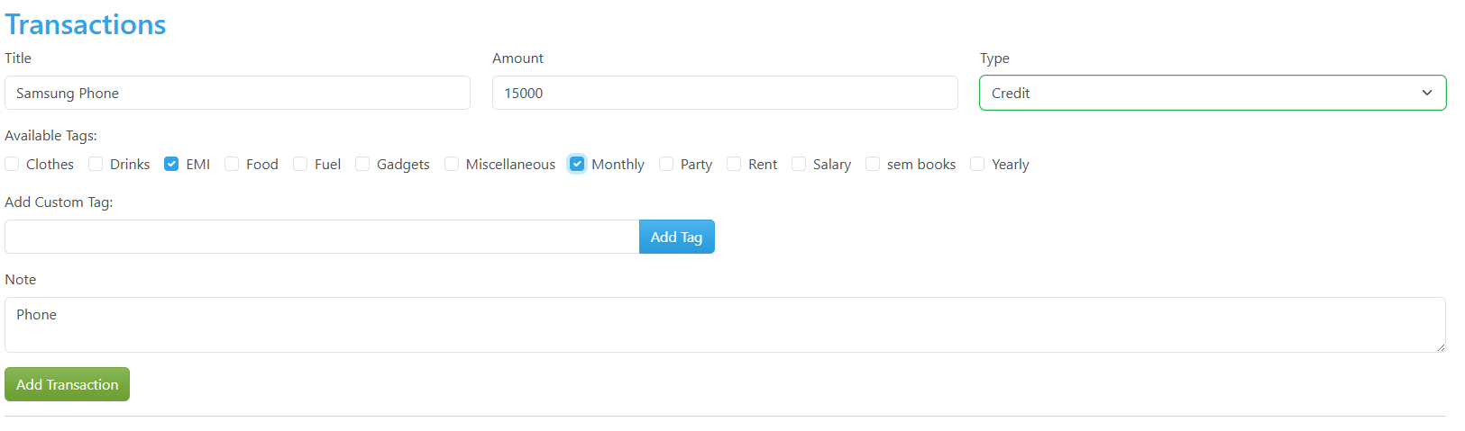
Figure 10 Adding custom or default tags to the transaction

- Ability to add optionally a note to a transaction
Users can add notes to the transactions to categorise these transactions for future reference. However notes are optional.

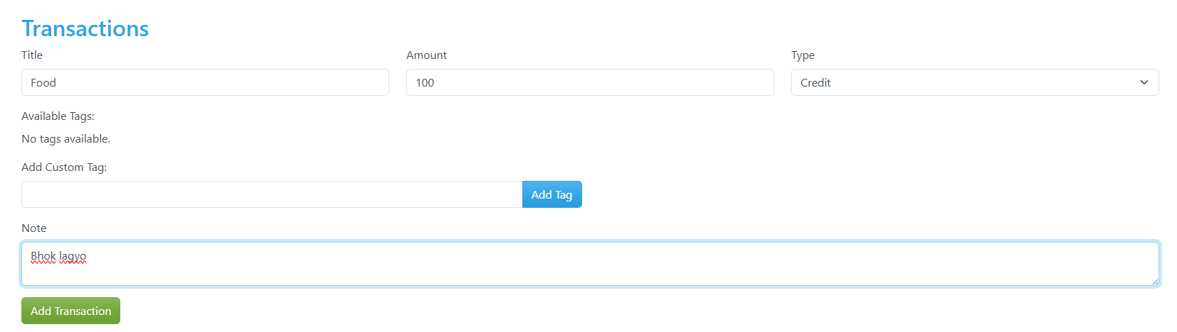
Figure 11 Adding notes to the transaction

- Filtering transactions by type, tags, and date range
Users can filter the transaction by the type, tags and date range for viewing list of transactions.
Figure 12 Filtering transaction through credit
Figure 13 Credit transaction

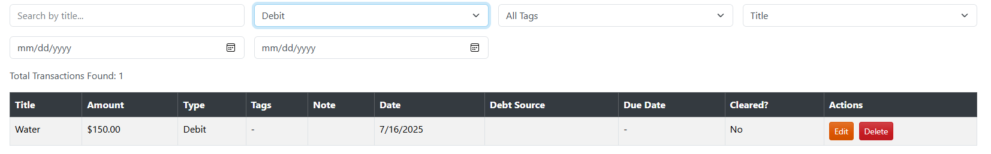
Figure 14 Filtering transaction of debit

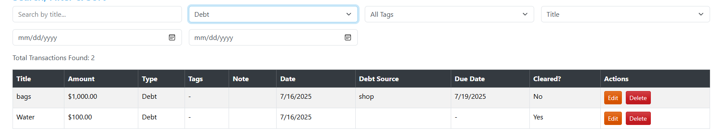
Figure 15 Filtering transaction of debt

Figure 16 Filtering transaction through tag

Figure 17 Food tag

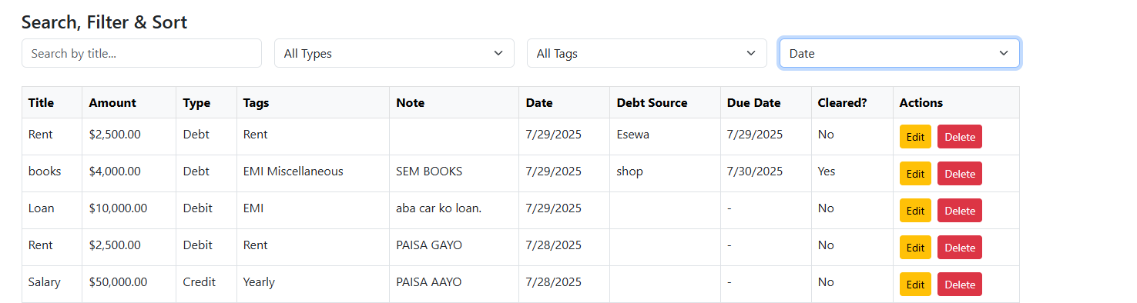
Figure 18 Filtering through dates

- Searching transactions by title, seamlessly with existing sorting and filtering results:
Users can filter the transactions based on transaction type, tags and a date range. The user can select the dropdown for the date picker.

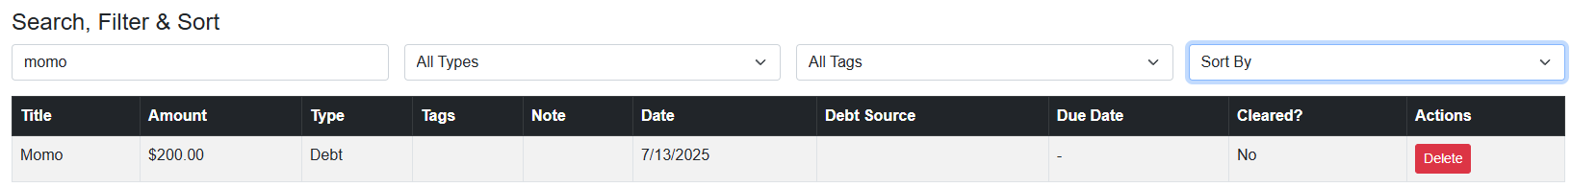

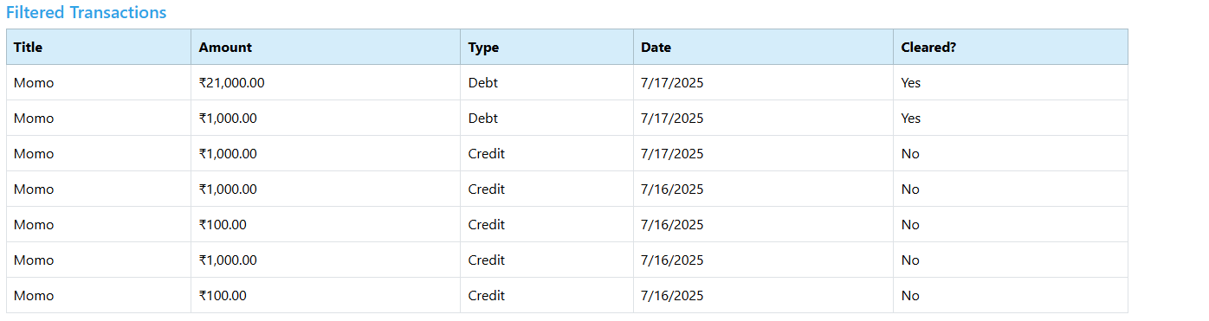
Figure 19 Searching transactions with title

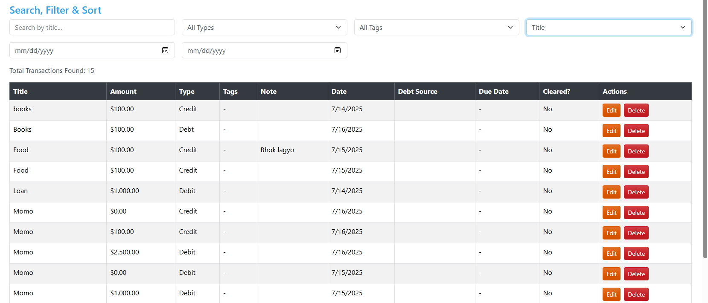
Figure 20 Filtering through title
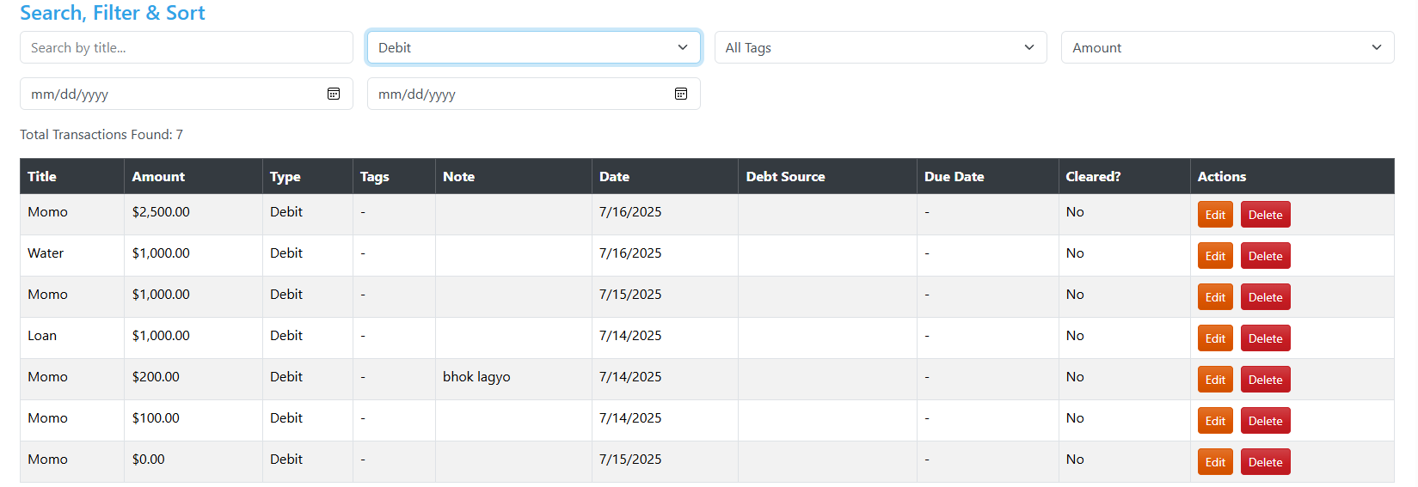
Figure 21 Filtering through Debit and Amount


Figure 22 Filtering through ascending date

- Searching transactions by title:
The users can search these transactions with the keywords or names of transactions which can provide accurate information about these transactions.


Figure 23 Searching transactions by title

- Display of total number of transactions and total transactions for (inflows + debts =outflows):
It shows an overview of the total number of transactions and the net balance by calculation of total transactions.
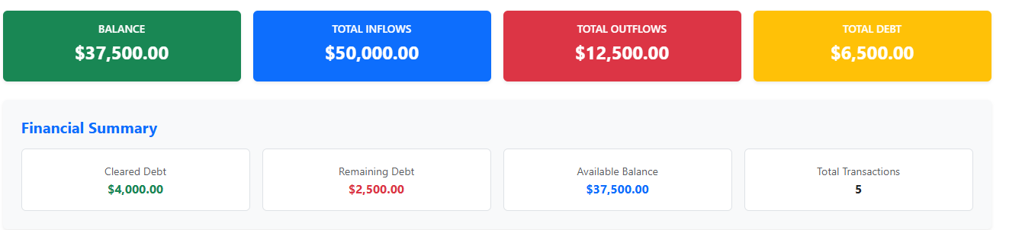
Figure 24 Total number of transactions

Figure 25 Debt transaction

Figure 26 Credit transaction
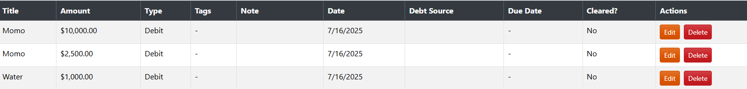
Figure 27 Debit transaction

- Display of total inflows, outflows, debt, cleared debt, remaining debts
It shows the user’s total income, total expenses, total clear debt and remaining debt during a particular period of time.

Figure 28 displaying of total inflows, outflows, debt, cleared debt and remaining debts

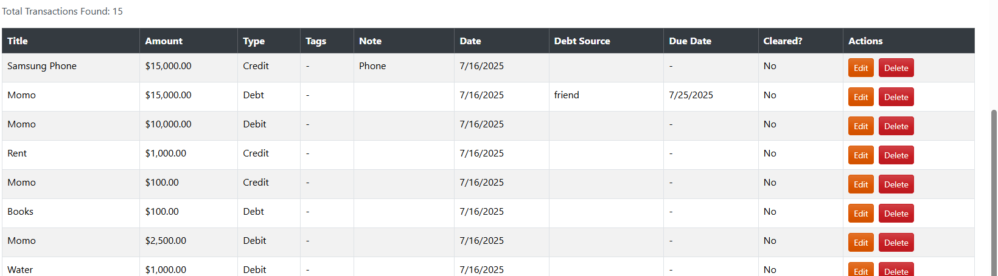
Figure 29 Total number of transactions on different types

- Display of highest/lowest inflow, outflow, and debt transactions
It helps to identify and highlights the highest and lowest transaction of each transaction type.

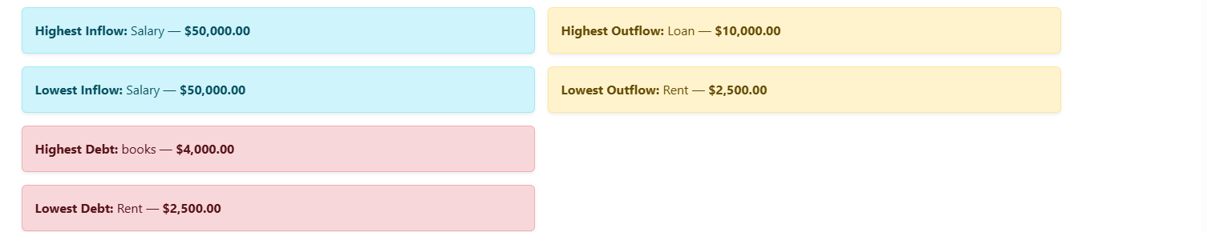
Figure 30 Highest and lowest transactions

Figure 31 All transactions in the particular date

- Properly listing pending debts in the dashboard:
The pending debts are shown in dashboard with an option to clear these pending dues with the given balance, total cash inflow or outflow.
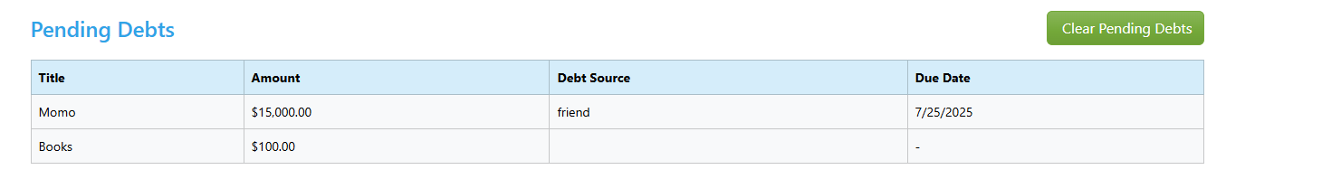
Figure 32 Pending debts in dashboard

- Dashboard filtering by specific date ranges:
Users can apply date filters to display the total transactions of the given time period. It is used as an analysis where users can analyse their transactions in a specified amount of time.
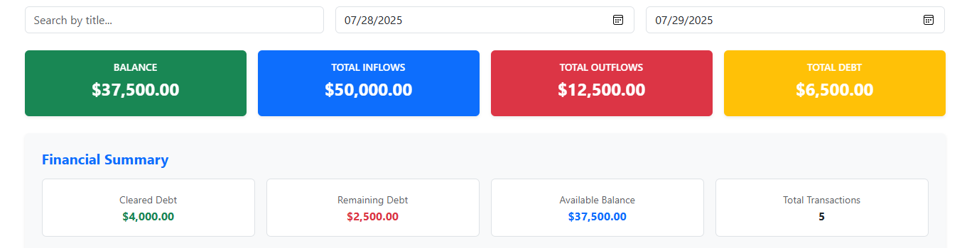
Figure 33 Dashboard with specified time range

- User Authentication(Login and Register):
User can access their accounts with login after they have finished registering themselves in the app. After successful signup, it is redirected to login.

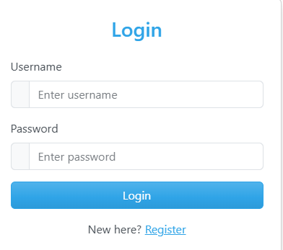
Figure 34 Login to the system
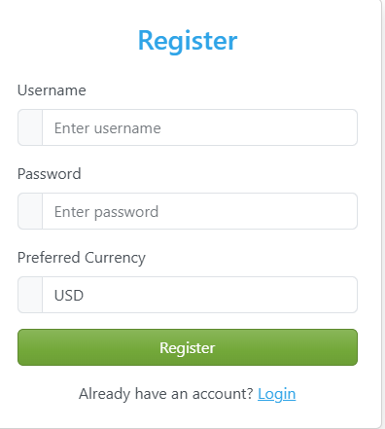
Figure 35 Register in the system

- Profile changes: After the initial signup or login user can change their currency and these transactions are updated across the app.
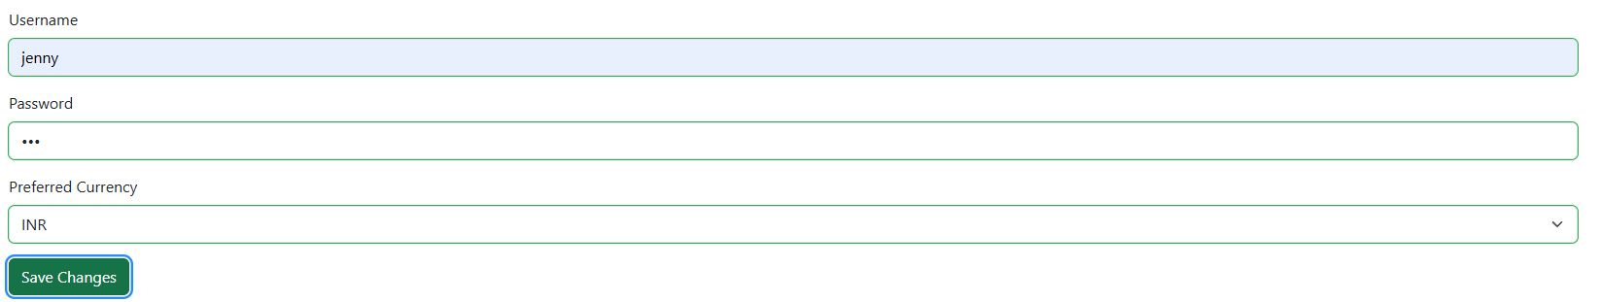
Figure 36 Profile options
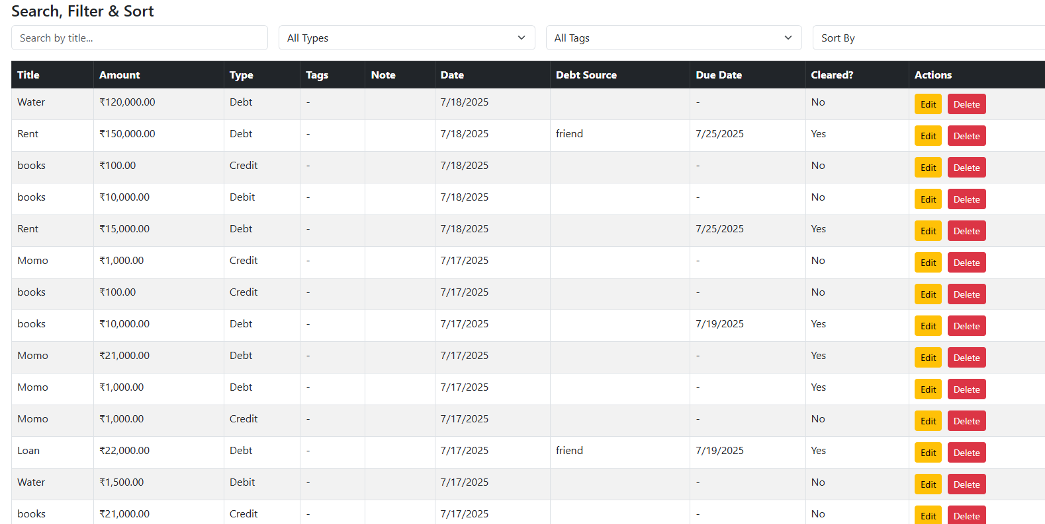
Figure 37 Change of transaction currency

- Proof of Work
- JSON storage
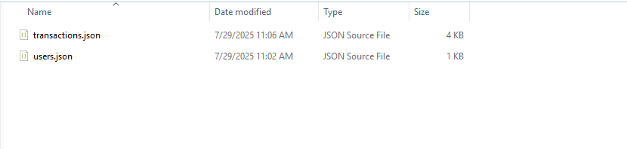
Figure 38 JSON storage

- Designs
- Login Screen
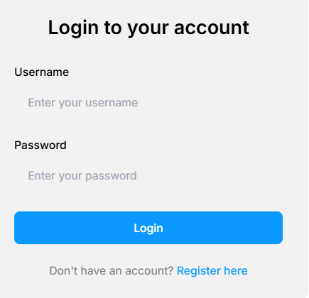

Figure 39 Login Screen

This is a wireframe of login screen from where users can login to the FinanceTracker if there are no authenticated users found it is directed towards the Register page.

- Register Screen

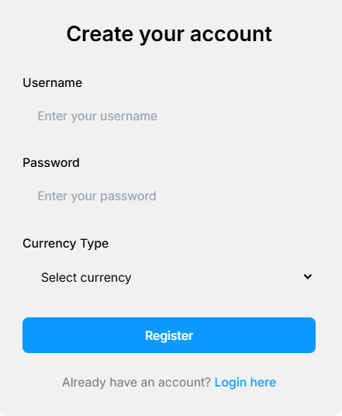
Figure 40 Registration Page
This is a wireframe of signup screen from where users can register to the FinanceTracker if there are authenticated users found it is directed towards the Login page.

- Profile

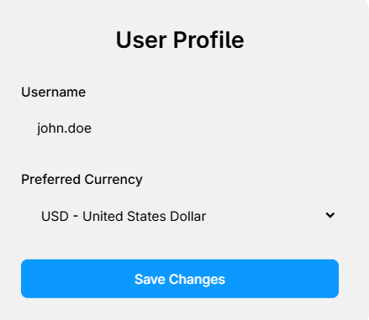
Figure 41 User profile page
This is a wireframe of profile page where authenticated users can change their currency for the app.

- Dashboard

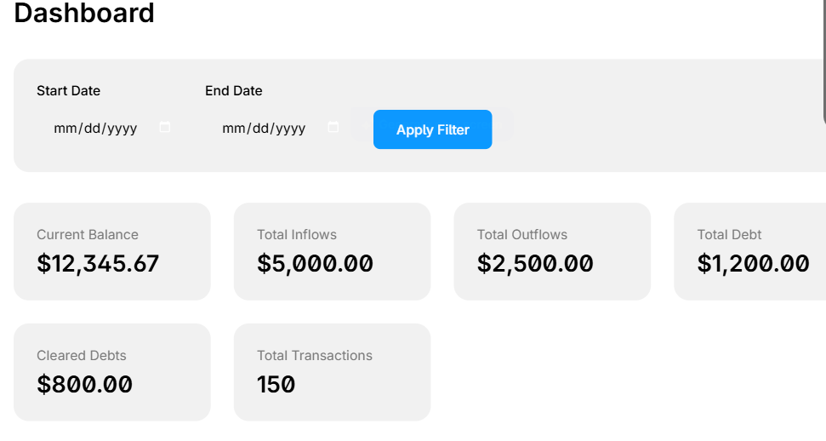
Figure 42 Dashboard Page

This is a dashboard page for users where users can see analytics of their transactions.
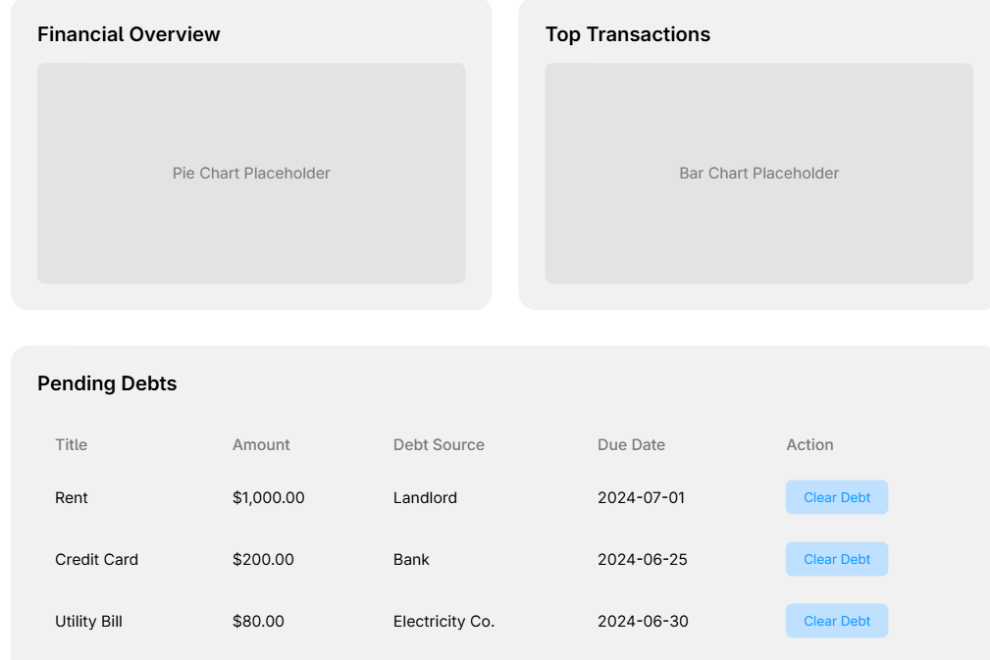
Figure 43 Continued Dashboard

- Transaction Page

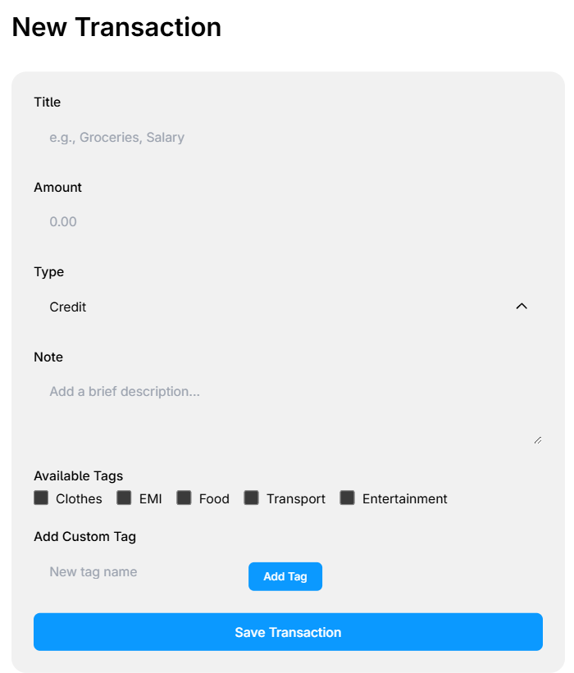
Figure 44 Transaction wireframe
This is a transaction page where users can add the transaction and add notes and default/custom tags to their transaction.

- UML Diagrams

- Entity Relationship Diagram(ERD)
An Entity Relationship (ER) Diagram is a type of flowchart that illustrates how “entities” such as people, objects or concepts relate to each other within a system. ER Diagrams are most often used to design or debug relational databases in the fields of software engineering, business information systems, education and research. Also known as ERDs or ER Models, they use a defined set of symbols such as rectangles, diamonds, ovals and connecting lines to depict the interconnectedness of entities, relationships and their attributes. They mirror grammatical structure, with entities as nouns and relationships as verbs. (LucidChart, 2017)

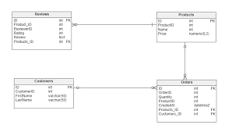
Figure 45 Example of ERD

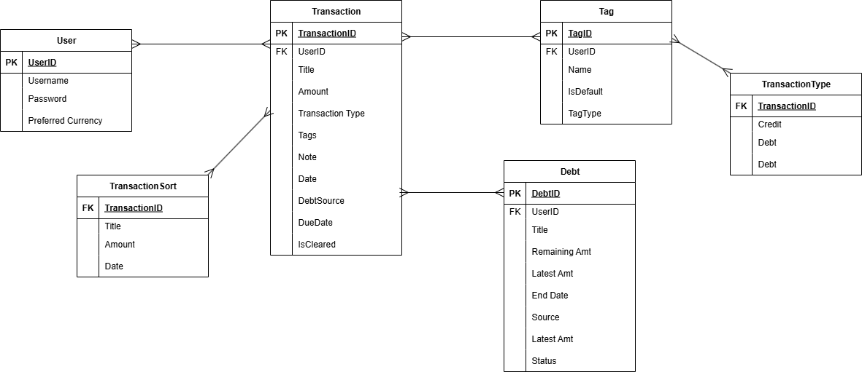
Figure 46 ERD of Finance Tracker

In my system called as Finance Tracker, a user can create multiple transactions, these multiple transactions can have multiple sources about the kind of transactions. These transactions also can contain of debts. These transactions are uniquely identified with the default or customisable tags and each of these tags are identified with the various types of transactions.

- Use Case Diagram
A Use Case Diagram in Unified Modelling Language (UML) is a visual representation that illustrates the interactions between users (actors) and a system. It captures the functional requirements of a system, showing how different users engage with various use cases, or specific functionalities, within the system. Use case diagrams provide a high-level overview of a system’s behaviour, making them useful for stakeholders, developers, and analysts to understand how a system is intended to operate from the user’s perspective, and how different processes relate to one another. They are crucial for defining system scope and requirements.

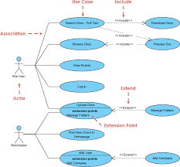
Figure 47 Use case diagram

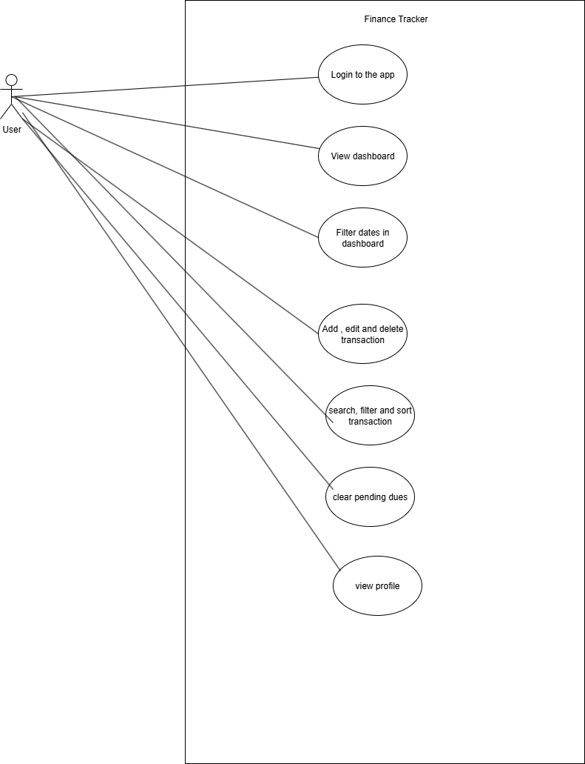
Figure 48 Use case diagram

- Class Diagram
A class diagram in the Unified Modelling Language (UML) is a type of static structure diagram that describes the structure of a system by showing the system's classes, their attributes, operations (or methods), and the relationships among objects. (Visual Paradigm, 2017)
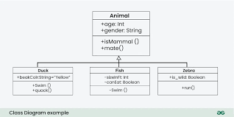
Figure 49 Example of class diagram

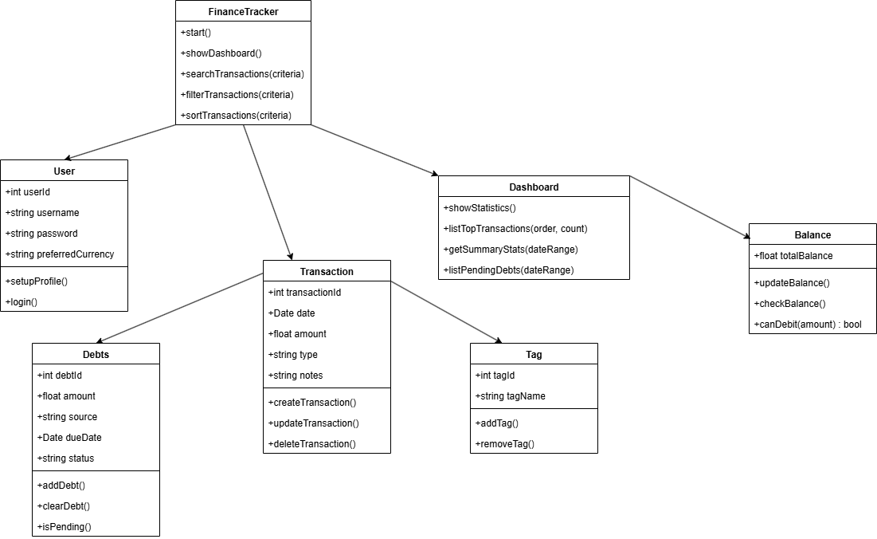
Figure 50 Class diagram

GitHub commit history

Figure 51 Added GitHub commit history as of 29th July 2025
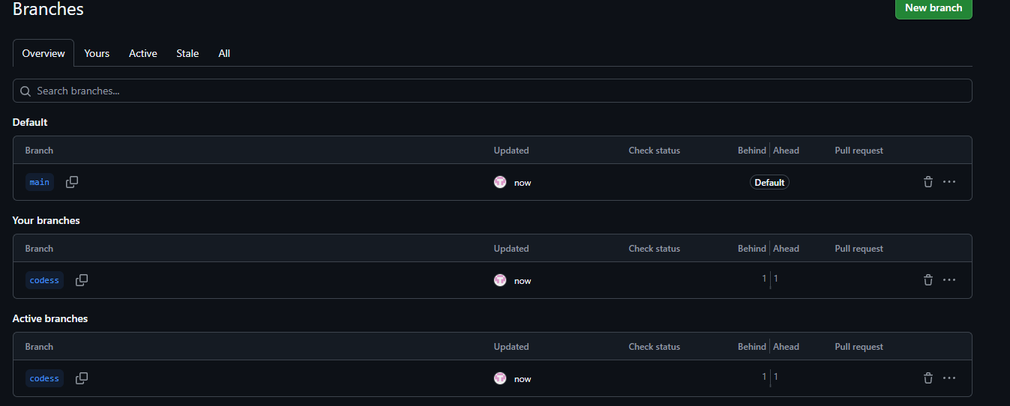
Figure 52 Merged and pulled the commit of all branches

System Testing

Test No | 1
Objective | Verify cash inflow transaction
Action | Adding transaction with Credit and filling details
Expected Result | Transaction appear as a credit.
Actual Result | Transaction added successfully.
Conclusion | Test is successful.

Table 1 Verifying credit transaction

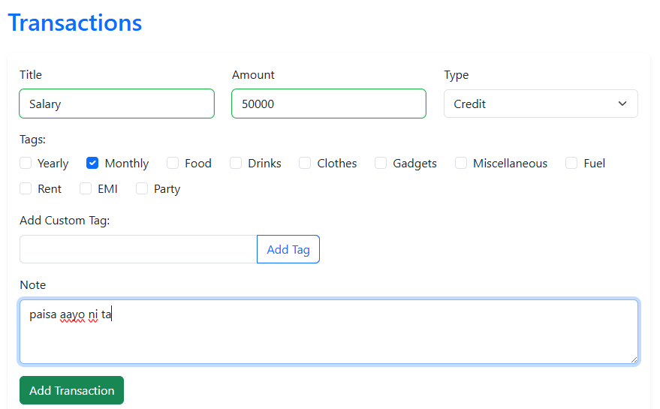
Figure 53 Cash inflow transaction

Test No | 2
Objective | Verify cash outflow transaction
Action | The balance is deducted from credit and is filled in as a debit transaction.
Expected Result | Transaction appear as a debit
Actual Result | Transaction added successfully.
Conclusion | Test is successful.

Table 2 Verifying debit transaction
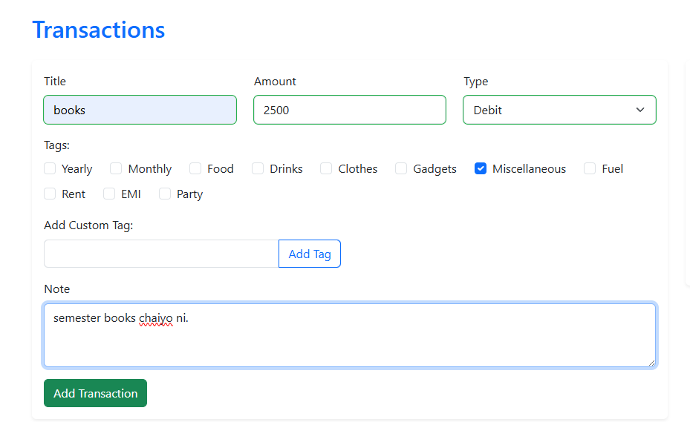
Figure 54 Debit transaction

Test No | 3
Objective | Verify debt transaction
Action | The transaction debt is saved only after mentioning the debt source and debt due date.
Expected Result | The transaction is added successfully and highlights pending debts.
Actual Result | The pending debts are highlighted in the dashboard.
Conclusion | Test is successful.

Table 3 Verify debt transaction
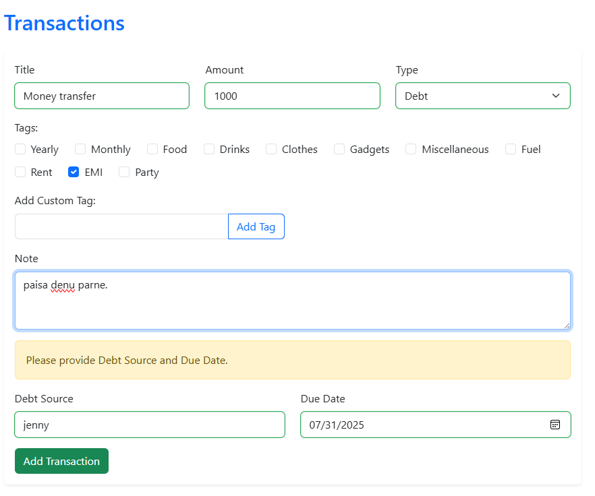
Figure 55 Debt transaction

Test No | 4
Objective | Check for sufficient balance
Action | The transaction shouldn’t add more balance when there is less credit.
Expected Result | The transaction isn’t supposed to add the cash outflow and deduct balance.
Actual Result | Outflow transactions are added and the balance is cleared from the balance.
Conclusion | Test is successful.

Table 4 Sufficient balance check
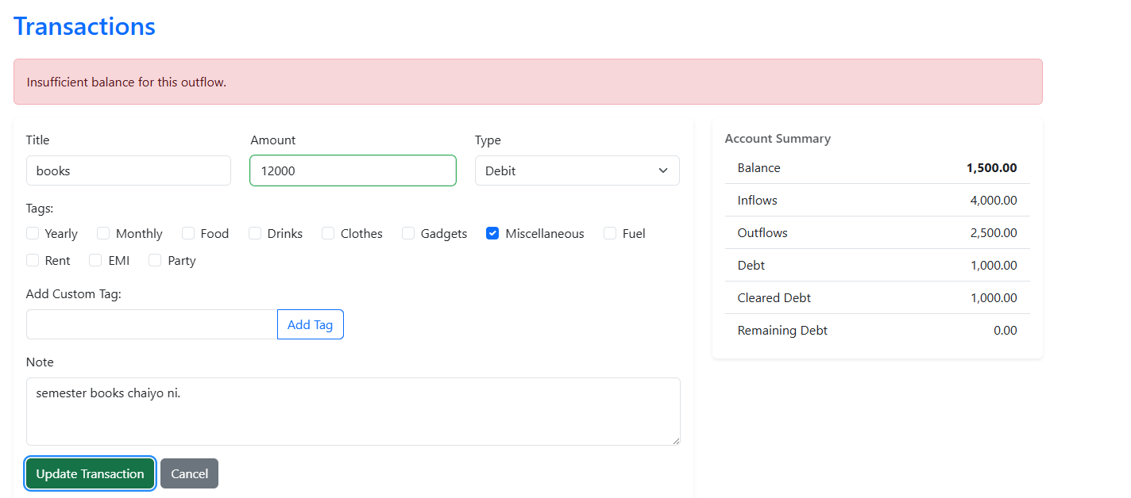
Figure 56 checking for sufficient balance

Test No | 5
Objective | Clearing debt from inflows
Action | The transaction should be able to clear debt from inflows.
Expected Result | The transaction is cleared from inflows to manage debt.
Actual Result | Inflows are maintained and can clear debts.
Conclusion | Test is successful.

Table 5 Clearing debts from inflow
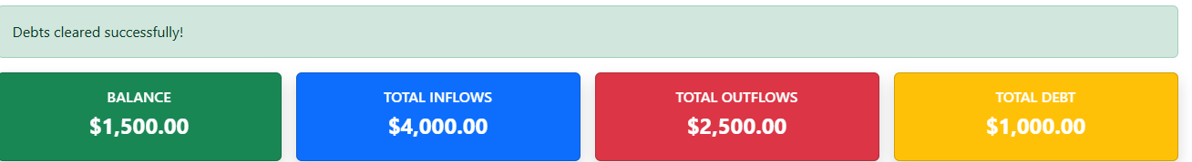
Test No | 6
Objective | Highlight pending debts
Action | The transaction shows all the pending debts.
Expected Result | The transaction list displays all pending debts.
Actual Result | The pending debts are highlighted.
Conclusion | Test is successful.

Table 6 Highlight pending debts

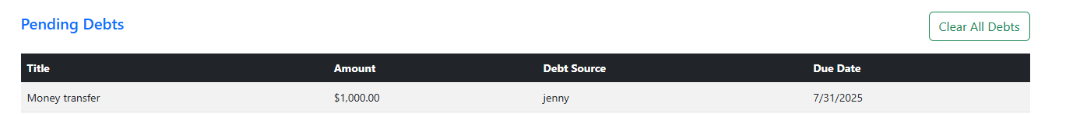
Figure 57 highlighting pending debts
Test No | 7
Objective | Ability to add custom or existing tags/labels to a transaction
Action | The transaction should be able to add the custom or default existing tags to the transaction.
Expected Result | The transaction contains the tags which can identify the transaction.
Actual Result | The default tags or custom tags can be used to identify the transaction.
Conclusion | Test is successful.

Table 7 Adding custom or existing tags
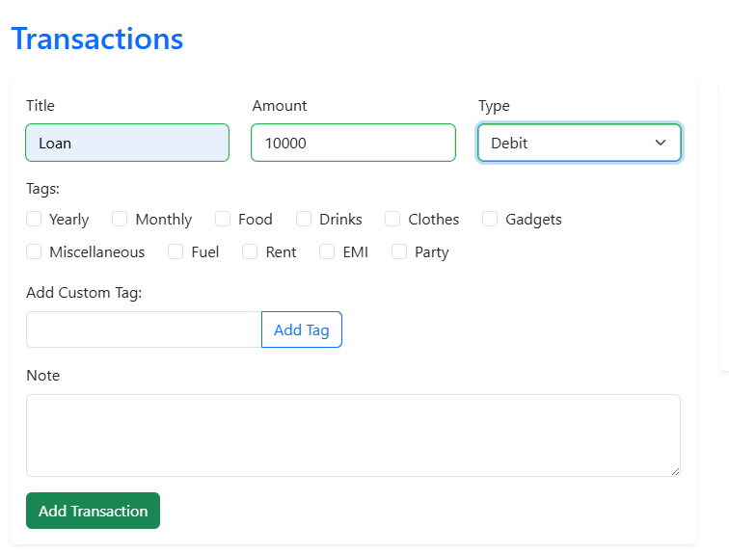
Figure 58 Adding transaction without custom or existing tags and notes.

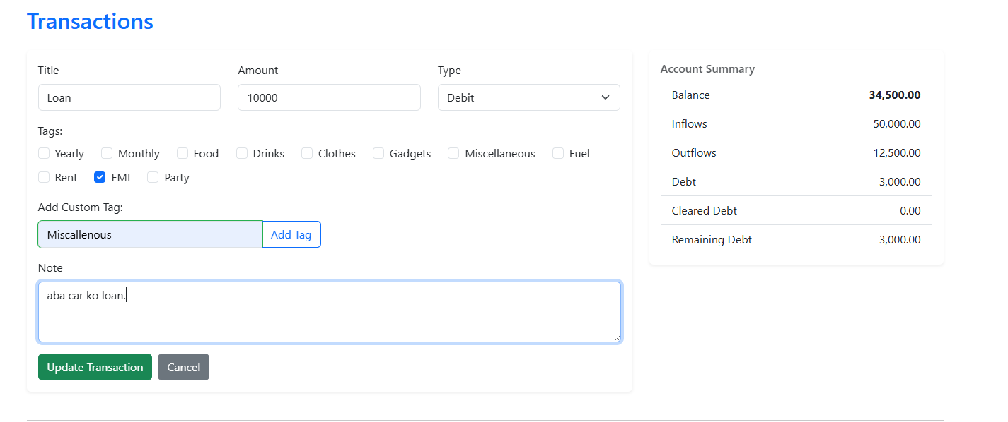
Figure 59 Updating transaction with custom or existing tags, labels and notes
Figure 60 Transaction added successfully

Test No | 8
Objective | Ability to add optionally a note to a transaction
Action | The transaction should be able to add notes to the transaction.
Expected Result | The transaction contains the notes which can identify the transaction.
Actual Result | The notes can be used to identify the transaction.
Conclusion | Test is successful.

Table 8 Adding notes to transaction
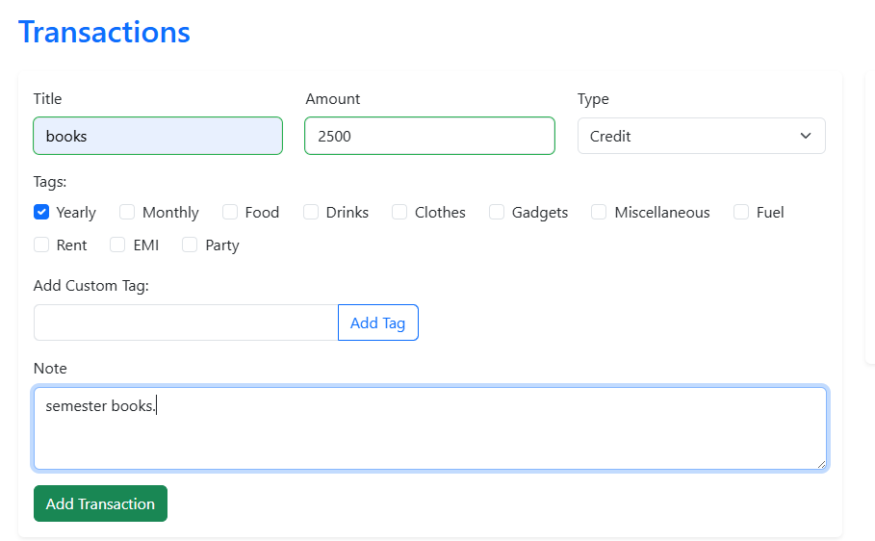
Figure 61 Adding notes to the transaction

Test No | 9
Objective | Filtering transactions by type, tags, and date range
Action | The transaction is used to filter transactions with type, tags and date range.
Expected Result | Transactions are filtered through types, tags and date range.
Actual Result | Transactions are filtered through types, tags and date range.
Conclusion | Test is successful.

Table 9 Filtering transactions by type, tags and date
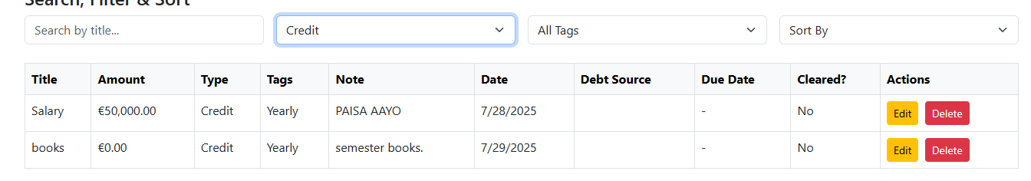
Figure 62 Filtering transactions by type
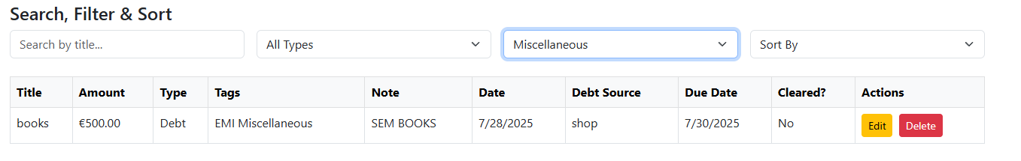
Figure 63 Filtering transactions by tag
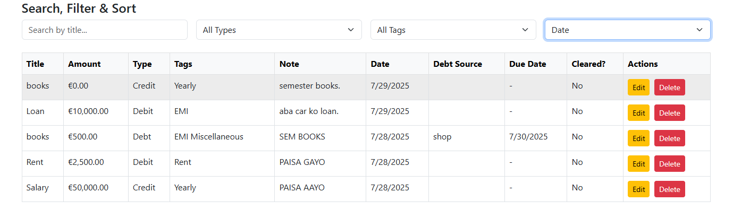
Figure 64 Filtering transactions by date

Test No | 10
Objective | Sorting transactions by date
Action | The transaction can be sorted through ascending or descending dates.
Expected Result | Transactions are sorted through the date range in a particular order.
Actual Result | Transactions are sorted through a particular order of date.
Conclusion | Test is successful.

Table 10 Sorting transactions by date
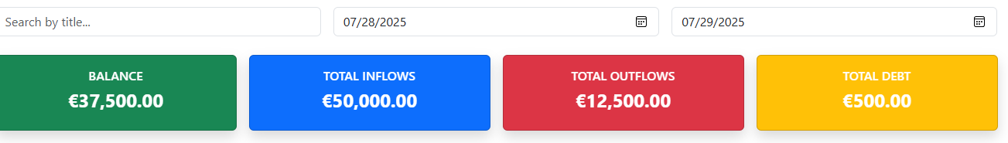
Figure 65 Sorting transactions by date
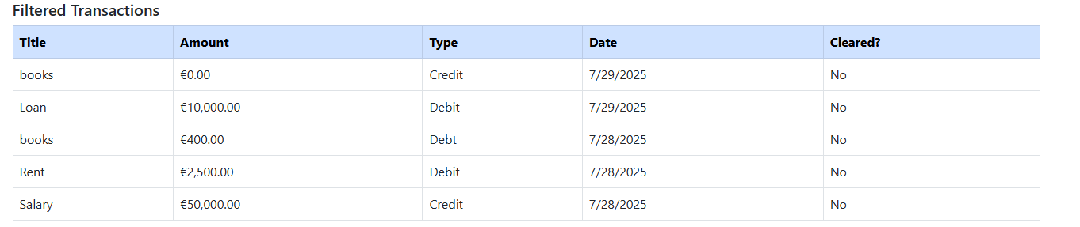
Figure 66 Sorted by date

Test No | 11
Objective | Searching transactions by title, seamlessly with existing sorting and filtering results
Action | The transactions are searched through title along with predefined sort and filter results.
Expected Result | The transactions are searched with the title with defined sort and filter results from before.
Actual Result | The transactions are searched with the title with defined sort and filter results from before.
Conclusion | Test is successful.

Table 11 Searching transactions by title with existing filter and sort results
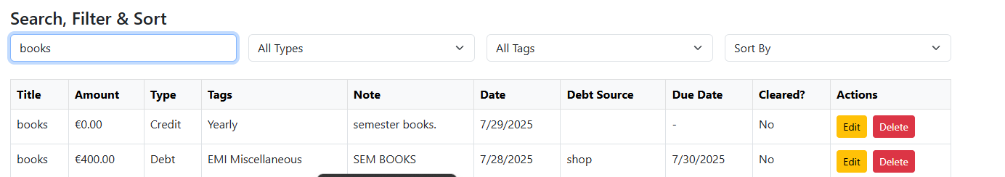
Figure 67 Searching transactions by title with existing filter and sort

Test No | 12
Objective | Display total number of transactions and total transactions (inflows + debts - outflows)
Action | The total number of transactions and total transactions are displayed in the dashboard.
Expected Result | The total transactions and number of transactions are displayed.
Actual Result | The total transactions and number of transactions are displayed.
Conclusion | Test is successful.

Table 12 Display total number of transaction and total transactions
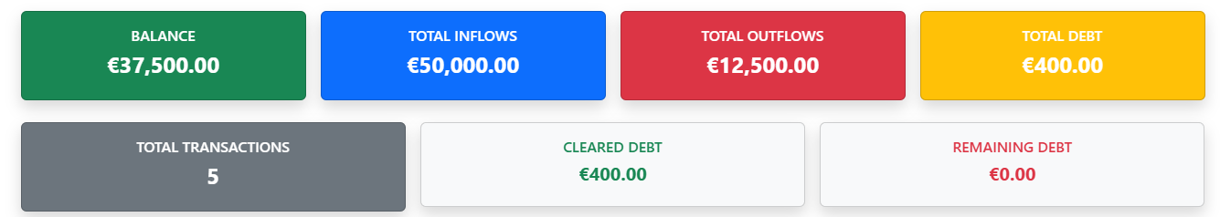
Figure 68 Total number of transactions
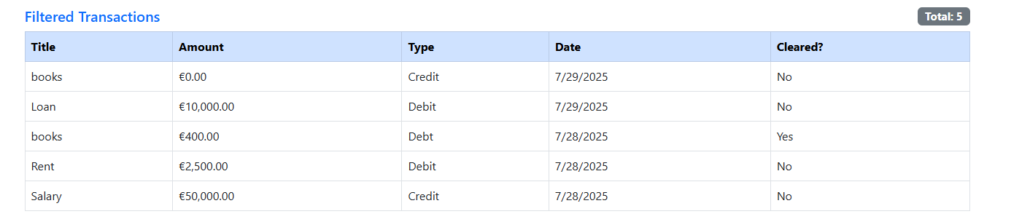
Figure 69 Total transactions

Test No | 13
Objective | Display of total inflows, outflows, debt, cleared debt, remaining debt
Action | The display of total inflows, outflows, all types of debts are displayed in dashboard.
Expected Result | There is a list of inflows, outflows and all types of debts can be seen while hovering to dashboard.
Actual Result | There is a list of inflows, outflows and all types of debts can be seen while hovering to dashboard.
Conclusion | Test is successful.

Table 13 Display of total inflows, outflows and debt related transactions
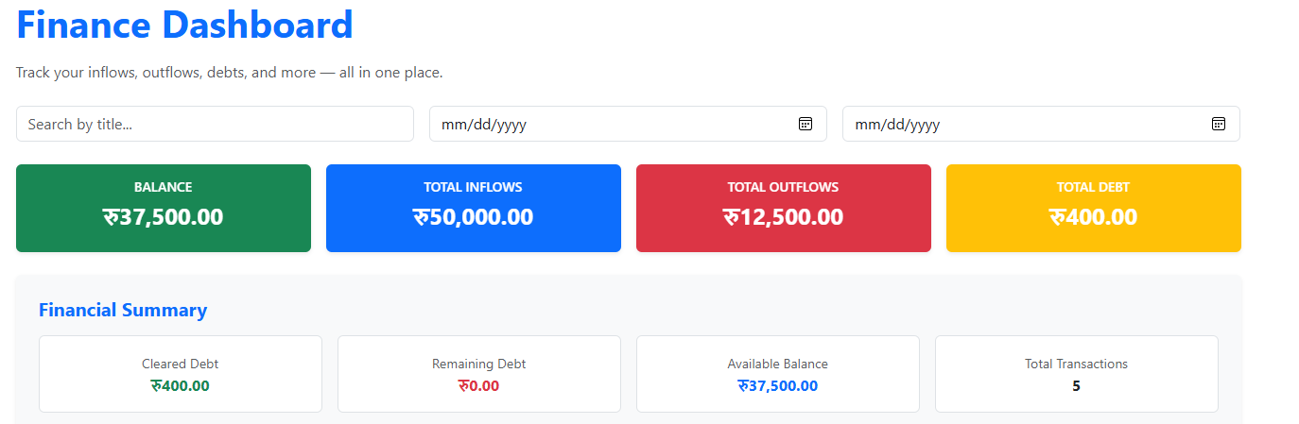
Figure 70 Display of total inflows, outflows, debt related transactions

Test No | 14
Objective | Display of highest/lowest inflow, outflow, and debt transactions
Action | When user hovers in dashboard page, they can view the highest , lowest inflow, outflow and debt transactions to identify.
Expected Result | User can see the highest and lowest inflow, outflow and debt transaction.
Actual Result | User can see the highest and lowest inflow, outflow and debt transaction.
Conclusion | Test is successful.

Table 14 Display of highest and lowest inflow, outflow and debt transactions

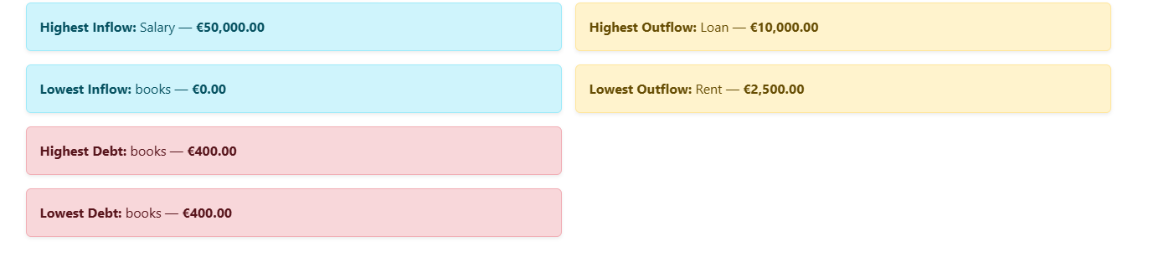
Figure 71 display of highest and lowest inflows, outflows and debt

Test No | 15
Objective | Properly listing pending debts in the dashboard
Action | The user hovers to pending debts in dashboard page and clicks on clear pending debts if there is required balance.
Expected Result | The user can view the pending debts and clears if there is required balance.
Actual Result | The user can view the pending debts and clear the pending debts.
Conclusion | Test is successful.

Table 15 Pending debts in dashboard

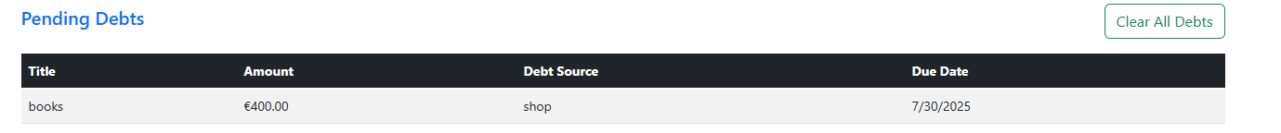
Table 16 Pending debts in dashboard
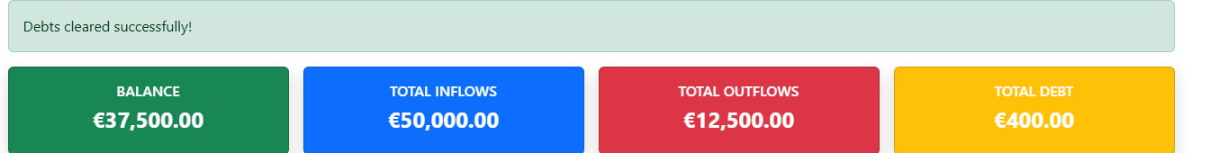
Table 17 Cleared debts successful

Test No | 16
Objective | Dashboard filtering by specific date ranges
Action | When user clicks on the dashboard page, we can sort out the dates to identify the transactions.
Expected Result | After searching by title along with the date range the transactions appear with those dates.
Actual Result | After searching by title along with the date range the transactions appear with those dates.
Conclusion | Test is successful.

Table 16 Filtering dates in the dashboard
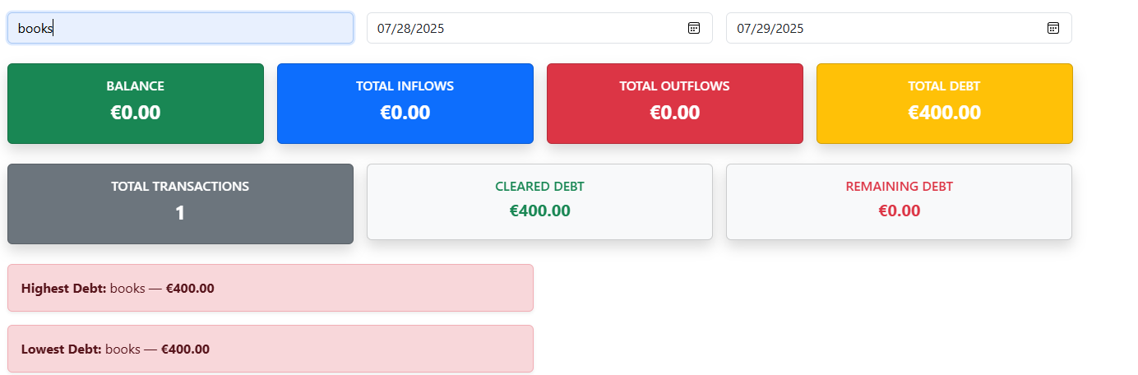
Figure 72 Filtering transactions by date in dashboard with title
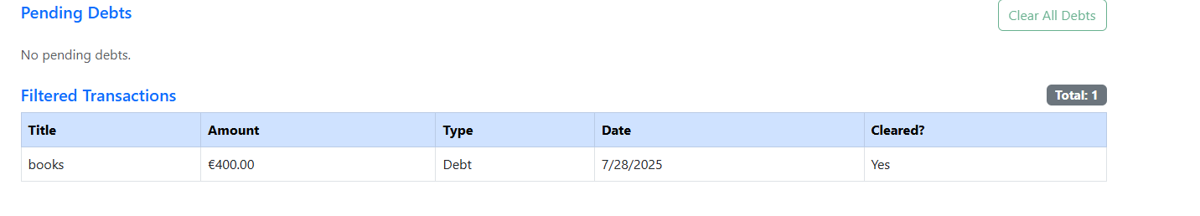
Figure 73 After filtering of transactions

Conclusion

This project- Personal Expense Tracker has been quite rewarding and a challenging experience that helped me build a real life project. This project has been made with the help of MAUI Blazor Hybrid app that has helped me to explore about .NET as well as understand newer technologies which helps to complete a particular app with the requirements as specified.
From making features such as authentication, sort and filter of transactions tags and debt tracking which helps to create an analytics of dashboard has made me understand about the importance of analysis made during any calculation.

Although it was time taking, I quite enjoyed the process of learning these core concepts, solving issues and making functional UI and development which taught me the values of learning and resilience. There were moments where I had lot many doubts and frustrations about the project workflow and with the effort created, the journey of learning seemed easier and understanding to overcome these challenges.

While these may not be as perfect as visioned but with the complete features from requirements I’m able to understand the project , technologies that were used as well as gained persistence and adaptability as an extra skill to polish.

5.Bibliography
Ansari, R., 2023. Build A Blazor Hybrid App with .NET MAUI for Cross-Platform Application. [Online]
Available at: https://www.c-sharpcorner.com/article/build-a-blazor-hybrid-app-with-net-maui-for-cross-platform-application/
[Accessed 12 July 2025].
GeeksforGeeks, 2019. Bootstrap Intro. [Online]
Available at: https://www.w3schools.com/bootstrap/bootstrap_get_started.asp
[Accessed 11 July 2025].
GeeksforGeeks, 2019. Git Intro. [Online]
Available at: https://www.w3schools.com/git/git_intro.asp?remote=github
[Accessed 11 July 2025].
JSON Org., 2019. JSON Introduction. [Online]
Available at: https://www.json.org/json-en.html
[Accessed 14 July 2025].
LucidChart, 2017. What is an ERD?. [Online]
Available at: https://www.lucidchart.com/pages/er-diagrams
[Accessed 12 July 2025].
Microsoft Corp., 2017. Dotnet Razor. [Online]
Available at: https://dotnet.microsoft.com/en-us/apps/aspnet/web-apps/blazor
[Accessed 11 July 2025].
Visual Paradigm, 2017. Class Diagram. [Online]
Available at: https://www.visual-paradigm.com/guide/uml-unified-modeling-language/what-is-class-diagram/
[Accessed 14 July 2025].

Bibliography
Ansari, R., 2023. Build A Blazor Hybrid App with .NET MAUI for Cross-Platform Application. [Online]
Available at: https://www.c-sharpcorner.com/article/build-a-blazor-hybrid-app-with-net-maui-for-cross-platform-application/
[Accessed 12 July 2025].
GeeksforGeeks, 2019. Bootstrap Intro. [Online]
Available at: https://www.w3schools.com/bootstrap/bootstrap_get_started.asp
[Accessed 11 July 2025].
GeeksforGeeks, 2019. Git Intro. [Online]
Available at: https://www.w3schools.com/git/git_intro.asp?remote=github
[Accessed 11 July 2025].
JSON Org., 2019. JSON Introduction. [Online]
Available at: https://www.json.org/json-en.html
[Accessed 14 July 2025].
LucidChart, 2017. What is an ERD?. [Online]
Available at: https://www.lucidchart.com/pages/er-diagrams
[Accessed 12 July 2025].
Microsoft Corp., 2017. Dotnet Razor. [Online]
Available at: https://dotnet.microsoft.com/en-us/apps/aspnet/web-apps/blazor
[Accessed 11 July 2025].
Visual Paradigm, 2017. Class Diagram. [Online]
Available at: https://www.visual-paradigm.com/guide/uml-unified-modeling-language/what-is-class-diagram/
[Accessed 14 July 2025].

