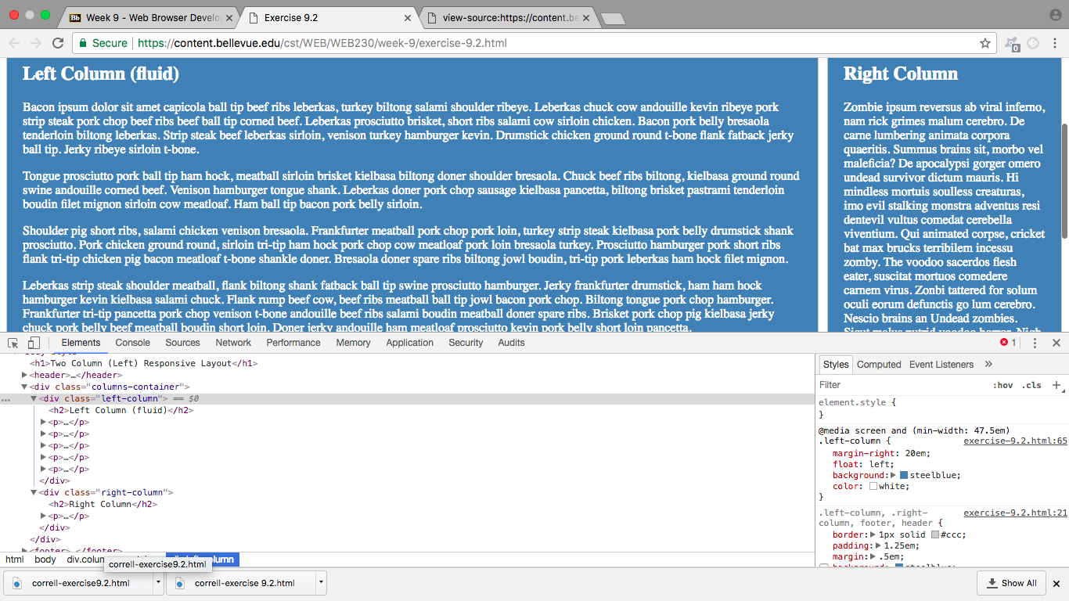

1. Because I’m working on a Mac, to open the DevTools I press option+command+J. This opens the boxes at the bottom with the code in it.
2. I then find the element I want to change, in this case the <div> element that contains the code for the right column. When I click on the element, it highlights it so I know I am looking at the information for that element.
3. The box on the right contains all of the styles for the element that is highlighted. To add more styles to the page, you simply click and it allows you to change the code right in the window. The check boxes beside the styles allow you to select and deselect which styles are displayed on the page.
4. The next step was to do the same for the left column however the styles for the left and right columns are grouped so it was already done.