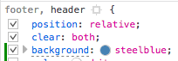

1. In the firefox browser, press option+command+I to open DevTools.
2. Under the inspector tab, you see the html code for the page.
3. To change the header and footer background color, find he <header> element and click to highlight it.
4. In the box to the right, you see the CSS styles for the highlighted element.
5. Find the style rule that applies styles to both the header and footer, and add a background color rule.
6. Next, to change the link font colors to white, add a rule that applies to the <a> elements and add a color property.