CARLETON UNIVERSITY

cuACS

System Design Document

Team QuackJaws
Jake Bauer
Ashlee Foureyes
Skyler Gubbels
Will Watt

Submitted to:
Dr. Christine Laurendeau
COMP3004 – Object-Oriented Software Engineering
School of Computer Science
Carleton University
March 21, 2019

Contents
1 Introduction 2
1.1 The cuACS System 2
1.2 Document Overview 2
2 Subsystem Decomposition 2
2.1 D2 Subsystem Decomposition 2
2.2 Full Subsystem Decomposition 6
2.3 Design Evolution 12
3 Design Strategies 12
3.1 Persistent Storage 12
3.2 Design Patterns 17
4 Index of Tables 17
5 Index of Figures 17

1 Introduction

1.1 The cuACS System

1.2 Document Overview

2 Subsystem Decomposition
{In this section, we will discuss two different subsystem decomposition and how the design has evolved since the first one}

2.1 D2 Subsystem Decomposition

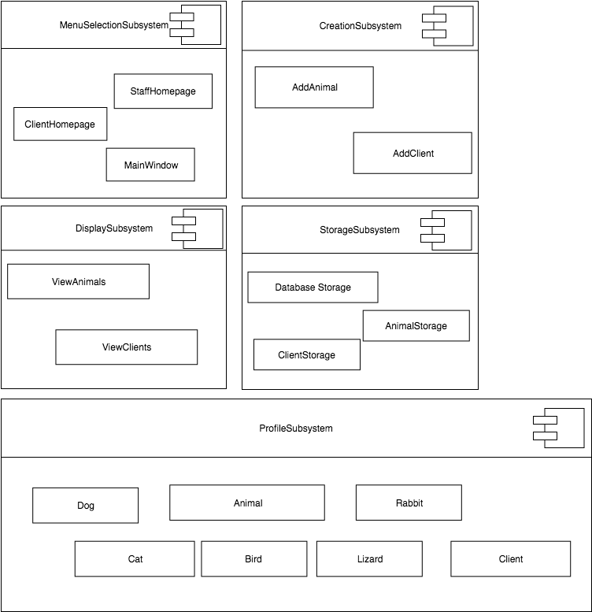

MenuSelectionSubsystem
- The MenuSelectionSubsystem for allowing the user to choose how they want to interact with the system.
MainWindow
- Responsible for letting the user decide if they want to log in to StaffHomepage or ClientHomepage. Checks for valid email if user is trying to log in as an existing Client.
StaffHomepage
- Allows the user to initiate the Animal/Client creation process. Allows the user to initiate the viewing of all Animals and Clients.
ClientHomepage
- Allows the user to view all Animals.

CreationSubsystem
- The CreationSubsystem is responsible for creating Animal and Client profiles. It is this subsystem that gathers all of the users’ inputs and stores them in new objects.
AddAnimal
- Gets all required information from the user and creates a new Animal object.
AddClient
- Gets all the required information from the user and creates a new Client object

DisplaySubsystem
- The Display subsystem is responsible for viewing all the Animals and Clients in the StorageSubsystem.
ViewAnimals
- Displays all animals in the StorageSubsystem along with all their attributes. Users are able to filter results by Animal species.
ViewClients
- Displays all clients in the StorageSubsystem along with their contact information.

StorageSubsystem
- Responsible for local and persistent storage of all Animal and Client objects. Responsible for assigning unique Animal and Client id’s.
AnimalStorage
- Responsible for storing all 5 species of Animal objects created by AddAnimal. Once AnimalStorage assigns id Animal object information is added to DatabaseStorage.
ClientStorage
- Responsible for storing the Clients. Once ClientStorage assigns a unique id the Client information is added to DatabaseStorage.
DatabaseStorage
- Persistent storage for all Animal and Client attributes. Used by MainWindow at startup to create new Animal/Client objects from database data.
ProfileSubsystem
- Responsible for locally storing information entered by the user in the form of Animal or Client objects.
Animal
- Includes 5 subclasses (Dog, Cat, Bird, Lizard, Rabbit). Used to store information input by user regarding Animals in the shelter. These are then stored in AnimalStorage.
Profile
- Used to store information input by user regarding their own profile. These are then stored in ClientStorage.

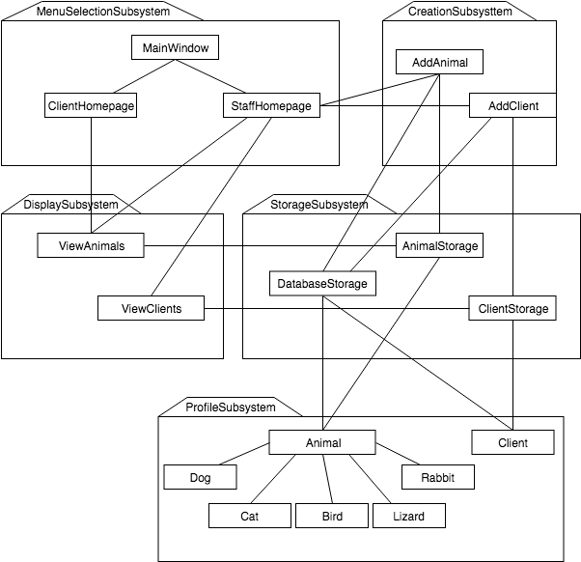

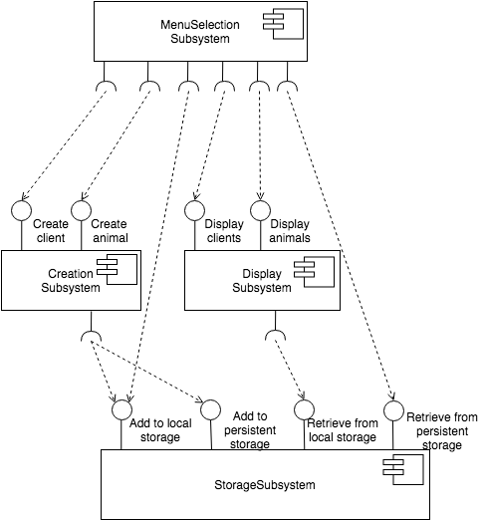

2.2 Full Subsystem Decomposition

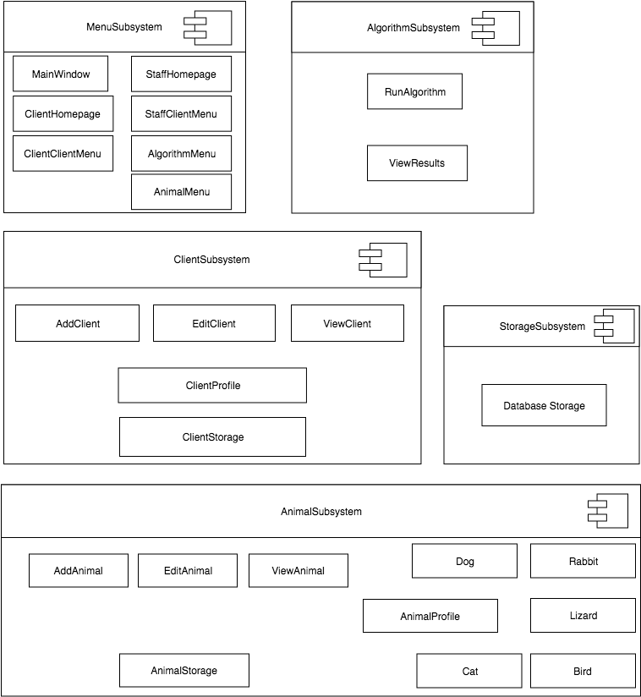

MenuSelectionSubsystem
- The MenuSelectionSubsystem is responsible for allowing the user to choose how they want to interact with the system. They choose which menu to access to perform certain actions.
MainWindow
- The MainWindow allows the user to decide if they want to log in to StaffHomepage or ClientHomepage. It checks for a valid email if the user is trying to log in as an existing Client.
StaffHomepage
- The StaffHomepage provides access to several menus which further encapsulate the functionality that staff members can execute.
StaffClientMenu
- The StaffClientMenu allows the staff member access to viewing and adding ClientProfiles.
AlgorithmMenu
- The AlgorithmMenu allows the staff member access to running the algorithm and viewing the results output by the algorithm.
AnimalMenu
- The AnimalMenu allows the staff member access to viewing and adding AnimalProfiles.
ClientHomepage
- The ClientHomepage provides access to a menu which further encapsulates the functionality that Clients can execute. It also provides access to the ViewAnimal class, allowing clients to view the AnimalProfiles of the animals in the shelter.
ClientClientMenu
- The ClientClientMenu allows a client access to viewing and editing their own ClientProfile.

ClientSubsystem
- The ClientSubsystem is responsible for handling everything relating to the Client type of user of the cuACS system. It is specifically responsible for loading ClientProfiles from persistent storage, handling adding clients and allowing those clients to edit their profiles, and viewing the clients.
AddClient
- The AddClient class provides the functionality for adding a new ClientProfile to the system.
ViewClient
- The ViewClient class provides functionality for displaying a ClientProfile’s information.
EditClient
- The EditClient class provides the facilities for editing the information contained in a ClientProfile.
ClientProfile
- The ClientProfile class represents the locally stored (non-persistent) client profiles which are acted upon by AddClient, ViewClient, and EditClient and are loaded into the system on startup.
ClientStorage
- The ClientStorage class is responsible for communicating between the locally stored ClientProfiles loaded at runtime and the persistent storage where all client profiles are saved to and loaded from.

AnimalSubsystem
- The AnimalSubsystem is responsible for handling everything relating to the Animals of the cuACS system. It is specifically responsible for loading AnimalProfiles from persistent storage, handling adding animals and editing their profiles, and viewing the animals.
AddAnimal
- The AddAnimal class provides the functionality for adding a new AnimalProfile to the system.
ViewAnimal
- The ViewClient class provides functionality for displaying an AnimalProfile’s information.
EditAnimal
- The EditAnimal class provides the facilities for editing the information contained in an AnimalProfile.
AnimalProfile
- The AnimalProfile class represents the locally stored (non-persistent) animal profiles which are acted upon by AddAnimal, ViewAnimal, and EditAnimal and are loaded into the system on startup. It includes five sub-classes for handling profile information for each type of animal.
Rabbit
- The Rabbit class represents the unique animal profile for rabbits containing rabbit-specific attributes in addition to basic animal ones.
Lizard
- The Lizard class represents the unique animal profile for lizards containing lizard-specific attributes in addition to basic animal ones.
Bird
- The Bird class represents the unique animal profile for birds containing bird-specific attributes in addition to basic animal ones.
Cat
- The Cat class represents the unique animal profile for cats containing cat-specific attributes in addition to basic animal ones.
Dog
- The Dog class represents the unique animal profile for dogs containing dog-specific attributes in addition to basic animal ones.

AnimalStorage
- The AnimalStorage class is responsible for communicating between the locally stored animal profiles loaded at run-time and the persistent storage where all animal profiles are saved to and loaded from.
StorageSubsystem
- The StorageSubsystem is responsible for the persistent storage of all ClientProfiles and AnimalProfiles.
DatabaseStorage
- DatabaseStorage is the persistent storage for all AnimalProfiles and ClientProfiles. Used by ClientStorage and AnimalStorage at startup to create new Animal/Client objects from database data, by those same classes when storing newly added or edited profiles, and by the Algorithm when reading profiles to determine matches.
AlgorithmSubsystem
- The AlgorithmSubsystem is responsible for handling the operation of the Animal-Client matching (ACM) algorithm.
RunAlgorithm
- The RunAlgorithm class controls the running of the ACM algorithm. It is used to launch an instance of the matching algorithm to compute the optimal matches between Clients and Animals.
ViewResults
- The ViewResults class displays results of the most recent run of the ACM algorithm.
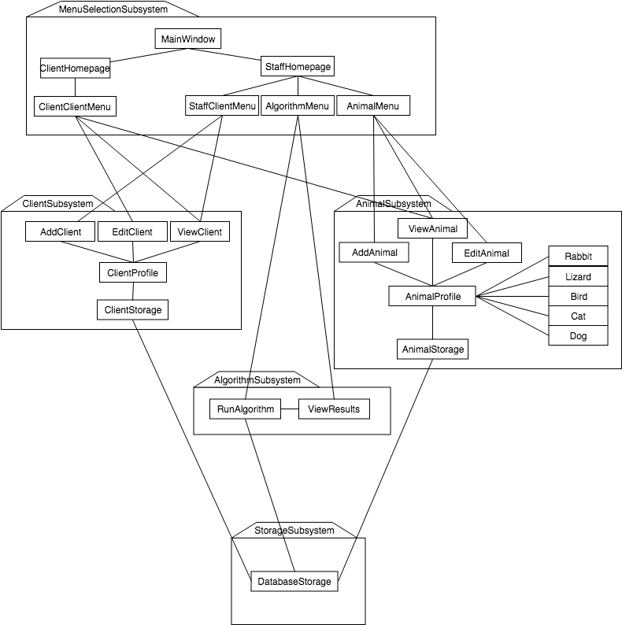
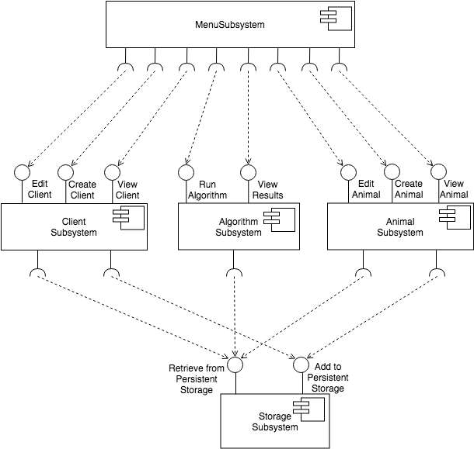

2.3 Design Evolution

3 Design Strategies
{general overview of what design strategies were employed}

3.1 Persistent Storage

The persistent data structure used in the cuACS system is a sqlite3 database. Using a database connected to QtCreator allows the program to efficiently and swiftly save data without the hassle of having to parse a plain-text file. Using a database also significantly increases the scalability of the program, allowing for many other animals and clients to be stored. When the program is loaded, a check for a database is performed, searching the operator’s host desktop directory for an existing database to load from. If a database does not exist, one is created and placed on the desktop, with the name “cuACS.db”. Providing the database on the desktop allows for simple access, if needed, for the operator or in-house IT staff; it also provides the operator with assurance that a database has been created for them, in a spot that they are familiar with. After the database is created, 6 tables are created– clientStorage, dogStorage, catStorage, lizardStorage, birdStorage and rabbitStorage, with corresponding schemas. (See section Table Schema to view each table’s associated schema.) A check for these 6 tables is also performed if an existing database is present, with the correct schema. After the database and tables have been established, the tables are populated with clients (25) and animals (27).
Each client/animal profile is represented in the database as a row, in the appropriate table – i.e. dogs are stored in the table titled ‘dogStorage’, clients in clientStorage, etc. The columns for each of the tables represent a client/animal’s attributes, such as for animals: name, breed, history, hypoallergenic, etc.; and for clients: name, address, wantsBird, has children, etc. Each of the attributes are stored in the database tables as a sqlite INTEGER type or sqlite TEXT type. For the case of an animal’s breed, the associated vector of breeds is converted into the a string in the format: [ (breed₁)(breed₂)(…)(breed_{n})], for the n breeds which are associated with an animal, this newly formed string is saved as a sqlite TEXT type. Booleans are stored as integers.
As the tables are read, and the data is loaded into the cuACS system, each table is read, row by row. When a row is being read, an object is created, and the corresponding column value is assigned to the objects attribute. For example, when lizardStorage is being read, the lizard object’s “space” attribute – denoting how much space the lizard needs to survive – is set by the value stored in the database for the column titled “space.” This is done in the exact same way for all animals, and all clients. When a row is finished being read, the object is complete. Next, the newly created object is pushed into the internal Animal or Client list. Using an internal list speeds up processing time and prevents having to query the database for every time a profile is viewed.
When adding a new client or animal to the persistent storage, all of the appropriate text-fields, radio-buttons and check boxes are read, and an animal or client object is created. When created, the object is added to the appropriate internal list (client or storage), as well as sent to the database class to be added to the cuACS database. Here, the object is deconstructed into its attributes for the object, and are stored into the database, by column, based on the profile they are (i.e. client, dog, bird, etc.). A unique identifying number is created for each client or animal in the system, called idNum. The idNum is used for distinguishing animals and clients from each other – this is used as the primary key in the database. A primary key is the key that is unique for each record (row) in the database. Assigning each animal and client a unique idNum prevents the data from being over written when a new animal or client is added to the appropriate table.
Adding a new client or animal to the persistent storage creates the appropriate object, (with a new, unique idNum) and send it’s to the databaseStorage class, to add it to the database. Here, we deconstruct the object into its attributes, storing each of them inside the table with columns representing the attributes. When it comes to editing a profile for a client or animal, we refer to the profile by its unique idNum identifier, to ensure that we only edit the profile desired and not any others – this is ensured because the idNum is used as the primary key, and cannot be replicated, for an entry into the database. An idNum is composed of 2 parts, the profile code, followed by an identifying number. Profile codes are as follows: ﻿Client = 1, Dog = 2, Cat = 3, Bird = 4, Lizard = 5, Rabbit = 6, and is the first digit for the idNum. The identifying number is calculated by determining how many clients or objects currently exist in the system, and for a newly created profile is incremented by one. By default, the identifying numbers start at 100. As an example, the first animal in the system would have idNum = profilecode+100, adding another animal would create the idNum profileCode+101, and so on. An example of the clients’ idNum is as follows: if there are 12 clients in the system and another one is being added, the last client idNum would have been 1112, the resulting idNum of the new client will be 1113. Creating and utilizing an idNum in this way allows assurance that no 2 keys are the same, maintaining uniqueness between all animals and clients.
Having these unique idNum keys, allows for easy edits of clients or animals to occur. Simply querying the database table for the idNum of an edited animal or client, allows the row to be easily updated. In order to ensure that all user changes are updated, the all profile data is pushed to the database table and stored for the given idNum.
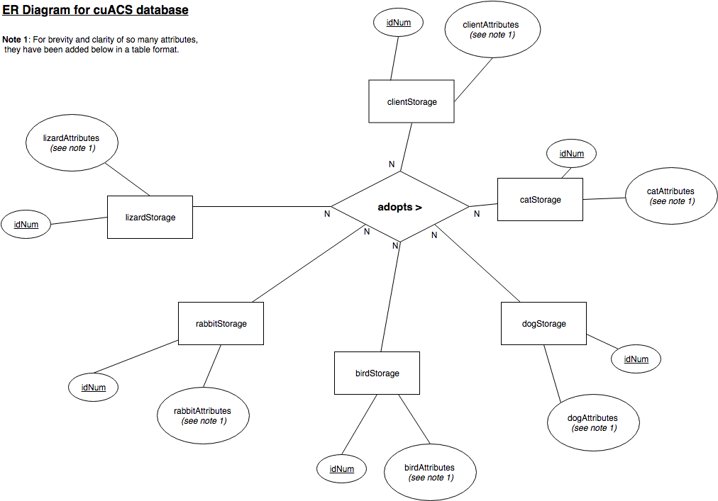
Client Attributes
idNum | protector | followCommandsCat | wantsRabbit
fName | energy | doesntShed | hasRabbitAllergies
lName | fearful | wantsBird | rabbitBreeds
address | affection | hasBirdAllergies | rabbitAge
phone | messy | birdBreeds | rabbitSize
email | wantsDog | birdAge | rabbitGender
city | hasDogAllergies | birdSize | isSocialRabbit
prov | dogBreeds | birdGender | needsGrooming
dwelling | dogAge | isQuietBird | rabbitColour
location | dogSize | isSocialBird | dogFur
workSchedule | dogGender | birdColour | catFur
activity | followsCommandsDog | wantsLizard | birdFur
hasChildren | houseTrained | hasLizardAllergies | lizardFur
hasAnimals | wantsCat | lizardBreeds | rabbitFur
travels | hasCatAllergies | lizardAge | quietness
children | catBreeds | lizardSize | age
goodWAnimals | catAge | lizardGender
strangers | catSize | easyToFeed
crowds | catGender | simpleLiving
noises | isCurious | lizardColour

Rabbit Attributes
idNum | energy
breed | fearful
name | affection
size | messy
age | nocturnal
gender | hypo
fur | lifeStyle
travels | history
children | pattern
goodWithAnimals | colour
strangers | grooming
crowds | attention
noises | filepath
protector

Dog Attributes
idNum | energy
breed | fearful
name | affection
size | messy
age | nocturnal
gender | hypo
fur | lifeStyle
travels | history
children | barks
goodWithAnimals | training
strangers | bathroomTrained
crowds | goodBoy
noises | filepath
protector

Cat Attributes
idNum | energy
breed | fearful
name | affection
size | messy
age | nocturnal
gender | hypo
fur | lifeStyle
travels | history
children | curiosity
goodWithAnimals | trained
strangers | shedding
crowds | filepath
noises
protector

Bird Attributes
idNum | energy
breed | fearful
name | affection
size | messy
age | nocturnal
gender | hypo
fur | lifeStyle
travels | history
children | loud
goodWithAnimals | social
strangers | colour
crowds | filepath
noises
protector

Lizard Attributes
idNum | energy
breed | fearful
name | affection
size | messy
age | nocturnal
gender | hypo
fur | lifeStyle
travels | history
children | diet
goodWithAnimals | colour
strangers | feed
crowds | space
noises | light
protector | filepath

3.2 Design Patterns

4 Index of Tables

5 Index of Figures

