Will’s To Do

* ~~Table Description~~, High Level Diagram, Relationship Diagram
  + ~~FR-2.1.2~~
  + ~~FR-2.1.3~~
  + FR-2.1.4
  + FR-2.3.0
  + FR-2.3.1
  + FR-2.4.0
* Change “client” to “staff” on UC Diagrams (first 2 FR)

**Assigned Functional Requirements – Will Watt**

* FR-2.1.1 - Client Contact Information
  + A client’s contact information should consist of:
    - Full name
    - Full mailing address
    - Phone number
    - Email address
* FR-2.1.2 - Client Personal Information
  + A client’s personal information should consist of:
    - Whether they have children
    - Whether they have other pets
    - Whether they travel a lot
    - Whether they exercise a lot
    - Whether they go out to crowded places often
    - What their typical sleeping patterns are like
    - Whether or not they tend to make loud noises
    - Whether or not they are messy
* FR-2.1.4 - Client Matching Preferences
  + A client should be able to look at all of the physical and non-physical attributes of the animals and select which ones they absolutely must have, which ones they would prefer to have, which ones they feel neutral about, which ones they would rather not have, and which ones they absolutely will not accept.
* FR-2.3.0 – View List of Clients
  + Staff should be able to view a list of all clients.
* FR-2.3.1 - View Detailed Client Information
  + Staff should be able to view the detailed information of a selected client.

* FR-2.4.0 - Edit Client Profile — Staff
  + Staff should be able to edit a chosen client’s information.

**FR-2.1.2 – Client Contact Information**

Use Case Table Description

|  |  |
| --- | --- |
| Use Case Name | Client Contact Information ----- UC #### |
| Participating Actors | Initiated by Staff or Client  Communicates with Client_Management_System |
| Flow of Events | 1. The Client or Staff selects the View Client option with profile ID number.  2. The Client or Staff selects client contact information  3. Client_Management_System displays a record of the client’s contact information. |
| Entry Condition | The client must be logged into cuACS  The client ID number must be valid |
| Exit Condition | - |
| Quality Requirements | Response time between Client selecting the client contact information option and receiving content should be no more than 10 seconds. |
| Traceability | FR-2.1.2 |

Relationship Use Case Diagram

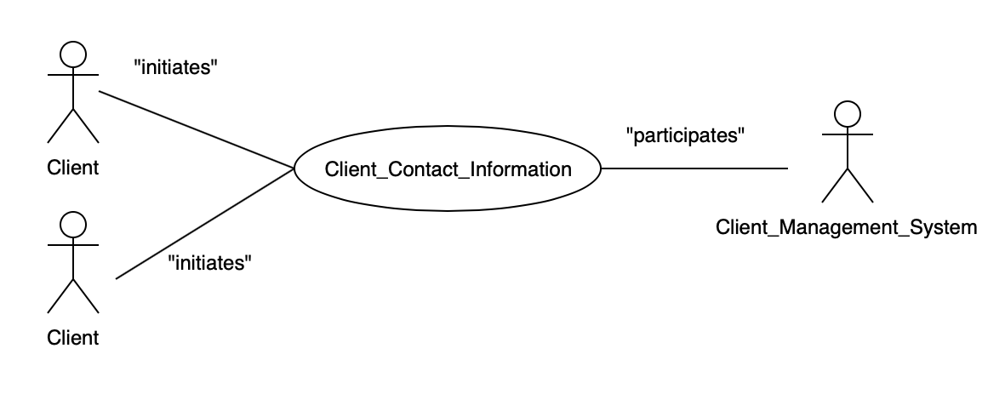

High Level Use Case Diagram

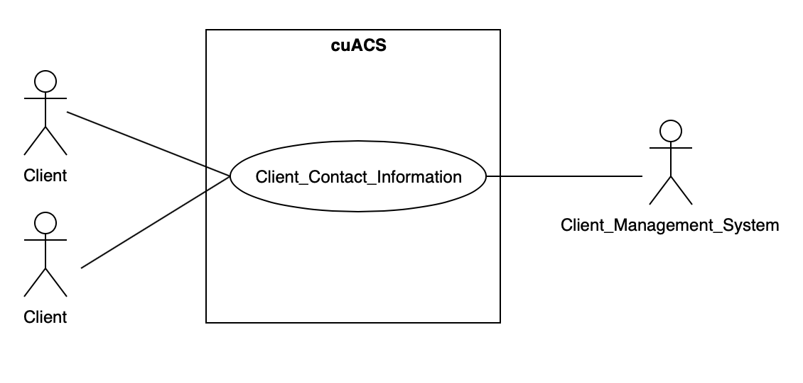

**FR-2.1.3 – Client Personal Information**

Use Case Table Description

|  |  |
| --- | --- |
| Use Case Name | Client Personal Information ----- UC #### |
| Participating Actors | Initiated by Staff or Client  Communicates with Client_Management_System |
| Flow of Events | 1. The Client or Staff selects the View Client option with profile ID number  2. The Client or Staff selects client personal information  3. Client_Management_System displays a record of the client’s personal information. |
| Entry Condition | The client must be logged into cuACS  The client ID number must be valid |
| Exit Condition | - |
| Quality Requirements | Response time between Client selecting the client personal information option and receiving content should be no more than 10 seconds. |
| Traceability | FR-2.1.3 |

Relationship Use Case Diagram

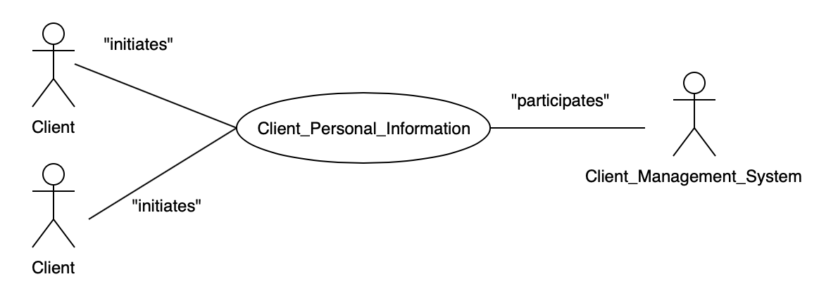

High Level Use Case Diagram

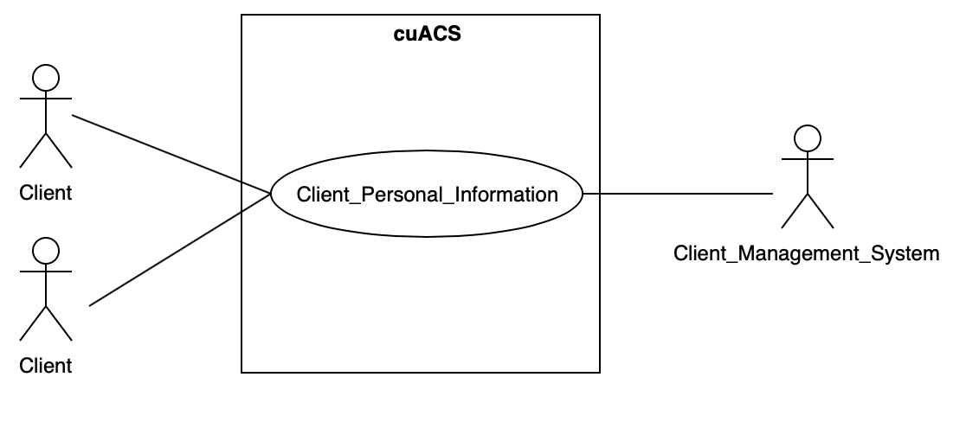

**FR-2.1.4 – Client Matching Preferences**

Use Case Table Description

|  |  |
| --- | --- |
| Use Case Name | Client Matching Preferences ----- UC #### |
| Participating Actors | Initiated by Client  Communicates with Client_Management_System |
| Flow of Events | 1. The Client selects the View Client option with profile ID number  2. The Client selects Client Matching Preferences  3. Client_Management_System displays a record of the client’s current pefrences, with an option to edit their preferences  4. The Client saves their preferences  5. The Client_Management_System updates the data in the storage device |
| Entry Condition | The client must be logged into cuACS  The client ID number must be valid |
| Exit Condition | The client’s matching preferences are subsequently updated to reflect the changes (if any) |
| Quality Requirements | Response time between Client selecting the Matching Preferences option and receiving content should be no more than 10 seconds.  The data is written to the storage device in no more than 2 seconds. |
| Traceability | FR-2.1.4 |

Relationship Use Case Diagram

High Level Use Case Diagram

**FR-2.3.0 – View List of Clients**

Use Case Table Description

|  |  |
| --- | --- |
| Use Case Name | View List of Clients ----- UC #### |
| Participating Actors | Initiated by Staff  Communicates with Client_Management_System |
| Flow of Events | 1. Staff member selects View Client List  2. The Client_Management_System provides a list of all clients stored in the data storage |
| Entry Condition | The staff member must be logged into cuACS |
| Exit Condition | - |
| Quality Requirements | Response time between Client selecting the client contact information option and receiving content should be no more than 10 seconds. |
| Traceability | FR-2.3.0 |

Relationship Use Case Diagram

High Level Use Case Diagram

**FR-2.3.1 – View Detailed Client Information**

Use Case Table Description

|  |  |
| --- | --- |
| Use Case Name | View Detailed Client Information ----- UC #### |
| Participating Actors | Initiated by Staff  Communicates with Client_Management_System |
| Flow of Events | 1. The Staff member selects the View Client option with profile ID number.  2. The Client or Staff selects *Detailed Client Information*  3. Client_Management_System displays a record with a complete look into all of a client’s information stored by cuACS  **ALTERNATE**  1. A Staff member selects View Client List  2. The Client_Management_System provides a list of all clients stored in the data storage  3. The Staff member clicks on a staff profile from the list  4. The Client or Staff selects *Detailed Client Information*  5. Client_Management_System displays a record with a complete look into all of a client’s information stored by cuACS |
| Entry Condition | The Staff Member must be logged into cuACS  The client ID number must be valid  **FOR ALTERNATE**  This use case **extends** the ViewListOfClients use case |
| Exit Condition | - |
| Quality Requirements | • Response time between Staff selecting the detailed client information option and receiving content should be no more than 10 seconds. |
| Traceability | FR-2.3.1 |

Relationship Use Case Diagram

High Level Use Case Diagram

**FR-2.4.0 – Edit Client Profile – Staff**

Use Case Table Description

|  |  |
| --- | --- |
| Use Case Name | Edit Client Profile ----- UC #### |
| Participating Actors | Initiated by Staff  Communicates with Client_Management_System |
| Flow of Events | 1. The Staff member selects the View Client option with client’s profile ID number.  2. The Staff member selects Edit Profile.  3. The Staff member enters the new details into the text fields and presses SAVE when complete.  4. Client_Management_System updates the information in the storage device, using the new information provided |
| Entry Condition | The staff member must be logged into cuACS  The client ID number must be valid |
| Exit Condition | The client’s new profile information details are subsequently updated to reflect the changes (if any) |
| Quality Requirements | • Response time between Client selecting the client contact information option and receiving content should be no more than 10 seconds.  The data is written to the storage device in no more than 2 seconds. |
| Traceability | FR-2.4.0 |

Relationship Use Case Diagram

High Level Use Case Diagram