# Use Case Table Descriptions – rough copy

FR-1.1.2 – View Animal Information - Clients

|  |  |
| --- | --- |
| Use Case Name | ViewAnimals |
| Participating Actors | Initiated by Client  Communicates with Animal Storage |
| Flow of Events | 1. The Client selects the ViewAnimals Option  2. Animal Storage displays animals currently available for adoption. |
| Entry Condition | The Client must be logged into cuACS |
| Exit Condition | - |
| Quality Requirements | • Response time between Client selecting the ViewAnimals option and receiving content should be no more than 10 seconds. |
| Traceability | FR-1.2.2 |

FR-1.2.3 View Detailed Animal Information – Clients

FR1.2.3.4 Select Animal? Possible new FR

|  |  |
| --- | --- |
| Use Case Name | ViewDetailsAnimal |
| Participating Actors | Initiated by Client  Communicates with Animal Storage, ViewAnimals |
| Flow of Events | 1. The Client selects the ViewAnimals option  2. Animal Storage displays animals currently available for adoption.  3. The Client selects what Animal they would like to view details on.  4. ViewDetailsAnimal provides details on the selected Animal. |
| Entry Condition | The Client must be logged into cuACS. |
| Exit Condition | - |
| Quality Requirements | • Response time between Client selecting the ViewDetailsAnimal on an Animal and receiving content should be no more than 10 seconds. |
| Traceability | FR-1.2.3 |

FR-1.3.0 Edit Animal Information

For Particpating Actors, do we list all – including the ones that would be listed by a different FR

Actor (ex. ViewAnimals already lists Animal Storage, so do we list it here too?)

|  |  |
| --- | --- |
| Use Case Name | EditAnimals |
| Participating Actors | Initiated by Staff  Communicates with Animal Storage, ViewAnimals, VIewDetailsAnimal |
| Flow of Events | 1. The Staff selects the ViewAnimals option.  2. Animal Storage displays all animals.  3. The Staff selects an Animal.  4. ViewDetailsAnimal provides details on the selected Animal.  5. Staff selects the EditAnimals function.  6. EditAnimals is launched, allowing Staff to edit the details of selected Animal. |
| Entry Condition | Staff member is logged into cuACS system. |
| Exit Condition | Animal’s edited details were submitted to Animal Storage. |
| Quality Requirements | • Response time between Staff selecting the EditAnimals on an Animal and receiving content should be no more than 10 seconds. |
| Traceability | FR-1.3.0 |

FR-2.0.0 Client Management

|  |  |
| --- | --- |
| Use Case Name | ClientManagement |
| Participating Actors | Initiated by Client or Staff  Communicates with Client Storage |
| Flow of Events | 1. Staff selects ClientManagement option.  2. Client Storage enables the display of customers. (Staff only)  3. Clients will only access their account when ClientManagement is displayed.  4. Staff or Client edits client account information. |
| Entry Condition | Staff must be logged on, Clients must be logged on. |
| Exit Condition | Edited Client information must be submitted to Client Storage. |
| Quality Requirements | • Response time between Client or Staff selecting the ClientManagement option and viewing content should be no more than 10 seconds. |
| Traceability | FR-2.0.0 |

Maybe split between client/staff?

FR-2.1.0 Add Clients

|  |  |
| --- | --- |
| Use Case Name | AddClients |
| Participating Actors | Initiated by Staff  Communicates with Client Storage |
| Flow of Events | 1. Staff selects ClientManagement option  2. Staff selects the AddClients option, where a profile is created.  3. A ClientID is assigned to the profile. This cannot be changed.  4. Staff enters basic contact info.  5. Staff submits, and Client profile is submitted to Client Storage. |
| Entry Condition | Staff must be logged on to cuACS. |
| Exit Condition | Staff must submit new profile to Client Storage. |
| Quality Requirements | All basic contact information must be entered. This includes phone number, email and name. |
| Traceability | FR-2.1.0 |

FR-2.1.1 Client Information

|  |  |
| --- | --- |
| Use Case Name | ClientInfo |
| Participating Actors | Initiated by Client or Staff  Communicates with ClientManagement, ClientStorage |
| Flow of Events | 1. Client or Staff selects ClientManagement option  2. If Staff, ClientManagement displays all clients. Staff selects a client.  3. If Client, ClientManagement displays their account. |
| Entry Condition | Client must be logged on.  Staff must be logged on. |
| Exit Condition |  |
| Quality Requirements |  |
| Traceability | • FR-2.1.1  •  FR-2.0.0 |

|  |  |
| --- | --- |
| Use Case Identifier | UC-XX |
| Use Case Name | **EditProfileInformation** |
| Participating Actors | Initiated by Client |
| Flow of Events | 1. Client selects Edit Profile Information option.  2. Client inputs updated profile information.  3. Client clicks Save Profile Information.  4. The system saves the profile information in a file. |
| Entry Condition | Client must be logged in to their account. |
| Exit Condition | Client must submit new profile. |
| Quality Requirements | All basic contact information must be entered. This includes phone number, email and name. |
| Traceability | FR-2.4.1, FR-4.0.0 |

FR-2.4.1

|  |  |
| --- | --- |
| Use Case Identifier | UC-XX |
| Use Case Name | **LaunchMatchingAlgorithm** |
| Participating Actors | Initiated by Staff Member |
| Flow of Events | 1. The staff member selects the option to run the algorithm.  2. The system will run the algorithm, reading the profile files of all animals and all clients.  3. The system stores the matching information in memory. |
| Entry Condition | Staff must be logged in to cuACS. |
| Exit Condition | - |
| Quality Requirements | While the algorithm is being run, a progress bar should appear showing the progress of matching. |
| Traceability | FR-3.0.0, FR-3.1.0, FR-3.4.0 |

FR-3.0.0

|  |  |
| --- | --- |
| Use Case Identifier | UC-XX |
| Use Case Name | **ViewAlgorithmOutput** |
| Participating Actors | Initiated by Staff Member |
| Flow of Events | 1. Staff selects View Algorithm Output option.  2. The system displays the information to the staff member |
| Entry Condition | An instance of the algorithm must have been run for output information to exist. |
| Exit Condition | - |
| Quality Requirements | A brief list showing identification for which animal was matched with each client, as well as a compatibility rating, should be displayed. |
| Traceability | FR-3.0.0, FR-3.2.0 |

|  |  |
| --- | --- |
| Use Case Identifier | UC-XX |
| Use Case Name | **ViewDetailedMatchingInformation** |
| Participating Actors | Initiated by Staff Member |
| Flow of Events | 1. From the output list view, the staff member selects the View Detailed Information option for a particular match in the output list.  2. The system displays to the staff member detailed information about the match made. |
| Entry Condition | An instance of the algorithm must have been run for output information to exist. |
| Exit Condition | - |
| Quality Requirements | All basic contact information must be entered. This includes phone number, email and name. |
| Traceability | FR-3.0.0, FR-3.3.0 |

|  |  |
| --- | --- |
| Use Case Identifier | UC-## |
| Name | AddAnimal |
| Participating Actors | Initiated by StaffMember |
| Flow of Events | 1. The StaffMember selects the AddAnimal option from the menu  2. The StaffMember inputs the information for Animal Attributes  3. The staff member saves the Animal to Storage |
| Entry Conditions | Must be logged in as StaffMember |
| Exit Conditions | Animal added to Storage |
| Quality Requirements | Animal entry should have constraints to reduce incorrect input |
| Traceability | FR-1.1.0 |

|  |  |
| --- | --- |
| Use Case Identifier | UC-## |
| Name | ViewAnimals |
| Participating Actors | Initiated by StaffMember |
| Flow of Events | 1. StaffMember selects view option from menu  2. Animals in storage are displayed to StaffMember |
| Entry Conditions | Must be logged in as StaffMember |
| Exit Conditions |  |
| Quality Requirements | List of Animals must be formatted so information is easily viewed and understood |
| Traceability | FR-1.2 |

|  |  |
| --- | --- |
| Use Case Identifier | UC-## |
| Name | ViewAnimalInformation |
| Participating Actors | Initiated by StaffMember |
| Flow of Events | 1. Staff member selects ViewAnimals option  2. When all Animals displayed StaffMember clicks on “ViewAnimalInformation”  3. Detailed attributes about that specific Animal are displayed |
| Entry Conditions | Must be logged in as Staff Member |
| Exit Conditions |  |
| Quality Requirements | Animal information must be cleanly represented |
| Traceability | FR-1.2.1 |

Use Case Table Description

|  |  |
| --- | --- |
| Use Case Name | Client Contact Information ----- UC #### |
| Participating Actors | Initiated by Staff or Client  Communicates with Client_Management_System |
| Flow of Events | 1. The Client or Staff selects the View Client option with profile ID number.  2. The Client or Staff selects client contact information  3. Client_Management_System displays a record of the client’s contact information. |
| Entry Condition | The client must be logged into cuACS  The client ID number must be valid |
| Exit Condition | - |
| Quality Requirements | Response time between Client selecting the client contact information option and receiving content should be no more than 10 seconds. |
| Traceability | FR-2.1.2 |

Relationship Use Case Diagram

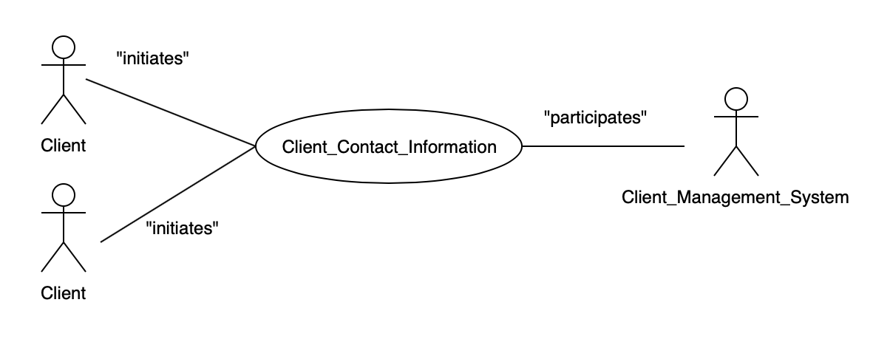

High Level Use Case Diagram

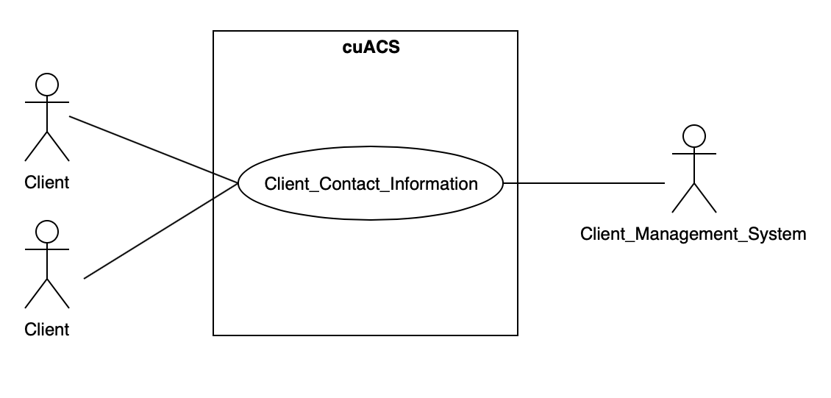

**FR-2.1.3 – Client Personal Information**

Use Case Table Description

|  |  |
| --- | --- |
| Use Case Name | Client Personal Information ----- UC #### |
| Participating Actors | Initiated by Staff or Client  Communicates with Client_Management_System |
| Flow of Events | 1. The Client or Staff selects the View Client option with profile ID number  2. The Client or Staff selects client personal information  3. Client_Management_System displays a record of the client’s personal information. |
| Entry Condition | The client must be logged into cuACS  The client ID number must be valid |
| Exit Condition | - |
| Quality Requirements | Response time between Client selecting the client personal information option and receiving content should be no more than 10 seconds. |
| Traceability | FR-2.1.3 |

Relationship Use Case Diagram

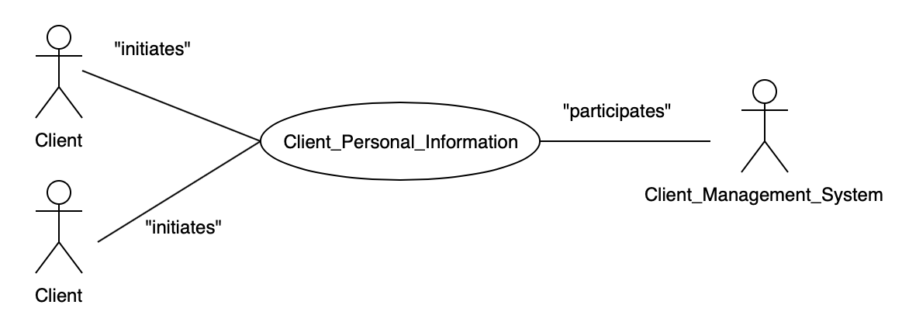

High Level Use Case Diagram

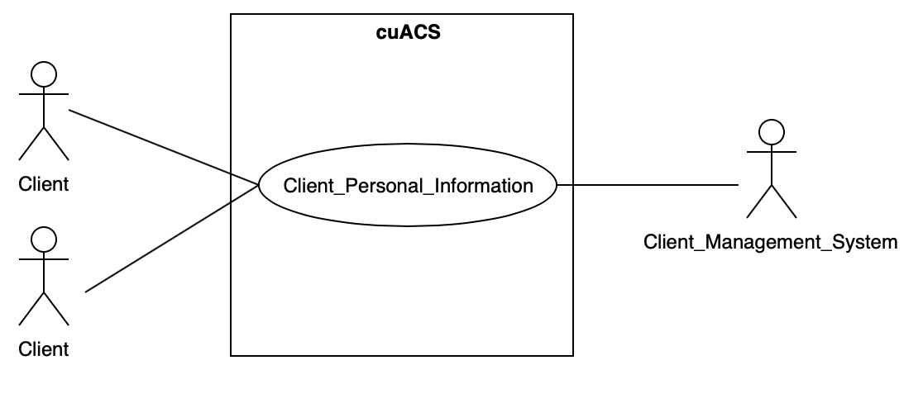

**FR-2.1.4 – Client Matching Preferences**

Use Case Table Description

|  |  |
| --- | --- |
| Use Case Name | Client Matching Preferences ----- UC #### |
| Participating Actors | Initiated by Client  Communicates with Client_Management_System |
| Flow of Events | 1. The Client selects the View Client option with profile ID number  2. The Client selects Client Matching Preferences  3. Client_Management_System displays a record of the client’s current pefrences, with an option to edit their preferences  4. The Client saves their preferences  5. The Client_Management_System updates the data in the storage device |
| Entry Condition | The client must be logged into cuACS  The client ID number must be valid |
| Exit Condition | The client’s matching preferences are subsequently updated to reflect the changes (if any) |
| Quality Requirements | Response time between Client selecting the Matching Preferences option and receiving content should be no more than 10 seconds.  The data is written to the storage device in no more than 2 seconds. |
| Traceability | FR-2.1.4 |

Relationship Use Case Diagram

High Level Use Case Diagram

**FR-2.3.0 – View List of Clients**

Use Case Table Description

|  |  |
| --- | --- |
| Use Case Name | View List of Clients ----- UC #### |
| Participating Actors | Initiated by Staff  Communicates with Client_Management_System |
| Flow of Events | 1. Staff member selects View Client List  2. The Client_Management_System provides a list of all clients stored in the data storage |
| Entry Condition | The staff member must be logged into cuACS |
| Exit Condition | - |
| Quality Requirements | Response time between Client selecting the client contact information option and receiving content should be no more than 10 seconds. |
| Traceability | FR-2.3.0 |

Relationship Use Case Diagram

High Level Use Case Diagram

**FR-2.3.1 – View Detailed Client Information**

Use Case Table Description

|  |  |
| --- | --- |
| Use Case Name | View Detailed Client Information ----- UC #### |
| Participating Actors | Initiated by Staff  Communicates with Client_Management_System |
| Flow of Events | 1. The Staff member selects the View Client option with profile ID number.  2. The Client or Staff selects *Detailed Client Information*  3. Client_Management_System displays a record with a complete look into all of a client’s information stored by cuACS  **ALTERNATE**  1. A Staff member selects View Client List  2. The Client_Management_System provides a list of all clients stored in the data storage  3. The Staff member clicks on a staff profile from the list  4. The Client or Staff selects *Detailed Client Information*  5. Client_Management_System displays a record with a complete look into all of a client’s information stored by cuACS |
| Entry Condition | The Staff Member must be logged into cuACS  The client ID number must be valid  **FOR ALTERNATE**  This use case **extends** the ViewListOfClients use case |
| Exit Condition | - |
| Quality Requirements | • Response time between Staff selecting the detailed client information option and receiving content should be no more than 10 seconds. |
| Traceability | FR-2.3.1 |

Relationship Use Case Diagram

High Level Use Case Diagram

**FR-2.4.0 – Edit Client Profile – Staff**

Use Case Table Description

|  |  |
| --- | --- |
| Use Case Name | Edit Client Profile ----- UC #### |
| Participating Actors | Initiated by Staff  Communicates with Client_Management_System |
| Flow of Events | 1. The Staff member selects the View Client option with client’s profile ID number.  2. The Staff member selects Edit Profile.  3. The Staff member enters the new details into the text fields and presses SAVE when complete.  4. Client_Management_System updates the information in the storage device, using the new information provided |
| Entry Condition | The staff member must be logged into cuACS  The client ID number must be valid |
| Exit Condition | The client’s new profile information details are subsequently updated to reflect the changes (if any) |
| Quality Requirements | • Response time between Client selecting the client contact information option and receiving content should be no more than 10 seconds.  The data is written to the storage device in no more than 2 seconds. |
| Traceability | FR-2.4.0 |

Relationship Use Case Diagram

High Level Use Case Diagram