Use Case Diagrams

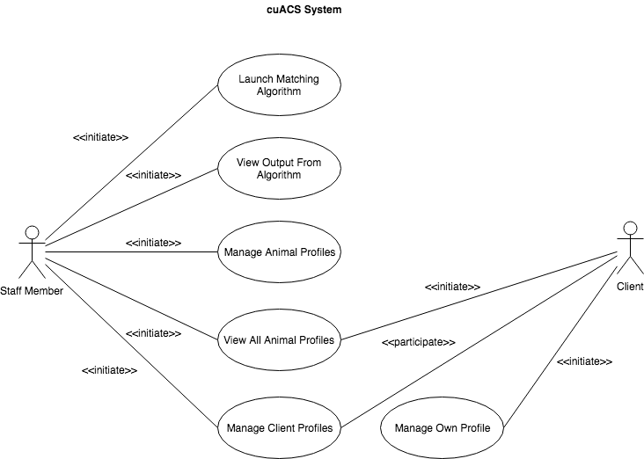

High Level Use Case Descriptions

|  |  |  |
| --- | --- | --- |
| UC-01 | **Run Matching Algorithm** | StaffMembers launch an instance of the animal-client matching algorithm and view its output. |
| UC-02 | **Manage Animal Profiles** | StaffMembers view, add, and alter animal profiles. |
| UC-03 | **View All Animal Profiles** | StaffMembers and Clients view a list of all animals which are registered in the shelter. They also view detailed profiles of selected animals. |
| UC-04 | **Manage Client Profiles** | StaffMembers manage the profiles of Clients including adding new profiles and editing existing ones. |
| UC-05 | **Manage Own Profile** | Clients manage their own profile, adding and removing information as desired. |

High Level Use Case Breakdowns

|  |  |
| --- | --- |
| Use Case Identifier | UC-01 |
| Use Case Name | **Run Matching Algorithm** |
| Participating Actor(s) | StaffMember |
| Flow of Events | 1. The StaffMember launches an instance of the ACM algorithm to match Clients and animals.  2. The StaffMember views a basic list of the matches resulting from running the algorithm.  3. The StaffMember chooses a desired match to view detailed information explaining why the match was made by the algorithm. |
| Entry Condition(s) | * The StaffMember is logged into cuACS. |
| Exit Condition(s) | - |
| Quality Requirement(s) | While the algorithm is being run, a progress bar should appear showing the progress of matching. A running instance of the algorithm should happen in the background and should not lock up the program. |
| Traceability | FR-3.0.0, FR-3.1.0, FR-3.2.0, FR-3.4.0, NFR-3 |

|  |  |
| --- | --- |
| Use Case Identifier | UC-02 |
| Use Case Name | **Manage Animal Profiles** |
| Participating Actor(s) | StaffMember |
| Flow of Events | 1. StaffMember chooses whether or not to add or alter an existin g animal profile  2. If the StaffMember chooses to add a new animal profile, they fill out the animal’s information  3. If the StaffMember chooses to alter an existing animal’s profile, they view the animal’s profile and edit the fields they wish to change.  4. Both choices result in the StaffMember saving the new or altered animal profile to persistent storage. |
| Entry Condition(s) | * The StaffMember is logged into cuACS. |
| Exit Condition(s) | * The new or altered animal profile is saved to persistent storage. |
| Quality Requirement(s) | - |
| Traceability | FR-1.1.0, FR-1.2.0, FR-1.3.0 |

|  |  |
| --- | --- |
| Use Case Identifier | UC-03 |
| Use Case Name | **View All Animal Profiles** |
| Participating Actor(s) | Initiated by StaffMember OR  Initiated by Client |
| Flow of Events | 1. StaffMember or Client chooses to view all of the animal profiles by accessing the relevant part of the user interface.  2. The StaffMember or Client select a specific animal to view more detailed information about that animal. |
| Entry Condition(s) | * The StaffMember, or Client, is logged into cuACS. |
| Exit Condition(s) | - |
| Quality Requirement(s) | - |
| Traceability | FR-1.2.0, FR-1.2.1, FR-1.2.2, FR-1.2.3 |

|  |  |
| --- | --- |
| Use Case Identifier | UC-04 |
| Use Case Name | **Manage Client Profiles** |
| Participating Actor(s) | Initiated by StaffMember  Communicates with Client |
| Flow of Events | 1. A StaffMember views the list of all clients.  2. A StaffMember chooses to add or edit an existing Client profile.  3. If the staff memebr chooses to add a Client profile, they create one and fill out all of the basic information necessary for the profile to be created.  4. If the StaffMember chooses to edit a Client’s profile, they choose the correct profile.  5. Then the StaffMember edits the fields that need to be changed.  6. Finally, for both choices, the Client profile is saved to persistent storage.  7. The Client can now view and edit their new or altered profile. |
| Entry Condition(s) | * The StaffMember is logged into cuACS. |
| Exit Condition(s) | * The new or altered Client profile is saved to persistent storage. |
| Quality Requirement(s) | - |
| Traceability | FR-2.0.0, FR-FR-2.1.0, FR-2.3.0, FR-2.3.1, FR-2.4.0, |

|  |  |
| --- | --- |
| Use Case Identifier | UC-05 |
| Use Case Name | **Manage Own Profile** |
| Participating Actor(s) | Initiated by Client |
| Flow of Events | 1. A Client sees their own profile  2. The Client makes a change to one or more fields in their profile information.  3. The Client saves their updated profile to persistent storage. |
| Entry Condition(s) | * The Client is logged in to their cuACS account. |
| Exit Condition(s) | * The Client’s updated profile is saved to persistent storage. |
| Quality Requirement(s) | - |
| Traceability | FR-2.4.1 |

Detailed Use Case Descriptions

|  |  |  |
| --- | --- | --- |
| UC-06 | **LaunchMatchingAlgorithm** | StaffMembers launch an instance of the animal Client matching algorith which runs in the background. |
| UC-07 | **ViewListOfMatches** | StaffMembers see a list of matched Clients and animals output by the algorithm. |
| UC-08 | **ViewDetailed InformationAboutASpecificMatch** | StaffMembers select one match from the list and view the detailed output about why the match was made by the algorithm. |
| UC-09 | **AddAnimalProfile** | A StaffMember adds a new animal profile, filling out all necessary information. |
| UC-10 | **EditAnimalProfile** | A StaffMember edits an animal’s profile, changing one or more fields. |
| UC-11 | **AddClientProfile** | A StaffMember adds a new client profile, filling out all the necessary information. |
| UC-12 | **EditClientProfile** | A StaffMember edits an existing client’s profile |
| UC-13 | **ViewAllAnimalProfiles** | A StaffMember OR a Client view a list of all the animals registered in the system. |
| UC-14 | **ViewDetailedAnimalProfile** | A StaffMember OR a Client view detailed ithe detailed profile of a selected animal. |
| UC-15 | **ViewAllClientProfiles** | A StaffMember views a list of all the clients registered in the system. |
| UC-16 | **ViewDetailedClientProfile** | A StaffMember views detailed information about a selected client. |
| UC-17 | **ViewOwnProfile** | A Client views their own complete profile. |
| UC-18 | **EditOwnProfile** | A Client makes desired modifications to the fiels that make up their profile. |
| UC-19 | **MissingProfilesError** | The system reports that insufficient profiles are available to run the matching algorithm. |
| UC-20 | **SaveFile** | The system saves a profile file to persistent storage. |
| UC-21 | **FileError** | There was an error processing a selected profile file (generalizes FileOpenError, FileFormatError, FileInputError, FileOutputError). The error is reported to the user and the operation is aborted. |
| UC-22 | **FileFormatError** | The system reports that the file containes a corrupted or incomplete data format. |
| UC-23 | **FileInputError** | The system reports that the file could not be read. |
| UC-24 | **FileOutputError** | The system reports that the file could not be written to. |
| UC-25 | **FileOpenError** | The system reports that the file could not be opened. |

|  |  |
| --- | --- |
| Use Case Identifier |  |
| Use Case Name |  |
| Participating Actor(s) |  |
| Flow of Events |  |
| Entry Condition(s) |  |
| Exit Condition(s) |  |
| Quality Requirement(s) |  |
| Traceability |  |