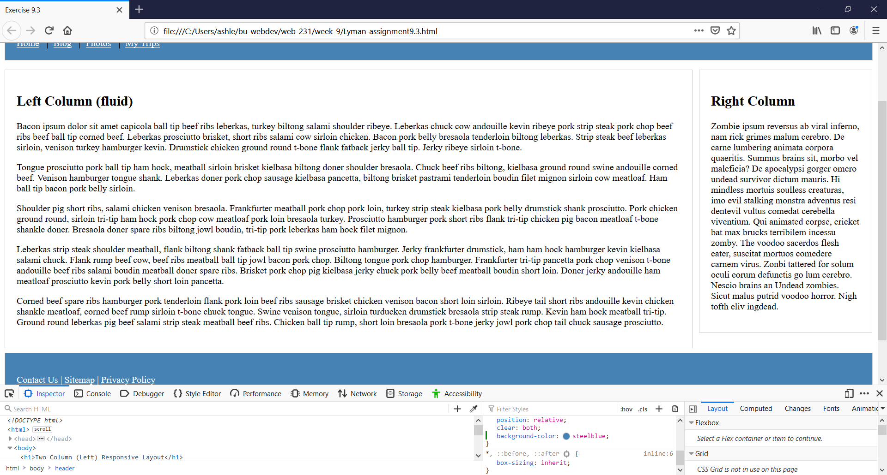

1. Click F12
2. Select header in Elements window
3. Go to footer, header rule and add background-color: steelblue;
4. Click the li tab and under .nav a rule type color: white;
5. Click on footer tab
6. Select the <p> element
7. In the styles window create new rule of footer a, footer p
8. Type color: white;
9. Expand screen to full size
10. Select alt and prt sc at the same time to screenshot
11. Paste in this document