**How to set break points in Chrome Dev Tools**

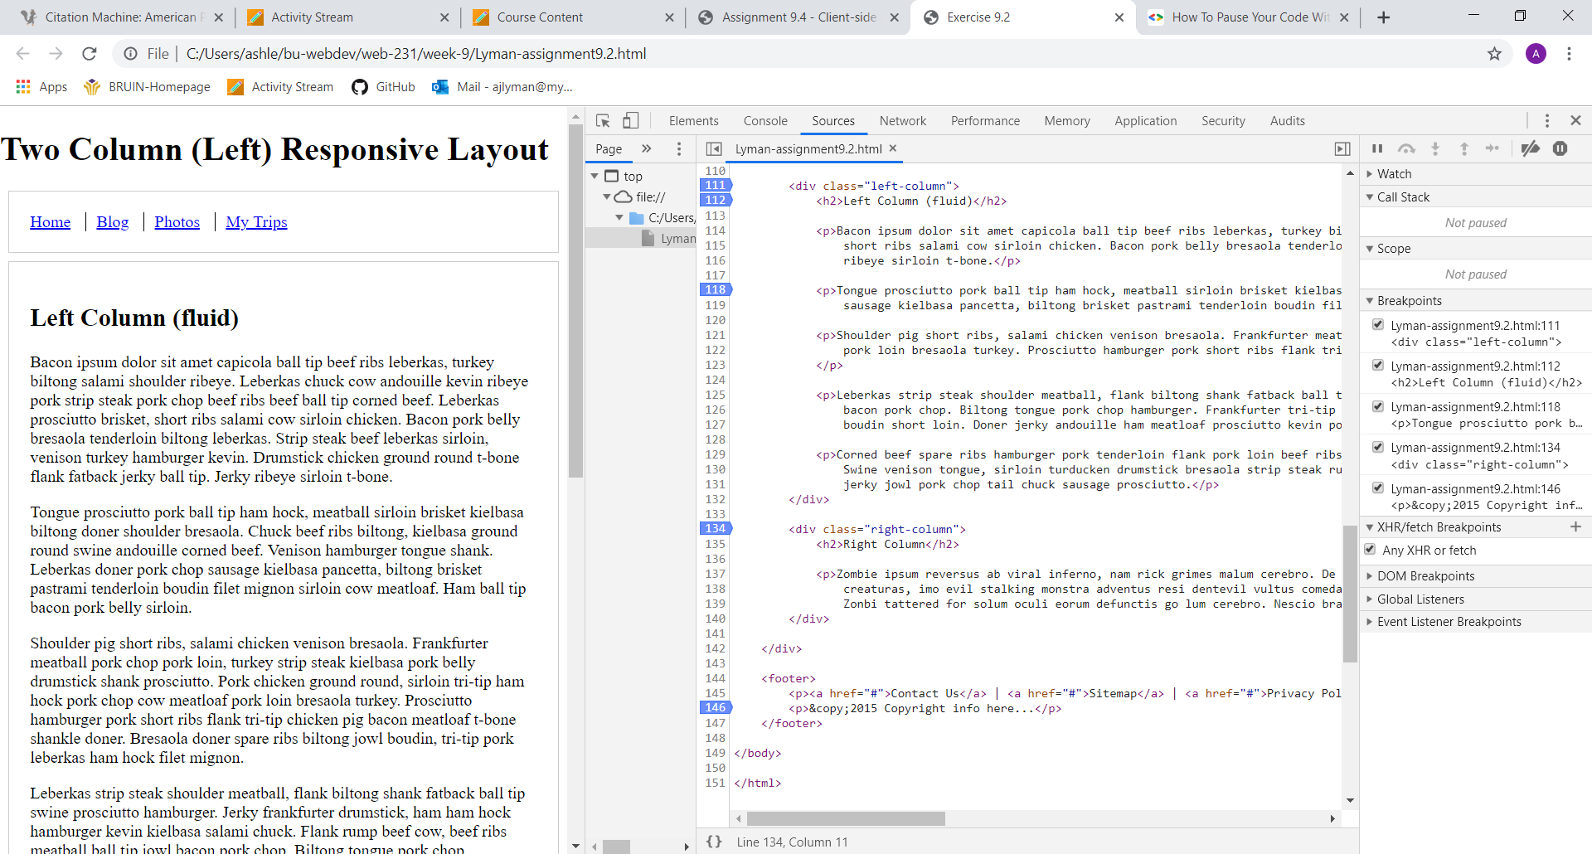

1. Open HTML document in browser
2. Press shortcut key F12 to open Dev Tools
3. Click on Sources Tab and make sure current document is selected in left side pane
4. To create a break point, simply click on the line you wish to break at
5. You can also right-click and set a break point
6. To set a conditional break point, right-click on the line number and select conditional break point

**How to log and read messages from JavaScript console window**

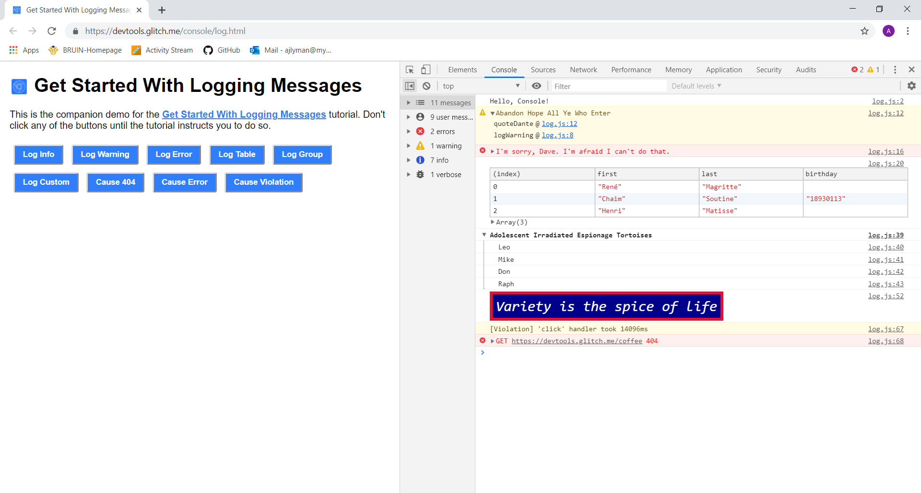

1. Open file in Chrome browser
2. Select the Console tab
3. Select areas in HTML document with messages
4. Messages will appear in the Console pane
5. You can also click the square with a backwards play arrow at the top
6. This will display all messages, errors, and warnings throughout the document

**How to select HTML elements in JavaScript console window**

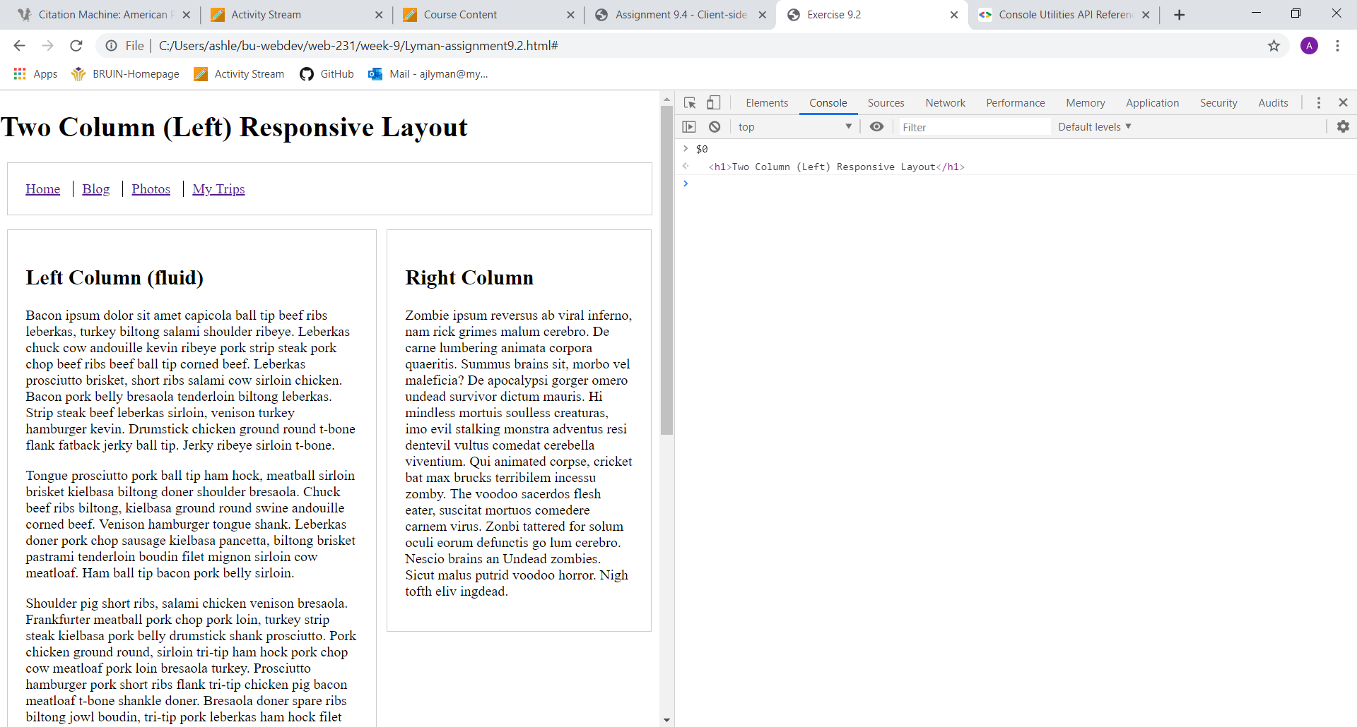

1. Open file in Chrome browser
2. Open Dev Tools with shortcut F12
3. In the elements tab you can find, throughout the document, a number and dollar sign that refers to a line of text in the document that you can view in the console window if you type it in
4. For example, in the document the line says == $0
5. Go to the console tab and type in $0
6. This will bring up the exact line of text in the console window

**How to stimulate CSS states (hover, focus) on live HTML elements**

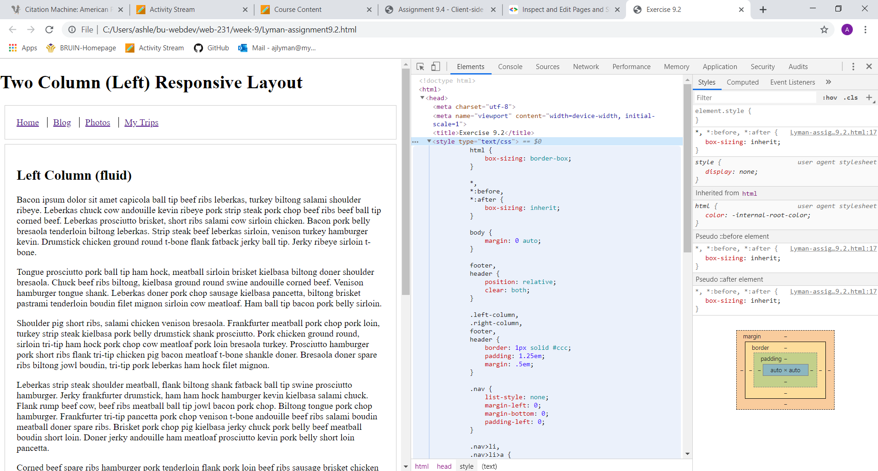

1. Open file in Chrome browser
2. Select F12 to open Dev Tools
3. The Elements tab and Styles pane should be opened
4. On the far-right hand side you will be able to simply edit CSS in document as you preview document
5. Changes will not save each time however
6. You need to set up persistent authoring if you want to persist your changes between page loads