# **Models of good practise**

## **Website speed test - Usability**

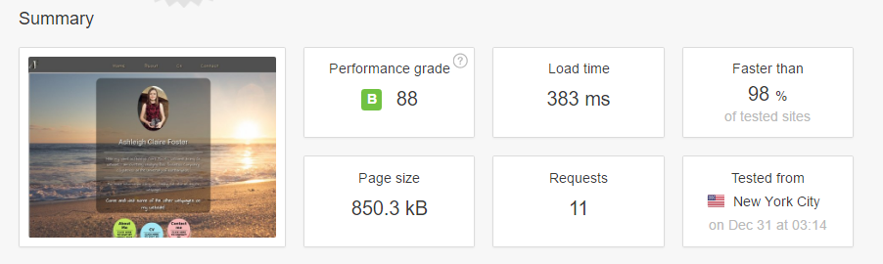One of the many models of good practise is the idea of having a website which loads webpages quite fast as having a slower processing website can not only be frustrating for the end-user but it can take up so much time and internet download/upload speed that the user may turn away from your website. Taking website speed into consideration I have decided to test how fast or how slow my website has performed. I found a resource called “pingdom.com” which came from one of the supporting documentations on NILE. So, I decided to put my Github URL in the speed test website and I decided to test the server from New York in the US. Below are the following results which were produced:

As shown in this screenshot the overall performance of my CV website performed extremely well! The reason for this is because I don’t have so much content all on one website which might take up so much memory or server space to load! I don’t have a ton of animations or a ton of images clogging up the website or a ton of content and hence why my website is faster than most websites out there hence the 98%!

**So, what exactly causes slow website performance?** [Reference: http://siliconfilter.com/the-slowest-tech-news-sites-scobleizer-pre-central-cult-of-mac-moconews-gizmodo-infographic/]

1. When a website profoundly adds a ton of advertisements on their website which not only makes the website process the adverts slower but it also then prevents other content on the website from loading properly on the website until the advertisements have fully processed. This is one of the reasons why I haven’t added any advertisements to my website at all or content which is likely to slow down my website and frustrate the end-user.
2. When social media widgets have been added to a website i.e. a “comments” section which links to a Facebook page or a “tweet” section which links to Twitter etc… Although these features might be useful to attract more people to your social media site it can cause a website to load a lot slower because not only is it trying to get server data from your own website but it is also trying to retrieve server data from an externally sourced website i.e. Facebook or Twitter. This can be especially true when it is trying to retrieve your users or group’s profile. This is one of the reasons why I haven’t included any social media widgets on my website and have just added social media buttons at the bottom in the footer section.
3. The last cause of a website performing slowly is when images are inadequately sized on a webpage or compressed correctly such as uncompressed images i.e. the image doesn’t lose any pixelated quality what so ever. This means that when the website is trying to load up on the internet is can run slowly and poorly i.e. loseless compression. This is one of the reasons why I have included compressed file types such as .jpg and .png which loses some of that pixelated quality i.e. lossy compression as it makes the website load up a lot faster.

## **The visual appearance of my website - Usability**

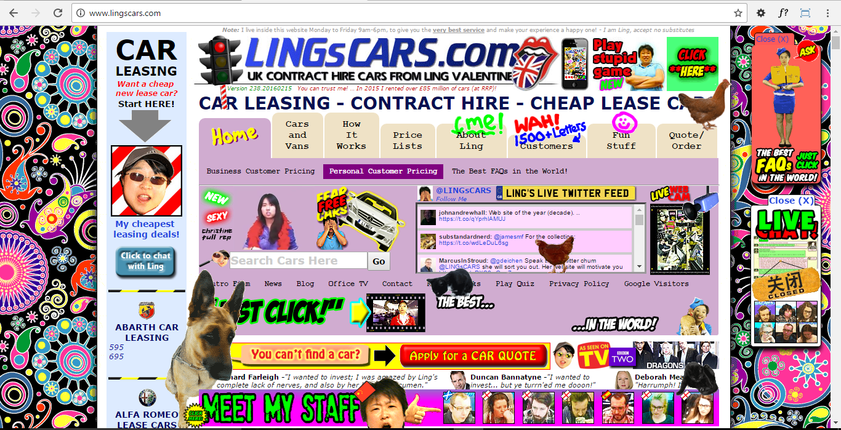The visual appearance of my website is quite key during the design and development stages. One of the first key stages which I did before even building my website was to research best practises of how CV webpages looked across a wide spectrum of CV websites. This helped me to make sure that I didn’t go straight into the development stage without putting any thought into the overall design of my CV website. As stated in the assignment brief “Simple CV portfolio” my CV portfolio website needs to be simple and easy to use without having too many fancy graphics or elements going on and this includes no JavaScript either! Just a pure basic CV website which is what I ended up creating using Atom. So, taking on the “Simple CV portfolio” website into consideration I made sure that whilst designing the wireframes that I didn’t add any fancy graphics or anything which would distract the user as this can put off the end-user who is viewing my website. I remember once seeing a website at college which showed a classic example of bad practise in regards to the overall visual appearance of the website. This is because the website used a lot of annoying animations, wasn’t layed out properly on the page, made my computer overheat quickly and it even had an annoying sound in the background! Therefore, I have made sure that my website is properly structured, that there aren’t any annoying sounds or any other elements which are likely to distract the end-user. Here is a classic example of bad practise in visual appearance of a website:

## **Navigation structure on a webpage - Usability**

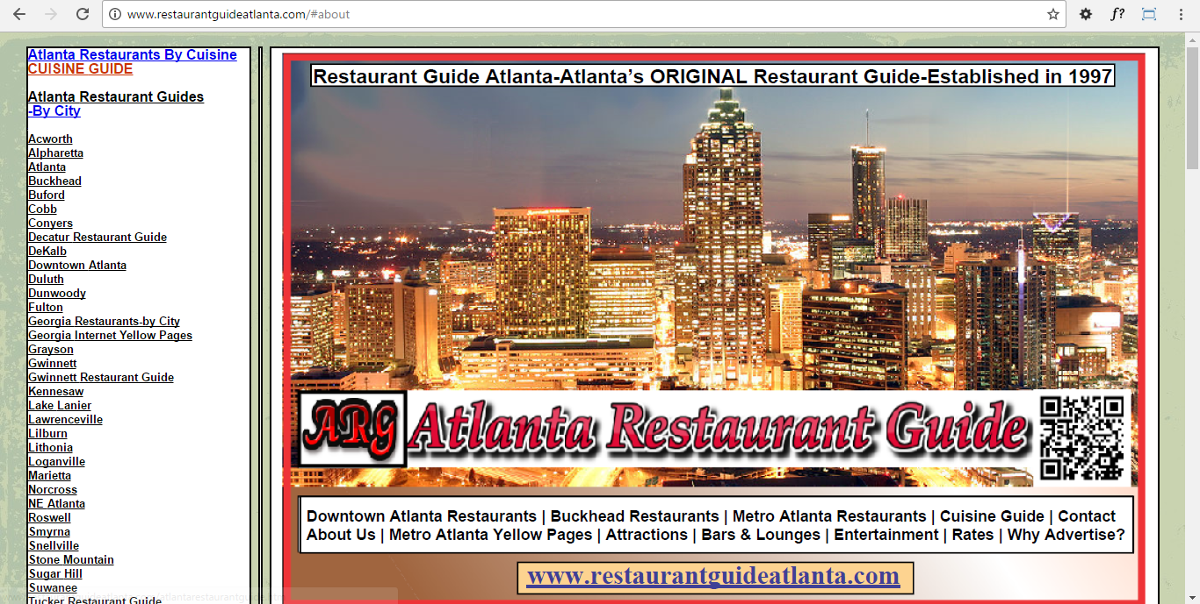Having a poor overall navigational structure can be bad for any website, especially if your potential employee wants to look at your website and he/she can’t navigate anywhere on the screen. How would it look to a potential employee (especially an employee who is working in the computing field) if the overall navigation of the website wasn’t structured properly on the page? A good example of a poor navigational structure is when external links have been missed out i.e. links which allow you to link to other webpages on your website i.e. on one page having “home, about, cv and contact” and then on another page having “home, about, contact”. This wouldn’t look very professional because not only is the navigation missing an external link (the CV page) but the navigational structure isn’t very consistent and looks like it hasn’t been properly implemented or tested. Therefore, on my website I have made sure that all the navigational links link to the appropriate pages and that I haven’t missed any external webpages links. I need to also make sure that the overall navigation is consistent in style and theme i.e. having the same font styles, font sizes and animations/overall theme. A good example of a poor navigation structured website is:

The navigation list menu isn’t very clear at all and looking at that website it looks like the navigation itself looks more like a paragraph column rather than a navigation menu.

## **File structure & names**

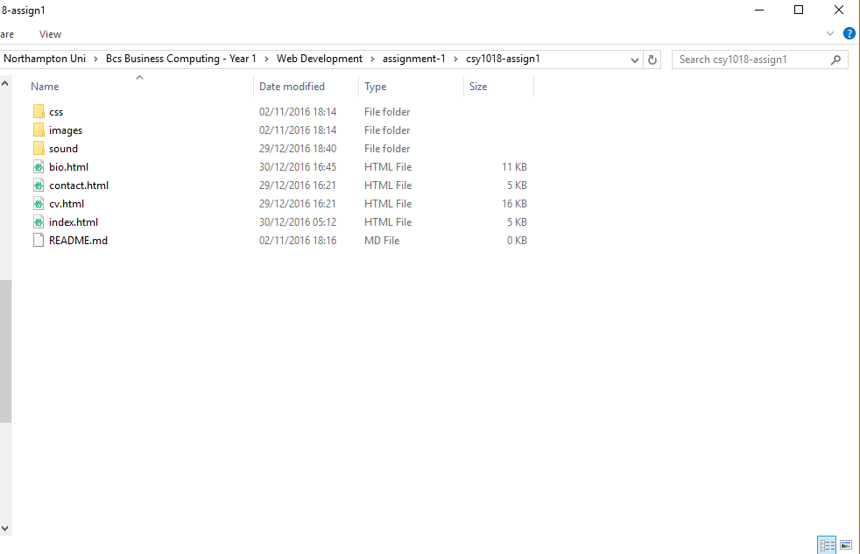Having an appropriate file structure and file names is essential before even thinking about designing and building any website. You need to make sure that when you are first creating your website files i.e. the HTML and CSS files that they are all in one simple folder as having the files in all different places will make the website not only unfunctional i.e. it won’t work as a website and the webpages won’t work together but also all of the files which are trying to attach to the website won’t be able to attach as they won’t be able to find the root directory to that file. The same applies to file names as if the file names haven’t been constructed or named properly then it’ll be a lot harder to find those files especially if you name the file a completely different name in the HTML code when trying to link the navigation up together. Therefore, for my website I have made sure that I have named all my files appropriately so that they have no spelling errors or spaces in-between them and I have also made sure that the files have been spelt properly in the HTML code.

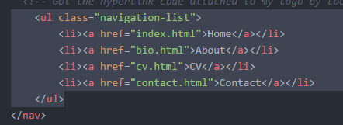

File names are appropriately structured in one single folder as shown above and the file names link up to each other appropriately as shown in the screenshot on the left.

## **Functionality of my website**

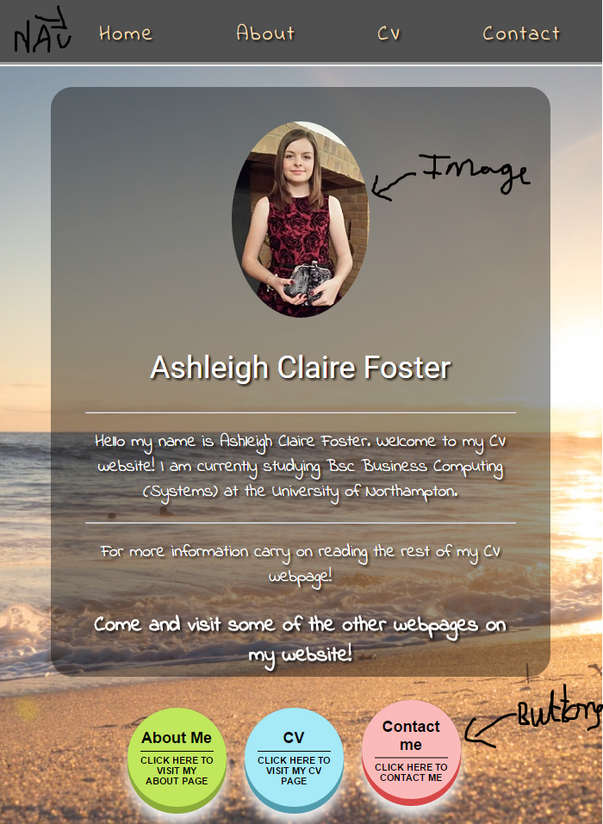For the functionality of a website I need to make sure that all the links i.e. external links on the navigation and buttons go to the appropriate webpages and that the contact form and images work properly on my CV portfolio website. The reason the functionality of any website is important is because without the website functioning properly it wouldn’t look very professional plus it’ll easily turn a lot of people away from your website so your viewing figures would go down considerably as the website isn’t very user friendly or functional enough for the end-user. Therefore, I have made sure that each of my navigation links and buttons link up to the appropriate webpages and not to different pages so that it confuses the end-user as well as making sure that the social media icons link up to the correct social media website. For the contact form, I have made sure that the proper functions have been put in place so that, for example, when the end-user puts in their email it automatically recognises that the input box is for an email and not for someone’s name or telephone number. Due to my form being a static form I am unable to implement the appropriate JavaScript which prevents the user from sending the contact form with error messages until they have filled out the contact form properly. For the image files, I need to make sure that they link up properly to the images folder directory otherwise the images won’t be showing up properly on the website and I also need to make sure that the image files are named according to what they are named in the image file and aren’t name a different name completely. Here are some good examples of things that I have used on my website that are regarded as the “functionality” of the website:

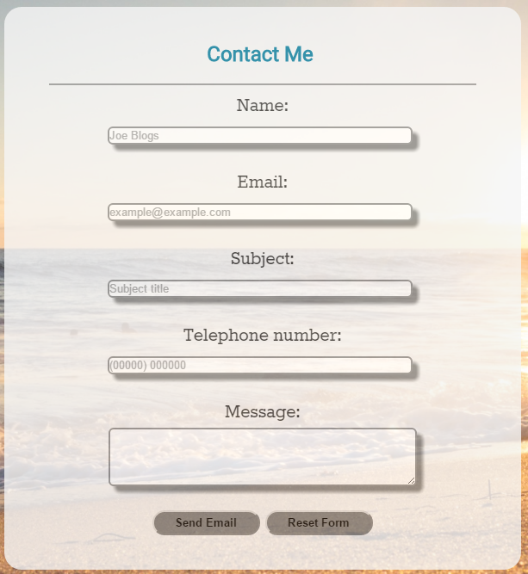

## **Readability of my website**

For the readability of my website I need to make sure that the font size conforms to current trends/conventions, that I had used a consistent colour scheme throughout my website, that I have included a wide variety of different font styles instead of using the default text style, need to make sure that the content which is on my CV portfolio website is relevant and that it doesn’t contain any jargon or content which isn’t relevant to a CV portfolio website and I need to make sure that I have checked the spelling, grammar and punctuation of each of the written text content on my website, especially on my about me page and contact page. The language which is being used isn’t relevant in this sense because my CV portfolio website isn’t being created for all different languages, it is just being created in English. Based on the readability as a key model of good practise I decided to look up the current font sizes and font styles which were being used in CV portfolio websites. Sadly, most the websites were using the pixel’s convention as their main font size but I managed to convert those pixels into ems using a converter. The overall font size of my CV portfolio website is clear and easy to read, especially from a distance and this was key for the overall design of my website because without having a clear enough font size or indeed font style the website would not only look unprofessional but it would be a lot harder for someone who has poor eye sight anyway to be able to read the text whether it is for someone with short or long sighted problems. This is also another reason why in the final stages of my website that I included a font shadow as it makes the text a lot bolder and easier to read. The same applies to the contact form which I built. As soon as you hover your mouse over the box it expands which then makes it easier to read the text for the end-user if they have eye sight problems. In terms of the overall spelling, punctuation, and grammar I checked this out using a word document which basically checked for any misspelt words or any sentences which didn’t “look right”. Unfortunately, I couldn’t get the Atom spell checker to work on my end due to not having the “command” key which was stated in the readme file on the spell checker package. Here is an example of the zoom feature on my contact form which allows the end-user to see the text a lot clearer when typing in the input box:

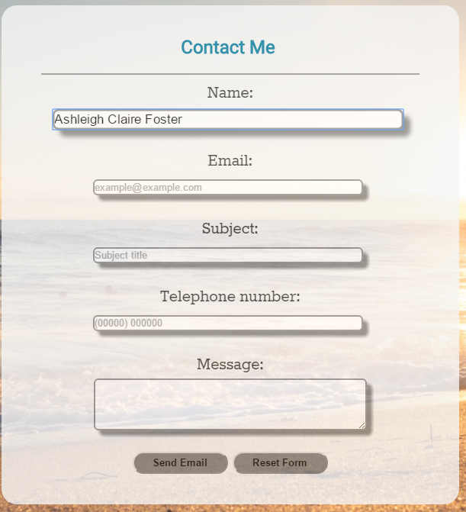

As shown in this screenshot example my mouse is hovered over the “name” input field and as you can see as I am typing my name into the field it is a lot easier to read the text. The only way to make sure that this feature works is if the end-user has their mouse over the input box so that it zooms in for them.

## **Accessibility**

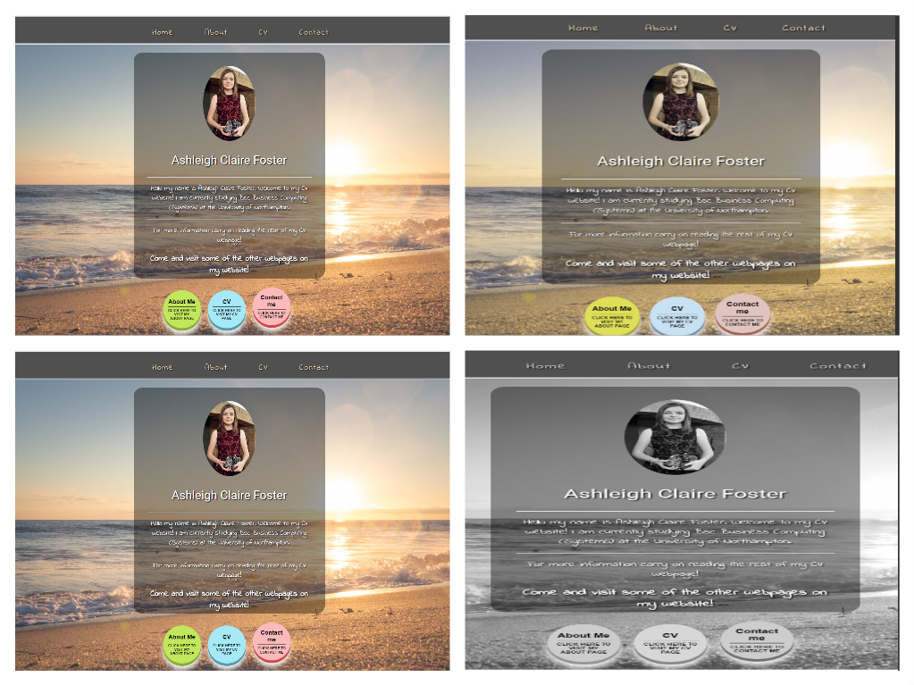In terms of accessibility for my website I need to make sure that I have added “alt” tags on each of my images. The reason I need to add “alt” tags on each of the images on my CV portfolio website is so that when a blind individual wants to view my website then they can use their “screen reader” to read the text which is on my website as well as what the image is about as screen readers can’t read image files themselves i.e. they can’t read .jpg or .png files etc… A good example of where I have included alt text is on the “about me” webpage where I have added a lot of images in a flex-box and the end user needs to be able to tell that there are images there rather than having no images read out on the screen reader when there are images on the webpage. Here is a good example of a piece of code where I have used an alt tag: **<img class="box" src="images/sunset.JPG" alt="This is a picture of a Florida sunset" title="Florida sunset" />**. The size of the device is another key accessibility feature which is why I have tried my hardest to add media queries in the appropriate places so that the overall design of my website is viewable on various devices such as desktops, laptops, tablets, and mobile phones. The only device I seem to be having a problem with currently is the mobile phone platform device but the rest of the devices work fine with the overall layout of my website. The overall colour scheme of the website needs to be taken into consideration when it comes to accessibility. This is because colour blind individuals can only see certain colours and most colour-blind individuals generally have problems with reds, greens, and yellows and sometimes blues. Based on this theory I have decided to test my home webpage on the most common blindness types as well as not being able to see any colours using a colour-blind simulator called color-blindess.com:

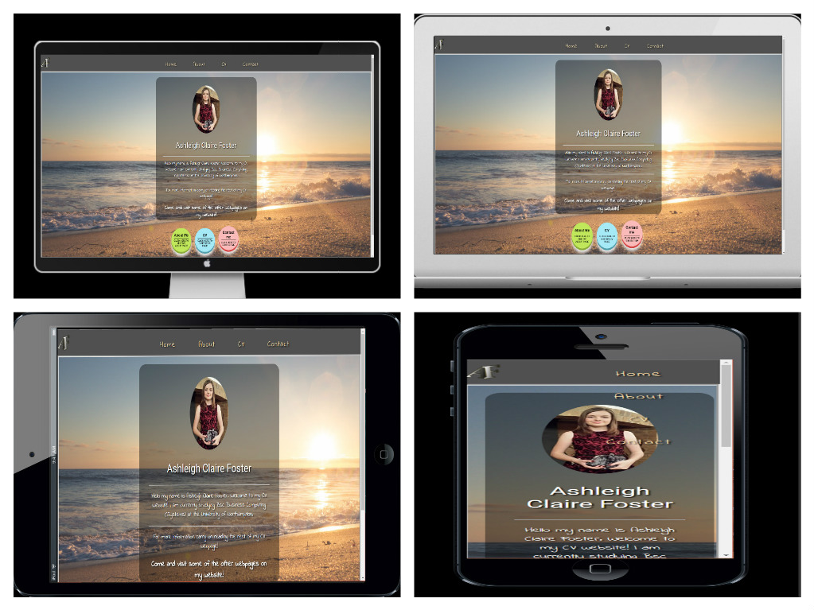**Devices for Accessibility:**

**Alt tags on images** (this part is the “about me” webpage but applies to all webpages):

