User Interface design plans

**Main User Interface** - buttons for new product, customer, and purchase

Add New Purchase

Add New Product

Add New Customer

Store Management System

**Add New Customer Interface** – fields for all necessary information, add and cancel buttons

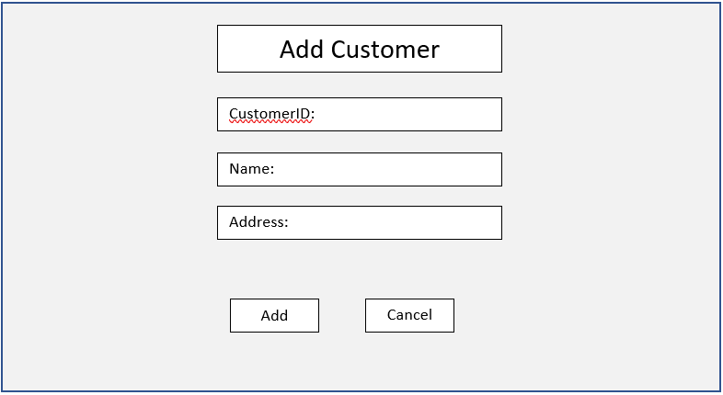

**New Product Interface –** fields for all necessary information, add and cancel buttons

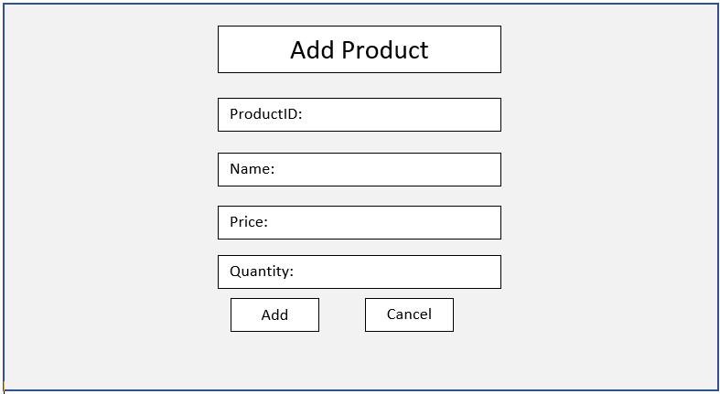

**New Purchase Interface –** fields for all necessary information, add and cancel buttons

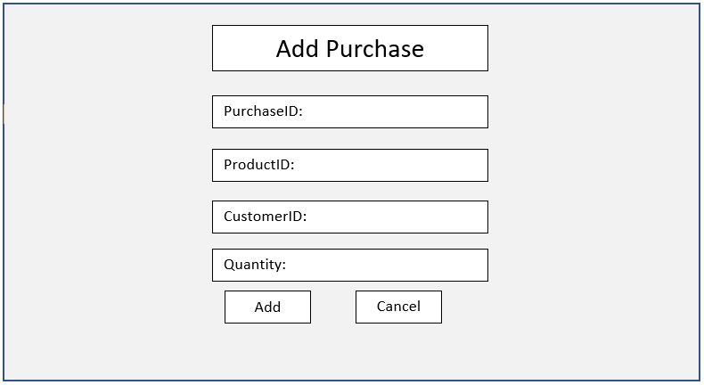

**Use Cases**

* User story – Add a new product into the system
  + Use case 1 – Add a new product
  + Use case 2 – Add a new product with a negative quantity
* User story – Add a new customer into the system
  + Use case 1 – add a new customer
  + Use case 2 – add a new customer with an empty name field
* User story – add a new purchase into the system
  + Use case 1 – add a new purchase
  + Use case 2 – add a new purchase with an invalid customer ID