User Interface design plans

**Main User Interface** - buttons for new product, customer, and purchase

Add New Purchase

Add New Product

Add New Customer

Store Management System

**Add New Customer Interface** – fields for all necessary information, add and cancel buttons

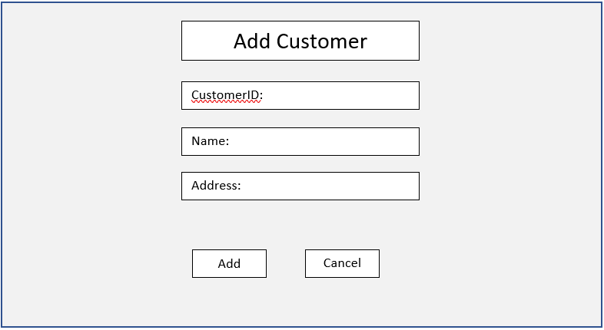

Update

**New Product Interface –** fields for all necessary information, add and cancel buttons

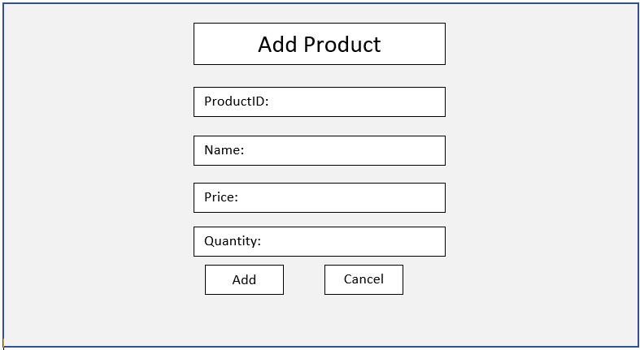

Update

**New Purchase Interface –** fields for all necessary information, add and cancel buttons

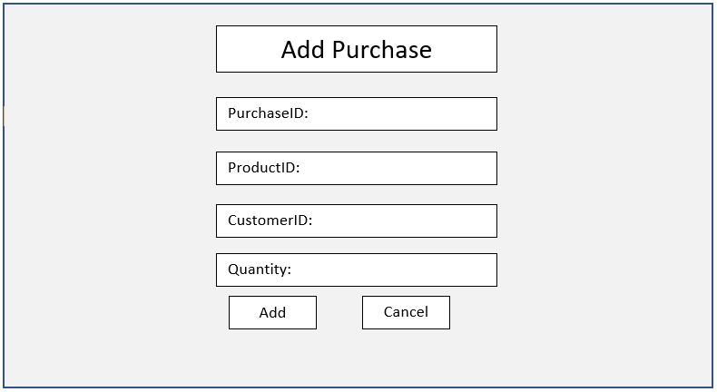

Update

Change Password

User ID:

New Password:

Search

Product ID:

Purchase ID’s with that product are…

Change User Type

User ID:

New Type:

**Use Cases**

* User story – Add a new product into the system
  + Use case 1 – Add a new product
* User story – Add a new customer into the system
  + Use case 1 – add a new customer
* User story – add a new purchase into the system
  + Use case 1 – add a new purchase
* User story – change password
  + Use case 1 – change password of existing user
* User story – add new user
  + Use case 1 – add new user to the system
* User story – change user type
  + Use case 1 – change user type
* User story – view summary
  + Use case 1 – view sale summary
* User story – view purchase history
  + Use case 1 – existing user views purchase history
* User story – search products
  + Use case 1 - existing user searches products