Predicting Kick Cars at Auto Auctions with Machine Learning
bUAN 6341.001: APPLIED MACHINE LEARNING

SUBMITTED BY - Group NO. 9
Venkat Reddy Malipatel,
Ashlesha Sanjay Kadam,
Tanmay Raju Shedge,
Sri Lalitha Manaswini Gabbita,
Venkata Sai Charan Reddy Boojala,
Sai Anuragh Sangoju.

Table of Contents

Section No. | Section Title | Page No.
1 | Motivation | 2
2 | Data | 2
 | Data Cleaning | 2
 | Data Preprocessing | 2
 | Exploratory Data Analysis | 3
3 | Model | 3
 | Logistics Regression | 3
 | Random Forest | 3
 | XGBoost | 4
 | LightGBM | 4
4 | Model Comparison | 5
5 | Conclusion | 8
 | Appendix | 9

1. Motivation

In this project, we employ machine learning techniques to distinguish between “good buys” and “bad buys” in vehicle auctions. A “good buy” is likely to yield a profit upon resale, while a “bad buy” could result in losses due to factors such as high repair costs or low resale value. Our models use historical auction data to aid in more informed decision-making, thus enhancing operational efficiency and reducing risk.

2. Data

The dataset comprises vehicle auction data, encompassing aspects like acquisition costs, pricing, and specifications, including:
Numeric Features: Acquisition cost, retail prices, odometer readings, and warranty costs.
Categorical Features: Vehicle make, model, color, and auction location.
Target Variable: IsBadBuy, indicating “good buy” (0) or “bad buy” (1).

Challenges:
Missing Values: Various features exhibit missing data necessitating imputation strategies.
Class Imbalance: A majority of the data labels vehicles as “good buys,” skewing the dataset.
Redundant Features: Removal of non-contributory features like ID columns.

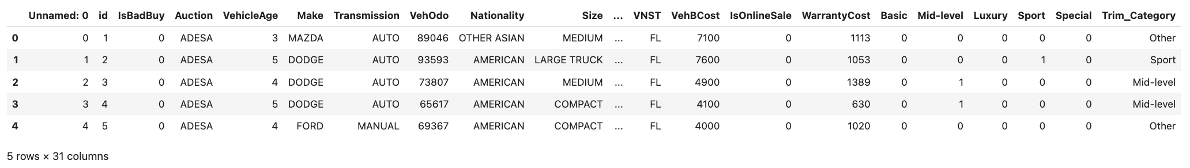
Figure 1. Sample of the Vehicle Auction Dataset

Data Cleaning & Preprocessing:

Irrelevant Columns Removal: Columns like IDs that do not impact model predictions were dropped.
Data Type Conversions: Transformed numeric-like strings to numeric formats.
Missing Value Handling: Median imputation for numeric features to reduce outlier impact and mode imputation for categorical features.
Feature Transformation: Implemented one-hot encoding for categorical variables and normalized numeric features using StandardScaler.
Class Imbalance Addressing: Applied SMOTE to balance the distribution of the target variable.

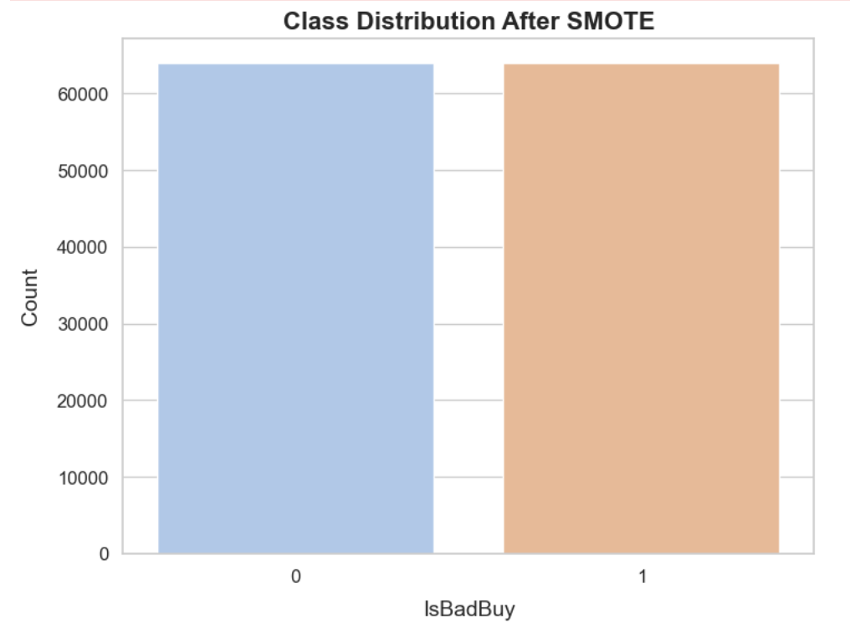
Figure 2. Balanced Class Distribution Post-SMOTE Application
Exploratory Data Analysis (EDA)

Target Variable Distribution: Visualized the skewed distribution and addressed it through SMOTE.
Correlation Analysis: Identified strong correlations among price-related features using heatmaps.
Feature Insights: Analyzed significant predictors such as vehicle age and odometer readings.

3. Model

Models Used and Hyperparameter Tuning:

- Logistic Regression:
Why Used: Logistic Regression serves as a simple and effective baseline for binary classification.
Hyperparameters Tuned:
max_iter: Set to 1000 to ensure convergence given the potentially large dataset.
Regularization strength; inverse of regularization (default grids include values like 0.01, 0.1, 1, 10) to control overfitting.

- Random Forest:
Why Used: Offers robustness against overfitting and can handle large datasets with a mix of numerical and categorical features.
Hyperparameters Tuned:
n_estimators: Number of trees in the forest (tested values: 100, 200, 300).
max_depth: Maximum number of levels in each tree (values like 10, 20, or None for unlimited depth).

- XGBoost (Extreme Gradient Boosting):
Why Used: Known for its speed and performance, particularly on structured data.
How it Works: Boosting algorithm that builds sequential trees, where each tree learns from the errors of the previous ones.
Hyperparameters Tuned:
• eval_metric: ‘logloss’ for binary classification.
• learning_rate: Step size shrinkage used to prevent overfitting (values like 0.01, 0.1, 0.2).
• max_depth: Controls the depth of the tree to prevent model from becoming too complex.

- LightGBM:
Why Used: Efficient with large data sets, and handles categorical features inherently well.
How it Works: Splits the data leaf-wise as opposed to level-wise, leading to better model adjustments.
Hyperparameters Tuned:
• num_leaves: Number of leaves in one tree (values like 31, 63, 127).
• max_depth: Limit on tree depth (used -1 for no limit, or specified depths such as 10 or 20)

Rationale for Hyperparameter Choices:
• Grid Search: Applied to systematically explore the combination of parameters for each model to optimize performance metrics such as accuracy and ROC AUC.
• Choice of Parameters: Focused on controlling model complexity (to avoid overfitting) and improving model learning (speed and accuracy).

Training and Testing
• Data Splitting: The resampled dataset (post-SMOTE) was split into training (80%) and testing (20%) sets.
• Feature Scaling: StandardScaler was applied to the numeric features before training.
• Evaluation Metrics:
• Accuracy
• ROC AUC (Receiver Operating Characteristic Area Under Curve)
• Precision, Recall, and F1-Score
• Confusion Matrix

4. Model Comparison

Logistics Regression -

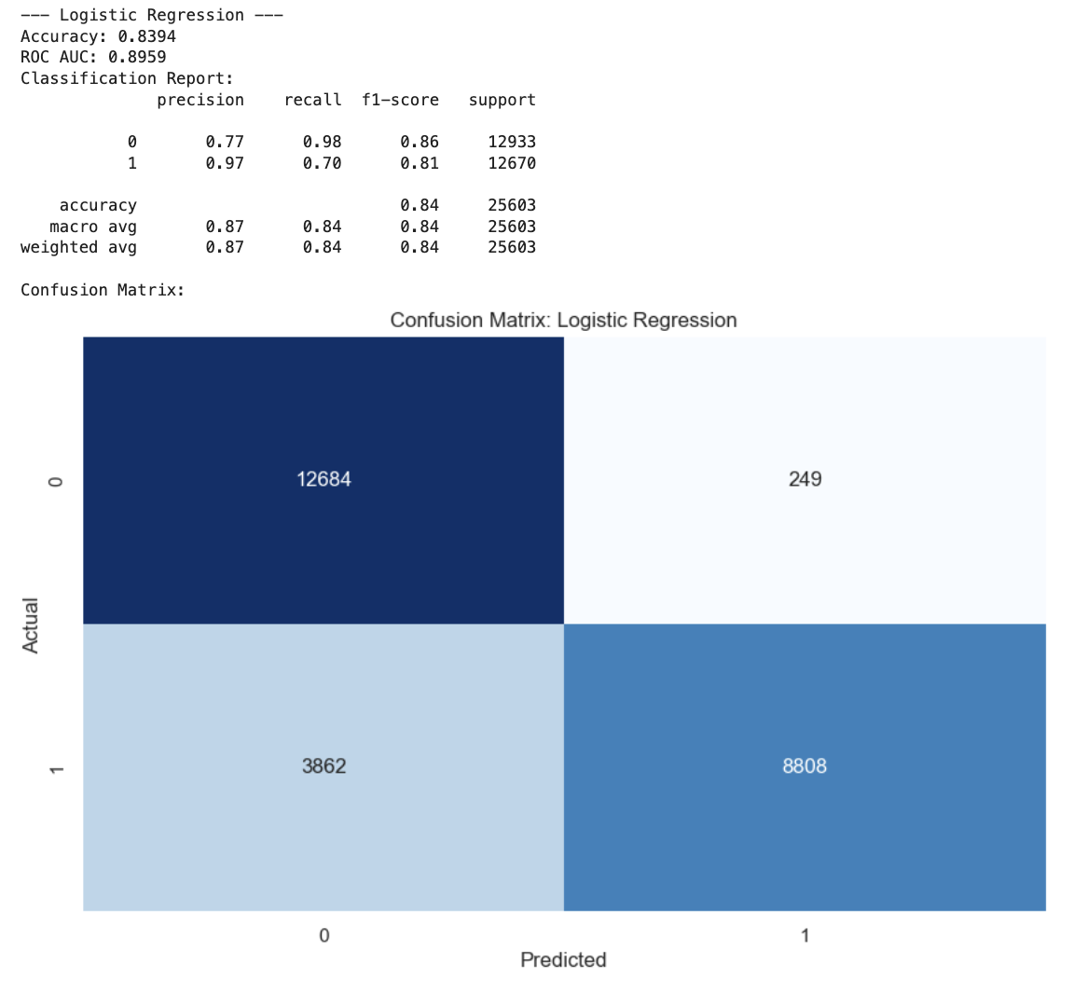
Figure 3. Performance Metrics for Logistic Regression Model
Random Forest -

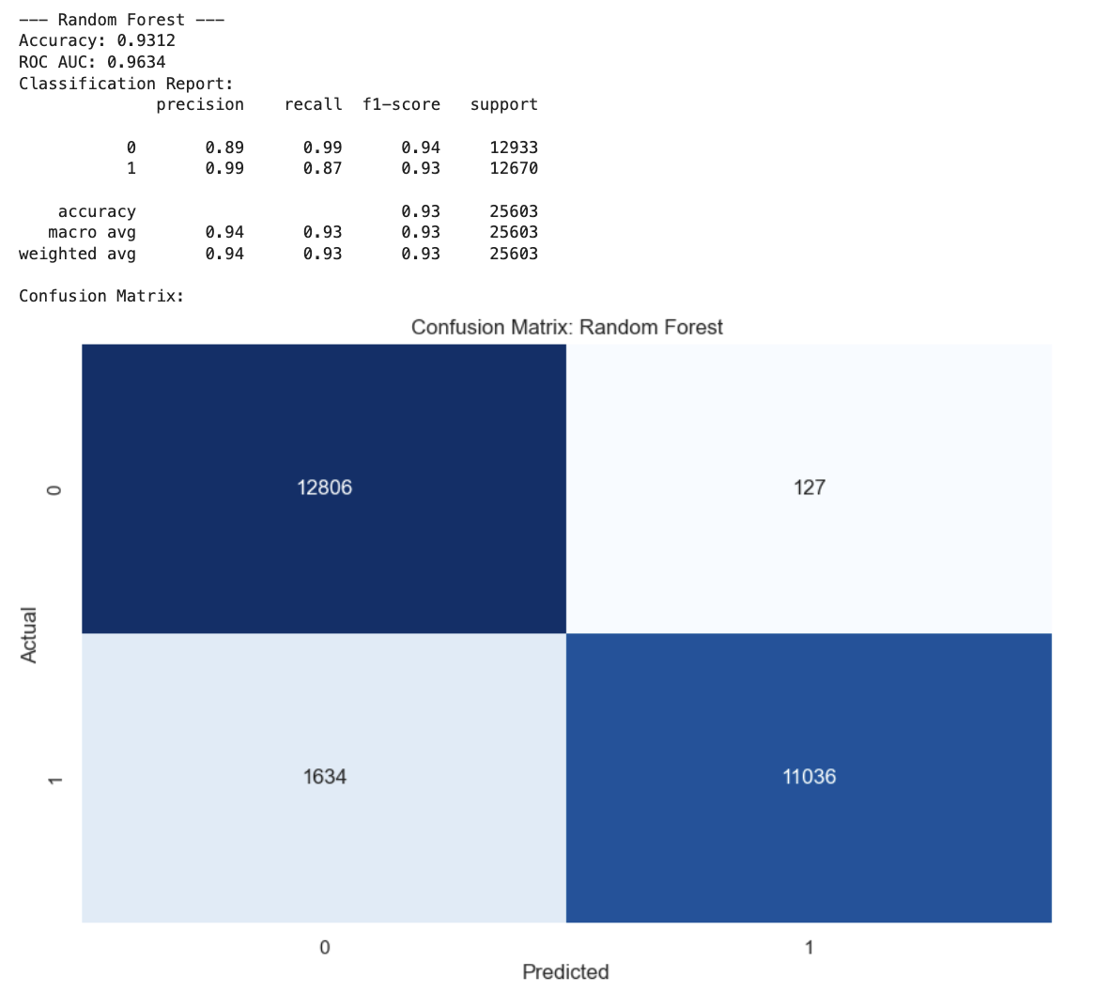
Figure 4. Performance Metrics for Random Forest Model

XGBoost –

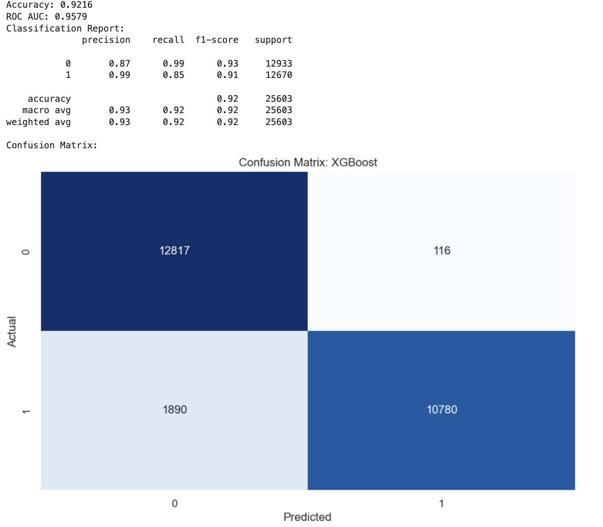
Figure 5. Performance Metrics for XGBoost ModelLightGBM –

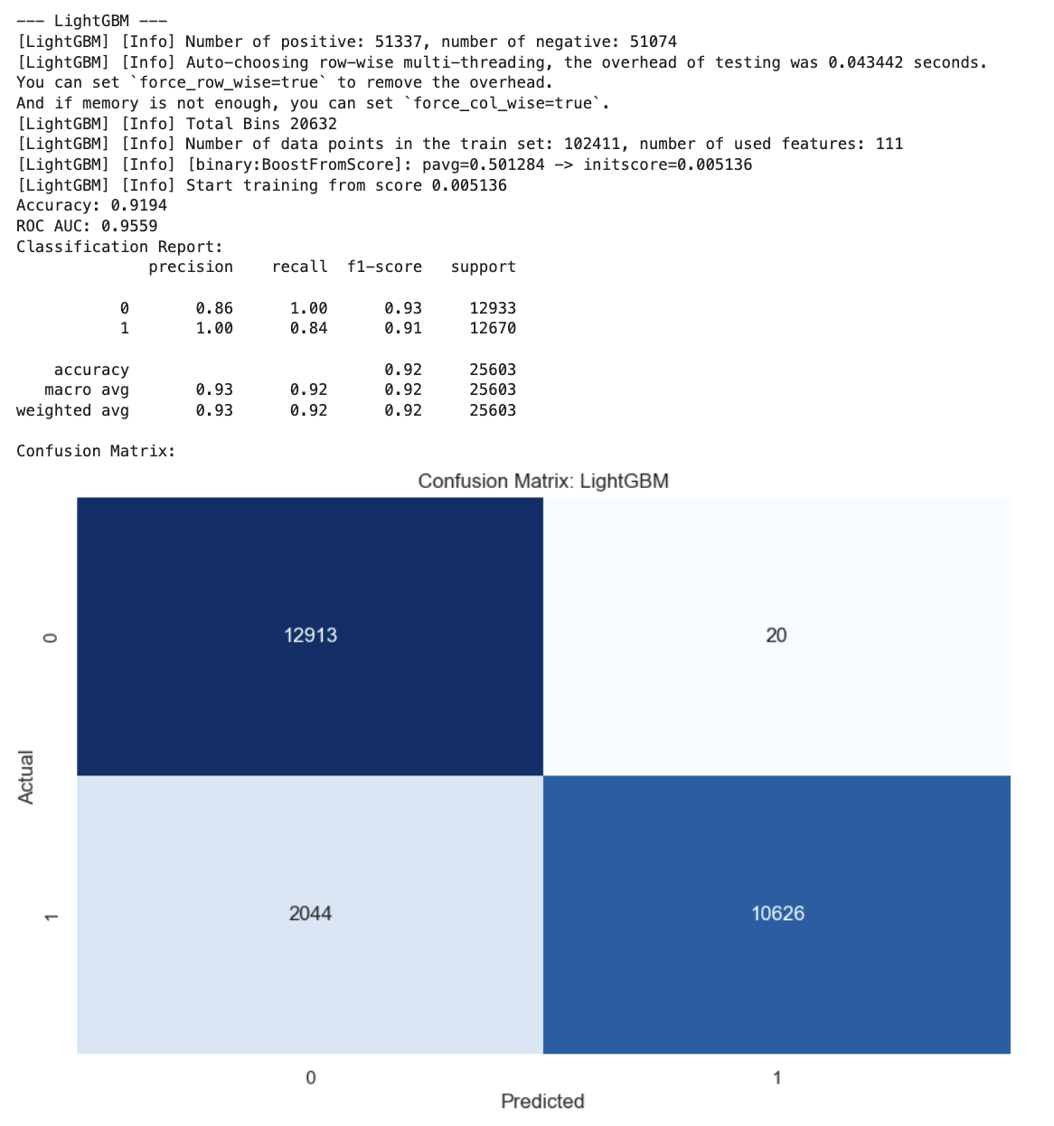
Figure 6. Performance Metrics for LightGBM Model
• Performance Metrics: Utilized accuracy, ROC AUC, precision, recall, and F1-score.

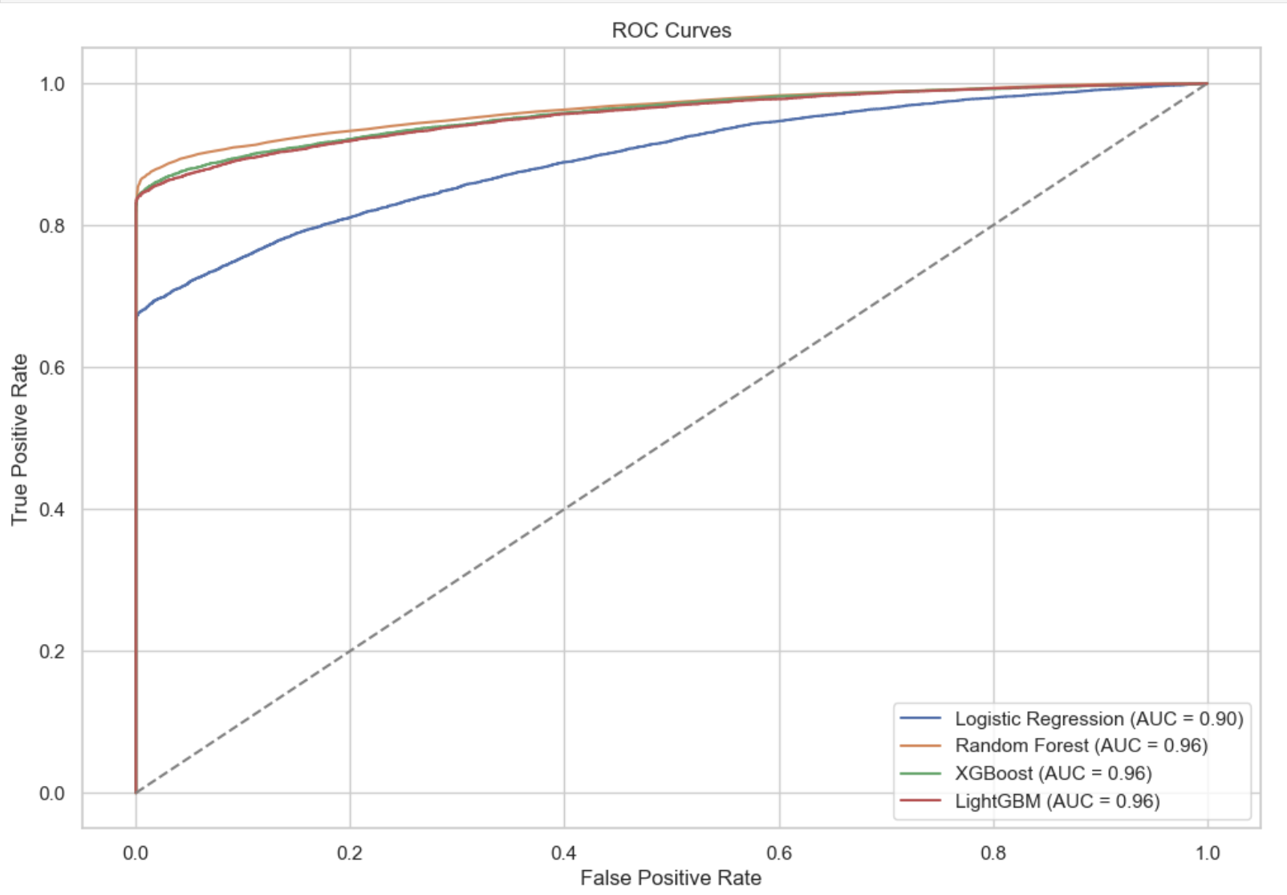
Figure 7. Receiver Operating Characteristic (ROC) Curves for Predictive Models
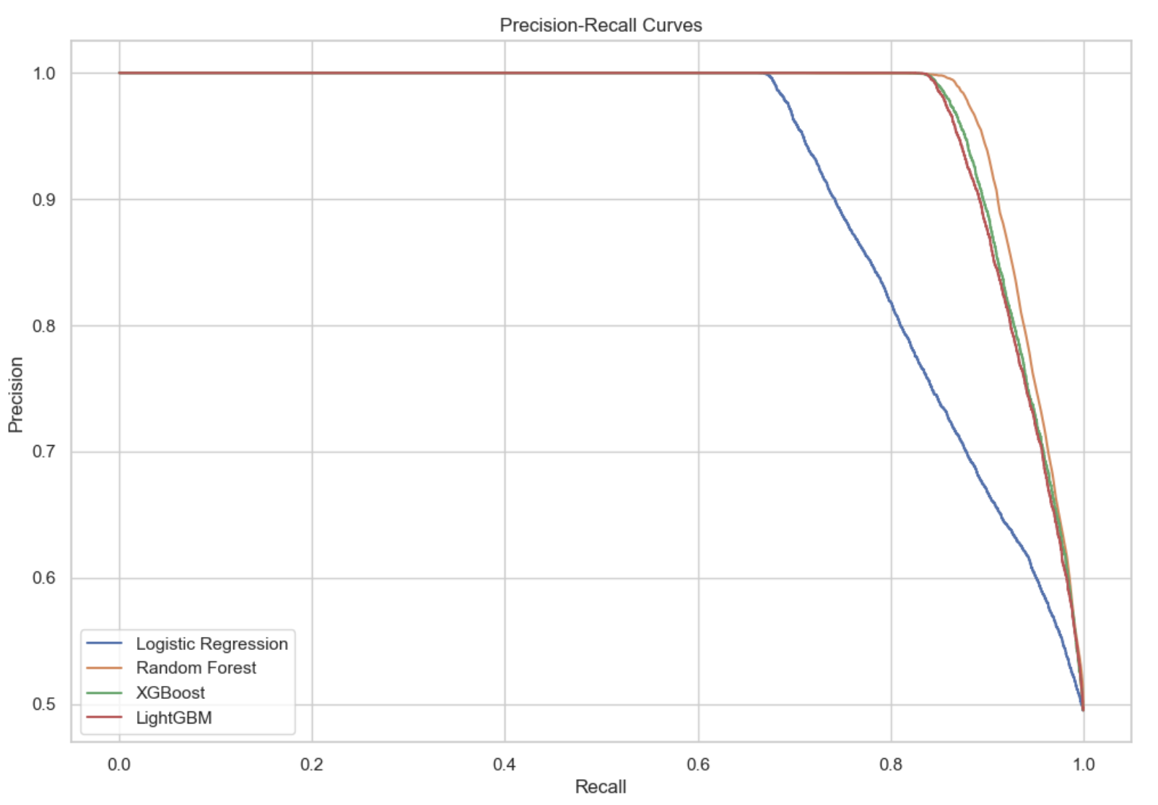
Figure 8. Precision-Recall Curves for Machine Learning Models
The metrics of accuracy, ROC AUC, precision, recall, and F1-score were chosen for model comparison to provide a comprehensive evaluation of each model’s performance, considering overall accuracy, ability to discriminate between classes, & balance between precision & recall, crucial for handling class imbalances.

5. Conclusion
Best Model: Random Forest emerged as most balanced & interpretable model, achieving an AUC of 0.963.
Feature Insights: Vehicle age, odometer readings, and acquisition price were critical predictors.
Impact of Preprocessing:
• SMOTE significantly improved recall for the minority class.
• Scaling ensured consistent model performance across features

Appendix
Additional visualizations:
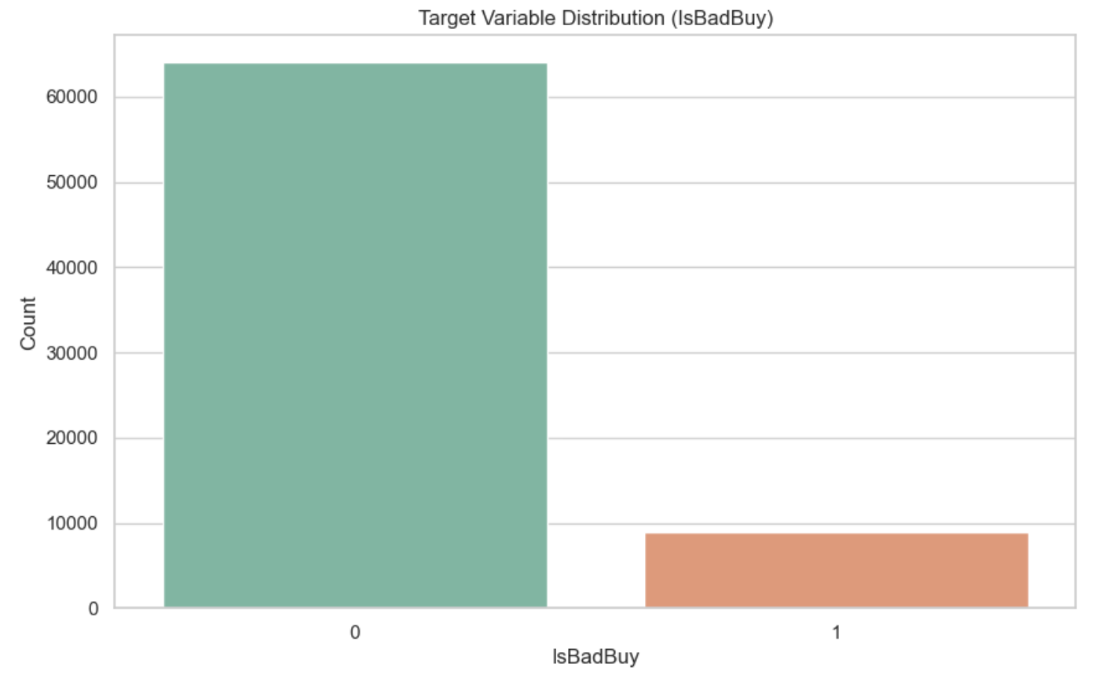
Figure 9. Original Class Distribution of the Target Variable ‘IsBadBuy’

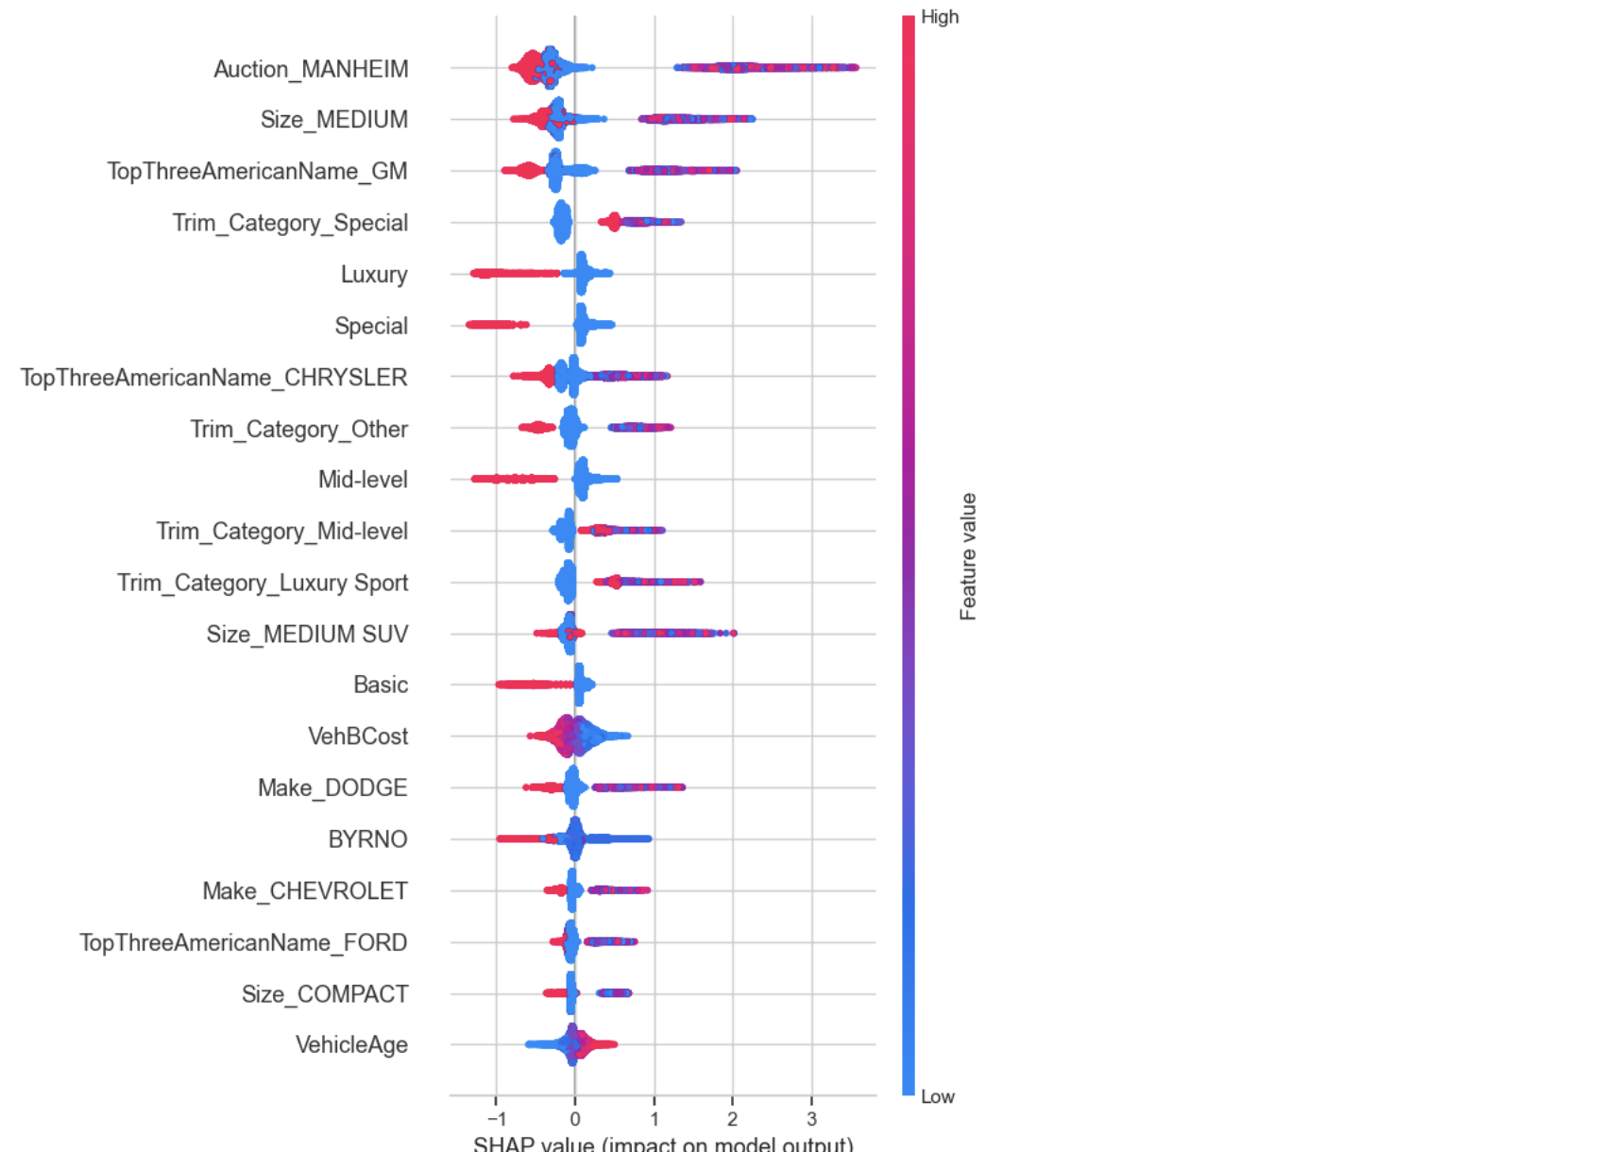
Figure 10. SHAP Value Summary Plot for Predictive Model

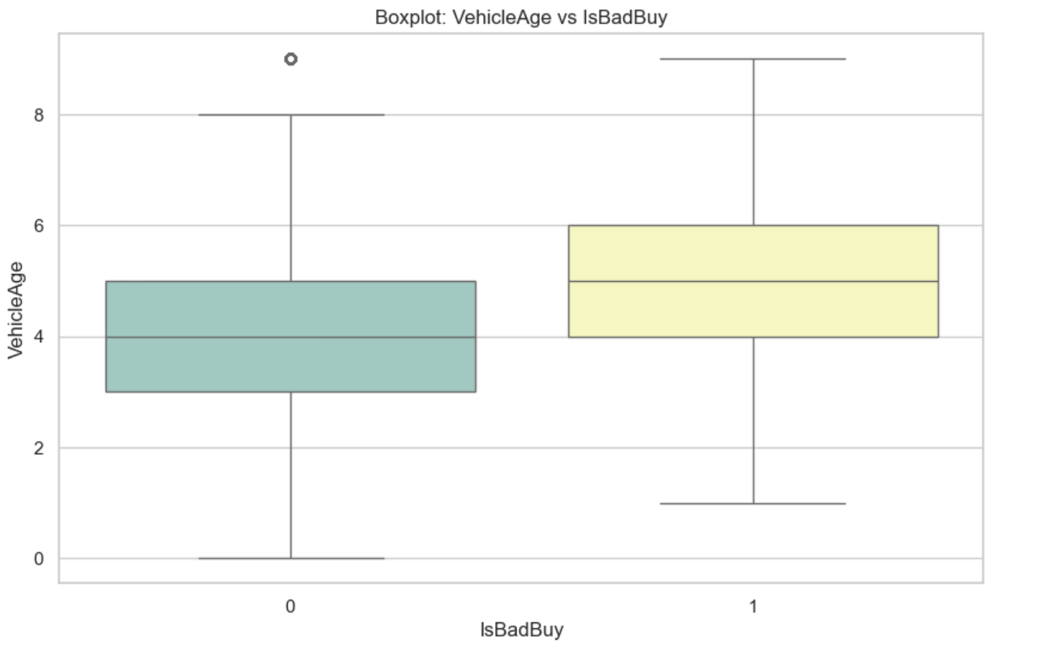
Figure 11. Boxplot of Vehicle Age by IsBadBuy Classification

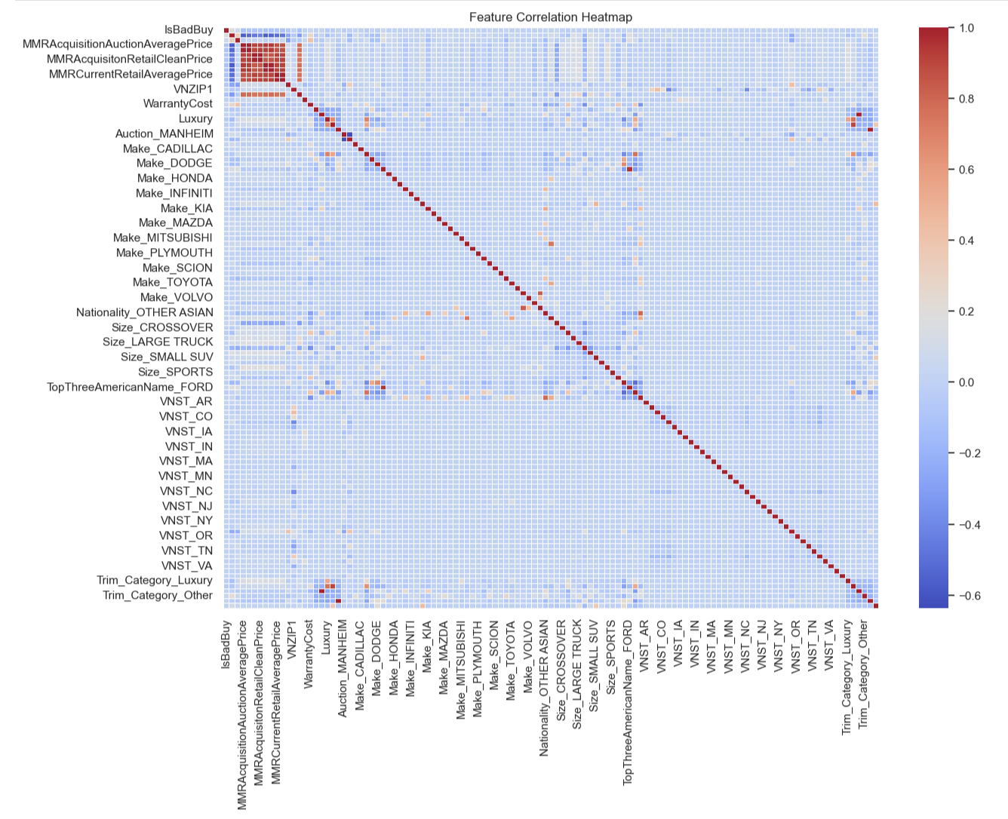
Figure 12. Feature Correlation Heatmap in Vehicle Auction Data

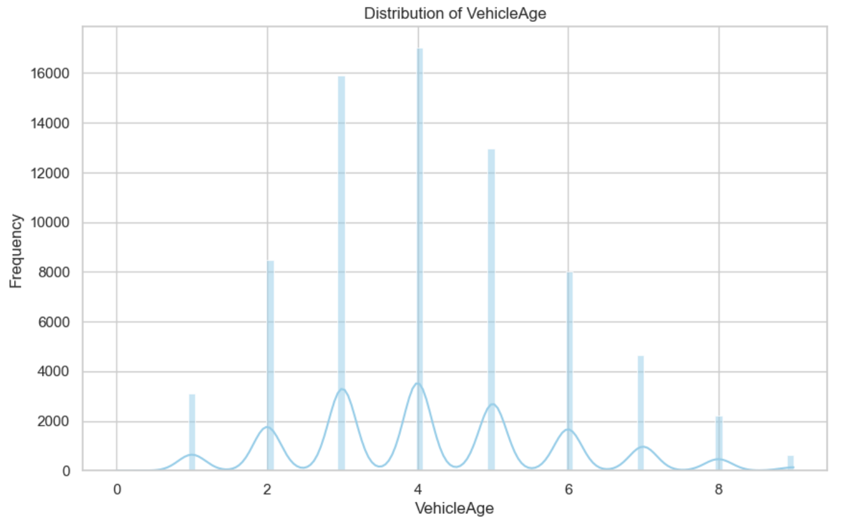
Figure 13. Histogram of Vehicle Age Distribution

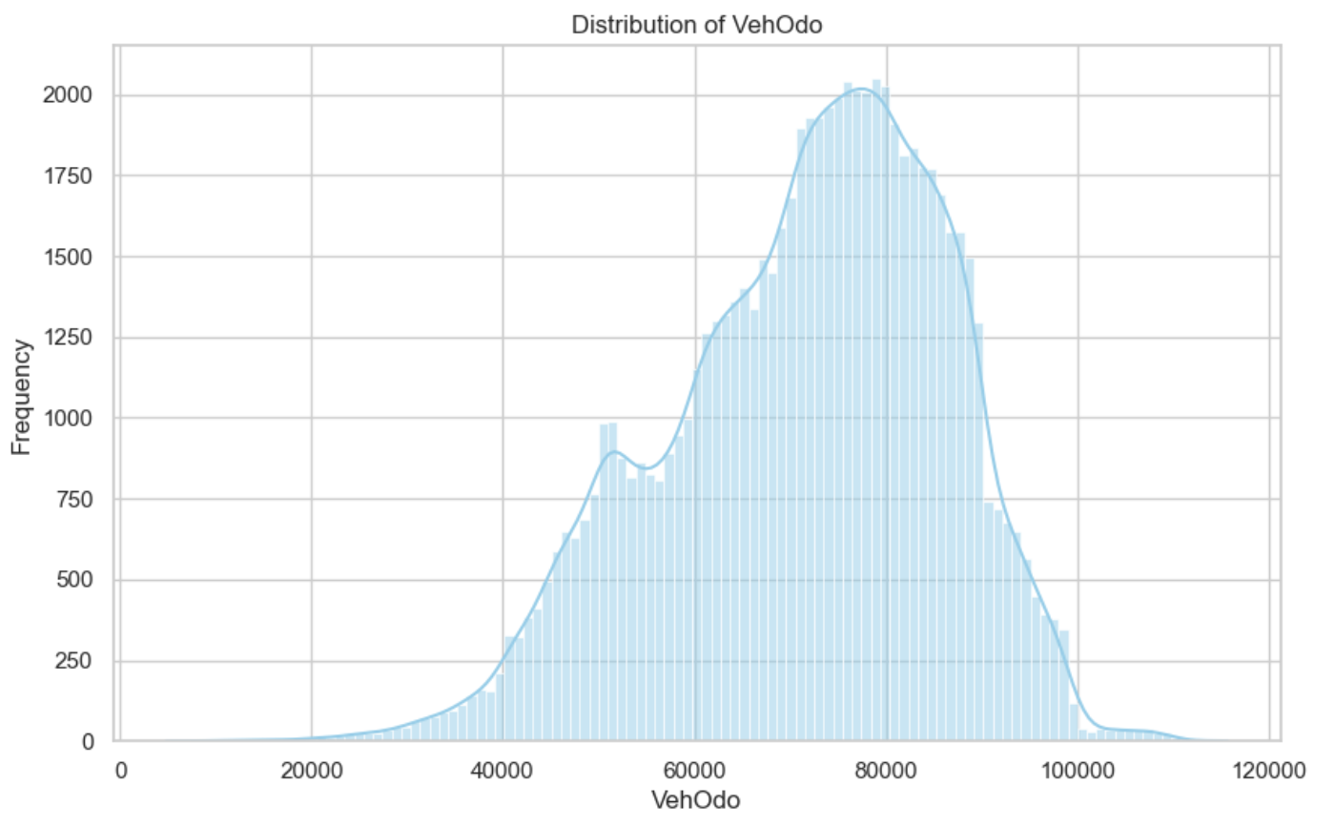
Figure 14. Histogram of Vehicle Odometer Readings Distribution

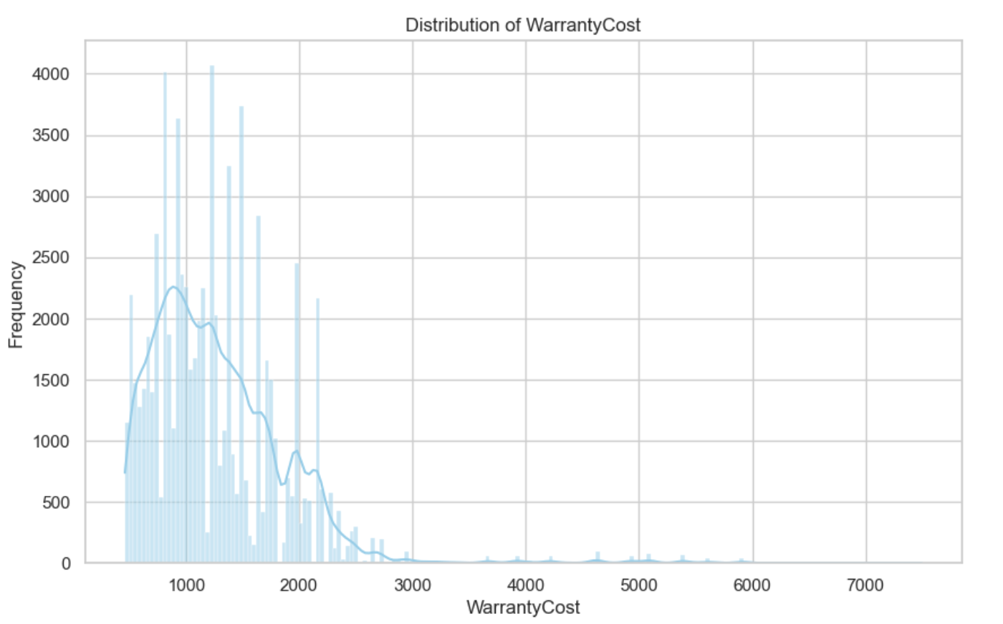
Figure 15. Histogram of Warranty Cost Distribution

References
• Auto Auctions in the U.S. https://www.manheim.com/ and https://www.adesa.com/
• SHAP Analysis https://shap.readthedocs.io/en/latest/
• Oversampling https://imbalanced-learn.org/stable/over_sampling.html#smote
• Gradient boosting https://www.geeksforgeeks.org/ml-gradient-boosting/ and
https://www.analyticsvidhya.com/blog/2020/02/4-boosting-algorithms-machine-
learning/
• Géron, A. (2017). Hands-On Machine Learning with Scikit-Learn, Keras, and TensorFlow.
O'Reilly Media.

