**CASE STUDY 4:**

* Here I’m using multistage Yaml pipelines.
* Build, test, creating infrastructure stages ran successfully and pipeline is waiting for approval in order to deploy app.

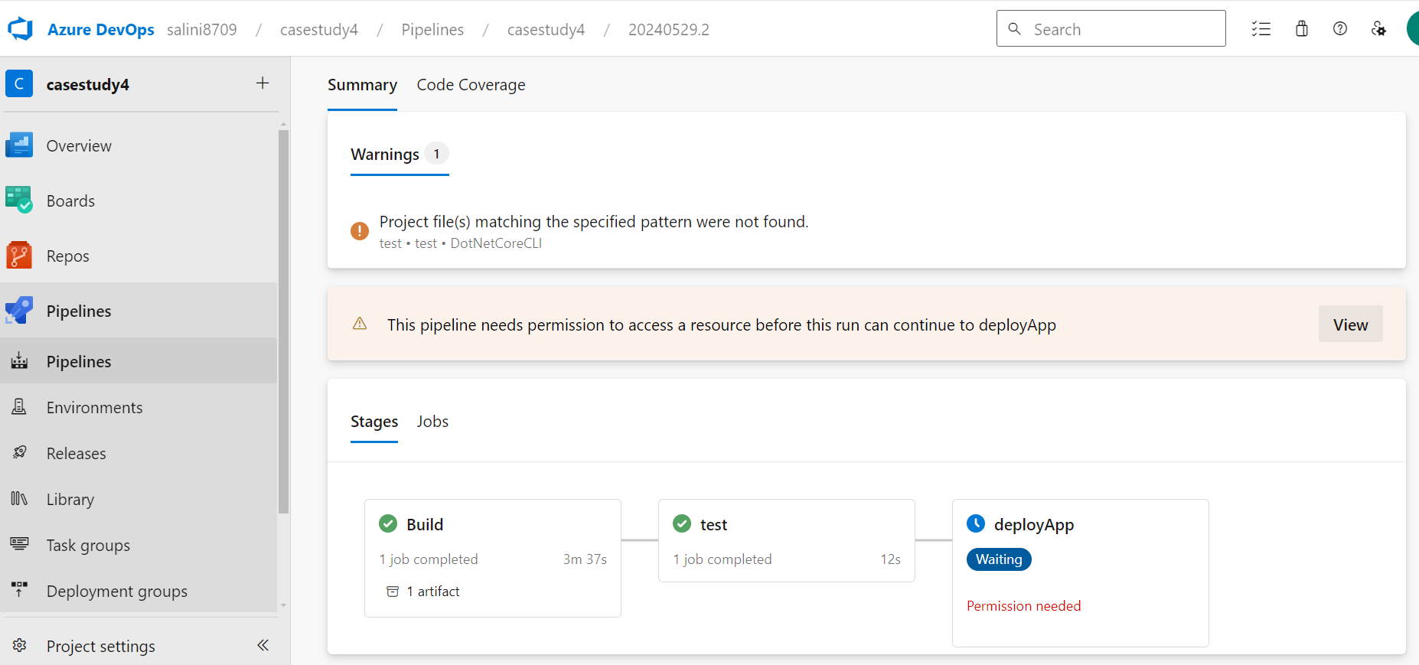

* This step shows, the approval request.

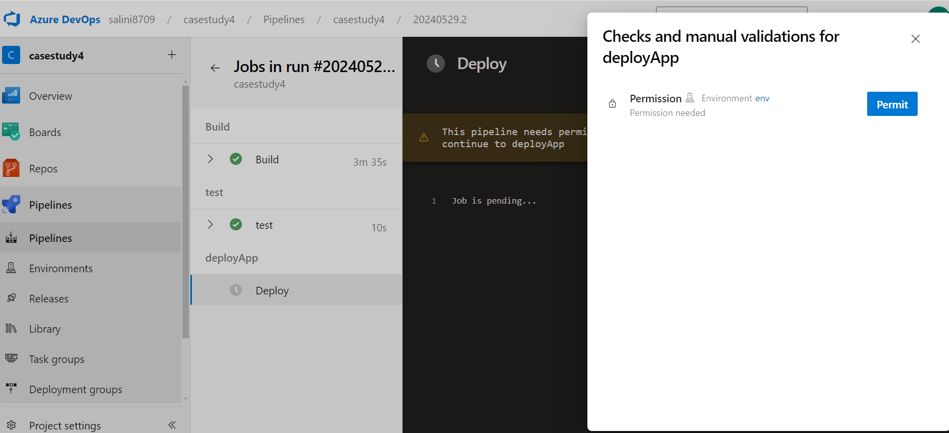

* In this step, approver can either reject or approve the pipeline and can also add comments, if necessary.

* As the approval is available, now the pipeline is executed successfully and the app is deployed.

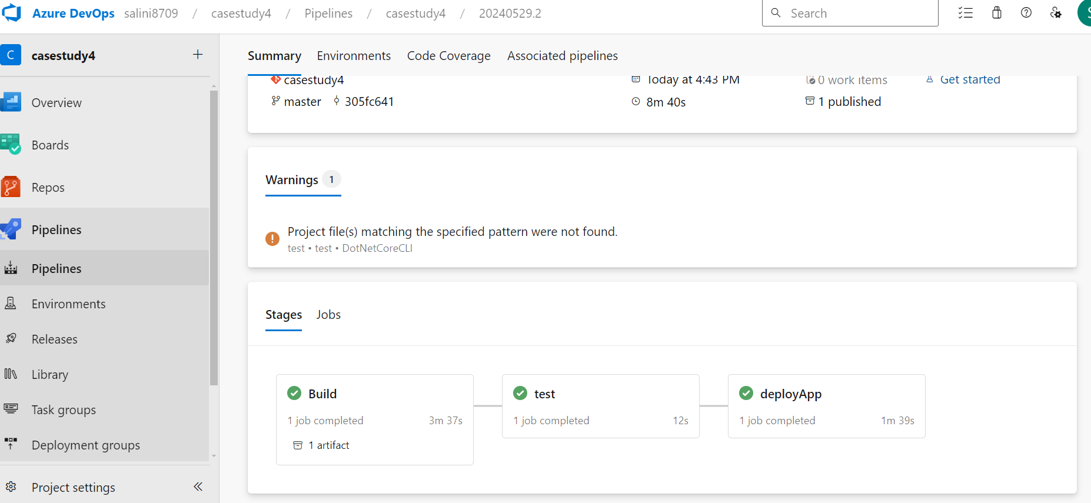

* Here is the output in web browser.

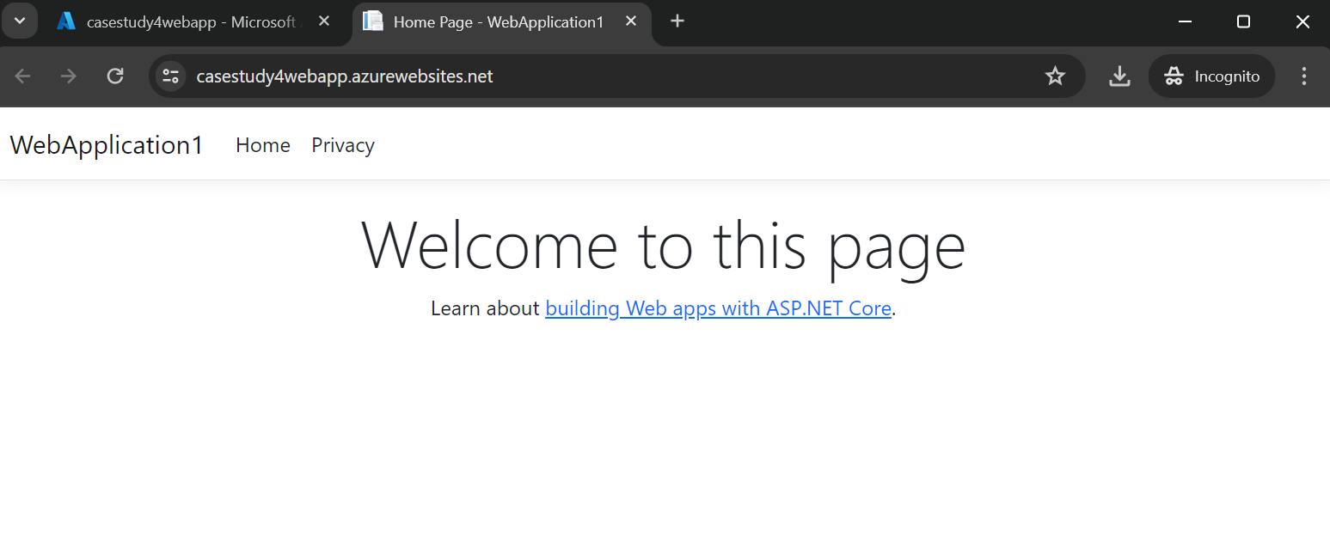

* This page shows the metrics of the resource. Here I’ve added Connections count, Requests count, HTTP server errors count. These metrics can be added as per our requirement.

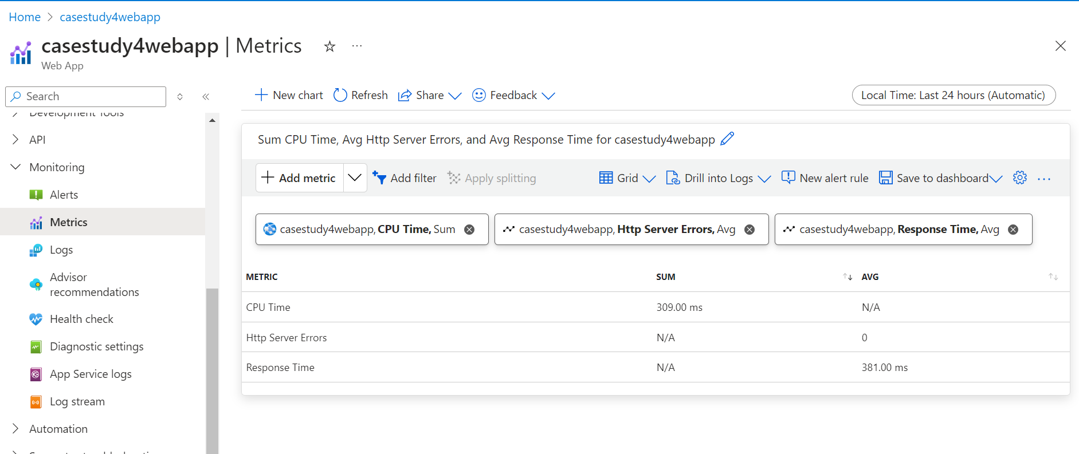

* Here, we can add the alerts by creating the alert rules.

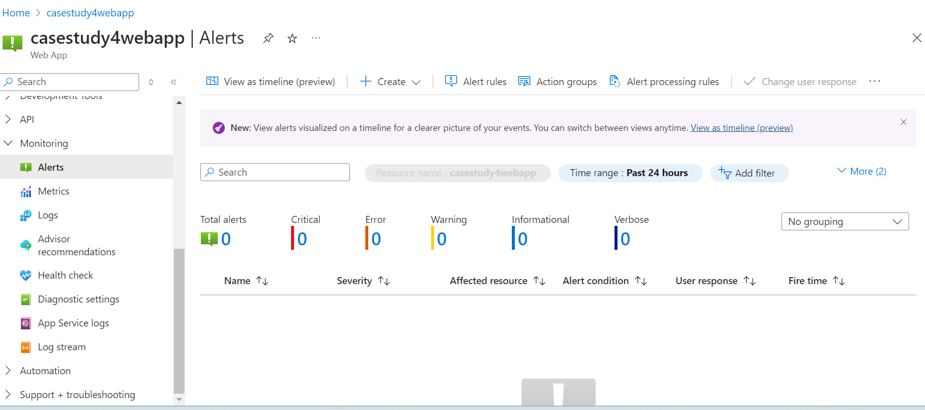

Deployment Diagram:

