# CASE STUDY 3

* Here I’ve used 2 different pipelines. One is for required infrastructure deployment and another one is for app deployment.
* This page shows successful deployments of both the pipelines.

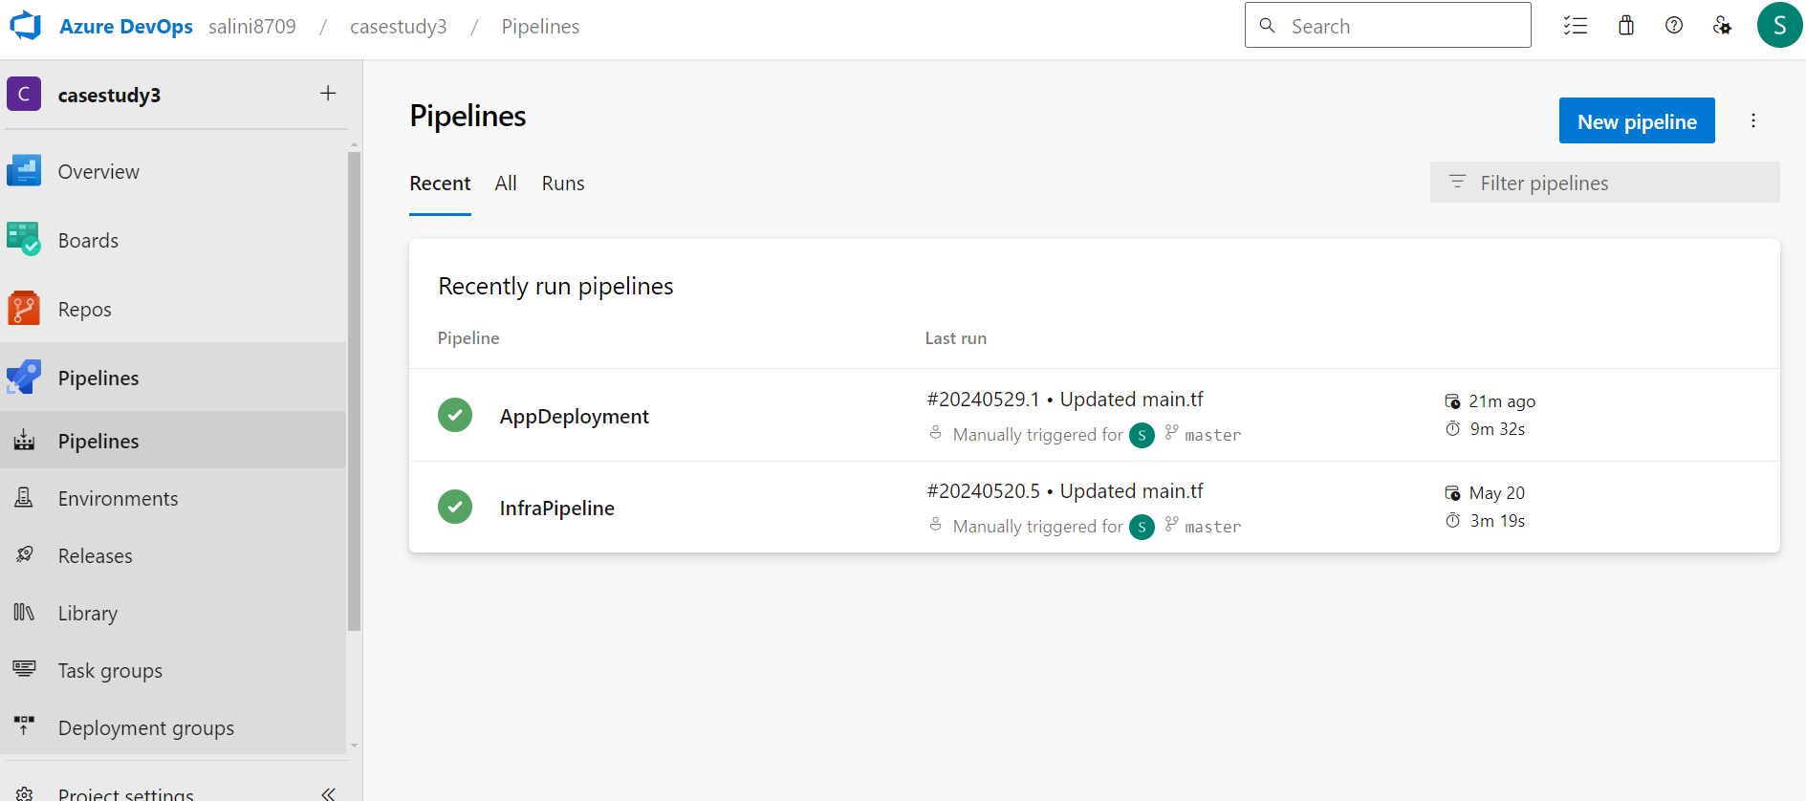

* This page shows the environment added to use in deployments.

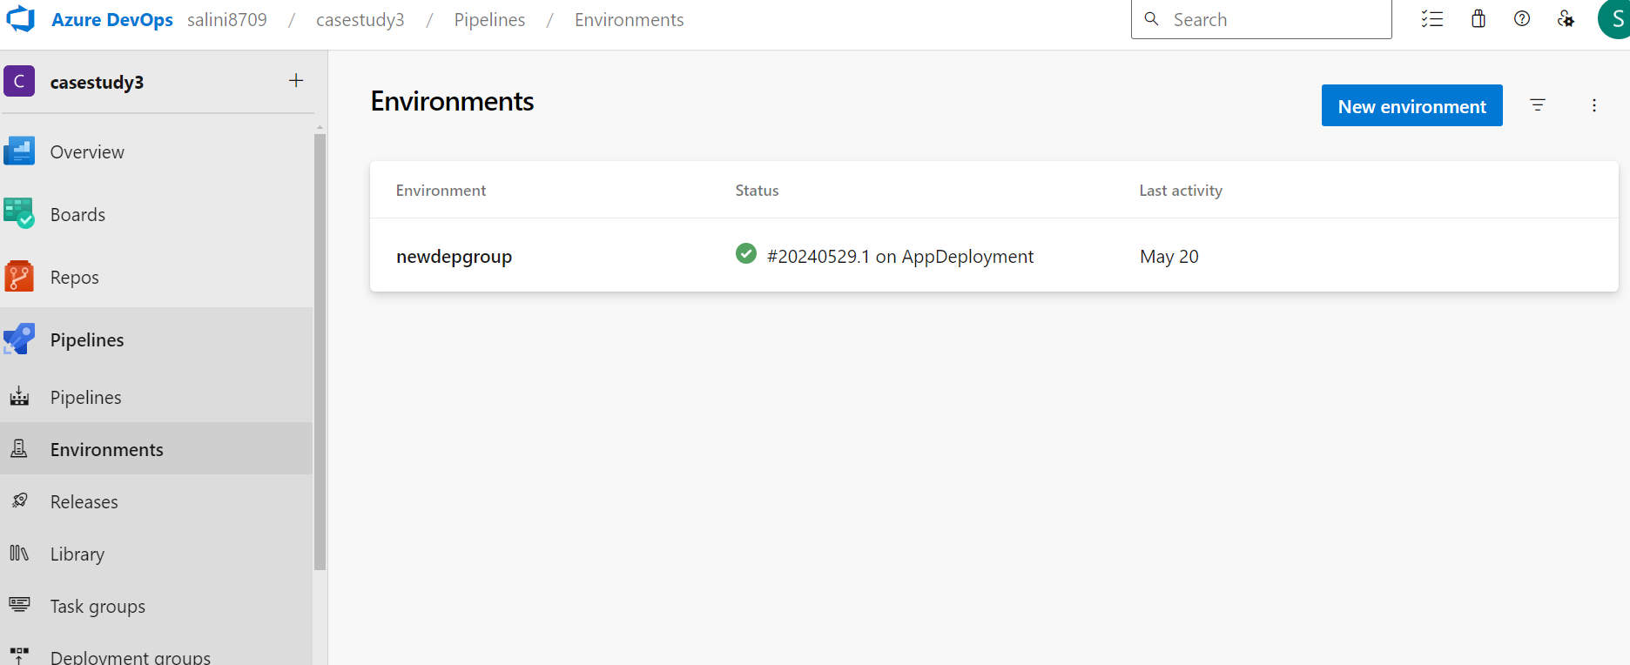

* This page shows that Review is required to move into deploy stage.

* In this step, approver can either reject or approve the pipeline and can also add comments if necessary.

* This step shows that pipeline is successfully executed.

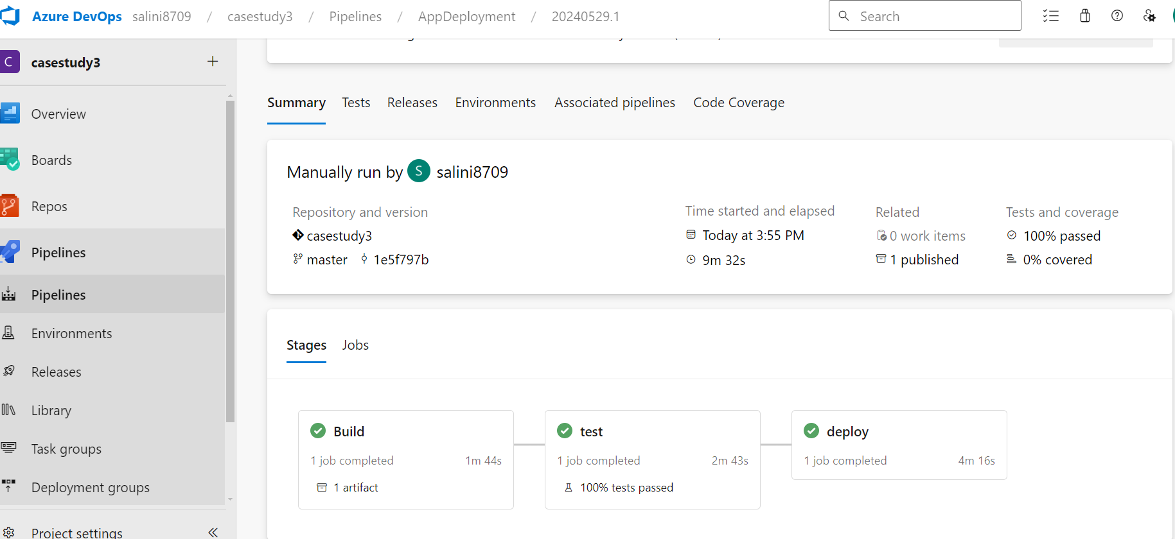

* This is the output in web browser.

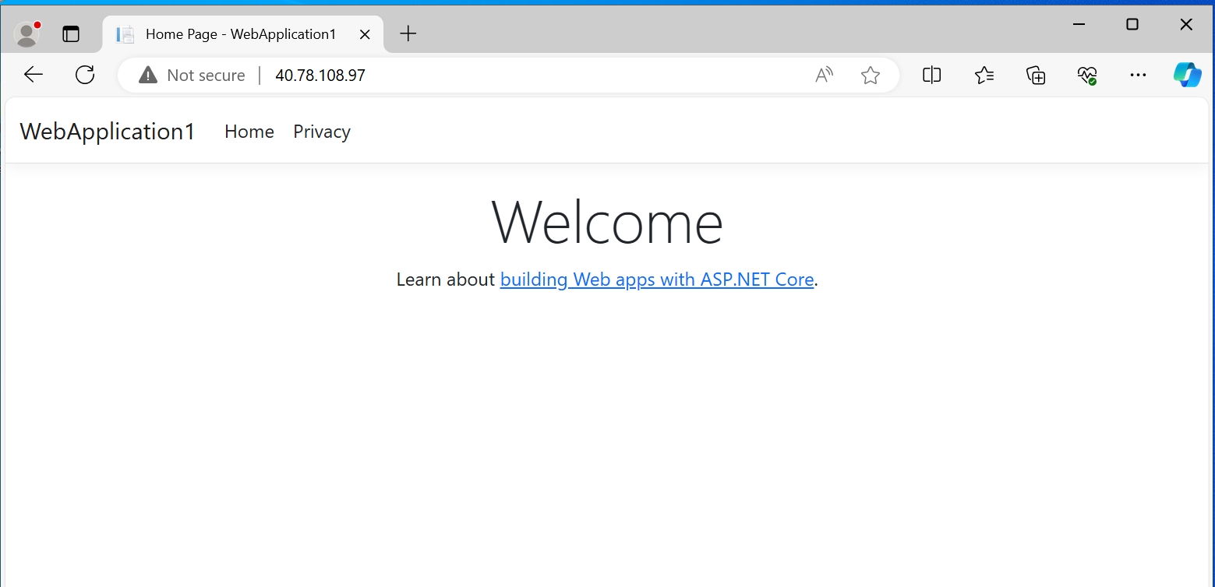

* Here alert rule can be created and if there are any alerts, those will be displayed.

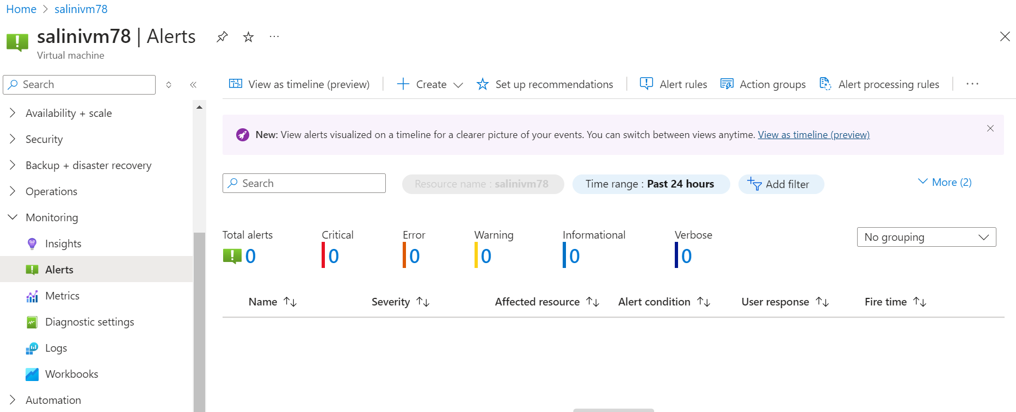

* Here, metrics of a virtual machine can be seen. I’ve added Percentage CPU, Outbound Flows, Available Memory Bytes. Metrics can be added based on our requirement.

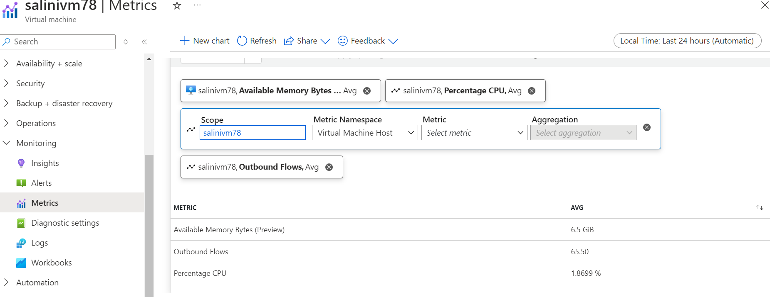

**DEPLOYMENT DIAGRAM:**

