GYM MANAGEMENT SYSTEM
Agile Sprint Management Report
Using Jira Scrum Board
Submitted to

NMAM INSTITUTE OF TECHNOLOGY, NITTE
(Off-Campus Centre, Nitte Deemed to be University, Nitte - 574 110, Karnataka, India)

In partial fulfillment of the requirements for the award of the

Degree of Bachelor of Technology

in

INFORMATION SCIENCE AND ENGINEERING

By

ASHLESH V. NAYAK NNM24IS042

Under the guidance of

Dr. JASON ELROY MARTIS
Associate Professor


2025 – 2026

1. Introduction

In this report, the process of simulating the Agile sprint for the Gym Management System project is explained. The entire process is done through a Scrum board in Jira. Agile is one of the most common methodologies for developing software applications. In this methodology, flexibility, continuous improvement, teamwork, and timely delivery of working software are encouraged. The key difference from the conventional approach is that in this methodology, the entire project is divided into smaller parts, and development is done in cycles. The aim of this assignment is to select a real-world software application and demonstrate to the class how a development team would plan, organize, and execute their tasks using the Scrum framework, which is one of the most popular implementations of the Agile methodology.[4]

Gym Management System is a real-world software application that is commonly used in the real world. This application is used to efficiently manage a gym’s daily operations in an organized fashion. The application can efficiently manage memberships, bookings, attendance, payments, and even equipment in a gym. The application makes things more efficient for people working in a gym and saves them from doing manual labor. There are two types of users for this application: one is for members, and the second is for admins. These two types of users have different requirements, and hence it is better to have separate user stories for this application.[1]

1.1 Project Overview
Field | Details
Project Name | Gym Management System
Project Key | PROJ
Methodology | Agile Scrum
Tool Used | Jira (Atlassian)
Sprint Name | GMS Sprint 1
Sprint Duration | 29 March 2026 - 12 April 2026 (2 Weeks)
Total User Stories | 10 (5 Member + 5 Admin)
Total Subtasks | 4 (under PROJ-6)
Total Story Points | 52

Summary Page:
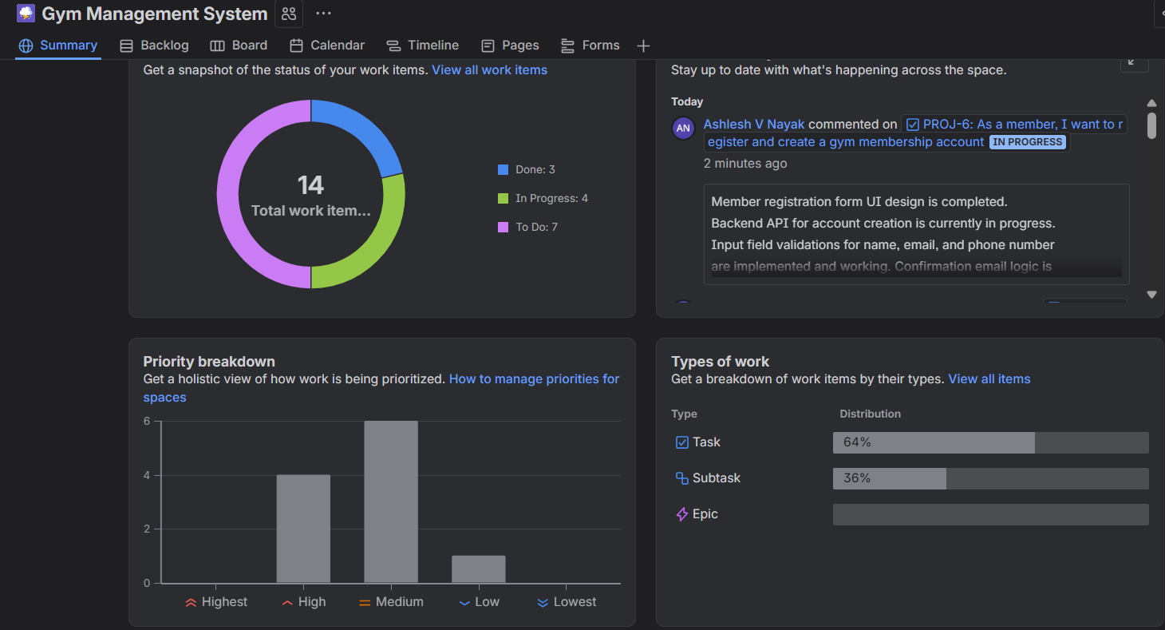
Figure1: Summary Page

2. Agile and Scrum Methodology

Agile development is a new way of doing software development. It involves developing and delivering small pieces of working software rather than all of it at once. This allows for flexibility in making changes and improvements in the product based on feedback. Agile development maintains three core values: flexibility in making changes, a team working well together, and involving the customer in the development process. By doing small pieces of development, a team can make improvements and deliver a product that best suits the needs of users.

The most popular method of Agile development is called Scrum. Scrum describes how Agile development can be used in software development. It divides development into small periods of time called sprints. Each sprint can last between one to four weeks. At the beginning of each sprint, a team selects development tasks from a product backlog and commits to completing those tasks in a sprint. Scrum also describes three roles in Agile development: Product Owner, Scrum Master, and Development Team.[3]

According to Sommerville, Agile development works best for small to medium-sized projects where requirements are likely to change in the future and cannot be known in advance. In such cases, continuous communication between team members is very important. The Agile development process is helpful in dealing with changes in software projects. It becomes easier for the team to make changes in the software projects. [1]

2.1 Key Scrum Concepts Used in This Project
Scrum Concept | How It Was Used
Product Backlog | All 10 user stories were included in the Jira backlog prior to the start of the sprint.
Sprint Backlog | All 10 user stories were moved into the GMS Sprint 1.
User Stories | Written as: As a [user], I want to [action], so that [benefit]
Sprint Planning | All user stories were assigned a priority level: High, Medium, or Low.
Sprint Board | Jira board with TO DO / IN PROGRESS / DONE columns.
Definition of Done (DoD) | The DoD was documented for the sample user story PROJ-6.
Subtasks | PROJ-6 was decomposed into 4 sub-tasks to demonstrate task-level planning.
[3][2]

3. User Stories

User stories are a brief and unambiguous description of a feature from the end user’s point of view. User stories use simple language that everyone can understand. A user story is normally described in the following format: As a [type of user], I want to [do a task], so that [achieve a goal or get a benefit][1]. The user story is normally brief so that everyone understands it quickly. It is brief so that everyone knows the best way to provide the greatest benefit to the end user.

In Scrum, user stories make up the product backlog. The product backlog is a collection of all the features to be included in the final product, improvements to be made to the final product, and any fixes to be made to the final product. The user stories in Scrum are normally handled by the Product Owner. The Product Owner may talk to other stakeholders and the development team to get a better understanding of the user stories. Before the sprint begins, the backlog is normally reviewed and clarified in a process called backlog grooming. During backlog grooming, the user stories may be broken down into smaller tasks. The user stories that are clearly understood and given priority are then chosen and added to a sprint for execution.[3]

3.1 Member User Stories
Story ID | User Story | Priority | Status | Story Points
PROJ-6 | As a member, I want to register and create a gym membership account so that I can access gym services | High | IN PROGRESS | 8
PROJ-7 | As a member, I want to book a fitness class online so that I can plan my workout schedule in advance | High | IN PROGRESS | 5
PROJ-8 | As a member, I want to view and track my workout history so that I can monitor my fitness progress | Medium | DONE | 3
PROJ-9 | As a member, I want to renew my membership online so that I don't have to visit the gym just for renewal | High | DONE | 5
PROJ-10 | As a member, I want to receive notifications for upcoming classes so that I never miss a session I signed up for | Medium | TO DO | 3

3.2 Admin User Stories
Story ID | User Story | Priority | Status | Story Points
PROJ-11 | As an admin, I want to add and manage gym equipment inventory so that the gym always has up-to-date records | Medium | DONE | 5
PROJ-12 | As an admin, I want to schedule and manage fitness classes so that members can see available sessions | High | IN PROGRESS | 8
PROJ-13 | As an admin, I want to view member attendance reports so that I can track engagement and plan resources | Medium | TO DO | 5
PROJ-14 | As an admin, I want to process membership payments so that all financial transactions are handled smoothly | High | IN PROGRESS | 8
PROJ-15 | As an admin, I want to send announcements to all members so that everyone gets important updates in time | Low | TO DO | 2

4. Sprint Planning and Priority Assignment
Sprint planning is the first and one of the most important activities in a sprint. This phase helps in setting directions for the entire sprint. This phase helps in deciding what needs to be done in a given period of time. In this phase, the development team and product owner collaborate in order to choose a number of product backlog items that can be achieved in a sprint. In this phase, a particular goal is also set for a sprint, which helps in performing all activities in a particular period of time. Prioritization plays a very important role in sprint planning. This helps in making the development process more effective by completing critical and high-value activities first.[3]
The priority levels indicate how important and urgent a particular task is. This helps the development team understand what to do first and what can be delayed. Jira has a number of priority levels. There are levels such as Highest, High, Medium, Low, Lowest, and so on. In our case, we will use three levels of priority. These are High, Medium, and Low.[2]

4.1 Priority Breakdown
Priority | Stories | Count
High | PROJ-6, PROJ-7, PROJ-9, PROJ-12, PROJ-14 | 5
Medium | PROJ-8, PROJ-10, PROJ-11, PROJ-13 | 4
Low | PROJ-15 | 1

The reason for this is simple: member registration (PROJ-6) and payment processing (PROJ-14) are High because without these functions, the entire system is useless. A gym app would not be an app if it doesn't allow people to sign up or pay for membership. Booking a class (PROJ-7) and class scheduling (PROJ-12) are High because these are pretty much what the gym does. Attendance reports and announcements are low priority because although useful, they aren't necessary.

Jira Backlog View showing all user 10 user stories:
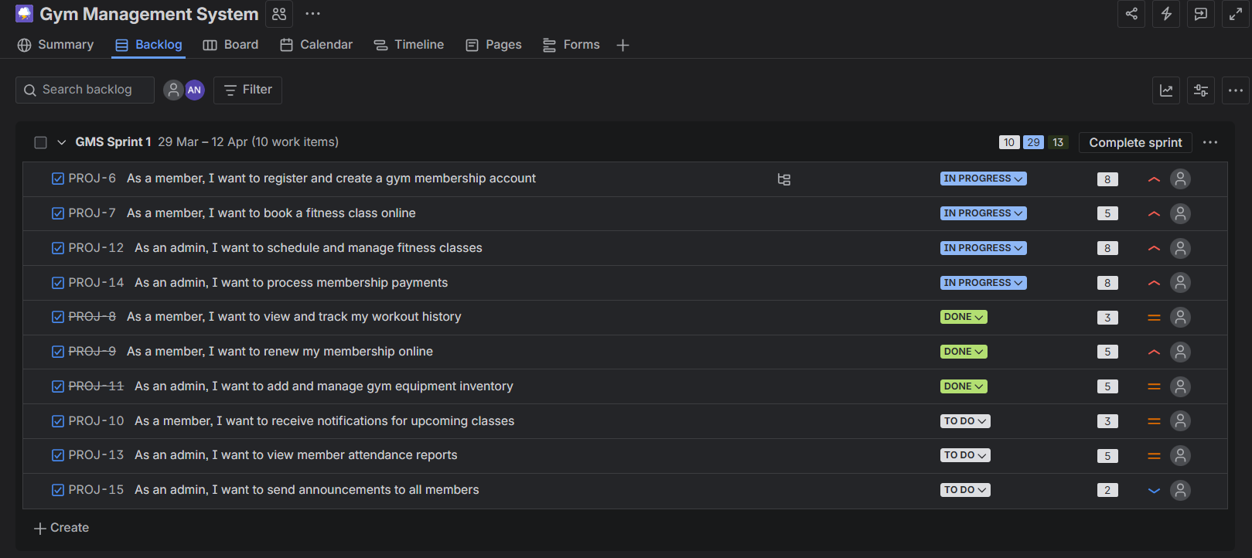Figure 2: Jira Backlog View showing all 10 user stories for GMS Sprint 1 with assigned priorities (High, Medium, Low) and current status
5. Sprint Simulation
Once all the stories were added to the backlog and given priority, they were moved to GMS Sprint 1, and the sprint was started. The sprint runs from March 29, 2026, to April 12, 2026. This is a standard two-week sprint [3].
The mid-sprint snapshot was then simulated using the Jira board. The tasks were assigned to all stages.[2].

5.1 Sprint Board Status (Mid-Sprint Snapshot)
TO DO (3) | IN PROGRESS (4) | DONE (3)
PROJ-10: Notifications for classes | PROJ-6: Register gym account | PROJ-8: View workout history
PROJ-13: Member attendance reports | PROJ-7: Book fitness class online | PROJ-9: Renew membership online
PROJ-15: Send announcements | PROJ-12: Schedule fitness classes | PROJ-11: Manage equipment inventory
 | PROJ-14: Process membership payments
The screenshot above is a view of the work in the middle of the sprint. It is a healthy mix of work. There are three stories completed, four stories in progress, and three stories in the queue. It is a view of what a real team’s board might look like in the middle of a two-week sprint with the high-priority work addressed firstt.[3]
Active sprint started:
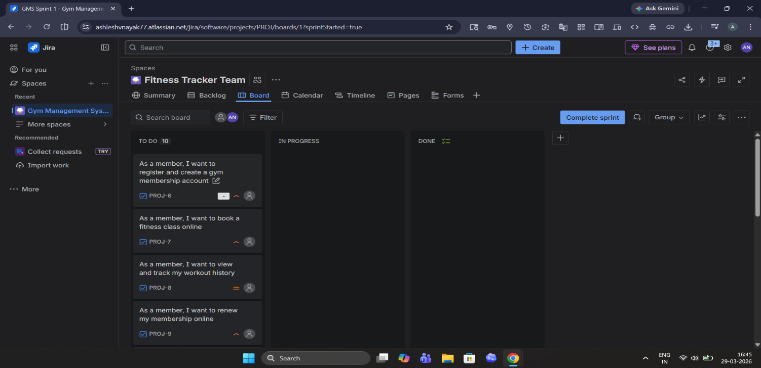
Figure 3:Active sprint started
Full Board View:
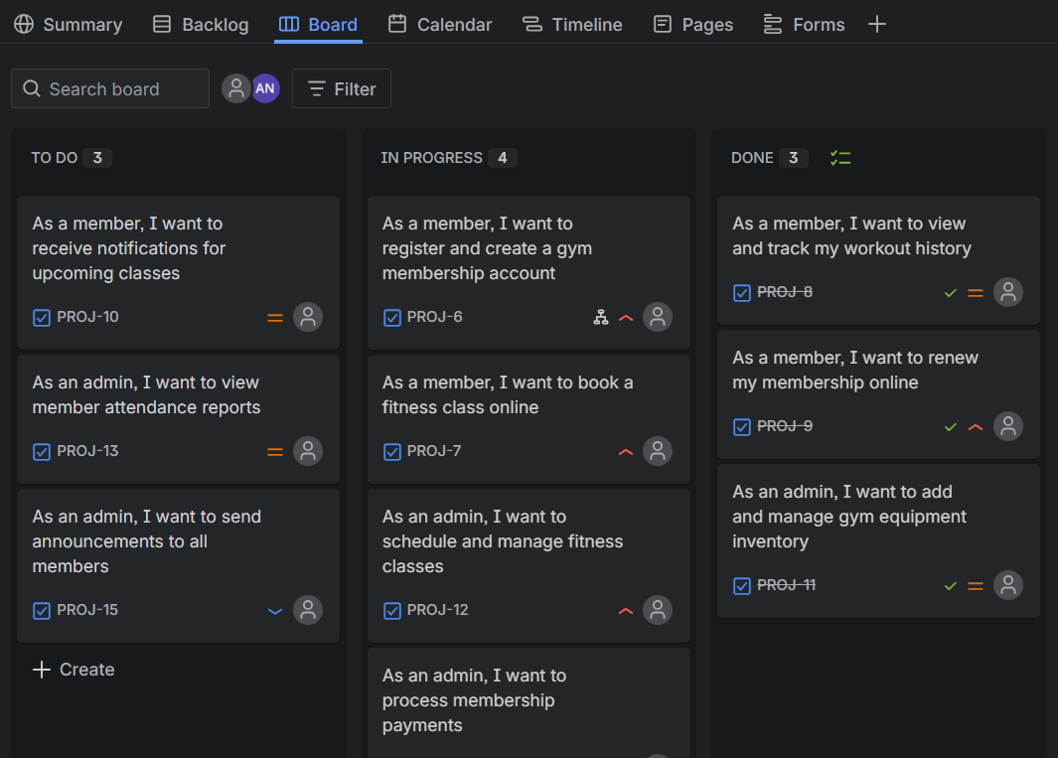Figure 4: Jira Scrum Board displaying mid-sprint progress of GMS Sprint 1with 3 tasks in TO DO, 4 tasks IN PROGRESS, and 3 tasks marked DONE
6. Detailed Documentation: PROJ-6

The first user story has been completely documented, as required by the assignment. PROJ-6 was chosen because it is the base of the entire system. Without member registration, no other feature makes sense.

6.1 Story Details
Field | Details
Story ID | PROJ-6
Title | As a member, I want to register and create a gym membership account
Full Story | As a member, I want to register and create a gym membership account so that I can access gym services and track my fitness.
Priority | High
Status | In Progress
Sprint | GMS Sprint 1

6.2 Acceptance Criteria
Acceptance criteria are the specific conditions a user story has to fulfill in order to be considered complete. In other words, acceptance criteria define what “done” means for a particular feature. This helps not only the Product Owner but also the development team. In a sense, acceptance criteria can be considered a contract between stakeholders and developers. This helps in avoiding confusion. For example, if a user story involves a feature for member registration, acceptance criteria will clearly outline what is needed.

The acceptance criteria for the member registration feature of the Gym Management System is:

The member is able to fill out a registration form with the necessary details such as the member’s name, email address, and phone number.

The system validates all the input fields to ensure that the information provided is correct.

After the registration is successful, the member is notified via email that the account has been created.

Once the account has been created, the member is able to log in using the registered details.

The acceptance criteria for the member registration feature of the Gym Management System is important as it enables the member to register an account with the system.

6.3 Definition of Done (DoD)
Definition of Done (DoD) is a checklist that is agreed upon by the entire Scrum team. The team consists of developers, testers, and the product owner. DoD is a checklist that defines the meaning of completion for a task or user story. DoD is used to ensure that quality is maintained for all items marked as ‘Done.’ DoD includes not only functionality but also quality, validation, etc. With a good DoD in place, everyone is aware that items in the ‘Done’ column are ready to ship.[3]
For the ‘Member Registration’ feature in the ‘Gym Management System,’ the DoD is as follows:
- The code for the registration feature is fully implemented and reviewed by at least one member to ensure correctness and maintainability.
- Unit tests for this feature have been implemented, and all tests pass, indicating that this feature is stable.
- The feature is also tested using different platforms, such as mobile and browser-based applications, to ensure proper functionality and compatibility.
- There are no critical or major bugs in this feature, indicating that it is stable and ready for use.
With this in mind, this feature is ready to move to the “Done” column, indicating that it satisfies both conditions.
PROJ-6 full detail
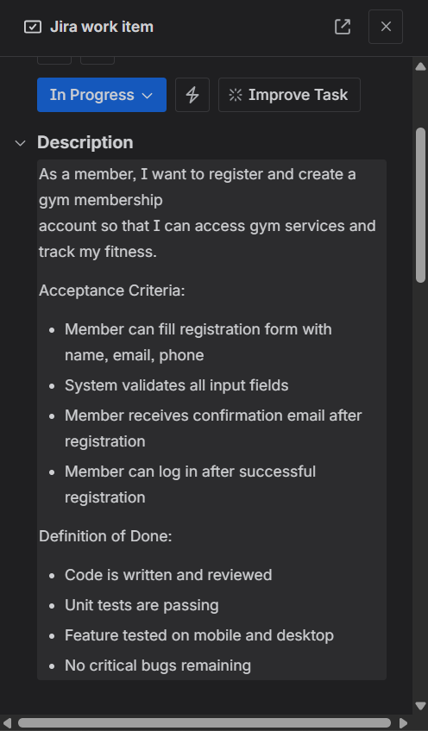
Figure 5: Detailed view of PROJ-6 showing the full user story description, acceptance criteria, and definition of done as documented in Jira

Comment on proj-6:
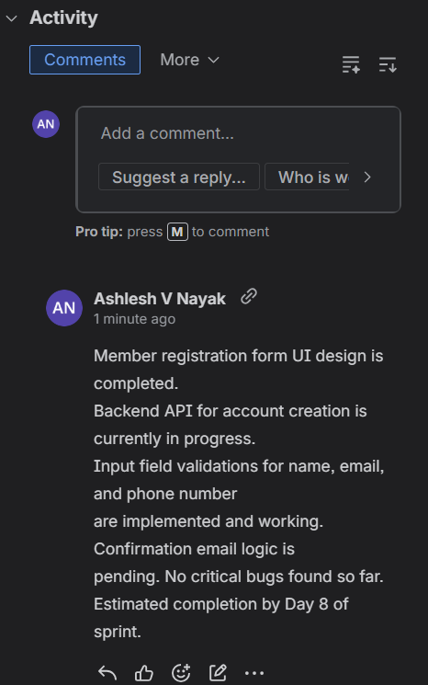
Figure 6: Comment on proj-6

6.4 Subtasks Breakdown
Big user stories are sometimes divided into small tasks. This is useful for allocating different developers to different tasks, for estimating the amount of effort required for a particular task, and for tracking detailed progress during a sprint. [2]
Subtask ID | Subtask Title | Status
PROJ-16 | Design registration form UI | TO DO
PROJ-17 | Build backend API for registration | TO DO
PROJ-18 | Implement email confirmation logic | TO DO
PROJ-19 | Write unit tests for registration module | TO DO
PROJ SUBTASKS:
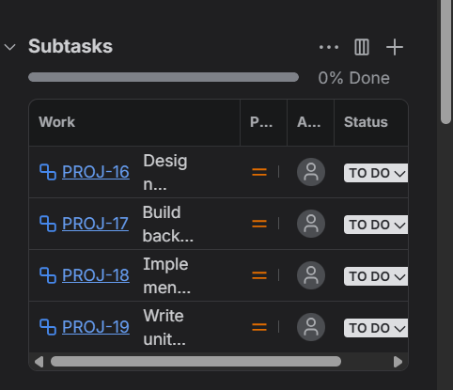
Figure 7: Subtask breakdown of PROJ-6 (Member Registration) into 4 individual development tasks (PROJ-16 to PROJ-19) demonstrating task-level sprint planning

7. How the Sprint Was Managed
However, managing a Scrum sprint is not just creating tasks and looking at them in a tool like Jira. Instead, it is a simple process that is repeated to keep all team members focused, organized, and aware of the goal of the sprint. To manage a Scrum sprint, communication is key, planning is essential, and tracking how tasks are moving is important so that all team members are aware of what is going on. A key part of Agile is creating software incrementally. In every cycle, a working part of a product is created, new features are added, and this cycle is repeated to keep improving and maintaining high quality.[1]

In this project, a Scrum sprint is managed, and a simple process is used. All parts of a Scrum cycle are watched to ensure that tasks are completed efficiently. A Scrum board in Jira is used, which helps track a workflow, so it is easy to know what is done, what is in progress, and what is still to be done.
In the next part, the step-by-step explanation of the Scrum sprint lifecycle is presented.

7.1 Step-by-Step Sprint Process
- Creating the Product Backlog: We have written all the 10 user stories and added them to the Jira backlog prior to planning the sprint. The Product Backlog needs to be ready prior to the start of the sprint. This is a principle of Scrum.[3]
- Figuring out what is important: We went through each user story and marked it as High, Medium, or Low based on how important it is for the system to work. The High ones are the ones we must do for the sprint. [2]
- Planning the Sprint: We took all the 10 user stories from the backlog and added them to the GMS Sprint 1. The sprint is for 2 weeks, from 29th March to 12th April 2026. This is the usual length for real Scrum sprints.
- Doing the work: As we work, we have moved tasks across the board. We started with the High priority backlog stories. The board looks like it is in the middle of the sprint: some done, some in progress, some waiting.
- Writing down the details: we documented all the details for one Product Backlog story: PROJ-6. This included what “done” means for the task and all the small details required for the task. We should do this for all high-priority Product Backlog stories when planning the sprint.[1][3]

7.2 Agile Concepts Demonstrated
Agile Concept | Where It Appears in This Project
Iterative Development | The work is done in 2-week sprints instead of trying to do everything at once.
User-Centric Design | Every task begins with a user story that focuses on the needs of the user, not the technical details.
Prioritization | Each user story is marked as High, Medium, or Low priority so the team knows where to start.
Transparency | The Jira board provides transparency into the sprint’s progress for everyone’s benefit.
Definition of Done | Clear criteria for PROJ-6 are established so there is no confusion about the completion of a feature.
Task Decomposition | PROJ-6 is decomposed into 4 sub-tasks to demonstrate how large a feature is compared to the work required to accomplish it.
[1][4][3][2]

7.3 Story Point Estimation - Fibonacci Scale

The amount of work and the level of complexity for a particular user story are estimated using story points. In the project, the Fibonacci sequence is used for story points. In the Fibonacci sequence, the numbers are 1, 2, 3, 5, 8, 13. The total capacity for GMS Sprint 1 is 52.

8. Jira Screenshots - Complete Set

These are the Jira screenshots from the sprint simulation. They demonstrate how the board was at different stages, from the setup of the backlog to moving the tasks across the board during the GMS Sprint 1.

Total of 8 screenshots were taken which include:
- Jira board full view
- Full backlog view
- Active Sprint Started
- Full board view
- proj 6 full detail page
- proj sub tasks
- sumjmary page
- comment on proj-6

Screenshot 1 – Jira Board(Full View)

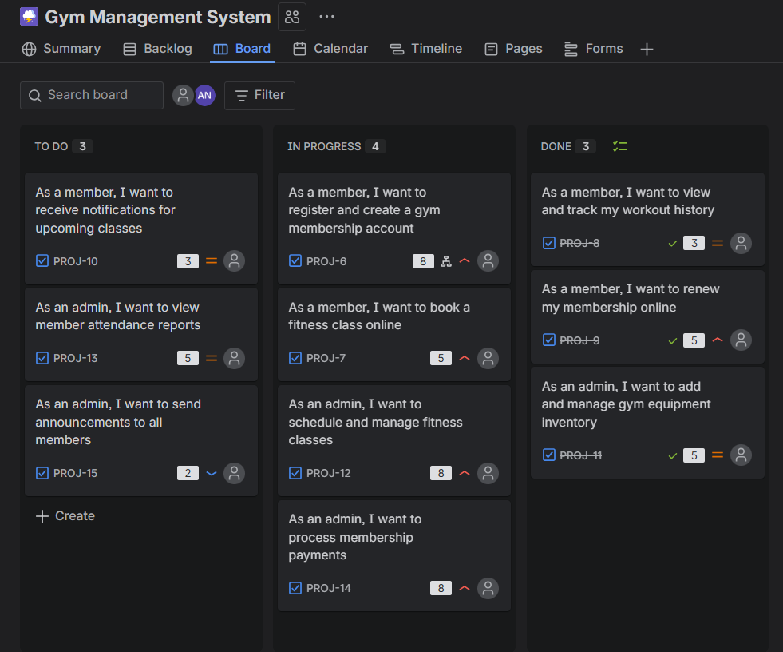

Screenshot 2- Backlog view



Screenshot 3 — Active Sprint Started
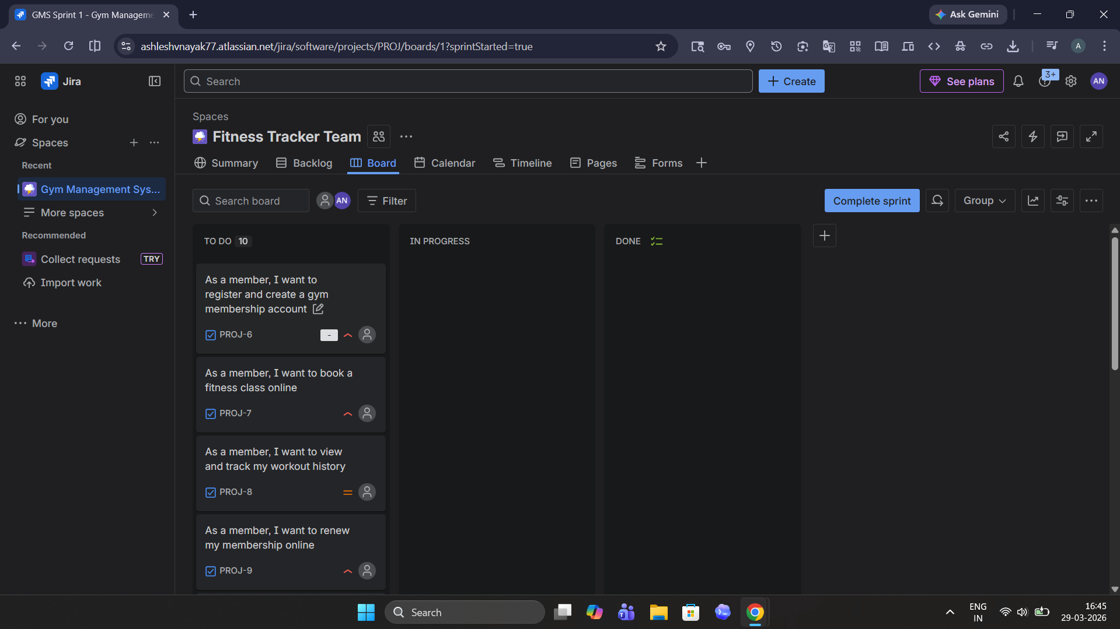

Screenshot 4- Full Board View

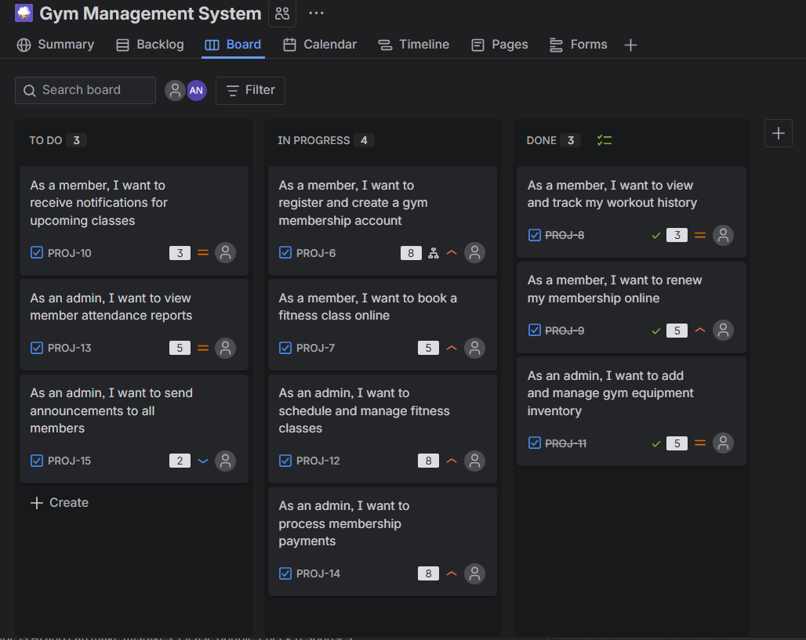

Screenshot 5- Proj 6 full detail page


Screenshot 6- Proj subtasks


Screenshot 7 – Summary page


Screenshot 8 - Comment on proj-6

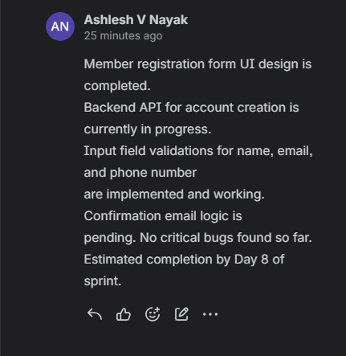

9. Conclusion
This project has demonstrated how Agile Scrum can be used in real-world software development using Jira as a tool. The Gym Management System was used as it is a real-world example of a system that everyone can understand. There are different types of users in a gym management system, such as members and administrators. This system has a number of functions, such as registration, management of members, attendance, and payment. This makes it an ideal system to use for a two-week sprint of moderate complexity.
The results of this project were how to write good user stories in Agile format. This involves writing user stories in a way where each feature of a system is considered from a user's perspective. The user stories were then ranked in order of business value using a high, medium, and low priority system. In addition, sprint progress was tracked using a Jira Scrum board. This allowed all team members to see how far each task was from being complete. A detailed user story was also documented, which included acceptance criteria and a detailed Definition of Done.[1][3]
The most important thing learned in this project was how Agile development differs from other methodologies. Agile development is not a toolset, such as Jira. Agile development is a mindset. This means using a mindset where you understand your users and what they need. This allows for better decision-making, team-building, and software development where you are focused on what your users need.[4]

If this project is to continue in the real world with a full team of developers, the next steps after this sprint will be:

- Sprint review, where the team will show the stakeholders the finished project.
- Sprint retrospective, where the team will evaluate what went well during the sprint and what didn't.
- Sprint planning for the next sprint, where the team will focus on the remaining tasks and new requirements for the second sprint.[3]

10. References
[1] Sommerville, I. (2016). Software Engineering, 9th Edition. Pearson Education. (Chapter 3: Agile Software Development)
[2] Atlassian. (2024). Jira Software Documentation. Available at: https://www.atlassian.com/software/jira
[3] Schwaber, K. and Sutherland, J. (2020). The Scrum Guide. Available at: https://scrumguides.org
[4] Agile Alliance. (2024). What is Agile? Available at: https://www.agilealliance.org/agile101

Declaration of Academic Integrity
I hereby declare that this assignment is my original work and has not been copied or plagiarized from any source. All references and resources used have been properly cited. Any ambiguities will lead to forfeiting my marks.
Student Signature:
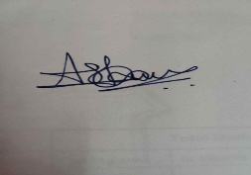
Date: 5th April 2026

