Final Project Notes and Info

* Maxpooling used to focus on brighter pixels (pixels in the dark background of space is less important).
* Convolutional neural networks apply a filter to an input to create a feature map that summarizes the presence of detected features in the input.
* Filters can be handcrafted, such as line detectors, but the innovation of convolutional neural networks is to learn the filters during training in the context of a specific prediction problem.
* Invariance preserves the identity of an object in an image. For instance, in this project as we crop and rotate the images of the galaxies, the CNN is supposed to observe that this altered image is meant to focus on a galaxy. <https://stats.stackexchange.com/questions/208936/what-is-translation-invariance-in-computer-vision-and-convolutional-neural-netwo>

Above link explains the different types of invariance that can occur for an image.

* Filters want to focus on a specific feature.
* 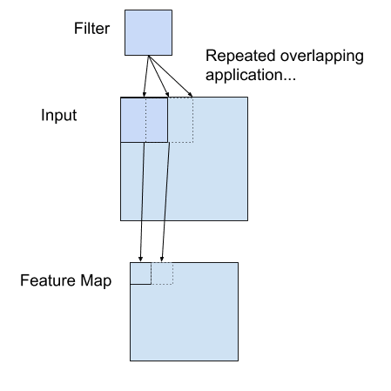
* The CNN will learn what types of features to extract from the input
* the network is forced to learn to extract features from the image that minimize the loss for the specific task the network is being trained to solve, e.g. extract features that are the most useful for classifying images as dogs or cats.
* 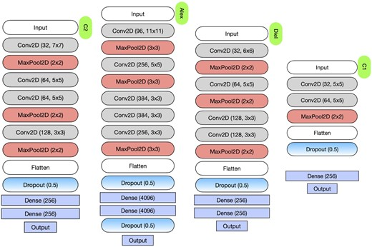
* Conv2D(32, 7X7).