CST 238

Puzzle 5: iPod

It’s your senior year in CSET and you’re broke like most college students. You remedy this by becoming a tutor for C++ Programming II.

A student, ZoëKravitz, asked you for help with her final project...which is an mp3 player (as you remember). You think this will be a piece of cake until you realize she built a full-on GUI on top of the project. The app was working, but now it’s just broken and the IDE (Qt Creator) she is using has no debugger (i.e. it actually does…no one set it up correctly in PV 228, though!).

You don’t mind helping, but you absolutely cannot stand screamo. You wish to help her with her program as quickly as possible since her playlist is nothing but Dance Gavin Dance songs (i.e. she says the band saved her life, so you don’t be rude and mute the volume).

To do:

1. ~~Get play button to work (hint: use console.log() to find the appropriate mouse area of the button).~~
2. ~~Make sure pause button works in that the button toggles between play and pause (hint: use song_current.pause()). Text on screen should reflect whether or not song is playing or paused.~~
3. ~~Get back and forward buttons working (i.e. should switch and automatically play the next or previous song).~~
4. ~~Make sure playlist cannot go out of bounds (i.e. back button should not do anything if zero or less, forward button should not do anything if greater than or equal to the number of songs in the playlist).~~
5. Make sure when band and song are playing, the text is reflected on the screen. See pic below for an example of what it’s supposed to look like.

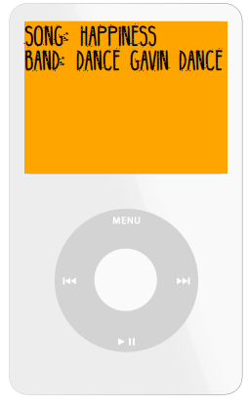

Extra Credit:

1. Create a slider that adjusts the volume.
2. Word wrap the songs to fit on screen.
3. Make song info on screen move as a marquee.
4. Show duration of song as it plays.
5. Actually create a menu that can display and list all songs.