Raw file:
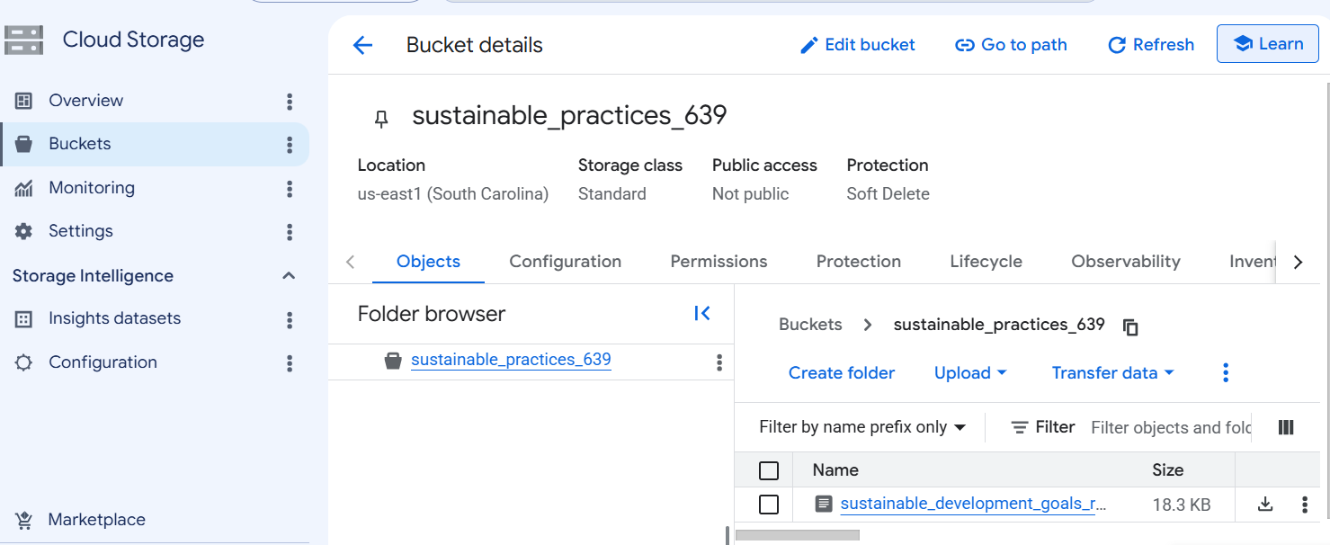
gcloud dataproc clusters create rag-cluster \
--region=us-central1 \
--single-node
gcloud dataproc jobs submit pyspark gcs_to_bq_preprocess.py \
--cluster=rag-cluster \
--region=us-central1
Dataproc job:
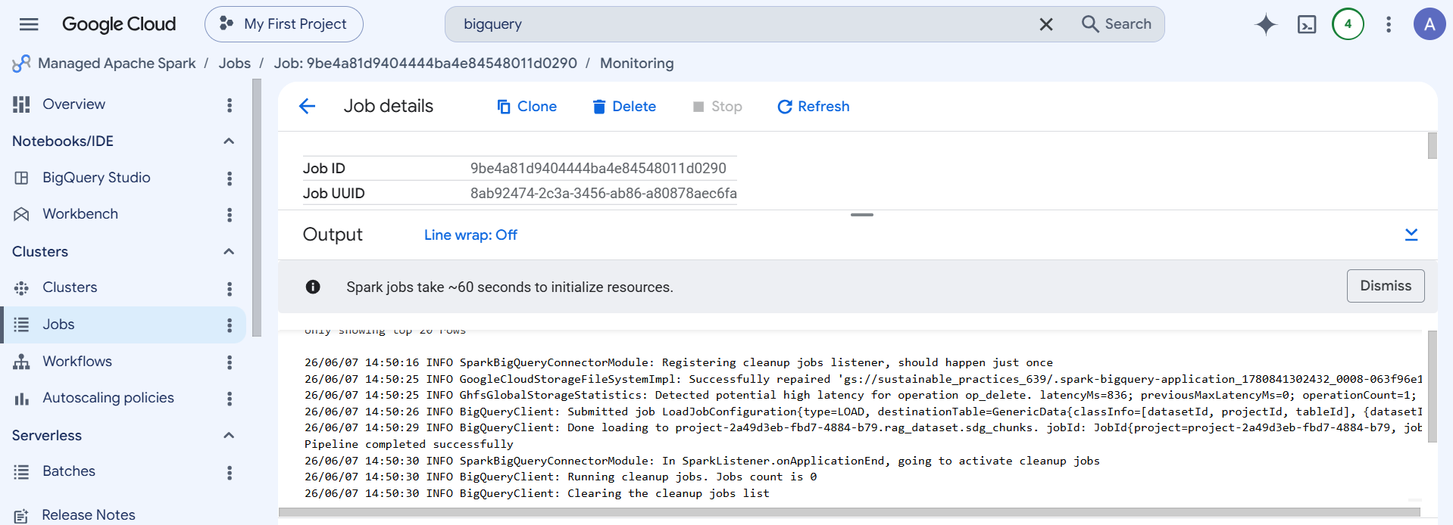

Transformed data ingested to Bigquery:
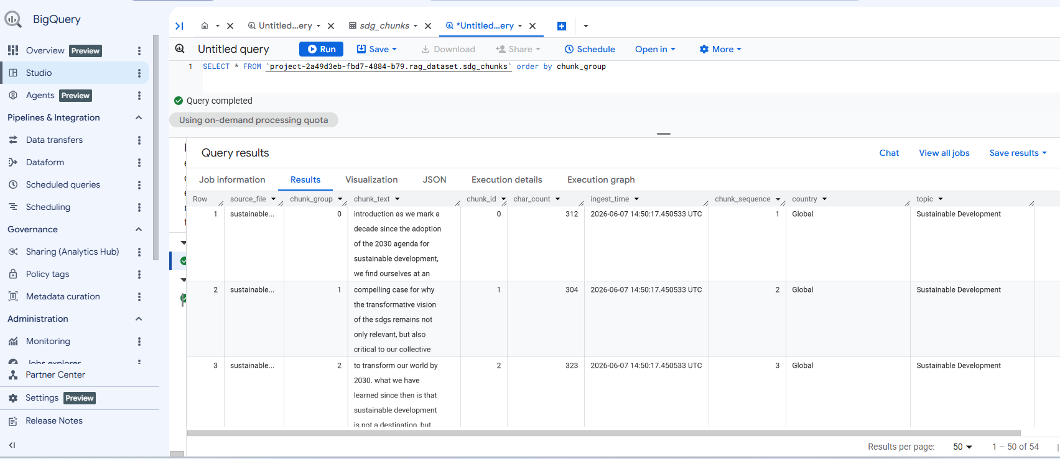

4. Create agent platform ai workbench instance:
