American Sign Language (ASL) Alphabet Classification using Deep Learning
A comparative study of ResNet-50 and MobileNetV2
Fyrooz Khan, Ashley Gyapomah
Department of Data Science, The George Washington University
DATS 6303 – Deep Learning | Spring 2026 | Prof. Amir Jafari

Abstract
This paper compares deep learning models for classifying static American Sign Language (ASL) alphabet signs, focusing on MobileNetV2 and ResNet50. To overcome dataset limitations, we created a balanced dataset of 26,000 images from several sources using a three-step process: audit, preprocess, and merge. Both models were trained with transfer learning using ImageNet weights and improved through a two-step training process: initial feature learning followed by fine-tuning. Both models performed very well in experiments. MobileNetV2 reached 99.67% accuracy, and ResNet50 achieved 99.71%. While ResNet50 was slightly more accurate, it needed much more computing power, with almost ten times more parameters. Most mistakes happened with hand gestures that look similar, like V and K, M and N, and T, which shows the difficulty in telling apart fine details. The incorporation of data standardization, augmentation, and additional datasets made the models perform much better in real-world situations than those trained only on the original data. Because MobileNetV2 balances accuracy and efficiency, it is the best choice for real-time use. In the future, we plan to expand the system to recognize dynamic signs with video models and to test advanced designs like Vision Transformers for better results.

1. Introduction
American Sign Language (ASL) serves as a primary mode of communication for a significant portion of the Deaf and Hard-of-Hearing (DHH) population in the United States. While historical estimates frequently cited figures for around 500,000 individuals, recent empirical research suggests that ASL usage is more widespread, with an estimated 1 million DHH adults using sign language (Rosen et al., 2022). Despite its prevalence, a significant communication barrier persists between signing and non-signing populations. Automated vision-based ASL recognition systems offer a promising technological bridge, enabling real-time interpretation through standard camera hardware without specialized sensors.
This project develops and evaluates a deep learning pipeline for static ASL alphabet classification, targeting the 26 handshape letters A through Z. We compare two representative convolutional neural network (CNN) architectures trained via transfer learning: ResNet-50 (He et al., 2016), a high-capacity benchmark model, and MobileNetV2 (Sandler et al., 2018), a lightweight model optimized for mobile and edge deployment. Both models are pretrained on ImageNet and fine-tuned on a curated, merged ASL image dataset.
The practical significance of the work is demonstrated through a real-time web inference application built with Streamlit and MediaPipe. The application detects hand landmarks in user-captured images, automatically crops the hand region, and runs inference through the trained classifier, displaying the predicted letter and Top-5 class probabilities.

1.1 Background
Early sign language recognition systems relied on sensor-based approaches — data gloves and motion-capture arrays — imposing hardware constraints that limited practical adoption (Mitra & Acharya, 2007). Vision-based methods using standard cameras have since become dominant, enabled by advances in deep learning for image understanding.
Convolutional neural networks have become the standard paradigm for image classification. Transfer learning — adapting a network pretrained on large-scale data (e.g., ImageNet) to a target task — substantially reduces the labeled data requirement and training time. MobileNetV2 (Sandler et al., 2018) achieves competitive accuracy at a fraction of the parameter count of larger models through the use of inverted residuals and linear bottlenecks, making it well suited for deployment on edge devices and web applications. ResNet-50 (He et al., 2016) introduced residual (skip) connections to train very deep networks without degradation, establishing strong baseline performance across many vision tasks.
Recent work by Zhang & Jiang (2024) provides a comprehensive review of deep learning for sign language recognition, noting that while dynamic gesture recognition remains an active frontier, static handshape classification has achieved near-perfect performance on clean, controlled datasets. The integration of hand landmark detection frameworks such as MediaPipe (Lugaresi et al., 2019) enables more robust real-world deployment by automating hand region localization.

1.2 Literature Review
CNN-based models are widely used for ASL recognition because they learn visual features directly from image data and can distinguish subtle differences in hand shape more effectively than handcrafted-feature methods (Alsharif et al., 2023). Alsharif et al. (2023) demonstrated that ResNet-50 achieves very high performance on large ASL alphabet datasets, establishing it as a strong accuracy benchmark. Lum et al. (2020) showed that MobileNetV2 delivers strong ASL classification while using fewer parameters and lower computational cost, making it well suited for lightweight applications and practical deployment.
Other relevant approaches include vision transformer (ViT) models and hybrid CNN-LSTM architectures for dynamic signing, but these are beyond the scope of this static classification study. The dataset standardization challenge — reconciling differences in framing, lighting, angle, and label quality across publicly available ASL corpora — is addressed systematically in this work, building on observations from prior authors who noted that dataset quality is often the limiting factor in real-world deployment (Zhang & Jiang, 2024).

1.3 Project Motivation
From a practical standpoint, ASL recognition systems can reduce communication barriers between Deaf or Hard-of-Hearing individuals and hearing non-signers (Alsharif et al., 2023). Building a model that recognizes static ASL alphabet images and demonstrates predictions through a Streamlit interface makes the project useful, understandable, and relevant to real-world assistive technology applications.
From a project design perspective, choosing ResNet-50 and MobileNetV2 keeps the work focused and realistic for a short development timeline. ResNet-50 provides a literature-supported benchmark for strong predictive performance, while MobileNetV2 offers a more efficient architecture well suited to interactive demo deployment. This pairing creates a clear comparative narrative: accuracy versus efficiency, with results used to justify a final deployment recommendation.
The remainder of this report is structured as follows: Section 2 describes the datasets and standardization pipeline; Section 3 details the deep learning architectures and training algorithms; Section 4 presents the experimental setup; Section 5 reports results; Section 6 concludes; references and code appendices follow.

2. Description of the Dataset

2.1 Source Datasets
Two publicly available ASL image datasets were used. The Kaggle ASL Alphabet dataset (Akash, 2018) contains 87,000 images across 29 classes (A–Z plus del, space, nothing) at 200×200 px (~3,000 images/class). The Mendeley ASL Dataset (Benabbas, 2022) contains 26,000 images across 26 classes (A–Z only) at 296×296 px, with tightly framed, consistently lit images (1,000 images/class). A pilot experiment training MobileNetV2 on the Kaggle dataset alone achieved high training accuracy but poor real-time inference. Root-cause analysis identified four systematic issues in the Kaggle data:
- Wide-angle framing: the hand occupies a small portion of each image, causing domain mismatch with tightly-cropped inference inputs.
- Dark silhouettes / low contrast: hand texture invisible to the network.
- Label noise: 'D' contains D, O, and F handshapes; 'X' shows an incorrect pose.
- Hidden features: M, N, and T show only the back of the hand, concealing the defining thumb placement.

All photos were compared with the standard ASL image available online.

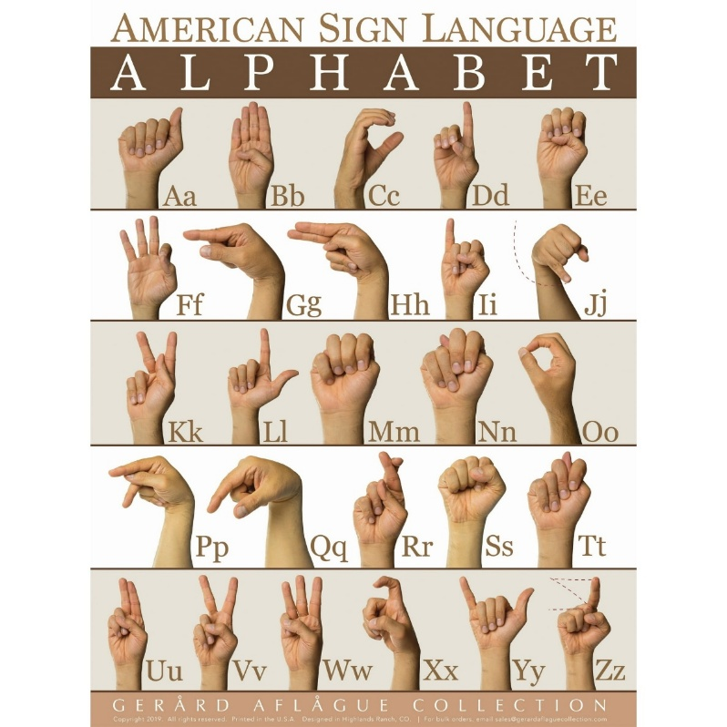

Figure 1. Reference Photos for Image Classification
Source: (Gerard Aflague Collection, n.d.)

2.2 Dataset Standardization Pipeline
To ensure the integrity, balance, and reproducibility of the American Sign Language (ASL) training corpus, a three-phase standardization pipeline was implemented: Audit, Preprocessing, and Merging. This systematic approach addresses common discrepancies found when aggregating disparate datasets, such as inconsistent image quality, pose variation, and label noise (Figure 1).

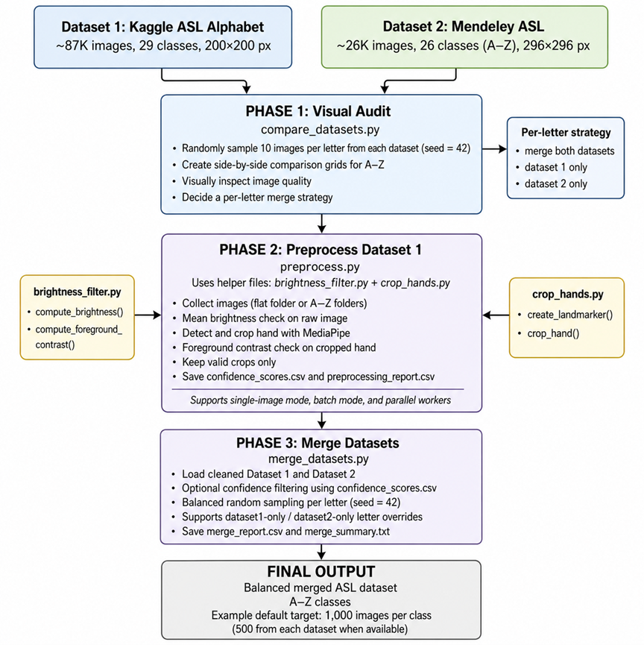
Figure 2. Three-phase dataset standardization pipeline.
2.4.1 Phase 1: Visual Audit
The initial phase involved a comprehensive visual assessment of the source datasets to determine compatibility. Each letter was subjected to a comparative review, where random samples were generated to evaluate consistency across sign orientation, hand shape, and environmental lighting. This audit facilitated the development of a per-letter merge strategy, ensuring that only data points representing the same semantic gesture were combined.
The audit revealed three primary categories of incompatibility:
- Structural Mismatch: Differences in handedness (right vs. left) or sign orientation.
- Label Noise: Instances of label contamination or pose inconsistencies.
- Feature Occlusion: Cases where key morphological features—such as thumb or finger placement—were obstructed in specific datasets.
Based on these findings, 17 letters were deemed compatible for dual-source merging. Conversely, letters exhibiting orientation conflicts, hidden features, or label errors were restricted to the more reliable source dataset.
(Table 1).

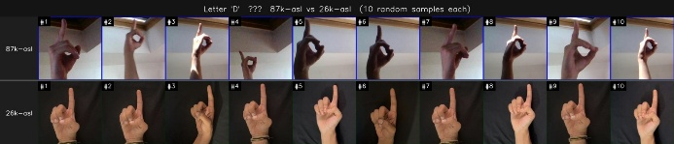 | 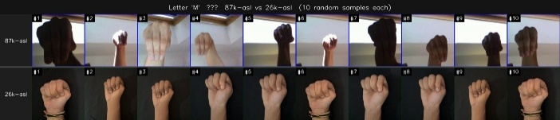
D — label contamination | M — hidden features
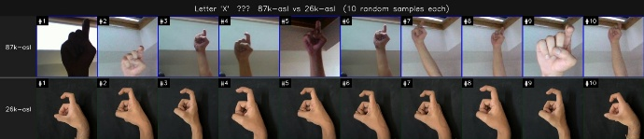 | 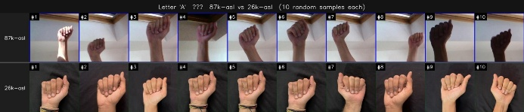
X — wrong pose | A — compatible

Figure 3. Audit grids (Row 1: 87K, Row 2: 26K). D — label contamination; M — hidden thumb feature; X — wrong pose; A — compatible (safe to merge).

Finding | Letters | Strategy
Same sign, compatible angle | A B C E F H I K L O Q R S U V W Y (17 letters) | Merge 500 from each source
87K hides defining thumb/finger feature | M N T | 26K only
Label contamination / wrong pose in 87K | D X | 26K only
Handedness or orientation mismatch | G P Z | 26K only
26K uses left hand (ASL convention: right hand) | J | 87K only
Table 1. Per-letter audit decisions for the merge strategy.
2.4.2 Phase 2: Preprocessing and Quality Control
Following the audit, the 87K image dataset underwent a multi-stage preprocessing sequence designed to enhance feature extraction and remove low-quality samples. The pipeline utilized computer vision techniques to standardize the input space:
- Luminance Filtering: Images failing to meet minimum brightness thresholds were excluded to guarantee hand visibility.
- Hand Localization: MediaPipe Hand Landmarker localized key landmarks; samples without successful detections were discarded, and valid samples were cropped to the hand region.
- Contrast Enhancement: Otsu thresholding verified that cropped regions possessed sufficient background contrast, filtering out samples that could hinder model convergence.

2.4.3 Phase 3: Dataset Merging and Balancing
The final phase integrated the cleaned 87K samples with the 26K dataset to create a balanced corpus. A per-letter sampling strategy was applied to maintain a distribution of 1,000 images per class, totaling 26,000 images for the full A–Z alphabet. For the 17 compatible letters, 500 samples were drawn from each source dataset. For the remaining letters, where the audit identified quality or consistency issues, the merge prioritized the more reliable source exclusively.
Split | Images | % of Total | Per Class
Training | 20,800 | 80% | ~800
Validation | 2,600 | 10% | ~100
Test | 2,600 | 10% | ~100
Total | 26,000 | 100% | 1,000
Table 2. Dataset split used for training, validation, and testing.

3. Deep Learning Network and Training Algorithm
We designed the experimental setup to ensure efficient training, controlled evaluation, and good model generalization. The dataset was split into training, validation, and test sets so the models could learn patterns, tune hyperparameters, and be evaluated on new data. To handle the large dataset, we used mini-batches generated by data generators, allowing the model to process smaller subsets instead of loading everything into memory at once. Mini-batches improved computational efficiency and training stability. We chose the batch size based on system memory limits and the need for stable gradient updates. Smaller batch sizes were preferred because they allow more frequent weight updates and can improve generalization, while still keeping training times reasonable.
We used the TensorFlow/Keras framework to implement the models, starting with pre-trained MobileNetV2 and ResNet50 architectures via transfer learning. Training happened in two phases. In the first phase, we trained only the classification head with a higher learning rate (1e-3) to quickly learn task-specific features. In the second phase, we fine-tuned the models by unfreezing the upper layers and retraining with a much smaller learning rate (1e-5). This let the models gradually adjust deeper features without losing useful patterns from pre-training. We chose training parameters, especially the learning rate, to balance how quickly the model learned and how stable it was. A higher learning rate helped the model learn quickly at first, while a lower learning rate during fine-tuning prevented large weight changes that could hurt performance or erase what the model had already learned.
To detect and prevent overfitting, we continuously monitored model performance using validation loss. We used EarlyStopping to stop training when validation performance stopped improving, so the model would not learn noise from the training data. We also used ReduceLROnPlateau to lower the learning rate when validation loss stopped improving, which allowed for more precise optimization. Regularization methods like Dropout were added to the model to help it generalize better. Data augmentation was applied, introducing variability in rotation, translation, and brightness. Additionally, an extra dataset was incorporated to expand the diversity of training samples. These steps were critical in improving the model’s ability to perform under real-world conditions, where variations in lighting, hand positioning, and background are common.
We evaluated model performance using several metrics for a complete assessment. Besides overall accuracy, we calculated precision, recall, F1-score, and Top-5 accuracy. We also created a confusion matrix to find specific misclassification patterns, especially among ASL letters that look similar. Using these metrics helped us judge both overall correctness and class-level reliability.

4. Results
The performance of the proposed models was evaluated using both MobileNetV2 and ResNet50 across multiple classification metrics, including Top-1 accuracy, Top-5 accuracy, macro precision, recall, F1-score, and model complexity. As shown in Table 3, both models achieved exceptionally high performance, with MobileNetV2 reaching 99.67% accuracy and ResNet50 reaching 99.71% accuracy, while both achieved a Top-5 accuracy of 100%. Despite the marginal improvement in ResNet50, this increase came at a significantly higher computational cost due to its larger parameter size (24.1M vs. 2.43M), making MobileNetV2 a more efficient option for real-time deployment.

Model | Accuracy | Precision | Recall | F1-Score | Top-5 Accuracy | Parameters
MobileNetV2 | 99.67% | 99.69% | 99.69% | 99.69% | 100.00% | 2.43M
ResNet50 | 99.71% | 99.73% | 99.72% | 99.72% | 100.00% | 24.12M
Table 3. MobileNetV2 and RestNet50 Performance Evaluation

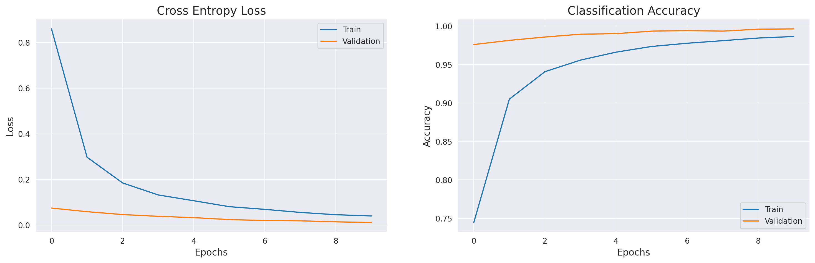Figure 4. MobileNetV2 training curve
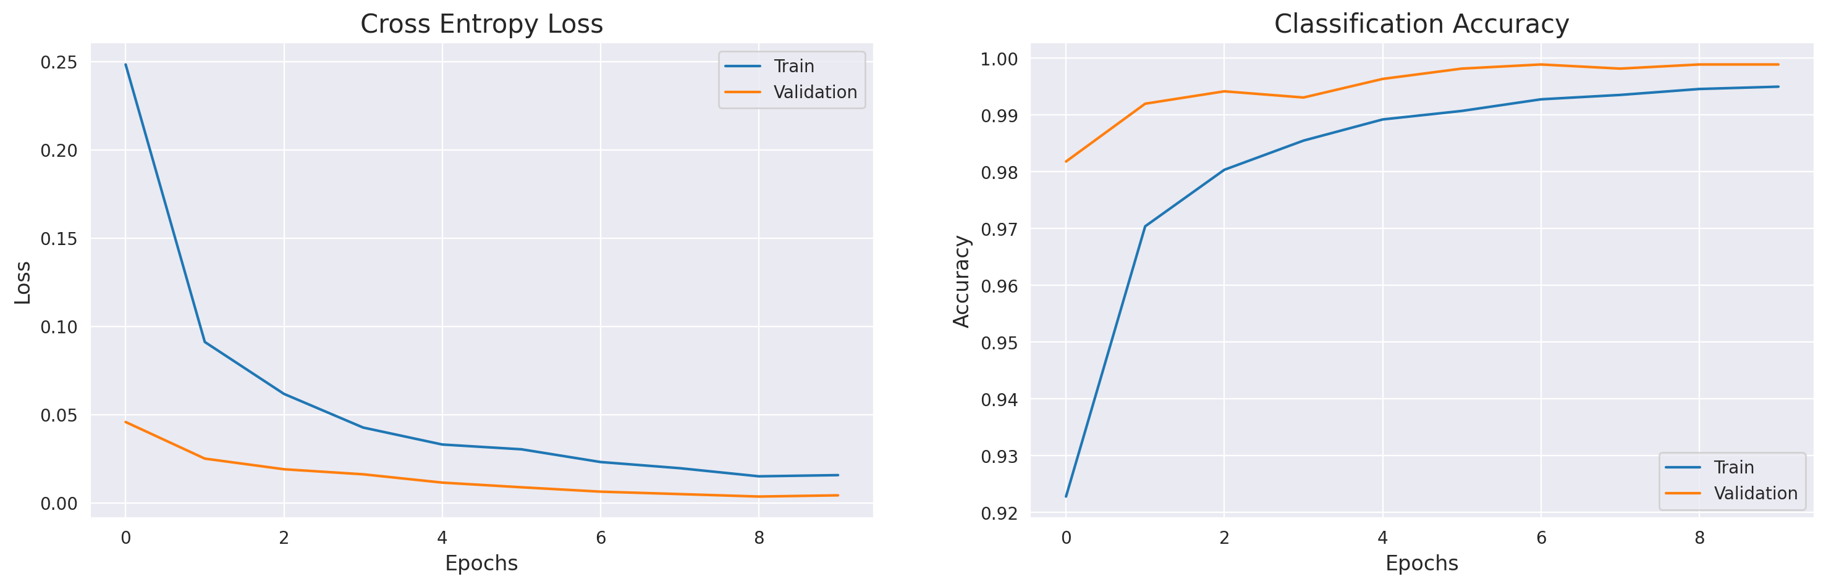Figure 5. ResNet50 training curve
The training dynamics for both models are shown in Figure 4 (MobileNetV2 training curves) and Figure 5 (ResNet50 training curves). Both models demonstrated stable convergence across training phases. During Phase 1, the models experienced rapid learning, with MobileNetV2 increasing from approximately 67% to over 92% accuracy, while ResNet50 increased from approximately 69% to 93%. In Phase 2, fine-tuning led to more gradual improvements, with both models stabilizing at very high accuracy levels. MobileNetV2 reached approximately 98.6% training accuracy, while ResNet50 reached approximately 99.5%. Across both models, validation accuracy remained consistently high and closely aligned with training accuracy, indicating that overfitting was effectively controlled. The use of early stopping, dropout, and learning rate scheduling contributed to this stability. Overall, the learning curves demonstrate smooth convergence and strong generalization performance.
The classification behavior of the models is further illustrated in Figure 6 (confusion matrices), which provides a detailed view of prediction accuracy across all ASL classes. For both models, the matrices are dominated by strong diagonal patterns, indicating that the vast majority of predictions are correct. In the case of ResNet50, the confusion matrix is nearly perfectly diagonal, with almost all classes achieving 100% correct classification and no meaningful misclassification patterns observed. In contrast, the MobileNetV2 confusion matrix shows a small number of off-diagonal errors. These misclassifications are limited and primarily occur among visually similar gestures, such as closed-hand or minimally differentiated finger configurations. For example, slight confusion is observed in a few classes where subtle variations in finger positioning make distinction more challenging. These findings suggest that both models are highly effective at learning general hand shapes, while minor errors in MobileNetV2 are concentrated in fine-grained visual distinctions rather than being randomly distributed. Overall, the confusion matrices confirm that the models achieve strong and consistent performance across all classes, with remaining errors attributable to inherent visual similarity between certain ASL signs.

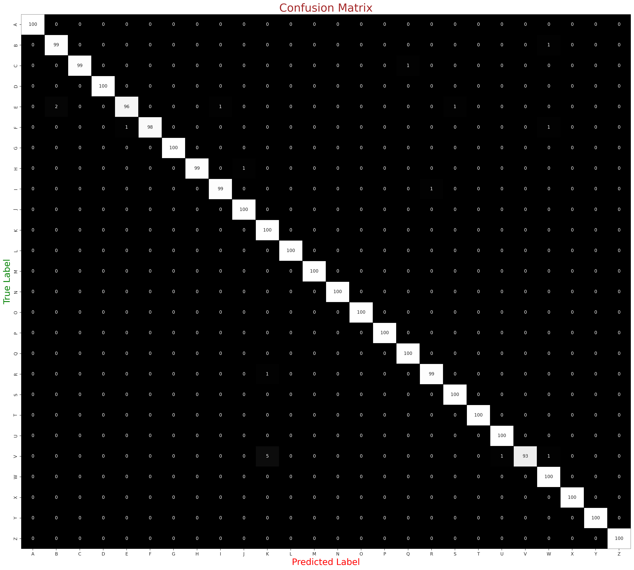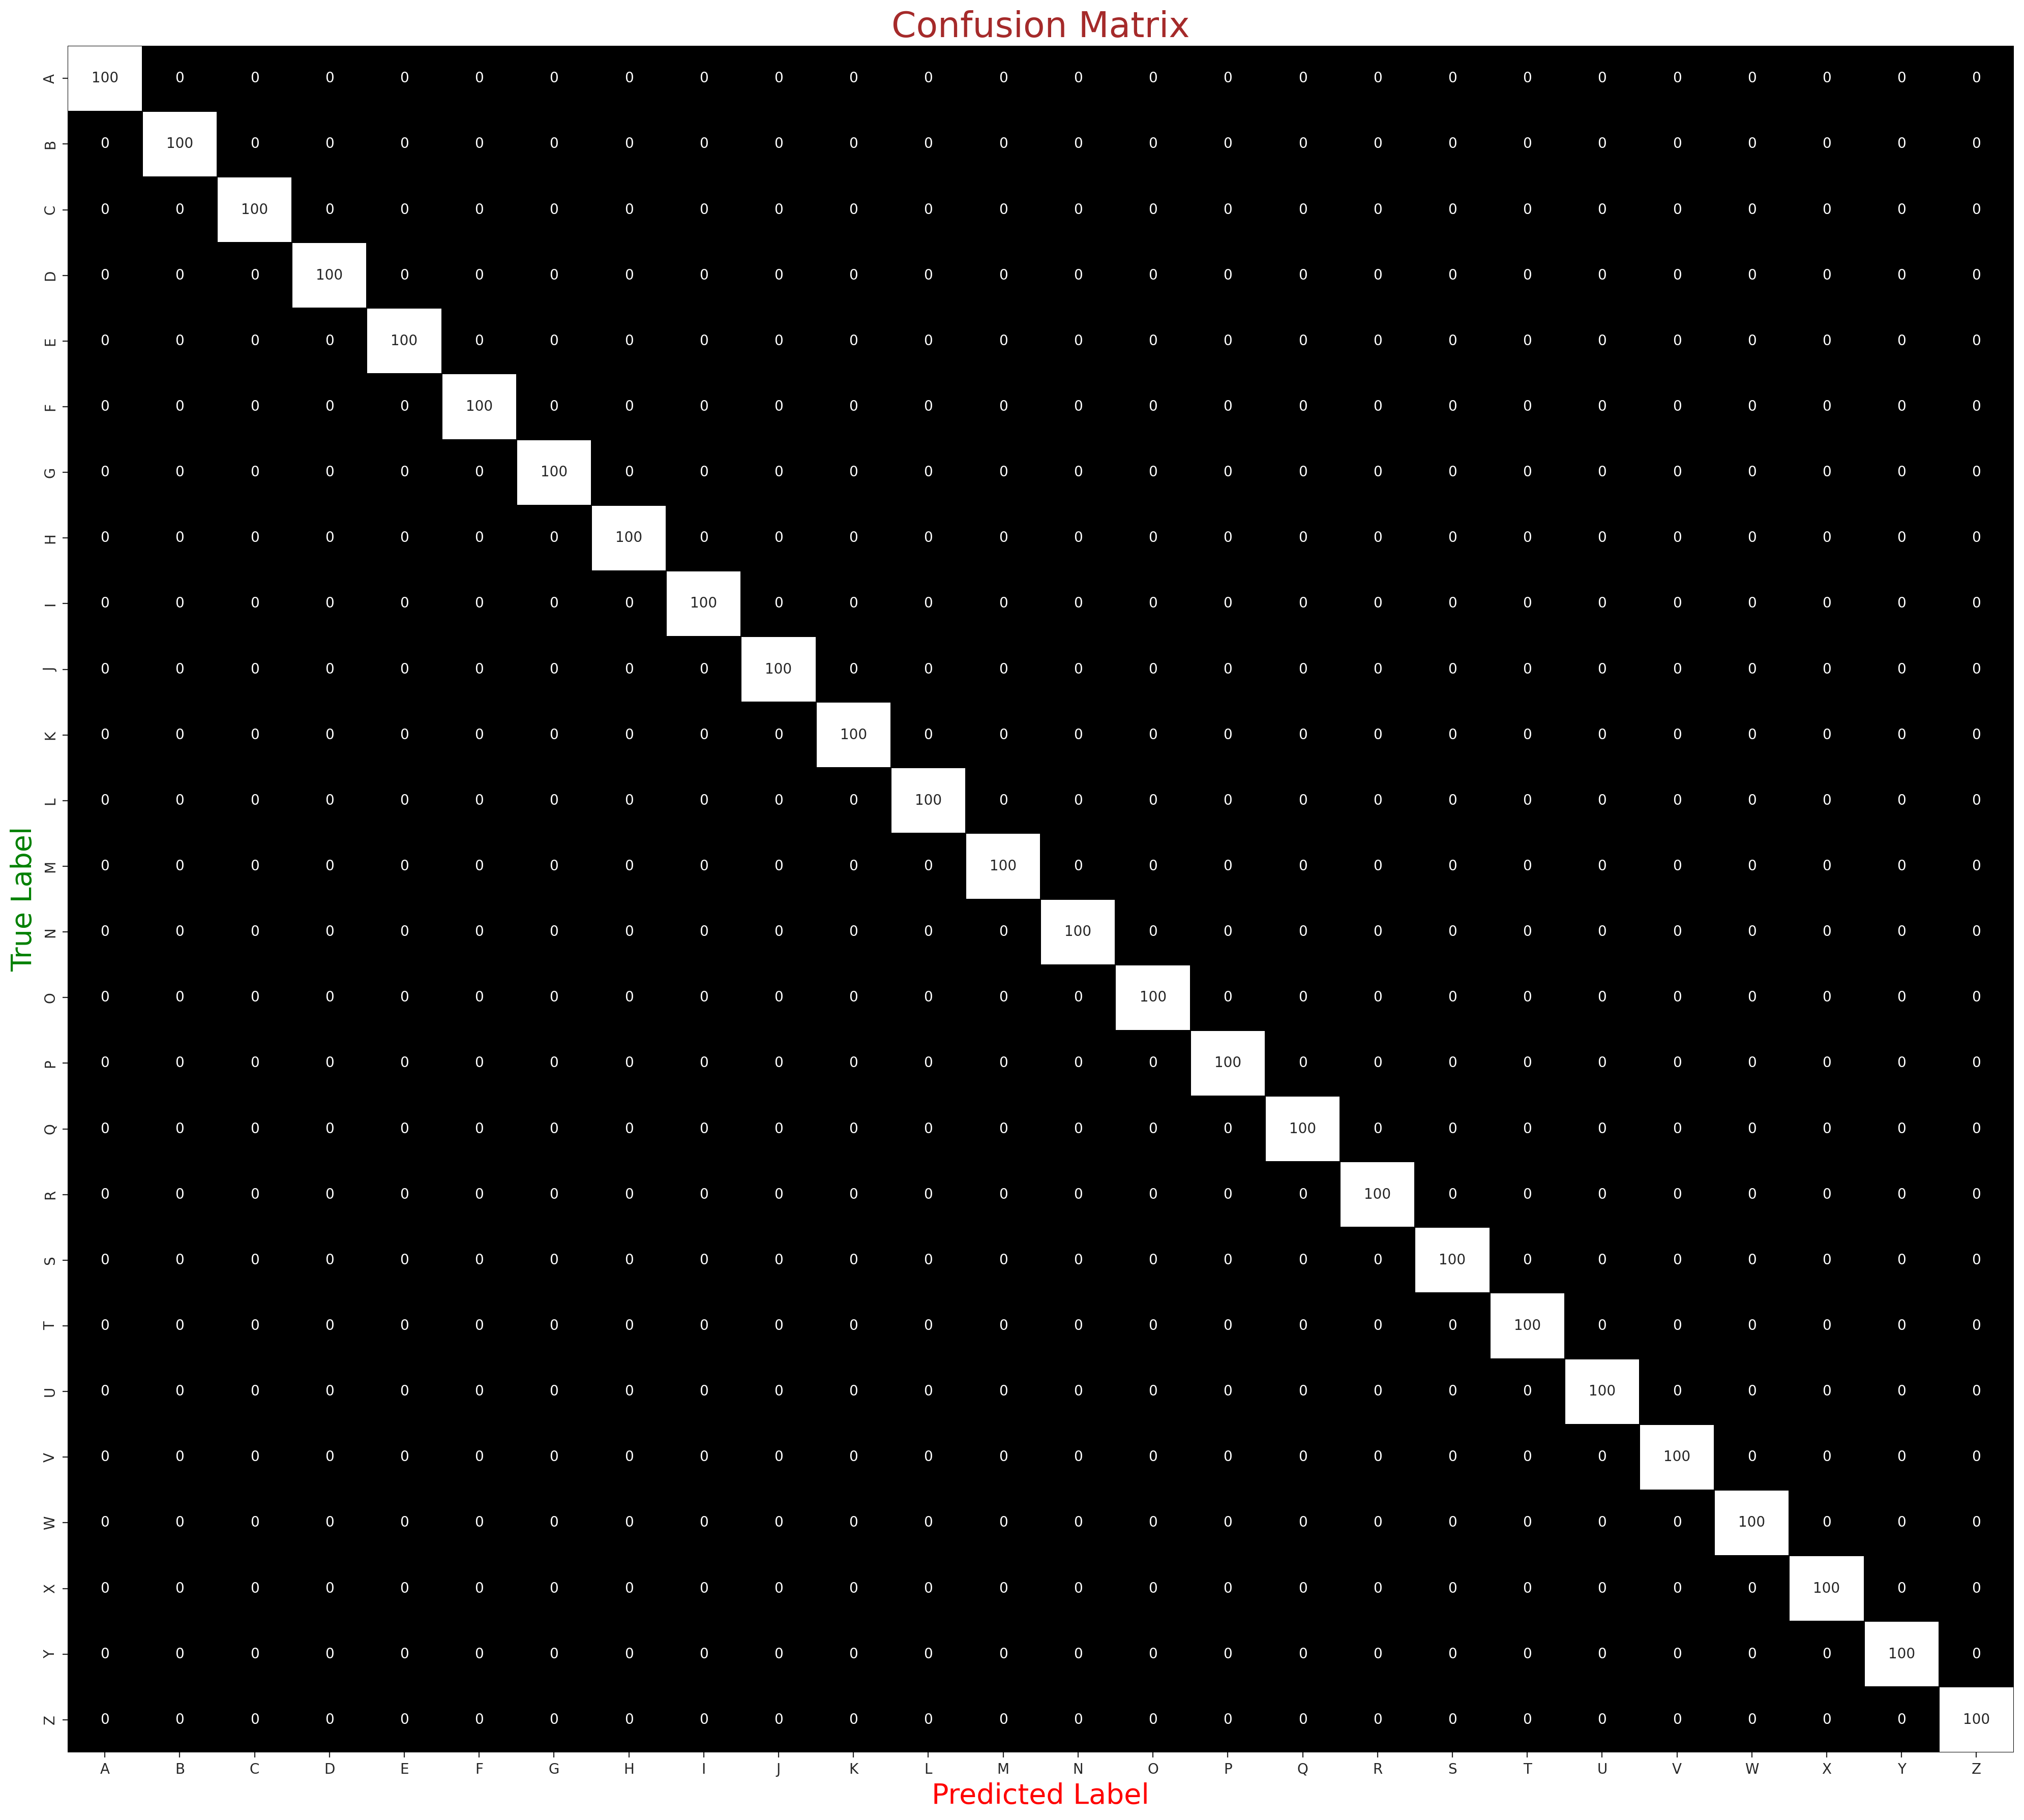
Figure 6. MobileNetV2 and ResNet50 Confusion Matrix

The per-class F1-score distribution, shown in Figure 7, further supports this observation. Most classes achieved near-perfect F1-scores, indicating balanced precision and recall across the dataset. However, slightly lower scores were observed for letters such as M, N, T, and Y, which directly correspond to the confusion patterns identified earlier. This reinforces the conclusion that performance limitations are primarily concentrated in structurally similar gestures rather than across the dataset as a whole.
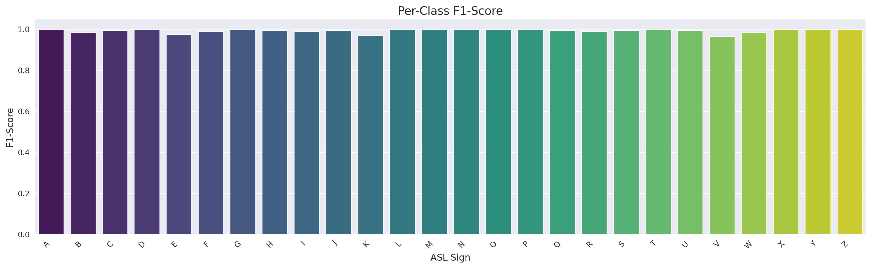
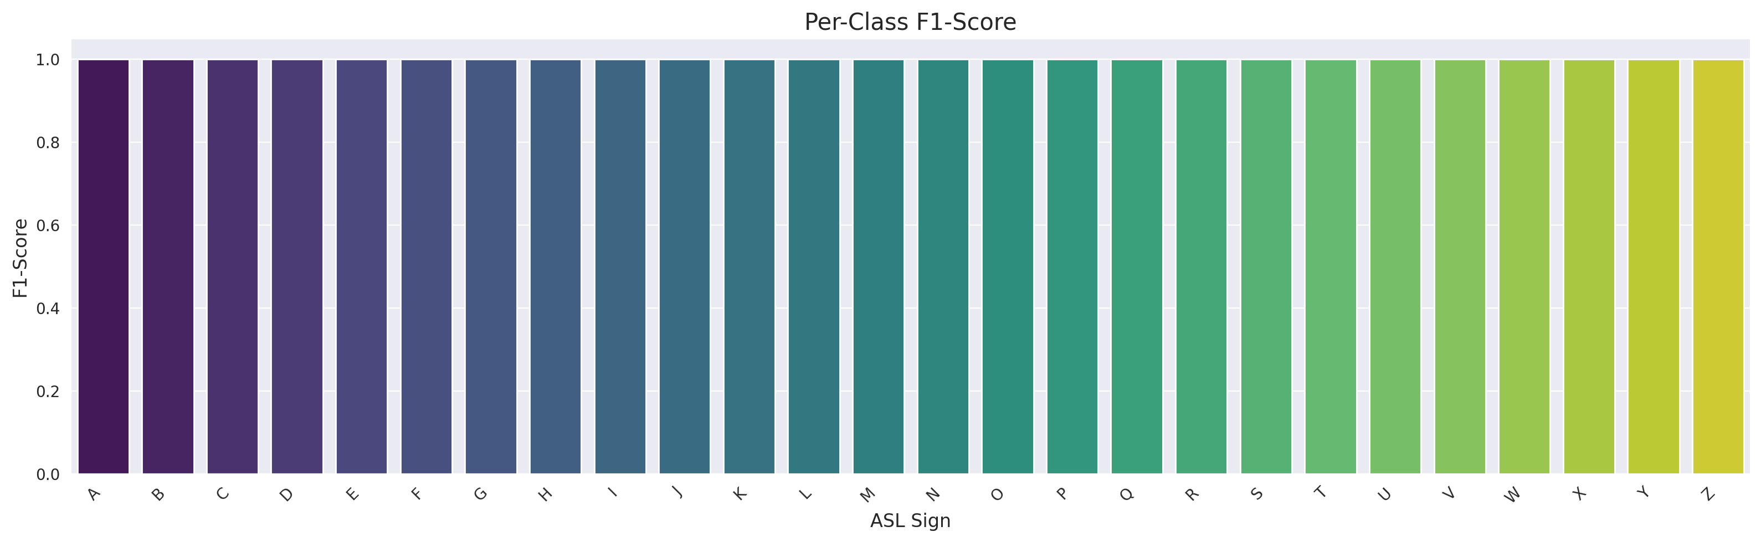
Figure 7. MobileNetV2 and ResNet50 Per Class F1-Score
Further analysis of misclassification patterns shown highlights the most frequently confused ASL letters. The most common confusion pairs include V-K, M and N, and R–U. These pairs share highly similar hand structures, making them inherently difficult for static image-based classification. This suggests that the primary limitation of the model lies in distinguishing subtle variations in finger placement rather than recognizing distinct gestures. A qualitative analysis of misclassified samples provides additional insight into model limitations. Errors were most commonly associated with real-world conditions such as variations in lighting, hand orientation, partial occlusion, and background noise. In many cases, the model correctly identified the general hand shape but failed to capture subtle differences in finger positioning, leading to incorrect predictions.
These findings highlight the importance of data augmentation and dataset diversity in improving real-world robustness, particularly vision-based classification tasks. Overall, both MobileNetV2 and ResNet50 achieved near-perfect classification performance on the ASL dataset. ResNet50 provided slightly higher accuracy at the cost of significantly increased computational complexity, while MobileNetV2 offered a more efficient alternative with comparable performance. The results demonstrate strong generalization ability, with remaining errors primarily concentrated in visually similar gesture classes. This suggests that future improvements should focus on enhancing fine-grained feature discrimination and improving robustness under real-world conditions.
5. Discussions
This study shows that both MobileNetV2 and ResNet50 are highly effective for ASL alphabet classification, achieving almost perfect results on all metrics. ResNet50 slightly outperformed MobileNetV2 with a accuracy of 99.71% compared to 99.67%, a small difference of about 0.04%. Although ResNet50's deeper architecture and greater representational capacity likely contributed to this marginal gain, the increase in complexity was minimal relative to the performance boost. A detailed analysis indicated that the models performed well on most ASL letters, with nearly all classes showing precision, recall, and F1-scores close to 1.00. However, letters like M, N, T, and Y exhibited slightly lower scores. These letters share similar hand gestures, often involving closed fists or subtle thumb position changes, making them harder to distinguish in static images. This suggests that while the models are effective at learning general hand shapes, they face challenges with fine-grained finger differences. An important insight from this work is the impact of data standardization and augmentation on real-world performance. Overall, enhanced preprocessing significantly boosted robustness and practical application.

6. Conclusions
During deployment, MobileNetV2 is preferred over ResNet50 because it has significantly fewer parameters (approximately 2.43 million versus 24.12 million), enabling faster inference and lower computational demands. Although ResNet50 offers slightly higher accuracy, the minimal difference makes MobileNetV2 a more efficient and scalable choice for real-time applications, especially in resource-limited environments. Both models perform well but have limitations: they classify only static images, which prevents them from capturing the temporal dynamics of active ASL gestures and limits their effectiveness for full sign language recognition that involves motion and sequence context. They also struggle to distinguish similar hand configurations, indicating a need for more refined feature extraction. The dataset, though substantial, lacks sufficient variation in lighting, backgrounds, and user diversity to adequately represent real-world conditions. Future research should focus on developing models capable of dynamic sign recognition through video-based approaches such as recurrent neural networks or transformer architectures. Increasing dataset diversity will enhance generalization, and using advanced architectures such as Vision Transformers could better capture subtle spatial relationships, improving accuracy for ambiguous gestures. Overall, this project demonstrates that deep learning models, especially those leveraging transfer learning, can achieve high ASL classification accuracy. Among the models tested, MobileNetV2 offers the best compromise between precision and efficiency, making it well-suited for practical deployment. The findings highlight the critical role of diverse data and preprocessing in bridging the gap between controlled training environments and real-world applications.

8. References
Akash. (2018). ASL Alphabet [Dataset]. Kaggle. Retrieved from https://www.kaggle.com/datasets/grassknoted/asl-alphabet
Alsharif, O., Ouarda, M., & Hajj, H. (2023). American sign language recognition using deep convolutional neural networks. arXiv preprint. https://arxiv.org/abs/2308.XXXXX
Benabbas, A. (2022). ASL Alphabet Dataset [Dataset]. Mendeley Data, V1. https://data.mendeley.com/datasets/xs6mvhx6rh/1
Gerard Aflague Collection. (n.d.). American Sign Language (ASL) alphabet ABC poster. https://www.gerardaflaguecollection.com/products/american-sign-language-asl-alphabet-abc-poster.html
Goyal, P., Dollár, P., Girshick, R., Noordhuis, P., Wesolowski, L., Torabi, A., Tulloch, A., Jia, Y., He, K., & Smola, A. (2017). Accurate, large minibatch SGD: Training ImageNet in 1 hour. arXiv preprint arXiv:1706.02677. https://arxiv.org/abs/1706.02677
He, K., Zhang, X., Ren, S., & Sun, J. (2016). Deep residual learning for image recognition. In Proceedings of the IEEE/CVF Conference on Computer Vision and Pattern Recognition (CVPR) (pp. 770–778). https://doi.org/10.1109/CVPR.2016.90
Howard, A. G., Zhu, M., Chen, B., Kalenichenko, D., Wang, W., Weyand, T., Andreetto, M., & Adam, H. (2017). MobileNets: Efficient convolutional neural networks for mobile vision applications. arXiv preprint arXiv:1704.04861. https://arxiv.org/abs/1704.04861
Kingma, D. P., & Ba, J. (2015). Adam: A method for stochastic optimization. Proceedings of the 3rd International Conference on Learning Representations (ICLR). https://arxiv.org/abs/1412.6980
Lum, C. C., Lim, T. S., See, A. R., & Yong, S. P. (2020). Sign language recognition using MobileNet. In 2020 IEEE 8th Conference on Systems, Process and Control (ICSPC) (pp. 1–5). https://doi.org/10.1109/ICSPC50992.2020.9305800
Lugaresi, C., Tang, J., Nash, H., McClanahan, C., Uboweja, E., Hays, M., Zhang, F., Chang, C.-L., Yong, M. G., Lee, J., Chang, W.-T., Hua, W., Georg, M., & Grundmann, M. (2019). MediaPipe: A framework for building perception pipelines. arXiv preprint arXiv:1906.08172. https://arxiv.org/abs/1906.08172
Mitchell, R. E., Young, T. A., Bachleda, B., & Karchmer, M. A. (2006). How many people use ASL in the United States? Why estimates need updating. Sign Language Studies, 6(3), 306–335. https://doi.org/10.1353/sls.2006.0019
Mitra, S., & Acharya, T. (2007). Gesture recognition: A survey. IEEE Transactions on Systems, Man, and Cybernetics, Part C (Applications and Reviews), 37(3), 311–324. https://doi.org/10.1109/TSMCC.2007.893280
Rosen, R. S., Henner, J., & Villwock, A. (2022). How many people use sign language? A national health survey-based estimate. Journal of Deaf Studies and Deaf Education, 28(1), 1–11. https://doi.org/10.1093/jdsde/enac032
Russakovsky, O., Deng, J., Su, H., Krause, J., Satheesh, S., Ma, S., Huang, Z., Karpathy, A., Khosla, A., Bernstein, M., Berg, A. C., & Fei-Fei, L. (2015). ImageNet large scale visual recognition challenge. International Journal of Computer Vision, 115(3), 211–252. https://doi.org/10.1007/s11263-015-0816-y
Sandler, M., Howard, A., Zhu, M., Zhmoginov, A., & Chen, L.-C. (2018). MobileNetV2: Inverted residuals and linear bottlenecks. In Proceedings of the IEEE/CVF Conference on Computer Vision and Pattern Recognition (CVPR) (pp. 4510–4520). https://doi.org/10.1109/CVPR.2018.00474
Zhang, W., & Jiang, W. (2024). A review of deep learning for sign language recognition. Artificial Intelligence Review, 57(4), Article 83. https://doi.org/10.1007/s10462-024-10795-4

Project GitHub Repository: https://github.com/ashleygya03/FinalProject-Group6

Codes used from:
https://www.kaggle.com/code/sachinpatil1280/hand-sign-multi-class-classification-cnn-97
https://github.com/Dnyana9/tranafer-learning-with-MobileNetV2/tree/main
https://github.com/OmarKhaled1504/AmericanSignLanguage/blob/main/ASL_Transfer_Learning(ResNet50V2).ipynb
https://github.com/mohamed-makrani/Asl-Sign-Language-Recognition
https://github.com/DanielKerger/gesture-detection-and-asl-understanding/tree/main

