Part number | Cost | Integration approach | Advantages | Disadvantages | Image
NUCLEO-F042K6 | £7.99 (Farnell) | - USB socket is for debug only  -Sockets placed on PCB so entire dev board can be integrated in to OSPS | - No need for MCU PCB design  - Nice dev environment for STM32  - Inexpensive  - Can upgrade by removing dev board from socket | - No USB interface  - Have to add cost of sockets to BoM | 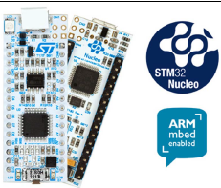
NUCLEO-F302R8 | £6.48 (Farnell) | - USB socket is for debug only  - Debug section removed from board to service as ST programmer  - MCU de-soldered from board and soldered down on OSPS board so  MCU can then be programmed in-situ | - USB interface possible  - Inexpensive  - User has a programmer to upgrade MCU when required  - Nice dev environment for STM32 | - User must de-solder LQFP package  - Documentation required for hacking programme | 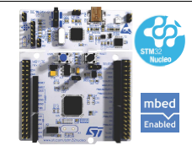
MSP-EXP430G2 | £7.63 (Farnell) | - Micro held in socket on dev board so program on board and place in socket on OSPS | - Simple transfer to design | - Micro not very sophisticated  - No USB comms | 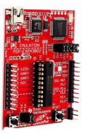
Arduino ISP | £9.39 (RS) | - A cheap programmer for use with all atmel micros | - Simple | - Expensive as mirco brought separately  - Arduino dev environment is rubbish | 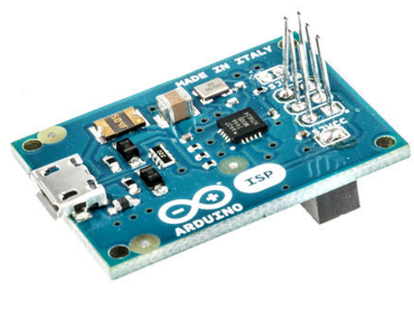
RasPi B+ | £20.75 (Farnell) | - Fit to socket on OSPS | - Lots of computing power  - Simple USB connection  - Linux | - No analogue inputs  - Expensive | 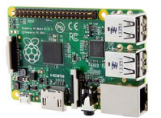
Sainsmart UNO | £9.99 (amazon) | - Rip off arduino  - Program on device on dev board an move over to socket on OSPS | - Simple | - No USB connection  - Arduino dev environment is rubbish | 