ELEC 3300

HOMEWORK 1: INTRODUCTION TO CubeIDE WORKSHEET

Please complete the following and submit your worksheet electronically before the deadline

Name : ___LI, Yu-hsi______ Student number : ___20819823____ LAB Session : ___LA1____

- Program Size in Hex: _______16c8____ for Optimization Level is None (-O0)

- Run your program up to the instruction
__asm(“NOP”); // Check Point for Question 2
Fill the following table. Remember you are using your *OWN* student ID.
NO MARKS WILL BE AWARDED IF YOU ARE NOT USING YOUR STUDENT ID

Expression |  | Type | Value (Please only write HEX NUMBERS below)
i |  | int | 0X20819823
j |  | int | 0X32891802
x |  | float | 0X821
y |  | double | 0Xcd9
stdid |  | int[8] | 0X20000000<stdid>
 | stdid[0] | int | 0X2
 | stdid[1] | int | 0X0
 | stdid[2] | int | 0X8
 | stdid[3] | int | 0X1
 | stdid[4] | int | 0X9
 | stdid[5] | int | 0X8
 | stdid[6] | int | 0X2
 | stdid[7] | int | 0X3
counter |  | int | 0X8
sum |  | int | 0X21

a. | What endianness is being used to store a word in memory in STM32? | Little endian
b. | Write down the hexadecimal value of stdid. | 0X20000000
c. | What is the meaning of the value you filled in part b? | The starting address of the array stdid
d. | How many bytes used for variables that declared as int? | 4 bytes
e. | How many bytes used for variables that declared as float? | 4 bytes
f. | Write down the hexadecimal value of x stored in memory. | 0XB81F0245
g. | What representation standard is being used to store x in memory? | IEEE754 single precision
h. | How many bytes used for variables that declared as double? | 8 bytes
i. | Write down the complete hexadecimal value of y stored in memory. | 0X7AA52C43 0X5CB2A940
j. | What representation standard is being used to store y in memory? | IEEE754 double precision
k. | Write down the starting address of the array swapid in hex format. | 0X2000006C
l. | Write down the starting address of the array oddid in hex format. | 0X2000008C
- Which SINGLE assembly instruction did the corresponding instruction take place

AND _______________ANDS__r3 r2___________________________________________

OR _______________ORRS__r3 r2___________________________________________

XOR _______________EORS__r3 r2____________________________________________

- Write down the answer of your result in hexadecimal format

ANDresult ___________________0X20811802_______________________________

ORresult ___________________0X32899832_______________________________

XORresult ___________________0X12088021_______________________________

What are the addresses of the following variables; please write it in hexadecimal format

ANDresult ___0X20000060_0X20000061_0X20000062_0X20000063____________

ORresult ___0X20000064_0X20000065_0X20000066_0X20000067____________

XORresult ___0X20000068_0X20000069_0X2000006A_0X2000006B____________

- What are the states of N, Z, C and V *AFTER* execution of ADDS R3, R0, R0 instruction?

N ______0_______ Z ______1_____

C ______0_______ V ______0_____

Please explain your result IN DETAIL with respect to the value in R3

N: ______the result is 0 is not negative, N flag = 0________________________________

Z: ______the result is 0, Z flag = 1_____________________________________________

C: ______0+0 don’t involve carry or borrow, C flag = 0____________________________

V: ______0+0 don’t involve overflow, V flag = 0_________________________________

- What are the states of C and V *AFTER* execution of ADDS R3, R1, R2 instruction?

C _______0______ V ______0_____

Please explain your result IN DETAIL with respect to your value in R3 to R1 and R2

_____0X20819823(R1) + 0X32891802(R2) = 0X530AB025(R3)_____________________

_____the calculation doesn’t involve carry, borrow or overflow_______________

- What are the states of C and V *AFTER* execution of SUBS R3, R1, R2 instruction?

C ______0_______ V _______0______

Please explain your result IN DETAIL with respect to your value in R3 to R1 and R2

_____0X20819823(R1) - 0X32891802(R2) = 0XEDF88021 (R3)_____________________

___the result is negative, but the calculation doesn’t involve carry, borrow, or overflow_____

- Please put a screen cap of your Traditional Memory View at Check Point for Question 8 here.

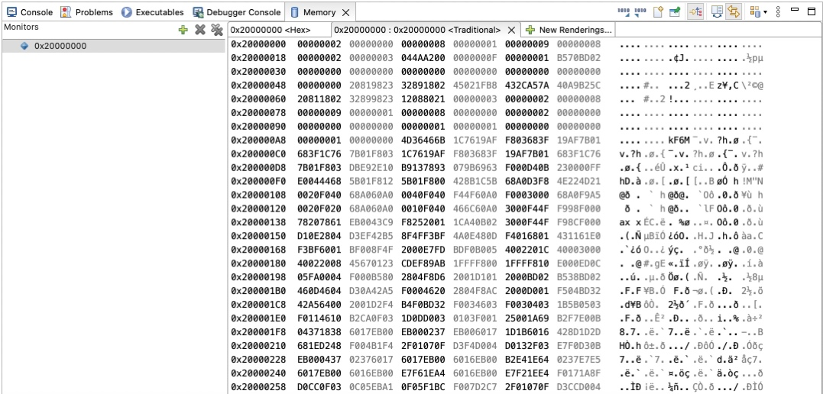

- Program Size in Hex: _____1304______ for Optimization Level is Optimize most (-O3)

Any difference compared to the Question 1 you found before? _Smaller than None Optimization_

Please briefly explain the optimization is being done by giving some examples with the help of Disassembly View.

____Optimization result in smaller code size for efficiency. Since it makes change in assembly code to use more register to store the variable that is being reuse. According to images below, none optimize one keep using r3 and r2 to store the variable and keep updating it with the value we need to use. The one with most optimize add r4 and r5 to store variables, which reduce the program size and improve the speed. _____________________________________

Optimization None (-O0)
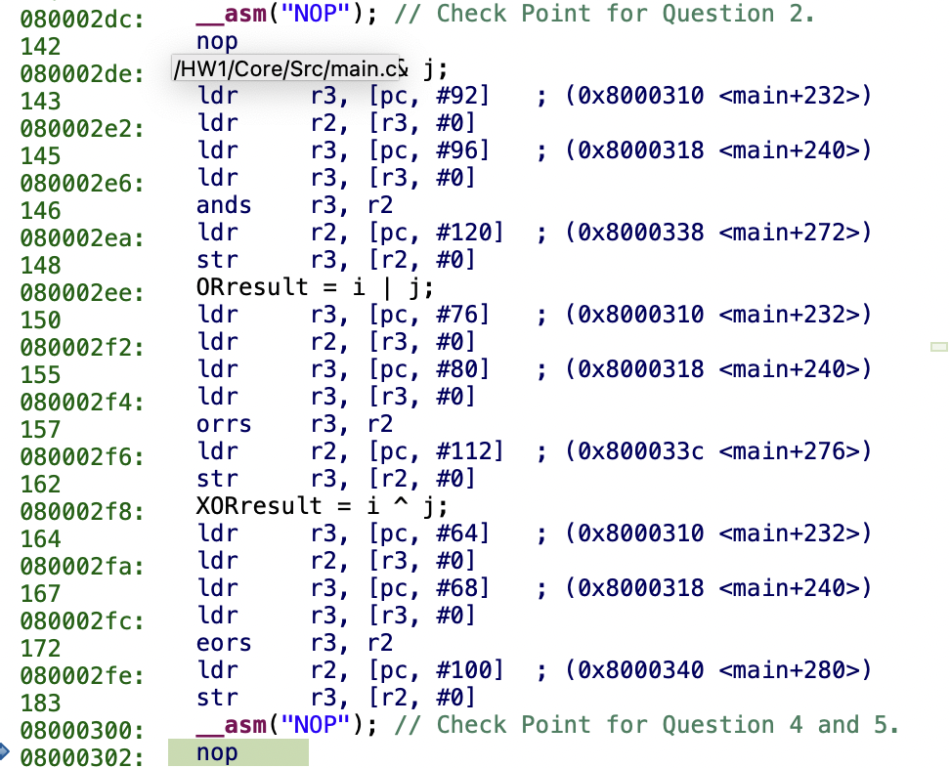

Optimisation most (-O3)
