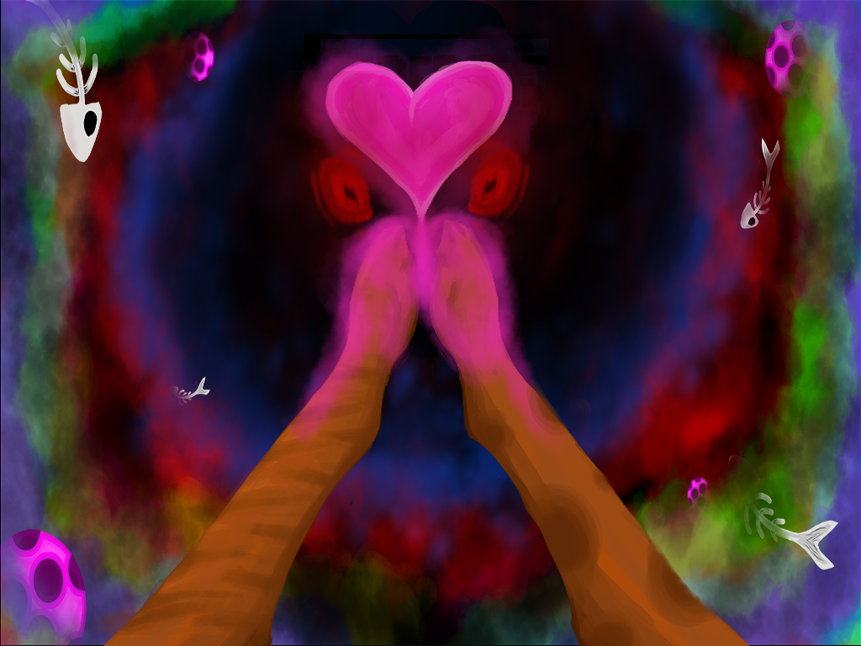

Usability Report

Acceptable Havoc

Sprint 5 – Beta

11/13/17

|  |  |  |
| --- | --- | --- |
| **Position Title** | **Name** | **Signature** |
| Artist | Brennen D |  |
| Programmer | Ashley P |  |
| Level Designer | Dominique S |  |
| Level Designer | Chris W |  |
| Programmer | Rui X |  |

Contents

Summary Overview 3

Methodology 3

Major Takeaways 3

Challenge 3

Conveyance 3

Engagement 3

Playtest Data 4

Demographics 4

Charts 4

Analysis 4

Challenge 5

Charts 5

Qualitative Feedback 5

Analysis 6

Conveyance 7

Charts 7

Qualitative Feedback 7

Analysis 7

Engagement 9

Charts 9

Qualitative Feedback 11

Analysis 11

Major Issues and Bugs 13

Appendix: Raw Notes, Qualitative Feedback, and Observations 14

# Summary Overview

## Methodology

On Monday November 13th, 2017, we took Francis' Feline Friendship Force to the Southern Methodist University campus for playtesting. We tested in both the Fondren Collaborative Commons and the Hughes-Trigg Student Center. During this time, we had 28 testers.

## Major Takeaways

### Challenge

* Testers reported within expected margins of our difficulty curve.
* Qualitatively, testers reported enjoying the puzzle/thinking elements of the game.
* 25% of testers quit after level 4 which might be due to initial difficulty after the tutorial levels.

### Conveyance

* Overall, testers felt as if the tutorial prepared them for the rest of the game.
* There is some confusion with how the cat and box interact.
  + We plan to address these issues with a change to the box tutorial and adding a shader element to the box when a cat is inside.
* There is some confusion over which cat the dog is chasing.
  + We are addressing this with changes to the level 3 tutorial.

### Engagement

* 86% of testers felt somewhat to very encouraged to retry levels.
* The overwhelming majority of mobile puzzle gamers stated they would be somewhat to very likely to download the game from the app store for free.
* Some players wanted more from the achievement system.

# Playtest Data

## Demographics

### Charts

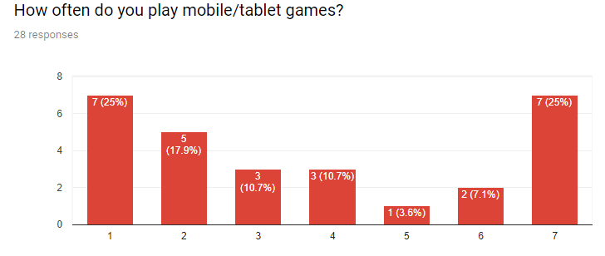

Figure *(1 = never, 7 = daily)*

*What type of games do you typically enjoy playing on mobile/tablet devices?*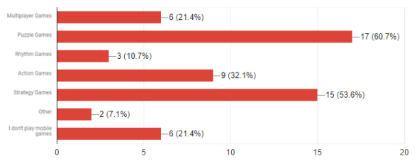

Figure

### Analysis

25% of testers reported that they did never play mobile or tablet games. 21% of our testers reported that they didn't play games on their mobile phone or tablet. However, we did find that most testers told us they played puzzle games, hitting our target demographic.

Of the testers that reported that they never play mobile games, we see that 4% of them acknowledge that while they may not identify as a frequent gamer, they enjoy some apps that they may not identify as full games. By having testers that self-identify as an infrequent or non-gamer, we see that we have hit a more casual group of players with our data.

## Challenge

### Charts

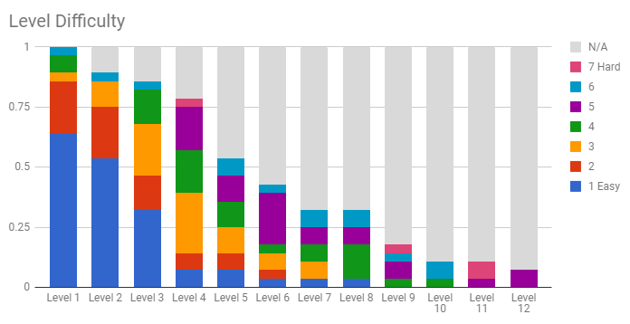

Figure

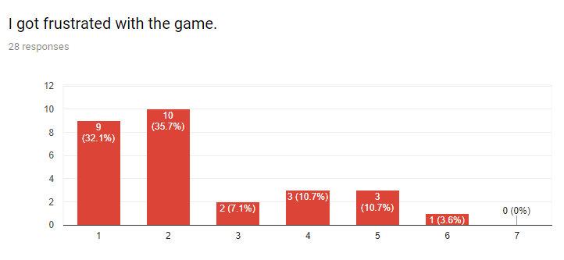

Figure *(1 = Strongly Disagree, 7 = Strongly Agree)*

### Qualitative Feedback

* Level 3 was too hard.
* My favorite part of the game was the puzzle elements.
* I wish there was a hint feature after I fail a level.
* It was tricky at first.

### Analysis

The testers reported within expected margins for level difficulty across all levels overall. Testers who found the first 3 levels to be in the difficulty range of 4+ were twice as likely to quit playing the game by level 4 than testers who ranked the difficulty in the 1-3 range.

25% of all testers quit playing after level 4, which we consider our first ‘non-tutorial’. This brings up concern that parts of our first three ‘tutorial levels’ are not preparing players for the puzzles for the rest of the game, though all but 1 tester who quit after level four felt the first three levels taught them all or most of what they need to know for the rest of the game (responding with a 5+ to that question, noted in the Conveyance section below).

78.6% of testers responded within the 1-3 range when asked if they agreed with the statement “I got frustrated with the game.” The testers in this range overall had comments along the lines of, “…it was tricky at first.” Some testers reporting in the 1-3 range wanted more mechanics as well. Of the 21.4% of testers who reported in the 4-7 range, all but 2 of the testers reported as not playing mobile puzzle games. The majority of testers that reported in the 4-7 range said that the levels were hard, and one advocated for a hint feature after many failed attempts.

Testers who reported playing mobile puzzle games were 4 times as likely to play until level 9 than testers who did not report playing mobile puzzle games; furthermore, only testers who identified as mobile puzzle games played until level 12.

There were no interesting correlations between self-identified mobile gamers and non-mobile gamers.

THE GOOD: testers tended to enjoy the puzzles and mechanics that we offer in the experience. Our difficulty curve follows expectations.

THE BAD: Testers were most likely to quit playing after level 4 which brings concern about different aspects of the difficulty curve. Testers who did not identify as mobile puzzle gamers wanted more mechanics or abilities in the game which might point to either a lack of understanding or dislike of the current puzzle elements we have in the game.

## Conveyance

### Charts

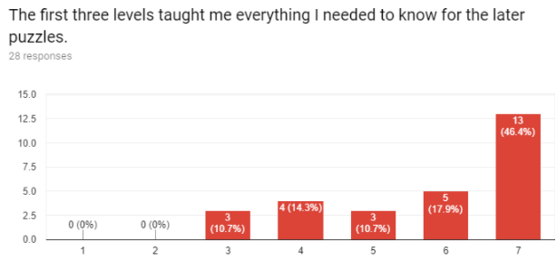

Figure *(1 = Strongly Disagree, 7 = Strongly Agree)*

### Qualitative Feedback

Questioning Moments of Game

* Notifying which box the player placed a cat into
* Knowing which cat the dog is going after
* Understanding how the achievement system works
* Have cats that can move be glowing, with available paths illuminated.

### Analysis

Tester feedback displays *Francis’ Feline Friendship Force* has reached a reasonable level of conveyance, but issues still arise.

46.4% of testers stated the 1st 3 levels prepared them for later puzzles. However, 25% of testers did not feel adequately prepared from the 1st 3 levels.

Testers were confused about 2 elements in the game: 1) knowing which dog the cat was targeting, 2) remembering which box a cat was placed into. For the box issue, applying the same outline used on the cat to the box will help remind. One tester stated, “level 3 was difficult” which is the last tutorial level. For this reason, teaching players in level 3 that the dog chases a cat that is highlighted in red will help inform.

THE GOOD: Overall testers felt that the first three levels prepared them for the rest of the game’s challenges. Additionally, testers did not comment about being confused about the overall goal or any not mentioned major elements of our game.

THE BAD: Testers had some confusion about which cat the dog was targeting, and some interactions with the cat and the box. Thankfully, these are easy changes that we have planned out and are implementing the fix.

## Engagement

### Charts

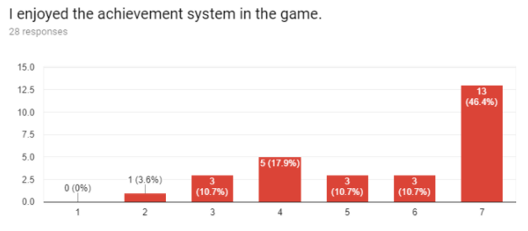

Figure *(1 = Strongly Disagree, 7 = Strongly Agree)*

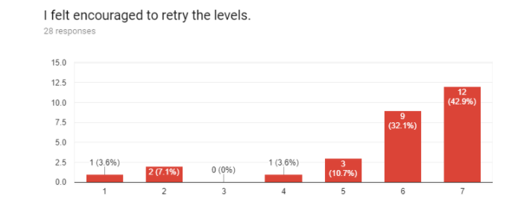

Figure *(1 = Strongly Disagree, 7 = Strongly Agree)*

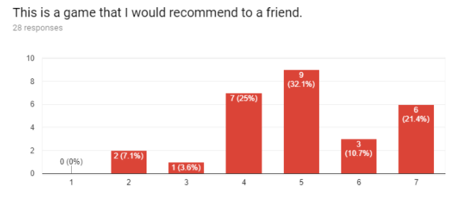

Figure *(1 = Strongly Disagree, 7 = Strongly Agree)*

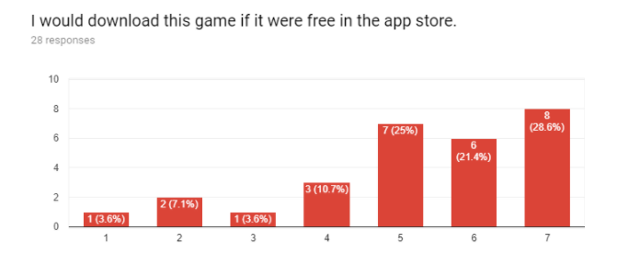

Figure *(1 = Strongly Disagree, 7 = Strongly Agree)*

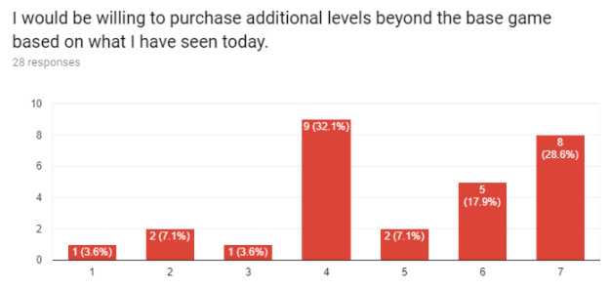

Figure *(1 = Strongly Agree, 7 = Strongly Disagree)*

### Qualitative Feedback

Questioning Moments of Game

* Understanding how the achievement system works.
* There was no reason to replay the levels besides personal accomplishment.

### Analysis

For the “I would be willing to purchase additional levels beyond the base game based on what I have seen today” question the data is flipped potentially making some of the responses inaccurate. If the data is accurate, 10% of testers said they would be likely to purchase additional levels if given the option based upon what they have seen today.

Over 75% of testers stated they would be very to somewhat likely to download this game in an app store if it were free. The majority of testers who reported they were mobile puzzle gamers ranked either likely or very likely to downloading the game for free in the app store.

Most testers enjoyed the achievement system and felt encouraged to retry levels, though some testers wanted the achievement system to have more of an impact on the game. Testers who stated they did not like the achievement system and they did not feel encouraged to retry levels would regularly skip through the achievements or stopped within the first four levels.

Some testers brought up that the 2 paw prints seemed confusing, believing that there were two achievements for each pair of paw prints. To address this, we are going to make the pair of paw prints just one paw print to represent one achievement. Majority of testers would recommend the game to a friend and download if it were free in the app store.

THE GOOD: Most players enjoyed the achievement system and were encouraged retry levels as we intended. Many testers would be likely to recommend this game to a friend. Many testers who are mobile puzzle gamers would download this game from the app store.

THE BAD: Some testers still had confusion on the achievement system which we are implementing small changes to hopefully make it clearer.

# Major Issues and Bugs

|  |  |  |
| --- | --- | --- |
| Severity Rating | Severity Category | Description |
| 4 | Unusable | Achievement system on level select screen doesn't display catnip collection after level 5. |
| 3 | Severe | Players don’t know they can move cats out of the box. |
| 3 | Severe | Players do not use the restart button to retry the level. |
| 2 | Moderate | Players don’t know or forget that they’ve already moved the cat into a box. |
| 2 | Moderate | 50% players don’t learn everything in tutorial levels. |
| 2 | Moderate | Players don’t read the tutorial texts thoroughly. |
| 2 | Moderate | Achievement 'pop' even when an achievement is achieved before. |
| 1 | Irritant | Players want to move the cat toward the dog. |
| 1 | Irritant | Players thought each footprint represents 2 achievements in level selector scene. |
| 1 | Irritant | Players want to know the direction that the dog is headed. |
| 1 | Irritant | Players want to get hints after several attempts are failed. |
| 1 | Irritant | Players try to move more than 1 node because of the laser pointer. |
| 1 | Irritant | Players want to skip a turn without moving the cat. |
|  |  |  |
|  |  |  |
|  |  |  |
|  |  |  |
|  |  |  |
|  |  |  |
|  |  |  |

# Appendix: Raw Notes, Qualitative Feedback, and Observations

|  |  |  |  |
| --- | --- | --- | --- |
| Tester | In response to… | Positive/Negative/Other | Tester Comments |
| 1 | Why I got frustrated | Negative | Could I skip a turn to wait for the dog to come to me. |
| 9 | Why I got frustrated | Other | A little difficult. |
| 13 | Why I got frustrated | Other | I was trying to figure it out. |
| 18 | Why I got frustrated | Negative | Level 3 was hard. |
| 25 | Why I got frustrated | Other | Might be nice to have a hint feature after multiple failed attempts |
| 26 | Why I got frustrated | Negative | You could get so incredibly close to solving a level, but be missing one key step to actually finish. SO CLOSE YET SO FAR |
| 27 | Why I got frustrated | Other | It was tricky at first. |
| 28 | Why I got frustrated | Negative | There was no reward to replaying levels beyond personal accomplishment |
| 1 | Favorite part of the game | Other | Everything felt responsive enough, no frustrations with control |
| 2 | Favorite part of the game | Positive | I liked the sound effects |
| 3 | Favorite part of the game | Positive | The cat high five volcano. |
| 4 | Favorite part of the game | Positive | Winning. |
| 10 | Favorite part of the game | Positive | Figuring out the puzzle. |
| 12 | Favorite part of the game | Positive | Progression of new mechanics. |
| 13 | Favorite part of the game | Positive | The idea of cats and dogs. |
| 14 | Favorite part of the game | Positive | Moving past the dogs and figuring out the right path |
| 15 | Favorite part of the game | Positive | Hiding in the boxes. |
| 16 | Favorite part of the game | Positive | The problem solving. |
| 17 | Favorite part of the game | Positive | The water. |
| 18 | Favorite part of the game | Positive | The sound |
| 21 | Favorite part of the game | Positive | The puzzle solving aspect |
| 22 | Favorite part of the game | Positive | The first level bc it was easy |
| 24 | Favorite part of the game | Positive | It made me think |
| 25 | Favorite part of the game | Positive | Different approach to puzzle games, not sure I've played anything like it |
| 26 | Favorite part of the game | Positive | Achievement trackers |
| 27 | Favorite part of the game | Positive | The concept |
| 28 | Favorite part of the game | Other | Game play was alright from a strategy point, even though concept was simplistic. |
| 1 | Anything you disliked | Negative | Everything seemed a little static. No fun animations to watch in movement or stationary. The pictures of the cats and dog seemed a little rough |
| 2 | Anything you disliked | Positive | No |
| 4 | Anything you disliked | Negative/Other | The dog |
| 10 | Anything you disliked | Positive | No |
| 12 | Anything you disliked | Negative/Other | I think it could use more mechanics to up difficulty and complexity. |
| 13 | Anything you disliked | Positive | No |
| 16 | Anything you disliked | Negative | Graphics |
| 17 | Anything you disliked | Positive | Nothing |
| 18 | Anything you disliked | Positive | No |
| 19 | Anything you disliked | Negative/Other | Level 3 |
| 20 | Anything you disliked | Positive | No |
| 21 | Anything you disliked | Positive | No |
| 22 | Anything you disliked | Negative/Positive | Not really. Just confusing |
| 24 | Anything you disliked | Negative | What the dog could see and not see was hard to understand sometimes |
| 25 | Anything you disliked | Negative | Nothing outside of graphics, which is understandable due to the development stage |
| 26 | Anything you disliked | Negative/Other | For a while I thought that I was forced to get all achievements in one run |
| 27 | Anything you disliked | Negative | not enough instructions on how to play |
| 28 | Anything you disliked | Negative | Home screen music is really annoying. Graphics were painful to watch (low res sprites) |
| 1 | Any additional feedback | Other | Add a "Do nothing" option so you don't have to do a useless move. |
| 3 | Any additional feedback | Negative/Other | - An indicator for where the dogs were headed, especially when there are multiple cats they can go to would be very helpful.  - The lazer pointer makes me feel like I can move more than 1 space at a time.  - More conveyance that the cat is in the box would be helpful atm its kind of hard to tell that there is a cat in a box. |
| 4 | Any additional feedback | Other | Theme cat dog |
| 15 | Any additional feedback | Negative | Maybe somehow improve the look |
| 16 | Any additional feedback | Positive | It was fun :) |
| 22 | Any additional feedback | Other | None |
| 25 | Any additional feedback | Positive/Other | Have cats that can move be glowing, with available paths illuminated. Some of the sound effects are a little abrasive, but sound was fun and fit the game. |
| 26 | Any additional feedback | Negative/Other | Difficulty spike was quick so maybe an additional intermediate level or two |
| 28 | Any additional feedback | Negative | Not clear what the paws mean, although I suspect it is achievements, and the achievements don't have incentive behind them. |