Drift Database Design and Normalization
Database Systems project | 7 October 2026
Drift manages a car-rental catalogue, customer accounts, reservations, extras and payment records. This document explains the database relationships and demonstrates how a booking worksheet is transformed from unnormalised form to third normal form using the staged method in the lecture notes.
The implemented MySQL schema contains 21 core tables and 24 declared foreign keys. The ERD describes that physical schema. The worked normalization describes a smaller logical projection so that repeating, partial and transitive dependencies can be followed without hiding the transformation in a large table.

How to read the diagrams
The four ERD views form one schema. Shared entities are repeated between views for readability; they are not duplicate tables. Each diagram shows primary and foreign key attributes. Other attributes are described in the entity inventory and normalization example.
Notation | Meaning
PK | Primary key uniquely identifies an entity occurrence.
FK | Foreign key references the parent entity key.
Double bar | Exactly one related occurrence.
Circle and bar | Zero or one related occurrence.
Circle and crow's foot | Zero or many related occurrences.
? after an attribute | The physical column permits NULL.
Underlined text in normalization tables | The chosen primary key. An asterisk marks a foreign key.
The lecture introduces entity rectangles, relationships and cardinality on pages 11–20. These implementation diagrams use crow’s-foot notation rather than the Chen diamonds shown on page 20; the same relationship meanings are preserved, with optionality shown explicitly.

Design assumptions
One booking reserves one vehicle. A booking may select several different extras; quantity records multiple units of an extra. The agreed price may differ between bookings. A vehicle can have multiple images and features. Pickup and return branches are separate roles and can refer to the same branch.

Fleet and location ERD
A province contains cities; a city contains branches. Each vehicle belongs to one branch and model. A model belongs to one category. VehicleFeature resolves the many-to-many relationship between vehicles and features using the compound primary key (vehicle_id, feature_id).
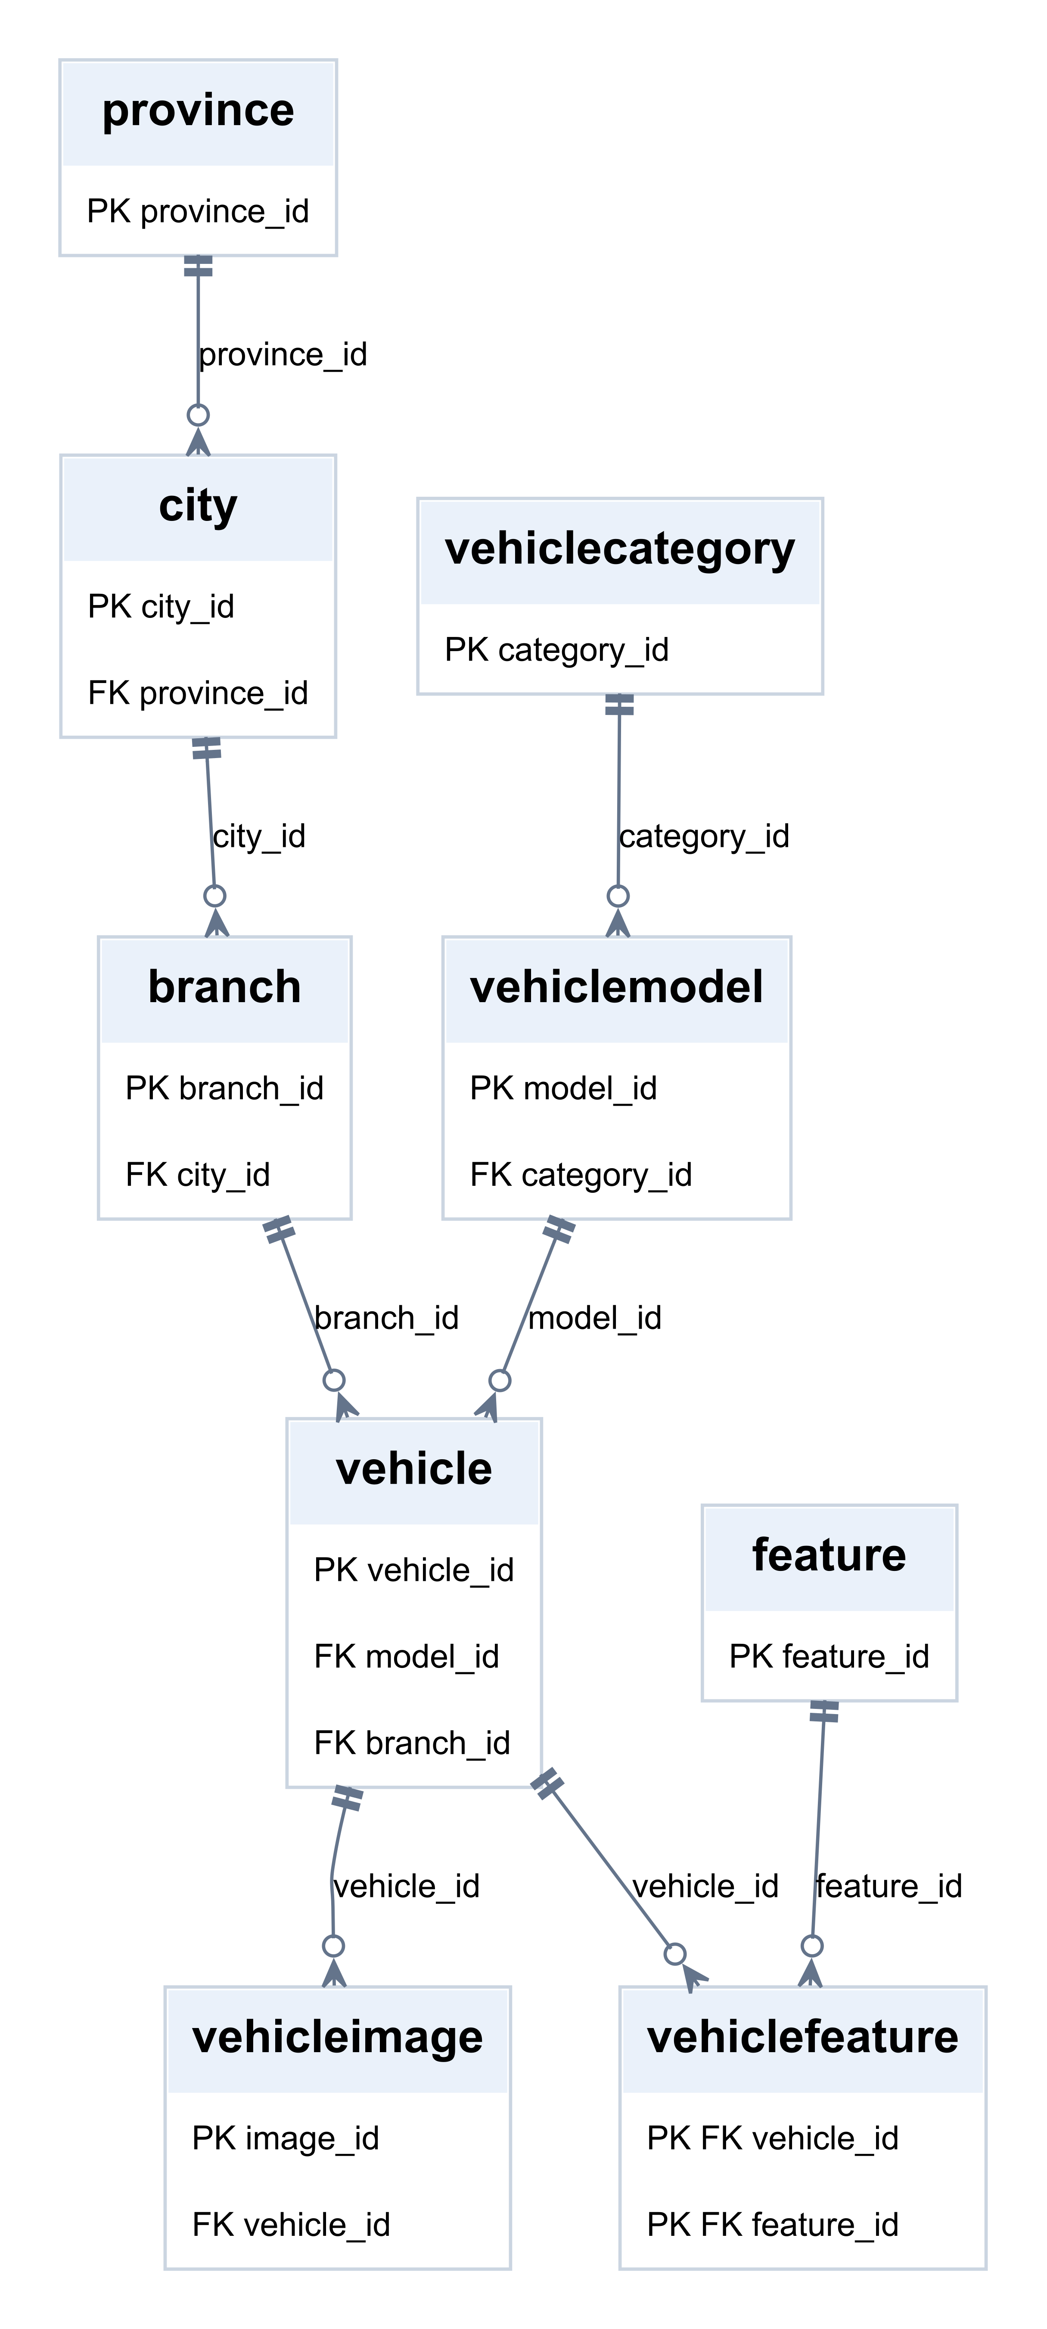
PK = primary key; FK = foreign key; ? = nullable. Lines show the declared SQL relationships.

Booking and payment ERD
Pickup and return are separate foreign keys. Booking.customer_id permits NULL in the schema, although the website requires a signed-in customer. One booking may have several payment attempts. BookingExtra has its own primary key and also enforces UNIQUE(booking_id, extra_id).
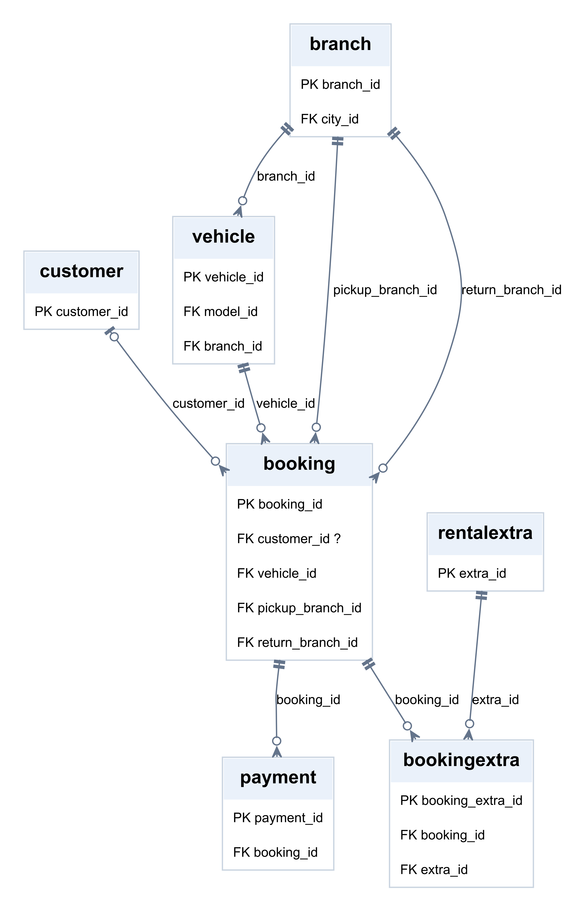
PK = primary key; FK = foreign key; ? = nullable. Lines show the declared SQL relationships.

Account ERD
AppUser.customer_id is nullable and unique: the physical customer-account association is optional one-to-one. A CHECK constraint requires a customer link for Customer-role accounts; Admin accounts may omit it. Sessions and password-reset records belong to exactly one account.
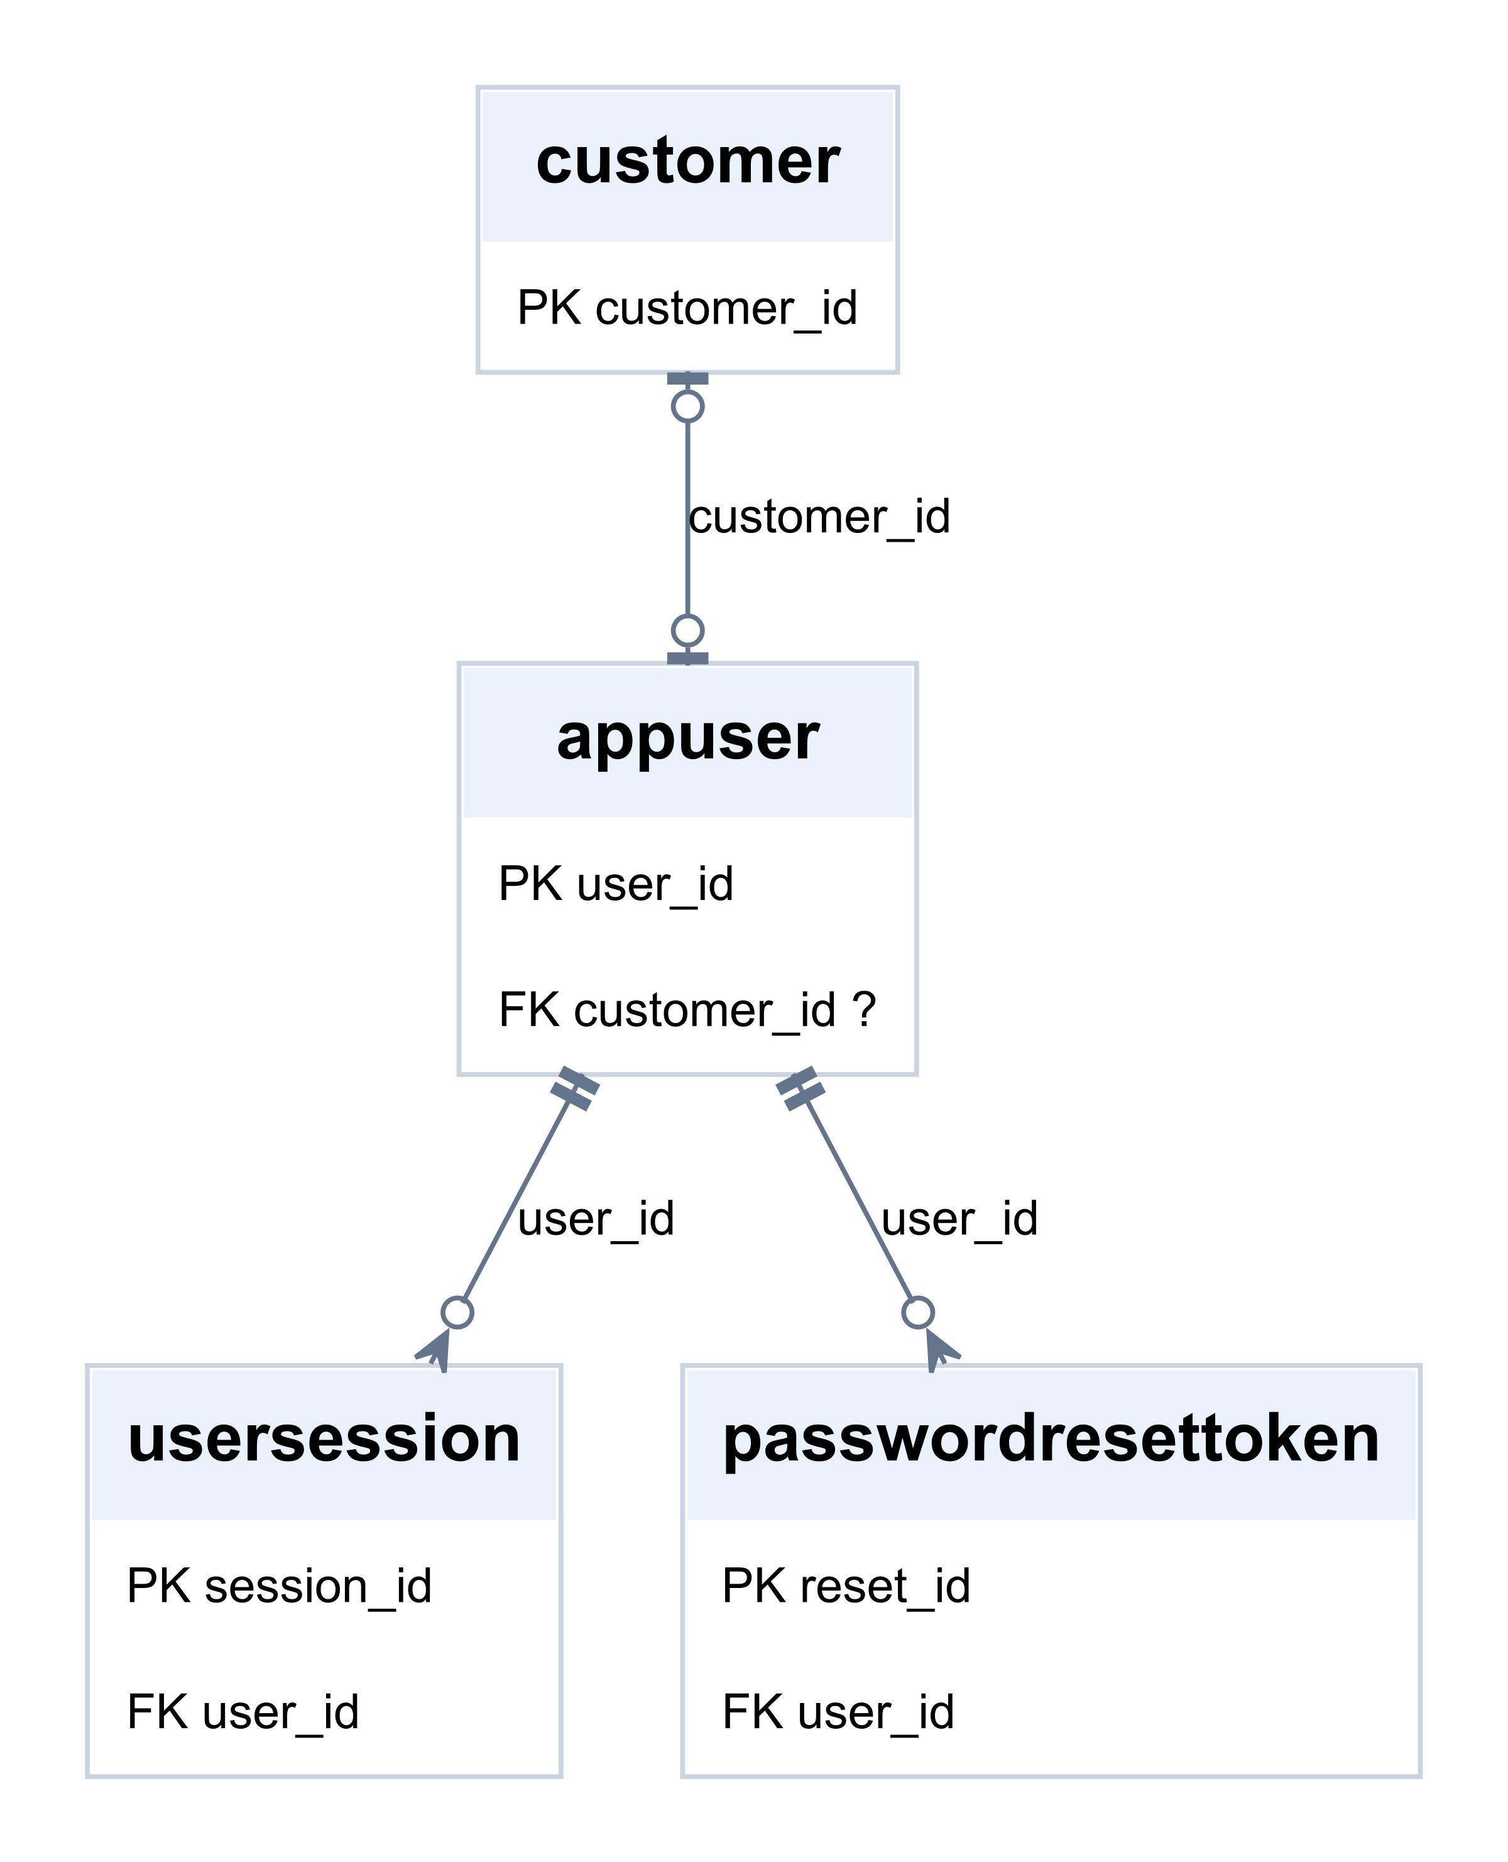
PK = primary key; FK = foreign key; ? = nullable. Lines show the declared SQL relationships.

History and review ERD
VehicleReview.booking_id is unique, so a booking has at most one review. Cancellation requests and status history may have no reviewing or changing user yet. Several cancellation requests can exist over time, but a generated unique key permits at most one pending request per booking.
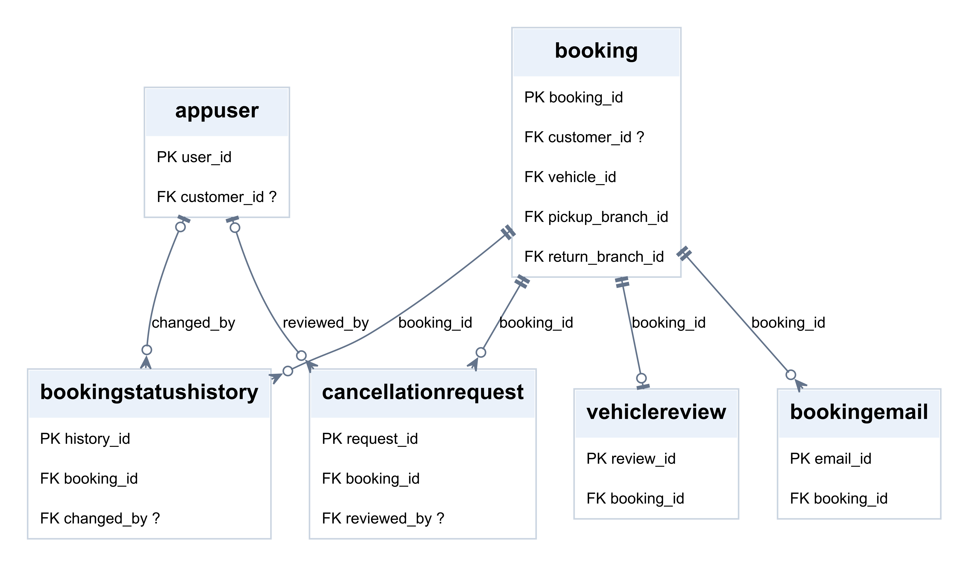
PK = primary key; FK = foreign key; ? = nullable. Lines show the declared SQL relationships.

Step 1 Select the source and identify UNF
Source: the booking screen and its selected-extras list. Following lecture pages 36–40, list the source attributes, choose BookingID as the key, and identify the repeating extras. Omit RentalDays, RentalSubtotal, ExtrasTotal, TotalCost and LineTotal from the logical exercise because they are calculated.
RentalWorksheet (BookingID, CustomerID, CustomerName, VehicleID, PickupBranchID, PickupBranchName, CityID, CityName, ProvinceID, ProvinceName, StartDate, EndDate, DailyRateApplied, {ExtraID, ExtraName, Quantity, UnitPrice})
The representative rows below illustrate the dependencies only. They are teaching examples, not customer records or records added to the running database. The same extra E1 has a different agreed price on B102, just as the lecture allows one employee to have different rates on different projects.
BookingID | CustomerID | CustomerName | VehicleID | PickupBranchID
B101 | C1 | Customer A | V1 | BR1
B102 | C1 | Customer A | V2 | BR1

Repeating group within each booking
BookingID | Extras {ExtraID, ExtraName, Quantity, UnitPrice}
B101 | {E1, GPS, 1, 50}; {E2, Child seat, 1, 80}
B102 | {E1, GPS, 1, 45}

Location and date attributes
BookingID | PickupBranchName | CityID / CityName | ProvinceID / ProvinceName
B101 | Central | CT1 / Kimberley | P1 / Northern Cape
B102 | Central | CT1 / Kimberley | P1 / Northern Cape
BookingID | StartDate | EndDate | DailyRateApplied
B101 | 2026-11-01 | 2026-11-03 | 500
B102 | 2026-11-05 | 2026-11-07 | 600
Update anomaly: a branch name is repeated across bookings. Insert anomaly: in one worksheet, an extra definition cannot be recorded without a booking. Delete anomaly: deleting the final booking for an extra could lose its definition. Separate entity tables remove these dependencies between unrelated operations.

Step 2 Remove repeating attributes for 1NF
Following lecture pages 41–44, move the repeating extras to a new relation. Copy BookingID into it and choose the compound key (BookingID, ExtraID). BookingHeader keeps one row per booking, including bookings with no extras.
BookingHeader (BookingID, CustomerID, CustomerName, VehicleID, PickupBranchID, PickupBranchName, CityID, CityName, ProvinceID, ProvinceName, StartDate, EndDate, DailyRateApplied)
BookingExtraFlat (BookingID*, ExtraID, ExtraName, Quantity, UnitPrice)
BookingID* | ExtraID | ExtraName | Quantity | UnitPrice
B101 | E1 | GPS | 1 | 50
B101 | E2 | Child seat | 1 | 80
B102 | E1 | GPS | 1 | 45

Functional dependencies
BookingID → all BookingHeader attributes.
(BookingID, ExtraID) → Quantity, UnitPrice.
ExtraID → ExtraName.
Every field holds one value, and the chosen key identifies each row. However, ExtraName depends on ExtraID alone, which is only part of the compound key. Therefore BookingExtraFlat is in 1NF but not 2NF.
The header is not duplicated for each extra. A join on BookingID can reconstruct the detail rows for bookings that have extras; a left join preserves bookings with none. No extra combinations or facts are introduced by this separation.

Why the agreed price stays on the detail row
E1 costs 50 on B101 and 45 on B102. Therefore ExtraID alone does not determine UnitPrice. The booking-extra pair determines the agreed price. Current catalogue prices are different facts and are stored in RentalExtra in the application.

Step 3 Remove partial dependencies for 2NF
Following lecture pages 45–49, examine each non-key attribute against each part of the compound key. Move ExtraName to RentalExtra because ExtraID determines it. Leave ExtraID in BookingExtra as a foreign key. The header has a simple key and carries forward unchanged.
BookingHeader (BookingID, CustomerID, CustomerName, VehicleID, PickupBranchID, PickupBranchName, CityID, CityName, ProvinceID, ProvinceName, StartDate, EndDate, DailyRateApplied)
RentalExtra (ExtraID, ExtraName)
BookingExtra (BookingID*, ExtraID*, Quantity, UnitPrice)
ExtraID | ExtraName
E1 | GPS
E2 | Child seat
BookingExtra retains the attributes that depend on both key parts:
BookingID* | ExtraID* | Quantity | UnitPrice
B101 | E1 | 1 | 50
B101 | E2 | 1 | 80
B102 | E1 | 1 | 45
Partial dependency removed: ExtraID → ExtraName.
Full dependency retained: (BookingID, ExtraID) → Quantity, UnitPrice.
Joining RentalExtra back to BookingExtra on ExtraID restores ExtraName without ambiguity because ExtraID is unique in RentalExtra. Choosing a surrogate key alone would not fix the original partial dependency: the compound candidate key must still be considered.

Step 4 Remove transitive dependencies for 3NF
Following lecture pages 50–55, move descriptions determined by another non-key attribute into a separate relation. Copy that determinant as the new key and keep a foreign key in the original relation.
Booking (BookingID, CustomerID*, VehicleID*, PickupBranchID*, StartDate, EndDate, DailyRateApplied)
Customer (CustomerID, CustomerName)
Branch (BranchID, BranchName, CityID*)
City (CityID, CityName, ProvinceID*)
Province (ProvinceID, ProvinceName)
RentalExtra (ExtraID, ExtraName)
BookingExtra (BookingID*, ExtraID*, Quantity, UnitPrice)
Dependencies separated:
CustomerID → CustomerName
BranchID → BranchName, CityID
CityID → CityName, ProvinceID
ProvinceID → ProvinceName
Originally BookingID → CustomerID → CustomerName and BookingID → PickupBranchID → CityID → ProvinceID caused indirect dependencies. Customer and location descriptions now depend on their own relation keys. RentalExtra and BookingExtra already satisfy 3NF for the stated attributes and assumptions.
PickupBranchID references BranchID. VehicleID references the independently normalised Vehicle relation. The live system applies the same Branch reference to ReturnBranchID. Underlined attributes are primary keys; * marks foreign keys. These are projected relations, not a replacement migration script.

Other entities and physical implementation

Vehicle catalogue normalization
UNF: VehicleSheet(VehicleID, ModelID, Brand, ModelName, CategoryID, CategoryName, {FeatureID, FeatureName}, {ImagePosition, ImageURL}).
1NF: remove the repeating groups to VehicleFeatureFlat(VehicleID, FeatureID, FeatureName) and VehicleImage(VehicleID, ImagePosition, ImageURL). The copied VehicleID is part of each new compound key.
2NF: move FeatureName, determined by FeatureID, to Feature. Keep VehicleFeature(VehicleID, FeatureID).
3NF: separate VehicleModel(ModelID, Brand, ModelName, CategoryID) and VehicleCategory(CategoryID, CategoryName). Vehicle retains ModelID as its foreign key. Each step uses the same tests as the booking example.

How the logical design maps to MySQL
Logical design | Implemented choice
CustomerName | Customer stores first_name and last_name.
BookingExtra compound key | booking_extra_id is the primary key; UNIQUE(booking_id, extra_id) preserves the business key.
Vehicle image compound key | image_id is the primary key; the live schema also controls image ordering and cover selection.
Current descriptions | Booking retains customer and vehicle name snapshots; BookingExtra retains the agreed extra description. These describe the booking-time state, not necessarily current catalogue values.
Agreed prices | daily_rate_applied and unit_price preserve the original agreement. Repricing the catalogue must not rewrite old bookings.
Calculated values | MySQL generates rental_days, rental_subtotal, total_cost and line_total. extras_total is a stored aggregate managed with booking extras in the application transaction.
The logical projection is normalised to 3NF under the stated dependencies. The full physical schema should not be presented as strictly 3NF without qualification: it includes calculated values, stored aggregates and historical snapshots. Historical prices are time-specific facts; they are not automatically erroneous duplicates of current prices.

Entity inventory and sources
Entity | Purpose
Province / City / Branch | Geographic hierarchy and rental locations (3 tables).
VehicleCategory / VehicleModel | Category and shared model definitions (2 tables).
Vehicle | Individual registered vehicle, rate and branch.
VehicleImage | Vehicle photographs and ordering.
Feature / VehicleFeature | Equipment definitions and vehicle-feature links (2 tables).
Customer | Personal and licence details.
AppUser | Login identity, password hash and account role.
UserSession / PasswordResetToken | Session and reset-token hashes (2 tables).
Booking | Reservation dates, parties, vehicle and agreed values.
RentalExtra / BookingExtra | Extra definitions and booking selections (2 tables).
Payment | Payment attempts and outcomes.
CancellationRequest | Cancellation requests and review decisions.
BookingStatusHistory | Booking status audit trail.
BookingEmail | Booking email queue and delivery records.
VehicleReview | At most one review per booking.

Sources and scope
Entity Relationships to Normal Forms, supplied lecture PDF: pages 11–27 for entities, relationships and keys; pages 28–35 for anomalies and stages; pages 36–55 for the worked transformation; pages 56–57 for the normal-form rules.
MySQL drift_car_rental: table, column, index and foreign-key metadata inspected on 7 October 2026. The ERD represents all 21 core tables and all 24 declared foreign keys. Generated cancellation constraints and unique review/account links were checked against the schema.
Transaction Management and Concurrency Control and Recovery in DBMS, pages 3 and 7–8, provides the transaction context for preserving booking consistency. Distributed Database Management Systems, pages 3–4, distinguishes a distributed database from a central database. The Data Warehouse and Data Mining, pages 2–6, distinguishes analytical reporting from operational storage. Drift’s operational schema is not described here as a distributed database or a data warehouse.
The normalization examples follow the lecturer’s method, using underlined keys and * for foreign keys. Later normal forms are outside this worked UNF-to-3NF example.

