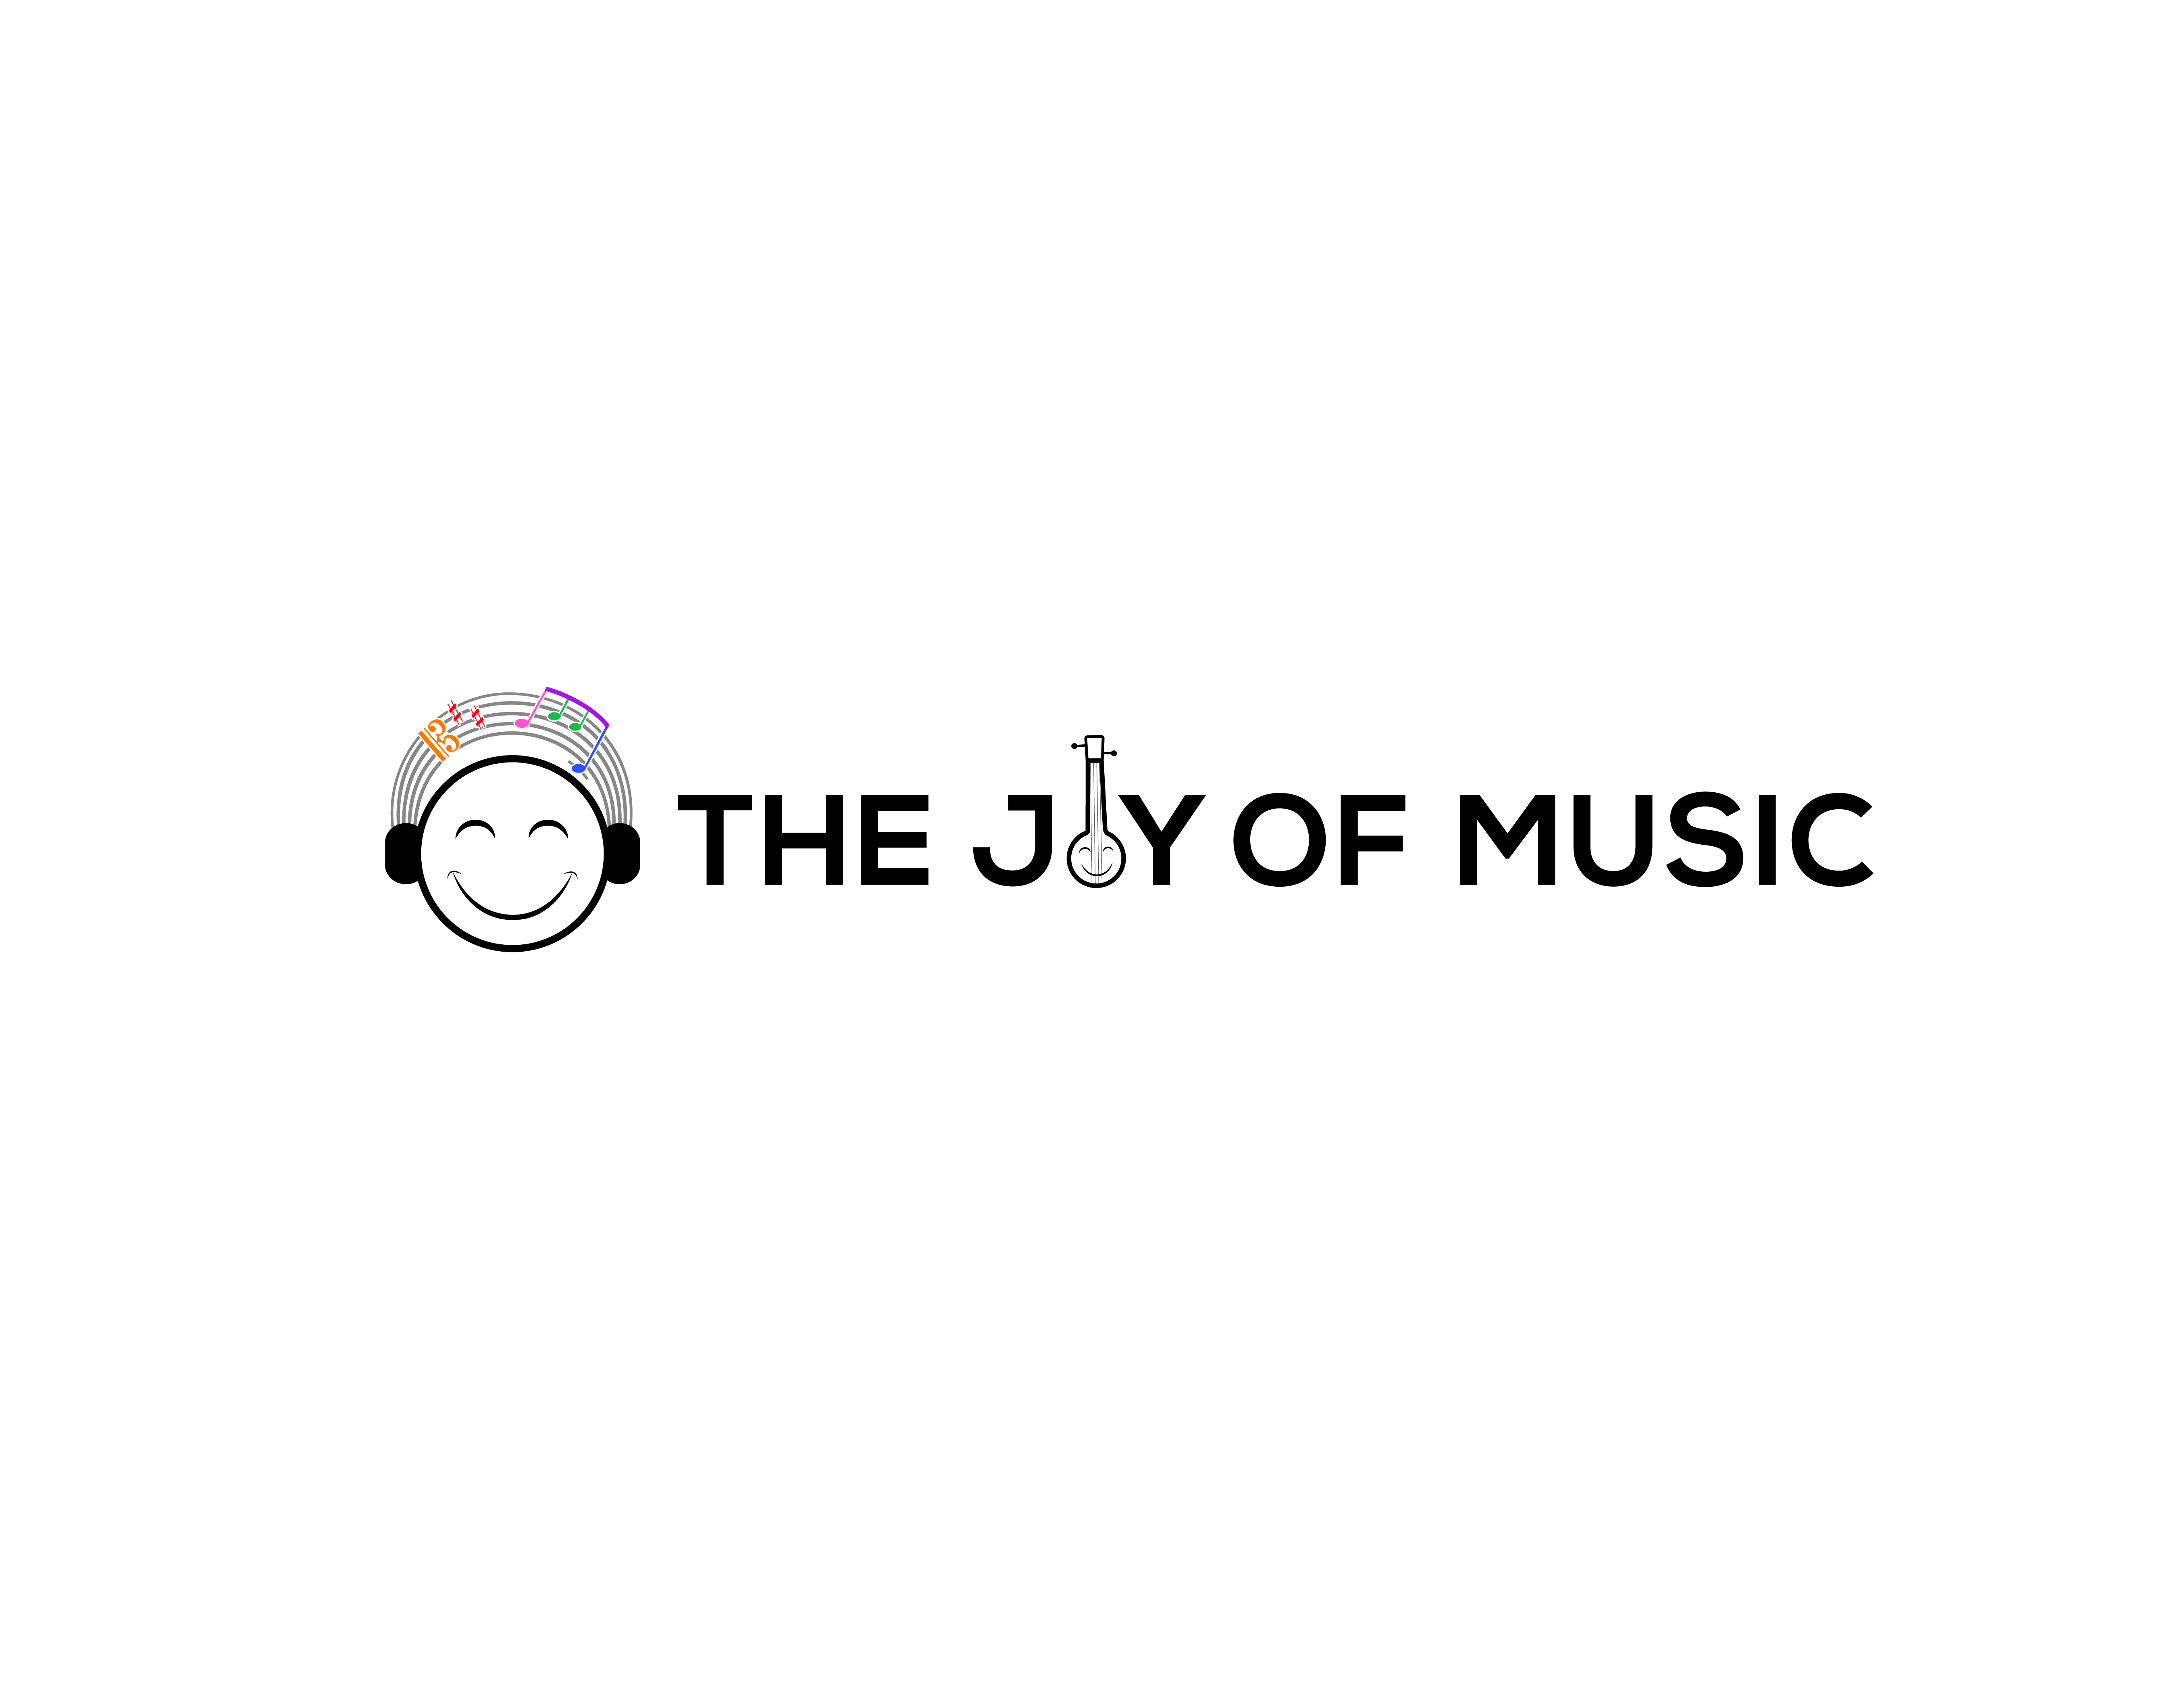
Carnatic Bingo | Bingo Sheet #6

Student Name: ___________________ | Teacher Name: ___________________ | City, State: ___________________
Parent Name: ____________________ | Parent Email: ___________________ | Parent WhatsApp: ________________

 | 1 | 2 | 3 | 4 | 5
A
B
C |  |  | ★ Answer MCQ ★
D
E
★ The FREE space (C3) may be crossed off by correctly answering the multiple choice question on the back.

I Heard
A1. A Malayalam composition | C4. A Telugu composition
A2. A Gopalakrishna Bharati composition | C5. A Papanasam Sivan composition
A3. A composition that started before the samam | D1. A Tamil composition
A4. A Kannada composition | D2. A composition that was not in Adi, Roopakam, Khanda Chapu, or Misra Chapu
A5. A Shyama Shastri composition | D3. A ragam with no madhyamam
B1. A composition that started after the samam | D4. A composition by a non-trinity composer
B2. A Purandaradasa composition | D5. A Thyagaraja composition
B3. Misra Chapu | E1. A composition that started on the samam
B4. A ragam or composition sung only for mic testing | E2. Khanda Chapu
B5. A Thani Avarthanam | E3. A prati-madhyama ragam
C1. A ragam with no Pa | E4. A Muthuswamy Dikshitar composition
C2. A Sanskrit composition | E5. Adi thalam


Carnatic Bingo | Bingo Sheet #6

Concert Tracking
Cell | Song | Ragam | Thalam | Composer | Improv  (A/T/N/K) | Comp. Type | Concert
Concert Details
Concert # | Date | Artist | Accompanists | Venue | Location | Artist Signature
Multiple Choice Question
The term Graha Bhedam in Carnatic music refers to:
□ A) Modulation by shifting the tonic
□ B) Improvisation without tala
□ C) Ornamentation using gamakas
□ D) Singing in multiple speeds
How to play: At a concert, when you hear or see something that matches one of the hints on page 1 ("I Heard"), put a check or X in the matching empty square (A1-E5). Get 5 in a row - horizontally, vertically, or diagonally - to complete your Bingo! The FREE space (C3) is unlocked by correctly answering the multiple choice question above.

