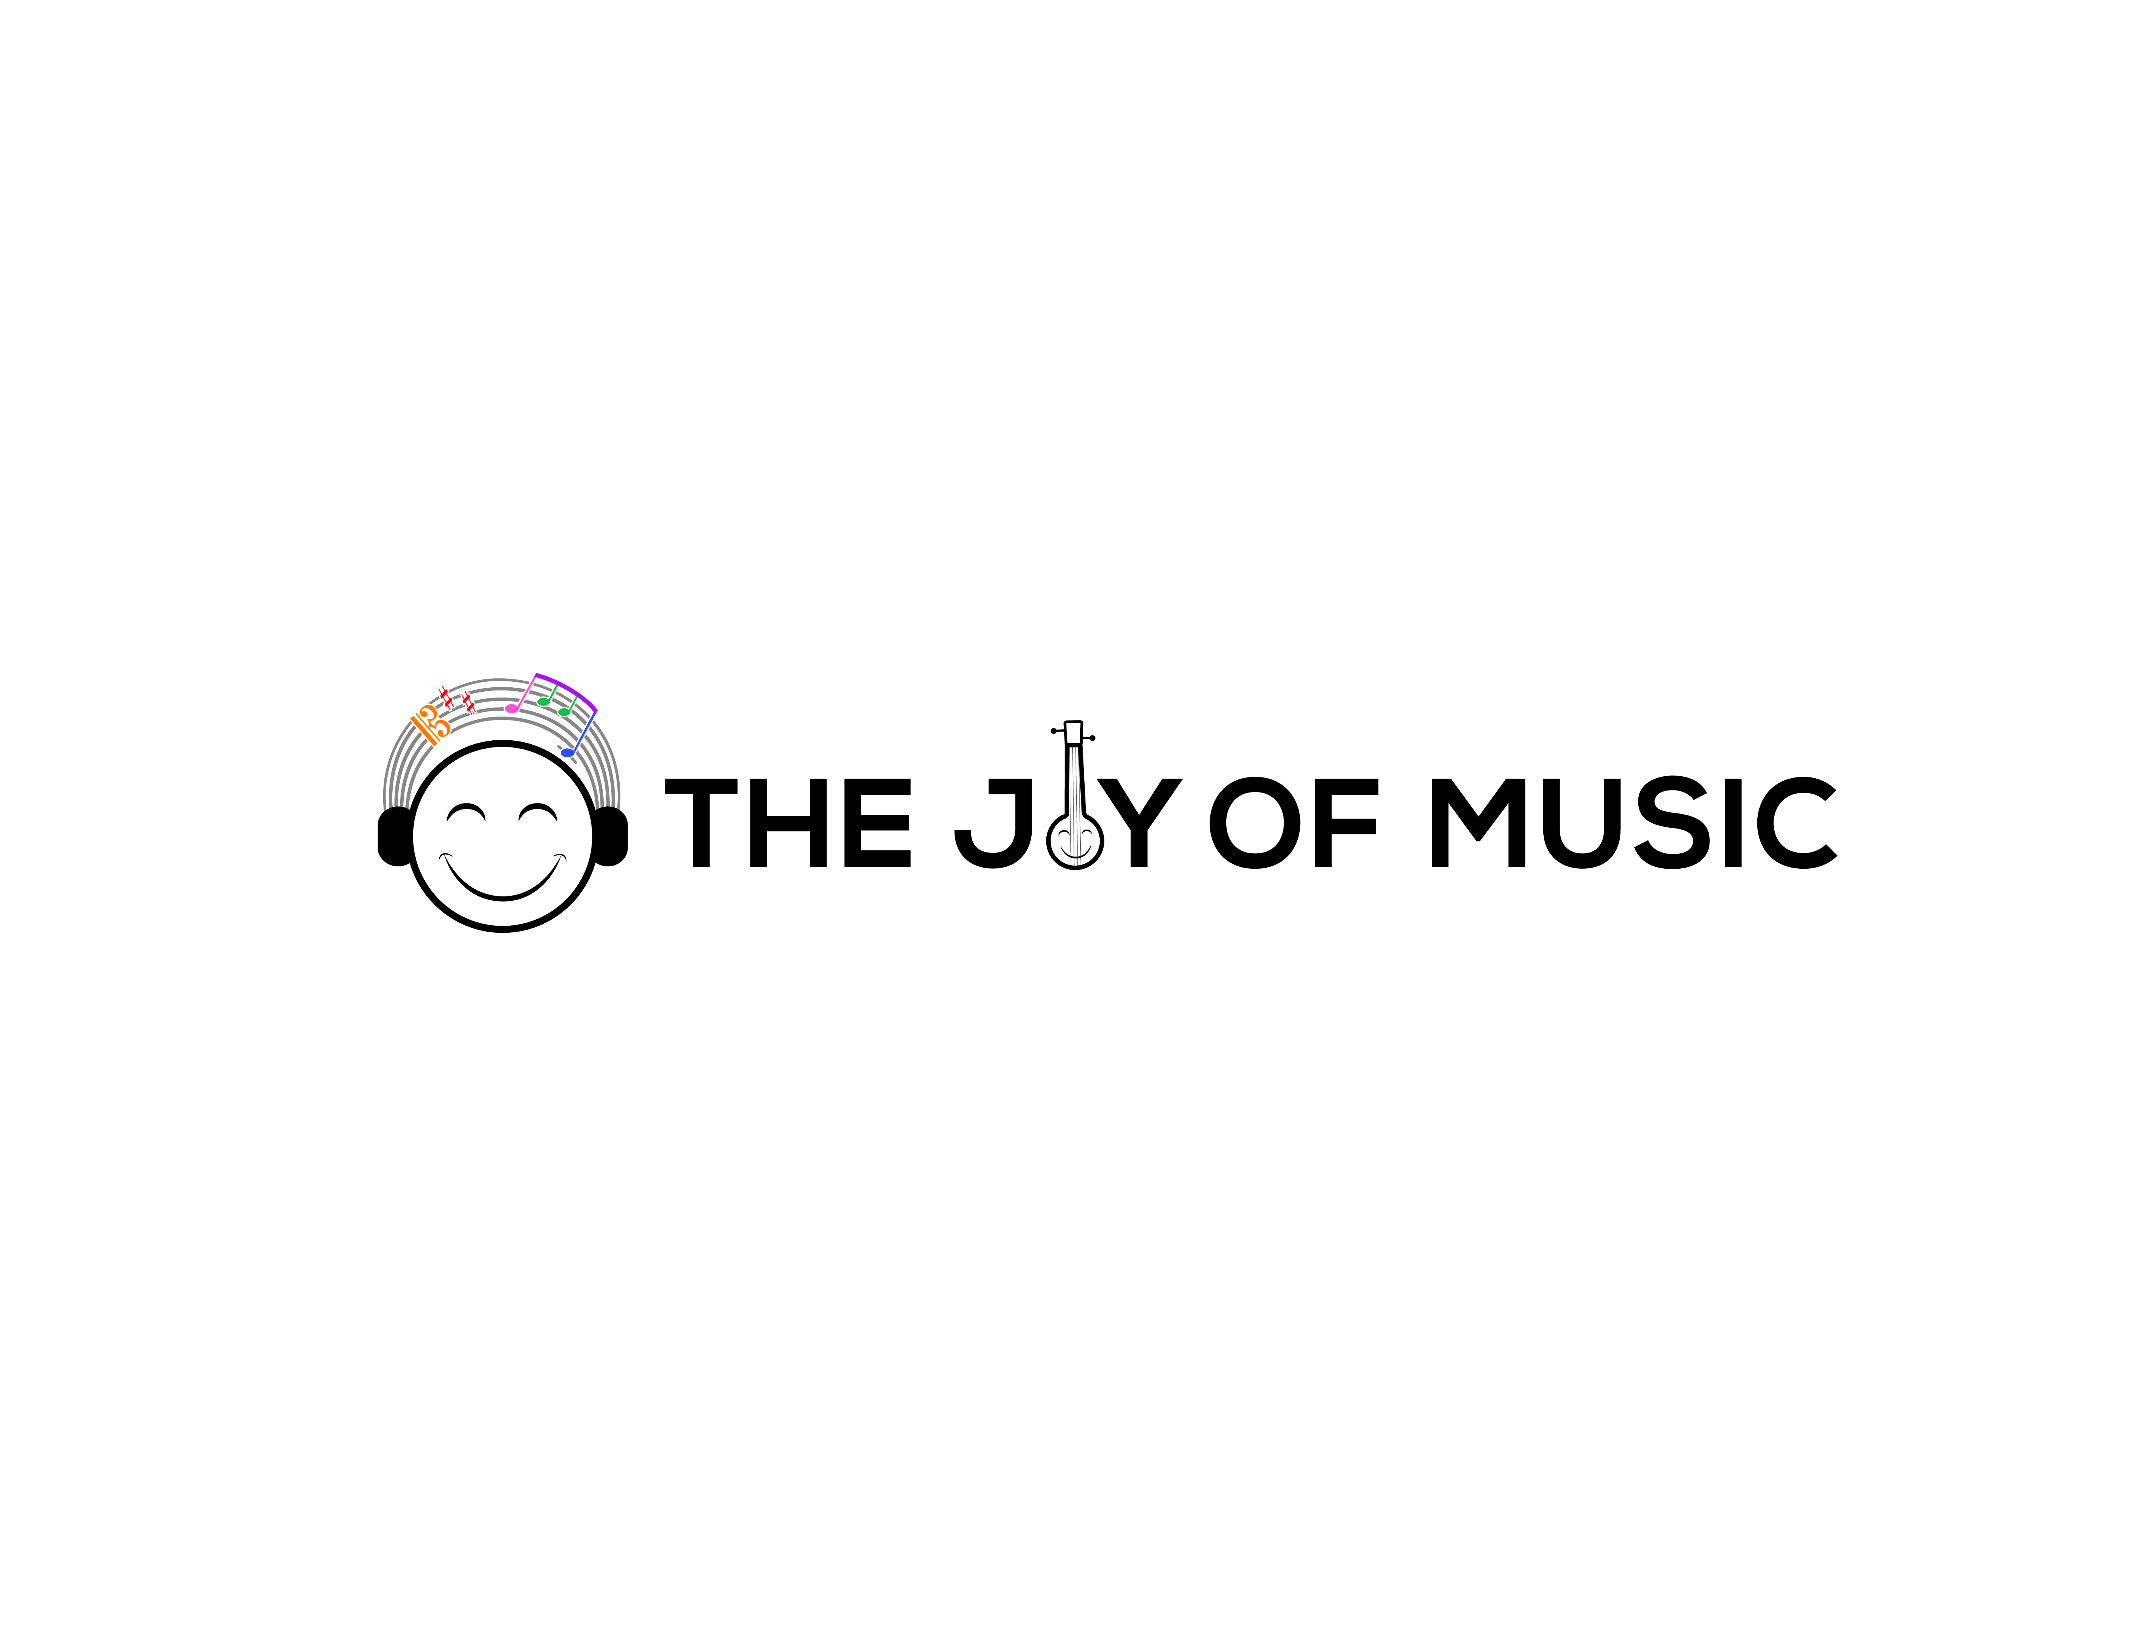
Carnatic Bingo | Bingo Sheet #8

Student Name: ___________________ | Teacher Name: ___________________ | City, State: ___________________
Parent Name: ____________________ | Parent Email: ___________________ | Parent WhatsApp: ________________

 | 1 | 2 | 3 | 4 | 5
A
B
C |  |  | ★ Answer MCQ ★
D
E
★ The FREE space (C3) may be crossed off by correctly answering the multiple choice question on the back.

I Heard…
A1. A ragam with no madhyamam | C4. A ragam or composition sung only for mic testing
A2. A Tamil composition | C5. A composition that was not in Adi, Roopakam, Khanda Chapu, or Misra Chapu
A3. Adi thalam | D1. A ragam with no Pa
A4. A Malayalam composition | D2. A Sanskrit composition
A5. A Shyama Shastri composition | D3. A composition that started before the samam
B1. A Thyagaraja composition | D4. A composition by a non-trinity composer
B2. Khanda Chapu | D5. A Papanasam Sivan composition
B3. A Gopalakrishna Bharati composition | E1. A Purandaradasa composition
B4. A Kannada composition | E2. A Thani Avarthanam
B5. A Muthuswamy Dikshitar composition | E3. A Telugu composition
C1. Misra Chapu | E4. A composition that started on the samam
C2. A composition that started after the samam | E5. A prati-madhyama ragam


Carnatic Bingo | Bingo Sheet #8

Concert Tracking
Cell | Song | Ragam | Thalam | Composer | Improv  (A/T/N/K) | Comp. Type | Concert
Concert Details
Concert # | Date | Artist | Accompanists | Venue | Location | Artist Signature
Multiple Choice Question
Which of the following rāgas is a janya of the Melakarta Kharaharapriya?
□ A) Hamsadhwani
□ B) Kalyani
□ C) Abheri
□ D) Nattai
How to play: At a concert, when you hear or see something that matches one of the hints on page 1 ("I Heard"), put a check or X in the matching empty square (A1-E5). Get 5 in a row - horizontally, vertically, or diagonally - to complete your Bingo! The FREE space (C3) is unlocked by correctly answering the multiple choice question above.

