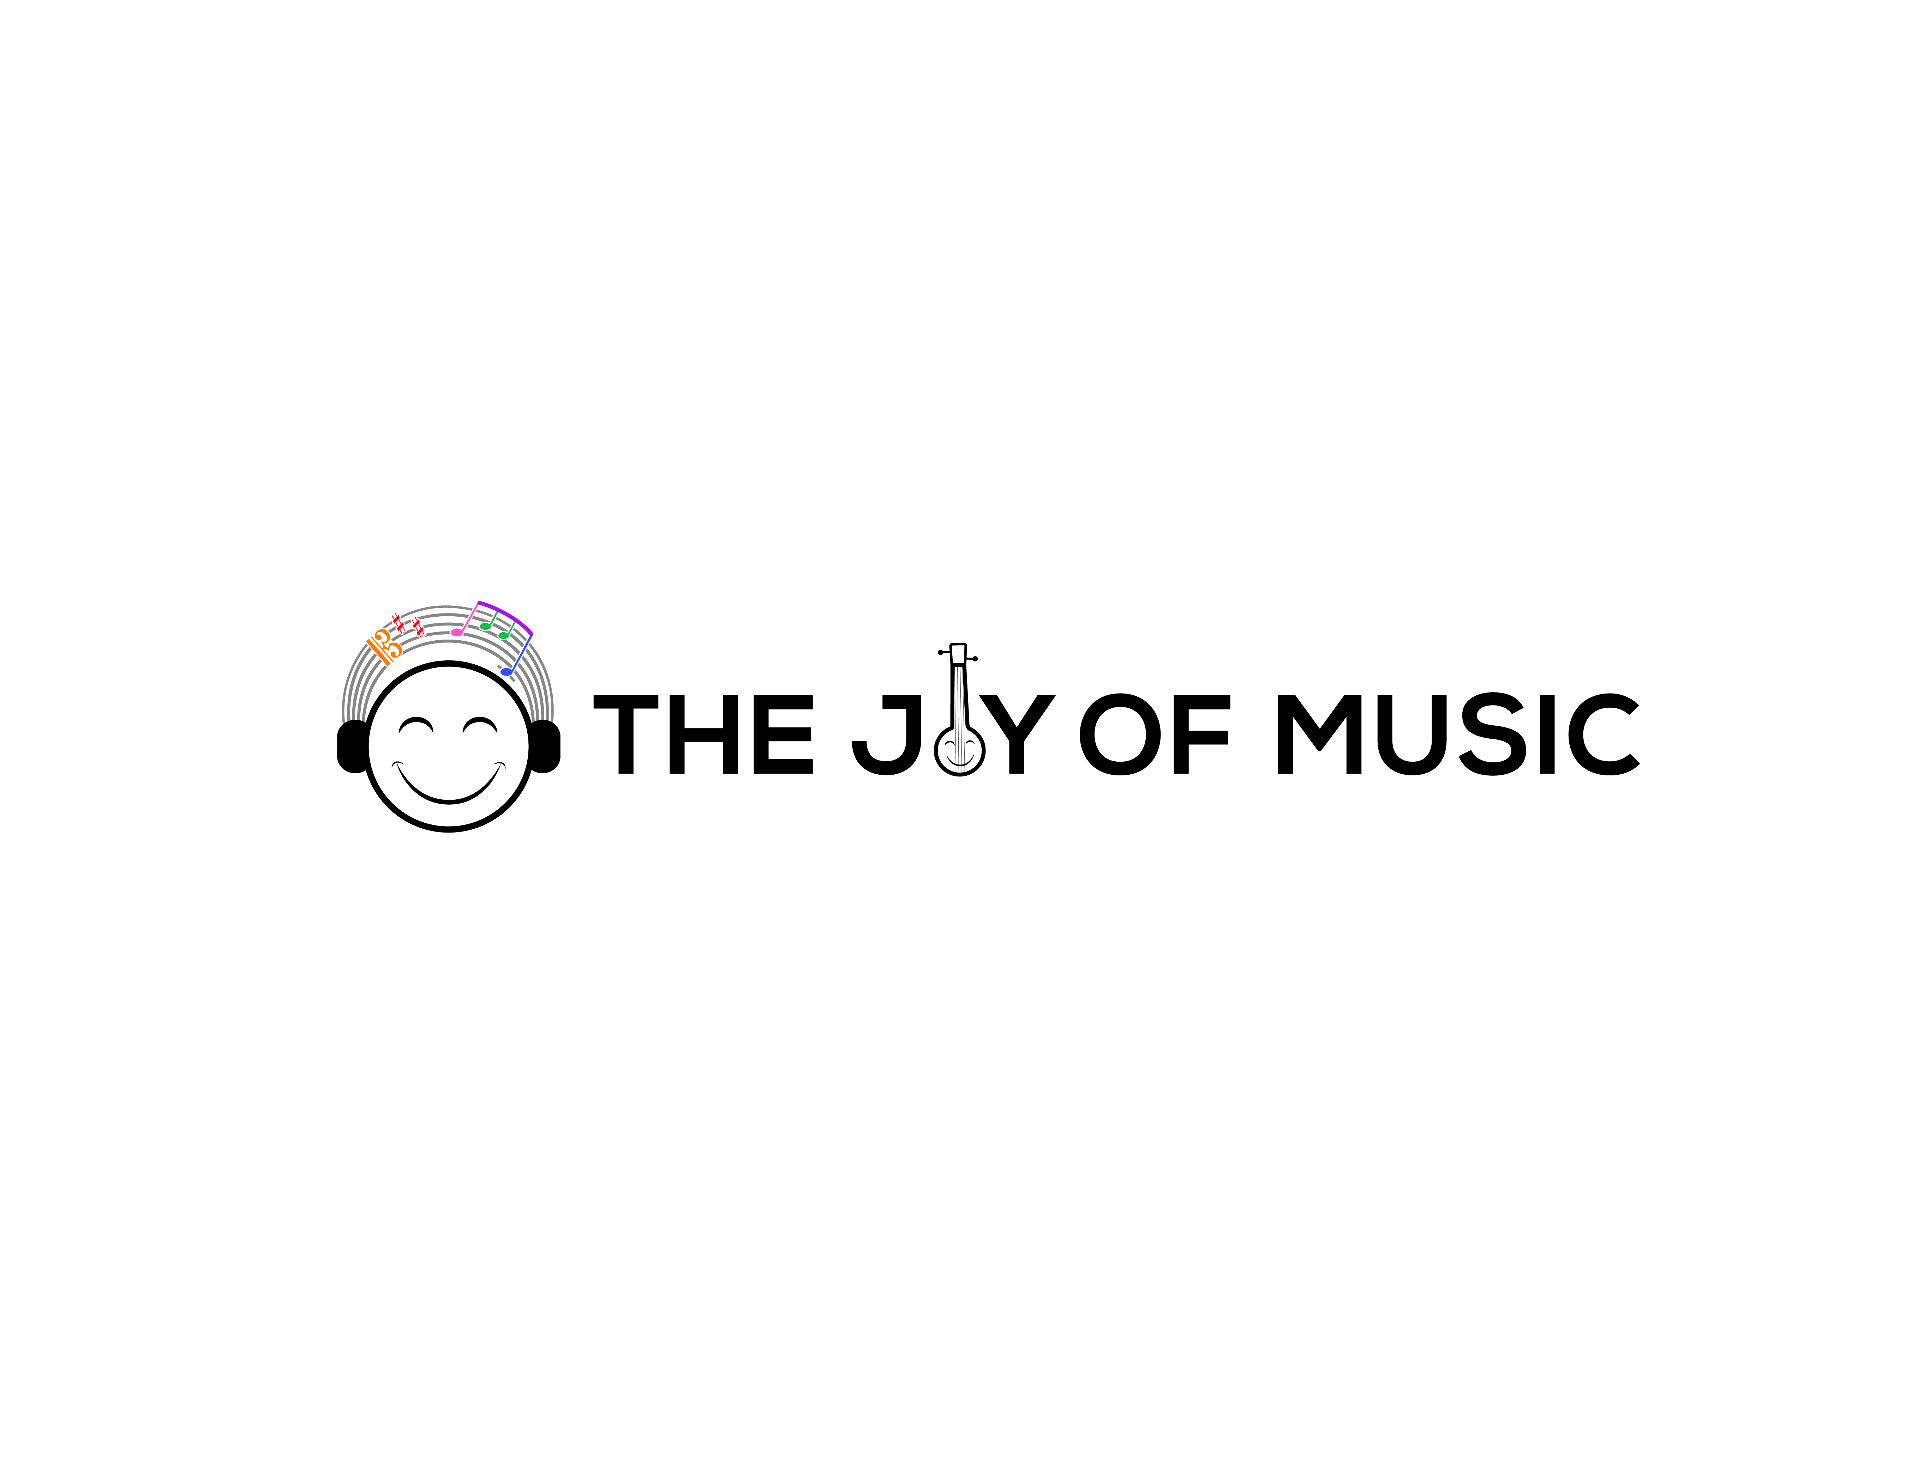
Carnatic Bingo | Bingo Sheet #9

Student Name: ___________________ | Teacher Name: ___________________ | City, State: ___________________
Parent Name: ____________________ | Parent Email: ___________________ | Parent WhatsApp: ________________

 | 1 | 2 | 3 | 4 | 5
A
B
C |  |  | ★ Answer MCQ ★
D
E
★ The FREE space (C3) may be crossed off by correctly answering the multiple choice question on the back.

I Heard…
A1. A Papanasam Sivan composition | C4. Khanda Chapu
A2. A Sanskrit composition | C5. A ragam or composition sung only for mic testing
A3. A Purandaradasa composition | D1. A ragam with no madhyamam
A4. A Thani Avarthanam | D2. A prati-madhyama ragam
A5. A composition by a non-trinity composer | D3. A ragam with no Pa
B1. A Malayalam composition | D4. A Muthuswamy Dikshitar composition
B2. A Kannada composition | D5. Adi thalam
B3. A composition that started after the samam | E1. A Shyama Shastri composition
B4. A Telugu composition | E2. Misra Chapu
B5. A composition that started on the samam | E3. A composition that was not in Adi, Roopakam, Khanda Chapu, or Misra Chapu
C1. A Thyagaraja composition | E4. A Gopalakrishna Bharati composition
C2. A composition that started before the samam | E5. A Tamil composition


Carnatic Bingo | Bingo Sheet #9

Concert Tracking
Cell | Song | Ragam | Thalam | Composer | Improv  (A/T/N/K) | Comp. Type | Concert
Concert Details
Concert # | Date | Artist | Accompanists | Venue | Location | Artist Signature
Multiple Choice Question
The concept of Neraval primarily involves:
□ A) Singing solfège patterns
□ B) Rhythmic percussion exchange
□ C) Improvisation on a chosen lyrical line
□ D) Tuning the tambura
How to play: At a concert, when you hear or see something that matches one of the hints on page 1 ("I Heard"), put a check or X in the matching empty square (A1-E5). Get 5 in a row - horizontally, vertically, or diagonally - to complete your Bingo! The FREE space (C3) is unlocked by correctly answering the multiple choice question above.

