1. Explain the heap property of a tree

**They do not have to be in numerical order, however they are in *an* order. The parent node is always greater than the children node; there can only be 2 children of a parent node.**

2. List and describe the 3 methods most often associated with a stack.

**Push: adds values to a stack**

**Pop: returns and removes**

**Peak/Top: returns the value without removing it**

3. Identify 3 errors in the following code snippet:

num = input()

def factorial(n):

if n = 0

return 1

elif:

return n * factorial(n-1)

num(factorial)

-**There is no colon after the “if” statement.**

**-Should be “==” instead of “=”**

**-The last line should return factorial(n) instead of num(factorial)**

4. Suppose there are 2 circles on a cartesian plane at (1,1) and (4,1), with a radius of m and n respectively. Write psuedocode that determines if the two circles overlap.

**If radius of the circle >= 3:**

**Print(“The two circles overlap”)**

**Elif radius of the circle < 3:**

**Print (“The two circles do not overlap”)**

5. Use pseudocode to design a class that represents a car.

**class Car(object):**

**def __init__(self, make model, year, color, mileage):**

**#initialize self**

**#initialize make**

**#initialize model**

**#initialize year**  
 **#initialize color**

**#initialize mileage**

**class Gas(obj):**

**def __init__(self, fuel tank, distance):**

**# initialize self**

**# initialize fuel tank and**

**#distance**

6. Explain the meaning and use of the global keyword in python

**A global keyword in python can hold a global variable and it is able to change the global variable from a local context. This is important when we want to keep track of multiple (global) variables.**

7. Draw a binary search tree containing the items added in order of [6, 5, 21, 1, 3, 8, 9, 7, 14,25]:

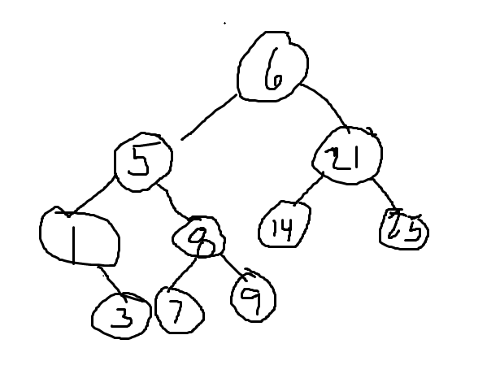

8. Give the Big-O runtime of the following code fragment:

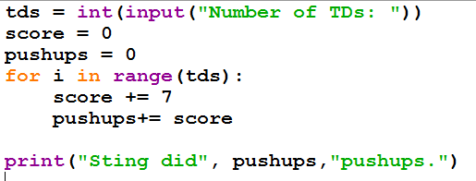

**N**

9.Give the Big-O runtime of the following code snippet:

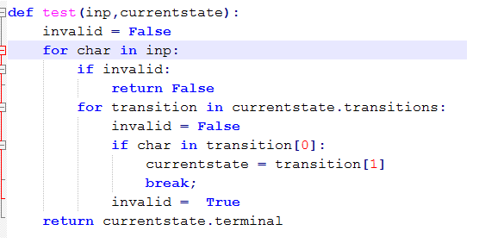

**N^2**

10. Write a python program that uses **a dictionary** to store the following states and capitals.

Des Moines, Iowa  
Jefferson City, Missouri  
Albany, New York  
Sacramento, California  
Austin, Texas  
Lincoln, Nebraska

Finally, print the capital of california from your dictionary.  
  
stateCapitals = {}

def addStates(num):

   #your solution here

print()  # modify this line as well

11. Define the following terms in the context of computer science:

a. Complexity: **used to measure how long an algorithm takes to run**

b. Heuristic: **easier way of solving a challenging problem.**

c. Linear: **more efficient way of solving a programming problem in a particular order**

d. Tree: **a hierarchical tree which has root values and subclasses of children nodes, which has parent nodes, and all of these nodes are linked together**

e. Stack**: has values (numbers / strings) which are kept in a specific order**

f. Node: **a part of bigger data structure; typically connected by vertices**

g. Graph: **where a mutable set of ordered pairs (edges or arcs) consists of and are connected through vertices or nodes.**

h. Queue: **a data structure which follows a specific order for operation to perform**

i. Quadratic: **in data structures, prevents collision between a hash table**

j. Exception: **where an error occurs and the code requires try/except handling to tell there is an error.**

k. Dictionary: **a list of key-value pairs.**