Continuum, CO, and water vapour maps of the Orion Nebula, First millimetre spectral imaging with CONCERTO

Abstract

This data release provides the first millimetre spectroscopic imaging of the Orion Nebula obtained with the CONCERTO instrument at APEX. The dataset covers 0.5 deg² centred on M42 at a typical angular resolution of 27″ at 250 GHz and with a spectral resolution of 6 GHz (sampled at 3 GHz), across the frequency range 130–310 GHz (0.97–2.3 mm). The observations were carried out on 2022-08-24 under ESO programme 110.23NK (110.A-4194), in excellent atmospheric conditions (pwv ~ 0.4 mm). A total of 11 on-the-fly scans with 2.4 h on-source time were calibrated and combined into a single spectral cube. The release includes a full calibrated spectral cube, velocity-integrated maps of the CO(2–1) line at 230.5 GHz and the H₂O 183.3 GHz line, a white-light average map, and continuum intensity and spectral slope maps. The typical noise is 47 mK per 3 GHz bin per beam in the spectral cube and 6–8 mK per beam in the photometric maps. Details of the processing, calibration, and validation of these data are provided in Désert et al. (2025, A&A, 701, A210; arXiv:2504.10487).

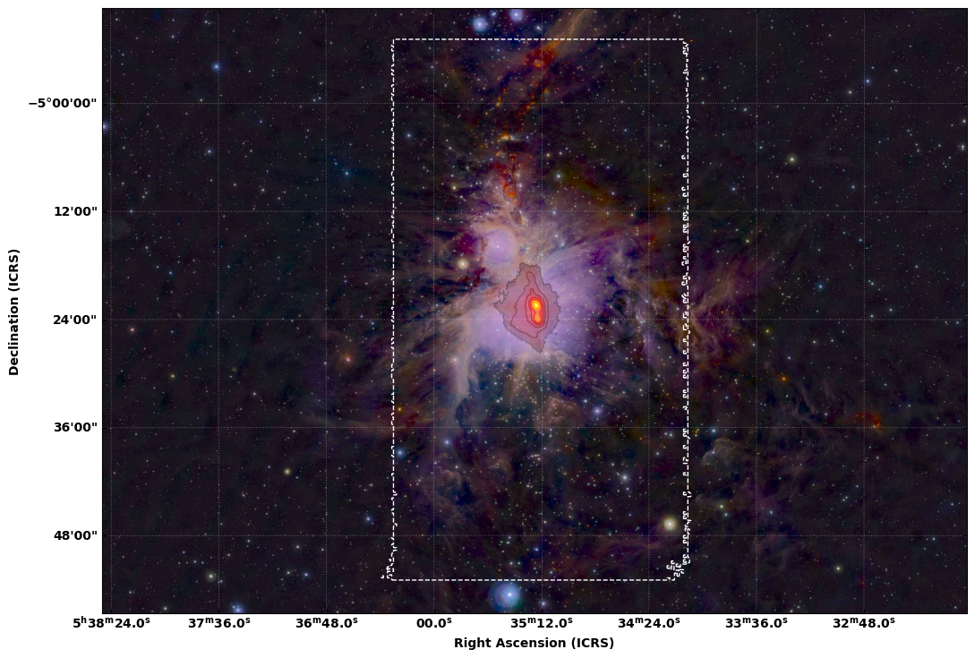

Fig 1. Near-infrared color image of the Orion A molecular cloud obtained with the VISTA telescope (Meingast et al. 2016; ESO programme 090.C-0797(A)), with R/G/B corresponding to the J/H/Ks bands (1.25/1.65/2.15 μm). Overlaid in red are contours of the CONCERTO 250 GHz photometric continuum map, showing the millimetre emission from dust and ionized gas. The dashed white rectangle indicates the field observed with CONCERTO at APEX.

Overview of Observations

The raw Time Ordered Information (TOI) from the ~3700 KID detectors was acquired in both photometric and spectroscopic modes. Due to quality selection, about 600 LF and 300 HF detectors were used in this early release. The Martin–Puplett interferometer rooftop mirror was swept continuously, producing interferograms every 0.25 s per detector; the maximum optical path difference corresponds to a spectral resolution of 6 GHz, sampled at 3 GHz.

In photometric mode, the TOI are averaged per interferometer cycle and projected into maps for the low– and high–frequency channels, after correction for atmospheric opacity and common-mode subtraction. Absolute calibration is obtained by comparison with NIKA2 260 GHz maps of Orion from the IRAM 30 m telescope (Perotto et al. 2020; André et al. 2025, in prep.), rescaled to 250 GHz. The calibration is consistent with CONCERTO’s planet/quasar measurements (Hu et al. 2024) and with Planck maps, and the overall photometric uncertainty is ~15%.

In spectroscopic mode, residual signals in the interferograms are removed (background modulation, mean offsets, correlated noise), and the interferograms are co-added in optical path difference (OPD) space. Fourier transformation then yields spectral cubes for the LF and HF channels. Calibration is performed by forcing the integrated cube to match the external NIKA2 photometry. The effective beam is a Gaussian with FWHM ≃ 27″ × (250 GHz / ν), with atmospheric emission largely cancelled by the differential beam configuration.

Release Content

The data concern millimetric low–resolution spectroscopic imaging of the Orion Nebula (M42). The observations cover 0.5 deg² centred at RA(J2000) = 05:35:17.3, Dec(J2000) = −05:23:28.0, at a distance of 414 ± 7 pc (Menten et al. 2007). The effective angular resolution is 27’’ at 250 GHz (scaling as 250 GHz/ν), corresponding to ~0.05 pc at the distance of Orion. The frequency coverage extends from 130 to 310 GHz with a spectral resolution of 6 GHz (sampled at 3 GHz). The final calibrated products include a spectral cube, line–integrated CO(2–1) and H₂O maps, photometric maps, and white–light averages. The total data volume is < 400 MB.

Release Notes

The photometric map has a better signal-to-noise than the white-light map because it concerns the data without the interferometric part. The spectroscopic and photometric beams are not the same. The effective beam for spectroscopic data is a Gaussian with FWHM of 27 arcsec (250GHz/nu) minus a flat disk of 18.6 arcmin diameter (corresponding to the field-of-view), effectively cancelling the atmospheric emission. For photometric data, the beam has full width at half maximum (FWHM) of 32.2’’ and 28.6’’ for LF and HF (hereafter approximated as 30’’), described by Hu et al. 2024, AA, 689, A20, and contains also the flat disk, this time in addition rather than in subtraction (here, atmospheric emission is cancelled with baselining at the subscan level).

The noise for the spectral cube is typically 47 mK per spectral bin of 3GHz and per beam measured outside the main Orion, and towards the centre of the map at around 200GHz. The median noise value from the error cube measured over the whole cube is 0.267K, which is given in the BNOISE cube header keyword value.

The noise for the photometric map is given as an extension and is typically 8 mK per beam measured outside the main Orion, and towards the centre of the map. The median noise value from the error image measured over the whole image is 0.01K, which is given in the BNOISE cube header keyword value.

Data Reduction and Calibration

The data have been calibrated using NIKA2/IRAM30m 1.2mm maps of Orion (Perotto et al. 2020). The overall calibration uncertainty is 15%. The final data are corrected from the atmospheric transmission and the CONCERTO bandpass.

Data Quality

Comparisons to external datasets demonstrate the reliability of the CONCERTO maps. In particular, the photometric calibration was cross–checked against NIKA2 1.2 mm (260 GHz) observations from the IRAM 30 m telescope. After convolution to a common 40″ resolution, the CONCERTO and NIKA2 maps show nearly identical large–scale morphology and flux levels. A pixel–by–pixel correlation (see Désert et al. 2025, Fig. 3) yields a tight linear relation with unit slope, confirming the absolute calibration to within ~15%. For the spectroscopic data, integrated CO(2–1) intensities agree closely with independent IRAM 30 m EMIR maps (Berné et al. 2014), despite CONCERTO requiring only 2.4 h of integration compared to 25 h with EMIR. These cross–checks confirm that the CONCERTO release products reproduce both the continuum and line emission with good fidelity.
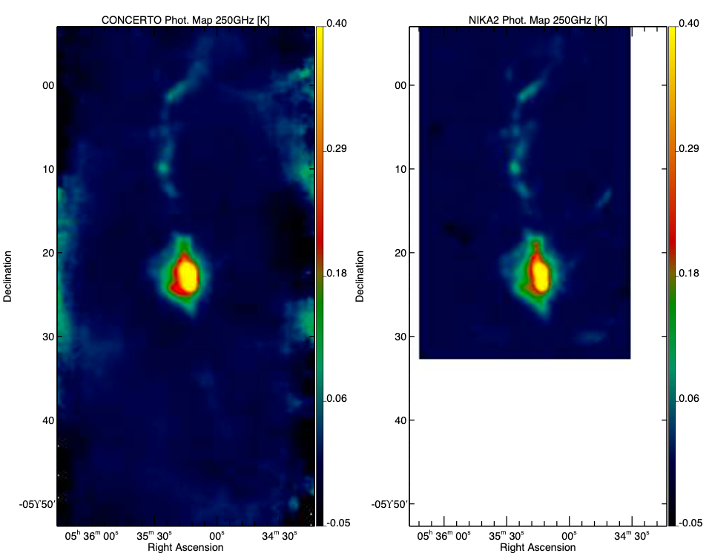

Fig. 2. Photometric map of Orion with CONCERTO (left) and NIKA2 (right) in brightness temperature at 250 GHz, convolved to a common 40″ resolution. The colour bar is in Kelvin, and the maps are saturated at 0.4 K to highlight faint structures. Both instruments recover the same large–scale morphology and diffuse emission. A direct pixel–by–pixel comparison (not shown here, see Désert et al. 2025, Fig. 3) demonstrates a tight linear correlation with unit slope, confirming that CONCERTO’s calibration is consistent with NIKA2 to within ~15%. This establishes the reliability of CONCERTO photometry across extended emission regions, while providing the unique advantage of simultaneous spectral coverage from 130 to 310 GHz.

Known issues

This is the first release of spectroscopic data from CONCERTO@APEX, and some limitations remain. The main systematic uncertainty arises from the imperfect knowledge of the instrument bandpass, which introduces small spectral “wiggles” at higher frequencies (> 270 GHz). This effect does not strongly impact the integrated CO or H₂O line measurements, but may bias continuum slopes at the few percent level. In addition, only ~900 of the ~3700 available KID detectors were retained in this early processing due to quality cuts, leading to lower mapping efficiency and higher noise than expected. Beam characterization is also preliminary: in photometric mode the response combines a Gaussian beam with a large flat disk, while in spectroscopic mode the two are differenced, but the exact beam models require refinement. Future releases will address these issues with improved bandpass measurements, a larger fraction of usable detectors, and better beam calibration.

Previous Releases

None

Data Format

Files Types

All files are in FITS format. Unless otherwise noted, the data are expressed in Kelvin brightness temperature.

- Orion_CONCERTO_ESO_2all_cube.fits
PRODCATG = SCIENCE.CUBE
Spectral cube calibrated in Kelvin brightness temperature, with an associated noise cube per pixel and spectral bin.

- Orion_CONCERTO_ESO_2all_whitelight.fits
PRODCATG = SCIENCE.IMAGE
White–light map obtained as the unweighted average of the spectral cube.

- Orion_CONCERTO_ESO_2all_CO.fits
PRODCATG = SCIENCE.IMAGE.FLUXMAP
Velocity–integrated intensity map of the CO (2–1) transition, in K km s⁻¹.

  - Orion_CONCERTO_ESO_2all_CO_err.fits
PRODCATG = ANCILLARY.RMSMAP
Associated error map.
  - Orion_CONCERTO_ESO_2all_CO_continuum.fits
PRODCATG = ANCILLARY.IMAGE.CONTINUUM
MEFITS with HDU 1 = DATA_EXT (continuum map) and HDU 2 = STAT_EXT (error map).
  - Orion_CONCERTO_ESO_2all_CO_spectralindex.fits
PRODCATG = ANCILLARY.IMAGE.SPECTRAL_INDEX
MEFITS with HDU 1 = DATA_EXT (spectral–index map) and HDU 2 = STAT_EXT (error map).

- Orion_CONCERTO_ESO_2all_H2O.fits
PRODCATG = SCIENCE.IMAGE.FLUXMAP
Velocity–integrated intensity map of the H₂O 3₁₃–2₂₀ transition, in K km s⁻¹.

  - Orion_CONCERTO_ESO_2all_H2O_err.fits
PRODCATG = ANCILLARY.RMSMAP
Associated error map.
  - Orion_CONCERTO_ESO_2all_H2O_continuum.fits
PRODCATG = ANCILLARY.IMAGE.CONTINUUM
MEFITS with HDU 1 = DATA_EXT (continuum map) and HDU 2 = STAT_EXT (error on the continuum map).
  - Orion_CONCERTO_ESO_2all_H2O_spectralindex.fits
PRODCATG = ANCILLARY.IMAGE.SPECTRAL_INDEX
MEFITS with HDU 1 = DATA_EXT (spectral–index map) and HDU 2 = STAT_EXT (error on the spectral-index map).

- Orion_CONCERTO_ESO_2all_phot.fits
PRODCATG = SCIENCE.IMAGE
Photometric map at a reference frequency of 250 GHz, in Kelvin
  - Orion_CONCERTO_ESO_2all_phot_err.fits
PRODCATG = ANCILLARY.RMSMAP
Associated error map.

Acknowledgements

When using this data please refer to the following publication:

Désert, F.-X., Macías-Pérez, J. F. ,Beelen, A. et al., 2025, A&A, 701, A210

According to the Data Access Policy for ESO data held in the ESO Science Archive Facility, all users are required to acknowledge the source of the data with appropriate citation in their publications.

Since processed data downloaded from the ESO Archive are assigned Digital Object Identifiers (DOIs), the following statement must be included in all publications making use of them:

- Based on data obtained from the ESO Science Archive Facility with DOI: https://doi.org/10.18727/archive/103

Science data products from the ESO archive may be distributed by third parties, and disseminated via other services, according to the terms of the Creative Commons Attribution 4.0 International license. Credit to the ESO provenance of the data must be acknowledged, and the file headers preserved.

