BIOSTAT 721 — Project 2
Jiaqi Wang
November 16, 2025

1 Setting

2 Data cleaning

3 Data importing

4 Check cleaning status
## Check for missing values:
## date co units_co pm25 units_pm o3 units_o3 year
## 0 0 0 0 0 0 0 0
## month
## 0
##
## Check variable types:
## date co units_co pm25 units_pm o3
## "Date" "numeric" "character" "numeric" "character" "numeric"
## units_o3 year month
## "character" "factor" "numeric"
##
## Check summary statistics (only for numeric columns):
## co pm25 o3 month
## Min. :0.1000 Min. : 0.000 Min. :0.0100 Min. : 1.000
## 1st Qu.:0.2000 1st Qu.: 5.200 1st Qu.:0.0320 1st Qu.: 3.000
## Median :0.3000 Median : 7.500 Median :0.0380 Median : 6.000
## Mean :0.3435 Mean : 7.832 Mean :0.0396 Mean : 5.927
## 3rd Qu.:0.4000 3rd Qu.:10.100 3rd Qu.:0.0480 3rd Qu.: 9.000
## Max. :1.3000 Max. :31.200 Max. :0.0680 Max. :12.000

5 Plot 1.
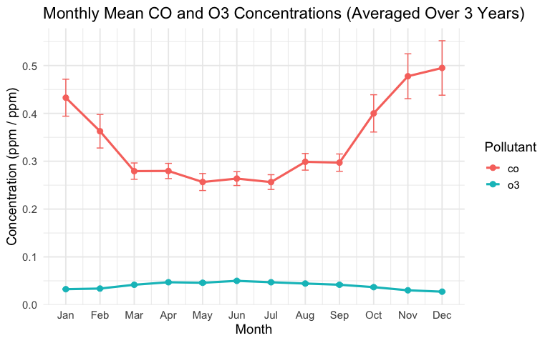

6 Plot 2.
