BIOSTAT 721 — Project 2
Jiaqi Wang
November 16, 2025

1 Setting

2 Introduction
Sickle Cell Disease (SCD) is a genetic blood disorder characterized by abnormally shaped red blood cells, which can lead to anemia, pain crises, and stroke. Recent studies suggest that exposure to air pollutants—such as CO, Ozone (O₃), and PM2.5—may aggravate vaso-occlusion and pain episodes in SCD patients.
This project explores associations between daily air pollution levels and SCD healthcare utilization in Durham County using:
EPA air quality data (2018–2020) from RDU monitoring station Duke Health SCD emergency visits / hospital data (hypothetical for now)

3 Data cleaning

3.1 2.1 Cleaning function

3.2 2.2 Data importing

3.3 2.3 Check cleaning status
## Check for missing values:
## date co units_co pm25 units_pm o3 units_o3 year
## 0 0 0 0 0 0 0 0
## month
## 0
##
## Check variable types:
## date co units_co pm25 units_pm o3
## "Date" "numeric" "character" "numeric" "character" "numeric"
## units_o3 year month
## "character" "factor" "numeric"
##
## Check summary statistics (only for numeric columns):
## co pm25 o3 month
## Min. :0.1000 Min. : 0.000 Min. :0.0100 Min. : 1.000
## 1st Qu.:0.2000 1st Qu.: 5.200 1st Qu.:0.0320 1st Qu.: 3.000
## Median :0.3000 Median : 7.500 Median :0.0380 Median : 6.000
## Mean :0.3435 Mean : 7.832 Mean :0.0396 Mean : 5.927
## 3rd Qu.:0.4000 3rd Qu.:10.100 3rd Qu.:0.0480 3rd Qu.: 9.000
## Max. :1.3000 Max. :31.200 Max. :0.0680 Max. :12.000

4 Exploratory analysis

4.1 Monthly PM2.5 trend
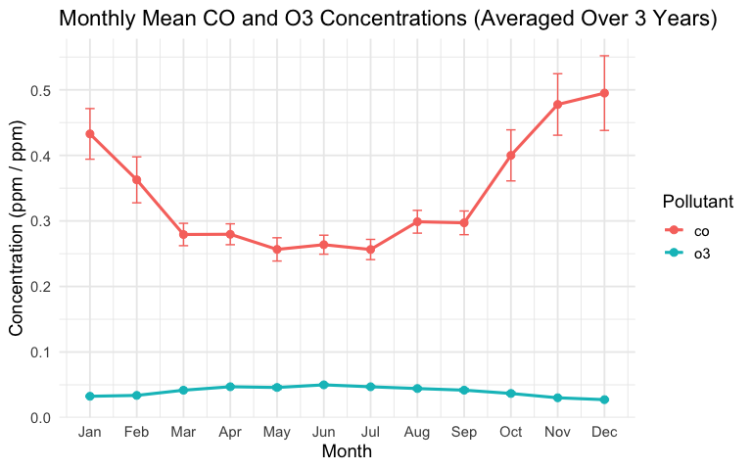

4.2 CO and O₃ Averages
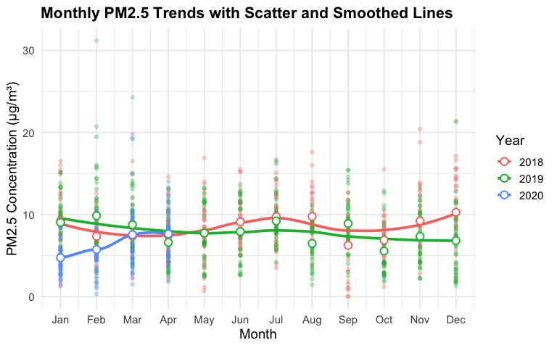

5 Link to the project github
https://github.com/ashleyw57/BIOSTAT721-Project2

