Name: Ashley Wong

**Front End Web Development Questionnaire**

**Do you have a current online portfolio?**

* My GitHub (<https://github.com/ashleywong9398/>) can be considered part of my portfolio.
* Also, I have a project hosted on Netlify (<https://darling-kleicha-77c66b.netlify.app/>), which can be included in my portfolio.

**How many projects would you be able to show in your portfolio?**

I can showcase **3-4 projects**, including **HTML projects, React projects, and Angular projects.**

**HTML**

<https://ashleywong9398.github.io/WEBD168/final>

<https://ashleywong9398.github.io/WEBD152/FinalProjectAshley/FinalProjectAssignment.html>

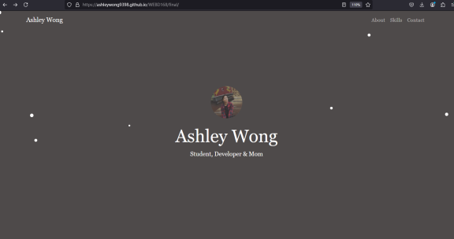 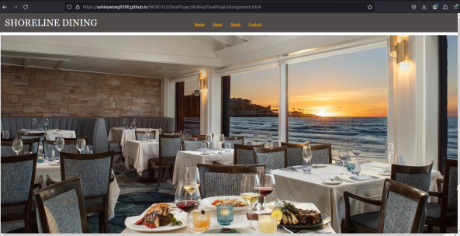

**React**

<https://darling-kleicha-77c66b.netlify.app/>

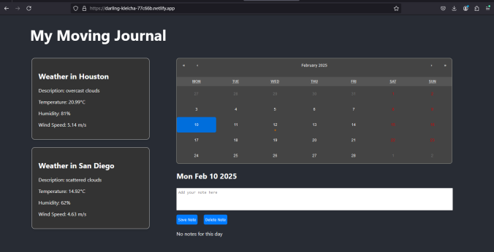

**Angular**

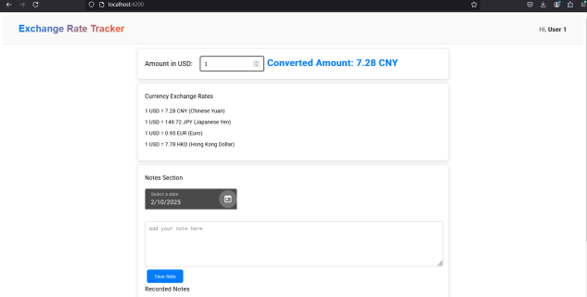

**List your skills in order of strength.**

React > HTML > CSS > JavaScript >JIRA>VBA>Photoshop

**What do you think makes a strong portfolio?**

* Clear and easy to read.
* Visually appealing design.
* Smooth functionality and user interaction.
* Concise content with key highlights.

**Describe your dream job(s)**

My dream job is **website updating, operations, and maintenance.**I previously worked **for 5 years at a gaming company in China,** where I was responsible for **permission code configuration management, Jira project workflow setup, risk assessment, and regular reporting.**Currently, my **spoken English is not very fluent,** so I am looking for a job that involves **simple communication and regular tasks.**

**Are you willing to relocate? If so, where?**

If there is a suitable job opportunity, I am **willing to relocate.**I **prefer to work in Texas.**